**Practical 02**

**CPU, Memory and I/O working together**

In this practical, you will use a simulator to run the code, observe and appreciate how CPU, Memory and I/O work together.

1. LMC Simulator
2. Input data, move the data from accumulator to memory
3. Input data1, data2 and add two numbers
4. Input data1, data2 and ADD two numbers, REPEAT infinitely.
5. Input data1, data2 and ADD two numbers, REPEAT 3 times.
6. Input data1, data2 and subtract two numbers
7. Countdown

# A. LMC Simulator

This practical is based on the excellent [LMC simulator](https://peterhigginson.co.uk/LMC/) provided by Peter Higginson. [(https://peterhigginson.co.uk/LMC/)](https://peterhigginson.co.uk/LMC/)

Little Man Computer Simulation (LMC) in **JavaScript** with Fetch/Execute

Online help for the LMC, go to <https://peterhigginson.co.uk/LMC/help.html>

The LMC simulator takes the following form:

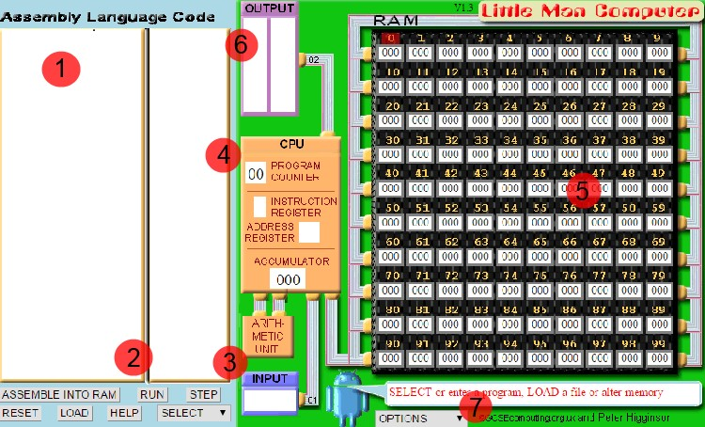

These are main components in the window that are easily recognizable:

1. The window for typing in the code
2. The two buttons - to load the code into memory and then run
3. The window for an input, if any - not necessary
4. An indicator that shows the progress of the code - step by step
5. Memory locations where instructions and data are stored, as specified in von Neumann architecture - 100 cells, from 00 to 99.
6. The window for the output/s during the execution of the code
7. Options for controlling the flow of the execution - slow to fast, etc

The best way to learn the LMC is running a set of codes, from the simplest to the more advanced gradually, rather than making an effort to understand the simulator fully at first.

You have to be familiar with the set of instructions. There are not many, just 11 of them. They are as follows:

|  |  |  |
| --- | --- | --- |
| **Mnemonic Code** | **Numeric Code** | **Instruction** |
| INP | 901 | Input data |
| ADD | 1XX | Add the contents of the memory address to the **Accumulator** |
| SUB | 2XX | Subtract the contents of the memory address from the  **Accumulator** |
| STA | 3XX | Store the value in the **Accumulator** in the memory address given. |
| LDA | 5XX | Load the **Accumulator** with the contents of the memory address given |
| BRA | 6XX | Branch - use the address given as the address of the next instruction |
| BRZ | 7XX | Branch to the address given if the Accumulator is zero |
| BRP | 8XX | Branch to the address given if the Accumulator is zero or positive |
| INP | 901 | Input data |
| OUT | 902 | Output data |
| HLT | HLT | Stop (Little Man has a rest). |
| DAT |  | Used to indicate a location that contains data. |

# B. Input data, move the data from accumulator to memory

1. Type the following code in the textbox:

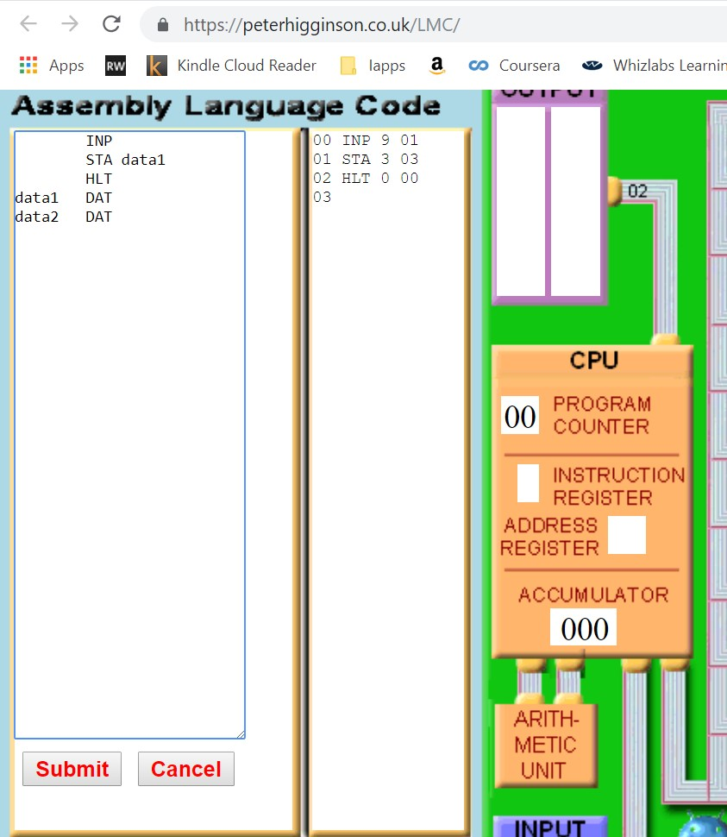

|  |
| --- |
| INP //input the first number in the accumulator STA data1 //store the first number in data1    HLT data1 DAT //data1 in the memory data2 DAT //data2 in the memory |

1. Observe the numeric code generated and loaded into memory(**click submit button**).

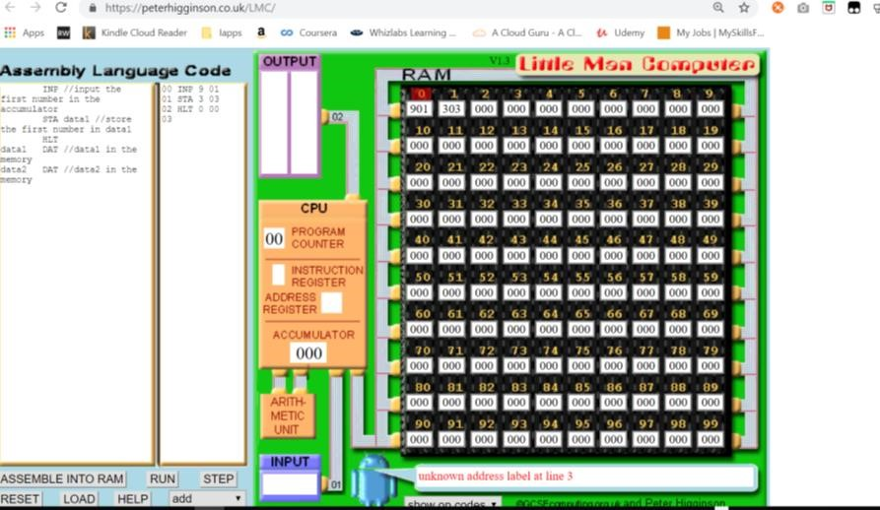

1. Run the code by clicking Step. observe the **red color** is for memory address, and **blue** is for data, or code.

1. Enter the first number as 8

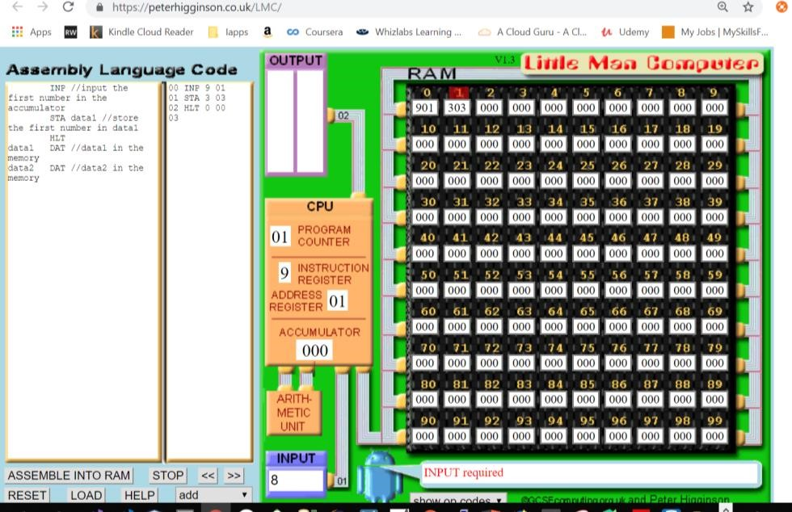

1. After entering the number, what is the value in the accumulator:

|  |  |
| --- | --- |
| Value in the ACCUMULATOR(in decimal) | 8 |

1. What is the next instruction to be executed by looking at the value of Program Counter?

|  |  |
| --- | --- |
| Value in the Program counter | 01 |

1. Click Step to execute STA (303), to move the first number from accumulator to memory.

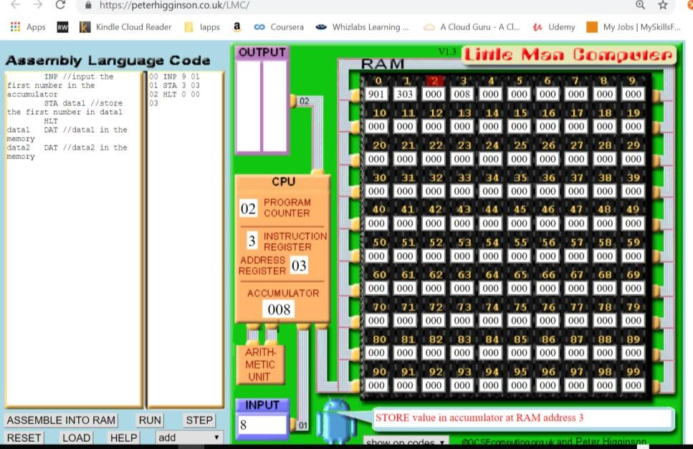

Where is the first number stored in the memory?

|  |  |
| --- | --- |
| Memory address for first number | 303 |
| Value stored in the above memory address | 1 |

1. Step again to execute HALT

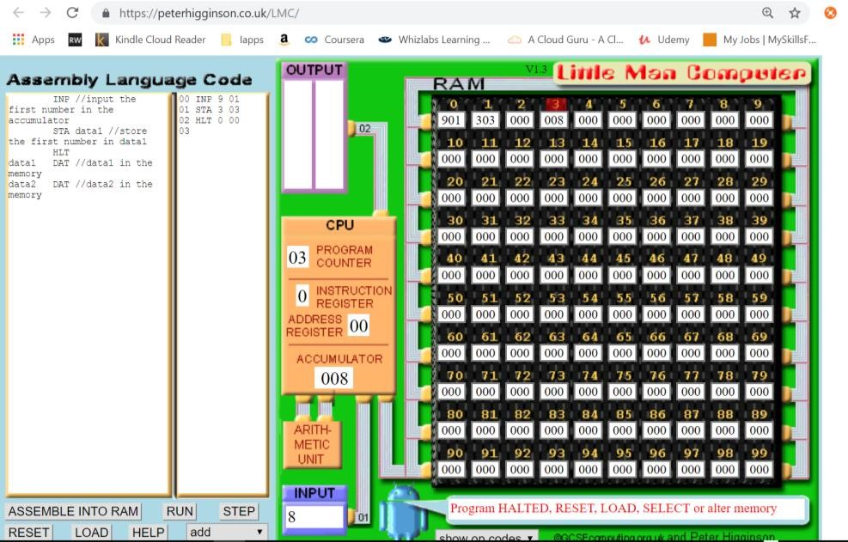

1. Observe the memory, filling the following table:

|  |  |  |
| --- | --- | --- |
| **Assembly Code** | **Numeric Code** | **Address** |
| INP | 901 | 0 |
| STA | 303 | 1 |
| HLT | 000 | 2 |
|  |  |  |
| **data** | **value** | **address** |
| Data1 | 8 | 3 |

1. Add more code to input data2

|  |
| --- |
| INP //input the first number in the accumulator STA data1 //store the first number in data1      INP //input the second number in the accumulator STA data2 //store the second number in data2    OUT //output the result  HLT  data1 DAT //data1 in the memory data2 DAT //data2 in the memory |

Run the code.

Enter first number as 8, and second number as 9

1. Observe the memory, filling the following table:

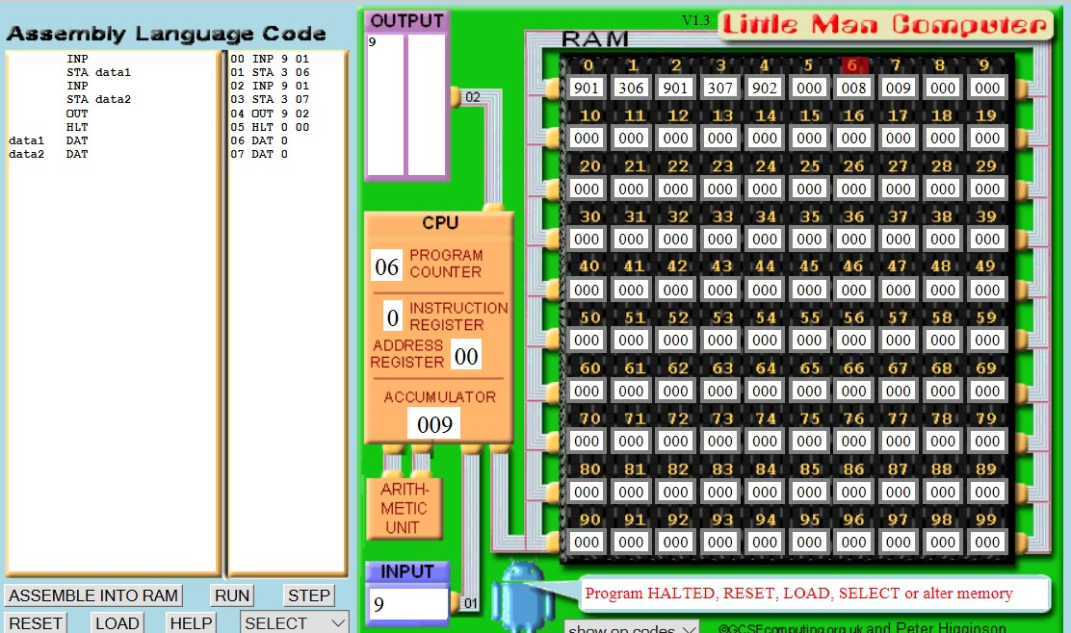

|  |  |  |
| --- | --- | --- |
| **Assembly Code** | **Numeric Code** | **Address** |
| INP | 901 | 0,2 |
| STA | 306, 307 | 1,3 |
| HLT | 000 | 5 |
|  |  |  |
| **data** | **value** | **address** |
| data1 | 8 | 6 |
| data2 | 9 | 7 |

# Input data1, data2 and add two numbers

1. Here is the code for adding two numbers and displaying the sum

|  |
| --- |
| INP //input the first number in the accumulator STA data1 //store the first number in data1      INP //input the second number in the accumulator STA data2 //store the second number in data2    LDA data1 //load the first number in data1 to accumulator ADD data2 //add the number with data2    OUT //output the result  HLT  data1 DAT //data1 in the memory data2 DAT //data2 in the memory |

1. Run the code to test if it works.
2. Observe the memory, register, and output at the end of the execution.

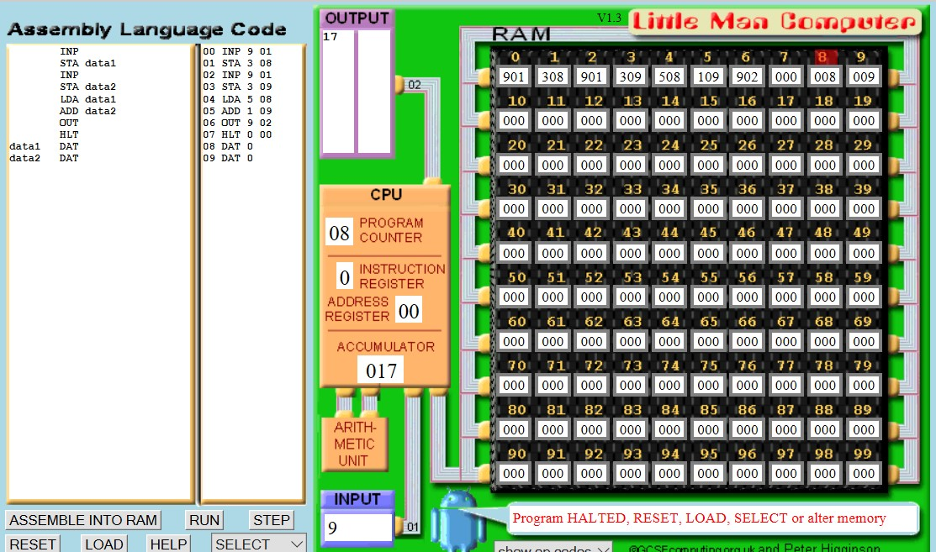

|  |  |  |
| --- | --- | --- |
| **Assembly Code** | **Numeric Code** | **Address** |
| INP | 901 | 0 |
| STA | 308 | 1 |
| INP | 901 | 2 |
| STA | 309 | 3 |
| LDA data1 | 508 | 4 |
| ADD data2 | 109 | 5 |
| OUT | 902 | 6 |
| HLT | 000 | 7 |
|  |  |  |
| **data** | **value** | **Address** |
| data1 | 8 | 8 |
| data2 | 9 | 9 |

1. Initialize data1 with value 10, and data2 with value 11

INP //input the first number in the accumulator STA data1 //store the first number in data1

INP //input the second number in the accumulator STA data2 //store the second number in data2

LDA data1 //load the first number in data1 to accumulator ADD data2 //add the number with data2

OUT //output the result

HLT

data1 DAT 10 //data1 in the memory with value 10 data2 DAT 11 //data2 in the memory with value 11

Submit the code, observe the memory locations for the two variables with initialized value “10”, “11”

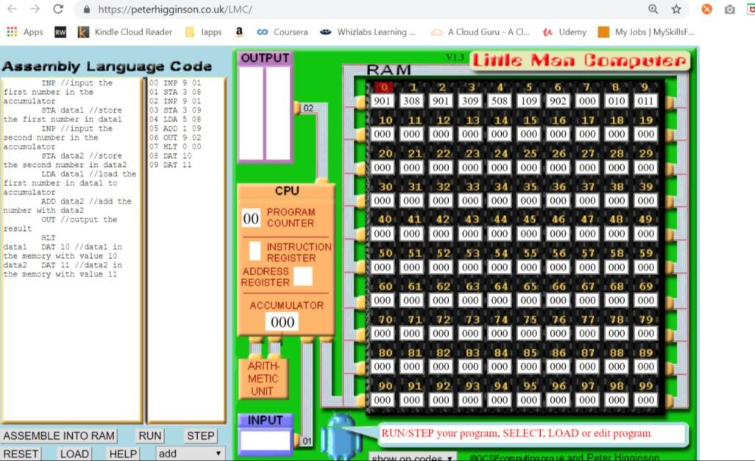

At the end of execution, what are the values in the above two addresses for data1 and data2?

(assuming user input for data1 is “8”, and data2 is “9”)

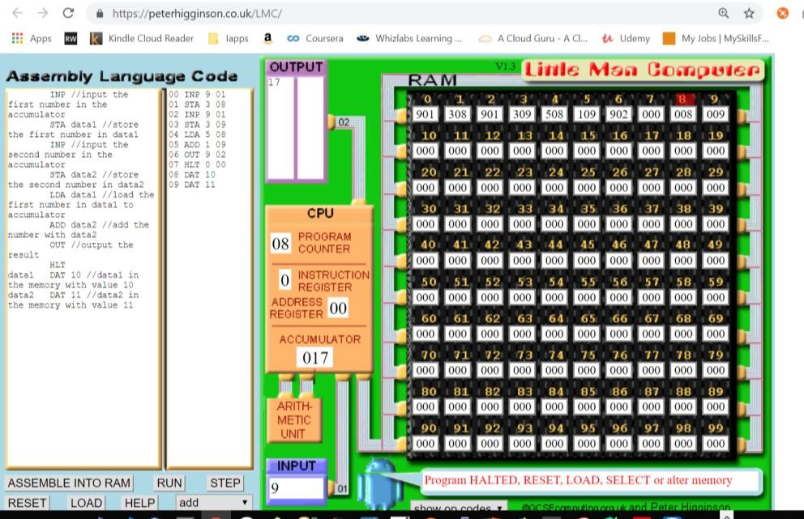

|  |  |
| --- | --- |
| **data** | **value** |
| data1 | 8 |
| data2 | 9 |

1. What if you enter the first number as character “a”?

|  |
| --- |
| A pop up will appear saying “Bad input - must be a number” |

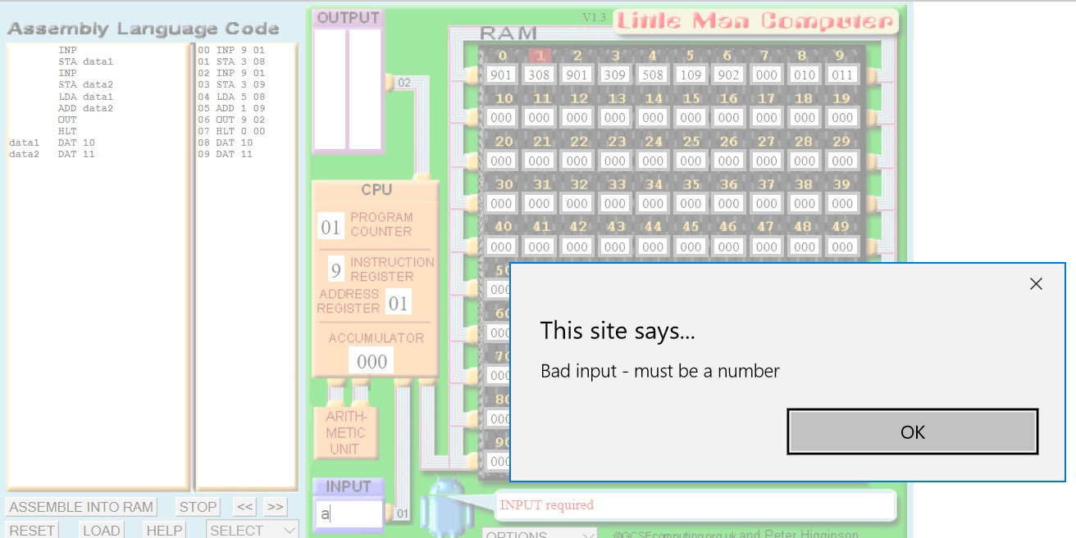

1. Test and run the program to find the MAXIMUM number which is VALID.

|  |  |
| --- | --- |
| Maximum input value | 999 |

1. **Input data1, data2 and ADD two numbers, REPEAT infinitely.**

* 1. Key in the code in simulator

|  |
| --- |
| START INP //input the first number in the accumulator STA data1 //store the first number in data1      INP //input the second number in the accumulator STA data2 //store the second number in data2    LDA data1 //load the first number in data1 to accumulator ADD data2 //add the number with data2    OUT //output the result    BRA START  HLT  data1 DAT 10 //data1 in the memory with value 10 data2 DAT 11 //data2 in the memory with value 11 |

* 1. Test the above code.

1. **Input data1, data2 and ADD two numbers, REPEAT 3 times.**

|  |
| --- |
| START INP //input the first number in the accumulator STA data1 //store the first number in data1    INP //input the second number in the accumulator STA data2 //store the second number in data2    LDA data1 //load the first number in data1 to accumulator ADD data2 //add the number with data2    OUT //output the result    LDA COUNT //load the COUNT  SUB ONE //Subtract 1  STA COUNT //store the result to COUNT  BRZ END //if value is zero, branch to END    BRA START END HLT data1 DAT 10 //data1 in the memory with value 10 data2 DAT 11 //data2 in the memory with value 11 ONE DAT 1  COUNT DAT 3 |

1. Run and test above code.

1. After loop for three times, the screen shot as follows:

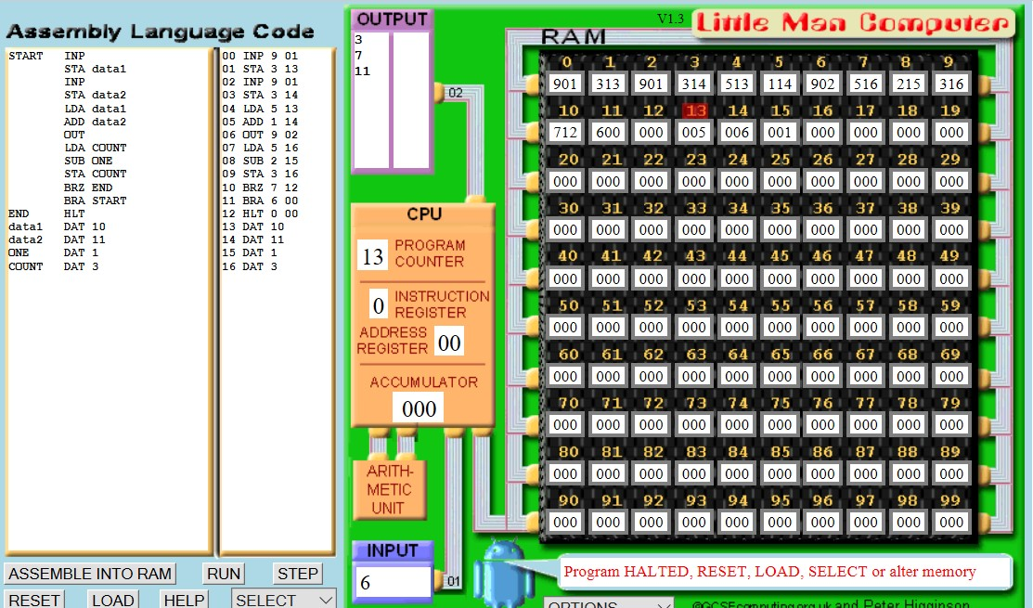

|  |  |
| --- | --- |
| **data1 address** | **13** |
| **data2 address** | **14** |
| **COUNT address** | **7** |
| **COUNT value in the end** | **516** |

In the above code, we use SUB ONE. Change to SUB 1 and test the above program to see if it works.

In your view, which approach is better?

|  |
| --- |
| Sub one |

**F. Input data1, data2 and subtract two numbers**

# (SELF DIRECTED LEARNING)

My code is shown below:

|  |
| --- |
| **INP**  **STA data1**  **INP**  **STA data2**  **LDA data1**  **SUB data2**  **OUT**  **HLT**  **data1 DAT**  **data2 DAT** |

# G. Countdown (SELF DIRECTED LEARNING)

Write the code to create a countdown and display the following items shown in the OUTPUT window. You should allow the user to input a number between three and seven.

Hint: you can use BRZ (based on value in ACC) and BRA instructions for iteration.

The program ends when the accumulator value is 0

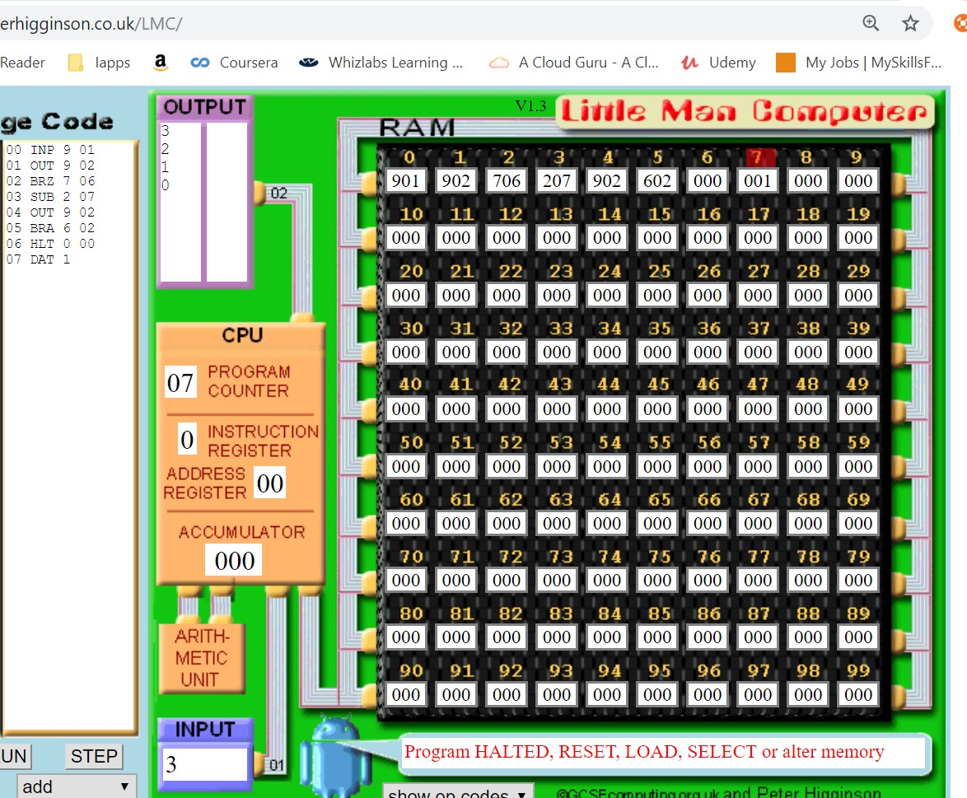

My code is shown below:

|  |
| --- |
| INP  START OUT  SUB ONE  BRZ END  BRA START  ONE DAT 01  END OUT  HLT |

**Reference:**

1. [**https://en.wikipedia.org/wiki/Little_man_computer**](https://en.wikipedia.org/wiki/Little_man_computer)
2. **Little man explain on youtube:** [**https://www.youtube.com/watch?v=kCyyZI1GgsQ**](https://www.youtube.com/watch?v=kCyyZI1GgsQ)