Justin Bee

SER 416

3/1/2020

Screen Shots

Index.html

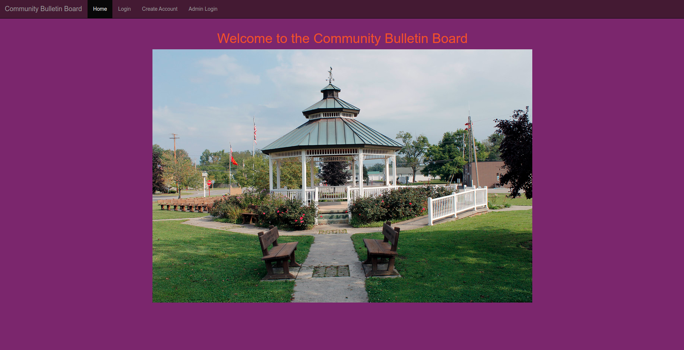

This is the index page, welcoming users that have not yet logged into the system. The user can navigate to the Login page, Create User page and the Admin login page from the top navigation bar.

Create-user.html

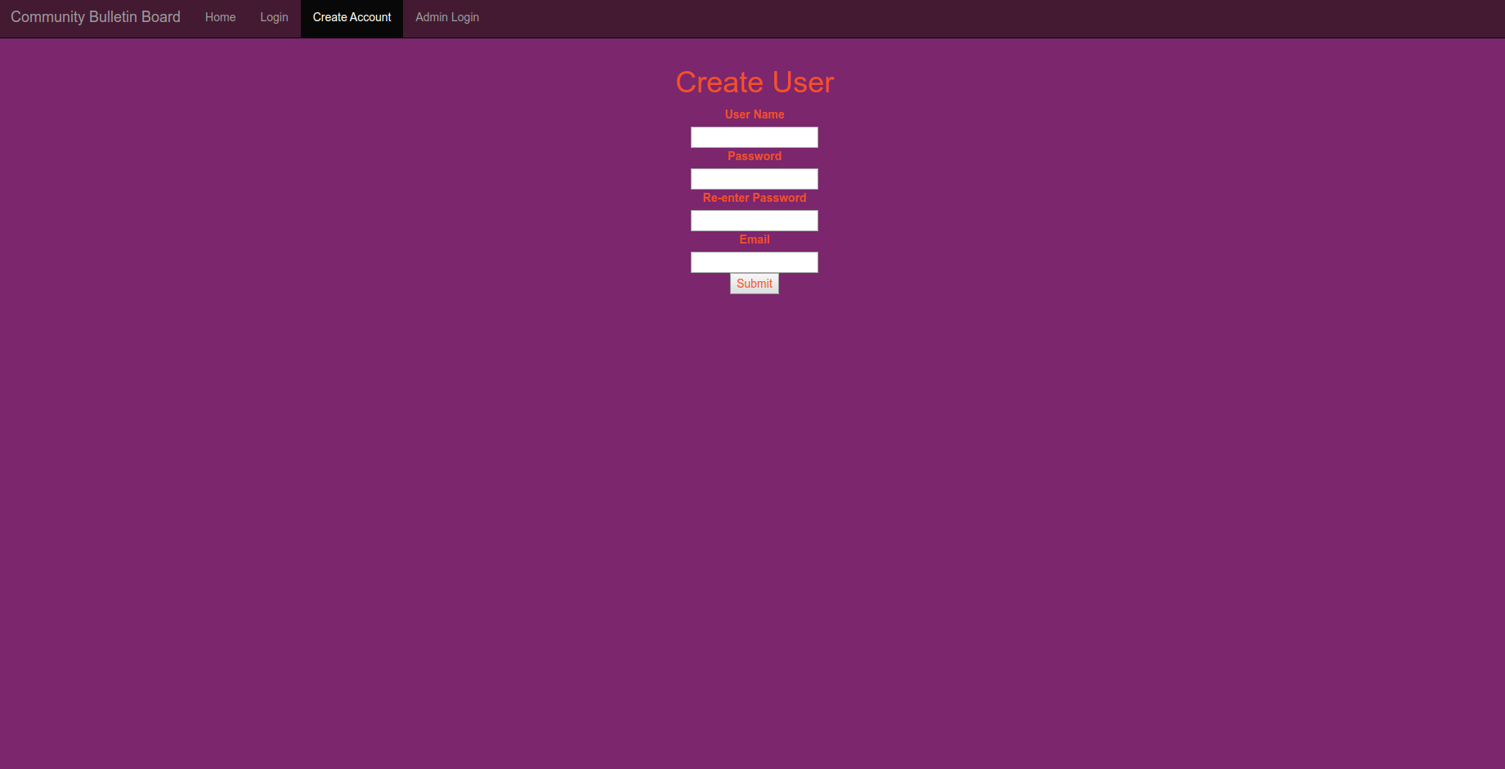

On this page there is a form for the user to enter information to create an account. After the user creates an account, they are brought back to the index.html page and can login selecting the appropriate link in the navigation bar. The create-user page also has navigation bar in case they want to go to the login pages instead.

Login.html

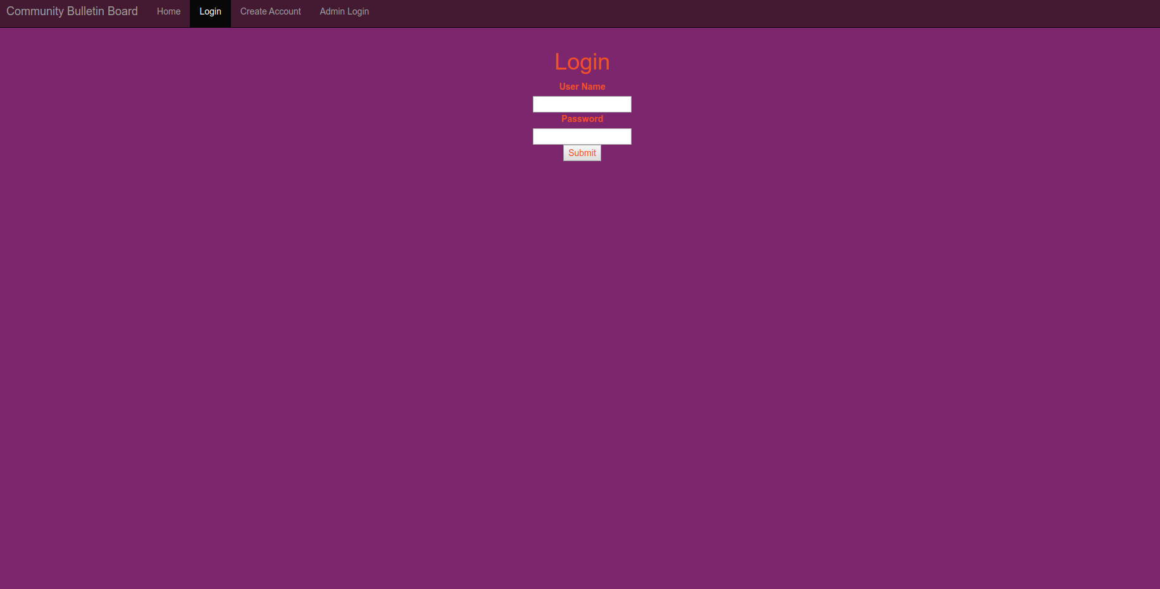

From the login page there is a form that allows the user to enter their username and password. Once this is verfied against the database, the user is brought to the customer portal page. This page also includes the navigation bar which allows them to go back to the index, create-user page, or admin-login pages.

Admin-login.html

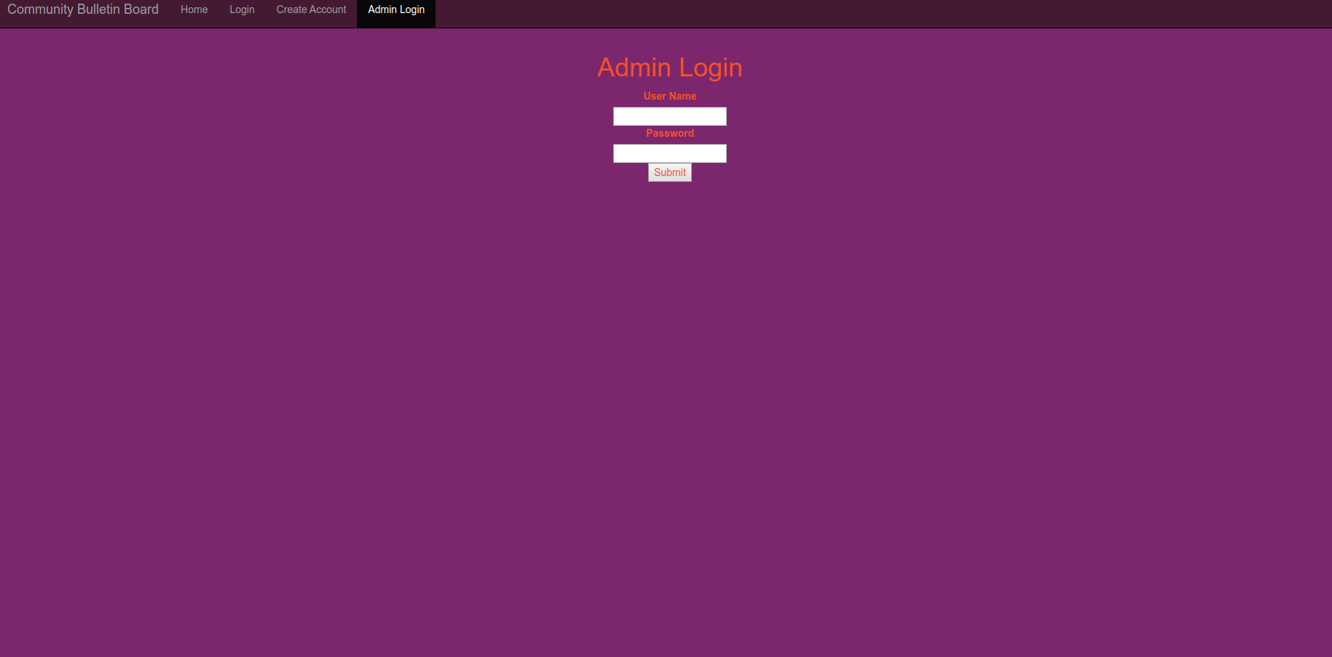

The admin-login page contains a form for the admins to enter username and password which then brings the admin to the admin-portal page. This page also includes the navigation bar which allows them to go back to the index, create-user page, or admin-login pages.

Customer-portal.html

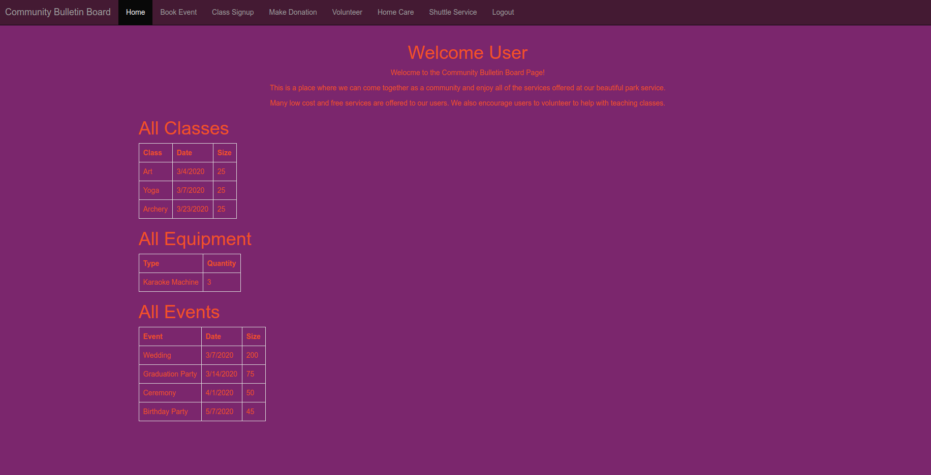

At the customer portal page, it shows the user which events, classes, and equipment they have rented.

This page contains a customer focused navigation bar which has links to the book-event page, the class-signup page make-donation page, homecare page, request-shuttle page and a logout link which brings the user back to the index page.

Book-event.html

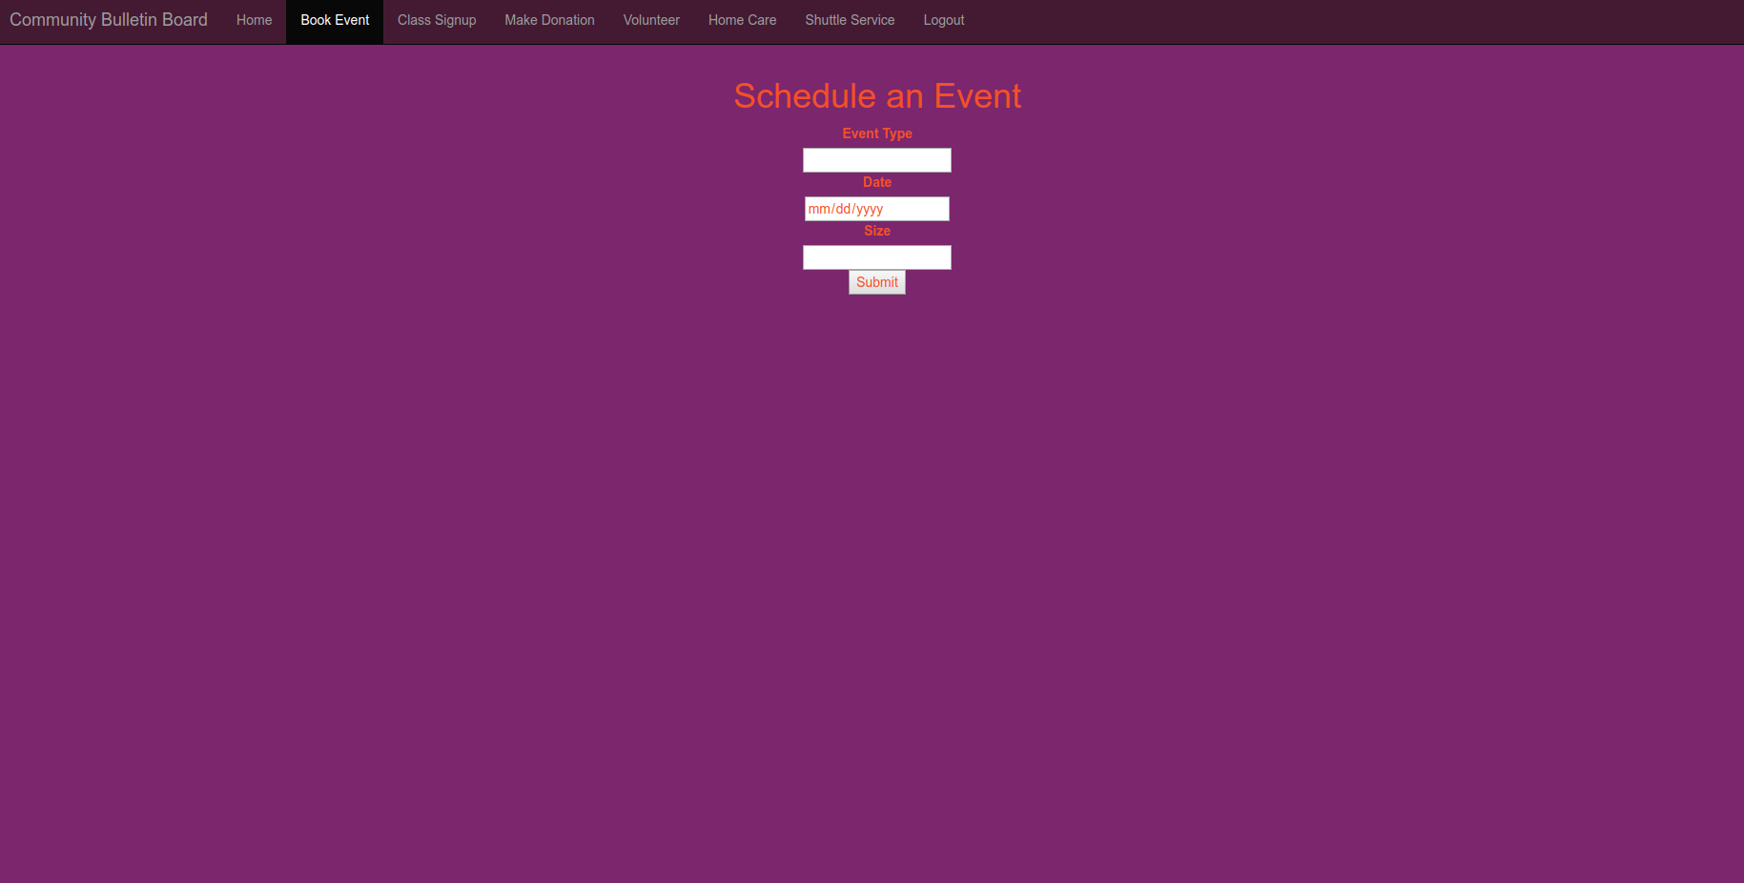

This page has a form that allows the user to enter the type of event, as well as the date requested and the number of guests. Once the user clicks submit they are brought to the confiramtion page. This page contains a customer focused navigation bar which has links to the book-event page, the class-signup page make-donation page, homecare page, request-shuttle page and a logout link which brings the user back to the index page.

Class-signup.html

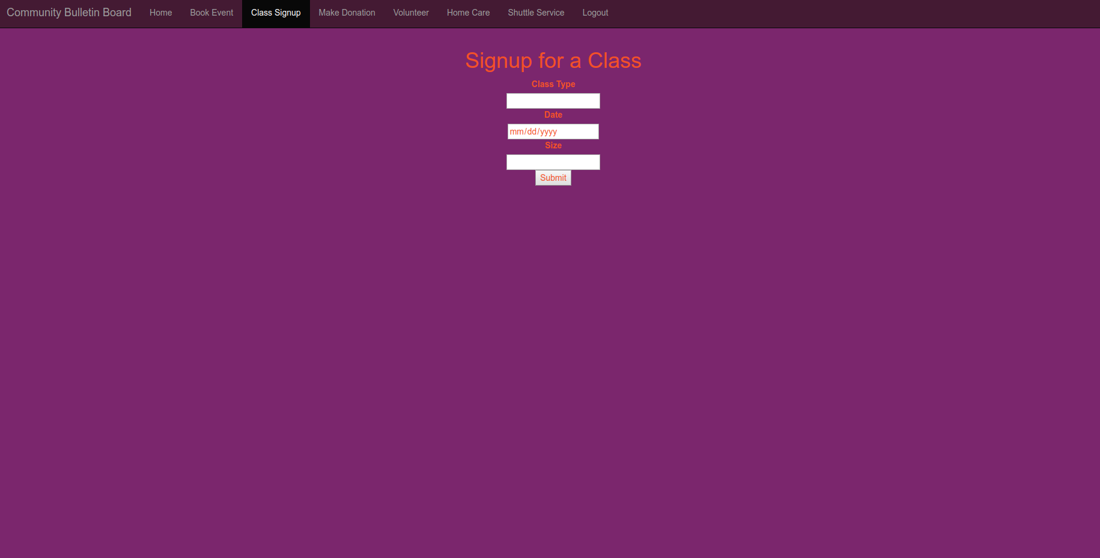

This page has a form for the user to enter type of class and date to signup for a class. This then brings the user to a confirmation page. This page contains a customer focused navigation bar which has links to the book-event page, the class-signup page make-donation page, homecare page, request-shuttle page and a logout link which brings the user back to the index page.

Make-donation.html

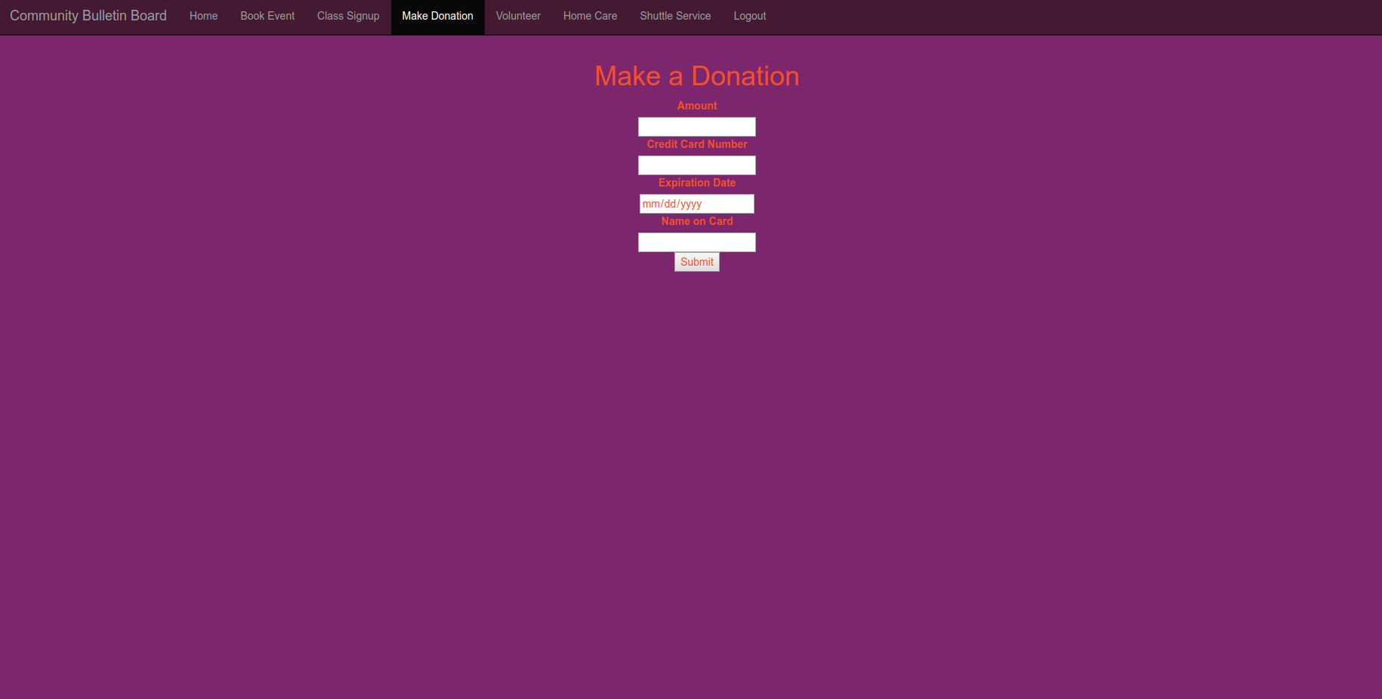

This page allows the user to enter the amount of donation as well as the credit card information to be used to make the donation. This then brings the user to the confirmation page. This page contains a customer focused navigation bar which has links to the book-event page, the class-signup page make-donation page, homecare page, request-shuttle page and a logout link which brings the user back to the index page.

Volunteer.html

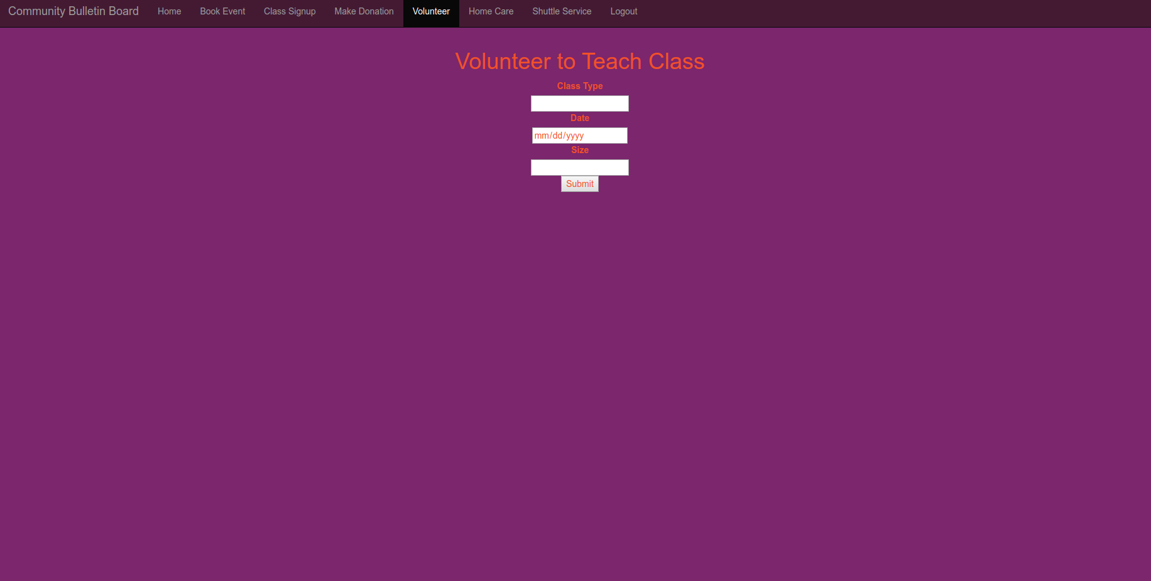

This page allows the user to enter the type of class that they want to teach, date and size of class. This brings the user to the confirmation page. This page contains a customer focused navigation bar which has links to the book-event page, the class-signup page make-donation page, homecare page, request-shuttle page and a logout link which brings the user back to the index page.

Request-homecare.html

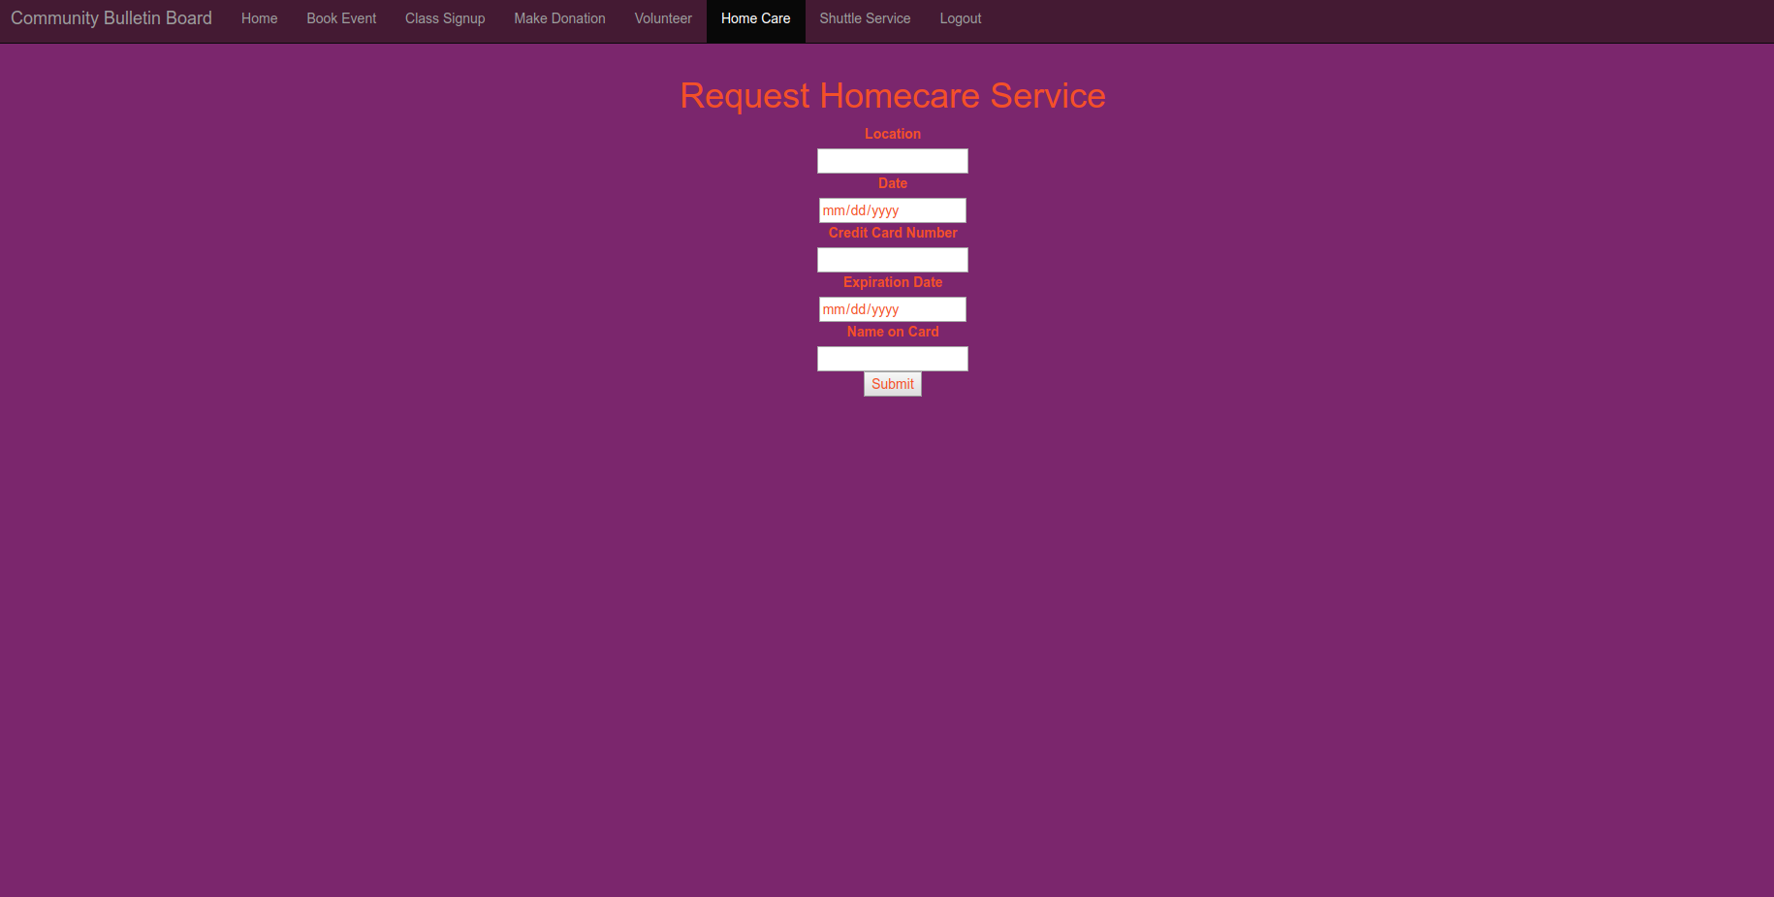

This page allows the user to enter the location, date, and credit card information to request homecare. Then they are brought to the confirmation page. This page contains a customer focused navigation bar which has links to the book-event page, the class-signup page make-donation page, homecare page, request-shuttle page and a logout link which brings the user back to the index page.

Request-shuttle.html

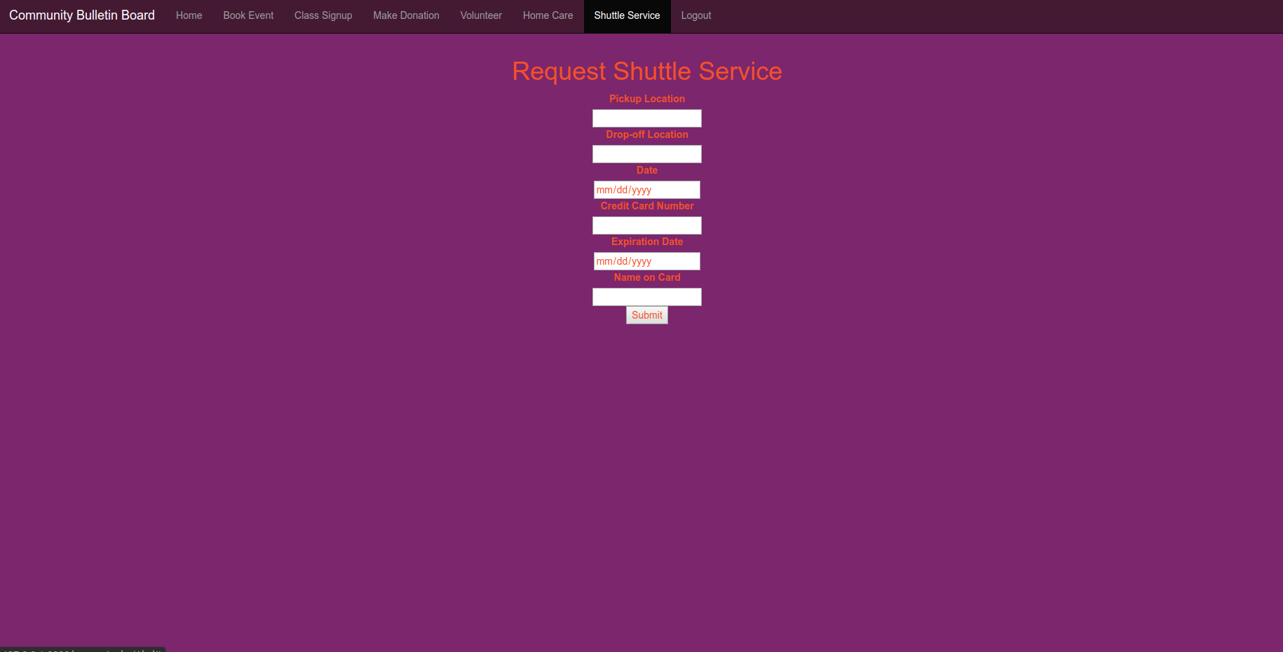

This page has fields for the user to enter the pick up location, drop off location, date, and credit card information for the user to request shuttle service. This brings the user to the confirmation page. This page contains a customer focused navigation bar which has links to the book-event page, the class-signup page make-donation page, homecare page, request-shuttle page and a logout link which brings the user back to the index page.

Confirmation.html

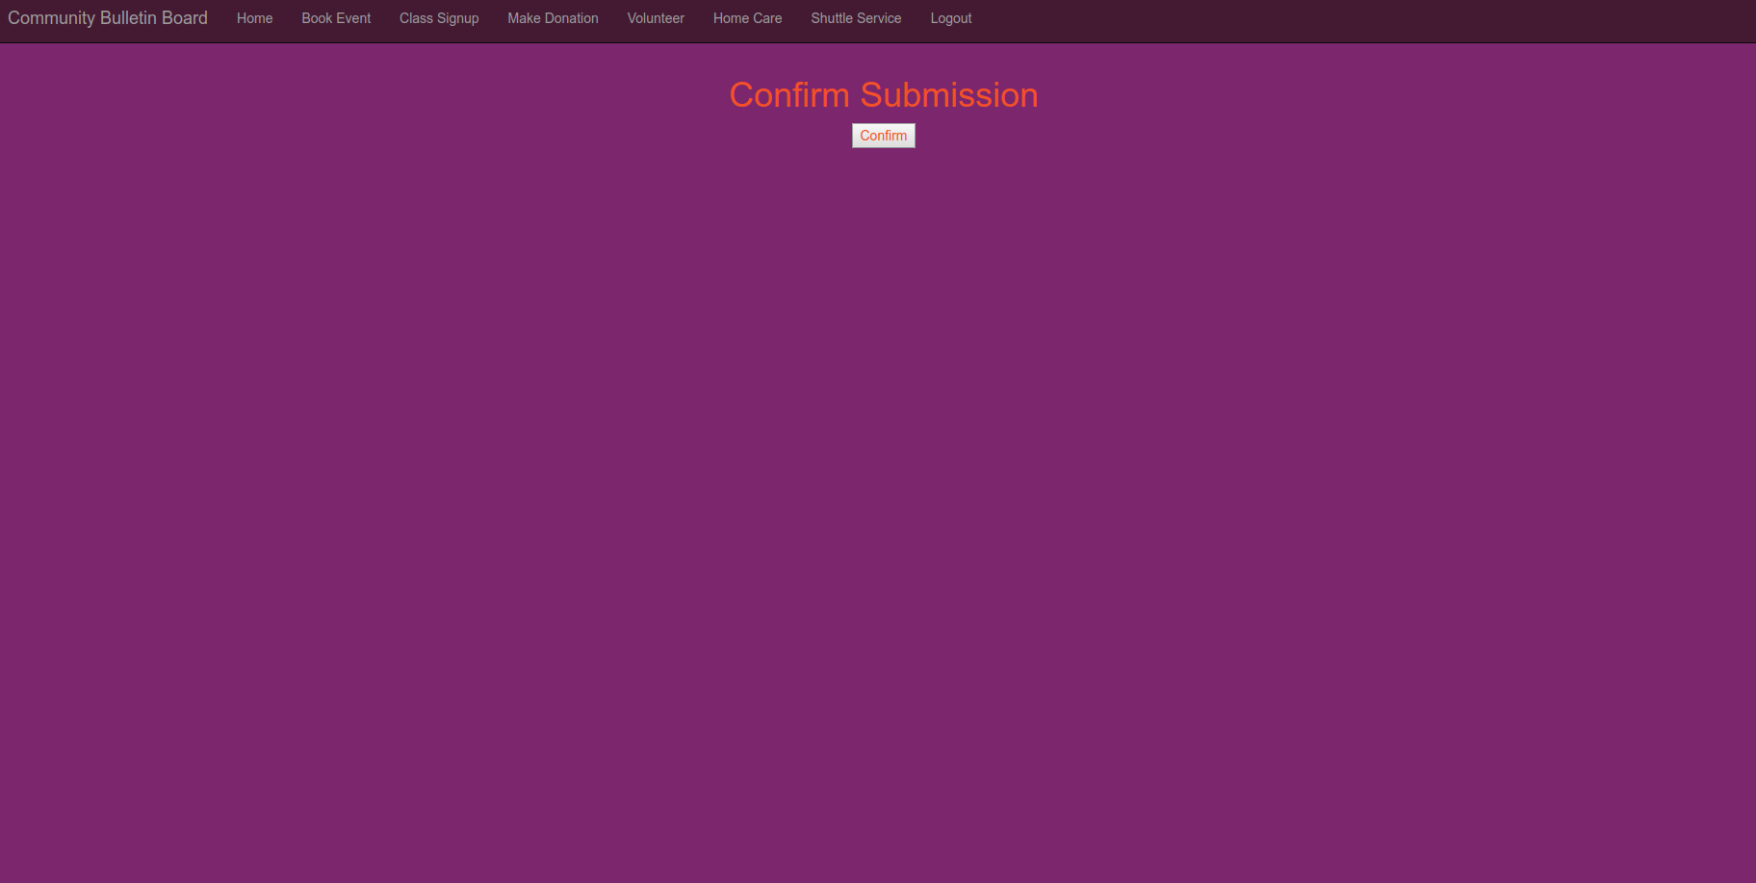

This page will display all of the relevant information from the previous page for the user to confirm. Upon confirmation, the user is brought back to the customer-portal. This page contains a customer focused navigation bar which has links to the book-event page, the class-signup page make-donation page, homecare page, request-shuttle page and a logout link which brings the user back to the index page.

View-classes.html

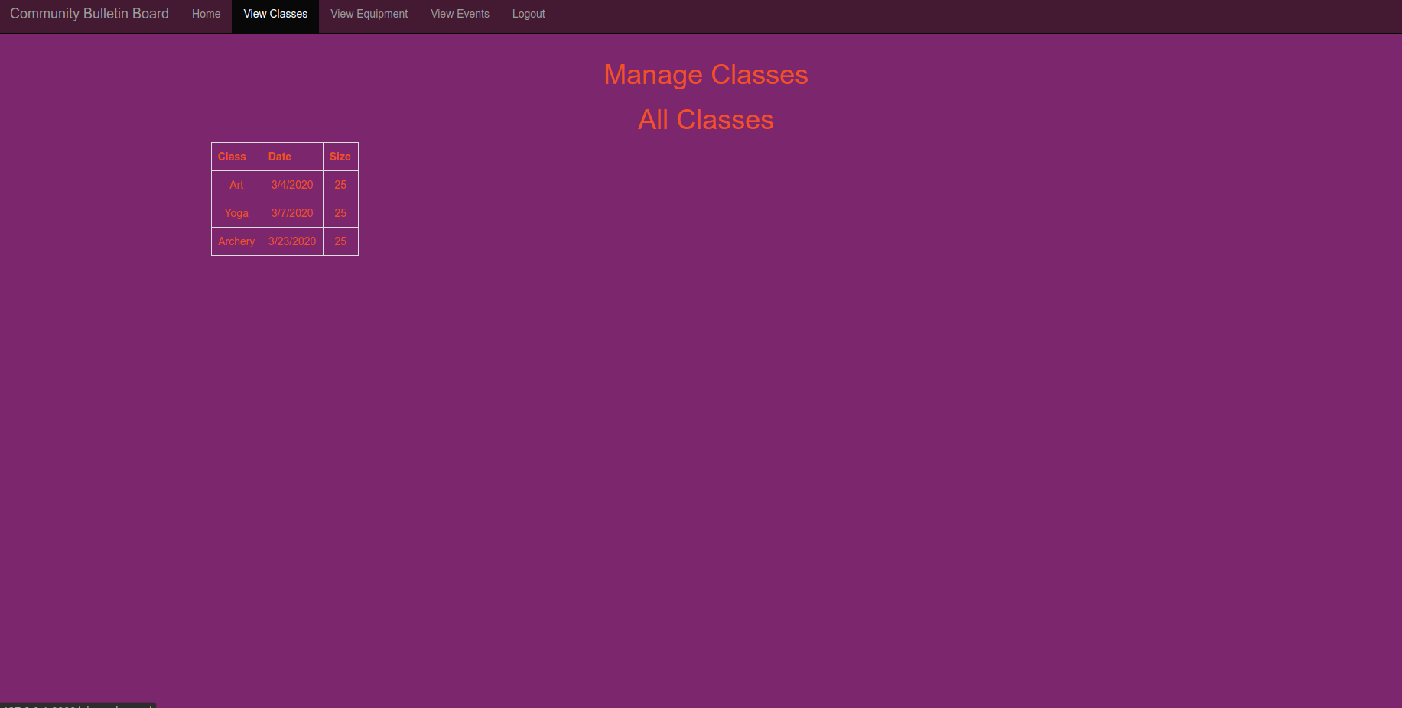

This page displays all of the classes with the information about each that are currently in the system in a table for the admin to view. This page contains the admin navigation bar which has links to the view-classes page, view-equipment page, view-events page, admin portal page and logout link which brings the user back to the index.

View-equipment.html

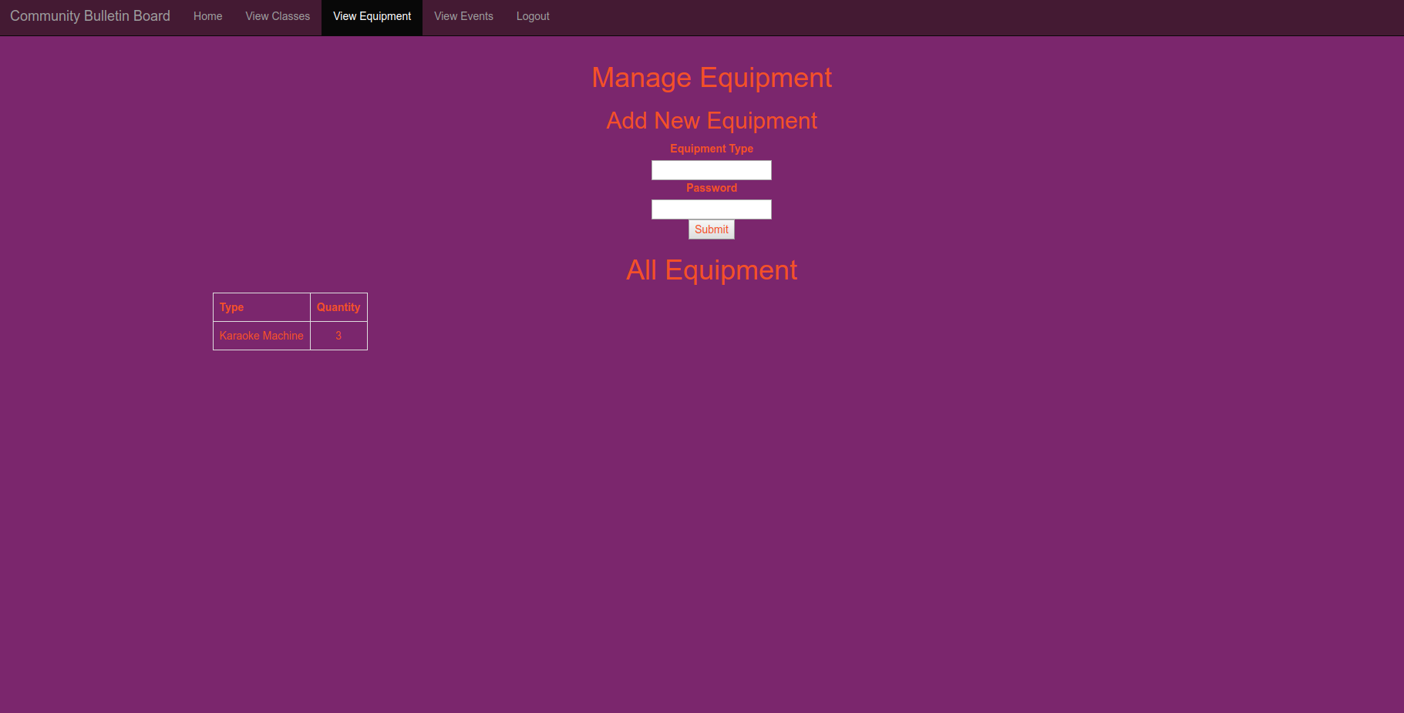

This page has fields for the admin to enter equipment type and quantity to add to the system. It also has a table which displays all of the equipment and quantities for each which are currently in the system. This page contains the admin navigation bar which has links to the view-classes page, view-equipment page, view-events page, admin portal page and logout link which brings the user back to the index.

View-events.html

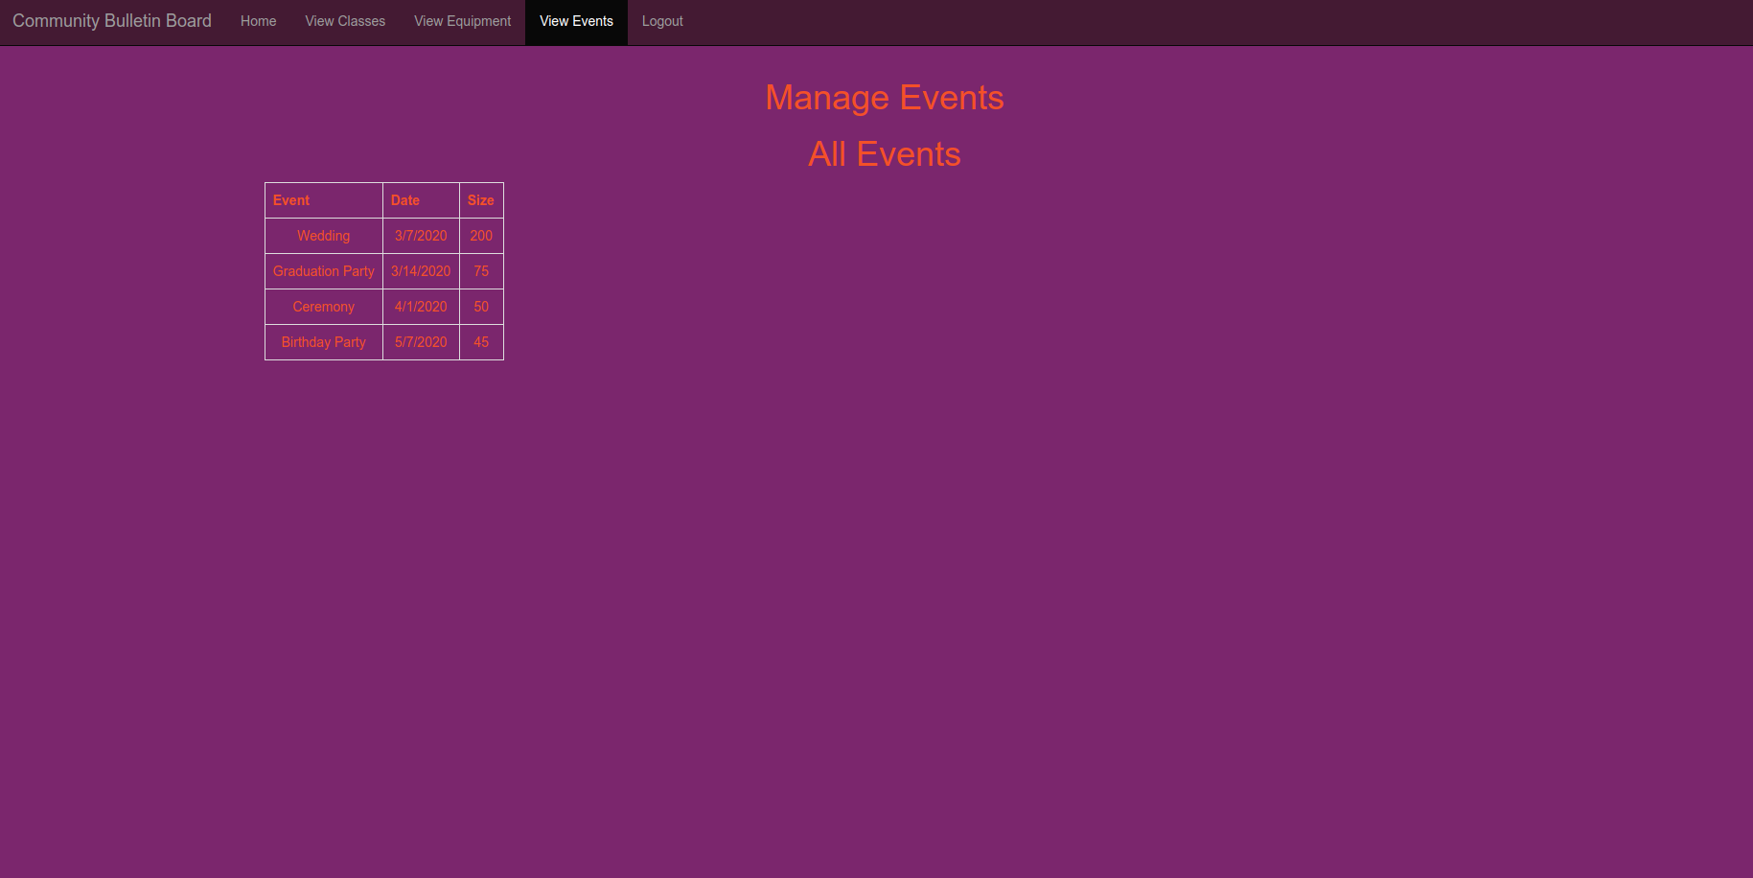

This page displays all of the events that are currently in the system as well as all of the information about each.