LUMIBOOK DIGITAL LIBRARY
Research, Requirements and Systems Design Documentation
Version 1.1 | 10 November 2026

Document Control
Project | LUMIBOOK Digital Library
Version | 1.1 — diagrams and schedule added
Date | 10 November 2026
Status | Proposed design; owner approval required

1. Project Overview
LUMIBOOK is a web-based platform for sharing authorized PDF learning resources. It supports a Free tier, Premium (up to 20 e-books and 10 downloads), Premium Plus (up to 58 e-books and 30 downloads), and All-Access (all eligible e-books and unlimited platform downloads). Paid plans use one-time payments. “Lifetime” means for the lifetime of the service under published terms; it is not a promise that the service or each title will exist forever.

2. Plan Matrix
Plan | E-book access | Downloads | Payment
Free | Free catalogue (proposed 5 titles) | 3/month (proposed) | Free
Premium | Up to 20 | 10 lifetime | One-time
Premium Plus | Up to 58 | 30 lifetime | One-time
All-Access | All eligible titles | Unlimited* | One-time
*Subject to fair-use, rate limits, and anti-abuse rules. Confirm Free limits, prices, currency, and title-selection rules before development.

3. Data Flow Diagram (DFD) — Level 0
The context diagram shows the system boundary and the major external entities exchanging information with LUMIBOOK.
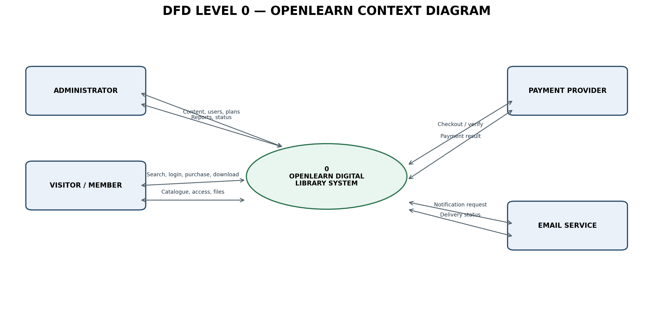

4. Data Flow Diagram (DFD) — Level 1
The Level 1 diagram decomposes the platform into account, catalogue, entitlement, payment, download, reporting, and notification processes.
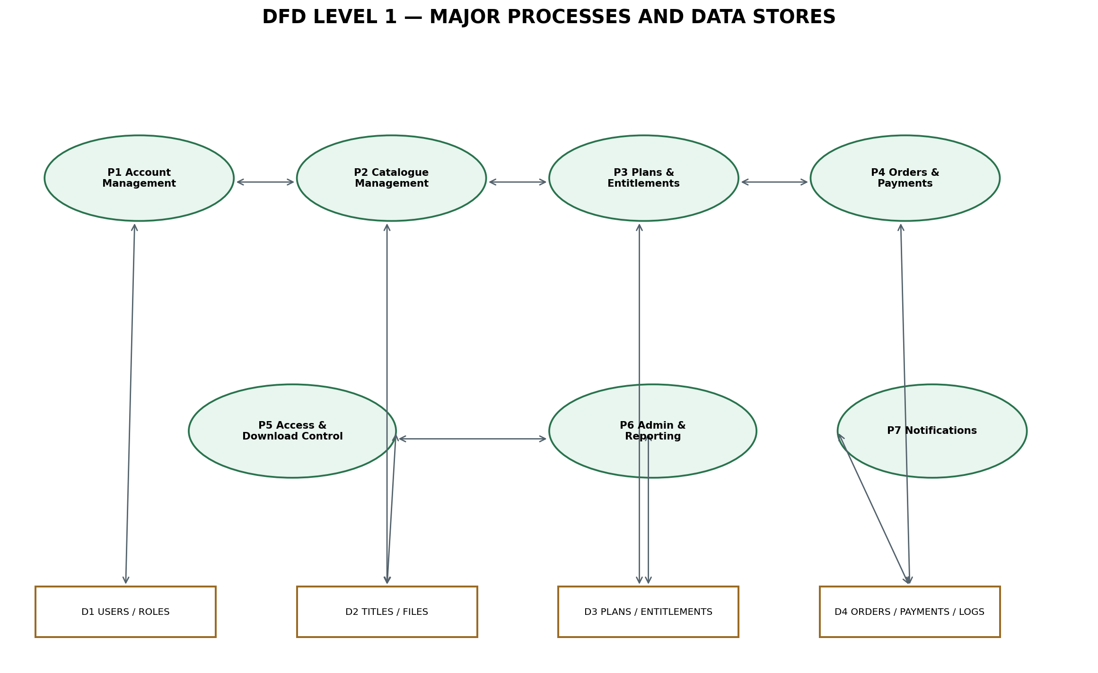

5. Entity Relationship Diagram (ERD)
The ERD illustrates the principal entities and relationships. Implement foreign keys, uniqueness constraints, indexes, timestamps, and transactional quota enforcement.
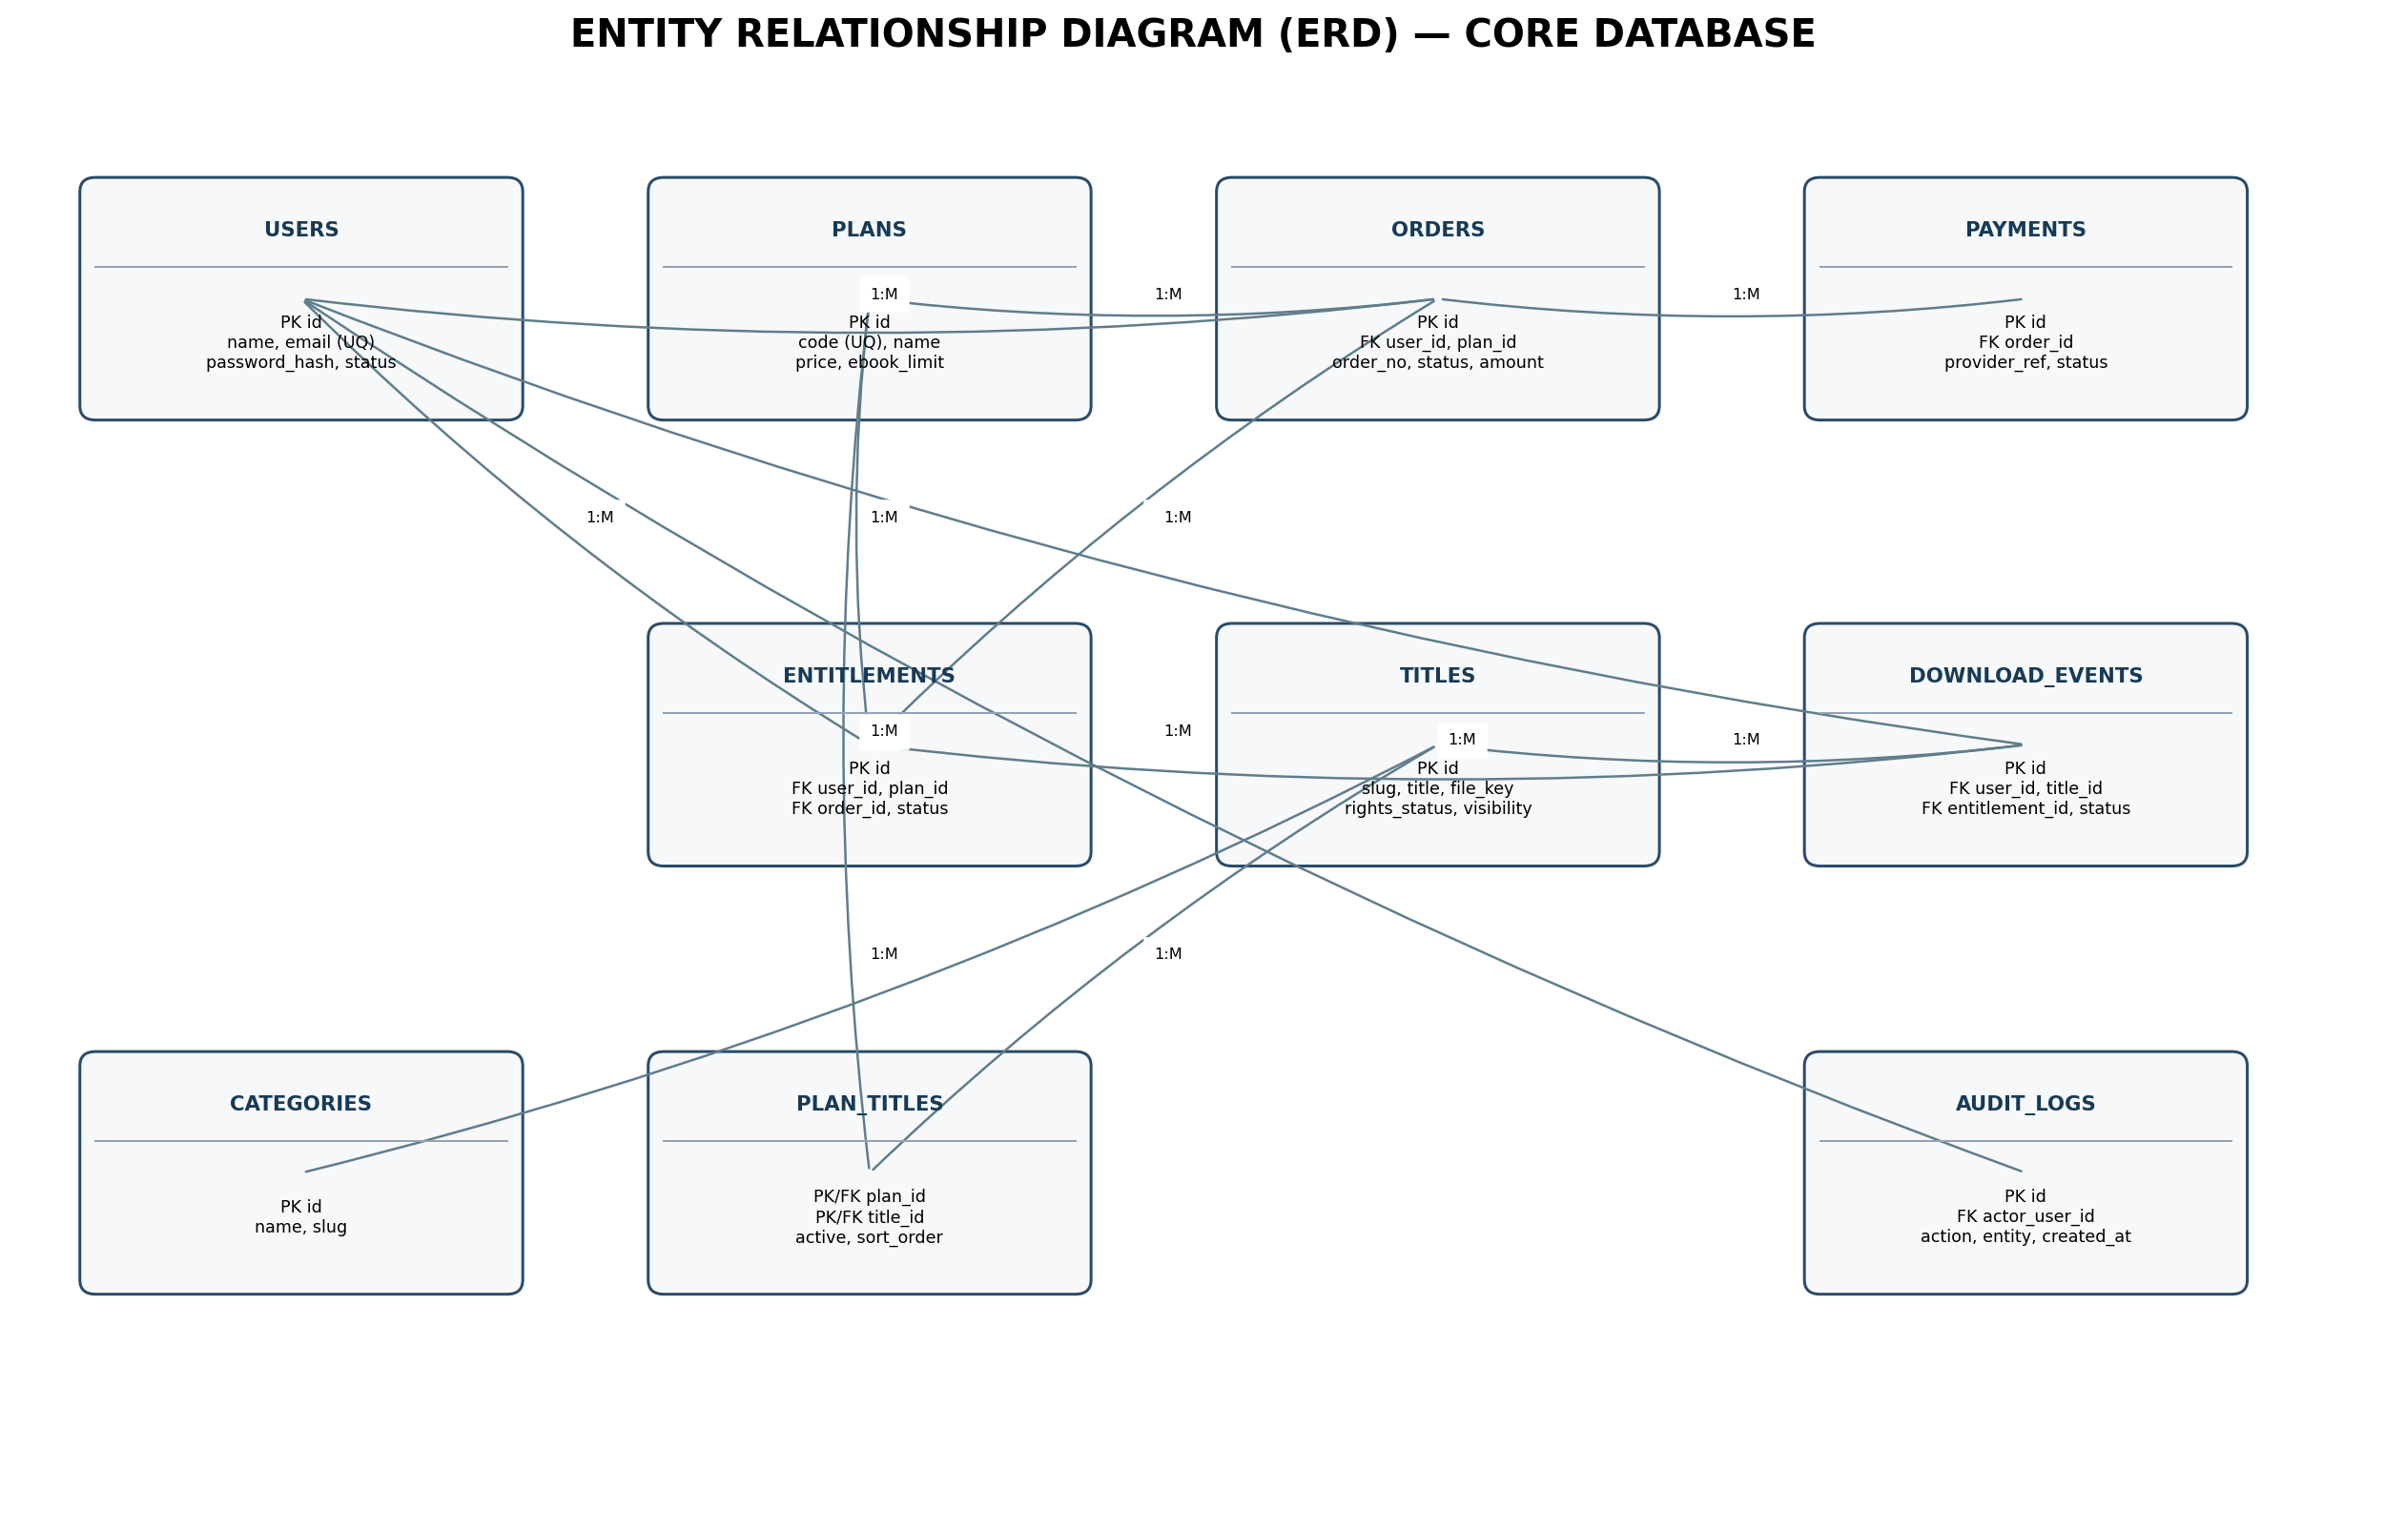

6. Core Database Tables
- users(id, name, email UNIQUE, password_hash, status, email_verified_at)
- roles(id, name); user_roles(user_id, role_id)
- plans(id, code UNIQUE, name, price, currency, ebook_limit, download_limit, unlimited flags)
- titles(id, slug UNIQUE, title, author, description, private_file_key, rights_status, visibility)
- categories(id, name, slug); title_categories(title_id, category_id)
- plan_titles(plan_id, title_id, active, sort_order)
- orders(id, user_id, plan_id, order_number, amount, status, paid_at)
- payments(id, order_id, provider, provider_reference, status, verified_at)
- entitlements(id, user_id, plan_id, order_id, status, starts_at, ends_at)
- download_events(id, user_id, title_id, entitlement_id, request_id, status, completed_at)
- audit_logs(id, actor_user_id, action, entity_type, entity_id, metadata, created_at)

7. Functional Requirements
- Users can register, verify email, sign in, sign out, and reset passwords.
- Administrators can upload PDFs, maintain metadata, categories, tags, cover images, and rights evidence.
- Visitors can search and filter published catalogue items.
- Users can view plan prices, limits, and one-time payment terms before checkout.
- Orders and payments are recorded; entitlements are activated only after server-side payment verification.
- Every protected title request checks authentication, entitlement, publication status, rights status, and download quota.
- Members can see their plan, accessible titles, download allowance, and purchase history.
- Administrators can manage content, users, plans, orders, payments, reports, and audit logs.

8. Non-Functional and Security Requirements
Use React + TypeScript, PHP Laravel API, and PostgreSQL. Store original PDFs outside the public web root or in private object storage. Issue short-lived authorized download links. Validate and scan uploads, use HTTPS, hash passwords securely, enforce role-based access on the server, verify payment webhooks, use idempotency, rate-limit sensitive endpoints, and keep audit logs. Do not store card numbers or CVV. Publish privacy, refund, service-lifetime, and copyright/takedown terms. Only distribute files for which the operator has lawful rights.

9. Payment and Download Workflows
Purchase: select plan → create pending order → complete provider checkout or submit proof → verify payment server-side → mark order paid → create entitlement → notify member.
Download: authenticate → check title is published and rights-cleared → check plan entitlement → check quota and rate limit → atomically reserve allowance → issue protected file → record completion/failure.

10. Gantt Chart — Proposed 16-Week Schedule
The schedule is an initial estimate. Tasks overlap where practical; adjust durations after confirming scope, team size, payment provider, and content volume.
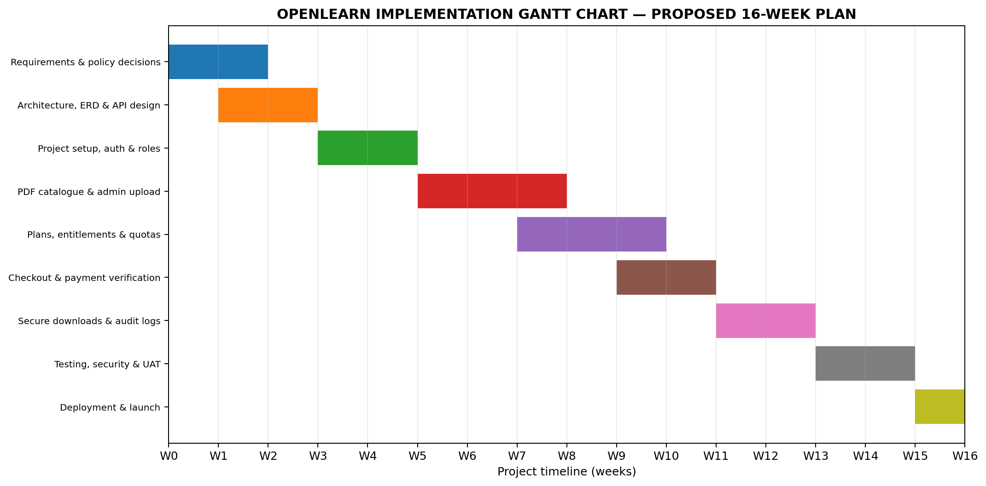

11. Implementation Phases
- Weeks 1–2: requirements, plan policies, legal/content-rights review.
- Weeks 2–3: architecture, ERD, API contracts, and UI wireframes.
- Weeks 4–5: project setup, authentication, roles, and database migrations.
- Weeks 6–8: PDF catalogue, metadata, protected upload, search, and admin tools.
- Weeks 8–10: plans, entitlements, curated collections, and quota engine.
- Weeks 10–11: checkout and verified payment integration.
- Weeks 12–13: secure downloads, event logs, notifications, and audit trail.
- Weeks 14–15: functional, security, accessibility, and user-acceptance testing.
- Week 16: production deployment, backups, monitoring, and launch.

12. Decisions Required Before Coding
- Confirm Free-plan title and download limits (proposed: 5 titles and 3 downloads/month).
- Set the three paid plan prices and currency.
- Choose curated fixed collections or let users select up to 20/58 titles; curated collections are recommended for v1.
- Confirm the 10/30 downloads are lifetime totals; this document assumes they are.
- Choose payment gateway and manual verification fallback.
- Define refund, chargeback, plan upgrade, suspension, service closure, and content removal policies.
- Confirm whether PDF previews are allowed and the permitted launch geography.
- Record rights/licences for every PDF before publication.

13. Conclusion
LUMIBOOK combines a searchable learning-resource catalogue with transparent lifetime access plans. The DFDs describe how information moves through the system, the ERD establishes the database structure, and the Gantt chart provides a proposed implementation schedule. Security, payment verification, content rights, and clear customer terms are essential to a reliable launch.

8. Brand Identity and Visual Standards
Brand status: LUMIBOOK is the proposed official working brand name for this project. It should be used consistently across the product interface, documentation, repository, and launch materials, subject to domain and trademark clearance before public commercial launch.

8.1 Brand Foundation
Brand name | LUMIBOOK
Category | Digital Library / Educational Technology (EdTech)
Primary tagline | Illuminate Your Mind.
Supporting descriptor | Your Digital World of Knowledge
Secondary campaign line | Read More. Learn More. Become More.
Brand promise | Make valuable learning resources easier to discover, access, and use.
Personality | Intelligent, welcoming, trustworthy, modern, and encouraging.

8.2 Mission, Vision and Positioning
Mission: To make valuable learning resources more accessible by providing a convenient and affordable digital library.
Vision: To become a trusted digital destination for lifelong learning and knowledge discovery.
Positioning: LUMIBOOK is a modern digital library where learners can discover, access, and download authorized educational resources through a clear membership and entitlement system.
Core message: Knowledge should be easier to discover, access, and use.

8.3 Logo Concept
The proposed logo combines an open-book symbol with a subtle beam or glow of light. The open book represents reading, education, and discovery; the light represents insight, curiosity, and the illumination of knowledge. The wordmark should use clean geometric lettering, with LUMIBOOK written in uppercase for a confident and recognizable identity.
Logo variants to prepare: (1) primary horizontal logo with symbol and wordmark; (2) stacked logo for narrow spaces; (3) symbol-only mark for favicon and app icon; and (4) monochrome versions for print, watermarking, and low-contrast applications.
Clear space: maintain at least the width of the logo symbol around the logo. Do not stretch, rotate, add unapproved effects, or place the logo on backgrounds that reduce contrast.

8.4 Color System
Midnight Navy | #101D32 | Primary brand color; trust, intelligence, professionalism.
Knowledge Gold | #E8C879 | Accent color; wisdom, excellence, and value.
Library White | #F5F7FA | Main light surface; clarity and readability.
Slate Blue | #53657D | Secondary interface color; technology and sophistication.

8.5 Typography
Recommended headings: Manrope or Plus Jakarta Sans. Recommended body text and interface labels: Inter. Use a clear type scale, comfortable line height, readable paragraph widths, and consistent font weights. The selected font files and licenses must be checked before bundling them into the production application.

8.6 Membership Naming and Brand Copy
LUMIBOOK FREE | Explore knowledge. | Basic access to selected learning resources; exact limits to be finalized.
LUMIBOOK PREMIUM | Expand your library. | Proposed access to up to 20 e-books and up to 10 downloads.
LUMIBOOK PREMIUM PLUS | Learn without limits. | Proposed access to 58 e-books and up to 30 downloads.
LUMIBOOK ALL ACCESS | Unlock everything. | Access to all eligible library titles with unlimited platform downloads, subject to fair-use and anti-abuse controls.
All paid membership plans are proposed as one-time lifetime purchases, not recurring subscriptions. The service terms must define lifetime as the operating lifetime of the service and explain how title removals, rights changes, account violations, and service closure are handled. Plan quotas, title collections, prices, and currency must be finalized before implementation.

8.7 Brand Voice and Interface Microcopy
Homepage headline | Your Next Chapter Starts Here.
Library introduction | Explore a World of Knowledge.
Membership section | Invest Once. Keep Learning.
Empty library state | Your learning journey is waiting. Discover your first book.
Access action | Unlock This Book
Download action | Download PDF
Voice principles: be clear rather than overly technical; encouraging rather than pushy; confident without making unrealistic promises; and consistent in the use of plan names, access labels, and download terminology.

8.8 Website Art Direction
The visual direction is premium, modern, and editorial: a calm library experience supported by contemporary technology patterns. The interface should use generous spacing, strong book-cover imagery, restrained gold accents, accessible contrast, and subtle motion rather than distracting effects.
- Homepage: brand hero, prominent search, featured titles, categories, and membership overview.
- Library catalogue: responsive book grid, search, filters, sorting, and clear access labels.
- Book detail: cover, title, author, description, category, preview where permitted, membership eligibility, and access action.
- My Library: unlocked titles, saved items if supported, and download history.
- Membership page: transparent comparison of Free, Premium, Premium Plus, and All Access.
- Member dashboard: plan status, available quota, recent activity, and account settings.
- Admin dashboard: catalogue and PDF management, rights metadata, membership/order management, user support, and analytics.

8.9 Brand Application and Governance
Use the same approved logo, color tokens, typography, membership names, and tone across the website, admin interface, transactional emails, social profiles, documentation, and promotional assets. Maintain a central design-token file and reusable UI components so the brand remains consistent as the platform grows.
Before public launch, conduct domain-name, social-handle, and trademark clearance in relevant markets. The proposed name and visual concept in this document are branding directions, not a legal clearance or guarantee of exclusive rights.

8.10 Brand Acceptance Checklist
- Confirm final adoption of the LUMIBOOK name.
- Complete domain, social-handle, and trademark checks.
- Approve the primary logo, stacked logo, favicon, and monochrome variants.
- Approve color tokens and typography choices.
- Apply the brand system to public pages, member dashboard, admin dashboard, and emails.
- Review accessibility, contrast, responsive behavior, and print/export use.

