SYNTRA AI
AUTONOMOUS INTELLIGENCE & PERSONAL ASSISTANT PLATFORM

Design and Development of SYNTRA AI: A Modular, Self-Hosted Autonomous Artificial Intelligence Assistant with Multi-Agent Orchestration, Persistent Memory, and Intelligent Task Automation
Research and Technical Design Paper
Prepared by: [Author Name]
Institution / Organization: [Institution Name]
Department / Program: [Department or Program]
Document version: 1.0
Date: 09 November 2026

DESIGN-STAGE MANUSCRIPT — NOT AN EMPIRICAL RESULTS REPORT

Publication and Authorship Notes
This manuscript is a system-design and development proposal. Replace all bracketed author and institutional fields, confirm institutional formatting rules, and add implementation evidence before submitting it as a completed empirical study. The architecture and diagrams are proposed designs. No system performance, participant feedback, or security-test outcome is asserted as having been measured.
Suggested contribution statement: The author is responsible for the system conception, requirements analysis, architecture, database design, implementation, and evaluation. Modify this statement to accurately reflect actual contributions.
Suggested publication type: Design and Development / System Architecture Paper.

Abstract
SYNTRA AI is proposed as a modular, self-hosted artificial intelligence assistant platform designed to integrate conversational interaction, model orchestration, persistent memory, retrieval-augmented generation (RAG), controlled tool execution, and workflow automation. The project addresses a practical engineering problem: users often rely on disconnected AI interfaces and automation utilities, while locally controlled, extensible assistants require coordinated application services, data governance, and security controls. This paper presents the proposed system's objectives, scope, architecture, logical data model, data-flow design, security approach, implementation methodology, and evaluation plan. The design separates a React and TypeScript presentation layer, a Laravel application and access-control layer, and a Python/FastAPI intelligence layer. PostgreSQL with pgvector is proposed for transactional records and semantic retrieval, Redis for asynchronous work, and Ollama or compatible providers for model inference. Agent capabilities are mediated by a permission-aware tool gateway with approval checkpoints, sandboxing, and audit logging. A design-science and iterative prototyping methodology is proposed, with evaluation criteria covering functional correctness, response latency, retrieval relevance, task completion, security, reliability, and usability. As the system is at the design stage, no empirical performance or user-study results are claimed. The paper therefore provides a reproducible engineering blueprint and an evaluation protocol for subsequent implementation and validation.

Keywords
autonomous AI assistant; multi-agent systems; self-hosted AI; retrieval-augmented generation; persistent memory; tool orchestration; software architecture; AI security

Table of Contents
In Microsoft Word, update the table of contents field after opening the document: References → Table of Contents → Automatic Table. The PDF edition contains a manually structured section sequence.

1. Introduction

1.1 Background
Generative AI systems have made natural-language interfaces useful for information retrieval, drafting, coding support, and decision assistance. However, a conversational interface alone does not constitute a dependable personal assistant. A practical assistant must preserve context, retrieve trusted information, interact with external tools, handle failures, and apply permissions before taking consequential actions. SYNTRA AI is conceived as a self-hostable platform that brings these capabilities into one controlled environment.

1.2 Problem Statement
Users who work across software projects, documents, development environments, and online services may need to switch between separate AI products and automation tools. This fragmentation can lead to duplicated context, inconsistent permissions, limited control over data location, and weak traceability of automated actions. The engineering problem addressed by this project is how to design an extensible personal AI platform that combines model access, memory, knowledge retrieval, agent orchestration, and controlled automation while retaining clear security boundaries.

1.3 General Objective
To design and develop SYNTRA AI, a modular, self-hosted autonomous assistant platform that supports conversational interaction, persistent context, retrieval-augmented knowledge access, specialized agents, and permission-controlled tool execution.

1.4 Specific Objectives
The project aims to: (1) design a modular architecture separating presentation, application, and AI services; (2) implement secure user authentication and authorization; (3) integrate local and optional hosted language models through a provider abstraction; (4) persist conversations and user-approved memories; (5) provide document ingestion and semantic retrieval; (6) support configurable agents and allowlisted tools; (7) require approval for sensitive operations; (8) record auditable execution events; and (9) define measurable tests for functionality, security, performance, and usability.

1.5 Research Questions
RQ1: How can a modular service architecture integrate conversational AI, memory, RAG, and agent tools in a self-hosted platform? RQ2: How can tool permissions, approval checkpoints, and audit records reduce the risk of unintended agent actions? RQ3: What evaluation protocol can assess the platform's functional correctness, retrieval quality, latency, reliability, and usability?

1.6 Significance
The proposed system can serve as a practical reference implementation for developers exploring self-hosted AI applications. It emphasizes modularity and explicit trust boundaries rather than unrestricted autonomy. It may also provide a reusable foundation for personal productivity, software development assistance, and controlled business-process automation.

1.7 Scope and Delimitations
The initial release targets a single primary user and a self-hosted deployment, while using a data model that can later support multiple users. The first release is intended to provide text chat, one or more model adapters, conversation persistence, basic memory, document retrieval, and a limited set of safe tools. Advanced voice, vision, proactive scheduling, multi-user tenancy, and broad integrations are later-stage capabilities. SYNTRA AI is not proposed as a foundation model trained from scratch, a replacement for professional judgment, or an unrestricted operating-system agent.

2. Review of Related Concepts and Technologies

2.1 Large Language Model Applications
An LLM application combines a model with surrounding software that manages prompts, context, data access, output validation, and user interaction. Model output is probabilistic and may be incorrect; therefore, application-level controls are required for reliable behavior. SYNTRA AI treats the model as one component in a larger system rather than as the sole authority for application decisions.

2.2 Agent Orchestration and Tool Use
An agentic workflow can interpret a request, select a tool, receive a result, and continue toward a goal. This flexibility introduces risk when a model can initiate external actions. SYNTRA AI therefore places tool execution behind a deterministic gateway that checks identity, permissions, input schemas, risk level, approval status, and execution limits. Workflow frameworks such as LangGraph document persistence and human-in-the-loop patterns that can inform implementation choices [5].

2.3 Retrieval-Augmented Generation
RAG retrieves relevant passages from a knowledge collection and supplies them to a language model as contextual evidence. The proposed pipeline includes file validation, text extraction, chunking, embedding generation, vector storage, similarity retrieval, and source-aware response construction. pgvector enables vector similarity search within PostgreSQL, allowing relational metadata and embeddings to be managed in one database [4]. Retrieval quality must be measured; the presence of vector search alone does not guarantee factual answers.

2.4 Local Model Serving
A self-hosted model runtime can improve control over where prompts and documents are processed, subject to the host's configuration and model license. Ollama exposes local and cloud API interfaces for model interaction and supports application integration through documented endpoints [3]. The architecture will isolate provider-specific details behind a model adapter so that models can be changed without rewriting business logic.

2.5 Trustworthy AI and Risk Management
NIST's AI Risk Management Framework and its Generative AI Profile provide guidance for identifying, assessing, and managing AI-related risks throughout system design and use [1, 2]. SYNTRA AI applies these principles through documented intended use, human oversight, logging, data governance, security testing, and explicit limitations.

2.6 Application and LLM Security
The OWASP Top 10:2025 identifies broad web application risks such as broken access control, security misconfiguration, software supply-chain failures, cryptographic failures, injection, and insecure design [6]. OWASP's GenAI security materials identify LLM-specific concerns including prompt injection, sensitive information disclosure, and excessive agency [7]. These risks are relevant to RAG and tool-enabled agents, and are addressed in the proposed threat model.

2.7 Research Gap and Design Rationale
The project does not claim that no comparable assistants exist. Its contribution is an integrated, inspectable reference design that combines self-hosting options, a familiar web application stack, memory and RAG, modular agents, and explicit action governance. The emphasis is on engineering transparency, extensibility, and measurable validation.

3. Methodology

3.1 Research and Development Approach
The project adopts a design-science and iterative software engineering approach. The artifact is the SYNTRA AI platform and its supporting architecture, database, APIs, and security controls. Development proceeds through problem definition, requirements analysis, architecture design, implementation, demonstration, and evaluation. Each iteration produces a testable increment.

3.2 Development Phases
Phase 1: requirements and threat analysis. Phase 2: application foundation and identity management. Phase 3: model gateway and chat. Phase 4: conversation persistence and memory. Phase 5: document ingestion and RAG. Phase 6: agent registry and tool gateway. Phase 7: approval workflow, audit logging, and sandboxing. Phase 8: voice/vision extensions and deployment hardening. The initial schedule is a planning estimate, not a guaranteed completion date.

3.3 Requirements Elicitation
Requirements are derived from the intended personal-assistant use cases and are to be refined through prototype demonstrations. Each requirement should be assigned an identifier, priority, acceptance criterion, owner, and test case. Security and privacy requirements are treated as design constraints, not optional enhancements.

3.4 Evaluation Design
Evaluation will use repeatable test datasets and scripted scenarios. Functional tests will verify core workflows. Retrieval tests will compare retrieved passages against labeled relevant passages. Agent tests will verify tool selection, argument validation, authorization, approval behavior, and safe failure. Performance tests will measure latency and resource consumption under defined hardware and workload conditions. Usability testing may be conducted with consenting participants after ethics and privacy requirements are reviewed.

3.5 Research Ethics and Data Handling
Testing should use synthetic or explicitly authorized data. Personal documents must not be uploaded to external model providers without informed authorization and a documented data-handling basis. If human participants are involved in a formal study, the researcher must follow applicable institutional ethics review, consent, retention, and privacy requirements.

4. Requirements Analysis

4.1 Stakeholders
Primary stakeholder: the system owner and authenticated user. Secondary stakeholders: system administrator, maintainers, model providers, and owners of connected services. External services are treated as untrusted boundaries unless explicitly configured and verified.

4.2 Functional Requirements
FR-01: authenticate users. FR-02: create, list, and archive conversations. FR-03: submit prompts and stream model responses. FR-04: configure model providers. FR-05: persist message history. FR-06: create, inspect, edit, and delete user-approved memories. FR-07: upload and index supported documents. FR-08: retrieve relevant document chunks with source references. FR-09: create and configure agents. FR-10: register allowlisted tools with typed schemas. FR-11: execute tools only after policy evaluation. FR-12: require human approval for designated high-impact actions. FR-13: record tool executions and approval decisions. FR-14: expose system health and operational logs to authorized administrators.

4.3 Non-Functional Requirements
NFR-01 Security: enforce authentication, least privilege, secret management, and auditability. NFR-02 Privacy: provide data retention and deletion controls. NFR-03 Reliability: handle provider failures, timeouts, retries, and partial execution safely. NFR-04 Maintainability: separate services and use documented interfaces. NFR-05 Portability: support containerized deployment. NFR-06 Performance: define and measure response and retrieval latency on documented hardware. NFR-07 Usability: provide understandable status, citations, errors, and approval prompts. NFR-08 Observability: capture structured logs, metrics, and trace identifiers without unnecessarily logging sensitive prompt content.

4.4 Use Cases
UC-01 Chat with SYNTRA: user submits a message and receives a streamed response. UC-02 Search personal knowledge: user asks a question and receives an answer grounded in authorized indexed documents. UC-03 Run an agent: user requests a task; the agent plans and proposes tool calls. UC-04 Approve action: user reviews the action summary and authorizes or rejects it. UC-05 Manage memory: user reviews, edits, or deletes a saved memory. UC-06 Configure model: administrator enables a provider and selects a model. UC-07 Review audit trail: authorized administrator filters tool and approval events.
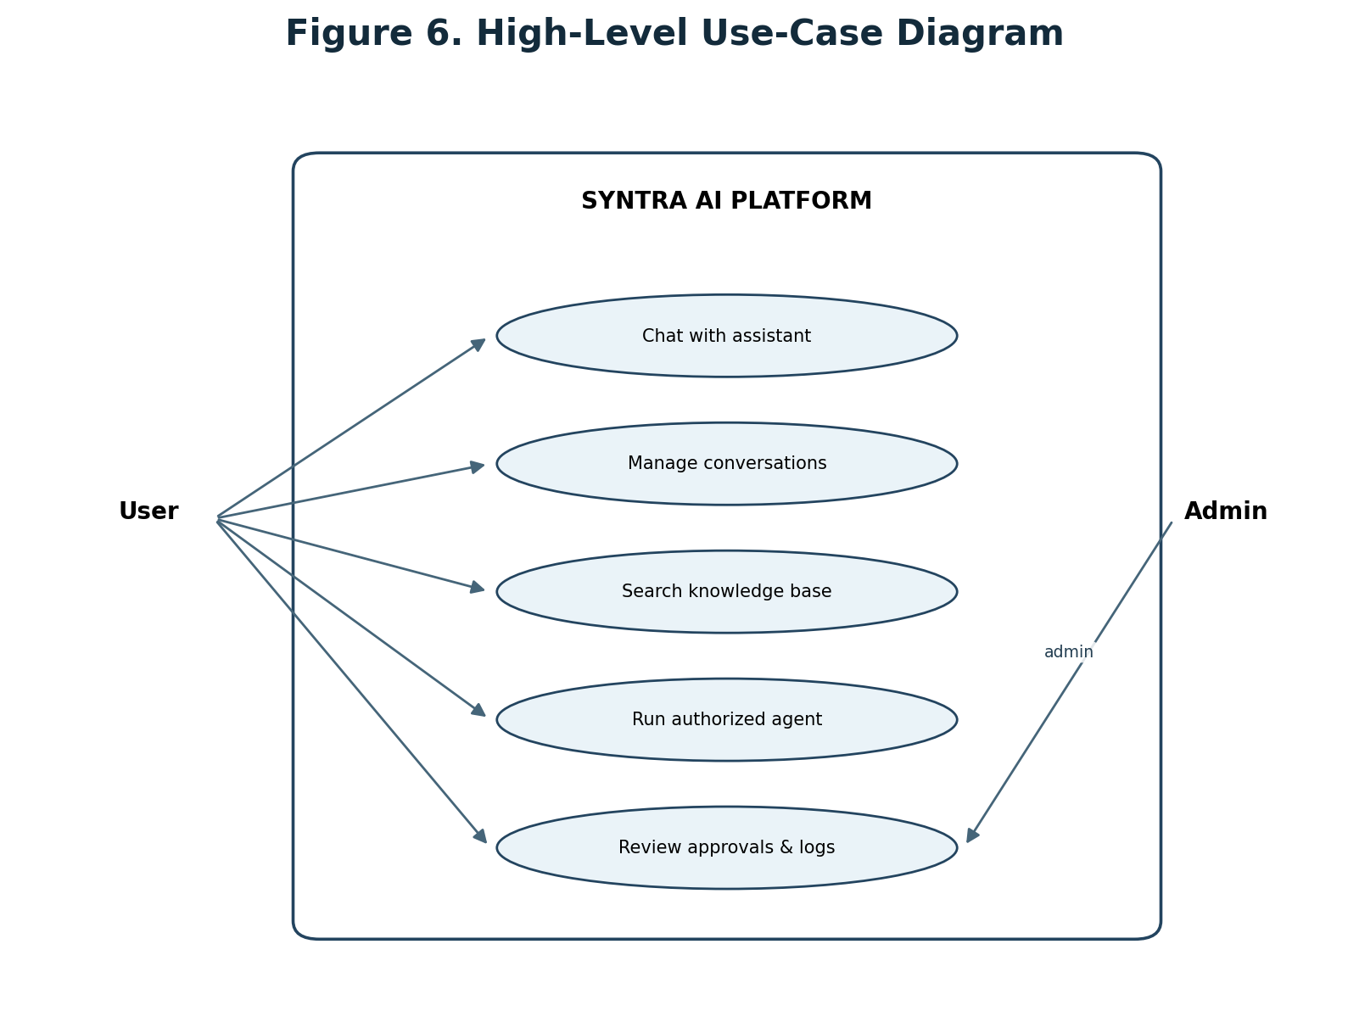
Figure 6. High-level use-case diagram.

5. Proposed System Architecture

5.1 Architectural Style
SYNTRA AI uses a modular service-oriented design with three principal application boundaries: (a) React/TypeScript presentation client; (b) Laravel application API for identity, permissions, persistence, and business workflows; and (c) Python/FastAPI intelligence service for model orchestration, retrieval pipelines, and agent execution. Supporting infrastructure includes PostgreSQL/pgvector, Redis, a model runtime such as Ollama, and a reverse proxy.

5.2 Presentation Layer
The web client provides the chat workspace, conversation history, agent management, knowledge library, model settings, approval queue, audit views, and system status. It communicates with the application API over HTTPS. Streaming responses may use Server-Sent Events or WebSockets depending on implementation requirements.

5.3 Application Layer
Laravel provides authentication, session management, request validation, user and resource ownership checks, policy enforcement, API versioning, and durable application records. It should not expose raw model-provider credentials to the browser. The Laravel service coordinates requests to the AI service using authenticated service-to-service communication.

5.4 Intelligence Layer
FastAPI hosts model adapters, prompt construction, context assembly, retrieval orchestration, agent state, and tool-call proposals. A provider interface isolates model-specific request and response formats. The model service must not directly bypass the application policy layer to access privileged infrastructure.

5.5 Data Layer
PostgreSQL stores users, conversations, messages, agents, tool definitions, approvals, audit events, and knowledge metadata. pgvector stores embeddings associated with document chunks and memory records. Redis is used for short-lived cache, job queues, and coordination; it is not the authoritative store for business records.

5.6 Model and Tool Boundaries
Model inference may occur locally through Ollama or through an explicitly configured external provider. Tool adapters expose narrowly scoped operations. Each call is validated against a schema and policy before execution. High-impact actions require approval. Tool execution should occur in a sandbox or constrained worker with timeouts, resource limits, and network restrictions.

5.7 Deployment Topology
A Docker Compose deployment may include frontend, Laravel API, Python AI service, PostgreSQL with pgvector, Redis, Nginx, and an optional local model runtime. Production deployment additionally requires TLS, firewall rules, backup automation, secrets management, monitoring, update procedures, and recovery testing.
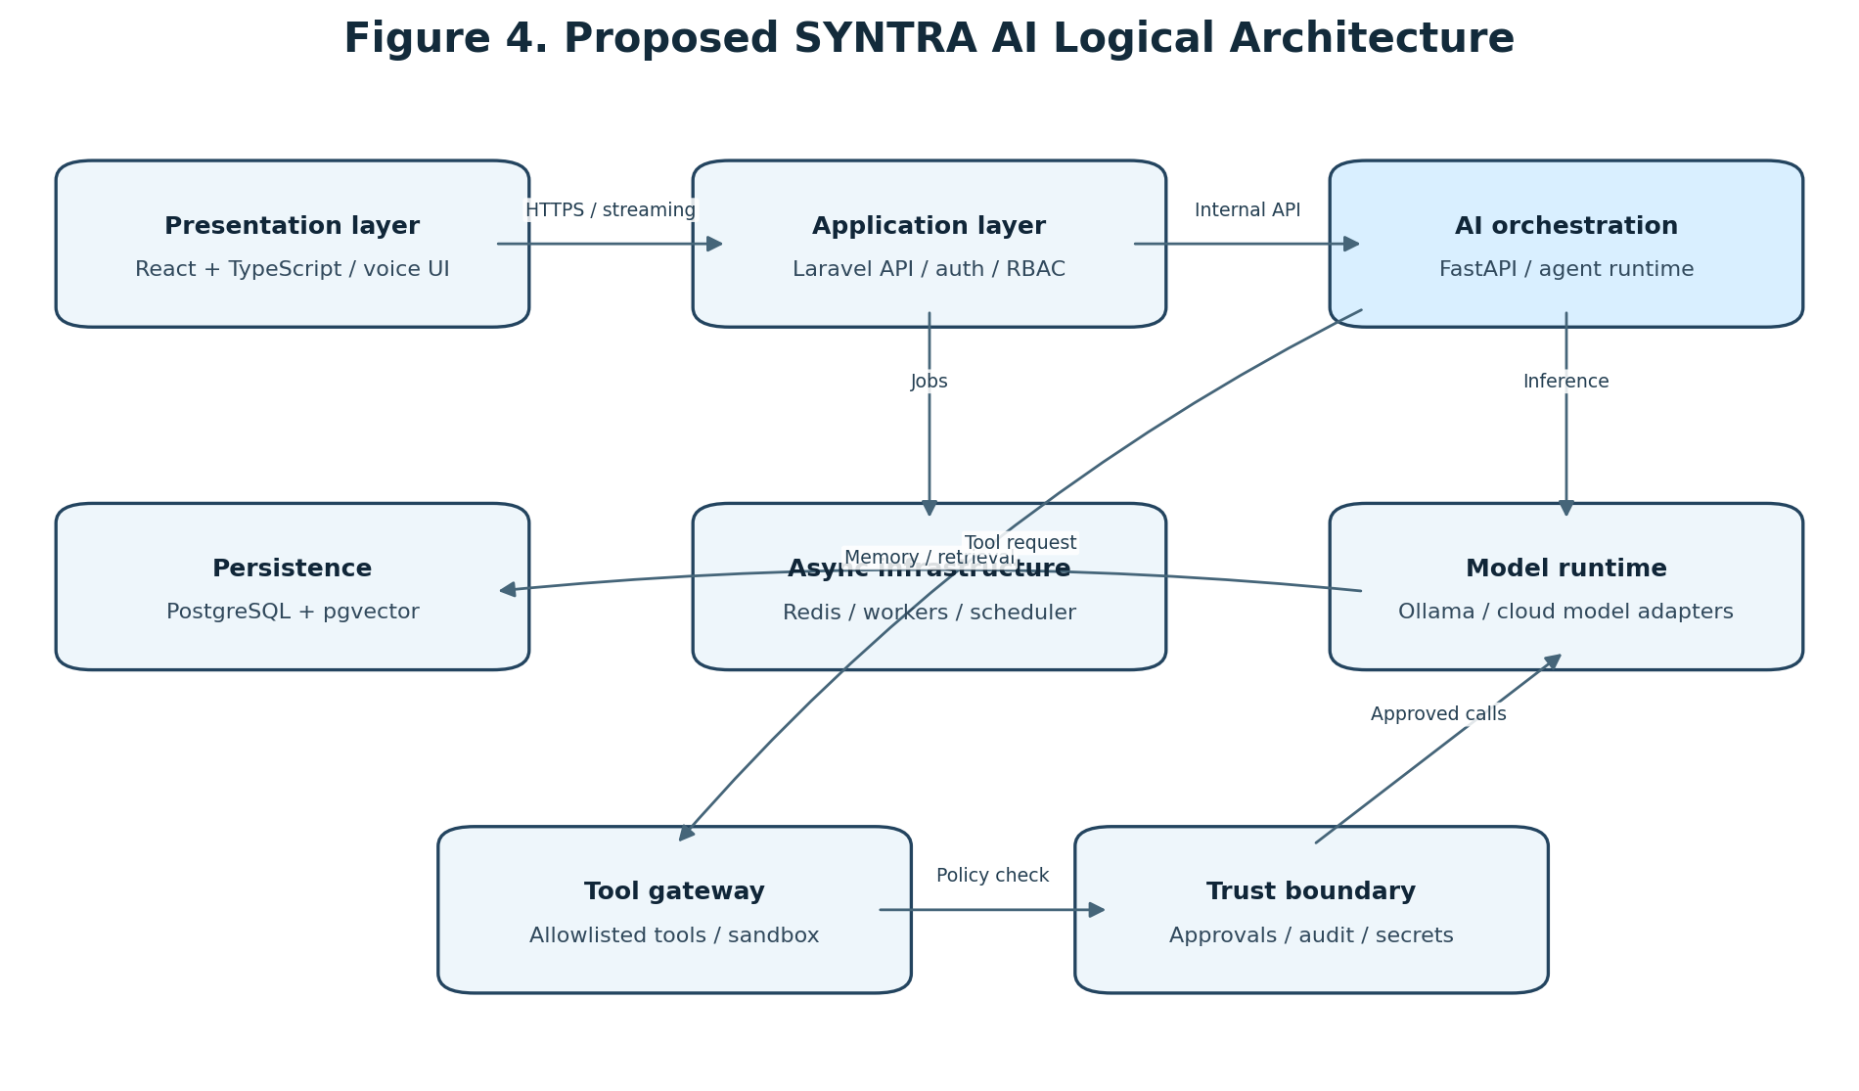
Figure 4. Proposed SYNTRA AI logical architecture.
Layer | Primary components | Responsibilities
Presentation | React, TypeScript | Chat, dashboard, agent console, approvals
Application | Laravel / PHP | Identity, API, policies, persistence, coordination
Intelligence | Python / FastAPI | Model adapters, RAG, agent orchestration
Data | PostgreSQL, pgvector, Redis | Records, embeddings, queues, cache
Runtime | Ollama / hosted provider | Language model inference
Execution | Tool gateway, sandbox, audit | Validated and permission-controlled actions

6. Data Flow Diagrams and Process Models

6.1 Context Diagram (DFD Level 0)
The context diagram treats SYNTRA AI as one process. The user supplies instructions, files, and approval decisions and receives responses and notifications. An administrator supplies configuration and policies. External model providers and connected services exchange inference requests or authorized API operations with the platform. The platform boundary must be explicit: external systems are not trusted merely because they are integrated.

6.2 DFD Level 1
The Level 1 diagram decomposes the platform into access/API handling, AI orchestration, context management, tool execution, and result presentation. Data stores include the application database, knowledge store, and audit store. Requests are authenticated before orchestration; retrieved context is scoped to the requesting user; tool proposals pass through policy checks; execution outcomes are recorded before the final result is presented.

6.3 DFD Level 2: Agent Execution
The Level 2 diagram expands the agent execution path: parse intent, plan task, retrieve context, decide whether a tool is needed, validate permissions, request approval where required, execute the approved operation, and synthesize a response. A denied, timed-out, or failed action must produce a safe and explicit result rather than silently continuing as if successful.

6.4 Sequence and State Considerations
A tool execution should move through states such as proposed, validated, awaiting_approval, approved, running, succeeded, failed, rejected, or expired. State transitions must be validated server-side. Duplicate submissions should be handled through idempotency keys where the underlying operation permits them.
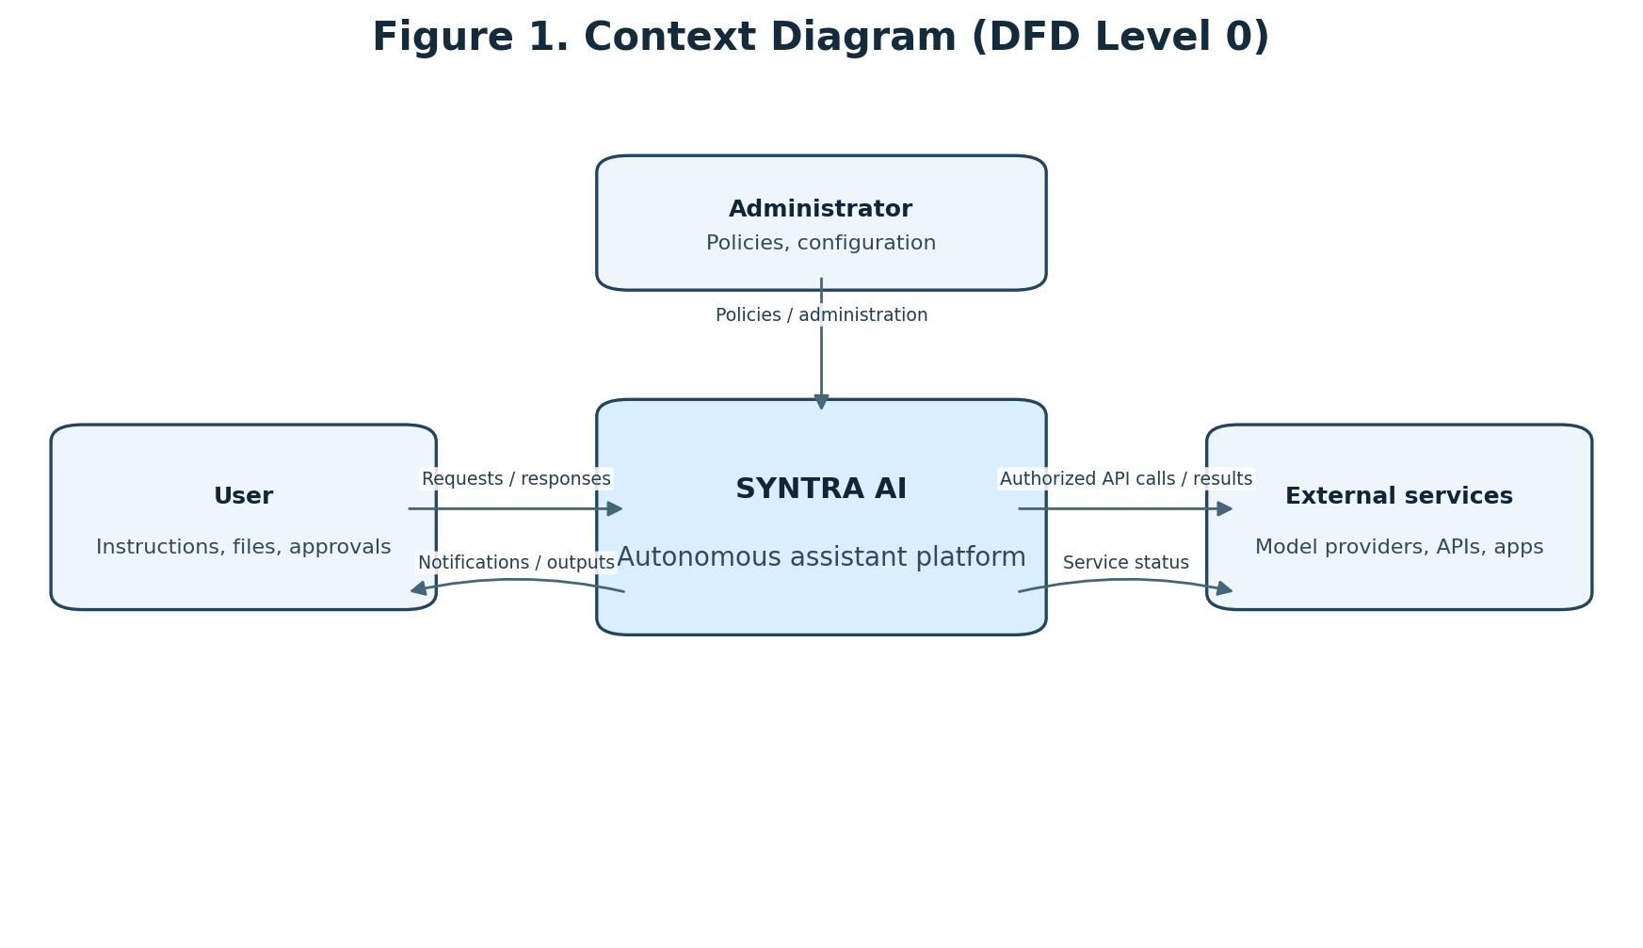
Figure 1. Context diagram (DFD Level 0).
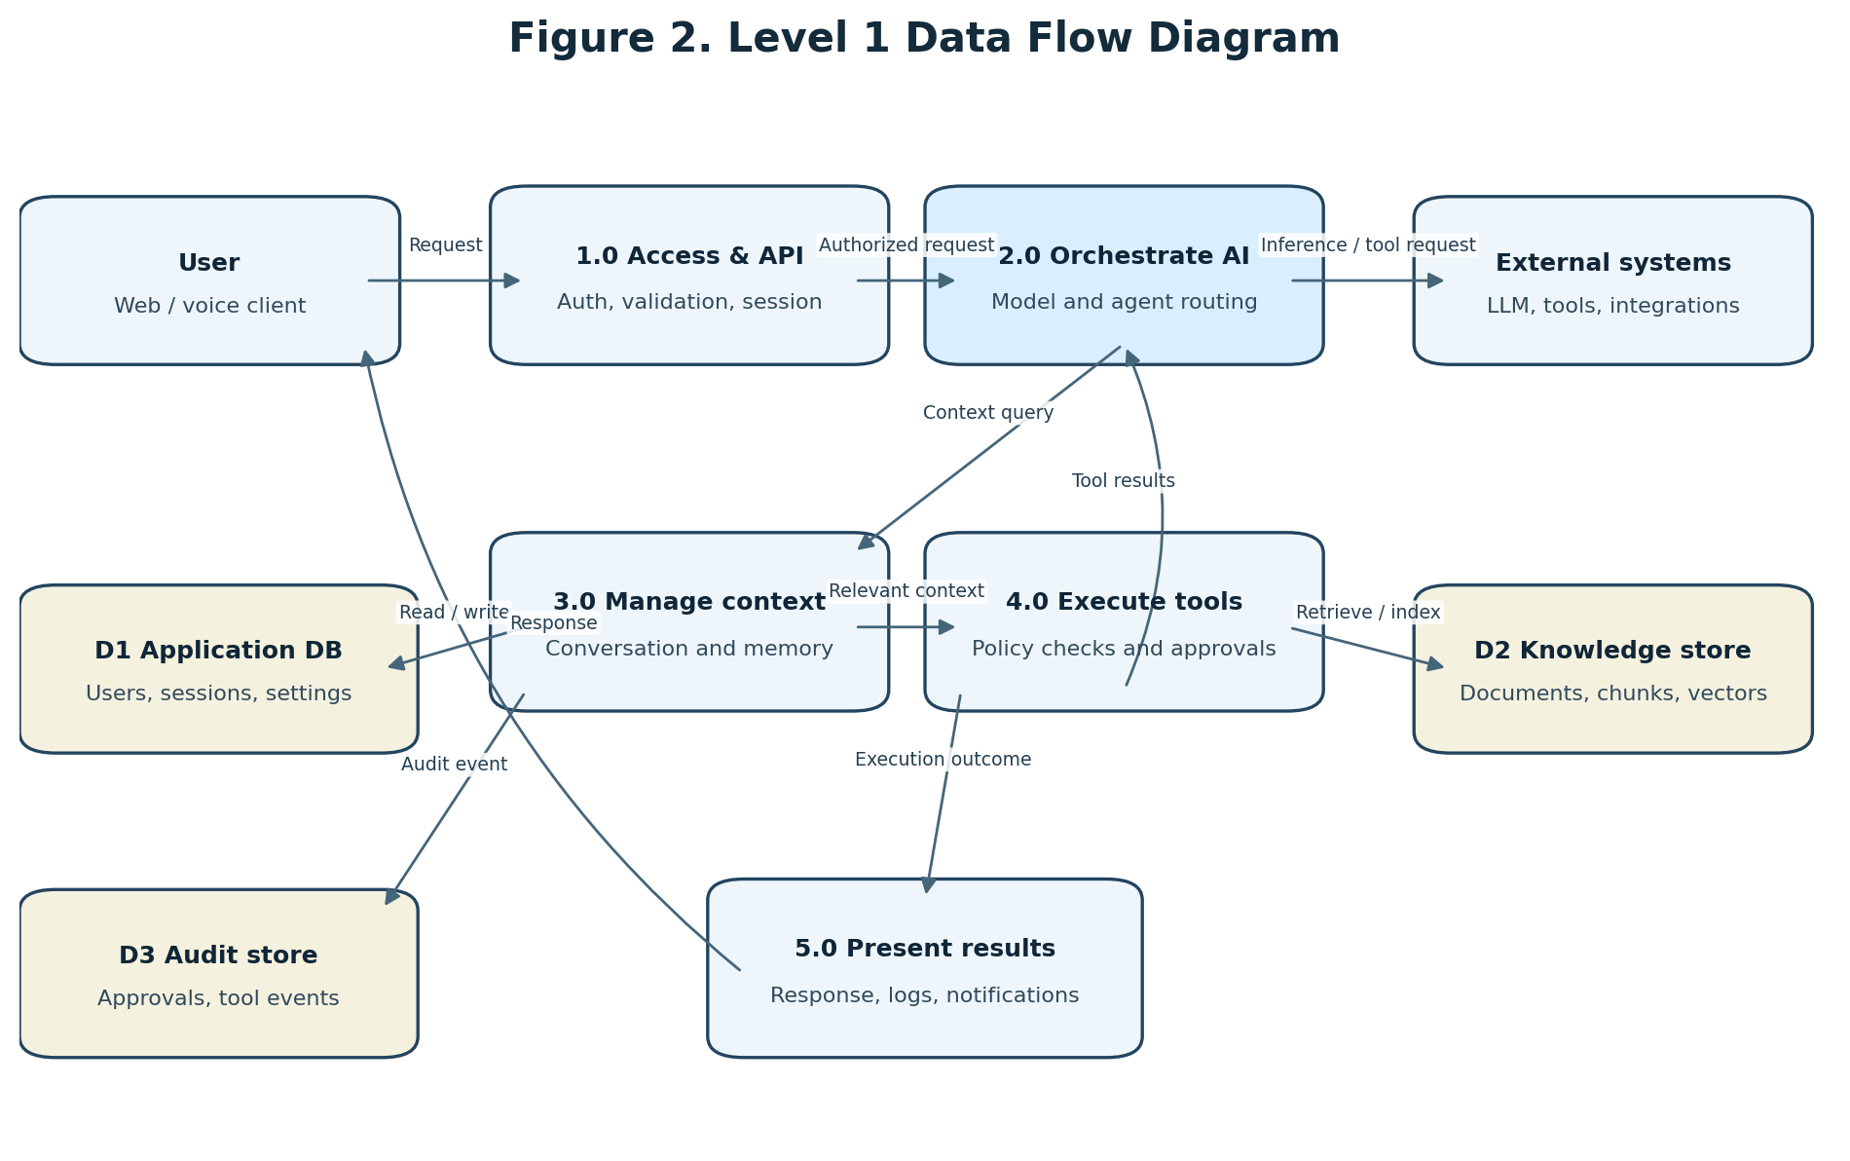
Figure 2. Level 1 data flow diagram.
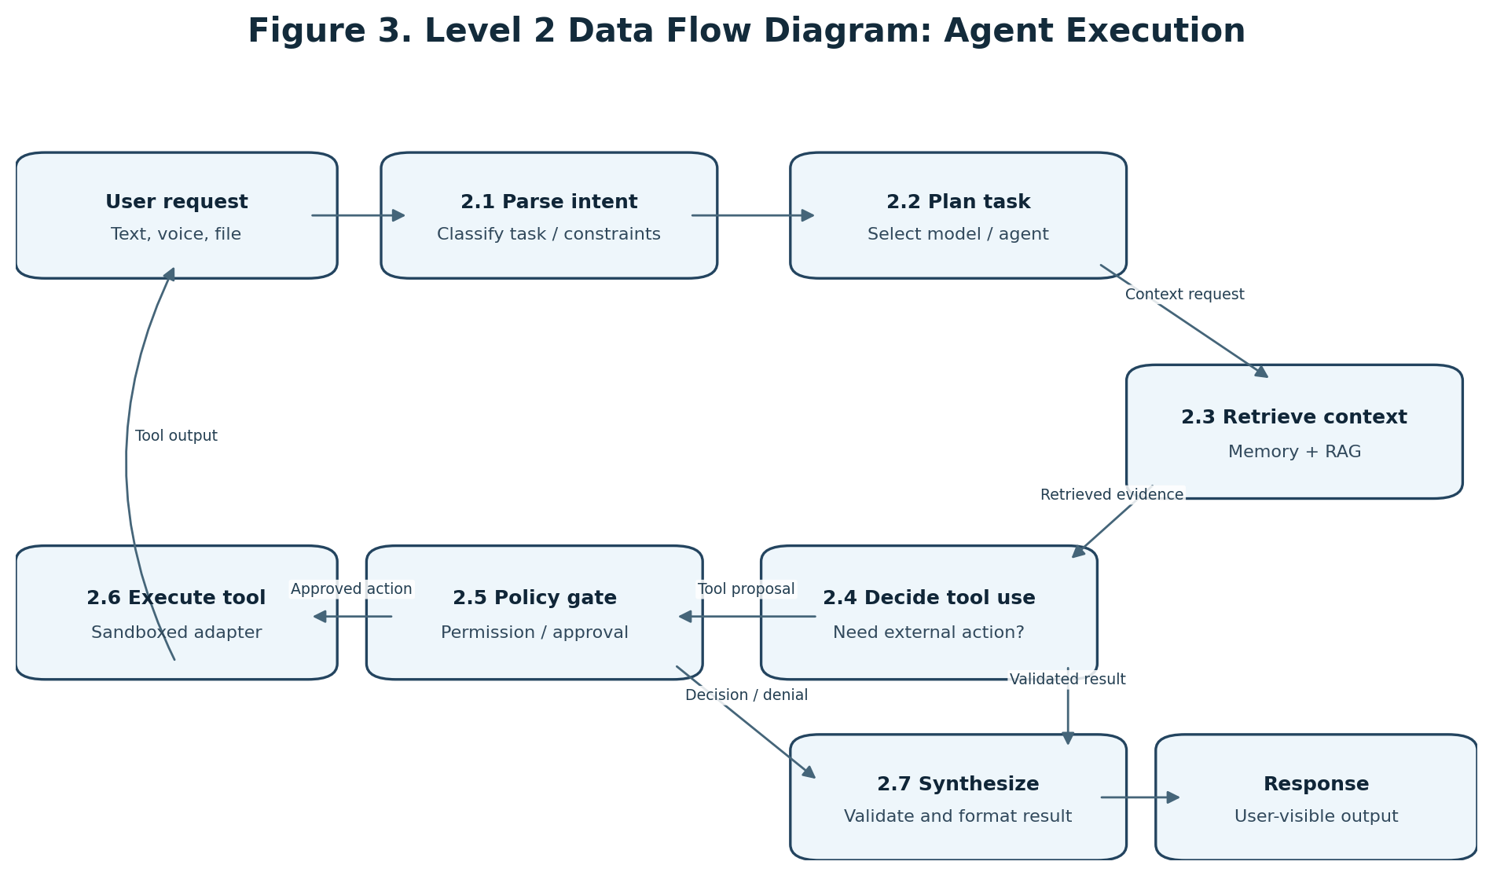
Figure 3. Level 2 data flow diagram for agent execution.

7. Database Design and ERD

7.1 Data Modeling Principles
The database design separates user-owned data, conversational data, agent configuration, tool execution, knowledge assets, and governance records. Foreign keys enforce referential integrity. Ownership checks are required in application policies in addition to relational constraints. Sensitive values such as API keys should be stored using a dedicated secrets mechanism or encrypted fields with managed keys, never as plaintext.

7.2 Core Entities
users: account identity and status. user_settings: user preferences. conversations: user-owned conversation containers. messages: ordered conversation messages and metadata. ai_models: configured model endpoints and capabilities. agents: agent identity, instructions, and configuration. agent_runs: execution records and state. tools: allowlisted tool definitions. tool_permissions: role or user grants. tool_executions: validated execution records. approval_requests: human decisions for sensitive actions. memories: user-approved persistent facts. knowledge_sources: uploaded or connected source metadata. documents: extracted document records. document_chunks: chunk text and embeddings. audit_logs: security-relevant events. workflows and workflow_steps: automation definitions and ordered operations.

7.3 ERD Interpretation
The ERD figure presents the core logical relationships. A user owns conversations, memories, agents, knowledge sources, and approval records. Conversations contain messages. Agents generate runs and may be associated with tools through a many-to-many relationship. Tools generate execution records. Knowledge sources contain documents, which are divided into chunks for retrieval. Agent runs may generate approval requests. The production schema should add timestamps, status fields, tenant/owner scoping, indexes, uniqueness constraints, and retention rules.

7.4 Key Constraints and Indexes
Recommended constraints include unique normalized email addresses, unique tool identifiers, unique model-provider/name pairs where appropriate, non-null ownership references, and enumerated execution states. Indexes should cover conversation ownership and update time, message conversation/time ordering, agent-run status and creation time, audit actor/time/event type, document ownership, and vector similarity search. Vector dimensions must match the selected embedding model and be versioned when models change.

7.5 Data Retention
The system should define configurable retention for raw prompts, generated responses, uploaded files, extracted chunks, embeddings, tool outputs, and audit records. Deletion workflows must account for derived data such as embeddings and cached copies. Backups must have documented retention and deletion limitations.
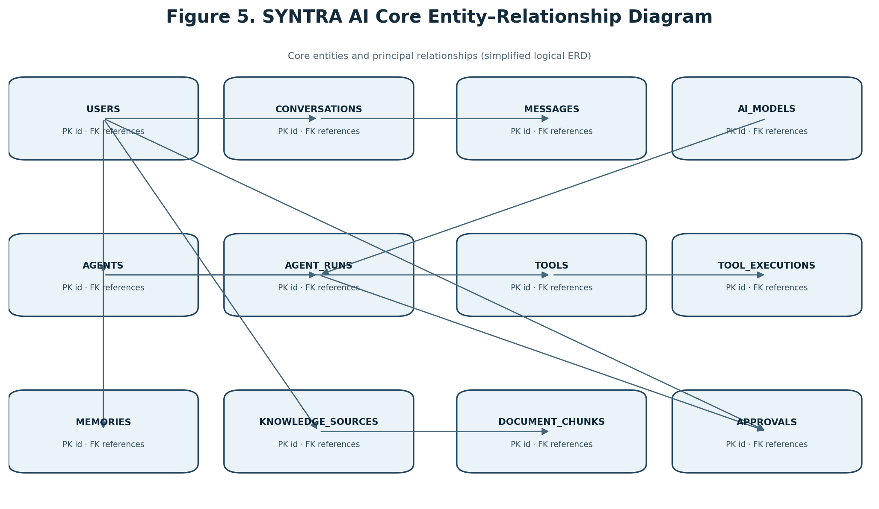
Figure 5. Core logical entity–relationship diagram.
Entity | Primary purpose | Important relationships
users | Account identity and ownership | Owns conversations, agents, memories, knowledge
conversations | Conversation containers | Belongs to user; contains messages
messages | Conversation turns | Belongs to conversation
ai_models | Provider/model configuration | Referenced by agent runs
agents | Agent configuration | Belongs to user; runs tasks; uses tools
agent_runs | Agent execution lifecycle | Belongs to agent; may request approval
tools | Allowlisted capabilities | Used by agents; produces executions
tool_executions | Tool call records | References tool and agent run
approval_requests | Human authorization decisions | References user and agent run
memories | Persistent user-approved facts | Belongs to user; may store embedding
knowledge_sources | Uploaded/connected source metadata | Belongs to user; contains documents
documents | Extracted document metadata | Belongs to source; contains chunks
document_chunks | Retrieval units and embeddings | Belongs to document
audit_logs | Security and activity records | References actor and affected resource

Table | Suggested key fields | Important constraints / indexes
users | id, name, email, password_hash, status | Unique normalized email; never store plaintext password
conversations | id, user_id, title, created_at, updated_at | Index user_id + updated_at
messages | id, conversation_id, role, content, metadata, created_at | Index conversation_id + created_at
agents | id, user_id, name, instructions, enabled | Index user_id; validate agent ownership
agent_runs | id, agent_id, model_id, status, started_at, finished_at | Index status + created_at
tools | id, slug, schema_json, risk_tier, enabled | Unique slug; schema validation
tool_executions | id, tool_id, agent_run_id, status, input_hash, result_ref | Index tool_id + created_at; redact secrets
approval_requests | id, agent_run_id, action_hash, status, expires_at | Approval bound to immutable action hash
memories | id, user_id, content, category, embedding, source | Index user_id; vector index after workload testing
document_chunks | id, document_id, chunk_index, content, embedding | Unique document_id + chunk_index; vector dimension fixed
audit_logs | id, actor_id, event_type, resource_type, resource_id, created_at | Append-oriented; index actor_id + created_at

8. Security, Privacy, and Governance

8.1 Threat Model
Relevant threats include prompt injection through user content or retrieved documents, unauthorized data access, credential disclosure, excessive agent permissions, malicious tool arguments, insecure output handling, model/provider compromise, denial of service, and audit-log tampering. The threat model should be reviewed as integrations and capabilities expand.

8.2 Least Privilege and Tool Gateway
Each tool should declare its purpose, input schema, output schema, permission scope, risk tier, timeout, and whether approval is mandatory. The gateway should bind the authenticated user and agent identity to every call. The model may propose an action, but deterministic application code decides whether it is permitted.

8.3 Human Approval
Actions such as deleting data, sending messages, publishing content, changing server configuration, spending money, or executing arbitrary commands should require explicit confirmation or be disallowed in the initial release. Approval screens should show the target, exact action, material parameters, and expected consequence. Approval should be time-limited and bound to the exact action payload.

8.4 Prompt Injection and Untrusted Content
Retrieved documents, web pages, emails, and tool outputs must be treated as data rather than trusted instructions. The system should separate trusted system policy from untrusted content, constrain tool schemas, validate outputs, and avoid giving retrieved content authority to modify permissions. No prompt-only mitigation should be treated as a complete security boundary.

8.5 Secrets and Network Security
Provider keys should be stored in environment-backed secret stores or a dedicated vault. Secrets must be redacted from logs and never placed in prompts. Internal services should authenticate each other. Network egress should be restricted for tool workers, and local model endpoints should not be exposed publicly without a secure gateway.

8.6 Privacy and User Control
Users should be able to inspect and delete memories and conversations according to the retention policy. The platform should disclose whether a request is processed locally or sent to an external provider. Data minimization, encryption in transit, encryption at rest where feasible, and documented backup practices are required.

8.7 Governance Framework
The project uses NIST AI RMF and the Generative AI Profile as governance references [1, 2]. The security baseline should be reviewed against OWASP web application guidance and the current OWASP GenAI/LLM risk materials at implementation time [6, 7]. Framework alignment is a design objective and must not be described as formal certification.

9. Implementation Plan

9.1 Recommended Technology Stack
Frontend: React and TypeScript. Application backend: Laravel/PHP. Intelligence service: Python and FastAPI. Primary database: PostgreSQL with pgvector. Queue/cache: Redis. Local inference: Ollama or another compatible runtime. Deployment: Docker Compose for development and initial self-hosting; production orchestration can be reconsidered when operational scale requires it. Voice services may use a speech-recognition engine and a text-to-speech engine selected after hardware and licensing evaluation.

9.2 Repository Organization
A monorepo is recommended with frontend/, backend/, ai-engine/, infrastructure/, documentation/, scripts/, docker-compose.yml, .env.example, and README.md. Each service should have its own dependency lockfile, tests, configuration, and container definition. Shared API contracts should be documented and versioned.

9.3 Milestone Plan
M1 (Weeks 1–2): repository, Docker, authentication, dashboard shell, database. M2 (Weeks 3–4): FastAPI service, model adapter, chat streaming, conversation persistence. M3 (Weeks 5–6): memory, embeddings, document ingestion, RAG. M4 (Weeks 7–9): agent registry, tool schemas, tool gateway, approval states. M5 (Weeks 10–11): voice and vision prototype. M6 (Weeks 12–13): workflow automation and selected integrations. M7 (Weeks 14–15): security hardening, backups, monitoring, deployment. M8 (Week 16): system testing, documentation, release candidate. This schedule is an estimate for a focused prototype and should be revised based on available time, hardware, and test findings.

9.4 Deployment Environments
Development should use local containers and synthetic data. Staging should mirror production configuration while using non-sensitive test data. Production should enforce TLS, strong authentication, restricted network exposure, backups, update procedures, monitoring, and a documented rollback plan.

9.5 Operational Maintenance
Maintenance includes model and dependency updates, vulnerability review, database migration management, backup restoration tests, monitoring of inference resource use, log rotation, and periodic review of tool permissions.

10. Testing and Evaluation Framework

10.1 Functional Testing
Test authentication, conversation lifecycle, streaming, model selection, memory operations, document upload, retrieval, agent creation, tool validation, approval decisions, and audit events. Each functional requirement should map to one or more test cases.

10.2 Retrieval Evaluation
Construct a labeled query set with expected relevant document passages. Measure Precision@k, Recall@k, and Mean Reciprocal Rank (MRR), and manually inspect answer grounding and citation correctness. Report dataset size, document composition, chunking strategy, embedding model, and retrieval parameters.

10.3 Agent and Tool Evaluation
Measure task completion rate on a fixed scenario suite, correct tool selection, schema-validation success, unauthorized-action rejection, approval enforcement, idempotency behavior, and recovery from tool failures. Include adversarial tests with prompt-injection content in documents and tool outputs.

10.4 Performance Evaluation
Measure time to first token, total response latency, retrieval latency, tool latency, queue delay, throughput, memory usage, CPU/GPU utilization, and failure rate. Results must state hardware, model version, quantization, context length, concurrency, prompt set, and network conditions. Do not compare models using undocumented or inconsistent settings.

10.5 Security Evaluation
Perform dependency scanning, static analysis, authentication and authorization tests, API fuzzing, secret scanning, prompt-injection tests, cross-user data-isolation tests, and sandbox escape review. Confirm that sensitive operations cannot bypass approval requirements.

10.6 Usability Evaluation
After the prototype is stable, conduct task-based usability sessions with consenting participants. Possible measures include task success, time on task, error rate, and a standardized questionnaire such as the System Usability Scale. Participant recruitment, consent, and data handling must follow applicable institutional requirements.

10.7 Evaluation Reporting
Report actual observations, test environment, sample sizes, metrics, failures, and limitations. If a test was not conducted, mark it as not evaluated. Do not replace missing evidence with estimated values.

11. Expected Outcomes and Contributions

11.1 Expected Technical Outcomes
The expected artifact is a deployable prototype with a web interface, application API, AI orchestration service, model adapter, conversation persistence, memory and RAG capability, agent registry, permission-aware tool gateway, approval workflow, and audit trail.

11.2 Expected Contributions
The project contributes (1) a modular reference architecture for a self-hosted assistant; (2) a relational and vector data model for conversations, memory, knowledge, agents, and governance; (3) a controlled tool-execution design; and (4) a reproducible evaluation plan for agent-enabled assistant systems.

11.3 Practical Value
The platform may support personal knowledge work, software development assistance, research support, and selected workflow automation. Its practical value will depend on measured reliability, security, usability, and maintenance effort.

12. Limitations and Future Work

12.1 Limitations
Local inference quality and speed depend on hardware and model selection. Language models can hallucinate, misinterpret context, or generate unsafe suggestions. RAG can retrieve irrelevant or incomplete evidence. Tool integrations may fail or change. Voice recognition may be affected by noise and accents. Self-hosting transfers responsibility for patching, backups, monitoring, and security to the operator. The proposed architecture has not yet been empirically validated.

12.2 Future Enhancements
Future work may include multi-user tenancy, advanced voice interaction, multimodal vision, proactive scheduling, mobile clients, plugin marketplace, model fine-tuning for narrow tasks, distributed inference, policy simulation, and formal security assessment. Each capability should be introduced only after threat analysis and measurable acceptance criteria are defined.

13. Conclusion

13.1 Conclusion
This paper presented the proposed design of SYNTRA AI, a modular, self-hosted autonomous assistant platform. The design combines a React/TypeScript interface, Laravel application services, a Python/FastAPI intelligence layer, PostgreSQL with pgvector, Redis, and local or hosted model providers. It integrates conversations, memory, RAG, agents, and controlled tools within an explicit governance model. The key design principle is that model-generated plans do not directly authorize actions: deterministic policy enforcement, user approval, sandboxing, and auditability remain application responsibilities. The next stage is implementation and empirical evaluation. Claims about performance, usability, or security effectiveness should be made only after the proposed tests have been conducted and their results documented.

References
[1] E. Tabassi, “Artificial Intelligence Risk Management Framework (AI RMF 1.0),” NIST AI 100-1, National Institute of Standards and Technology, 2023. https://doi.org/10.6028/NIST.AI.100-1
[2] C. Autio, R. Schwartz, J. Dunietz, S. Jain, M. Stanley, E. Tabassi, P. Hall, and K. Roberts, “Artificial Intelligence Risk Management Framework: Generative Artificial Intelligence Profile,” NIST AI 600-1, National Institute of Standards and Technology, 2024. https://doi.org/10.6028/NIST.AI.600-1
[3] Ollama, “Ollama Documentation: API and Model Runtime,” official documentation. https://docs.ollama.com/
[4] pgvector, “Open-source vector similarity search for Postgres,” project documentation. https://github.com/pgvector/pgvector
[5] LangChain, “LangGraph Persistence and Human-in-the-Loop Workflows,” official documentation. https://langchain-ai.github.io/langgraph/
[6] OWASP Foundation, “OWASP Top 10:2025,” 2025. https://top10.owasp.org/2025/
[7] OWASP GenAI Security Project, “OWASP Top 10 for Large Language Model Applications,” current project resources. https://genai.owasp.org/llm-top-10/
[8] PostgreSQL Global Development Group, “PostgreSQL Documentation,” official documentation. https://www.postgresql.org/docs/
[9] FastAPI, “FastAPI Documentation,” official documentation. https://fastapi.tiangolo.com/
[10] Laravel, “Laravel Documentation,” official documentation. https://laravel.com/docs
[11] React, “React Documentation,” official documentation. https://react.dev/
[12] Redis, “Redis Documentation,” official documentation. https://redis.io/docs/

Appendix A. Initial API Surface (Proposed)
Method | Endpoint | Purpose
POST | /api/v1/auth/login | Authenticate user
GET | /api/v1/conversations | List owned conversations
POST | /api/v1/conversations | Create conversation
POST | /api/v1/conversations/{id}/messages | Submit prompt and receive streamed response
GET | /api/v1/agents | List authorized agents
POST | /api/v1/agents | Create agent
POST | /api/v1/agent-runs | Start an agent run
POST | /api/v1/approvals/{id}/decision | Approve or reject pending action
POST | /api/v1/knowledge/sources | Upload knowledge source
GET | /api/v1/audit-logs | Review authorized audit records

Appendix B. Initial Acceptance Checklist
- User can authenticate and only access owned resources.
- User can create conversations and messages persist after restart.
- At least one model provider can generate a response through the model adapter.
- Model responses stream to the interface with clear failure handling.
- Memory records can be inspected, edited, and deleted by their owner.
- Uploaded documents can be indexed and retrieved with source metadata.
- Agent tool calls are schema-validated and permission-checked.
- Sensitive actions cannot execute without the required approval.
- Tool executions and approval decisions create audit events.
- Backup restoration and security test procedures are documented.

Appendix C. Items Required Before Publication
- Replace author, institution, department, and contact details.
- Confirm the target journal or conference template, citation style, and word limits.
- Implement the proposed system or clearly retain the manuscript as a design proposal.
- Add dated screenshots and versioned implementation details where appropriate.
- Run the evaluation protocol and report actual results, sample sizes, and hardware.
- Obtain required ethics approval and participant consent if human-subject evaluation is performed.
- Verify every reference and ensure all citations comply with the target venue.
- Review originality, licensing, model terms, data protection, and disclosure requirements.

