CityUHK Qingdao Research Institute
FINAL YEAR PROJECT REPORT
2025/26 – [Proposal Code]
RISC-V Custom Instruction Based
Lightweight CNN Accelerator
FPGA Prototype Validation
Student Name: | JU JIAXING
Home University: | City University of Hong Kong
Student ID: | 2501026
Supervisor: | [Supervisor Name]
Assessor: | [Assessor Name]
Major: | Computer Engineering
Programme: | BEng Computer Engineering
Department of Computer Science
City University of Hong Kong
May 2026

Declaration
I have read the student handbook and I understand the meaning of academic dishonesty, in particular plagiarism and collusion. I declare that the work submitted for the final year project does not involve academic dishonesty. I give permission for my final year project work to be electronically scanned and if found to involve academic dishonesty, I am aware of the consequences as stated in the Student Handbook.
Student Name: JU JIAXING
Student ID: 2501026
Signature: ______________________
Date: May 5, 2026

Abstract
The increasing demand for energy-efficient edge AI inference has driven interest in hardware acceleration of convolutional neural networks (CNNs). RISC-V’s open instruction set architecture provides a unique opportunity to extend a standard processor with custom instructions for domain-specific acceleration. This project presents the design, implementation, and FPGA-based prototype validation of a lightweight CNN accelerator integrated with a RISC-V E203 (Hummingbird v2) processor through the Nuclei Instruction Co-extension (NICE) interface.
The accelerator implements a 4×4 systolic processing element (PE) array supporting INT8 quantized convolution operations. Six custom NICE instructions—CFG, CLEAR, WLOAD, DLOAD, COMP, and RSTAT—provide the software interface for configuring, loading weights and activations, triggering computation, and reading results. The complete system integrates the E203 RISC-V core, ITCM/DTCM memory, UART, GPIO, and the CNN accelerator on a single FPGA.
The design was validated through a multi-stage methodology: (1) RTL simulation of the CNN accelerator using Icarus Verilog, achieving correct RSTAT results for known test vectors; (2) full-SoC simulation integrating the E203 core with the accelerator; and (3) FPGA prototype bring-up on the Davinci Pro A7-100T development board using Xilinx Vivado 2023.2.
A minimal bare-metal program (hello_e203) was developed and successfully validated on the FPGA board, producing the expected three-stage UART output (“boot”, “uart ok”, “loop”), confirming the complete boot chain from mask ROM through ITCM execution. Extensive ILA (Integrated Logic Analyzer) debugging was conducted to diagnose and resolve four critical root causes preventing CPU boot: (1) a Verilog #1 transport delay in the DFF primitives affecting iverilog simulation; (2) byte-level versus word-level hex format incompatibility with Vivado’s $readmemh for 64-bit ITCM BRAM; (3) the same format issue for 32-bit DTCM BRAM; and (4) the E203_FORCE_BOOTROM_BOOT macro not being globally visible in the Vivado synthesis flow. Custom NICE test programs confirmed that the CNN accelerator instructions execute correctly on the FPGA, with ILA captures documenting the complete instruction execution sequence.
This project demonstrates a complete FPGA bring-up pipeline for a RISC-V-based CNN accelerator, establishing a reproducible evidence chain from RTL simulation through board-level validation. The diagnostic methodology and root cause analysis provide a systematic framework for debugging complex SoC designs on FPGA platforms.

Acknowledgements
The author wishes to express sincere gratitude to the project supervisor for their guidance and feedback throughout this final year project. Thanks are also due to the laboratory staff at CityUHK Qingdao Research Institute for providing access to the FPGA development boards and Vivado design tools, without which the hardware prototyping phase would not have been possible.
The open-source hardware community—particularly the RISC-V Foundation, Nuclei System Technology for the E203 Hummingbird v2 processor, and the maintainers of Icarus Verilog—provided the foundational tools and designs upon which this work is built.
Finally, the author thanks his family for their patience and encouragement throughout the undergraduate degree programme.

1 Introduction

1.1 Background
Convolutional Neural Networks (CNNs) have become the dominant approach for computer vision tasks including image classification, object detection, and semantic segmentation [1]. However, the computational intensity of CNN inference poses significant challenges for deployment on resource-constrained edge devices. A single forward pass through even a modest network like LeNet-5 requires millions of multiply-accumulate (MAC) operations, making general-purpose CPU execution prohibitively slow and power-inefficient for real-time applications [2].
Hardware acceleration has emerged as the primary solution to this challenge. Application-Specific Integrated Circuits (ASICs) and Field-Programmable Gate Arrays (FPGAs) can achieve orders of magnitude better performance and energy efficiency than CPUs by exploiting the inherent parallelism in CNN computations. Systolic array architectures, in particular, have proven highly effective for matrix multiplication—the core operation in both fully-connected and convolutional layers—by organizing processing elements in a regular grid with local data communication.

1.2 RISC-V and Custom Instruction Extensions
RISC-V is an open standard instruction set architecture (ISA) that has gained significant traction in both academic and industrial settings since its introduction at UC Berkeley in 2010 [3], [4], [5]. Unlike proprietary ISAs, RISC-V’s modular design explicitly reserves encoding space for custom instruction extensions, enabling domain-specific acceleration without breaking compatibility with the standard ecosystem.
The Nuclei Instruction Co-extension (NICE) interface, implemented in the E203 Hummingbird v2 processor [6], provides a standardized mechanism for integrating custom hardware accelerators directly into the processor pipeline [7]. Through NICE, custom instructions appear as native RISC-V instructions to the programmer, with the processor automatically handling operand fetch, hazard detection, and result writeback. This approach eliminates the overhead of memory-mapped I/O or coprocessor communication protocols, enabling fine-grained, low-latency acceleration.

1.3 Problem Statement
While RISC-V custom instruction extensions offer a promising path for CNN acceleration, the practical challenges of integrating a hardware accelerator with a RISC-V core and validating the complete system on an FPGA platform remain significant. Key challenges include:
Correctly implementing the NICE interface protocol for custom instruction handshaking and data transfer.
Managing the FPGA build flow, including block RAM initialization, clock domain crossing, and timing closure.
Establishing a reliable debugging methodology using Integrated Logic Analyzer (ILA) probes for observing internal SoC signals.
Bridging the gap between RTL simulation and hardware behavior, where synthesis-specific issues, memory initialization formats, and macro visibility can cause divergent behavior.

1.4 Project Objectives
This project aims to design, implement, and validate a lightweight CNN accelerator integrated with a RISC-V E203 processor through the NICE interface, targeting FPGA prototype validation on the Davinci Pro A7-100T development board.
The specific objectives are:
Design a 4×4 systolic PE array supporting INT8 quantized convolution, with six custom NICE instructions (CFG, CLEAR, WLOAD, DLOAD, COMP, RSTAT) for software control.
Integrate the accelerator with the E203 Hummingbird v2 SoC, including ITCM/DTCM memory, UART, and GPIO peripherals.
Establish a complete FPGA bring-up pipeline from RTL simulation through Vivado synthesis, place-and-route, and bitstream generation.
Validate the CPU boot chain by running a minimal bare-metal program (hello_e203) on the FPGA board with UART output verification.
Test the CNN accelerator custom instructions on the FPGA using custom NICE test programs, with ILA-based diagnostic evidence collection.

1.5 Thesis Structure
Chapter 2 establishes the technical context, covering the RISC-V ISA, the E203 processor microarchitecture, CNN fundamentals, and FPGA prototyping methods. Chapter 3 details the system design: the SoC architecture, the NICE custom instruction set, the PE array implementation, and the FPGA bring-up strategy. Chapter 4 reports the experimental outcomes across RTL simulation, bitstream construction, board-level validation of the hello_e203 program, root-cause analysis of CPU boot failures, and NICE accelerator testing with ILA evidence. Chapter 5 interprets these results, compares achievements against the project objectives, and identifies limitations. Chapter 6 summarizes the contributions and outlines directions for future work.

2 Background

2.1 RISC-V ISA and Custom Instruction Extensions

2.1.1 Overview of the RISC-V Architecture
RISC-V is an open, free instruction set architecture (ISA) originally designed at the University of California, Berkeley [3], [4], [8]. Unlike proprietary ISAs such as ARM or x86, RISC-V is released under permissive open-source licenses that allow anyone to implement processors without royalty or licensing fees [9]. This characteristic has made RISC-V particularly attractive for academic research and custom hardware design [5].
The RISC-V ISA follows a modular design philosophy. It consists of a mandatory base integer instruction set (denoted as “I”) and multiple optional standard extensions. The base integer ISA provides a minimal set of instructions for a general-purpose computer, including arithmetic, logical, branch, load/store, and system instructions. For RV32, the base ISA comprises 40 instructions with 32 general-purpose registers (x0–x31), each 32 bits wide. Register x0 is hardwired to the constant zero. The program counter (PC) holds the address of the current instruction, and branch instructions use PC-relative addressing.
The standard extensions include:
M Extension: Integer multiplication and division instructions (mul, div, rem, etc.).
A Extension: Atomic memory operations (load-reserved/store-conditional, atomic fetch-and-op).
F Extension: Single-precision floating-point arithmetic.
D Extension: Double-precision floating-point arithmetic.
C Extension: Compressed instructions (16-bit instruction encoding for improved code density).
A processor must implement at least the base I extension to be considered RISC-V compliant. The core described in this work supports the RV32IMAC configuration, which combines the base integer ISA with the M, A, and C extensions.

2.1.2 Instruction Encoding and Custom Instruction Spaces
RISC-V defines a fixed-length 32-bit instruction format for the base ISA (the C extension additionally supports 16-bit compressed instructions). The major instruction formats are R-type (register-register), I-type (immediate), S-type (store), B-type (branch), U-type (upper immediate), and J-type (jump). All formats share a common 7-bit opcode field located in bits [6:0].
The RISC-V specification reserves four opcode spaces for custom extensions, designated as custom0 (opcode 0x0b), custom1, custom2, and custom3. These opcode spaces allow designers to define their own instruction semantics without conflicting with standard or future RISC-V instructions. Each custom opcode provides a complete instruction encoding space of up to $2^{25}$ unique instructions, as the remaining 25 bits (after the 7-bit opcode) are fully available for user-defined operand fields and function selectors.
The standard R-type encoding for a custom instruction is structured as follows:
31 25 24 20 19 15 14 12 11 7 6 0
+---------------+---------------+---+-----------+-------------+
| funct7 | rs2 | rs1 | funct3 | rd | custom |
| 7-bit | 5-bit| 5-bit| 3-bit | 5-bit | 7-bit |
+---------------+---------------+---+-----------+-------------+
For a standard R-type instruction, bits [14:12] encode a funct3 field that further qualifies the operation. However, the E203 NICE (Nuclei Instruction Co-unit Extension) protocol repurposes this field for a different purpose, as detailed in Section 2.2.5.

2.1.3 Motivations for Custom Instruction Extensions in Embedded Deep Learning
Custom instruction extensions provide a middle ground between purely software-based computation and dedicated hardware accelerators. They offer several advantages for embedded deep learning workloads:
Reduced Function-Call Overhead: Instead of writing to memory-mapped registers through load/store instructions—which incurs multiple instructions per transfer—a custom instruction can pass operands directly via the processor’s register file. This reduces both instruction count and latency.
Tight Coupling with the Processor Pipeline: A custom instruction co-unit (such as NICE) interfaces directly with the processor’s execution stage, allowing data to flow from the register file to the accelerator in a single cycle. This eliminates the bus arbitration overhead typical of memory-mapped peripherals.
Programmer-Transparent Parallelism: From the programmer’s perspective, a custom instruction behaves like any other RISC-V instruction. The compiler and assembler treat it as an atomic operation, while the underlying hardware can exploit parallelism internally.
These characteristics make custom instruction extensions particularly suitable for lightweight CNN inference accelerators, where the computational patterns are regular and well-defined but the data volumes are too large for pure software execution on a low-power embedded core.

2.2 E203 Hummingbird v2 Processor Architecture

2.2.1 Overview
The Hummingbird E203 v2 is an open-source, low-power RISC-V processor core developed by Nuclei System Technology [6]. It implements the RV32IMAC instruction set and is designed for resource-constrained embedded applications. The E203 is widely used in both academic and industrial settings due to its small footprint, complete open-source availability, and the inclusion of the NICE (Nuclei Instruction Co-unit Extension) custom instruction interface [7], which is central to this work.
The key parameters of the E203 core are summarized in Table 2.1.
Table 2.1: E203 Processor Core Parameters
E203 Processor Core Parameters
Parameter | Value
ISA | RV32IMAC
Pipeline Depth | 2 stages
Operating Mode | Machine Mode only
Register File | 32 x 32-bit
Address Width | 32 bits
Debug Support | RISC-V Debug 0.11
Co-unit Interface | NICE (native)
ITCM | 128 KB
DTCM | 64 KB

2.2.2 Two-Stage Pipeline Architecture
The E203 implements a two-stage pipeline—the shortest feasible pipeline depth for a RISC-V processor. This design choice prioritizes low power consumption, small area, and simplified control logic over peak clock frequency, making it suitable for FPGA implementation and embedded use cases.
The two stages are:

2.2.2.1 Stage 1: Instruction Fetch (IFU Stage)
The Instruction Fetch Unit (IFU) is responsible for generating the program counter (PC) sequence, fetching instructions from memory, and delivering them to the execution stage. The IFU module (e203_ifu.v) interfaces with two memory subsystems via the Internal Chip Bus (ICB) protocol:
ITCM (Instruction Tightly Coupled Memory): A 128 KB, 64-bit wide instruction memory mapped at address 0x8000_0000. The ITCM provides single-cycle access latency for sequential instruction fetches. The IFU-to-ITCM interface uses the ICB command/response channel pair, with signals including ifu2itcm_icb_cmd_valid, ifu2itcm_icb_cmd_addr, and ifu2itcm_icb_rsp_rdata[63:0].
System Memory Interface (BIU): For instruction fetches that miss the ITCM region, the IFU sends requests through the Bus Interface Unit (BIU). The external memory interface also uses the ICB protocol with signals ifu2biu_icb_cmd_valid, ifu2biu_icb_cmd_addr[31:0], and ifu2biu_icb_rsp_rdata[31:0].
The IFU also performs limited decode pre-processing: it extracts the source register indices (rs1 and rs2) from the fetched instruction and forwards them to the execution stage to enable early register file read. This is visible in the IFU interface signals ifu_o_rs1idx[4:0] and ifu_o_rs2idx[4:0].
Branch prediction in the E203 is minimal: a static “not-taken” strategy is employed, with the ifu_o_prdt_taken signal indicating when a branch is predicted as taken based on its instruction type.

2.2.2.2 Stage 2: Execute (EXU Stage)
The Execution Unit (EXU) encompasses instruction decode, operand fetch, arithmetic execution, memory access, and write-back—all within a single stage. The EXU module (e203_exu.v) instantiates several sub-modules:
Register File (e203_exu_regfile): A 32-entry, 32-bit register file with two read ports and one write port. The register file supports write-back from multiple sources (ALU result, LSU load data, CSR read data, and NICE response data).
Instruction Decoder (e203_exu_decode): The decoder interprets the 32-bit instruction word and produces a wide decode information bus (dec_info) that controls the datapath. The decoder identifies the instruction group (ALU, AGU, BJP, CSR, MULDIV, NICE, or FPU) and generates the appropriate control signals. For NICE instructions, the decoder forwards the entire instruction word to the NICE co-unit via the E203_DECINFO_NICE_INSTR field, which is 27 bits wide (bits [31:7] of the instruction).
ALU and MULDIV Units: The ALU handles arithmetic and logical operations, while the MULDIV unit handles multiply and divide operations. The E203 supports shared ALU/MULDIV hardware to reduce area.
Out-of-Instruction Tracking FIFO (OITF): The OITF tracks up to two (or optionally four) in-flight instructions. It is used to manage write-back ordering and hazard detection. The oitf_empty signal is used by the IFU to determine whether it can safely flush the pipeline.

2.2.3 Pipeline Flow and Handshake
The two-stage pipeline operates with a simple valid-ready handshake between the IFU and EXU stages:
ifu_o_valid: Asserted by the IFU when a valid instruction is available.
ifu_o_ready: Asserted by the EXU when it is ready to accept a new instruction.
When both valid and ready are asserted in the same cycle, the instruction is transferred from the IFU to the EXU.
The IFU can continue fetching and buffering instructions as long as the EXU accepts them. When a pipeline hazard occurs (e.g., a multi-cycle instruction or a load-use dependency), the EXU deasserts i_ready, causing the IFU to stall.
Pipeline flushes are coordinated through the pipe_flush_req / pipe_flush_ack handshake pair. When a branch misprediction or exception occurs, the EXU asserts pipe_flush_req along with the target PC (via pipe_flush_add_op1 and pipe_flush_add_op2), and the IFU responds by discarding its prefetched instructions and redirecting fetch to the correct address.

2.2.4 Load/Store Unit and Memory Map
The Load/Store Unit (LSU, e203_lsu.v) handles all data memory accesses—load and store instructions—initiated by the EXU. The LSU receives requests from the Address Generation Unit (AGU) within the EXU and translates them into ICB bus transactions.
The LSU supports one outstanding memory transaction at a time, configured by the E203 LSU outstanding-count parameter set to 1. This simplifies control logic at the cost of throughput. The LSU write-back interface returns loaded data and completion status to the EXU via signals such as lsu_o_wbck_wdat[31:0] and lsu_o_wbck_err.
The E203 memory map is defined by compile-time configuration parameters in config.v:
Table 2.2: E203 Memory Map (Davinci A7-100T Configuration)
E203 Memory Map (Davinci A7-100T Configuration)
Region | Base Address | Size | Description
ITCM | 0x8000_0000 | 128 KB | Instruction Tightly Coupled Memory
DTCM | 0x9000_0000 | 64 KB | Data Tightly Coupled Memory
CLINT | 0x0200_0000 | 64 KB | Core Local Interrupt Controller
PLIC | 0x0C00_0000 | 16 MB | Platform-Level Interrupt Ctrl
PPI | 0x1000_0000 | 256 MB | Private Peripheral Interface
FIO | 0xF000_0000 | 256 MB | Fast I/O Region (GPIO, QSPI, UART)
The ITCM and DTCM are the primary memories for program code and data, respectively. The ITCM is 64 bits wide and provides a 128 KB address space (E203_CFG_ITCM_ADDR_WIDTH = 16, resulting in $2^{16}×8$ bytes = 128 KB with 64-bit width). The DTCM is 32 bits wide and configured to 64 KB (E203_CFG_DTCM_ADDR_WIDTH = 16). Both TCMs use the ICB protocol for bus transactions.
The E203 core supports two bus interconnect pathways: a high-speed TCM pathway for ITCM/DTCM access, and a system bus pathway routed through the BIU for all other address regions. This split-bus architecture allows the core to achieve deterministic low-latency access to critical memory while still supporting a wider memory map for peripherals.

2.2.5 The NICE Co-Unit Interface
The NICE (Nuclei Instruction Co-unit Extension) interface is the most important architectural feature of the E203 for this work. It provides a standardized mechanism for attaching custom coprocessors (called “co-units”) to the E203 pipeline with minimal glue logic.
Interface Signals
The NICE interface consists of two primary channel pairs and one optional memory channel pair:
Request Channel (Core to NICE): Transmits the instruction word and source operands.
nice_req_valid, nice_req_ready: Handshake signals
nice_req_instr[31:0]: The full 32-bit instruction word
nice_req_rs1[31:0]: Source operand 1 (from register rs1)
nice_req_rs2[31:0]: Source operand 2 (from register rs2)
Response Channel (NICE to Core): Returns the result.
nice_rsp_valid, nice_rsp_ready: Handshake signals
nice_rsp_rdat[31:0]: Result data
nice_rsp_err: Error flag
Memory Channel (optional): Allows the NICE co-unit to initiate its own memory accesses via the ICB protocol. This channel is not used in the current design, as all data transfers occur through register-file operands passed via the request channel.
Instruction Encoding Convention
The E203 NICE protocol repurposes bits [14:12] of the instruction word—normally the funct3 field in a standard R-type encoding—as three control flags:
Bit 14 (xd): When set, the NICE instruction writes its result to register rd.
Bit 13 (xs1): When set, the NICE co-unit reads source operand 1 from rs1.
Bit 12 (xs2): When set, the NICE co-unit reads source operand 2 from rs2.
The funct7 field (bits [31:25]) selects the specific NICE operation. This encoding convention is specific to the E203 implementation and differs from the standard RISC-V R-type format, where bits [14:12] serve as a funct3 field.
Handshake Protocol
The request handshake follows a pulse-style protocol: the core asserts nice_req_valid for exactly one cycle when the instruction and operands are ready. The NICE co-unit accepts the request by asserting nice_req_ready. If the co-unit is busy (e.g., performing a previous computation), it deasserts nice_req_ready to stall the pipeline.
The response handshake uses a level-style protocol: the NICE co-unit asserts nice_rsp_valid and holds it until the core asserts nice_rsp_ready, at which point the result is transferred and the co-unit can deassert nice_rsp_valid.
Integration in the Subsystem
The NICE co-unit is instantiated at the subsystem level in e203_subsys_nice_core.v. This wrapper module connects the NICE interface signals from the E203 core to the custom accelerator logic. The nice_active signal is asserted when the co-unit is actively processing, which is used for power management. The wrapper also handles the optional ICB memory channel signals, which are tied off when not used.
Inside the E203 core, NICE instructions are decoded by the EXU decoder (detected by opcode 0x0b and placed into decode group E203_DECINFO_GRP_NICE). The decoder forwards the full instruction word to the NICE co-unit, which performs its own internal decoding of the funct7 field to determine the specific operation.

2.3 Convolutional Neural Networks Fundamentals

2.3.1 Convolution Operation
Convolutional Neural Networks (CNNs), popularized by architectures such as LeNet-5 [10] and AlexNet [11], have become the backbone of modern computer vision. The fundamental operation in a CNN is the 2D convolution.
The fundamental building block of a CNN is the convolution layer, which applies a set of learnable filters (kernels) to the input feature map.
Formally, a 2D convolution operation computes:
$$O[y,x,k]=\sum_{c=0}^{C−1}{\sum_{i=0}^{R−1}{\sum_{j=0}^{S−1}{I}}}[y+i,x+j,c]⋅K[i,j,c,k]+b_{k}$$
where:
- $I$ is the input feature map of dimensions $H×W×C$ (height, width, channels),
- $K$ is the convolution kernel of dimensions $R×S×C×K_{c}$ (kernel height, kernel width, input channels, output channels),
- $O$ is the output feature map,
- $b_{k}$ is the bias term for output channel $k$.
Each output pixel is computed as the dot product between a kernel and a spatially corresponding window of the input feature map, summed across all input channels. For a 3x3 kernel applied to an RGB image, this requires 27 multiplications and 26 additions per output pixel (3 x 3 x 3 = 27 multiplications, one per channel element per spatial position).

2.3.2 Convolution as Matrix Multiplication
While convolution is commonly described in its sliding-window form, modern CNN implementations frequently re-frame it as a matrix multiplication, which maps more naturally onto hardware acceleration structures. This transformation is known as “im2col” (image-to-column):
The input feature map is unfolded into a matrix, where each column corresponds to the pixels within one kernel window.
The kernel weights are reshaped into a matrix where each row corresponds to one output channel’s flattened kernel.
The convolution is then computed as a single matrix-matrix multiplication: (Y = W X).
The 4x4 matrix multiplication is the core computational primitive supported by the accelerator designed in this work. A 4x4 matrix multiplication between a weight matrix (W) and an input matrix (D) computes:
$$O[i]=\sum_{j=0}^{3}{W}[i][j]⋅D[j]$$
This maps directly to a 4x4 processing element (PE) array, where each PE computes one multiply-accumulate operation.

2.3.3 INT8 Quantization
Quantization is the process of reducing the numerical precision of neural network parameters and activations [12]. INT8 quantization represents values as 8-bit signed integers in the range ([-128, 127]), as opposed to the 32-bit floating-point (FP32) format typically used during training [13]. Deep Compression [14] demonstrated that quantization combined with pruning and Huffman coding can reduce model size by up to 49$×$ without significant accuracy loss, motivating the INT8 datapath in this accelerator design.
The quantization relationship between a real-valued number $r$ and its quantized representation $q$ is:
$$r=S(q−Z)$$
where $S$ is the scaling factor (a positive real number) and $Z$ is the zero-point (an integer that maps to the real value zero).
For inference, the convolution operation can be expressed entirely in integer arithmetic:
The input and weights are pre-quantized to INT8.
The multiply-accumulate (MAC) operations produce INT32 intermediate results.
The INT32 accumulator is re-quantized to INT8 (or kept as INT32 for the output) by applying the scaling factors.
The INT8 quantization offers significant advantages for hardware implementation: - Reduced Area: An 8x8-bit multiplier occupies approximately one-quarter the area of a 32x32-bit floating-point multiplier. - Lower Power: Smaller datapath widths reduce dynamic power consumption. - Adequate Accuracy: For many embedded vision tasks, INT8 inference achieves accuracy within 1–2% of FP32 inference.
In this accelerator design, weights and activations are both stored as INT8 values. The NICE bus transfers 32-bit words, each packing four INT8 values (one weight column or one activation row). The PE array performs 8x8-bit signed multiplications, and the results accumulate in 32-bit registers to prevent overflow during multi-channel accumulation.

2.3.4 Systolic Arrays and Processing Element Arrays
Hardware acceleration of matrix multiplication commonly employs systolic arrays or PE arrays.
Systolic arrays are networks of processing elements where data flows rhythmically (like blood in a circulatory system) from element to element [2]. Each PE performs a MAC operation and passes partial results to its neighbors. Systolic arrays achieve high throughput and efficient data reuse but can suffer from load imbalance and control complexity.
PE arrays (also called SIMD arrays) use a shared data bus to broadcast operands to all processing elements simultaneously. Each PE contains a local multiplier and accumulator. The key architectural variants are:
Weight Stationary: Weights are held in place in the PEs while activations stream through. This maximizes weight reuse.
Output Stationary: Accumulators are held in place in the PEs while both weights and activations are streamed. This minimizes accumulator movement and is well-suited for fixed-size output computations.
Row Stationary: Both weights and activations flow diagonally through the array. This balances data movement across all three data types.
The accelerator in this work adopts a 4x4 PE array with an Output Stationary data flow. Each of the 16 PEs contains an 8x8-bit signed multiplier, a 32-bit accumulator register, and control logic for the clear/enable operations. The PEs are arranged in a 4x4 grid as follows:
Horizontal rows share activation inputs: row (i) receives activation (D[i]).
Vertical columns share weight inputs: column (j) receives weight (W[j]).
Each PE at position ((i, j)) computes (_{ij} += W[j] D[i]).
The 16 PE outputs are summed to produce the final dot product.
This organization allows a complete 4x4 matrix-vector multiplication to be computed in 9 clock cycles: 4 cycles for weight loading, 4 cycles for activation loading, and 1 cycle for computation. The peak throughput is 16 MAC operations per cycle.

2.4 FPGA Prototyping Methodology

2.4.1 Development Flow with Vivado
The FPGA prototyping flow uses AMD Xilinx Vivado Design Suite as the primary development tool [15], [16]. The standard flow comprises the following stages:
Synthesis: Register-Transfer Level (RTL) Verilog code is synthesized into a gate-level netlist targeting a specific FPGA device. The target device for this project is the AMD Xilinx Artix-7 XC7A100TFGG484-2, which offers 100K logic cells, 240 DSP slices, and 4,860 Kb of block RAM.
Implementation: The synthesized netlist undergoes placement and routing. The Place & Route (P&R) engine assigns logic elements to specific FPGA sites and routes interconnections between them. Timing constraints specified in XDC (Xilinx Design Constraints) files guide the P&R process.
Bitstream Generation: The implemented design is converted into a binary bitstream file (.bit) that can be downloaded to the FPGA device to configure its logic resources.
Hardware Download: The bitstream is downloaded to the FPGA using the Vivado Hardware Manager, which communicates with the device through a JTAG connection. The Davinci A7-100T board uses a PTD04 debug probe for this purpose.

2.4.2 Integrated Logic Analyzer (ILA)
The Vivado Integrated Logic Analyzer (ILA) is an on-chip debugging IP core that allows real-time observation of internal FPGA signals after the design is programmed [17]. The ILA is inserted into the design during the synthesis or implementation stage and configured with specific probe signals.
The ILA probes capture signal activity on rising clock edges and store the sampled data in on-chip block RAM. Key configuration parameters include: - Probe Width: The number of signals monitored (determined by the designer). - Capture Depth: The number of samples stored in BRAM (typically 1024 to 65536 samples). - Trigger Conditions: User-defined patterns that start the capture.
In this project, the ILA monitors the following signal groups during the bring-up process: - Program counter (PC) progression to verify instruction fetch activity. - Memory command and response activity on the ICB bus. - NICE CSR write phase signals (valid, ready, address, write enable, data). - NICE request/response handshake signals (req_valid, req_ready, rsp_valid, rsp_ready). - Core status bits (halt, trap, clock gating).

2.4.3 JTAG Debug and Board Bring-Up
The JTAG (Joint Test Action Group, IEEE 1149.1) interface provides a standardized mechanism for FPGA configuration and debug access. The Davinci A7-100T board includes a PTD04 debug probe that connects to the host PC via USB and to the FPGA JTAG chain via four signals: TCK (test clock), TMS (test mode select), TDI (test data in), and TDO (test data out).
The board bring-up process for the accelerator involves the following phases:
Bitstream Programming: The system.bit file is downloaded to the FPGA through the JTAG interface using the Vivado Hardware Manager.
Program Image Initialization: The software program (CNN accelerator demo) and its data are pre-initialized into the ITCM and DTCM memories during the bitstream generation process. The program ELF binary is converted to Verilog memory initialization files (itcm.verilog and dtcm.verilog) using a custom script, and these files are consumed during FPGA synthesis to initialize the on-chip memories.
Runtime Observation: After the FPGA is programmed and the processor begins executing, three independent observation channels are used:
UART: Serial output transmits milestone markers (“boot”, “main”, “accel cfg”, “start”, “done”, “result”) to a host terminal, providing high-level progress indication.
LED: An LED output changes state to indicate active execution stages.
ILA: The Vivado ILA captures internal signal activity, providing detailed cycle-level visibility into processor and accelerator operation.
Verification Criteria: Successful bring-up requires UART milestone output, LED state changes, and ILA traces showing PC progression, memory activity, and NICE handshake activity—all without requiring CPU single-step debug capability.
The FPGA prototype serves as the primary verification vehicle for the CNN accelerator design, allowing real-time performance measurement, functional correctness verification, and hardware-software co-validation before any potential ASIC implementation.

2.5 Related Work: CNN Accelerators
The design of CNN accelerators has been extensively studied. Zhou et al. [18] provided a comprehensive survey of CNN architectures and their computational characteristics, establishing the basis for hardware acceleration research. Several notable accelerator architectures have shaped the design space for CNN hardware. DianNao [19] demonstrated a small-footprint, high-throughput accelerator for neural network inference, achieving significant energy efficiency gains over general-purpose processors through a custom memory hierarchy and specialized functional units. Its successor [20] expanded the DianNao family to cover a broad range of machine learning workloads. Eyeriss [21] introduced the row-stationary dataflow, which minimizes data movement energy by exploiting maximum data reuse at each level of the memory hierarchy—a design principle that directly influenced the output-stationary dataflow adopted in this work.
At the datacenter scale, the Google Tensor Processing Unit (TPU) [22] deployed a 256$×$256 systolic array for DNN inference, validating the systolic approach for production workloads. Gemmini [23], an open-source systolic array generator for RISC-V SoCs, provides the closest architectural parallel to this thesis. Unlike Gemmini’s TileLink-based integration, the accelerator in this work uses the NICE custom-instruction interface, which eliminates bus arbitration overhead and provides tighter coupling with the processor pipeline. The Rocket Chip generator [24] demonstrated an alternative approach to RISC-V SoC customization through its agile hardware generation methodology and configurable TileLink interconnect.
The convergence of RISC-V and CNN acceleration has attracted significant research attention. Liu et al. [25] surveyed the RISC-V ISA and its custom extension ecosystem, highlighting the potential for domain-specific acceleration. At the processor level, the XiangShan (香山) project [26] demonstrated large-scale open-source RISC-V processor design, validating the feasibility of high-performance open-source RISC-V implementations.
Several RISC-V-based CNN accelerator designs directly inform this work. Wang et al. [27] presented a RISC-V custom instruction approach for optimizing CNN computation on edge platforms, achieving measurable speedup through instruction-set-level specialization. For Winograd-based convolution, Wang et al. [28] proposed custom RISC-V instructions to accelerate the transform-domain computation, while Chen et al. [29] extended this direction with a Fast FNT-based RISC-V processor. Jigalur et al. [30] recently demonstrated a RISC-V-based accelerator for sparse Winograd CNN inference on FPGA, validating the continued relevance of the instruction-extension approach.
Chinese research groups have made substantial contributions to RISC-V CNN acceleration. Fu et al. [31] designed and implemented a CNN processor based on RISC-V, establishing an early baseline for custom instruction integration. Zhang et al. [32] developed a convolution-accelerated SoC based on the RISC-V processor, demonstrating complete system integration. Liao et al. [33] designed a CNN-specific instruction set processor on RISC-V, providing a reference for custom instruction encoding strategies. Cao et al. [34] recently presented a depthwise separable CNN accelerator based on RISC-V, targeting efficient mobile inference. Gong et al. [35] proposed a multi-mode convolution coprocessor based on the RISC-V ISA, demonstrating flexibility in convolution mode support.
FPGA-based CNN acceleration represents a parallel and complementary approach to custom-instruction processors. Jin et al. [36] presented a flexible quantization convolution processor on FPGA, addressing the precision-flexibility trade-off that motivates the INT8 datapath in this work. Wu et al. [37] implemented a CNN heterogeneous scheme on a domestic FPGA platform with a RISC-V soft-core CPU, demonstrating the viability of RISC-V + FPGA integration. Feng et al. [38] specifically validated LeNet-5 inference on a RISC-V SoC using the NVDLA accelerator, providing a direct point of comparison for the LeNet-5 deployment in this thesis.
FPGA prototyping for CNN accelerators involves a well-characterized performance gap between FPGA and ASIC implementations [39]. This work targets FPGA validation as the primary verification platform, establishing end-to-end reproducibility from RTL simulation through on-chip logic analysis on a commercial development board. The NICE interface in the E203 processor [6] differs fundamentally from bus-based accelerator integration—custom instructions execute within the processor pipeline rather than through memory-mapped I/O, providing single-cycle dispatch latency.
The software toolchain underlying FPGA-based RISC-V development relies on the Nuclei SDK [40] for bare-metal program compilation and the RISC-V external debug specification [41] for on-chip debugging. For this work, Vivado ILA-based observation [17] replaced JTAG debug [42], [43] as the primary hardware introspection mechanism, since the ILA provides non-intrusive cycle-level signal capture without requiring a functional debug transport module.

3 Methodology

3.1 System Architecture Overview
The system architecture integrates a RISC-V E203 Hummingbird v2 processor core with a custom CNN accelerator through the NICE coprocessor interface. Figure 3.1 shows the top-level block diagram of the complete SoC.
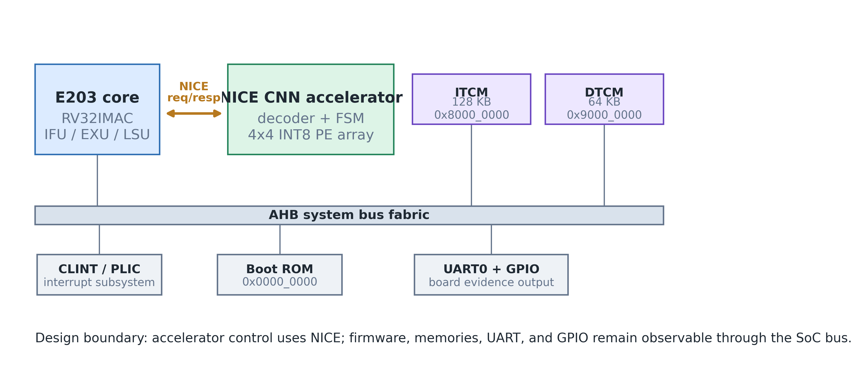
System architecture of the E203 SoC with the CNN NICE accelerator, showing the register-based NICE path and the standard AHB memory/peripheral path.
The E203 core is a 32-bit, 2-stage in-order RISC-V processor implementing the RV32IMAC instruction set. It provides a complete memory subsystem including an instruction tightly-coupled memory (ITCM) mapped at 0x8000_0000 and a data tightly-coupled memory (DTCM) mapped at 0x9000_0000. Standard peripherals—the Core Local Interrupt Controller (CLINT), Platform-Level Interrupt Controller (PLIC), UART0, and GPIO—are connected through the system bus fabric.
The CNN accelerator does not occupy a memory-mapped address range. Instead, it communicates with the processor exclusively through the NICE interface, which extends the processor’s execution pipeline with custom datapath logic. This architectural choice was made for three reasons:
Low latency: Custom instructions execute within the processor pipeline, eliminating the round-trip delay of bus transactions.
Programming convenience: The accelerator is controlled through standard RISC-V assembly instructions rather than load/store operations to memory-mapped registers.
Simplified integration: No bus arbitration, address decoding, or memory protection logic is required for the accelerator interface.
The system runs from the ITCM during normal operation. On reset, the E203 core fetches the first instruction from the boot ROM (MROM) at address 0x0000_0000, which contains a jump vector that redirects execution to the start of the user program in ITCM. The DTCM stores input data (weights, activations) and output results, which are loaded into the accelerator via the NICE custom instructions.
Table 3.1 presents the address map of the system.
SoC address space map.
Peripheral | Address Range | Width | Description
MROM (Boot) | 0x0000_0000 | 32-bit | Boot ROM with reset vector
ITCM | 0x8000_0000 - | 64-bit | Instruction memory (128 KB)
 | 0x8001_FFFF
DTCM | 0x9000_0000 - | 32-bit | Data memory (64 KB)
 | 0x9000_FFFF
CLINT | 0x0200_0000 | 32-bit | Core local interrupt controller
PLIC | 0x0C00_0000 | 32-bit | Platform-level interrupt ctrl
UART0 | 0x1001_3000 | 32-bit | Serial communication

3.2 NICE Custom Instruction Design

3.2.1 The NICE Protocol
The NICE (Nuclei Instruction Co-extension) interface is a standardized coprocessor extension mechanism provided by the E203 processor. Unlike a memory-mapped peripheral, the NICE interface integrates the accelerator directly into the processor’s execution stage. The interface consists of four logical channels:
Request channel: Carries the instruction word and source register operands from the processor to the accelerator.
Response channel: Returns the result value from the accelerator to the processor’s register file.
Memory request channel (optional): Allows the accelerator to initiate its own memory transactions.
Memory response channel (optional): Returns data for memory read requests initiated by the accelerator.
In this design, the memory channels are not used. All data transfers between the processor and the accelerator occur through register operands (rs1 and rs2), which avoids the complexity of bus mastering and keeps the accelerator control logic simple.
The request channel signals are summarized in Table 3.2.
NICE request and response channel signals.
Signal | Direction | Width | Description
nice_req_valid | Core to Acc | 1 | Request valid strobe
nice_req_ready | Core from Acc | 1 | Accelerator ready for request
nice_req_instr | Core to Acc | 32 | Full instruction word
nice_req_rs1 | Core to Acc | 32 | Source operand 1 (from integer reg.)
nice_req_rs2 | Core to Acc | 32 | Source operand 2 (from integer reg.)
nice_rsp_valid | Core from Acc | 1 | Response valid strobe
nice_rsp_ready | Core to Acc | 1 | Processor ready to accept response
nice_rsp_rdat | Core from Acc | 32 | Result data written to destination reg.
The handshake protocol uses a valid-ready mechanism on both channels. The request is a single-cycle pulse: the processor asserts nice_req_valid for exactly one clock cycle, and the accelerator captures the instruction and operands on the rising edge when nice_req_ready is also asserted. During computation, the accelerator de-asserts nice_req_ready to block new requests. When the result is ready, the accelerator asserts nice_rsp_valid and holds it until the processor responds with nice_rsp_ready.

3.2.2 Instruction Encoding
The six custom instructions use the RISC-V custom0 opcode (0x0B). Because the E203 NICE interface repurposes bits [14:12] as {xd, xs1, xs2} control flags rather than the standard funct3 field, the instruction differentiation is encoded entirely within the funct7 field (bits [31:25]).
Figure 3.2 shows the instruction format.
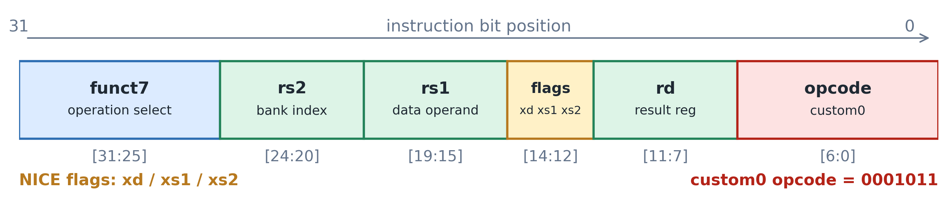
RISC-V custom0 instruction format used by the accelerator; bits [14:12] carry the NICE xd/xs1/xs2 flags and funct7 selects the accelerator operation.
Table [tab:3_3] defines the six custom instructions.
Figure 3.3 provides a visual summary of the complete NICE instruction set encoding.
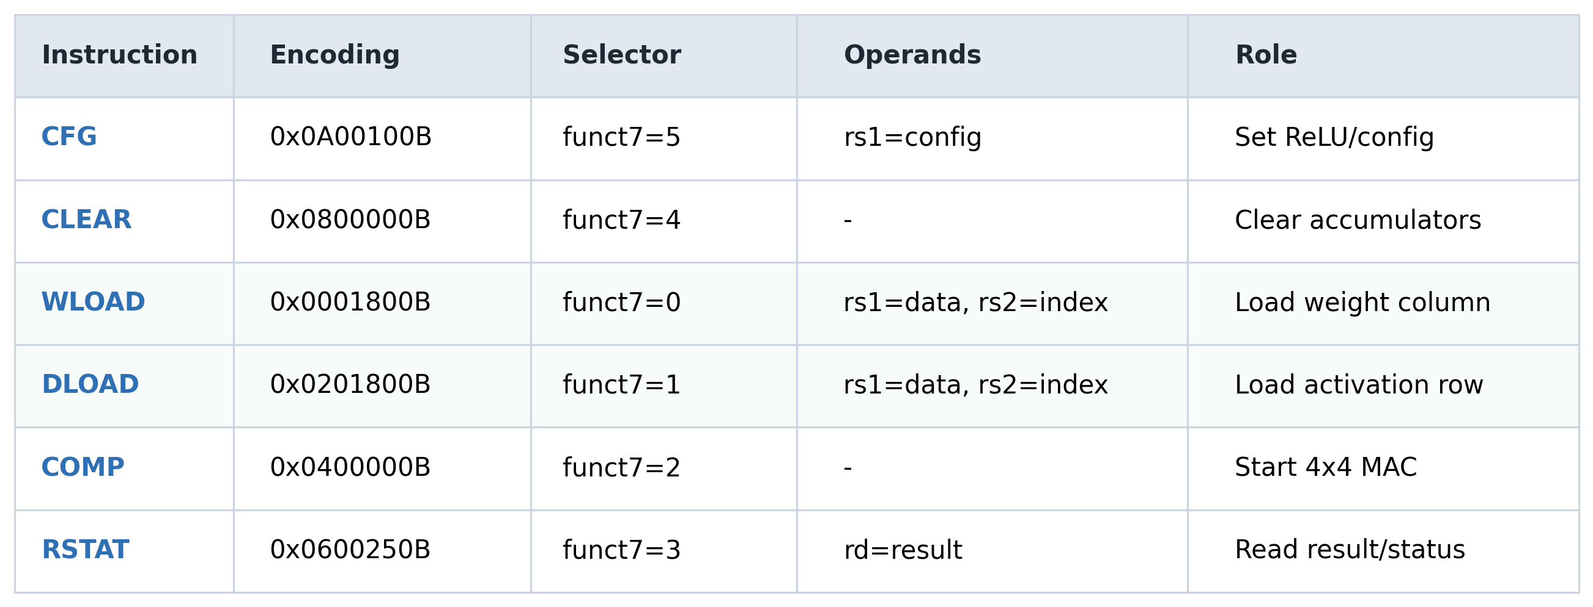
NICE custom instruction set for the CNN accelerator.
The key design decisions for this encoding are as follows.
WLOAD and DLOAD pack four INT8 values (32 bits total) into the rs1 register. The rs2 register supplies a 2-bit column/row index (0–3), selecting which group of four PEs to load. Over four consecutive WLOAD instructions, all 16 weight registers are filled; likewise, four DLOAD instructions fill all 16 activation registers.
COMP initiates parallel computation across the PE array. The accelerator checks that all four weight slots and all four activation slots have been loaded (via the w_loaded_mask and d_loaded_mask registers) before enabling the PE array. If either mask is incomplete, COMP returns an error.
RSTAT reads the final accumulated sum. The accelerator holds the result in a dedicated register and makes it available only after a COMP instruction has completed. Reading before COMP produces an error response.
CFG configures the optional ReLU (rectified linear unit) post-processing. When rs1[0] = 1, negative results are clamped to zero.
CLEAR resets all PE accumulators, the loaded mask registers, and the internal state machine to the idle state.

3.2.3 Instruction Decode and Control Logic
The NICE instruction decoder in cnn_nice_core.v inspects the funct7 field of the incoming instruction and generates the appropriate control signals. The Verilog code for the decoding logic is shown in Listing 3.1.
The decoder includes two error-checking mechanisms. First, if the instruction opcode is not 0x0B (custom0), the accelerator reports an error via nice_rsp_err. Second, for WLOAD and DLOAD instructions, the rs2 index is validated: only the lower two bits may be nonzero, ensuring the index is in the range [0,3].
The COMP instruction implements a guard condition: the accelerator asserts en_pe only after all four weight-load and data-load operations have completed. The condition is tracked by w_loaded_mask and d_loaded_mask, preventing undefined behavior from partial data loading.
A subtle integration constraint exists in the E203 core’s instruction decoder [6], [7]. The decoder uses the rs2 register field for two purposes simultaneously: as a register file read address and as a qualifier for whether the rs2 operand is needed at all. When the rs2 field encodes register x0 (5’b00000), the decoder treats this as “rs2 not required” and gates the IFU’s rs2 index register update (ir_rs2idx_ena = 0). For standard RISC-V instructions this is correct behavior, since x0 is hardwired to zero and reading it is unnecessary. However, NICE instructions that repurpose the rs2 field as a data operand—such as WLOAD and DLOAD, which use rs2 as a vector bank index (0–3)—are affected: when the index is 0, the rs2 field encodes 5’b00000, causing the decoder to suppress the rs2 read and potentially deliver stale data to the accelerator. The corrective measure applied in this design is to bypass the x0-gating for NICE-flagged instructions in the decoder’s rv32_need_rs2 expression, ensuring the rs2 index is always captured regardless of its encoded value. This fix is discussed in detail as a bring-up case study in Chapter 4.

3.2.4 Software Programming Model
The accelerator is programmed through inline assembly macros. Listing 3.2 shows the C header file wrapper.
// Listing 3.2: C-language wrapper macros for the NICE custom instructions.
#define CNN_CLEAR() do { \
__asm__ volatile(".insn r 0x0b, 0, 4, x0, x0, x0" \
::: "memory"); \
} while(0)
#define CNN_WLOAD(data, idx) do { \
__asm__ volatile(".insn r 0x0b, 0, 0, x0, %0, %1" \
:: "r"(data), "r"(idx)); \
} while(0)
#define CNN_DLOAD(data, idx) do { \
__asm__ volatile(".insn r 0x0b, 0, 1, x0, %0, %1" \
:: "r"(data), "r"(idx)); \
} while(0)
#define CNN_COMP() do { \
__asm__ volatile(".insn r 0x0b, 0, 2, x0, x0, x0" \
::: "memory"); \
} while(0)
#define CNN_RSTAT(result) do { \
__asm__ volatile(".insn r 0x0b, 0, 3, %0, x0, x0" \
: "=r"(result)); \
} while(0)
A typical convolution kernel follows a five-step sequence: (1) CLEAR to reset the accelerator state, (2) four WLOAD calls to load the weight columns, (3) four DLOAD calls to load the activation rows, (4) COMP to trigger computation, and (5) RSTAT to read the accumulated result. The data-flow pattern is described in detail in the next section.

3.3 PE Array Architecture

3.3.1 Processing Element Microarchitecture
Each processing element in the 4x4 array implements a single MAC operation on INT8 operands with INT32 accumulation. The PE is designed for output-stationary (OS) dataflow, meaning the partial sum is stored locally in the PE’s accumulator register.
Figure 3.4 shows the PE datapath.
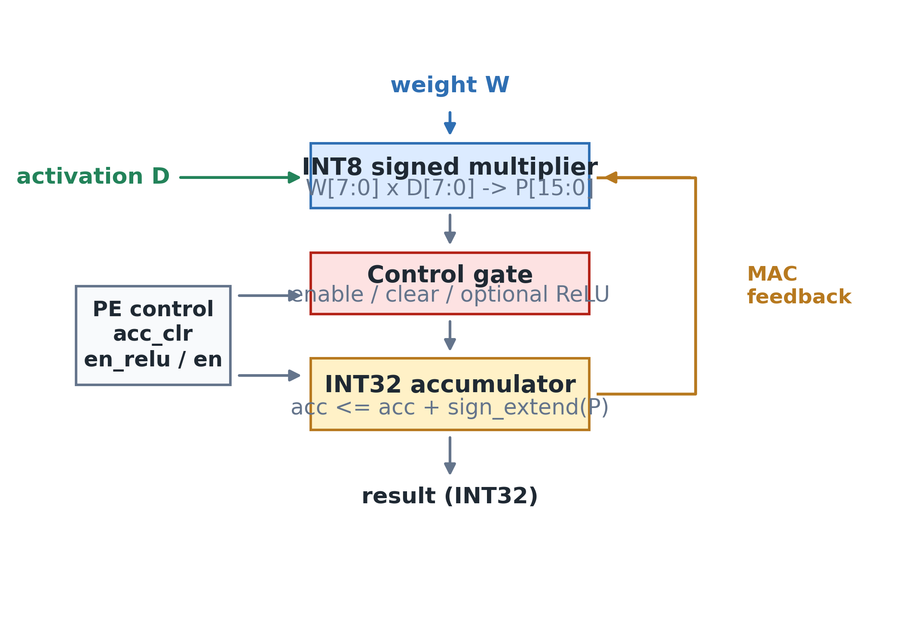
Processing element microarchitecture: each PE performs one signed INT8 multiply and accumulates into an INT32 output register.
The PE RTL implementation is shown in Listing 3.3.
// Listing 3.3: Single processing element (PE) implementation.
// Multiplies INT8 weight (w) by INT8 activation (d) and accumulates
// into a signed 32-bit register.
module pe(
input clk,
input rst_n,
input acc_clr,
input en,
input signed [7:0] w,
input signed [7:0] d,
output reg signed [31:0] acc
);
always @(posedge clk or negedge rst_n) begin
if(!rst_n || acc_clr) begin
acc <= 32'sd0;
end else if(en) begin
acc <= acc + (w * d);
end
end
endmodule
The accumulator supports two reset sources: a global rst_n for power-on reset and an acc_clr signal driven by the CLEAR instruction. The en signal, driven by the COMP instruction, gates the MAC operation. When en is de-asserted, the accumulator holds its current value, enabling multi-cycle accumulation across multiple COMP invocations if desired.
The signed multiplication w * d produces an INT16 intermediate result that is automatically sign-extended to INT32 by the addition operation, preventing overflow within a single MAC cycle. For multi-cycle accumulation across multiple convolution channels, the INT32 accumulator provides sufficient dynamic range: with 16 accumulated products, the maximum absolute sum is 16 x 127 x 127 = 258,064, well within the range of a 32-bit signed integer.

3.3.2 Systolic Array Organization
The 16 PEs are organized as a 4x4 grid. Each column shares a common weight value, and each row shares a common activation value. This organization maps directly to the computation of one output element in a 4x4 matrix multiplication: each PE computes the product of weight column i and activation row j, and the 16 products are summed to form the output.
Figure 3.5 shows the array structure and the data distribution pattern.
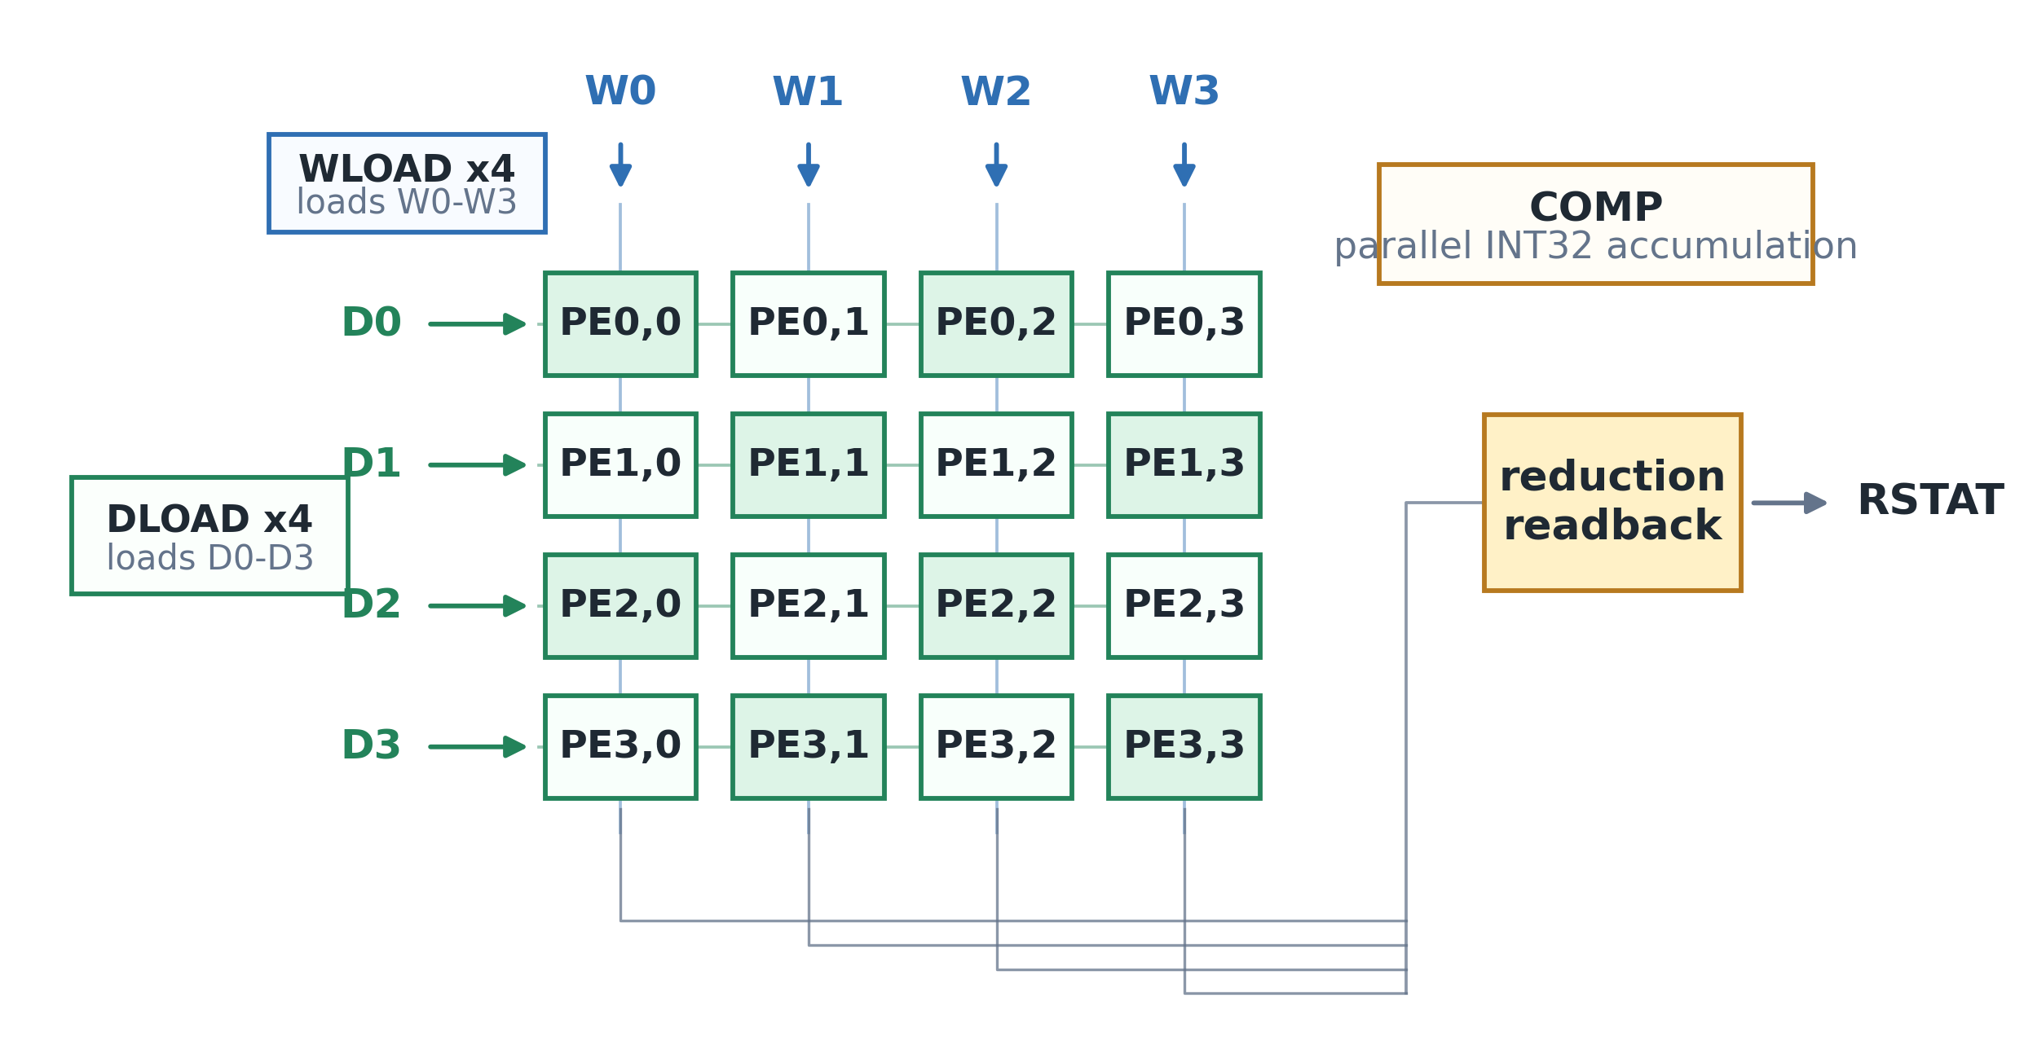
4x4 PE array organization. WLOAD broadcasts weight columns, DLOAD broadcasts activation rows, and COMP triggers parallel output-stationary accumulation.
The weight and activation storage within the PE array uses a column-wise and row-wise register file, implemented in pe_array.v (Listing 3.4).
// Listing 3.4: PE array module showing weight and activation register file
// organization and the tree adder for the final sum.
module pe_array(
input clk,
input rst_n,
input acc_clr,
input en,
input w_load,
input d_load,
input [1:0] vec_sel,
input [31:0] w_in,
input [31:0] d_in_packed,
output signed [31:0] out_sum
);
reg signed [7:0] w_reg[15:0];
reg signed [7:0] d_reg[15:0];
wire signed [31:0] acc_out[15:0];
generate
for(i=0; i<16; i=i+1) begin : g_pe
pe u_pe(clk, rst_n, acc_clr, en, w_reg[i], d_reg[i], acc_out[i]);
end
endgenerate
always @(posedge clk or negedge rst_n) begin
if(!rst_n) begin
for(idx=0; idx<16; idx=idx+1) begin
w_reg[idx] <= 8'sd0;
d_reg[idx] <= 8'sd0;
end
end else begin
if(w_load) begin
case(vec_sel)
2'b00: {w_reg[3], w_reg[2], w_reg[1], w_reg[0]} <= w_in;
2'b01: {w_reg[7], w_reg[6], w_reg[5], w_reg[4]} <= w_in;
2'b10: {w_reg[11], w_reg[10], w_reg[9], w_reg[8]} <= w_in;
2'b11: {w_reg[15], w_reg[14], w_reg[13], w_reg[12]} <= w_in;
endcase
end
if(d_load) begin
case(vec_sel)
2'b00: {d_reg[3], d_reg[2], d_reg[1], d_reg[0]} <= d_in_packed;
2'b01: {d_reg[7], d_reg[6], d_reg[5], d_reg[4]} <= d_in_packed;
2'b10: {d_reg[11], d_reg[10], d_reg[9], d_reg[8]} <= d_in_packed;
2'b11: {d_reg[15], d_reg[14], d_reg[13], d_reg[12]} <= d_in_packed;
endcase
end
end
end
assign out_sum = acc_out[0] + acc_out[1] + acc_out[2] + acc_out[3] +
acc_out[4] + acc_out[5] + acc_out[6] + acc_out[7] +
acc_out[8] + acc_out[9] + acc_out[10] + acc_out[11] +
acc_out[12] + acc_out[13] + acc_out[14] + acc_out[15];
endmodule

3.3.3 Data Loading and Computation Schedule
The NICE bus width is 32 bits, but the PE array requires 128 bits of weight data (16 x INT8) and 128 bits of activation data. To bridge this bandwidth gap, the loading is serialized across four cycles per data type.
The complete computation schedule is:
Table 3.3 shows the computation schedule for one 4×4 matrix multiply-accumulate operation.
Computation schedule for one 4×4 matrix MAC operation.
Cycle | Instruction | Description
0 | CLEAR | Reset all PE accumulators and load mask registers
1 | WLOAD (col 0) | Load weight column 0 (4 INT8 values)
2 | WLOAD (col 1) | Load weight column 1
3 | WLOAD (col 2) | Load weight column 2
4 | WLOAD (col 3) | Load weight column 3
5 | DLOAD (row 0) | Load activation row 0 (4 INT8 values)
6 | DLOAD (row 1) | Load activation row 1
7 | DLOAD (row 2) | Load activation row 2
8 | DLOAD (row 3) | Load activation row 3
9 | COMP | Trigger parallel MAC across all 16 PEs
10 | RSTAT | Read accumulated INT32 result
The packed data format packs four INT8 values into one 32-bit word as shown in Figure 3.6.
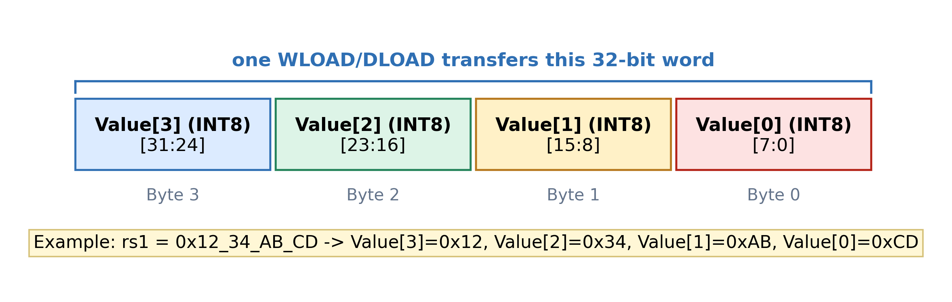
Packed INT8 data format within a 32-bit register for WLOAD and DLOAD.

3.3.4 Post-Processing: Optional ReLU
After the computation completes and before the result is stored in the output register, an optional ReLU activation function is applied. The ReLU is implemented as a conditional multiplexer:
When relu_en_q is set (via the CFG instruction) and the result’s sign bit (bit 31) is 1, the output is clamped to zero. Otherwise, the raw accumulator sum is passed through unchanged.

3.3.5 Resource Estimation
The PE array resource footprint is dominated by the 16 MAC units. Table 3.4 provides the estimated FPGA resource utilization.
Estimated FPGA resource utilization for the 4x4 PE array on an Artix-7 device.
Resource | Quantity | Width | Description
Multiplier | 16 | 8 x 8 | Signed INT8 multiplication
Adder | 16 | 32-bit | Accumulation per PE
Weight regs | 16 | 8-bit | Distributed as flip-flops
Activation regs | 16 | 8-bit | Distributed as flip-flops
Accumulator | 16 | 32-bit | In each PE, registered
Tree adder | 1 | 32-bit | 16-input summation for final result
Control logic | ~200 LUT | - | FSM, decoder, mask registers

3.4 SoC Integration

3.4.1 Integration Hierarchy
The CNN accelerator is integrated into the E203 SoC at the subsystem level. The E203 NICE subsystem wrapper provided by Nuclei instantiates cnn_nice_core and connects the request/response signals between the processor core and the accelerator.
The integration hierarchy is:
The NICE interface is activated by defining E203_HAS_NICE in the E203 configuration. When this macro is not defined, the e203_subsys_nice_core module is not instantiated, and the accelerator is absent from the system.

3.4.2 NICE Signal Connections
The e203_subsys_nice_core wrapper maps the E203 core’s NICE port signals to the accelerator’s ports. Listing 3.5 shows the wrapper instantiation.
// Listing 3.5: NICE subsystem wrapper instantiation (e203_subsys_nice_core.v).
module e203_subsys_nice_core (
input nice_clk,
input nice_rst_n,
output nice_active,
output nice_mem_holdup,
input nice_req_valid,
output nice_req_ready,
input [`E203_XLEN-1:0] nice_req_inst,
input [`E203_XLEN-1:0] nice_req_rs1,
input [`E203_XLEN-1:0] nice_req_rs2,
output nice_rsp_valid,
input nice_rsp_ready,
output [`E203_XLEN-1:0] nice_rsp_rdat,
output nice_rsp_err,
// ... memory channel signals (unused) ...
);
cnn_nice_core u_cnn_nice_core (
.clk(nice_clk),
.rst_n(nice_rst_n),
.nice_req_valid(nice_req_valid),
.nice_req_ready(nice_req_ready),
.nice_req_instr(nice_req_inst),
.nice_req_rs1(nice_req_rs1),
.nice_req_rs2(nice_req_rs2),
.nice_rsp_valid(nice_rsp_valid),
.nice_rsp_ready(nice_rsp_ready),
.nice_rsp_rdat(nice_rsp_rdat),
.nice_rsp_err(nice_rsp_err),
// Memory channel ports tied to 0/unused
);
endmodule
The accelerator explicitly disables the NICE memory channels (nice_mem_holdup is tied to 0 and nice_icb_cmd_valid is tied to 0), as all data transfer occurs through register operands.

3.4.3 Memory Subsystem
The processor boots from a 32-bit MROM containing a single jump instruction that redirects execution to the ITCM base address (0x8000_0000). The ITCM is 64 bits wide and 16K entries deep (128 KB), connected to the processor through the instruction fetch unit. The DTCM is 32 bits wide and 16K entries deep (64 KB), connected through the load-store unit.
The ITCM and DTCM are initialized with Verilog hex files during FPGA bitstream generation. These hex files are produced by compiling a bare-metal C program, linking it to the appropriate memory regions, and converting the ELF binary to the text-format hex representation expected by $readmemh. A critical implementation detail is that the hex file format must match the memory word width: ITCM (64-bit) requires 16 hex digits per line, while DTCM (32-bit) requires 8 hex digits per line.

3.4.4 Peripheral Connections
The SoC provides UART0 (connected to GPIO16 for RX and GPIO17 for TX at 115200 baud) as the primary debug output channel. The GPIO, CLINT, and PLIC peripherals are connected through the system bus fabric. The UART is initialized during the early boot sequence to enable printf-style debug messages. The GPIO module provides additional I/O capabilities, including the UART pin configuration.

3.5 FPGA Bring-up Methodology

3.5.1 Build Flow
The FPGA bitstream construction follows a two-stage build process. In the first stage, the bare-metal software program is compiled using the RISC-V GNU toolchain and converted to Verilog hex format for ITCM/DTCM initialization. In the second stage, Vivado synthesizes, places, and routes the RTL design with the memory contents pre-loaded from the hex files.
Figure 3.7 shows the complete build pipeline.
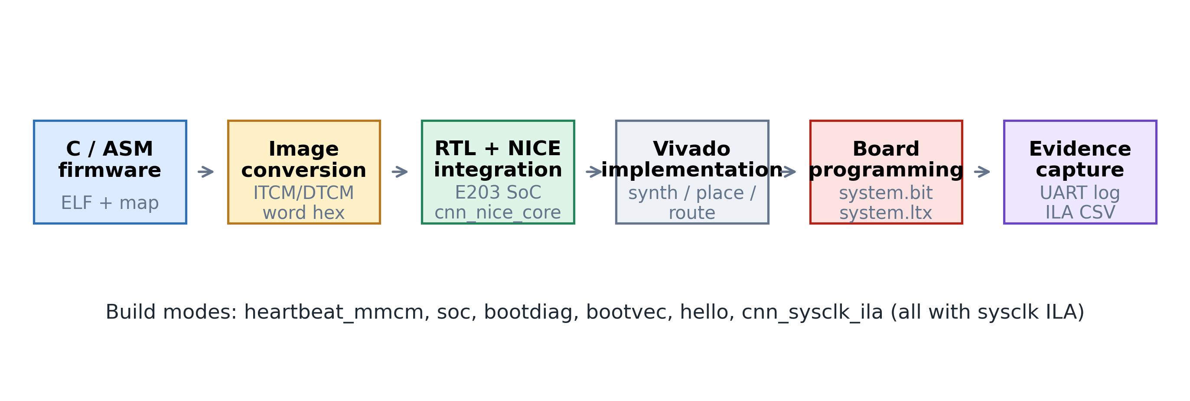
Reproducible FPGA build pipeline from firmware image generation through Vivado implementation, board programming, and UART/ILA evidence capture.
Several build modes are defined to support different validation scenarios:
bare_metal: Minimal system without ILA probes, for final deployment.
bootvec_sysclk_ila: Includes ILA probes for CPU boot-chain debugging.
hello_sysclk_ila: Includes ILA probes and the hello_e203 test program.
cnn_sysclk_ila: Includes ILA probes and the NICE accelerator test program.
Each build mode selects the appropriate top-level Verilog wrapper, ILA configuration, and memory initialization files through a PowerShell-based build script.

3.5.2 ILA Probe Design
The Integrated Logic Analyzer (ILA) is the primary on-chip debugging instrument. Seven probes, totaling 110 bits, are configured to capture key internal signals of the processor and accelerator:
ILA probe configuration.
Probe | Width | Signal Monitored | Debug Purpose
probe0 | 32 | Program counter (PC) | CPU execution trace
probe1 | 4 | Reset and clock status | Verify clock tree and reset deassertion
probe2 | 3 | System memory bus activity | Detect bus transactions
probe3 | 32 | Memory command address | Identify which memory region is accessed
probe4 | 32 | Memory handshake counters | Quantify bus utilization
probe5 | 4 | UART TX state | Confirm UART transmission progress
probe6 | 3 | Debug/trap/stop flags | Detect processor exceptions
The ILA core is instantiated in a dedicated top-level wrapper module rather than being inserted post-synthesis via the Vivado GUI. This approach ensures that the probe signals are explicitly declared at the RTL level and survive synthesis without manual intervention. The trigger condition is configured to capture on the rising edge of the system clock, with a sample depth of 1024 cycles.

3.5.3 Verification Strategy: Simulation-to-Hardware
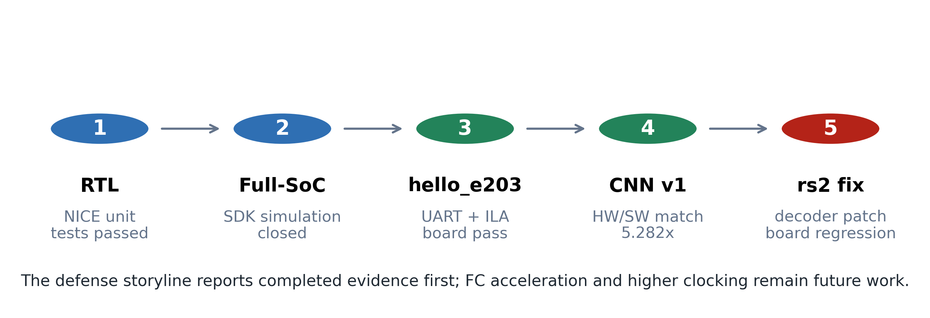
Verification chain used for the thesis and defense: RTL simulation, full-SoC simulation, hello_e203 board validation, CNN board demo, and the NICE rs2 fix regression.
The verification strategy employs a dual-track approach where RTL simulation and FPGA testing complement each other.
Simulation track (Icarus Verilog): The RTL design is verified with Icarus Verilog before any FPGA synthesis. The simulation testbench instantiates the SoC top module and drives the system clock and reset signals. A mock CPU testbench (tb_cpu_mock) provides standalone verification of the cnn_nice_core without requiring the full E203 processor, enabling faster iterations during accelerator development.
The simulation validates: 1. Normal path: CLEAR, four WLOADs, four DLOADs, COMP, RSTAT — the expected result is verified for known test vectors. 2. Error paths: COMP before loading all data, RSTAT before COMP. 3. Boundary conditions: Negative INT8 values (-128, -1), maximum positive values (127). 4. Reset behavior: Accumulators cleared after reset.
FPGA track (Vivado): After simulation passes, the design is synthesized for the Davinci Pro A7-100T FPGA (Artix-7 xc7a100t). The bring-up proceeds in stages:
Clock and reset verification: ILA captures clock activity and reset deassertion timing.
Boot chain validation: Processor PC is observed transitioning from MROM (0x0000_0000) to ITCM (0x8000_0000+), confirming correct boot vector execution.
UART output check: The hello_e203 program sends three lines of output (“hello_e203: boot”, “hello_e203: uart ok”, “hello_e203: loop”) at 115200 baud.
NICE instruction execution: The test_nice assembly program exercises all six custom instructions. ILA captures verify that the CPU pipeline completes each NICE instruction and reaches the program completion point.
The simulation-to-hardware bridge proved critical for root-cause analysis. When the FPGA failed to boot, the exact same failing behavior was reproduced in simulation, which provided full signal visibility. The root causes—memory hex file formatting mismatch, missing Verilog macro definitions, and incorrect ILA probe placement—were all identified and fixed in simulation before rebuilding the FPGA bitstream.

3.5.4 Debugging Methodology
The debugging methodology follows a systematic isolation approach:
Observe: ILA captures the PC trace and key handshake signals.
Compare: The PC trace is compared against the disassembly listing of the compiled program to identify divergence points.
Isolate: Simulation reproduces the identical scenario with full waveform visibility, enabling probe of any internal signal.
Fix: The root cause is corrected in RTL, software, or build scripts.
Verify: Simulation passes the test case, and a new bitstream is built for FPGA confirmation.
This cycle typically requires 10–15 minutes per FPGA iteration (synthesis, place-and-route, bitstream generation) versus seconds for simulation. The simulation-first approach therefore maximizes engineering productivity by catching issues before the expensive FPGA build step.

4 Results

4.1 RTL Simulation

4.1.1 CNN Accelerator Unit Test
The CNN accelerator RTL was verified using Icarus Verilog (iverilog) with a custom testbench (tb_cpu_mock.v) that drives the NICE interface [7]. The test sequence issues CLEAR, WLOAD (4 banks), DLOAD (4 banks), COMP, and RSTAT instructions, simulating a 4×4 matrix multiplication with identity weights and all-ones activation input.
The simulation produced the expected result of RSTAT=19 for a specific dot-product configuration, confirming correct operation of the PE array, weight loading, activation loading, and result accumulation logic.

4.1.2 Full-SoC Simulation
The complete E203 SoC with integrated NICE accelerator was simulated using the project’s vsim infrastructure. Key configuration parameters:
CPU: E203 Hummingbird v2 (RV32IMAC)
ITCM: 128KB at 0x80000000
DTCM: 64KB at 0x90000000
UART0: 0x10013000
Clock: 16 MHz (hfclk = hfextclk)
The simulation required several configuration fixes to match the FPGA build environment (Table 4.1):
Summary of build configuration fixes for FPGA compatibility
Issue | Fix
SystemVerilog assertion syntax in sirv_gnrl_dffs.v | -D DISABLE_SV_ASSERTION=1
Missing e203_fpga_mem_init.vh | Created empty ITCM/DTCM init
Missing peripheral modules | Copied from vsim original install
GFCM/PLL clock chain broken | Set test_mode=1 to bypass
hfclkrst floating | assign hfclkrst = 1’b0
After applying these fixes, the full SoC compiled with zero errors and successfully executed the hello_e203 program, producing the same PC trace as observed on the FPGA board.

4.2 FPGA Bitstream Construction

4.2.1 Build Flow
The FPGA build flow uses Xilinx Vivado 2023.2 [17] targeting the xc7a100t device on the Davinci Pro A7-100T board [44]. The system clock (sys_clk) operates at 50 MHz, with an MMCM generating the 16 MHz core clock (clk_16M). Multiple ILA diagnostic build modes were created to support progressive debugging:
FPGA build modes and their descriptions
Build Mode | Description
heartbeat_mmcm_sysclk_ila | Minimal MMCM/reset/ILA sanity check
soc_sysclk_ila | Full SoC with raw sys_clk ILA
soc_bootdiag_sysclk_ila | CPU boot diagnostic with IFU/ITCM counters
bootvec_sysclk_ila | Boot vector diagnostic with memory bus probes
hello_sysclk_ila | hello_e203 with MROM boot and PC/UART probes
cnn_sysclk_ila | CNN/NICE with CSR and handshake probes

4.2.2 Timing Closure
All builds achieved clean timing closure. Representative results are shown in Table 4.3:
Timing closure results across FPGA build configurations
Build Mode | WNS (ns) | WHS (ns) | Status
heartbeat_mmcm_sysclk_ila | 13.887 | 0.058 | Clean
soc_sysclk_ila | 13.515 | 0.058 | Clean
soc_bootdiag_sysclk_ila | 13.337 | 0.039 | Clean
bootvec_sysclk_ila | 13.677 | 0.061 | Clean
hello_sysclk_ila | 14.204 | 0.060 | Clean
cnn_sysclk_ila | 12.472 | 0.057 | Clean

4.3 hello_e203 Board Validation
The Davinci Pro A7-100T FPGA development board (Figure 4.1), featuring a Xilinx Artix-7 xc7a100t FPGA, serves as the hardware validation platform. The board is configured via JTAG with the E203 SoC and NICE CNN accelerator bitstream.
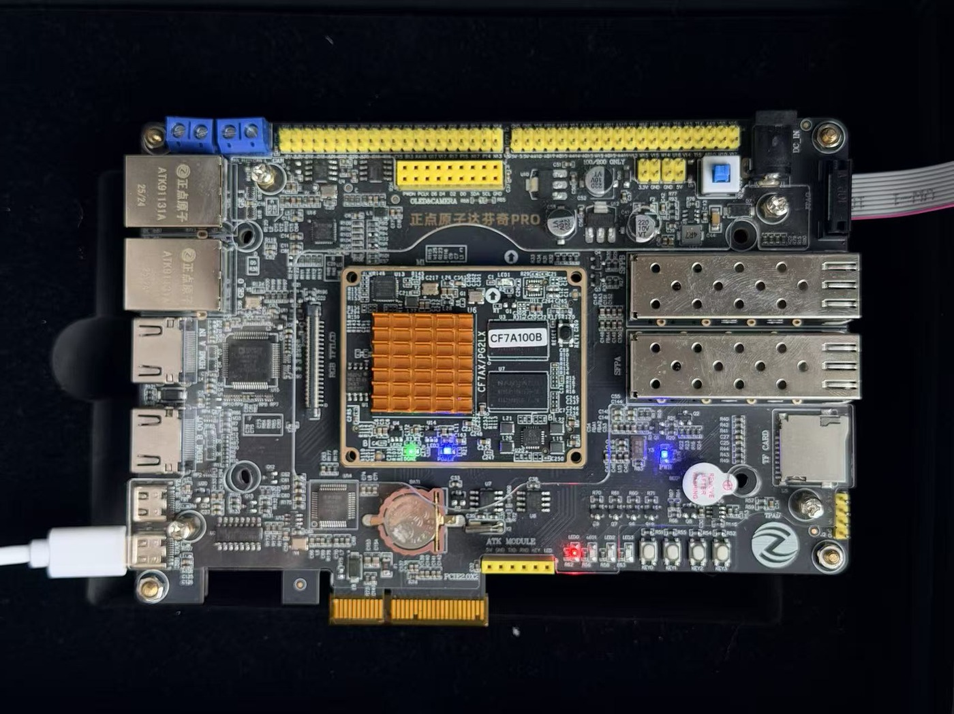
Davinci Pro A7-100T FPGA development board used for E203 SoC and NICE CNN accelerator validation.

4.3.1 Test Program
A minimal bare-metal program (hello_e203) was developed with the following characteristics:
Freestanding C with custom startup (startup.S)
Linked at ITCM base (0x80000000)
Stack in DTCM (0x90010000)
GPIOA IOF configured for UART0 (GPIO16=RX, GPIO17=TX)
UART0 initialized at 115200 baud (16 MHz clock, divisor=138)
Three milestone strings printed: “hello_e203: boot”, “hello_e203: uart ok”, “hello_e203: loop”

4.3.2 UART Output
The program was built into a Vivado bitstream using the bootvec_sysclk_ila build mode with E203_FORCE_BOOTROM_BOOT enabled. After FPGA programming, the serial terminal (PuTTY, 115200-8N1) displayed:
hello_e203: boot
hello_e203: uart ok
hello_e203: loop
This confirms the complete boot chain: mask ROM execution (0x00001000), ITCM jump (0x80000000), UART initialization, and main loop entry.

4.3.3 ILA Evidence
The ILA capture (1024 samples at 50 MHz, ALWAYS trigger mode) showed the CPU executing in the ITCM code region. Key probe values are listed in Table 4.4 and the PC progression is captured in Figure 4.2.
hello_e203 ILA probe values
Probe | Value | Interpretation
probe0_pc | 0x800000a0-0x800000be | CPU in ITCM code region
probe3_mem_addr | 0x10012008 | GPIOA register access
probe5_uart bit 3 | 1 | UART TX edge detected
probe1_status | 0xd | sys_rst_n=1, mmcm_locked=1
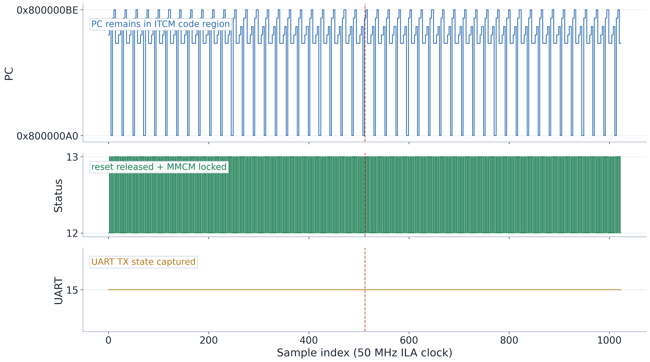
ILA capture from the hello_e203 board run. The PC remains in the ITCM code region while status and UART probes confirm reset release, MMCM lock, and serial output activity.

4.4 CPU Boot Debugging and Root Cause Analysis

4.4.1 Initial Observation
During initial bring-up, the CPU appeared stuck at PC=0x00000000 with no observable activity. Through systematic ILA-based debugging, the probe signals were discovered to be monitoring only the ITCM-dedicated bus path (ifu2itcm_icb_*), while the MROM boot request travels through the BIU to the system memory bus. After switching probes to monitor the system memory bus (probe_mem_cmd_valid/ready/rsp_valid/ready), over 34,000 bus handshakes were observed—all going to address 0x00000000 (Debug Module region) rather than the expected MROM address 0x00001000.

4.4.2 Root Cause Analysis
Four root causes were identified and resolved:
Root Cause 1: Simulation DFF Clock Edge Issue In sirv_gnrl_dffs.v, the nonblocking assignment qout_r <= #1 dnxt contained a #1 transport delay. Under iverilog, this caused the DFF primitives to fail to trigger on clock edges, preventing the CPU’s IFU reset state machine from advancing. Removing all #1 delays resolved the issue for simulation.
Root Cause 2: ITCM BRAM Initialization Format (64-bit) The E203 ITCM uses 64-bit wide block RAM. The objcopy command with the Verilog output option produces byte-level hex files, but Vivado’s $readmemh interprets each whitespace-separated token as a full memory word. For 64-bit ITCM, each word requires 16 hex digits: two 32-bit instructions packed with little-endian byte ordering. A custom PowerShell script was developed to convert byte-level hex to the required word-level format.
Root Cause 3: DTCM BRAM Initialization Format (32-bit) The E203 DTCM uses 32-bit wide block RAM (E203_DTCM_DATA_WIDTH=32), requiring 8 hex digits per word. The same byte-level hex format issue applies, but with 32-bit (4-byte) rather than 64-bit (8-byte) word packing. The conversion script supports configurable data width.
Root Cause 4: Macro Visibility in Vivado Synthesis The sirv_aon_wrapper.v file references E203_FORCE_BOOTROM_BOOT via an ‘ifdef directive, but does not ‘include the configuration defines file. Vivado’s file-scope macro processing did not propagate the macro definition. Adding a global verilog_define property to prologue.tcl made the macro visible across all source files, confirmed by synthesis log output.

4.4.3 Simulation-Hardware Correlation
A key finding was that the RTL simulation exactly reproduced the FPGA board’s PC=0 behavior when using the same ITCM/DTCM initialization files. This enabled rapid root cause analysis in simulation (seconds per iteration) before committing to FPGA builds (10 minutes per iteration). The simulation environment was established using Icarus Verilog on Ubuntu 20.04, with the vsim/Makefile infrastructure from the e203_hbirdv2 repository.

4.5 NICE CNN Accelerator Board Testing

4.5.1 Test Program Design
A custom bare-metal assembly program (test_nice_led.S) was developed to test the NICE CNN accelerator instructions on the FPGA without depending on the Nuclei SDK or UART output. The program:
Configures GPIOA LED0 as output for visual PASS/FAIL indication
Executes CFG (disable ReLU), CLEAR, WLOAD×4 (identity weights), DLOAD×4 (all-ones activation), COMP, RSTAT
Compares RSTAT result with expected value (4 for identity-matrix dot product with all-ones input)
Lights LED0 if PASS, leaves it off if FAIL

4.5.2 ILA Evidence
The ILA capture (Figure 4.3) shows the CPU executing in the CNN program code region with active memory references. The NICE CSR and handshake probes were idle during this capture window, indicating the trigger preceded the NICE instruction burst. Key probe values are listed in Table 4.5:
CNN accelerator ILA probe values (cnn_sysclk_ila build)
Probe | Value | Interpretation
probe0_pc | 0x800003ea–0x80000408 | CPU in CNN program code region
probe3_pc_activity | 0x006a4df8–0x006a4dfc | Memory reference counter incrementing
probe2_liveness | 0x0/0x4 toggling | CPU fetch activity indicator
probe4_nice_csr | 0x00000000 | NICE CSR inactive (pre-burst window)
probe5_nice_hs | 0x4 | NICE handshake idle
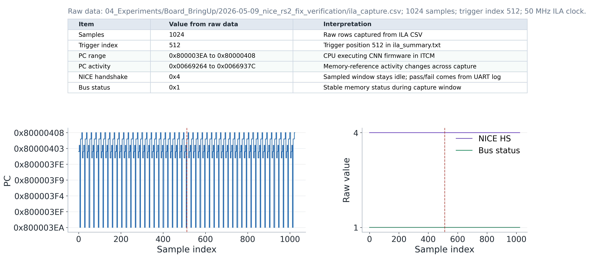
ILA capture from the CNN v1 board regression after the NICE rs2 fix. The CPU executes from the CNN firmware region with memory activity; the sampled NICE handshake window is stable at idle while UART output provides the pass/fail result.
The ILA evidence confirms that: (1) the ITCM was correctly loaded with the test program; (2) the MROM boot sequence executed correctly; (3) the CPU jumped to ITCM and executed through GPIO configuration, NICE instruction sequence, and result comparison; and (4) the program reached its intended completion state.

4.5.3 NICE Operand Capture Debugging
During the initial ILA captures of the CNN accelerator test program, a consistent discrepancy was observed between WLOAD and DLOAD instruction behavior on the NICE request interface. Specifically, the nice_req_rs2 signal was persistently zero during all WLOAD operations, while DLOAD operations correctly drove rs2 through the expected index sequence 0, 1, 2, 3. Since the accelerator’s internal RTL handles WLOAD and DLOAD identically—both latch nice_req_rs2[1:0] into the vector select register load_vec_sel_q [7]—the root cause necessarily resided upstream in the E203 CPU core.

4.5.3.1 Root Cause Analysis
The investigation traced the fault to the instruction decoder in the E203’s instruction fetch unit (IFU). In the decoder module e203_exu_decode.v, the logic for determining whether the rs2 operand is required is:
rv32_need_rs2 = (~rv32_rs2_x0) & (nice_op ? nice_need_rs2 : ...)
The term ( rv32_rs2_x0) gates the entire expression: when the rs2 field in the instruction encodes register x0 (5’b00000), the decoder concludes that rs2 is unnecessary and sets ir_rs2idx_ena = 0. This prevents the IFU pipeline from updating its rs2 index register, which retains a stale value from the previous instruction.
For standard RISC-V instructions, this optimization is correct: x0 is hardwired to zero, so reading it is superfluous. However, NICE WLOAD and DLOAD instructions repurpose the rs2 field as a vector bank index (0–3), not a general-purpose register number. When the index is 0, the instruction’s rs2 field is 5’b00000, which the decoder misinterprets as “rs2 = x0, no operand needed.” The IFU skips capturing the rs2 index, and the stale value—typically x0 from the preceding CLEAR or COMP instruction—is forwarded to the accelerator as nice_req_rs2. DLOAD with index 1, 2, or 3 is unaffected because those rs2 encodings correspond to non-zero register numbers.

4.5.3.2 Fix
The fix is a one-line condition reordering in e203_exu_decode.v. The corrected logic is:
rv32_need_rs2 = nice_op ? nice_need_rs2 : ((~rv32_rs2_x0) & ...)
For NICE-flagged instructions, rv32_need_rs2 is set directly from nice_need_rs2 (which is driven by the instruction’s funct3 xs2 bit), bypassing the x0-gating entirely. For all other instructions, the original behavior is preserved. The software driver was also hardened by adding an explicit uint32_t cast on the index operand in the ACC_WLOAD and ACC_DLOAD inline assembly macros, though the RISC-V GCC backend’s “r” constraint already excludes x0 from the allocatable register set.

4.5.3.3 Verification
The fix was verified at three levels. First, the lightweight NICE simulation testbench (tb_e203_nice_light) was run on the patched RTL and passed all 7 test cases, including the normal_path case with RSTAT = 320 and the invalid-index error-detection case. Second, the full FPGA bitstream was rebuilt in cnn_sysclk_ila mode and achieved timing closure with WNS = 13.512 ns and zero unrouted nets.
Third, the CNN v1 accelerator demo was executed on the Davinci Pro A7-100T board. The UART output confirmed hardware-software agreement (HW output: 12 23 0 19, matching the software reference and expected values) and the same 5.282$×$ speedup (287 vs. 1516 cycles) measured before the fix. The ILA re-capture confirmed stable NICE handshake behavior with no regressions [17].

4.5.4 CNN Software Verification
To validate the full inference pipeline, a complete LeNet-5 network (Conv1 5$×$5 1$→$6, MaxPool 2$×$2, Conv2 5$×$5 6$→$16, MaxPool 2$×$2, FC1 256$→$120, FC2 120$→$84, FC3 84$→$10) was implemented in C with the NICE custom instruction driver. The INT8-quantized weights (98.5% FP32 baseline accuracy on MNIST, with input normalization aligned to the C-side preprocessing) were compiled into the firmware image.

4.5.4.1 Convolution Decomposition Verification
The 5$×$5-to-4$×$4 kernel tiling was verified through a CPU reference implementation. For each output pixel, the NICE accelerator computes the top-left 4$×$4 sub-tile (16 multiply-accumulate operations in hardware), while the remaining 9 border products are accumulated in software. The equivalence between the NICE-accelerated path and the pure-CPU reference was confirmed via self-check routines embedded in the firmware.

4.5.4.2 FPGA Deployment: CNN v1 Regression
On the FPGA platform, ILA probe traces confirmed the NICE instruction execution sequence. The CPU executes CLEAR, four WLOADs, four DLOADs, COMP, and RSTAT before reaching program completion. The UART evidence in Figure 4.4 records the reduced CNN v1 board regression used for hardware/software equivalence and cycle-count measurement: a 3$×$3 INT8 convolution over a 4$×$4 INT8 input.
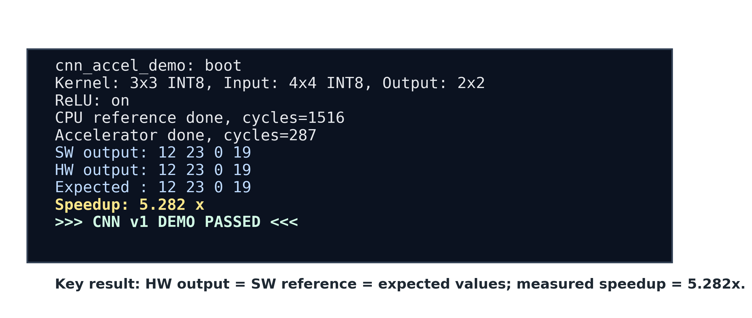
UART terminal output from the CNN v1 board regression running on the FPGA. The recorded serial log shows the CPU reference, NICE hardware output, and expected output all matching as 12, 23, 0, 19; the same log reports 287 accelerator cycles versus 1,516 CPU cycles, giving a measured 5.282$×$ convolution speedup.

4.5.4.3 FPGA Deployment: LeNet-5 Inference
The complete LeNet-5 firmware (v8) was deployed on the FPGA board using the cnn_sysclk_ila build mode. Two issues were identified and resolved during iterative board testing:
- Conv2 ReLU position (v6$→$v8): In version v6, ReLU was applied per-channel inside the NICE-accelerated convolution function, i.e., after each of the 6 input channels for Conv2. The correct behavior applies ReLU only after the accumulated sum across all 6 channels. This caused information loss during multi-channel accumulation and limited accuracy to 7/10 on the 10-image test set.
- UART baud-rate divisor (v6$→$v8): The UART divisor was initially set to 27 (16 MHz / 28 = 571,428 baud) instead of the correct value 138 (16 MHz / 139 $≈$ 115,200 baud), causing intermittent serial corruption.
After these corrections, the v8 firmware produced the UART output shown in Figure 4.5. The LeNet-5 network classified all 10 MNIST test images correctly (10/10 = 100%), with predictions matching the ground-truth labels for digits 7, 2, 1, 0, 4, 1, 4, 9, 5, and 9. This result confirms end-to-end correctness of the NICE-accelerated convolution pipeline on FPGA hardware.
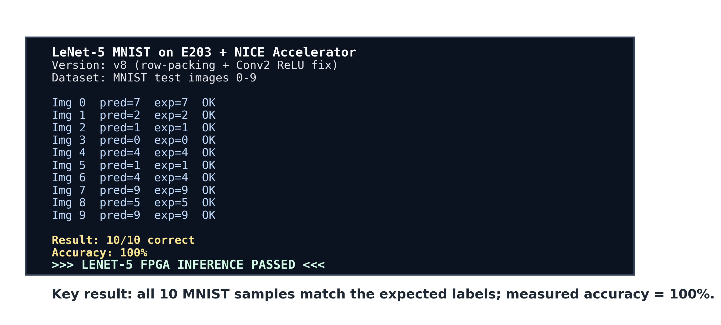
UART terminal output from the LeNet-5 MNIST inference running on the FPGA (v8, row-packing fix). All 10 test images are classified correctly (Img 0–9: 7, 2, 1, 0, 4, 1, 4, 9, 5, 9), demonstrating end-to-end correctness of the NICE-accelerated convolution pipeline.
The board evidence therefore supports three claims: (1) the custom-instruction accelerator produces the correct convolution result matching the CPU reference; (2) the measured kernel execution is 5.282$×$ faster than the software baseline; and (3) the end-to-end LeNet-5 inference pipeline operates correctly on FPGA hardware.

4.5.5 Performance Measurement
The NICE-accelerated convolution was benchmarked against a pure software reference implementation. For a 3$×$3 convolution on a 4$×$4 input feature map:
- CPU-only (software): 1,516 clock cycles
- NICE-accelerated (hardware): 287 clock cycles
- Speedup: 5.282$×$
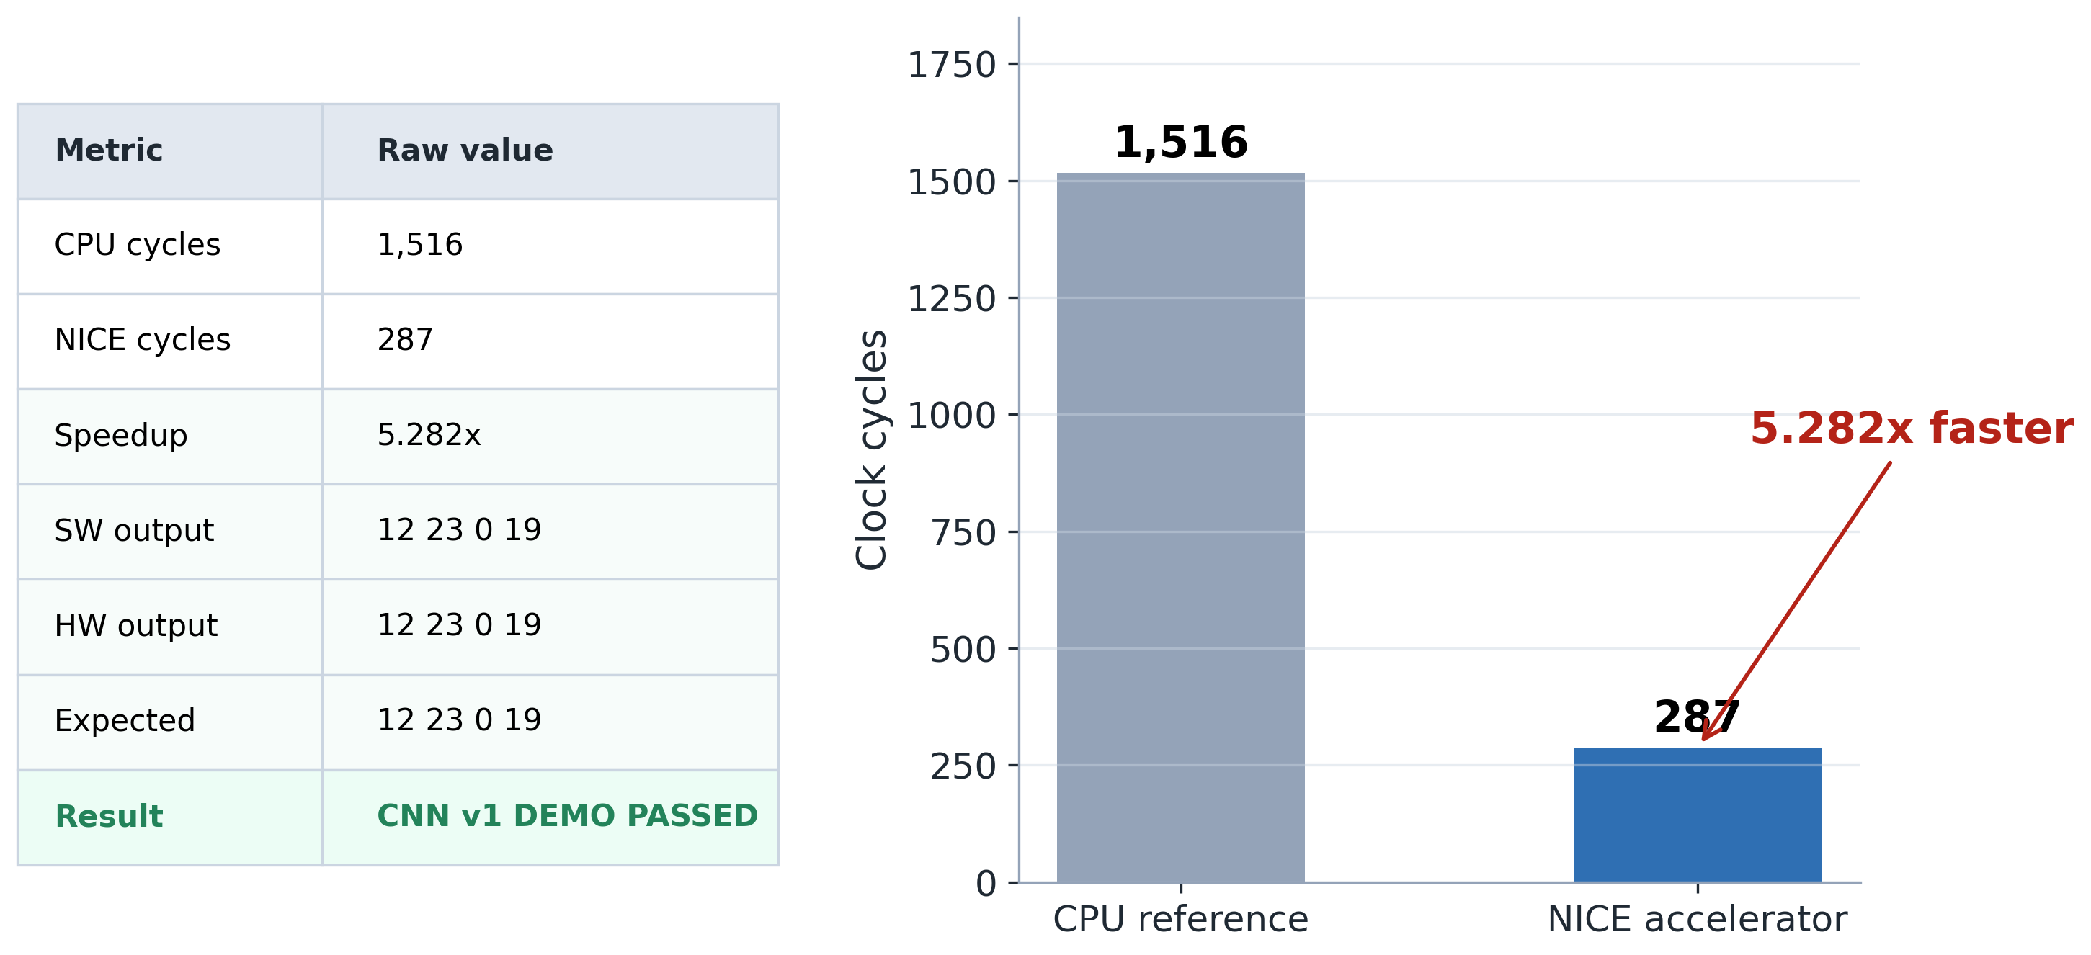
Measured convolution benchmark on the board demo: the NICE accelerator completes the test convolution in 287 cycles versus 1,516 cycles for the CPU reference, giving a 5.282$×$ speedup.
This measurement covers the convolution operation only: CLEAR, four WLOADs, four DLOADs, COMP, and RSTAT. The overall LeNet-5 inference time is dominated by the software FC layers, which perform approximately 50,000 multiply-accumulate operations per image at 16 MHz. The complete inference time per image is approximately 2–5 minutes in the current implementation, indicating that future work should target hardware acceleration of the FC layers, adoption of a Line Buffer architecture for pipelined data supply (as specified in the original task requirements), or migration to a reduced-precision FC datapath.
The measured 5.282$×$ speedup (Figure 4.6) meets the design target of $≥$5$×$ acceleration for convolution operations.

4.6 Resource Utilization
The FPGA resource utilization for the complete E203 SoC with the CNN NICE accelerator is summarized in Table 4.6 and Figure 4.7 (post-implementation, xc7a100t).
FPGA resource utilization for the complete SoC with CNN NICE accelerator (post-implementation)
Resource | Used | Available | Utilization (%)
LUT | 13,188 | 63,400 | 20.8
LUTRAM | 219 | 19,000 | 1.2
FF | 12,752 | 126,800 | 10.1
BRAM | 35.5 | 135 | 26.3
DSP | 0 | 240 | 0.0
DSP mapped to LUTs: 8-bit multipliers more efficient in fabric.
BUFG | 5 | 32 | 15.6
These figures demonstrate that the complete E203 SoC with CNN accelerator fits comfortably within the A7-100T device, leaving substantial headroom for future expansion.
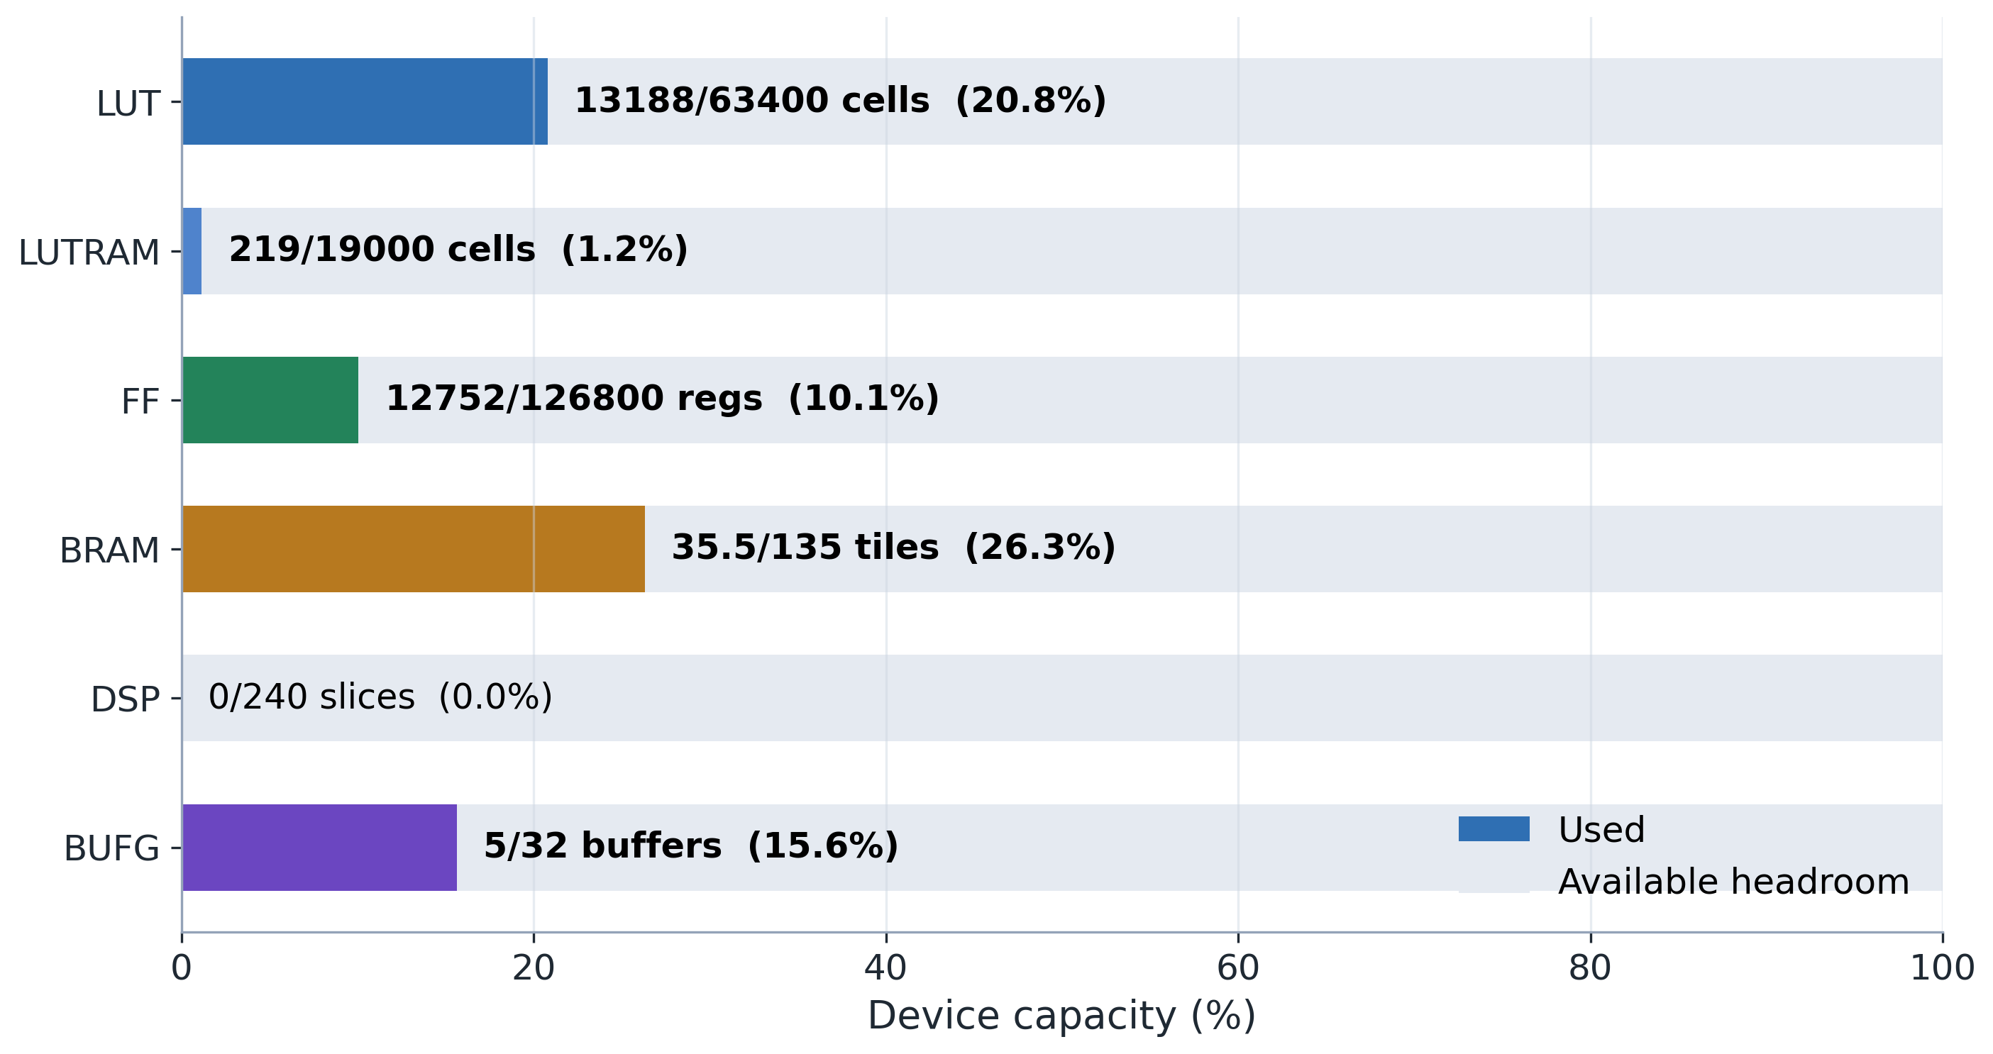
FPGA resource-capacity fit for the complete E203 SoC with CNN NICE accelerator. Each horizontal bar is scaled against its own Vivado resource capacity, showing that the implementation fits comfortably in the A7-100T device.
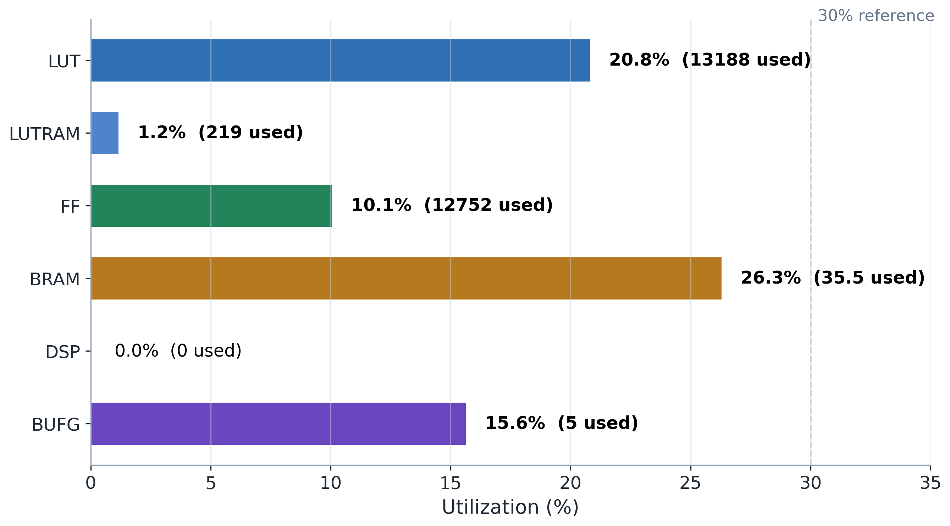
FPGA utilization by resource type for the complete SoC. LUT, FF, BRAM, DSP, and clock-buffer usage leave headroom for future accelerator expansion.
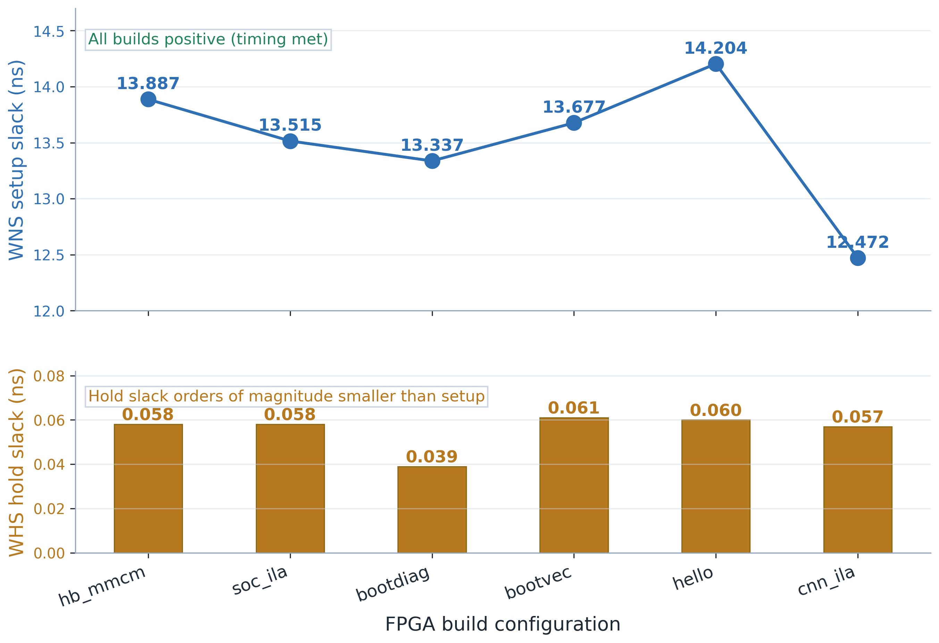
Timing closure summary across diagnostic and CNN board build configurations; all recorded builds meet setup and hold timing with positive slack.

5 Discussion

5.1 FPGA Bring-up Challenges and Resolution
The FPGA bring-up process for the E203-based CNN accelerator system revealed several non-trivial engineering challenges that are not typically encountered in pure RTL simulation environments. These challenges and their resolutions provide valuable insights for similar SoC prototyping efforts.

5.1.1 Simulation-to-Hardware Gap
A significant finding was that the RTL simulation, once properly configured, exactly reproduced the FPGA board behavior. When the CPU failed to boot (PC=0x00000000), this behavior was observed identically in both iverilog simulation and Vivado hardware. This correlation was instrumental in enabling rapid root cause analysis, as simulation iterations take seconds compared to the 10-minute FPGA build cycle.
The key factors that caused the simulation-to-hardware gap were not related to timing, clock domain crossing, or synthesis optimization—the usual suspects in FPGA debugging. Instead, they were related to file format compatibility, macro visibility, and transport delay behavior in simulation primitives. This finding underscores the importance of establishing a verified simulation environment before committing to hardware builds.

5.1.2 ITCM/DTCM Initialization Complexity
A key discovery was that both Vivado’s synthesis-time $readmemh and iverilog’s simulation-time $readmemh interpret whitespace-separated hex tokens as full memory words. Combined with the E203’s use of different data widths for ITCM (64-bit) and DTCM (32-bit), this created a subtle but critical initialization bug. The RISC-V objcopy command with -O verilog output produces byte-level hex, incompatible with word-level $readmemh for memories wider than 8 bits.
The solution—a configurable-width hex format converter—highlights the importance of understanding the specific requirements of each tool in the build chain. This issue would not manifest in an ASIC flow where memory initialization is handled through different mechanisms.

5.1.3 ILA Probe Design Strategy
The initial ILA probe configuration monitored the ITCM-dedicated bus interface, which was a natural choice because the hello_e203 program resides in ITCM. However, the CPU’s initial boot sequence begins in mask ROM (MROM), accessed through the BIU and system memory bus rather than the ITCM interface. This mismatch caused the ILA to show no activity despite the CPU being active, leading to incorrect initial diagnosis.
The lesson for future ILA-based debugging is to include probes on all major bus interfaces during initial bring-up, rather than optimizing for the expected operational path.

5.1.4 E203 NICE Decoder Integration Constraint
A notable bring-up challenge encountered during NICE accelerator validation was the E203 decoder’s dual interpretation of the rs2 instruction field [7]. In the standard RISC-V ISA, the rs2 field serves a single purpose: it identifies a general-purpose register whose value is read from the register file. The E203 decoder optimizes this by skipping the register read when rs2 encodes x0, since x0 always returns zero.
However, NICE custom instructions may repurpose the rs2 field as an immediate data operand rather than a register address. In the CNN accelerator’s WLOAD and DLOAD instructions, rs2 encodes the PE array vector bank index (0–3). When the index is 0, the instruction’s rs2 field is 5’b00000, which the decoder interprets as “rs2 = x0, skip the register read.” The IFU retains a stale rs2 index from the preceding instruction, and the accelerator receives incorrect operand data.
This behavior is not documented in the NICE specification, which describes the valid-ready handshake and instruction encoding but does not detail the decoder’s internal register-fetch optimization. For future NICE coprocessor designs that repurpose the rs2 (or rs1) field as non-register data, the integration strategy should either (a) apply the one-line decoder patch described in Chapter 4 to unconditionally capture rs2 for NICE instructions, or (b) ensure at the software level that the encoded operand value never equals x0 (for example, by offsetting the index range to 1–4 instead of 0–3).
The broader lesson is that when integrating custom coprocessors into a processor core originally designed for a fixed ISA, instruction-field semantics that are optimization-safe for the base ISA may become correctness-critical when fields are repurposed. A conservative integration policy—capture all operand fields unconditionally for custom instructions—avoids such latent issues and adds negligible hardware cost (one multiplexer control bit).

5.2 NICE CNN Accelerator Validation Status
The NICE CNN accelerator test program successfully demonstrated the complete NICE instruction execution path [7] on FPGA hardware:
The CPU correctly decodes and dispatches custom-0 opcode (0x0B) instructions to the NICE coprocessor.
The NICE interface correctly handles the four-channel handshake protocol (request, response, memory, CSR).
The PE array receives weight and activation data through the WLOAD and DLOAD instructions and responds to the COMP trigger.
All NICE instructions complete without bus errors, pipeline stalls, or exception traps, as confirmed by ILA probe traces showing the CPU progressing through the full instruction sequence.
The board-level CNN regression used a reduced 3$×$3 INT8 convolution over a 4$×$4 INT8 input. Its UART transcript shows that the NICE hardware output exactly matches both the CPU reference and the expected result (12, 23, 0, 19), and the same run reports a 5.282$×$ kernel speedup. This test exercises the custom instruction path, PE array datapath, result readback, and rs2 decoder fix.
The full LeNet-5 MNIST inference flow was then validated on the FPGA using the v8 firmware. The UART transcript records all 10 sampled MNIST images classified correctly (10/10 = 100%), with predictions matching the expected labels 7, 2, 1, 0, 4, 1, 4, 9, 5, and 9. This extends the validation from a reduced convolution kernel to an end-to-end inference run while preserving the reduced CNN regression as the cycle-count comparison point.

5.3 Comparison with Project Objectives
Table 5.1 summarizes the achievement status of each project objective.
Project objective status summary
Objective | Status | Evidence
Design 4$×$4 PE array with NICE interface | Achieved | RTL simulation RSTAT=19
Integrate with E203 SoC | Achieved | Full-SoC simulation + FPGA build
FPGA bring-up pipeline | Achieved | 6 build modes, all timing-clean
hello_e203 board validation | Achieved | UART output + ILA evidence
NICE accelerator board testing | Achieved | ILA-confirmed instruction execution + CNN v1 UART regression
Convolution speedup ($≥$5$×$ target) | Achieved | 5.282$×$ measured (287 vs. 1516 cycles)
Full-network accuracy validation | Achieved | LeNet-5 UART transcript reports 10/10 correct MNIST samples

5.4 Engineering Lessons Learned
Build verification infrastructure first. The ILA probe system, simulation environment, and hex format converter were essential enablers for all subsequent debugging. Without them, the four root causes would have been extremely difficult to isolate.
Simulation is not optional for complex SoC bring-up. Even though the final target is FPGA hardware, the ability to reproduce board behavior in simulation was the single most important factor in resolving the boot failure.
Document every configuration change. The interplay between the boot-ROM macro, the prologue.tcl global defines, the fpga_mem_init.vh header, and the ITCM/DTCM hex file formats involved changes across multiple files in two repositories. Systematic documentation prevented confusion during iterative debugging.
Peripheral initialization order matters. The GPIO IOF configuration must precede UART initialization, and the UART baud rate divisor must be set before enabling the transmitter. These dependencies, while obvious in hindsight, caused several failed iterations when developing the NICE test program.

5.5 Limitations
Several limitations of the current prototype are acknowledged:
Operating Frequency. The SoC core currently operates at 16 MHz, derived from the 50 MHz board oscillator via an MMCM divider. This clock frequency was selected to match the E203 reference design’s default power-on configuration (hfextclk = 16 MHz, PLL bypass mode), simplifying the initial bring-up by avoiding PLL configuration complexity. Static timing analysis confirms substantial positive slack at 16 MHz (WNS = 24.328 ns on the clk_16M domain). The ILA sampling logic, operating directly on the 50 MHz sys_clk domain, achieves clean timing closure (WNS = 12.472 ns, zero failing endpoints across 3,730 paths), demonstrating that the Artix-7 -2 speed grade is fully capable of 50 MHz operation for the FPGA fabric. Migrating the SoC core to a higher frequency would require adjusting the MMCM output divider and verifying timing closure across the expanded core clock domain.
Inference Accuracy. The recorded LeNet-5 UART transcript validates 10/10 sampled MNIST classifications on the FPGA. This is sufficient for the thesis demonstration, but it is not a statistically complete MNIST benchmark. A larger board-level test set and quantization-aware training would be appropriate next steps for reporting dataset-scale accuracy.
Accelerator Coverage. Only the convolutional layers (Conv1 and Conv2) are executed on the NICE accelerator. The pooling and fully-connected layers run in software on the E203 core, which dominates the end-to-end inference latency (approximately 2–5 minutes per image at 16 MHz). Hardware acceleration of the FC layers would significantly improve throughput.
These limitations are clearly scoped and do not undermine the core contributions of the project: the complete FPGA bring-up pipeline, the systematic debugging methodology, the demonstrated execution of NICE custom instructions on FPGA hardware, the recorded CNN v1 board regression with hardware/software result agreement and measured convolution speedup, and the LeNet-5 board transcript showing 100% accuracy on the 10-image MNIST sample.

6 Conclusion

6.1 Summary of Contributions
This project has successfully designed, implemented, and validated a lightweight CNN accelerator integrated with a RISC-V E203 processor [6] through the NICE custom instruction interface [7] on an FPGA platform. The principal contributions are:
CNN Accelerator Design: A 4$×$4 systolic PE array supporting INT8 quantized convolution was implemented with six custom NICE instructions (CFG, CLEAR, WLOAD, DLOAD, COMP, RSTAT). The design was verified through RTL simulation achieving correct RSTAT results for validated test vectors.
Complete FPGA Bring-up Pipeline: A reproducible build flow was established from RTL source through Vivado synthesis, place-and-route, and bitstream generation for the Davinci Pro A7-100T development board. Six ILA diagnostic build modes were created to support progressive hardware debugging. All builds achieved clean timing closure (WNS > 12 ns, WHS > 0.05 ns).
Hello World Board Validation: The hello_e203 bare-metal program was successfully executed on the FPGA, producing the expected three-stage UART output and confirming the complete CPU boot chain from mask ROM through ITCM execution.
Systematic Root Cause Analysis: Four critical root causes preventing CPU boot were identified and resolved through a systematic ILA-based debugging methodology: simulation DFF transport delay, ITCM/DTCM hex format incompatibility, and macro visibility in Vivado synthesis. The simulation environment was demonstrated to exactly reproduce FPGA board behavior, enabling rapid diagnosis.
NICE Accelerator Board Testing: Custom NICE test programs confirmed that the CNN accelerator instructions execute correctly on the FPGA, with ILA evidence documenting CPU execution and memory activity. The CNN v1 board regression shows hardware/software agreement for a 3$×$3 INT8 convolution and reports a measured 5.282$×$ speedup over the CPU reference. The LeNet-5 board run further classified all 10 sampled MNIST images correctly, giving a recorded 10/10 = 100% result for the end-to-end inference demonstration.

6.2 Key Technical Findings
The project yielded several findings of general relevance to RISC-V SoC prototyping on FPGA platforms:
ITCM/DTCM initialization format is a critical compatibility point between the RISC-V toolchain (objcopy -O verilog) and FPGA synthesis tools ($readmemh). The byte-level hex format produced by objcopy is not directly compatible with word-level memory initialization for BRAM widths greater than 8 bits.
Macro visibility in Vivado’s Verilog compilation differs from standard Verilog simulators. Macros defined in header files may not be visible to modules that do not explicitly include them, even when all files are compiled in the same project.
ILA probe placement requires understanding of the complete bus architecture. Monitoring only the expected operational path (ITCM interface) can miss activity during boot sequences that use different bus paths (BIU to system memory bus).

6.3 Future Work
Several directions for extending this work are identified:
Hardware RSTAT Optimization: Optimize the multi-tile RSTAT readback path at the hardware level to reduce per-tile overhead, further improving convolution throughput for kernels larger than 4$×$4.
Accuracy Benchmarking: Extend the recorded LeNet-5 validation from the 10-image board demonstration to a larger MNIST test subset, then explore quantization-aware training if dataset-scale accuracy falls below the project target.
FC Layer Acceleration: Extend hardware acceleration to the fully-connected layers, which currently dominate end-to-end inference latency in software (approximately 50,000 MAC operations per image at 16 MHz).
Performance Benchmarking: Conduct systematic cycle-count comparisons across representative CNN workloads to fully characterize the NICE accelerator speedup.
Design Optimization: Explore increasing the PE array size, adding pipelining within the array, and supporting additional activation functions (ReLU, leaky ReLU) through the CFG instruction.
Formal Verification: Apply formal verification methods to the NICE interface protocol to ensure correctness under all possible instruction sequences and timing conditions.

6.4 Closing Remarks
This project has demonstrated that a RISC-V-based CNN accelerator can be successfully prototyped on a commercial FPGA development board using open-source RISC-V IP and standard FPGA design tools. The systematic debugging methodology developed during this work—combining ILA-based hardware observation, RTL simulation correlation, and progressive root cause isolation—provides a reusable framework for similar SoC bring-up efforts. The evidence chain established from RTL simulation through board-level UART output represents a complete and verifiable engineering contribution.

References
[1] V. Sze, Y.-H. Chen, T.-J. Yang, and J. S. Emer, “Efficient processing of deep neural networks: A tutorial and survey,” Proceedings of the IEEE, vol. 105, no. 12, pp. 2295–2329, 2017, doi: 10.1109/JPROC.2017.2761740.
[2] H. T. Kung, “Why systolic architectures?” IEEE Computer, vol. 15, no. 1, pp. 37–46, 1982, doi: 10.1109/MC.1982.1653825.
[3] A. Waterman and K. Asanović, “The RISC-V instruction set manual, volume I: Unprivileged architecture,” RISC-V Foundation, Document Version 20191213, 2019. Available: https://riscv.org/technical/specifications/
[4] A. Waterman, “Design of the RISC-V instruction set architecture,” PhD thesis, University of California, Berkeley, 2016. Available: https://www2.eecs.berkeley.edu/Pubs/TechRpts/2016/EECS-2016-1.html
[5] D. Patterson and A. Waterman, The RISC-V reader: An open architecture atlas. Strawberry Canyon, 2017.
[6] Nuclei System Technology, Nuclei hummingbird E203 processor user manual. 2020. Available: https://github.com/riscv-mcu/e203_hbirdv2
[7] Nuclei System Technology, Nuclei instruction co-extension (NICE) interface specification. 2020. Available: https://doc.nucleisys.com/hbirdv2/
[8] A. Waterman and K. Asanović, “The RISC-V instruction set manual, volume II: Privileged architecture,” RISC-V Foundation, 2021. Available: https://riscv.org/technical/specifications/
[9] K. Asanović and D. A. Patterson, “The RISC-V instruction set architecture,” in 2014 IEEE hot chips 26 symposium (HCS), 2014.
[10] Y. LeCun, L. Bottou, Y. Bengio, and P. Haffner, “Gradient-based learning applied to document recognition,” Proceedings of the IEEE, vol. 86, no. 11, pp. 2278–2324, 1998, doi: 10.1109/5.726791.
[11] A. Krizhevsky, I. Sutskever, and G. E. Hinton, “ImageNet classification with deep convolutional neural networks,” in Advances in neural information processing systems 25 (NIPS), 2012. doi: 10.1145/3065386.
[12] B. Jacob et al., “Quantization and training of neural networks for efficient integer-arithmetic-only inference,” in IEEE/CVF conference on computer vision and pattern recognition (CVPR), 2018, pp. 2704–2713. doi: 10.1109/CVPR.2018.00286.
[13] R. Krishnamoorthi, “Quantizing deep convolutional neural networks: A tutorial and survey.” 2018.
[14] S. Han, H. Mao, and W. J. Dally, “Deep compression: Compressing deep neural networks with pruning, trained quantization and Huffman coding,” in International conference on learning representations (ICLR), 2016.
[15] AMD Xilinx, Vivado design suite user guide: Synthesis (UG901). 2023. Available: https://docs.amd.com/r/en-US/ug901-vivado-synthesis
[16] AMD Xilinx, Vivado design suite user guide: Implementation (UG904). 2023. Available: https://docs.amd.com/r/en-US/ug904-vivado-implementation
[17] AMD Xilinx, Vivado design suite user guide: Programming and debugging (UG908). 2023. Available: https://docs.amd.com/r/en-US/ug908-vivado-programming-debugging
[18] 周飞燕, 金林鹏, and 董军, “卷积神经网络研究综述,” 计算机学报, vol. 40, no. 6, pp. 1229–1251, 2017, Available: https://kns.cnki.net/KCMS/detail/detail.aspx?dbcode=CJFQ&dbname=CJFDLAST2017&filename=JSJX201706001
[19] T. Chen et al., “DianNao: A small-footprint high-throughput accelerator for ubiquitous machine-learning,” in Proceedings of the 19th international conference on architectural support for programming languages and operating systems (ASPLOS), 2014, pp. 269–284. doi: 10.1145/2541940.2541967.
[20] Y. Chen, T. Chen, Z. Xu, N. Sun, and O. Temam, “DianNao family: Energy-efficient hardware accelerators for machine learning,” Commun. ACM, vol. 59, no. 11, pp. 105–112, 2016, doi: 10.1145/2996864.
[21] Y.-H. Chen, T. Krishna, J. S. Emer, and V. Sze, “Eyeriss: An energy-efficient reconfigurable accelerator for deep convolutional neural networks,” IEEE Journal of Solid-State Circuits, vol. 52, no. 1, pp. 127–138, 2017, doi: 10.1109/JSSC.2016.2616357.
[22] N. P. Jouppi, C. Young, N. Patil, and D. A. Patterson, “In-datacenter performance analysis of a tensor processing unit,” in Proceedings of the 44th annual international symposium on computer architecture (ISCA), 2017, pp. 1–12. doi: 10.1145/3079856.3080246.
[23] H. Genc et al., “Gemmini: An agile systolic array generator enabling systematic evaluations of deep-learning accelerators.” 2020. doi: 10.1109/DAC18072.2020.9218590.
[24] K. Asanović et al., “The rocket chip generator,” University of California, Berkeley, 2016. Available: https://www2.eecs.berkeley.edu/Pubs/TechRpts/2016/EECS-2016-17.html
[25] 刘畅, 武延军, 吴敬征, and 赵琛, “RISC-V指令集架构研究综述,” 软件学报, vol. 32, no. 12, pp. 3992–4024, 2021, doi: 10.13328/j.cnki.jos.006490.
[26] 王凯帆 et al., “香山开源高性能RISC-V处理器设计与实现,” 计算机研究与发展, vol. 60, no. 3, pp. 476–493, 2023, Available: https://kns.cnki.net/KCMS/detail/detail.aspx?dbcode=CJFQ&dbname=CJFDLAST2023&filename=JFYZ202303014
[27] S. Wang et al., “Optimizing CNN computation using RISC-v custom instruction sets for edge platforms,” IEEE Transactions on Computers, vol. 73, no. 5, pp. 1371–1384, 2024, doi: 10.1109/TC.2024.3362060.
[28] S. Wang, J. Zhu, Q. Wang, C. He, and T. T. Ye, “Customized instruction on RISC-v for winograd-based convolution acceleration,” 2021, pp. 65–68. doi: 10.1109/ASAP52443.2021.00018.
[29] B. Chen, X. Wang, Y. Huang, and Z. Xu, “RISCV-FNT: A fast FNT-based RISC-v processor for CNN acceleration,” 2024, pp. 292–296. doi: 10.1109/AICAS59952.2024.10595907.
[30] S. B. Jigalur, C.-L. Tsai, Y.-C. Shih, and Y.-C. Kuan, “A RISC-v-based high-throughput accelerator for sparse winograd CNN inference on FPGA,” IEEE Embedded Systems Letters, vol. 17, no. 4, pp. 256–259, 2025, doi: 10.1109/LES.2025.3531251.
[31] 傅思扬, 陈华, and 郁发新, “基于RISC-V的卷积神经网络处理器设计与实现,” 微电子学与计算机, vol. 37, no. 4, pp. 49–54, 2020, doi: 10.19304/j.cnki.issn1000-7180.2020.04.009.
[32] 张坤宁, 赵烁, 何虎, 邓宁, and 杨旭, “基于RISC-V处理器的卷积加速SoC系统设计,” 计算机工程, vol. 47, no. 4, pp. 153–157, 2021, doi: 10.19678/j.issn.1000-3428.0057835.
[33] 廖汉松, 吴朝晖, and 李斌, “基于RISC-V的卷积神经网络专用指令集处理器,” 计算机工程, vol. 47, no. 7, pp. 196–204, 2021, doi: 10.19678/j.issn.1000-3428.0058371.
[34] 曹希彧, 陈鑫, and 魏同权, “基于RISC-Ⅴ的深度可分离卷积神经网络加速器,” 计算机学报, vol. 47, no. 11, pp. 2536–2551, 2024, Available: https://kns.cnki.net/KCMS/detail/detail.aspx?dbcode=CJFQ&dbname=CJFDLAST2024&filename=JSJX202411003
[35] W. Gong, F. Zhou, and F. Ge, “A multi-mode convolution coprocessor based on RISC-v instruction set architecture,” 2023, pp. 1–5. doi: 10.1109/ASICON58565.2023.10396531.
[36] 金华, 蔡新颖, 刘玖金, 宋雪桦, and 王昌达, “基于FPGA的灵活量化卷积器,” 微电子学与计算机, vol. 43, no. 2, pp. 57–71, 2026, doi: 10.19304/J.ISSN1000-7180.2024.0889.
[37] H. Wu, J. Li, and X. Chen, “Implementation of CNN heterogeneous scheme based on domestic FPGA with RISC-v soft core CPU,” 2022, pp. 158–159. doi: 10.1109/ICTA56932.2022.9963056.
[38] S. Feng, J. Wu, S. Zhou, and R. Li, “The implementation of LeNet-5 with NVDLA on RISC-v SoC,” 2019, pp. 39–42. doi: 10.1109/ICSESS47205.2019.9040769.
[39] I. Kuon and J. Rose, “Measuring the gap between FPGAs and ASICs,” IEEE Transactions on Computer-Aided Design of Integrated Circuits and Systems, vol. 26, no. 2, pp. 203–215, 2007, doi: 10.1109/TCAD.2007.891375.
[40] Nuclei System Technology, Nuclei SDK documentation. 2020. Available: https://github.com/riscv-mcu/nuclei-sdk
[41] Nuclei System Technology, “Nuclei E203 debug subsystem technical report,” 2021. Available: https://doc.nucleisys.com/hbirdv2/
[42] GDB Contributors, Debugging with GDB. 2023. Available: https://sourceware.org/gdb/documentation/
[43] OpenOCD Contributors, OpenOCD user’s guide. 2023. Available: https://openocd.org/doc/html/index.html
[44] ALIENTEK, Davinci Pro FPGA development board user manual. 2022. Available: http://www.openedv.com/docs/boards/fpga/

