**Background**

In this data science task, our goal is to use NLP technology to analyze the Fed's rate-setting materials, understand the critical parameters in its policy decisions, and analyze the Fed's rate-setting intentions according to the changes in the key parameters. We use two main sections: FOMC minutes from 2019 to 2022 and federal Open Market Committee statements.

The FOMC minutes are published as a detailed report on the meetings of the Federal Open Market Committee, which meets eight times a year to discuss national economic and financial conditions, monetary policy, and Federal Reserve interest rates. In addition, the minutes shed light on the position of the Fed and some committee members on the current situation and necessary steps for monetary policy. The Federal Open Market Committee statement is the primary tool the Fed uses to communicate monetary policy with investors. It publishes eight times a year, disclosing the committee's votes on interest rates and other policy measures, along with notes on economic conditions influencing members' votes.

**Data preprocessing**

Next, we will use Python as our processing tool. As the Data material of the Federal Reserve is in PDF format, the PDF data is loaded into the processing program first. Since our data contains not only the data of different years but also the data of other months, the nested loop format is used to load the PDF data. After that, the data is preprocessed into complete and clean data, including dividing into separate tokens, removing disused words, removing blank symbols, and reasonably organizing the data according to the date. Then run the data to see what key changes we should watch over time, such as indicating that the Fed has become more hawkish or dovish or whether the fed policy has shifted to a tighter or easier side.

**Modeling**

In the process of analysis, we based on two methods: word frequency analysis and topic model analysis. Word frequency analysis is based on the transformation of keywords in the materials of each rate-setting meeting to know the overall change rule of the Federal Reserve, such as whether to raise or lower interest rates. The topic model analysis is based on different time nodes, using the algorithm to get the topic of the whole article. Compared with word frequency analysis, the topic model is more comprehensive in the content of the whole article, that is to say, using all the information of the whole article, integrating the global content, and then synthesizing several topics. Using the topic changes, we can know the changing trend of the Attitude of the Federal Reserve.

As shown in the figure below, the word cloud, in the whole material by using this graph, we can filter out helpful vocabulary, such as some financial words: inflation, table, prices, and unemployment, near the words that the trend of vocabulary, such as increasing or decreasing, statistical analysis can understand the trend of change.

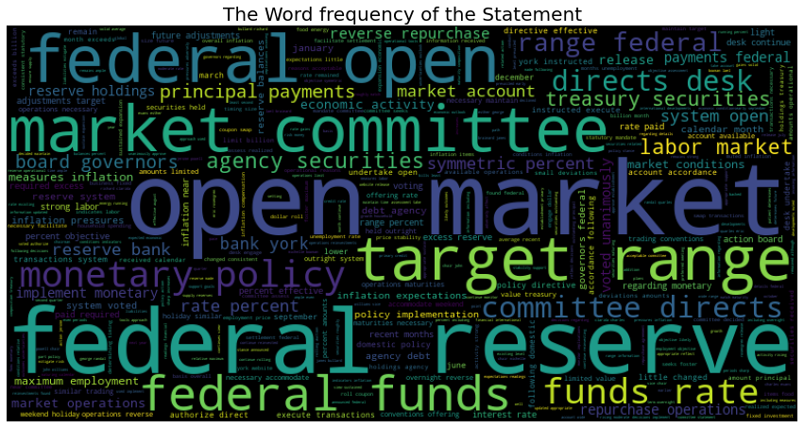

Below is an analysis of the Top30 word frequencies in the fed's statement for January 2019. (Note: I also did this for the rest of the years, but due to page limitation, I can only include one graph, for the rest, please check the code). We can see keywords such as labor, inflation, release, currency, and unemployment. In addition, we can also see the trend charts for the other seven months, such as the chart below, and draw relevant conclusions.

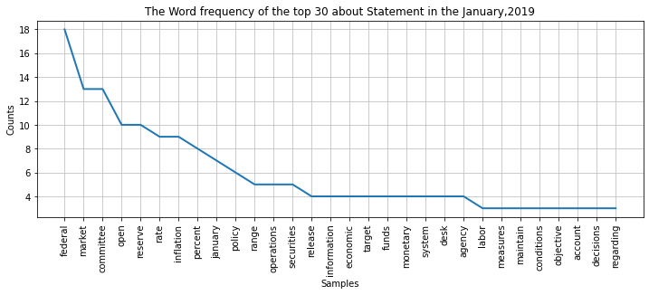

In the topic model, the topic is the probability distribution of all characters in the text as the support set, indicating the frequency of occurrence of this character. That is, characters with high relevance to this topic have a higher probability of occurrence. A topic model attempts to represent this characteristic of the document in a mathematical framework. The topic model automatically analyzes each document, counts the words in the document, and determines the information contained in the current document based on the statistics. As shown in the figure below, topics in all materials can be analyzed by using topic changes in different years to figure out the entire change path of the Federal Reserve.

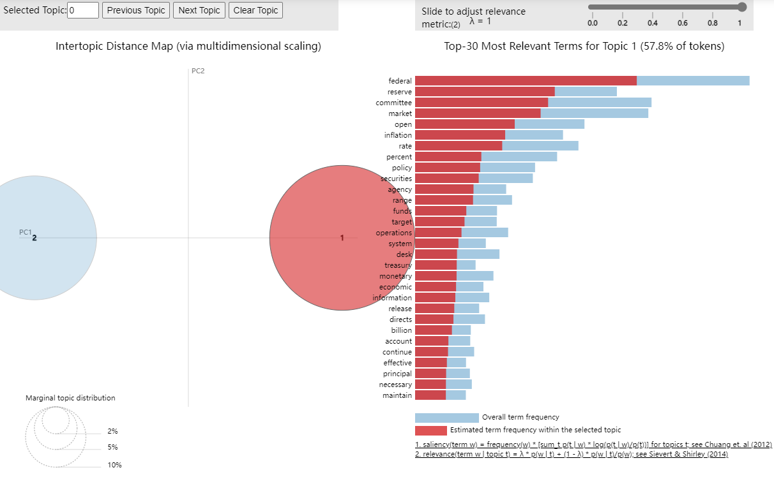

**Conclusion**

There are dual objectives of the Fed's monetary policy: to promote maximum employment and price stability.

It can be seen from the materials of January that: The Attitude of the Federal Reserve significantly reversed, "brake" the interest rate hike, stressed patience, released a solid dovish signal, and significantly lowered the expected interest rate at the March meeting of the same year. However, on July 31, 2019, the Federal Reserve ended its meeting and released a statement, lowering the target range of the federal funds rate by 25 basis points to 2%-2.25%, the first rate cut since the end of 2008. At the same time, the contraction of the balance sheet will be ended in August (initially scheduled for September). In addition, the Federal Reserve decided to end the shrinking of its balance sheet two months ahead of schedule on August 1, EST. In the data analysis, it is evident that the critical words in January and August changed significantly.

In 2020, faced with the possibility of catastrophic consequences to the US economy caused by the outbreak of COVID-19, the Federal Reserve repeatedly crossed the "red line" -- cut interest rates to zero twice in March, restarted the "quantitative easing (QE)" program, launched a series of emergency lending facilities to support the market, and carried out quantitative easing policies throughout the year. Signs of trends such as rate cuts and easing can be seen in changes in critical words.

In the past several months of 2022, fundamental vocabulary changes can be observed based on actual changes; we observed some frequently appeared words such as "release, increase, inflation, raise," which had not appeared in the past 2021. It is worth noting that the [Federal Reserve, on](https://www.federalreserve.gov/newsevents/pressreleases/monetary20220615a.htm) [June 15, 2022](https://www.federalreserve.gov/newsevents/pressreleases/monetary20220615a.htm), [lifted interest](https://www.bloomberg.com/news/articles/2022-06-15/fed-hikes-rates-75-basis-points-intensifying-inflation-fight?sref=Hjm5biAW) [rates](https://www.bloomberg.com/news/articles/2022-06-15/fed-hikes-rates-75-basis-points-intensifying-inflation-fight?sref=Hjm5biAW) by 0.75 percentage points, the third hike this year and the [largest since 1994](https://www.federalreserve.gov/monetarypolicy/openmarket_archive.htm). The move is aimed at countering the [fastest pace of](https://theconversation.com/inflation-hits-fresh-40-year-high-pushing-fed-to-get-more-aggressive-with-interest-rates-and-the-beveridge-curve-should-give-it-courage-to-do-so-184896) [inflation in over 40 years](https://theconversation.com/inflation-hits-fresh-40-year-high-pushing-fed-to-get-more-aggressive-with-interest-rates-and-the-beveridge-curve-should-give-it-courage-to-do-so-184896). Hence, based on the current trend, we estimate that the Fed's policy will pivot towards the tighter side for at least a year.