1. **Group Number: 11**
2. **Group Members:**

**Rachelle Rogers – rar3868, 33.33%**

**Rambo Wu –rw24388 33.33%**

**Justin Tran – jdt2725,** **33.33%**

1. **Application Name: The Drake Escape**
2. **Mockups:**

**1.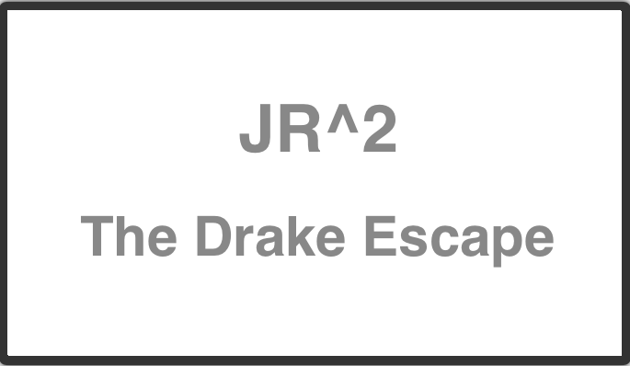  
2.** 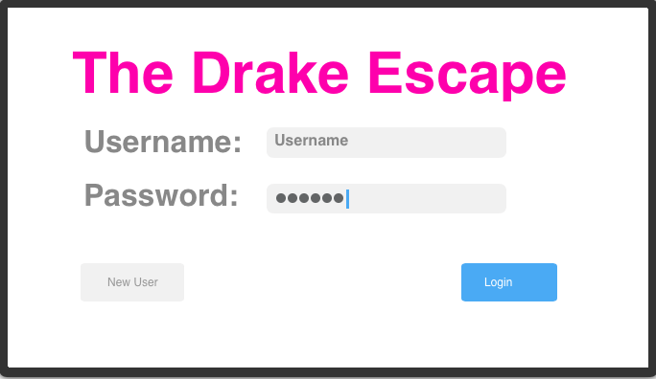

**3.** 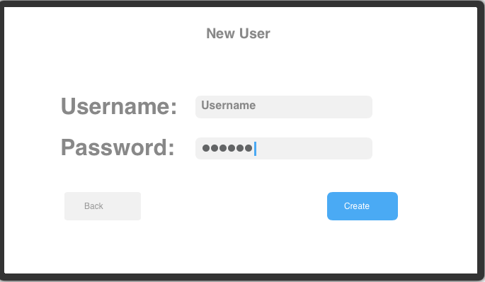

**4.** 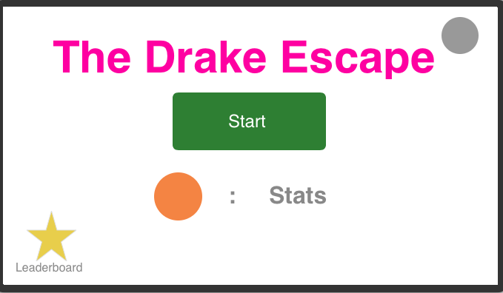

**5.**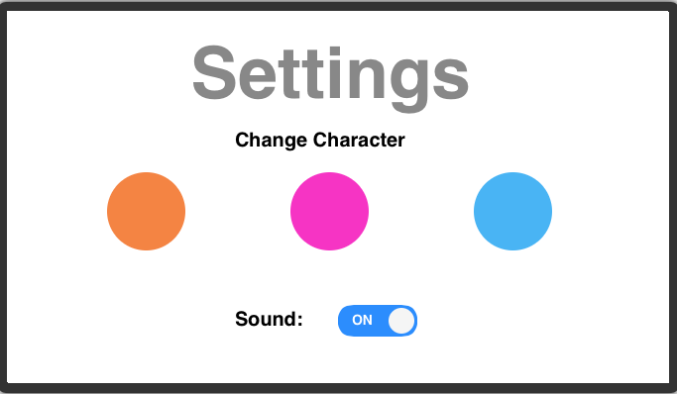

**6.**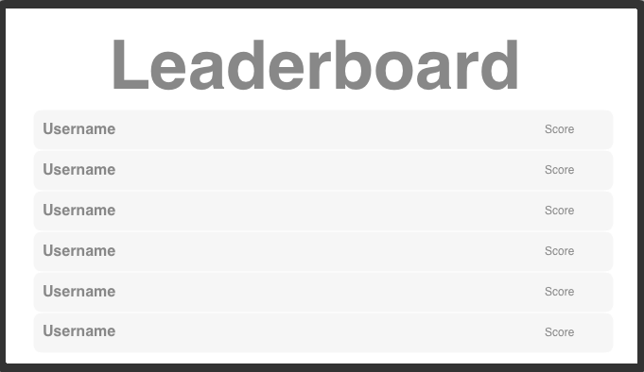

**7.**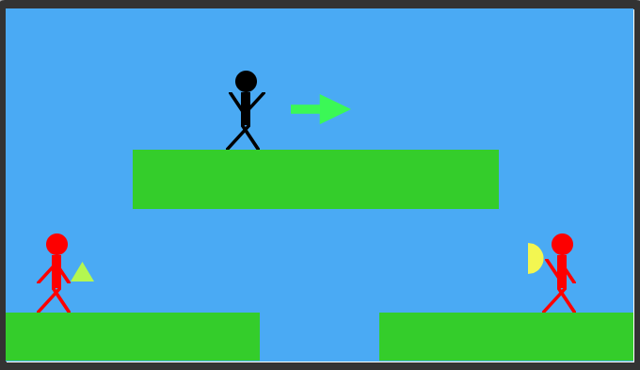

**8. (Overall Flow)**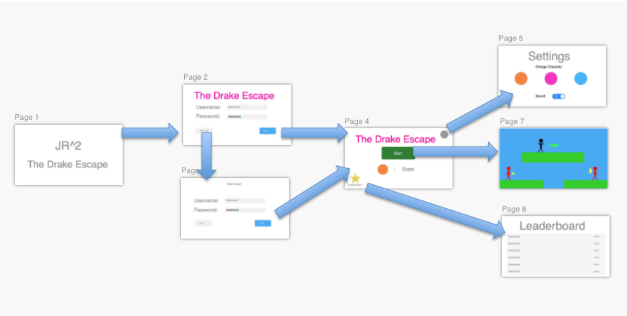

1. **Operational Descriptions: Descriptions of how the user makes use of the interface to perform each of the available operations in the application.**

**This is a basic sketch of the UI. We were limited to the functions of Fluid UI.**

**1. The initial screen is simply an intro screen with the title of our “company” and the title of the game.**

**2. The screen following this will be the log in screen. The user is prompted for their username and password. If the user has not played before or does not have an account, they can tap the new user button to create an account. Otherwise, if the user has a username and password, they can log in and immediately go to the main screen after validation.**

**3. This shows the pop up for new users. Here, they can create their username and password, and save it to get directed to the main screen. There will also be a back button if the user accidentally clicked on the new user button in the previous screen.**

**4.This is the main screen. It contains many user options such as starting the game, settings (upper right hand corner, will look like a gear in actual app), display of the user’s character’s face (orange circle) and their stats, and leaderboard (bottom left hand corner, will be a trophy in actual app).**

**5.When the user taps on settings, they’ll be taken to this settings screen. Here, they can chose to change their character to a different character. The circles represent where the character’s faces will be. Below, they have the option to turn the sound on or off for when they’re playing the game.**

**6.This screen is the leaderboard where usernames and scores will be displayed ascending. We will use a Table View Controller to implement this.**

**7.This screen will be the actual game. It features the main character (on the floating median) who will have the option to move around the screen. The arrow represents the right horizontal movement of the character when the user holds down their finger on the right hand side of the screen. Likewise, the character will be able to move to the left if the user holds down their finger on the left hand side of the screen. The character can also jump if the user taps their finger on the screen. The red characters in the game represent the “enemies” where the character will have to avoid and shoot them. The items they’re holding represent the weapons they will use against the user’s character.**

**8.This is a screenshot of what the overall flow of the app will look like. Here you can see which screens are connected by what and where the user will be directed.**