|  |
| --- |
|  |
| The Documentation |
| [Type the document subtitle] |
|  |
| **[Your Name]** |
| **[Pick the date]** |

[Type the abstract of the document here. The abstract is typically a short summary of the contents of the document. Type the abstract of the document here. The abstract is typically a short summary of the contents of the document.]

Table of Contents

[To update the table of contents, right click the message below and select Update Field (F9 on PC, ⌥⌘U on Mac).]

**No table of contents entries found.**

1. Pages
   1. Page Tree

Login  
register  
Admin  
AdminOp  
Client  
Storehouse  
goodin&out  
goodsnew  
delivery  
Order  
Supply

* 1. Login
     1. User Interface

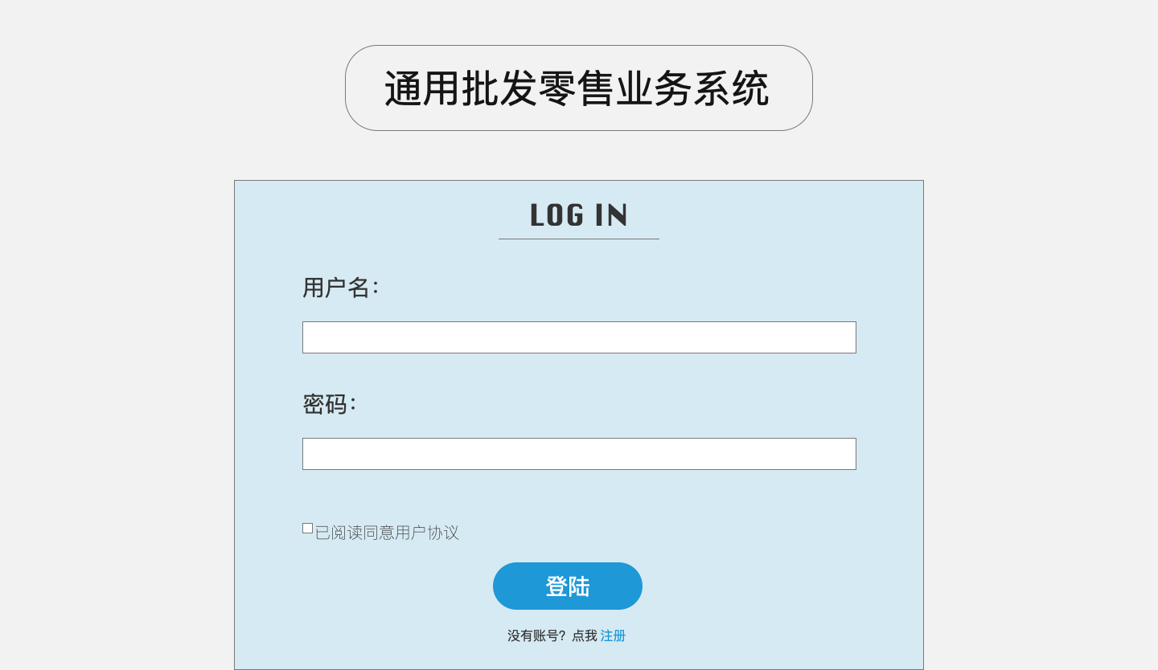

* 1. register
     1. User Interface

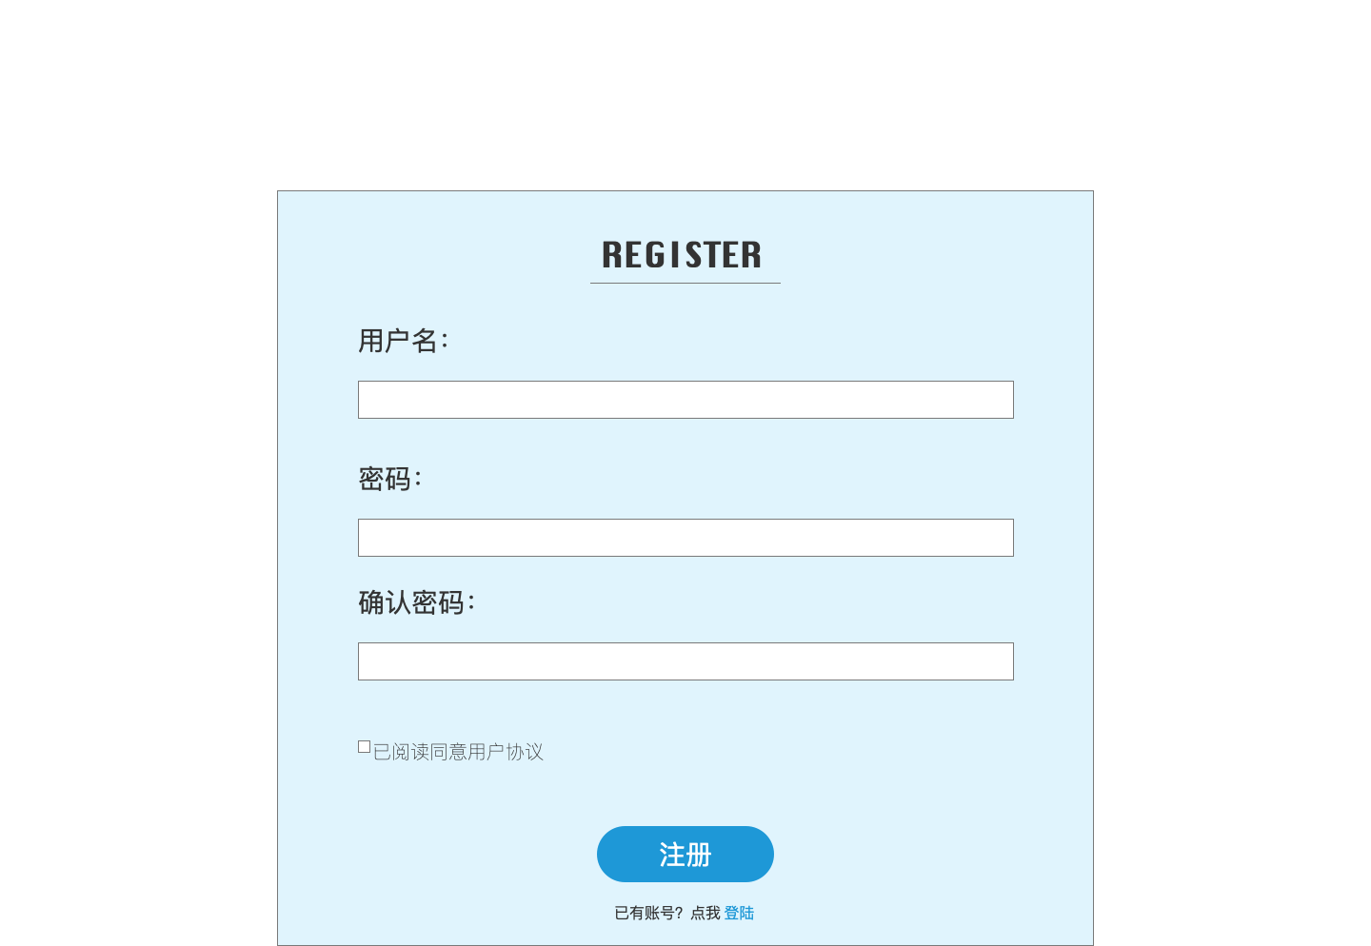

* 1. Admin
     1. User Interface

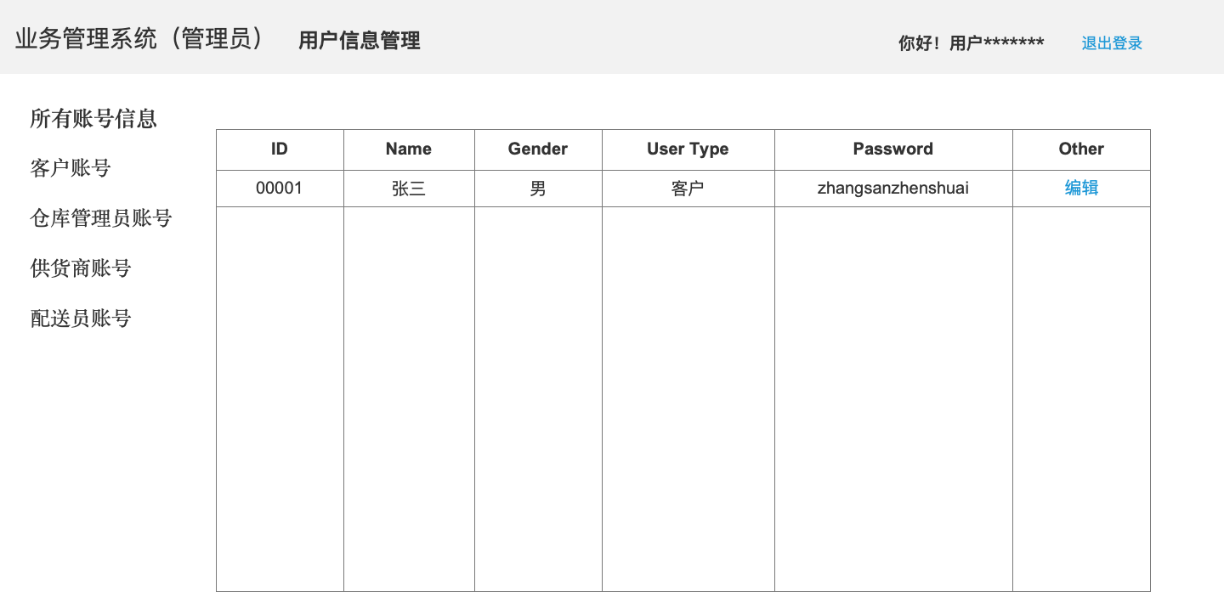

* 1. AdminOp
     1. User Interface

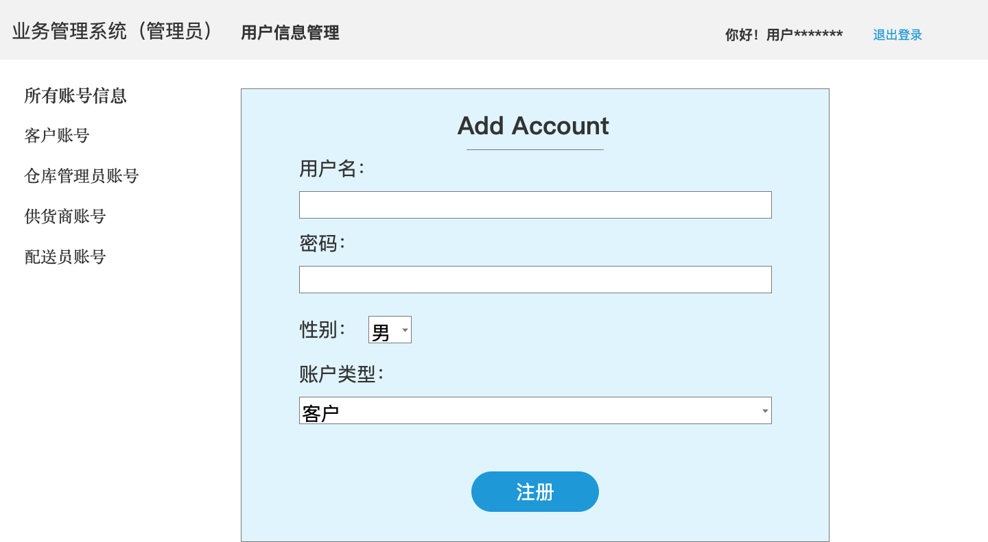

* 1. Client
     1. User Interface

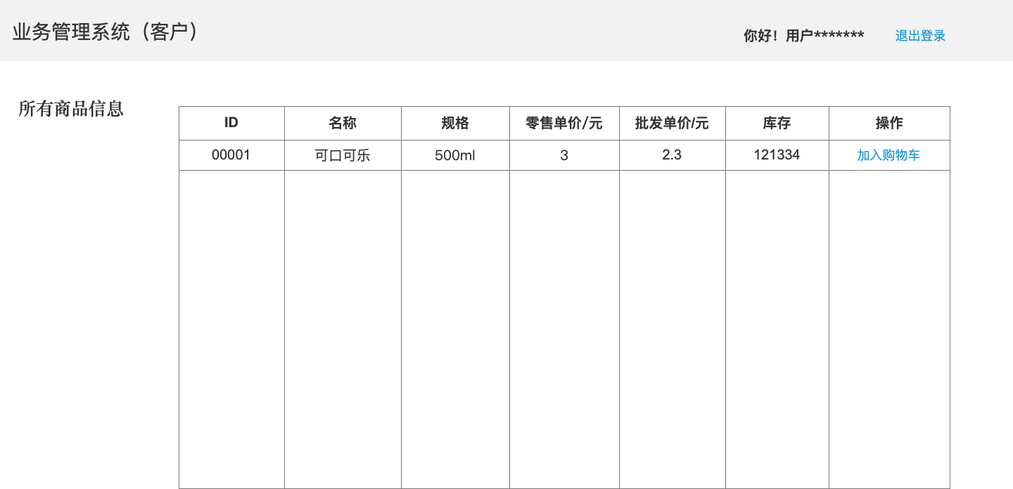

* 1. Storehouse
     1. User Interface

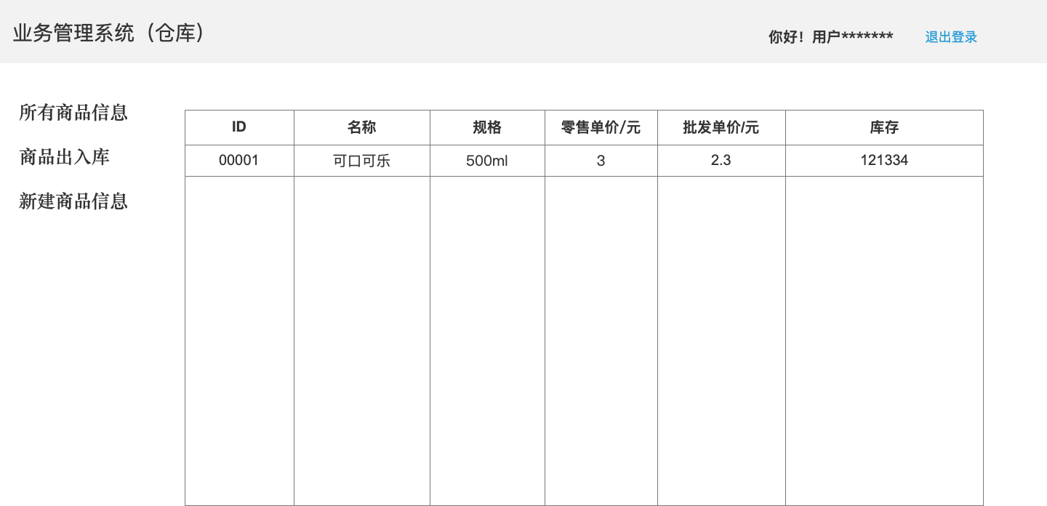

* 1. goodin&out
     1. User Interface

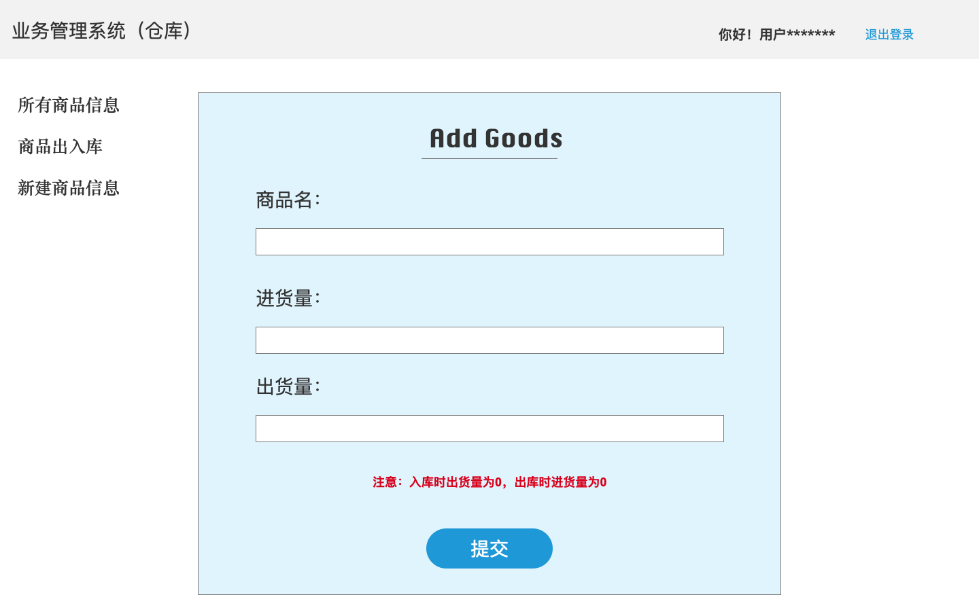

* 1. goodsnew
     1. User Interface

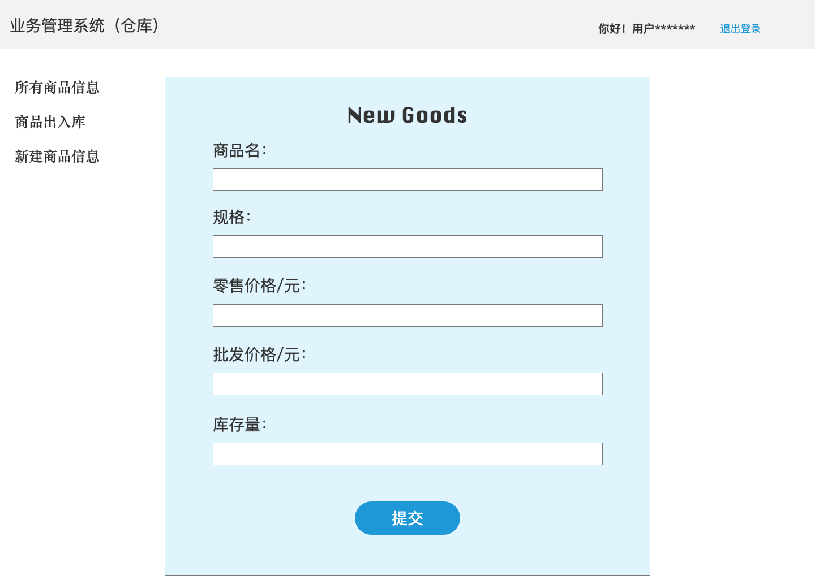

* 1. delivery
     1. User Interface

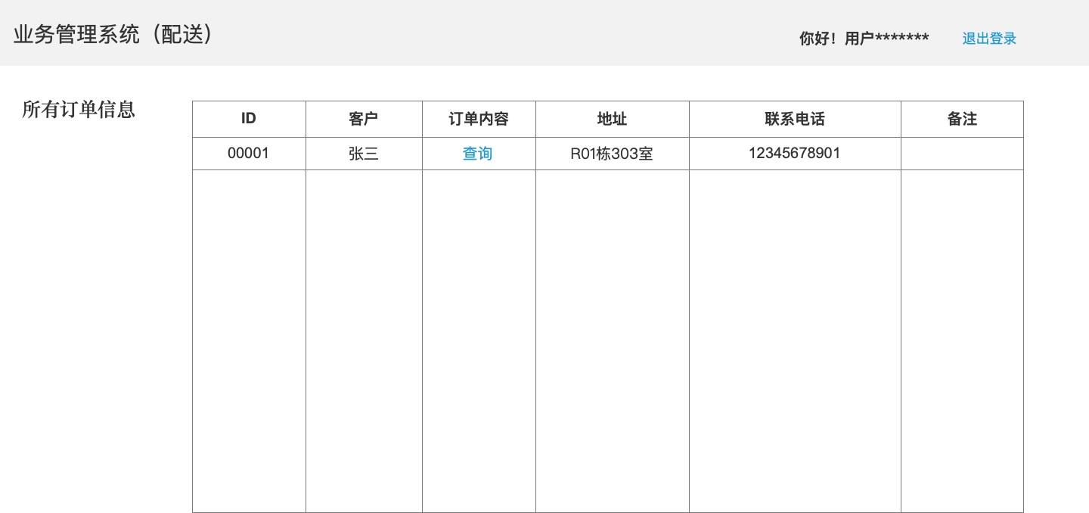

* 1. Order
     1. User Interface

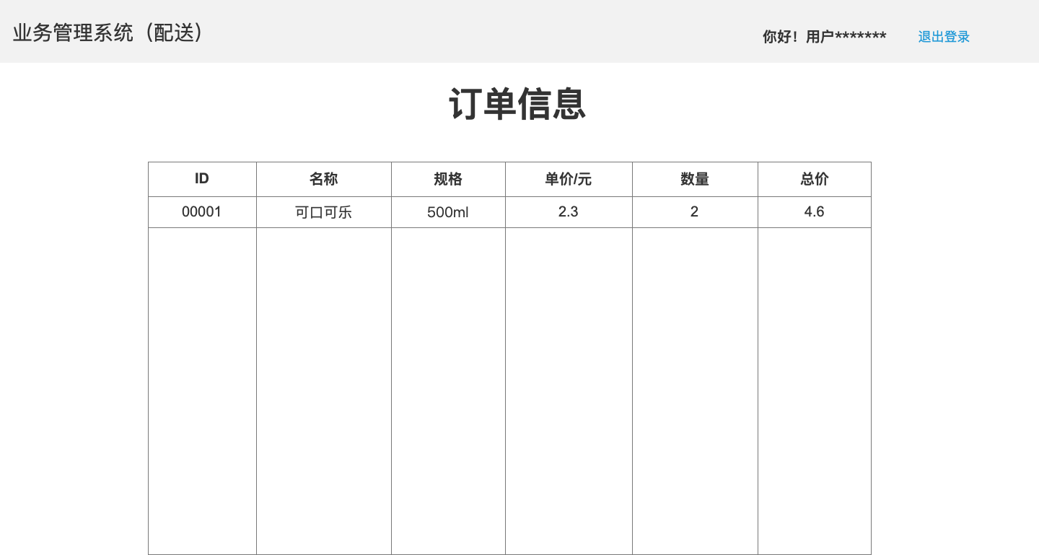

* 1. Supply
     1. User Interface

