**LO3: BRAND GUIDE ITERATIONS**

You present the successive iterations of your creative process, and the connections between them, of your methodically substantiated, iterative design and development process.

Successive iterations: It is my fault for not writing as much down regarding the brand guide in feed pulse. I have one good checkpoint which shows a lot of feedback and we made changes and improvements based on those. The rest of the feedback were we made changes to were not written down, which I will improve for these next weeks.  
  
I made a side by side comparison inside Figma which the changes, the checkpoint and why these changes are an improvement. You can view the Figma file [here](https://www.figma.com/design/aQxjv1O8SbyWyRhndONYRK/Brand-guide?node-id=5-272&t=pUYemk8EBxBxn3uw-1). It will show you a side by side with what changed, it is the same was the image on the bottom of the screen (just in case the Figma doesn’t work).  
  
In this document I will tell you about why the changes we made were **improvements**.  
  
Frist to second version:  
The first improvement was the addition of adding more colour to the guide. This is an improvement because our brand goals are to be fun and eye-catching and we gave of a business-like vibe with the first version.   
  
We experimented with adding puzzle pieces to the title and trying a colourful text effect using layers on the title on the first page. This is an improvement because it make it more playful and matches with our studio more.

We also added mock-ups. This is an improvements because it seems professional and gives the reader a better view of our brand inside the real world.  
  
Second to third (current version):

The puzzle pieces was a nice try to improving and adding more fun to the guide but it also worked against readability. The text effect with layers and colours were a better idea and we sticked with that. This is an improvement since it adds the playfulness, eye-catching and fun vibe that our brand wants.  
  
We removed some of the business-like mock-ups and created more fun ones. This is an improvement because the reader can see what our brand would look like in the real world as we want to be. The cap, mug and poster are more fun than the business-like ones.  
  
**Reflection**: Looking back I should’ve asked for more Feedpulse checkpoints on the brand guide. Right now we have only one feed pulse point which isn’t enough. Me and Minh have asked and validated the brand guide multiple times and created iterations based on the feedback but did not write down what was the feedback as much as we should’ve done.  
For the next weeks I will make sure to write down all the feedback that I get in a feed pulse 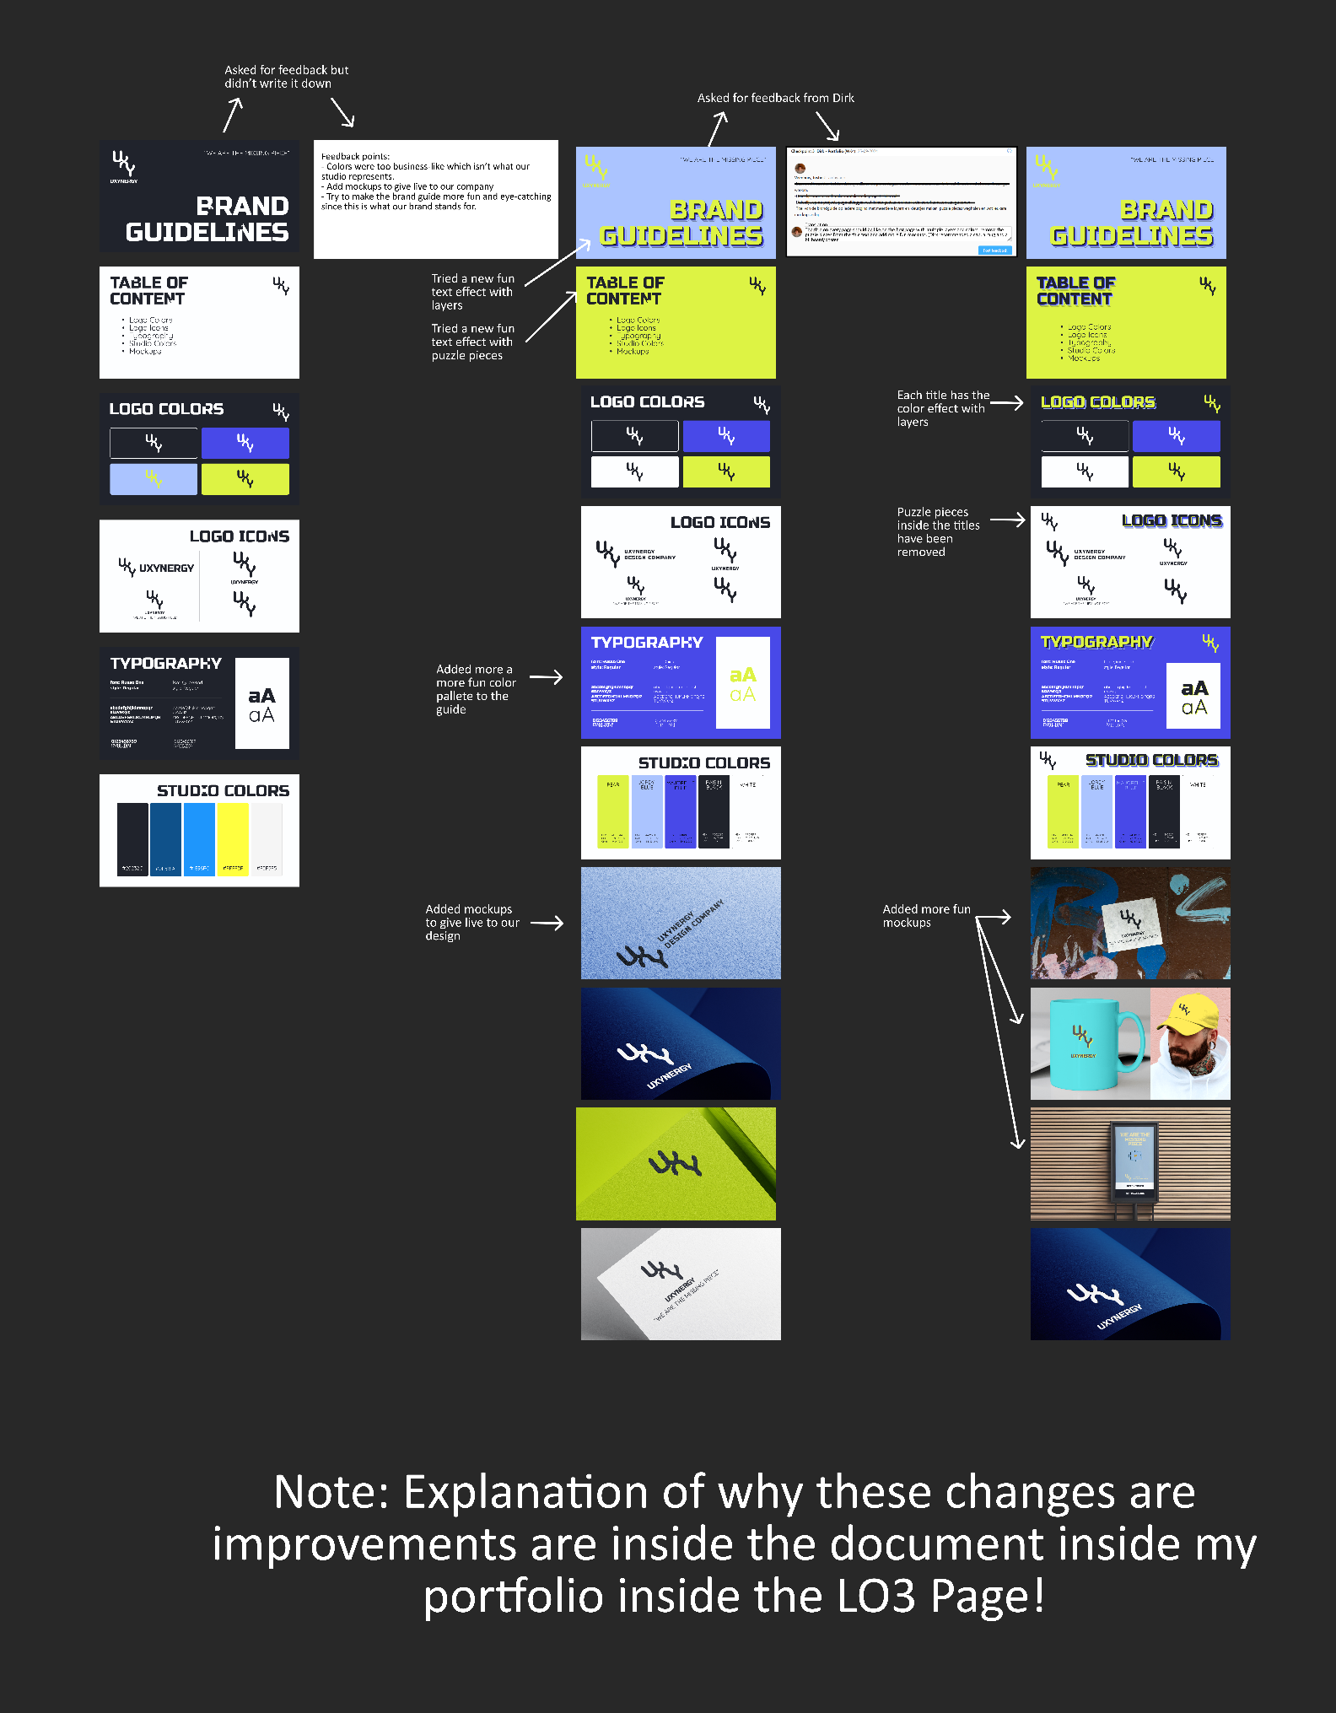instead of ones or twice.