**LO1: CREATING THE BRAND GUIDE**

You create engaging concepts and translate them into interactive validated media products by applying user-cantered design principles, visual design techniques and by exploring emerging trends and developments in media, design and technologies.

Engaging and Validated media product:   
To make sure we had a engaging brand guide we made sure to ask feedback from both teachers and students.

**What did we learn?** We learned that the first version that we had wasn’t engaging at all. We want our brand to give out a fun and eye-catching vibe but the first version didn’t match that. After changing our colour pallet, the colour combo’s got more fun and eye-catching. We experimented with text effects and Dirk told us that it looked attracting so we made sure to implement that text effect on each title. The mock-up’s that we had weren’t as fun as our brand tries to be so I made more fun mock-up’s such as a cap, a cup and a billboard poster, using unique colours.  
  
**Reflection**: After validating and improving our media product we created a better brand guide which resulted in a more engaging product and a better heads up for our brand story, identity and it will help us when we pitch ourselves to a client.

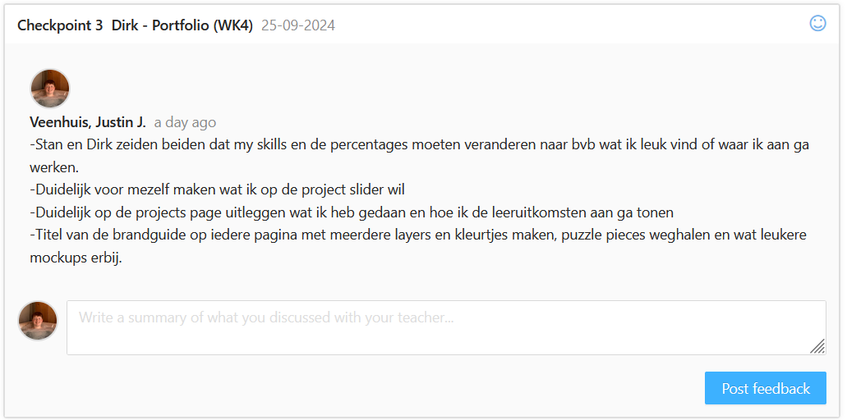

**What should’ve been better?** I should have asked more feedback and checkpoints in the future. If I did that we would’ve spend less time on mock-ups that weren’t engaging enough and we would’ve finished the brand guide earlier.