**LO1: PERSONAL PORTFOLIO**

You create engaging concepts and translate them into interactive validated media products by applying user-cantered design principles, visual design techniques and by exploring emerging trends and developments in media, design and technologies.

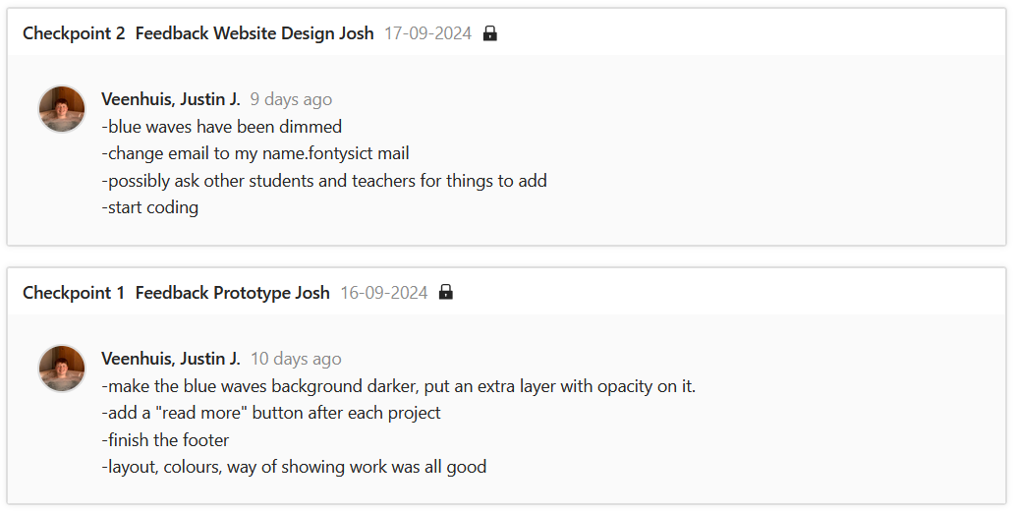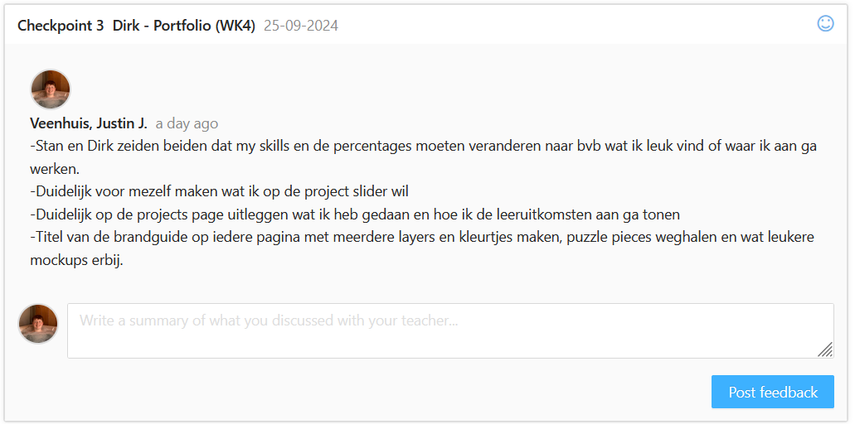Interactive and validated media product:   
I made sure to make my Figma prototype interactive and keep my errors so that the user could engage with my product, see my flaws and feel more attracted to it. Here is the link to the [Figma](https://www.figma.com/design/Y3RYcACKv8jjKh6WGwuNT8/Portfolio?node-id=0-1&t=w5sOa3eYZnOnbVwR-1).  
I also showed my portfolio and the work that I did to the teachers and asked feedback on them. This makes them validated products. I also made sure to write all of this down in Feed pulse.

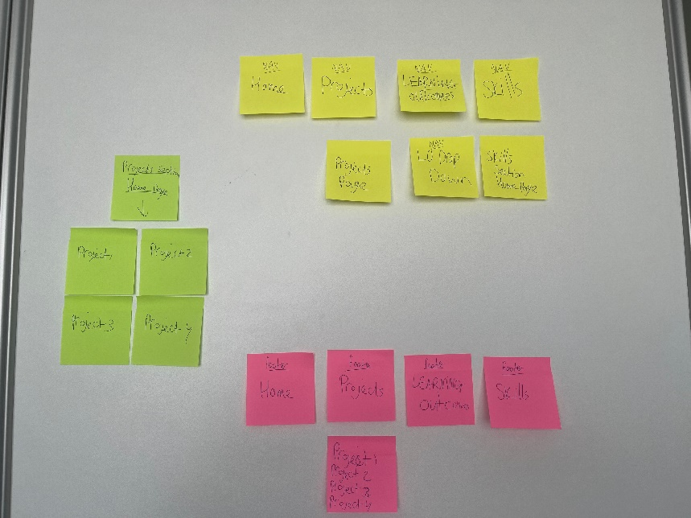Applying user centered design principles:  
I made to use a user centered design approach while creating my portfolio. I did card sorting to make sure that my website has a clear navigation. I asked my peers to navigate through my portfolio to double check that my navigation was clear. So usability testing and card sorting has been used.

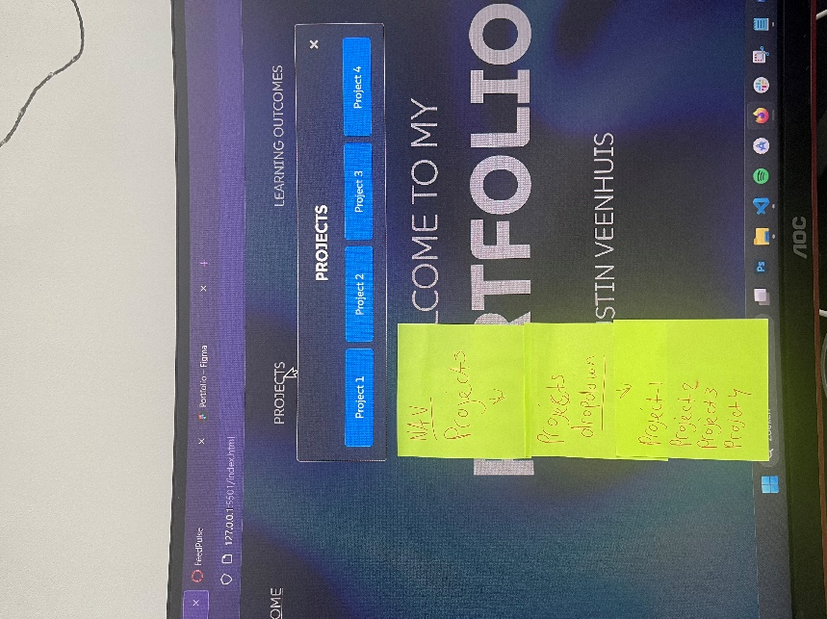**Were there any improvements made after that?** Yes, after usability testing me and a couple of people that I tested with noticed that since there are multiple projects that it would be better to also have a dropdown with multiple options, just like how I did with the learning outcomes. This would make the usability better and a more clear navigation. So I updated the card sorting and tested it again and now the testers had no trouble anymore with navigation.