**LO2: VERSION CONTROL AND GIT PUSHES**

You document and comment your code using version control in a personal and team context and communicate technical recommendations.

Documenting, commenting my code in a personal and team context:

After multiple semesters I know how frustrating it can be when you are working on a team project and you have people in your team that put ZERO comments when they push their work. So at the start of the semester I made sure to comment my code and push often as documentation.

I also tried making a readme, I have never made one before and I should’ve asked more feedback on that.  
  
**Reflection**: Looking back I realised that I could’ve made more clear comments and I will make sure to keep on doing that so that when we get to developing in a team context, it won’t create any problems. In a personal context it is nice and I can understand what was done in each push.

I also should’ve added more comments as I was coding to prevent any unknowns.

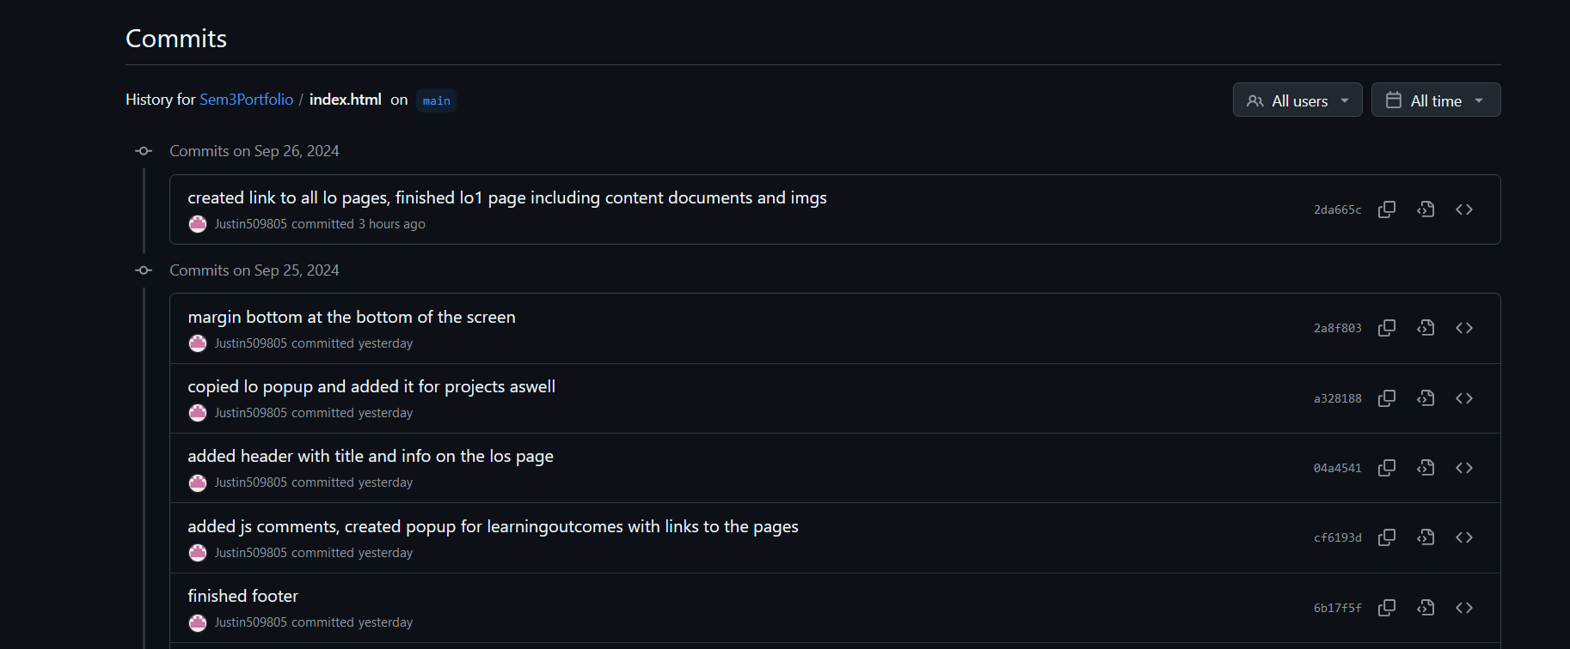Here is the link to my [GitHub](https://github.com/Justin509805/Sem3Portfolio) to see my comments and push comments.