Justin Weigle

Database Management Systems

HW 4

**INSERT Trials**

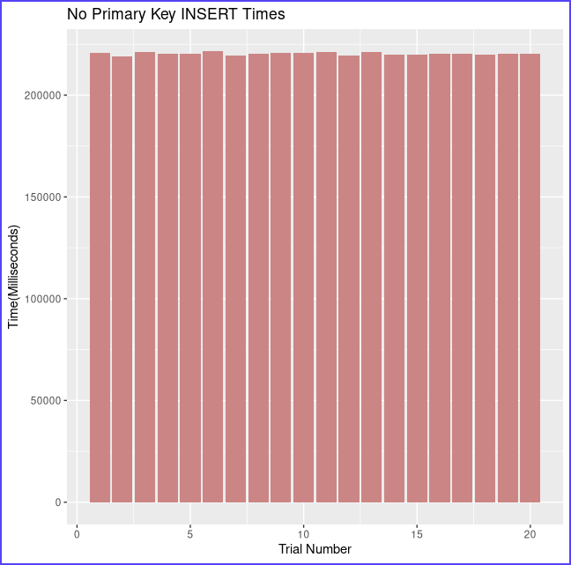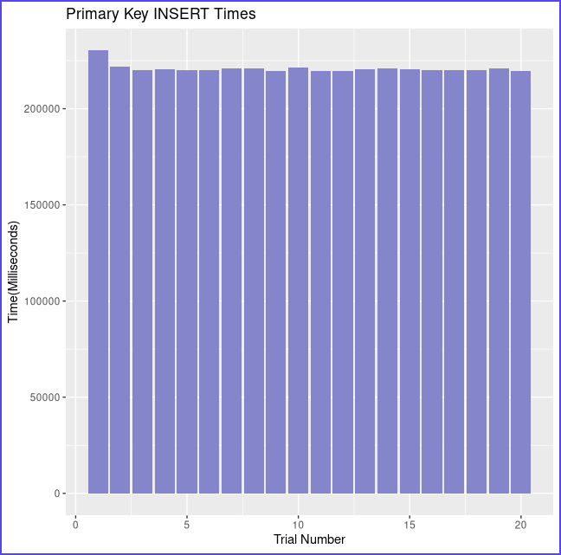

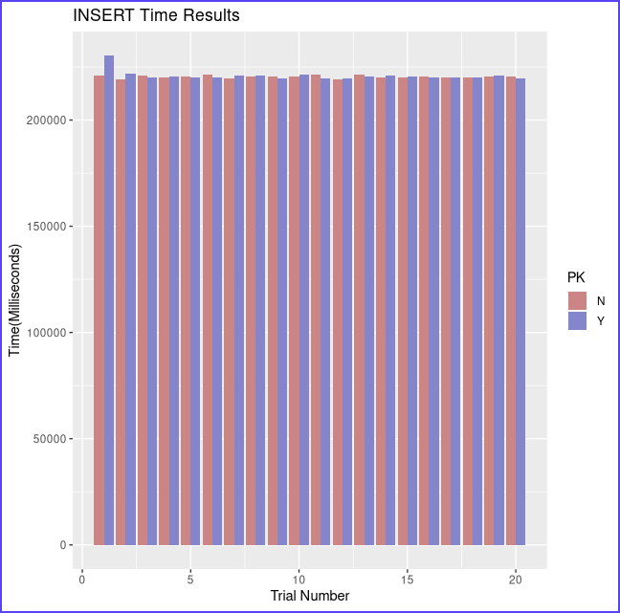

Running **25,000 insertions** on the database **20 times** resulted in the following results:

* With Primary Key
  + Average time: 220868.2 milliseconds
  + Standard deviation: 2282.662 milliseconds
* Without Primary Key
  + Average time: 220373.4 milliseconds
  + Standard deviation: 647.669 milliseconds
* T Test
  + Standard Error: 530.5667
  + t: 0.9325877
  + P value: 0.3611

**Null Hypothesis**:

The difference between the average times of 25000 insertions is 0 whether using a primary key or not.

**Result**:

Fail to reject the null hypothesis.

**Conclusion**:

With 95% confidence, there is insufficient evidence to reject the null hypothesis, and therefore it can be concluded that there is no difference in insertion time whether using a primary key or not

**SELECT Trials**

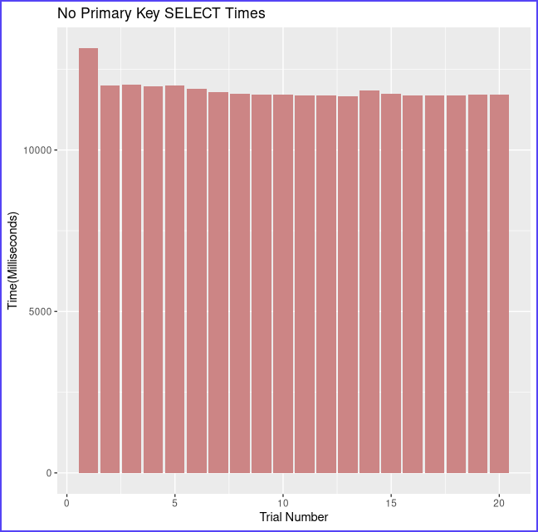

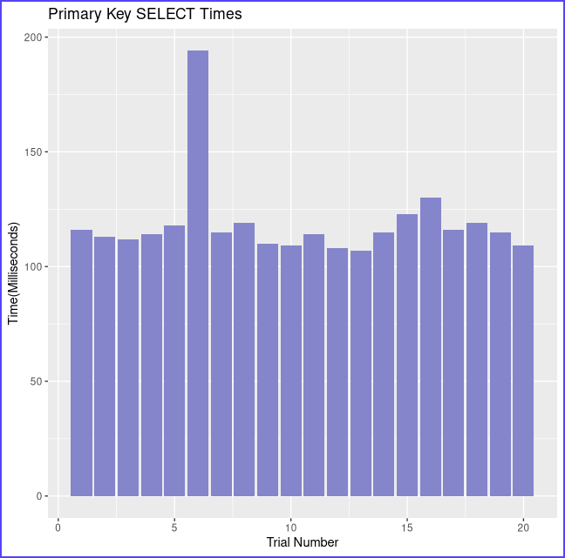

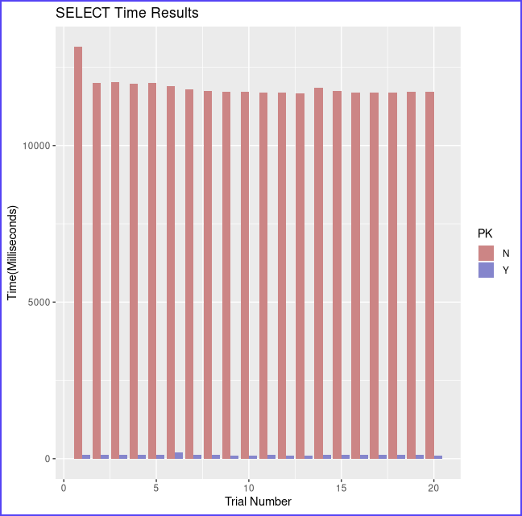

Running **100 selects** of row size **400** on the database **20 times** resulted in the following results:

* With Primary Key
  + Average time: 118.8 milliseconds
  + Standard deviation: 18.509 milliseconds
* Without Primary Key
  + Average time: 11857.5 milliseconds
  + Standard deviation: 326.759 milliseconds
* T Test
  + Standard Error: 73.1827
  + t: 160.4
  + P value: 2.2 x 10-16 (2.2e-16)

**Null Hypothesis**:

The difference between the average times of 100 selections is 0 whether using a primary key or not.

**Result**:

Reject the null hypothesis.

**Conclusion**:

With 95% confidence, there is sufficient evidence to reject the null hypothesis, and therefore it can be concluded that there is a difference in selection time when using a primary key. It is faster when using a primary key.