Online Supplement 1
Table 2 shows the full topic model results for our study on ‘family’ discourses on reddit’s r/QAnonCasualties. The first column displays each topic’s number (assigned by HDBSCAN), which corresponds to the topic number listed in the paper’s abridged table (i.e. Table 1). The second column lists the number of unique sentences for each topic (i.e. count). The representative words in the first column come from BERTopic’s unique class-based tf-idf algorithm, along with some customizations, which produces words that best distinguish each individual topic from others. Similarly, representative sentences offer sentences which best explain the topic—derived from a slightly improved version of BERTopic’s code (available in the OSF repository). These representations were used to develop the topic names found in the paper’s abridged table. The final columns show the frequency of each topic over time (i.e. Timeline) and the percentage of total upvotes for each individual topic, just as those found in Table 1. Please note, the table excludes HDBSCAN’s noise category (i.e. Topic –1). In contrast to the abridged table, these topics are ordered by total number of unique sentences (i.e. count) for each topic—BERTopic’s default descending order.

Table 2

Topic | Count | Representative Words | Representative Sentences | Timeline | Upvotes
0 | 6181 | ['adjacent', 'qs', 'qfamily', 'anon', 'qultists', 'qmom', 'followers', 'hole', 'sub', 'qultist'] | ['My one Q family member is very much against that.', 'I do this with my Q family member too!', 'I get this from my Q family too.', 'I have Q family.', 'With Q people like my family.', 'I was never into Q, but have family members into it.', 'My Q family anyway.', 'What can you do about Q friends and family?', 'I have my own Q family members and friends.', 'So you have Q family members?'] | 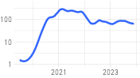 | 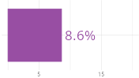
5 | 5655 | ['man', 'guy', 'needs', 'job', 'wife', 'rest', 'behavior', 'daughter', 'marriage', 'help'] | ['His family is my family now.', 'He is family to me.', 'Him and his family?', 'His family is your family.', 'His family is very.', 'He is your family.', 'His family, too.', 'It was all about him and his family.', 'Even his own family.', 'Or what about his family?'] | 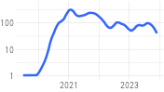 | 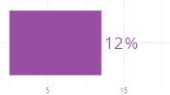
8 | 5232 | ['woman', 'daughter', 'worried', 'rest', 'facebook', 'phone', 'relationship', 'money', 'home', 'things'] | ['She is not my family.', 'How is her family?', 'They are her family.', 'Everyone in the family but her had it.', 'She is not my family, nor will she ever be.', 'Not only from her but from her family.', 'She has a family.', 'Her family is from there.', 'This is her family.', 'Someone in her family?'] | 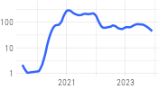 | 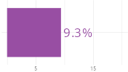
7 | 2301 | ['vaccinated', 'vaccine', 'unvaccinated', 'vaccines', 'shot', 'vaccination', 'pfizer', 'shots', 'vaccinations', 'booster'] | ['Almost all of my family is vaccinated.', 'Most of my family is also vaccinated.', 'And if they were not vaccinated, they would not be around our family.', 'My family is vaccinated.', 'Whole family is Q although some have been vaccinated.', 'None of the family is vaccinated.', 'Everyone in our family who can be vaccinated, is, except for them.', 'My whole family is vaccinated.', 'Everyone in my family is vaccinated.', 'Meanwhile, the whole family is vaccinated.'] | 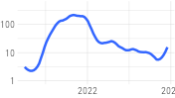 | 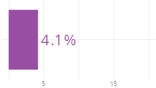
19 | 1999 | ['church', 'christian', 'evangelical', 'religious', 'catholic', 'beliefs', 'religion', 'atheist', 'bible', 'faith'] | ['I cant say the same about my Christian family members.', 'Is your family Christian?', 'My family and church have NEVER been that way.', 'My family is Christian and so am I.', 'Is that side of your family also evangelical Christian?', 'My sister and her family do go to church, but I wouldnt say shes an evangelical Christian.', '> Is your family Christian?', 'My family is Christian.', 'My whole family is Christian.', 'They all align more with my evangelical family than they do with the Catholic Church.'] | 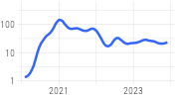 | 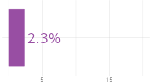
2 | 1942 | ['covid', 'pandemic', 'virus', 'hoax', 'flu', 'sick', 'cold', 'quarantine', 'deniers', 'hospital'] | ['Im the only one in my family with a vaccine, and the only one who hasnt had COVID.', 'i have a family member who diEd of COVID.', 'The entire family got covid.', 'Most of them have had Covid, a few got really sick and some extended family members died.', 'Our Q family member is the only one who hasnt had Covid yet .', 'A member of my family has Covid.', 'And all have had Covid but me and my family have not.', 'I was the first in my family to get covid.', 'Several family members have had covid.', 'My family already had Covid.'] | 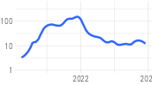 | 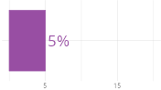
51 | 1737 | ['extended', 'large', 'different', 'friend', 'small', 'close', 'similar', 'colleagues', 'group', 'origin'] | ['Its almost my whole family.', 'They are still family?', 'This is MY family.', 'but my whole family.', 'Much of my family is the same.', 'I have 3 in my family.', 'Because they were my family.', 'Same with family.', 'Even if they were family.', 'Everyone in my family.'] | 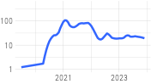 | 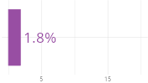
1 | 1642 | ['qanon', 'coronavirus', 'theories', 'qanons', 'conspiracy', 'obsessed', 'followers', 'believers', 'theorists', 'podcast'] | ['Sorry, but your family ARE Qanon.', 'QAnon and covid conspiracy theories are part of the same family.', 'He can have his QAnon family because I want no part of it.', 'I have several members of the QAnon cult in my family.', 'I have lost family and friends to QAnon too.', 'I have lost family and friends to QAnon.', 'I have lost my family to Qanon conspiracy.', 'Do you have a Qanon in your family too?', 'Whole family is QAnon.', 'Family in QAnon.'] | 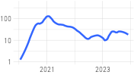 | 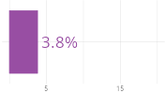
50 | 1638 | ['insanity', 'crazy', 'craziness', 'anger', 'insane', 'angry', 'respect', 'rational', 'fuck', 'madness'] | ['I lost my entire family to this insanity.', 'Im sorry you have to deal with crazy family members.', 'Not my immediate family, theyre rational and sane, but much of my extended family.', 'Im so sorry that you have lost family to this insanity.', 'Do you feel like your friends and family are against you?', 'Your family is crazy.', 'Do you want to be crazy like your family, or are you better than that?', 'Sorry you have to deal with that insanity with your family.', 'Even may put you against your own family.', 'We are here for each other because so many of us lost family to this insanity.'] | 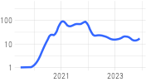 | 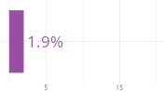
12 | 1590 | ['sorry', 'loss', 'condolences', 'deepest', 'tragedy', 'sympathies', 'horrible', 'situation', 'tragic', 'hope'] | ['Im sorry about your family.', 'Im sorry for your family.', 'Im so sorry about your family.', 'Im so sorry your family is among them.', 'Im so sorry its your whole family.', 'Im sorry you and your family has to go through this.', 'Im so sorry you have had to go through this with your family.', 'Im sorry about your family too.', 'Im sorry about your family as well.', 'Im sorry this has to be your family.'] | 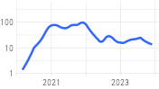 | 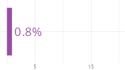
45 | 1537 | ['stay', 'change', 'proud', 'strong', 'best', 'care', 'courage', 'decision', 'hobbies', 'healthy'] | ['Make your family of friends.', 'Find family and/or friends who think like you do.', 'And...give your family time.', 'Find family in friends.', 'Give up on your family.', 'Do what you have to for you, for your family.', 'Time to get out of that family.', 'Move on and find your family elsewhere.', 'What if they go after my family?', 'Get the whole family behind it.'] | 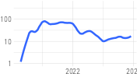 | 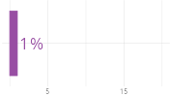
41 | 1378 | ['lies', 'jobs', 'mass', 'victims', 'killing', 'accountable', 'enemy', 'violence', 'enemies', 'murder'] | ['So many have family members lost to constant lies and misinformation.', 'It all has real world impact (losing money, losing friends/family, jobs, etc).', 'Would you rather know the truth or have a lie break up you family?', 'Sometimes you lie because you dont want your family to hurt you.', 'I mean, its family member against family member.', 'How do they not even care about family?', 'They turn against friends and family and sometimes cause themselves to lose their jobs.', 'Sometimes its right for their family, sometimes for them, sometimes for others.', 'No one would care so much about lying about that to let family die.', 'And losing friends, family along the way.'] | 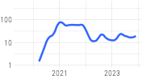 | 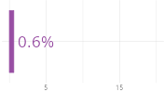
40 | 1323 | ['choice', 'new', 'isolated', 'intentional', 'choices', 'lonely', 'loneliness', 'biological', 'life', 'future'] | ['We cant choose our family but you can choose friends who become family.', 'Your chosen family can be your family.', 'Your family is who you choose to have in your life.', 'you can build a family for yourself, out of people you DO CHOOSE to have in your life.', 'They are your family, but you can make a new family of choice.', 'Sometimes in life you choose your who is family.', 'We cant choose our family but we can choose friends whom we can make family.', 'We really cant choose our family, but we get to choose our chosen family.', 'Your family can also be the people you choose to be your family.', 'The family you choose is family too.'] | 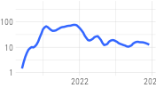 | 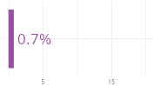
11 | 1297 | ['holidays', 'thanksgiving', 'holiday', 'dinner', 'birthday', 'gatherings', 'gathering', 'vacation', 'events', 'traditions'] | ['No holidays with family?', 'With my family at Christmas we did the same.', 'My extended family have all been gathering for holidays.', 'CHRISTMAS WAS A TIME FOR FAMILY!', 'My sister in law even invited someone from Focus on the Family to Christmas dinner one year!', 'So no Christmas for my extended family this year.', 'We usually spend Thanksgiving and Christmas with my family but not this year.', 'No more Thanksgiving or Christmas together, no more of that family time.', 'Drop by the family house for planned events such as a birthday party or Christmas dinner.', 'This is how Christmas, Thanksgiving, a family trip, and two birthday get-togethers went last year.'] | 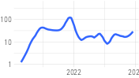 | 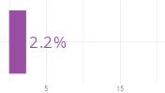
4 | 1295 | ['cult', 'cults', 'mormon', 'scientology', 'cultists', 'exit', 'witnesses', 'cultish', 'leader', 'victims'] | ['The problem with cults, the cult has to come before the family.', 'I have a lot of family members still in the cult....', 'The cult over family.', 'I have lost many friends and family to this cult.', 'I am sorry that you have lost a family member to the cult.', 'So many of us have lost family and friends to this cult.', 'Side with a cult over your own family?', 'I lost most of my family to the cult.', 'So how do you help your friends and family get out of a cult.', 'I have lost at least two family members to this cult.'] | 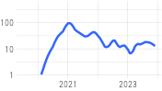 | 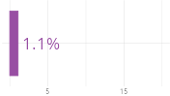
27 | 1260 | ['contact', 'college', 'money', 'food', 'financial', 'graduate', 'water', 'school', 'degree', 'class'] | ['etc etc I am no contact from my entire family.', 'I went no contact with my family.', 'I am no contact with my family and have been for years.', '> Do you have to be in contact at all with this family member?', 'Do you have to be in contact at all with this family member?', 'After you go to college, cut all contact with your family.', 'You should go no contact with your family', 'I had to go no contact with my family too.', 'I am no contact with my family.', 'I have had to go no contact with my family.'] | 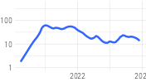 | 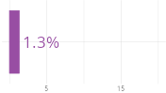
24 | 1238 | ['facebook', 'fb', 'photos', 'chat', 'youtube', 'media', 'account', 'pictures', 'social', 'text'] | ['Last month a family member posted about using Telegram on the social media.', 'I shared this with 2 family members on Facebook.', 'He has more photos of trump and his family up than he did of myself or his own family.', 'My mom uses group chats to text the family since shes been banned off Facebook.', 'Today most of my family (and ex-friends) are blocked on FB.', 'Get your family off Facebook.', 'My whole family group chat is going on and on about it and Im like shit not again', 'My parents, and most of my family, are all blocked on social media.', 'Do your family members use facebook?', 'I had a fb account w/connections, friends, family, posts, whatever, and I deleted it.'] | 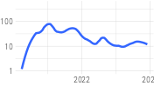 | 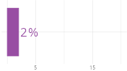
56 | 1177 | ['dysfunctional', 'hard', 'love', 'difficult', 'broken', 'breaking', 'tough', 'relationships', 'decision', 'unconditional'] | ['I love my family, I really do.', 'Life is difficult enough without losing the support and love of your family.', 'Its really hard when those people are also your family!', 'Losing family is hard.', 'Its hard losing your family.', 'Family should love you more than that.', 'its just hard to give up my family.', 'I love my family, but I cant keep this up.', 'I love my family but this is so so hard.', 'Our family has been through it too.'] | 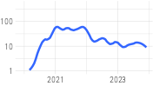
29 | 1022 | ['luck', 'hope', 'best', 'wishes', 'healing', 'heal', 'recovery', 'blessings', 'better', 'strength'] | ['I wish you good luck with your family.', 'Good luck...I wish you and your family well.', 'Good luck and best wishes to you and your family.', 'I wish you and your family the best of luck.', 'I wish you luck and hope it works out for you and your family.', 'Best of luck to you and your family, I really hope it gets better.', 'I really wish you the best of luck with your family!', 'I wish you and your family the best of luck, OP.', 'I wish you the best of luck with your family.', 'Good luck and I wish the best for your family.'] | 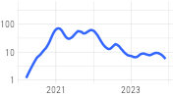 | 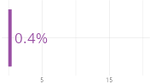
39 | 1018 | ['safe', 'safety', 'risk', 'danger', 'baby', 'child', 'dangerous', 'vulnerable', 'health', 'unsafe'] | ['You must protect your family.', 'Do what you have to do to protect your family.', 'But I have a family of my own to protect.', 'You have your family to protect.', 'Do what you have to do to protect yourself and your family!', 'Do everything you can to protect your family.', 'Protect your family.', 'But you have YOUR family to protect.', 'Protect yourself and family.', 'You are here to protect yourself and your family.'] | 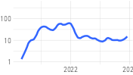
26 | 1015 | ['conspiracy', 'conspiracies', 'theories', 'theorists', 'theory', 'theorist', 'chemtrails', 'elites', 'moon', 'conspiratorial'] | ['So my cousins and all their family have been conspiracy theories for years.', 'So its not my family which is in the conspiracy world.', 'Most of my family are conspiracy theorists.', 'My family was always conspiracy theorists.', 'These conspiracy theories are like a death in a family.', 'I have lost my husband and many family members to these conspiracy theories.', 'I hate what conspiracy theories have done to my relationships with my family.', 'Its more like a family of conspiracy theories now than a single thing.', 'My family was also deep into conspiracy theories.', '3. How many of your family and friends are also conspiracy theorists?'] | 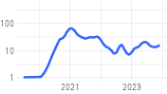
32 | 996 | ['suicide', 'casualties', 'sand', 'secret', 'secrets', 'quiet', 'trustworthy', 'silence', 'communication', 'parents'] | ['You can tell them anything and everything about your family member.', 'And when you do, tell your family why.', 'Tell their family.', '* Tell your friends, other family.', 'Do that to your family.', 'Tell your family.', 'But I cant do that to my family.', 'Tell your family and friends.', 'Your family might not.', 'Tell your friends and family.'] | 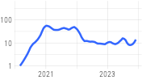
37 | 968 | ['conservative', 'liberal', 'republican', 'wing', 'republicans', 'conservatives', 'progressive', 'democrat', 'alt', 'democrats'] | ['My family has always been on the right leaning/conservative side.', 'And more left in a very conservative family as well.', '>My family was always conservative.', 'My family is/was very conservative.', 'My family is all conservative.', 'My wife and I are liberal, her family is conservative.', 'Most of my family are conservative.', 'My family was always conservative.', 'Family is conservative.', 'My family is mostly conservative.'] | 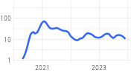 | 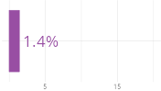
34 | 920 | ['politics', 'political', 'ideology', 'radicalization', 'rule', 'views', 'extremism', 'authoritarian', 'differences', 'election'] | ['Maybe talk to your family no politics around the kids.', 'You cant tell politics come between your family.', 'Family is way more important than politics.', 'I cant talk politics to anyone in my family anymore.', 'I have had family say just dont talk about politics.', 'Why are politics more important than family?', 'If only family members would keep their politics to themselves, people would get on so much better.', 'Family over Politics.', '> Family is way more important than politics.', 'Political talk was never a thing for my family until Trump.'] | 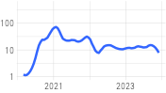
3 | 901 | ['mask', 'masks', 'vaccine', 'covid', 'positive', 'vaccines', 'anti', 'vaxxed', 'virus', 'unvaccinated'] | ['Also, regarding the face masks, my family is anti-masks, anti-vaccines.', 'My family is the same way about masks.', 'Theyd rather die and never see their family again than simply wear a mask.', 'I wear a mask any time that Im not home nor inside the family car.', 'So finally I just asked her to please wear a mask for the rest of the family.', 'Was my mom actually choosing not to wear a mask over her family?', 'She will not wear a mask and so has not done anything with the family in two years.', 'My family and I still mask too.', 'My unvaxxed family wont even wear a mask around their elderly father.', 'We have several family members who refuse to mask and/or wear a mask.'] | 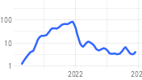 | 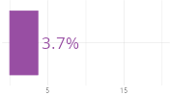
30 | 900 | ['distance', 'dog', 'home', 'job', 'dogs', 'college', 'house', 'pet', 'cats', 'sane'] | ['Do you have any friends or family you could stay with?', 'Can you go and stay with family or friends?', 'Do you have family you can call?', 'Do you have any other family or friends that you can stay with?', 'Do you have any family or friends that could stay with you?', 'Do you have family you can go to or something.', 'Do you have family to be around?', 'Do you have family you can go to?', 'I had a family to go back to.', 'A family to go back to?'] | 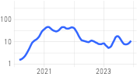
57 | 841 | ['biological', 'dynamics', 'dynamic', 'genetics', 'words', 'divide', 'love', 'applies', 'overrated', 'logical'] | ['Know there are people out there not like your family.', 'Its just not the same when its your family.', 'The family you have is the family you make.', 'Your family is no more.', 'Family are just people.', 'Just because of fAmIlY?', 'That is what family is for.', 'Family is everything there.', 'Family will always be family.', 'Family is everything.'] | 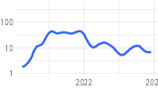 | 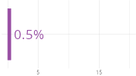
17 | 821 | ['doctor', 'medical', 'doctors', 'cancer', 'medicine', 'pharmacy', 'patients', 'hospital', 'patient', 'insurance'] | ['Have your dad ask your family doctor about it.', 'Do you trust your family doctor?', 'If you have a family doctor then you should talk to them about what would be best for you.', 'Ask the advice of your family doctor.', 'You can also talk to your family doctor.', 'Find a family doctor, if you dont have one.', 'Find a doctor you trust and follow the best medical advice available to you for your family.', 'Is there a family doctor you could talk to?', 'Well the doctor told his family it had nothing to do with it.', 'Same for your family doctor.'] | 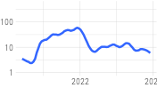
36 | 792 | ['trump', 'rush', 'supporters', 'election', 'president', 'republican', 'liberal', 'presidency', 'supporter', 'trumpers'] | ['I came from that family and they are also Trump supporters.', 'My aunt was the only person in our family who voted for Trump.', 'Or is this all new to you and your family (like since trump)?', 'I also wanted to feel like I was part of the family, which is why I voted for trump.', 'However, I do have family who are Trump supporters.', 'everyone in my family that can vote is voting for trump.', 'So was Trump and his whole family.', 'Think the kind of family that really wanted Rush Limbaugh to run for president.', 'Same here, family members also said they would vote for trump if they could.', 'I lost several friends and family members to Trump.'] | 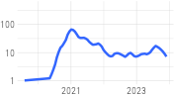
31 | 775 | ['miles', 'area', 'rural', 'state', 'south', 'country', 'city', 'place', 'cities', 'roommate'] | ['Are you moving further away from your family?', 'I live away from my whole family in...', 'Have a friend that moved to portland (in part to get far far away from family).', 'My brother-in-law moved their family three hours away a few years ago.', 'I moved out of california and came to idaho about 3 years ago with my family.', 'All of my family lives in another state in a rural area & my husband and I are in the city.', 'So my parents moved to another state 7 years ago to be near my (sane) brother and his family.', 'This is my family and I have moved away.', 'My husband and I moved in with family when we moved back to our home state.', 'I moved across the country to get away from family like this.'] | 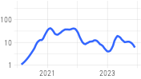
48 | 711 | ['lucky', 'wonderful', 'fortunate', 'bio', 'amazing', 'entire', 'friend', 'half', 'dark', 'spouse'] | ['I have also lost my family.', 'I lost part of my family to.this.', 'I have lost friends and family....', 'I lost my family to this too.', 'So many here have lost friends and family.', 'I lost my family and my friends.', 'I have lost my family.', 'I have lost friends and family over this.', 'I have lost family and friends to the .', 'Lost my family too.'] | 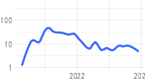
33 | 699 | ['military', 'science', 'propaganda', 'war', 'scientists', 'news', 'research', 'internet', 'civil', 'values'] | ['Im just grateful I live in a family where we all believe in science.', 'I truly believe that if there is a civil war, I will be on the opposite side as a lot of my family', 'Im sorry your family is so susceptible to anti-science propaganda.', 'Actually we come from a big military family.', 'My family was and still is science science science.', 'The sad thing is most of these people have family that served in the military.', 'We had a family friend who had served in the Navy during World War 2.', 'I come from a military family.', 'I need to explain that I come from a military family.', 'My older family members are from a time where any news story they saw was fact.'] | 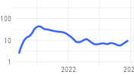
23 | 678 | ['mom', 'mother', 'grandma', 'aunt', 'mum', 'laws', 'dad', 'auntie', 'law', 'father'] | ['The only person in my family I talk to is my dad.', 'I had an aunt by law in a similar situation and all she ever wanted was a family.', 'I think we all here have/had friends or family just like your dad.', 'Your family should understand what your mom is into.', 'My family is this way with my aunt.', 'I am so sorry about your family, and mom especially.', 'Tell your mom to talk to my family about it.', 'Im so sorry you and your mom have this person in your family.', 'My mom and her family though?', 'Most of all, very sorry with situation with your mom and your family.'] | 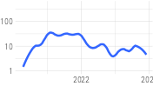
44 | 675 | ['fear', 'scared', 'worried', 'afraid', 'scary', 'terrified', 'responsible', 'responsibility', 'scares', 'obligation'] | ['This has me so worried about my family.', 'Im scared, but I know Im not getting anyone in my family back.', 'And scared to tell my family.', 'Im so worried about my whole family.', 'I think a lot of my fear too is that the rest of my family will think that I dont care about them.', 'I fear that I have lost my brother and his family due to this.', 'This is a fear I have with a lot of extended family members.', 'I fear for my friends and family there.', 'Im worried for your family.', 'I just get scared because Im so terrified of my family finding out.'] | 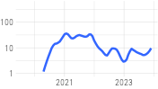
16 | 652 | ['court', 'lawyer', 'attorney', 'law', 'custody', 'judges', 'courts', 'legal', 'lawyers', 'judge'] | ['And get a great family law/divorce attorney.', 'Just 20 years of family law experience talking here... consult with a divorce attorney.', 'Others said this but call a Family Law attorney.', 'In a divorce/child custody family law case.', 'Contact a family law attorney.', 'Talk to a family law attorney.', 'I have a call in to a family law attorney.', 'Am family law attorney but not yours.', 'I am a family law attorney.', 'Family law lawyer here.'] | 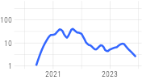 | 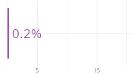
6 | 631 | ['vax', 'vaxxed', 'anti', 'antivax', 'vaxx', 'vaxxers', 'vaxxer', 'unvaxxed', 'antivaxxers', 'vaxed'] | ['Thankfully my family is not anti-vax.', 'I worry about my anti-vax family too.', 'nearly everyone in my family is anti-mask and anti-vax and everything else.', 'My entire family are and have always been anti-vax, and Ive never been vaccinated before.', '4 anti-vax family members got it.', 'I want to show this to all my anti-vax friends and family.', 'My family is very anti-vax.', 'Same with my anti-vax family.', 'His family is anti-vax.', 'Most of my family is anti vax as well.'] | 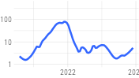
42 | 628 | ['abusive', 'abuse', 'delusions', 'abusers', 'violence', 'sexual', 'abuser', 'delusional', 'paranoid', 'child'] | ['So, I was a victim of childhood sexual abuse, by a family friend.', 'Sounds like you are in an abusive family.', 'You said your family was abusive before this.', 'a) you do no t want any further contact with abusive family members, and', 'I am so sorry you have such an abusive family.', 'My family was also abusive.', 'And that family was never abusive.', 'Child sexual abuse happens but it is almost always a family member or family friend.', 'Your family is abusive', 'My family had also always been abusive.'] | 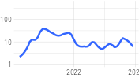
46 | 628 | ['help', 'intervention', 'trusted', 'shelter', 'emergency', 'shelters', 'interventions', 'services', 'teachers', 'resources'] | ['\\\\>Can I help my family?', 'Do you have family who can help?', 'Do you have any family that can help you?', 'It will help you and also your family.', 'Your friends and family will help you.', 'Reach out to us and your friends and family for help if you need it.', 'Get help from family and friends.', 'Do you have another family members you can reach out to help you?', 'If you have family you can talk to and get some help from, reach out to them.', 'Reach out to family and friends for help.'] | 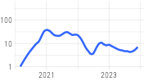
21 | 624 | ['mental', 'schizophrenia', 'illness', 'bipolar', 'health', 'psychosis', 'schizophrenic', 'disorder', 'psychotic', 'ill'] | ['I have a long history of dealing with mental illness in my family.', 'OP - is there a history of mental illness in your family?', 'Does anyone in your family have a history of mental illness?', 'No mental illness that I know of in the family.', '>We do have a history of mental illness in our family.', 'Theres a lot of mental illness in my family, like schizophrenia.', 'I have mental illness in my family.', 'We do have a history of mental illness in our family.', 'Any family history of mental health issues such as schizophrenia?', 'And mental illness (bipolar and schizophrenia) run in my family.'] | 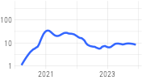
14 | 594 | ['addiction', 'alcoholic', 'alcoholics', 'addicts', 'addict', 'trafficking', 'annihilators', 'drug', 'sober', 'abductions'] | ['Have you considered joining al-anon, which is for family members of addicts?', 'Alcoholism or addiction is a FAMILY disease.', 'I also deal with drug addict family across the US.', 'Consider reading some books on Al-Anon - the literature for family members of alcoholics.', 'Do you not understand this the advice given to family members of addicts and alcoholics?', 'This is for friends and family of alcoholics and addicts.', 'No one else in the family has an addiction.', 'Not with my addiction and now, not with my family.', 'Have you ever considered Al-anon (the 12 step group for friends and family members of Alcoholics)?', 'We try to help our family that has alcohol or drug addiction and this is similar.'] | 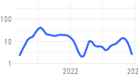 | 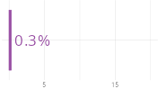
47 | 586 | ['ties', 'bonds', 'estrangement', 'important', 'relationship', 'relationships', 'boat', 'ocpd', 'memories', 'feathers'] | ['My family let me down so many times that I cut ties with the entire extended years ago.', 'I have had to cut ties with my own family.', 'Im sorry that you have to cut ties with your family.', 'Its hard to cut ties with family but you have to do what is best for you.', 'I know,because my family has cut ties with a lot of members,some we were close to.', 'It was hard for me to cut ties with my family but I had to.', 'I cut all ties with all family.', 'I cut ties with all of my family except my brother, years ago.', 'My family was already too far gone two years ago when I cut ties with them.', 'My mom has cut ties with some of her family because of it as well.'] | 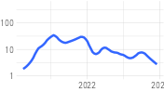
28 | 574 | ['happy', 'congratulations', 'thankful', 'congrats', 'glad', 'grateful', 'supportive', 'happiness', 'best', 'light'] | ['Happy for you and the family.', 'I am happy for you and your family.', 'I am so happy for you and your family!', 'Very very happy for you two and your family.', 'You friends and family must be happy to have you back', 'So happy for your family!!', 'Thank you and so happy for you and your family.', 'Im so happy for you and your family!', 'Your family will be so happy for you.', 'Your family must be so happy to have you back.'] | 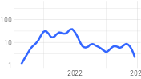
13 | 569 | ['racist', 'white', 'black', 'immigrants', 'asian', 'hispanic', 'racism', 'racists', 'mexican', 'race'] | ['I was born into a racist family.', 'I happen to be half Mexican, my dad and his side of the family are white.', 'My family was extremely racist.', 'His family is extremely racist.', 'Or they may sell to a Black family who then has to deal with the racist neighbor.', 'Love is in no way only black or white, especially with family.', 'His family isnt racist (theyre white and Im not) That is, until Trump came along.', 'My family is racist.', 'He and his family have always been racist.', 'As someone who is mixed race, I see it from both my Mexican family and my white family.'] | 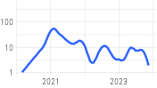
54 | 567 | ['wife', 'experience', 'rift', 'husband', 'husbands', 'normal', 'union', 'wifes', 'similar', 'fr'] | ['Anyone else with family like this?', 'I have family like this too.', 'ALL OF MY FAMILY IS LIKE THIS.', 'Your family might not get it, but I do.', 'Had to do the same with some of my family too.', 'I had to do this for myself and my family.', 'That has become one whole side of my family.', 'I had to do this with my whole family.', 'My family has done the same...', 'My family has done the same.'] | 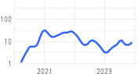
25 | 546 | ['jewish', 'holocaust', 'nazis', 'maga', 'nazi', 'fascist', 'german', 'semitic', 'fascism', 'fascists'] | ['My entire family is liberal and Jewish.', 'As a Jewish person with actual family killed in the Holocaust, thanks for pushing back.', 'My family is Jewish and conservative too.', 'Told me (a jew, who lost family in the Holocaust) that Im the same as a nazi for supporting BLM.', 'Half my family is Jewish.', 'It is totally anti Semitic my family are lost that my good friend just happens to be Jewish.', 'The man may not like Jews but has he ever spent a week with a Jewish family?', 'My family is Jewish.', 'I have Jewish family too!', 'Is your family Jewish??'] | 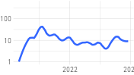
38 | 541 | ['support', 'supportive', 'network', 'glad', 'emotional', 'strong', 'need', 'community', 'group', 'additional'] | ['I hope you at least have support from friends or family.', 'I hope you have support from your friends and family.', 'I hope you can get support from friends and family.', 'I hope you have the support of family and friends.', 'Do you have some support within your family?', 'Your family and friends will be your support.', 'I know you are being supportive for your family but I hope you also have the support you need.', 'Do you have any support from friends and family?', 'Do you have a family or support system?', 'Do you have any support from family or friends?'] | 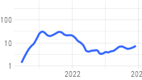
20 | 520 | ['police', 'sick', 'services', 'cps', 'domestic', 'cops', 'hotline', 'advocacy', 'divorce', 'restraining'] | ['If a family member cannot take them, please call your local police department.', 'Be there for your sick friend, or their family, if you can.', 'Only a sick person would do this to their family.', 'You can also call your local Children & Family Services for advice/file a report.', 'Report to family services?', 'Talk to family members first, see after for the police.', 'Call your family, call lawyers, call the police, call protective services.', 'I myself did report a family to CPS once.', 'Your family is sick.', 'Are there friends/ family members you can stay with if you want to report this to police or CPS?'] | 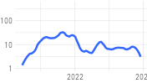
55 | 519 | ['devastating', 'exhausting', 'problem', 'worse', 'mess', 'sad', 'worst', 'problems', 'hands', 'carnage'] | ['I feel so bad for those who have family members in this.', 'Dealing with that in my own family.', 'Im dealing with this too with two family members.', 'It really sucks when this crap happens with immediate family.', 'We deal with it in my family too.', 'Your family sucks.', 'And its sucks that your family is like this but you just have to except it.', 'Sucks when its family though.', 'It really sucks when people put this crap over the well being of family.', 'Sounds like your family just sucks.'] | 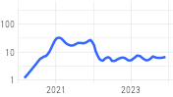
52 | 480 | ['cousins', 'adoptive', 'close', 'closest', 'uncles', 'siblings', 'breadwinner', 'blended', 'aunts', 'median'] | ['I have a family out here too.', 'I have my own family now, and they get all of me.', 'Was there for family.', 'Any other family?', 'I have some family.', 'Any family at all?', 'Do you see your family often?', 'I have other family.', 'You have any other family?', 'You have family.'] | 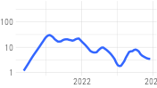
49 | 446 | ['conversations', 'conversation', 'cassette', 'room', 'table', 'communication', 'vague', 'laptop', 'towers', 'sibling'] | ['Were any family members trying to talk you out of it?', 'I havent spoken to my parents or any of that side of my family in 8 years.', 'I just dont talk to family like that.', 'Now I feel like I cannot even talk to my family.', 'I cant even talk to my own family or friends anymore - its just too much.', 'I have a few family members like this also which I dont talk to them .', 'No other family to talk with about this.', 'I dont talk to any of my family members.', 'Do you still talk to your family?', 'There is so much else to talk about with family.'] | 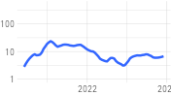
9 | 445 | ['dad', 'father', 'dads', 'fathers', 'grandfather', 'stepdad', 'manner', 'grandpa', 'monies', 'jurisdiction'] | ['You can still love your dad without loving his family, right?', 'I am so to hear this and I hope the best for your father and family.', 'I really hope your dad comes around as I hope my family does.', 'Your dad needs to know to protect you and your family.', 'Im so sorry for you, your family and your father.', 'Also - Im so sorry your family is doing this, especially at such a time with your father.', 'I am so sorry - for you, your family, and especially your dad.', 'Im very sorry for your dad, you & your family.', 'So sorry for the loss of your Dad and the rest of your family.', 'I hope your dad gets help and that your mother and other family are safe.'] | 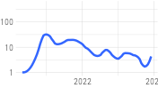
22 | 439 | ['therapist', 'therapy', 'counseling', 'therapists', 'counselor', 'trauma', 'counselling', 'psychologist', 'sessions', 'couples'] | ['Ask for help ~ see a therapist as a family.', 'I hope you are/were able to get therapy to talk about your trauma and your family.', 'Have you considered family therapy or marriage counseling?', 'What about family therapy?', 'Your therapist, your family and your friends.', 'Id recommend speaking to a therapist about this whole situation, maybe even family/couples therapy?', 'It may be just be a therapist, or maybe your family or friends.', 'Whether that be with another family member, friend, or therapist.', 'Get a family therapist.', 'perhaps family therapy?'] | 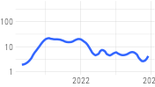
53 | 426 | ['estranged', 'closer', 'amazing', 'siblings', 'maternal', 'divorced', 'extended', 'close', 'years', 'decent'] | ['Me & my husband are both estranged from family- his, because of their politics.', 'Im estranged from my family because of this shit.', 'The rest of my family is estranged for the most part.', 'But it estranged me from my other friends and family.', 'I never thought I would be estranged from my family, we were so close!', 'I am estranged from all family now because they are just too crazy!', 'Parents have become estranged from family members.', 'It is. I was estranged from my own family for about a year when I was in it.', 'Why are you estranged from the rest of the family?', 'Is there a group for people with estranged family?'] | 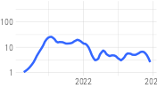
43 | 425 | ['grief', 'loss', 'alive', 'dead', 'painful', 'death', 'process', 'lesson', 'weight', 'pain'] | ['Mourn the loss of your family.', 'Best of luck mourning the loss of family while theyre still alive really sucks.', 'I mourn every day, and grieve for the loss and destruction of a once-happy family life.', 'I feel like Ive been grieving the loss of my family the past four years.', 'Ive been grieving the loss of my family for a year, my mom is especially hard.', 'You are grieving the loss of your entire family.', 'Sometimes we must mourn the loss of a family member who has not died.', 'Its like grieving the loss of a family member but they are still here.', 'You are grieving the loss of a family.', '> and you are mourning your family mourn the family you loved and move on.'] | 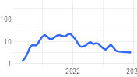 | 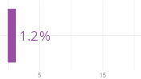
10 | 424 | ['brother', 'husband', 'fiance', 'son', 'ultimatum', 'uncle', 'ghosting', 'coroner', 'hubby', 'smartest'] | ['Your family needs to go no contact with your brother.', 'Your husband is your family, just be with him and take care of yourself.', 'Is the brother that you dont talk to still around your other family members?', 'I left my brother and his family at the same time, he is into it, too.', 'Your brother needs help and you and your family need to feel safe.', 'Your brother has a family and everything.', 'I am so sorry for you, your brother, his wife, your family.', 'I think you need to keep your husband away from your family.', 'Im sorry you, your brother and family are going through this.', 'Im so sorry for your husband to have lost his family like this.'] | 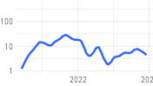
35 | 413 | ['story', 'nuts', 'stories', 'drip', 'sausage', 'fascinating', 'similar', 'derp', 'sums', 'phrase'] | ['Could you say that to your family?', 'I get this from my family a lot.', 'Your story sounds a lot like what is going on in my family.', 'Literally the exact story of my family / mother right now', 'I only heard this story once because no one in my family talks about it.', 'Just posted my own story recently and I thought my family was nuts but this is almost...', 'My family has a similar story.', 'There were a lot of family members on the story.', 'My family story is so similar.', 'So many have the same story with a family member.'] | 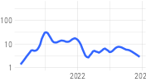
18 | 412 | ['toxic', 'justnofamily', 'toxicity', 'poison', 'raisedbynarcissists', 'pilots', 'healthiest', 'poisons', 'poisonous', 'dumping'] | ['Your family sounds really toxic.', 'That family sounds toxic.', 'Let go of toxic family members.', 'If there are toxic people in your life- family or not- then it is best to cut them out.', 'Sometimes you need to cut the toxic people from your life, even if they are family.', '(its a toxic family)', 'Toxic people are not family.', 'I have a very toxic family.', 'im sorry that you have such a toxic family', 'Toxic people should be cut out of your life, family or not.'] | 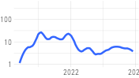 | 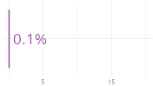
15 | 385 | ['trans', 'gay', 'queer', 'homophobic', 'lesbian', 'sexuality', 'transgender', 'bisexual', 'straight', 'binary'] | ['Some of my family is conservative and they dont speak about gay extended family members.', 'My family is the same and I am also bi,trans and closeted.', 'Hey girl, queer woman (she/her) here from a very conservative, largely anti-gay family.', '5. Gay agenda / trans plot to destroy the family', 'My own family were being extremely homophobic knowing I am gay.', 'And its when the gay couple family friend, came out as a woman.', 'If I was gay or trans, I have no doubts I would be kicked out of my family and excommunicated.', 'I have trans family members.', 'What if you have a child who is trans or gay or otherwise vulnerable into a family like this??', 'We have gay family members.'] | 