Problem 1

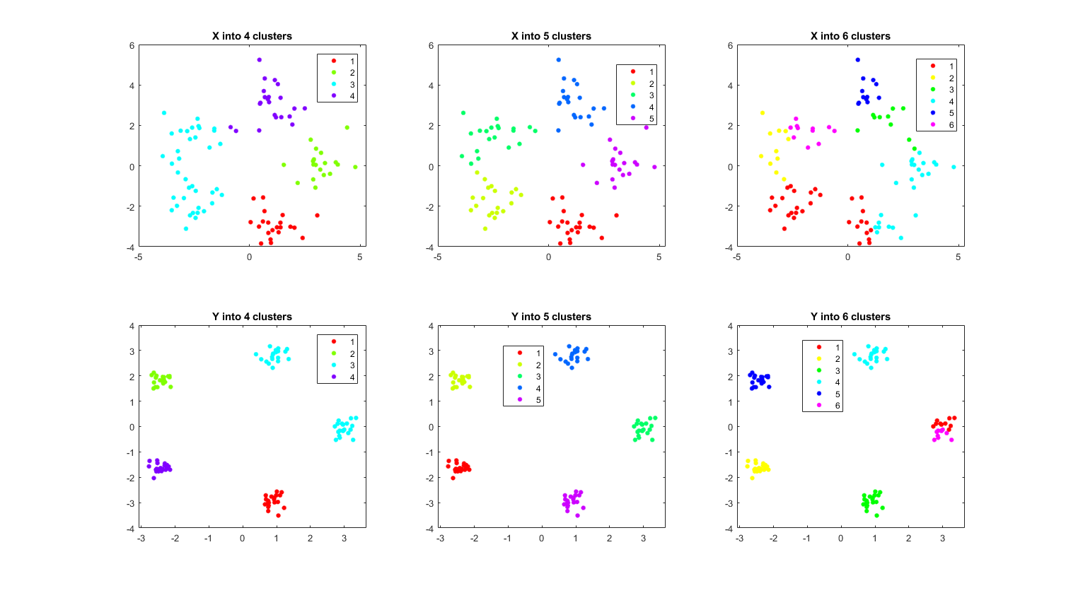

如上圖所示，X在分為4或5類的時候比較恰當，分成6類的時候會有如圈選處的錯誤；Y則是在分為5類的時候最為適合，由肉眼所見。

Problem 2

a)

|  |  |  |
| --- | --- | --- |
| K=2 |  |  |
| K=5 |  |  |
| K=10 |  |  |
| K=15 |  |  |
| K=20 |  |  |

b)

RGB:

|  |  |  |  |  |  |  |
| --- | --- | --- | --- | --- | --- | --- |
|  | Original | K=2 | K=5 | K=10 | K=15 | K=20 |
| Size(KB) | 92.4 | 81.2 | 93.1 | 93.0 | 94.1 | 93.6 |
| Ratio | N/A | 1.299% | -0.758% | -0.649% | -1.84% | -1.299% |

Grayscale:

|  |  |  |  |  |  |  |
| --- | --- | --- | --- | --- | --- | --- |
|  | Original | K=2 | K=5 | K=10 | K=15 | K=20 |
| Size(KB) | 213 | 58.1 | 75.8 | 73.5 | 72.1 | 73 |
| Ratio | N/A | 72.7% | 64.4% | 65.5% | 66.2% | 65.7% |

c)

RGB影像的壓縮比我想像中的低，只有在K=2的時候有正的壓縮比，但在K=2的情況下還不如使用灰階影像，所以好像沒有壓縮的必要。

灰階影像則是壓縮比都差不多，所以選擇K=20保留最多細節的即可。