**How to use the inflow turbulence module**

**Basic Requirement**

system: Ubuntu 14.04 LTS or above

software: OpenFOAM V6

**1. Installation of the inflow turbulence module in OpenFOAM**

(1) Install OpenFOAM V6 (details can be found at <https://openfoam.org/download/6-ubuntu/>);

(2) Create a project directory within the $HOME/OpenFOAM directory by typing:

mkdir -p $FOAM_RUN

(3) Copy the “inflowTurbulence” folder into the above folder by typing:

cp -r ./inflowTurbulence/ $FOAM_RUN

(4) Compile the codes in “inflowTurbulence” library by typing:

wmake

**2. How to use the inflow turbulence module in a CFD simulation**

For demonstration, let’s take the project “channel” in the attached files for example. There are three folders i.e. “0”, “constant” and “system” in this project.

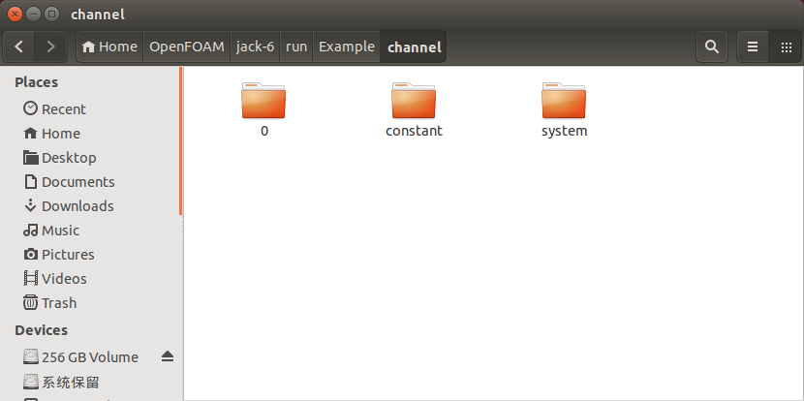

The “0” folder contain the initial and boundary conditions and for field variables like velocity, pressure and so on. The “constant” folder has files regarding to the mesh geometry information and flow constants such as viscosity. The “system” folder consists of files that define numerical schemes and computational parameters such as time-step size.

The developed inflow turbulence module could be regarded as a boundary condition for velocity. To implement it in a simulation, the first thing you need to do is adding:

libs("libturbulentInflow.so");

in the “controlDict” file contained in the “system” folder.

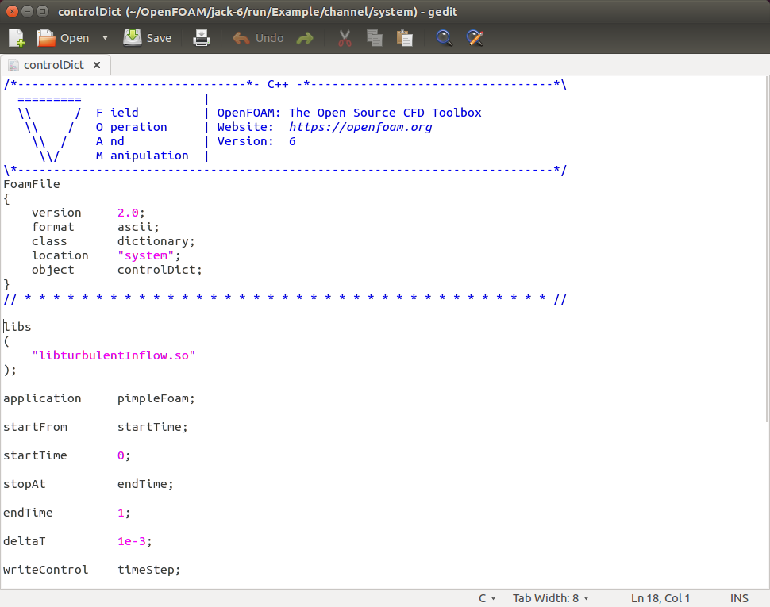

This allows system to include the library complied in the first step during a simulation. Next, you should edit the “U” file contained in the “0” folder and “inflowProperties” file in the “constant” folder in a specified manner. The details will be discussed next. In the “U” file, you will find a lot dictionaries and each dictionary contain a lot of parameters. Here we only focus on the dictionary named as “inlet” which contains all the parameters need to be specified for inflow condition.

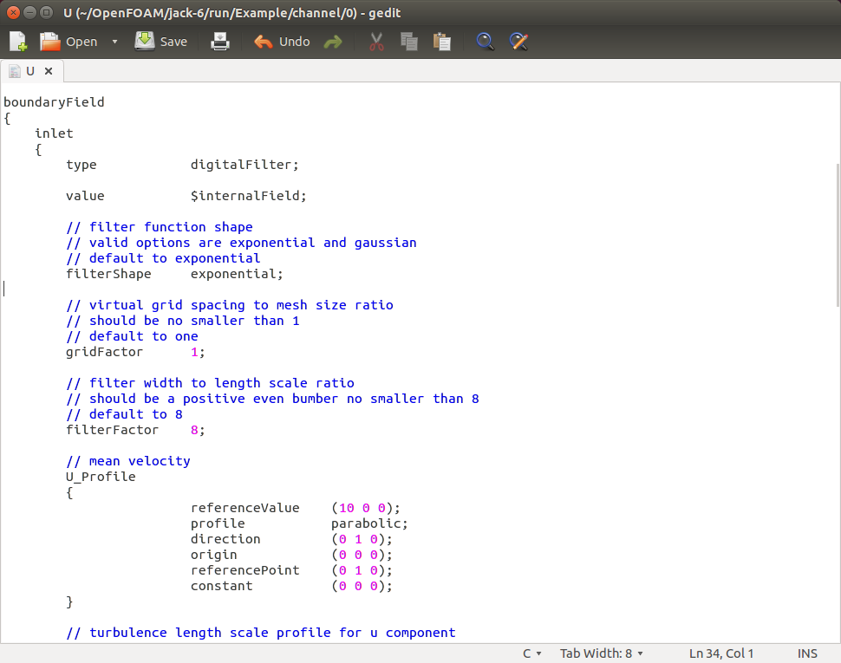

The first parameter need to be defined for “inlet” is “type”, the role of this parameter is to tell the system what kind of boundary condition you want use. Currently, the developed inflow turbulence module right now provides two options i.e. “digitalFilter” and “syntheticEddy”.

**Table 1 Basic Parameters**

|  |  |  |  |  |
| --- | --- | --- | --- | --- |
| **Parameter name (as displayed)** | **type (int, float, char, string)** | **known limits?** | **sensible default value** | **remarks** |
| type | string | "digitalFilter" and "syntheticEddy" |  |  |
| value | string |  | $internalField |  |

Once an option is chosen, there are some parameters related this particular option only. For “digitalFilter” method, they are “filterShape”, “girdFactor” and “filterFactor”; For “syntheticEddy” method, they are “velocityShape” and “eddyDensity”.

**Table 2 Parameters relates to the “digitalFilter” method**

|  |  |  |  |  |
| --- | --- | --- | --- | --- |
| **Parameter name (as displayed)** | **type (int, float, char, string)** | **known limits?** | **sensible default value** | **remarks** |
| shapeFunction | char | "gaussian" and "exponential" | exponential |  |
| girdFactor | float | >=1 | 1 |  |
| filterFactor | int | >=4 | 4 |  |

**Table 3 Parameters relates to the “syntheticEddy” method**

|  |  |  |  |  |
| --- | --- | --- | --- | --- |
| **Parameter name (as displayed)** | **type (int, float, char, string)** | **known limits?** | **sensible default value** | **remarks** |
| velocityShape | string | "gaussian", "tent" and "step" | "gaussian" |  |
| eddyDensity | float | >=1 | 1 |  |

Now let’s move on with the “inflowProperties” file in the “constant” folder, and you will find a list of dictionaries named as “U_Profile”, “Lu_Profile”, “Lv_Profile”, “Lw_Profile” and “I_Profile”. Parameters in these dictionaries describe the profile of the statistical properties of the target turbulence. In each dictionary listed above, the first parameter need to be defined is “profile” and valid options are “uniform”, “exponential” and “parabolic”.

For “uniform” profile, the only additional parameter need to be specified is the “referenceValue”; For “exponential” and “parabolic” profile, other parameters to be specified are “referenceValue”, “direction”, “origin”, “referencePoint” and “constant”. The “exponential” profile also has a parameter named “alpha” in addition to those listed above.

The parameters “direction”, “origin” and “referencePoint” are three dimensional vectors whereas “referenceValue” and “constant” have the same dimensions as the corresponding field variable. More specifically, “U”, “Lu”, “Lv” and “Lw” are three dimensional vectors while “I” along is a symmetric tensor.

**Table 4 Parameters that define turbulence properties at the inflow boundary**

|  |  |  |  |  |
| --- | --- | --- | --- | --- |
| **Parameter name (as displayed)** | **type (int, float, char, string)** | **known limits?** | **sensible default value** | **remarks** |
| profile | string | "uniform" "exponential"  "parabolic" | "uniform" |  |
| referenceValue | List<float> |  | List<0> |  |
| referencePoint | vector<float> |  | (0 0 0) |  |
| origin | vector<float> |  | (0 0 0) |  |
| direction | vector<float> |  | (0 1 0) | should be a unit vector |
| constant | List<float> |  | List<0> |  |
| alpha | vector<float> |  | (0 0 0) | Required for “exponential” only |

Once complete, one may carry out a CFD simulation via OpenFOAM as normal.