Restaurant Database Report

Olivier Bachand and Justin Bouffard
Champlain College Lennoxville
420-350-LE: Using Databases
Caroline Fortier
December 8, 2025
Contents
Database Creation 3
CRUD Operations (Queries) 4
Confidentiality, Authorization & Integrity 6
User Authentication 6
Authorization 6
Integrity Constraints 8
Stored Procedures & Automated Operations 9
Triggers 10
Backup & Restore 14

Database Creation
Explanation of how we created the tables:
Followed the ERD for all the table names and attributes. We also followed the attribution of the foreign and primary keys based on the ERD. For the on delete cascade, we used almost everywhere to prevent orphaned rows, except for the orders table. The goal is to allow the restaurant to always keep their orders history no matter what happens in the other tables. If an employee is deleted, for example, you don’t want the orders they made to be deleted in case you need the order history for other purposes.

CRUD Operations (Queries)
Explanation of how we made the CRUD operations:
For inserting 3 new menu items into the menu table, we used an INSERT statement specifying these values for each item: name, description, price, category_id, and is_available. There was no need to manually assign a primary key, since it was set to auto-increment.
For updating prices, we chose to put a 15% discount on main courses. To do so, we simply made an UPDATE statement in which we set the price to price times 0.85 where the category_id is equal to 2. This refers to the main course category.
For deleting discontinued courses, we just changed the is_available field to FALSE on items that are discontinued. We did this to keep a record of them even if they are not served anymore.
To place a new order with multiple lines, we put everything between a START TRANSACTION and a COMMIT. This way, if something fails, the statements that did work are reverted. It helps a lot with debugging. First, we inserted into the orders table, then we declared a @new_order_id variable that is set to the last insert using a built-in function. Next, we made an insert into the order_item table with multiple items. The order id was the @new_order_id variable. We also used subqueries to select item prices with their names. Lastly, we set the total_amount to the total of every order item that has the new order id using a subquery that selects the sum where the id matches.
To assign a delivery driver, we just made an insert in the delivery table with the new order id as the order_id, 3 as the delivery driver id, NOW() as the assigned time, and ASSIGNED as the status.
To change the status of that order, we made an update on the orders table and set the status to PREPARING where the id is equal to @new_order_id, which refers to the same order as before.
To list sales per day, we selected the order date from the orders table and the sum of total sales from the order_item table. We had to JOIN these two tables where the order id matched. We finished the SELECT statement with a GROUP BY to group all the sales by date.
To group them by category, we did something similar, except we selected the category instead of the date. To do so, we had to JOIN the following tables: order_item, menu, and category. This gave us access to the category name. We then grouped by category_name.
To delete an order, we first had to cancel it by updating the orders table and setting the status to CANCELLED on the order we wanted to delete. Then, we deleted from the orders table where the id was the same as the one we cancelled. This is to respect business rules.

Confidentiality, Authorization & Integrity

User Authentication
Explanation of how we created the users:
We created the three users: cashier_user, cook_user, and manager_user. For the hosts, we changed it based on the rights of the users. The manager can connect from anywhere (hostname:%), the cook can only connect from a machine on the local network (hostname:192.168.1.%), and the cashier can only connect from the selected machine (hostname:localhost). For their grants, we followed the same principles. The manager has all rights (ALL PRIVILEGES), the cook can see all tables (for work purposes) and only update the orders’ status (restricting their grants to only what they need to do), and the cashier can select and insert on all tables (be able to do modifications while working, for the cooks and rest of the restaurant after new orders).

Authorization
Show grants output for each user:
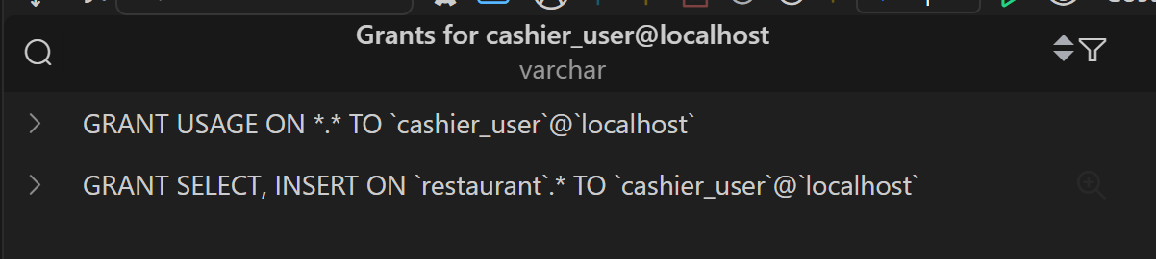
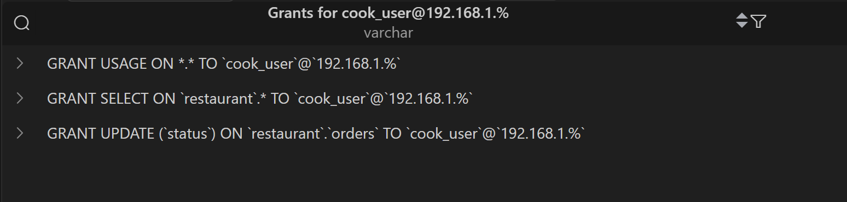
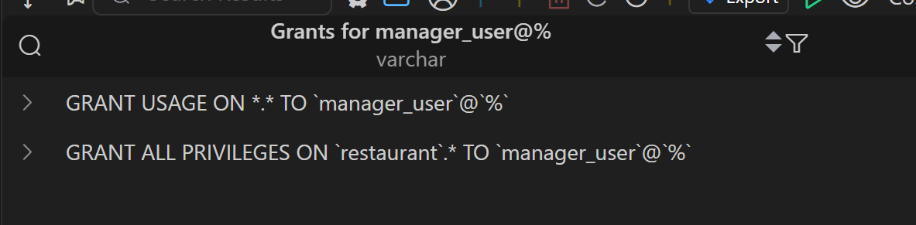
Screenshots of failed commands executed by users without permissions:
Cashier:
Cook:
Manager: Has all permissions

Integrity Constraints
Explanation of the integrity constraints we used:
We followed the integrity constraints already present in the ERD and added on delete cascade for foreign keys on all tables except for the orders table, for a reason we explained in Database Creation.

Stored Procedures & Automated Operations
Explanation of the operations:
Calculate total order price (sf_calculate_order_total):
This function calculates the total price of a single order. It has one parameter which is the id of the order you want to calculate the total price of. It declares a decimal variable called total, and sets it to the result of a query that gets the sum of the line totals of the order_items that have the correct order_id. Finally it returns the total variable. By getting the sum of the line totals, we get the total order price (adding all the prices of the items of the order together).

Validate if order can be cancelled (sf_can_cancel_order):
This stored function returns a Boolean that represents if the order can be cancelled. It takes an INT as an argument that represents the order_id that needs to be checked. It firsts declares a variable to contain the order status. Then, it selects the status of the order with the order_id into the status variable. It returns false if the status is equal to 'DELIVERED', 'CANCELLED', or 'OUT_FOR_DELIVERY', since users cannot cancel orders that are fully prepared, or already cancelled.

Mark order as delivered and timestamp it (sp_mark_order_delivered):
This procedure has one IN parameter that represents the order_id and its type is INT. It updates the orders table and sets the status to DELIVERED, and does the same with the delivery table, but also set the delivery_time to NOW().

Triggers
Explanation of the triggers with test case:
Automatically Update Inventory When an Item Is Ordered:
Purpose:
This trigger ensures that whenever a new order item is added, the system automatically deducts the correct quantity of ingredients from the inventory. This keeps stock levels accurate without requiring manual updates.
How It Works:
- The trigger runs after a row is inserted in the order_item table.
- It looks up all ingredients required to make the ordered menu item.
- It multiplies the quantity ordered by each ingredient’s required amount (quantity_per_unit) to have the correct amount to deduce.
- It reduces current_quantity in the inventory table accordingly.

Test Case (testing to see if the trigger works)
- Before inserting an order, we query the inventory to see the initial stock levels:
SELECT inventory_item_id, name, current_quantity
FROM restaurant.inventory
LIMIT 5;
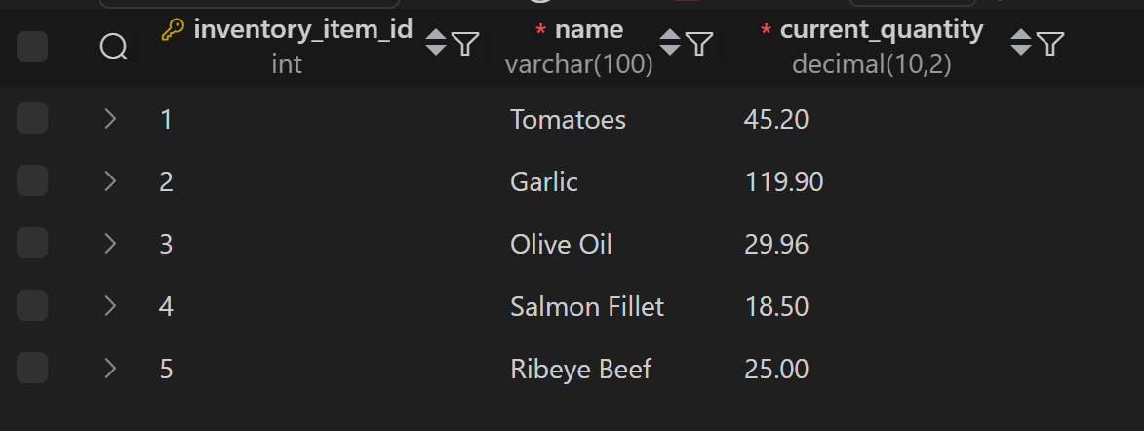

- We check the menu item ingredients to see which one should decrease and to be able to know how much it will decrease in the inventory:
SELECT menu_item_id, inventory_item_id, quantity_per_unit
FROM restaurant.menu_item_ingredient
LIMIT 5;
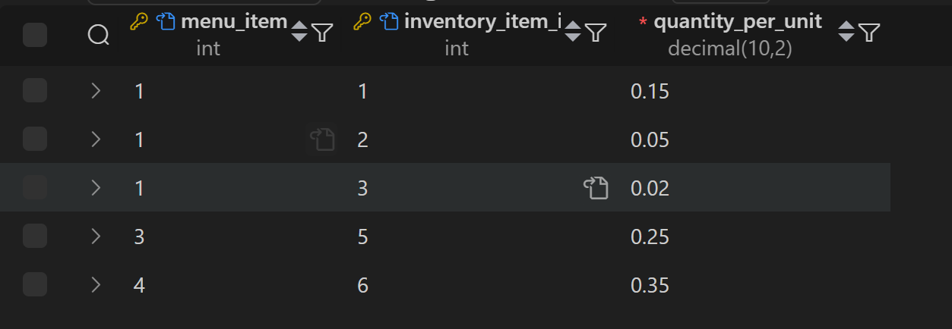

- We insert a new order item to trigger the inventory update:
INSERT INTO restaurant.order_item (order_id, menu_item_id, quantity, unit_price, line_total)
VALUES (1, 1, 2, 12.99, 25.98);

- After the trigger fires, we check inventory again:
SELECT inventory_item_id, name, current_quantity
FROM restaurant.inventory
LIMIT 5;
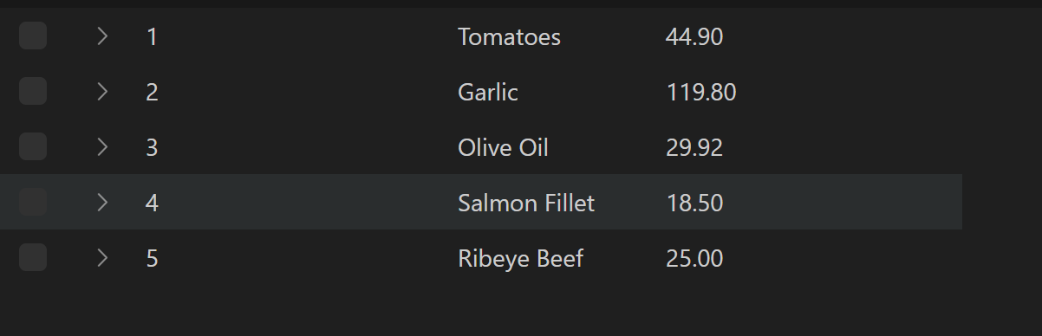
Expected Results:
- Every ingredient used by menu_item_id = 1 will have its stock reduced.
- (Example for tomatoes) New stock (44.90) = old stock (45.20) – (ordered quantity (2) × ingredient quantity_per_unit (0.15))
Prevent deletion of menu items that are part of active orders:
Explanation:
This trigger is executed before a delete on the menu table, because we want to prevent the deletion under certain circumstances, so we do it before. It starts by declaring a variable called active_order_count to store how many orders are using the menu item that is being deleted. A select is used to get the count of items where the menu item id is the same as the one being deleted and where the status is either PENDING, PREPARING OR OUT FOR DELIVERY. That count is stored into the variable. If the count is bigger than 0, then it throws an error , which prevents deletion of the item and prompts the user.
Test Case:
We simply try to delete a row from the menu table that is part of an active order:
After trying to delete:
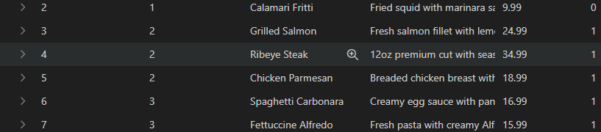
As expected, an error is thrown and the deletion was cancelled, because this item is part of an order that is out for delivery.

Backup & Restore
Commands used:
mysqldump -u root -p --databases restaurant > restaurant_backup.sql
mysql -u root -p < backups/restaurant_backup.sql
Screenshots of dump file:
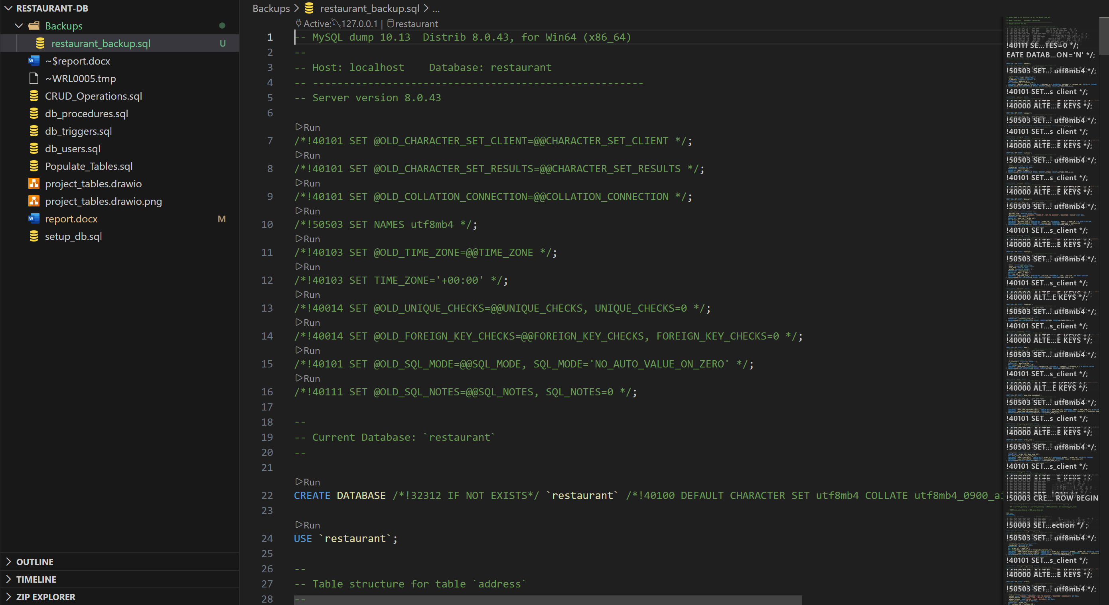
First 20–30 lines of the SQL dump:
-- MySQL dump 10.13 Distrib 8.0.43, for Win64 (x86_64)
--
-- Host: localhost Database: restaurant
-- ------------------------------------------------------
-- Server version 8.0.43
/*!40101 SET @OLD_CHARACTER_SET_CLIENT=@@CHARACTER_SET_CLIENT */;
/*!40101 SET @OLD_CHARACTER_SET_RESULTS=@@CHARACTER_SET_RESULTS */;
/*!40101 SET @OLD_COLLATION_CONNECTION=@@COLLATION_CONNECTION */;
/*!50503 SET NAMES utf8mb4 */;
/*!40103 SET @OLD_TIME_ZONE=@@TIME_ZONE */;
/*!40103 SET TIME_ZONE='+00:00' */;
/*!40014 SET @OLD_UNIQUE_CHECKS=@@UNIQUE_CHECKS, UNIQUE_CHECKS=0 */;
/*!40014 SET @OLD_FOREIGN_KEY_CHECKS=@@FOREIGN_KEY_CHECKS, FOREIGN_KEY_CHECKS=0 */;
/*!40101 SET @OLD_SQL_MODE=@@SQL_MODE, SQL_MODE='NO_AUTO_VALUE_ON_ZERO' */;
/*!40111 SET @OLD_SQL_NOTES=@@SQL_NOTES, SQL_NOTES=0 */;
--
-- Current Database: `restaurant`
--
CREATE DATABASE /*!32312 IF NOT EXISTS*/ `restaurant` /*!40100 DEFAULT CHARACTER SET utf8mb4 COLLATE utf8mb4_0900_ai_ci */ /*!80016 DEFAULT ENCRYPTION='N' */;
USE `restaurant`;

Screenshots of restore success:
Before drop:
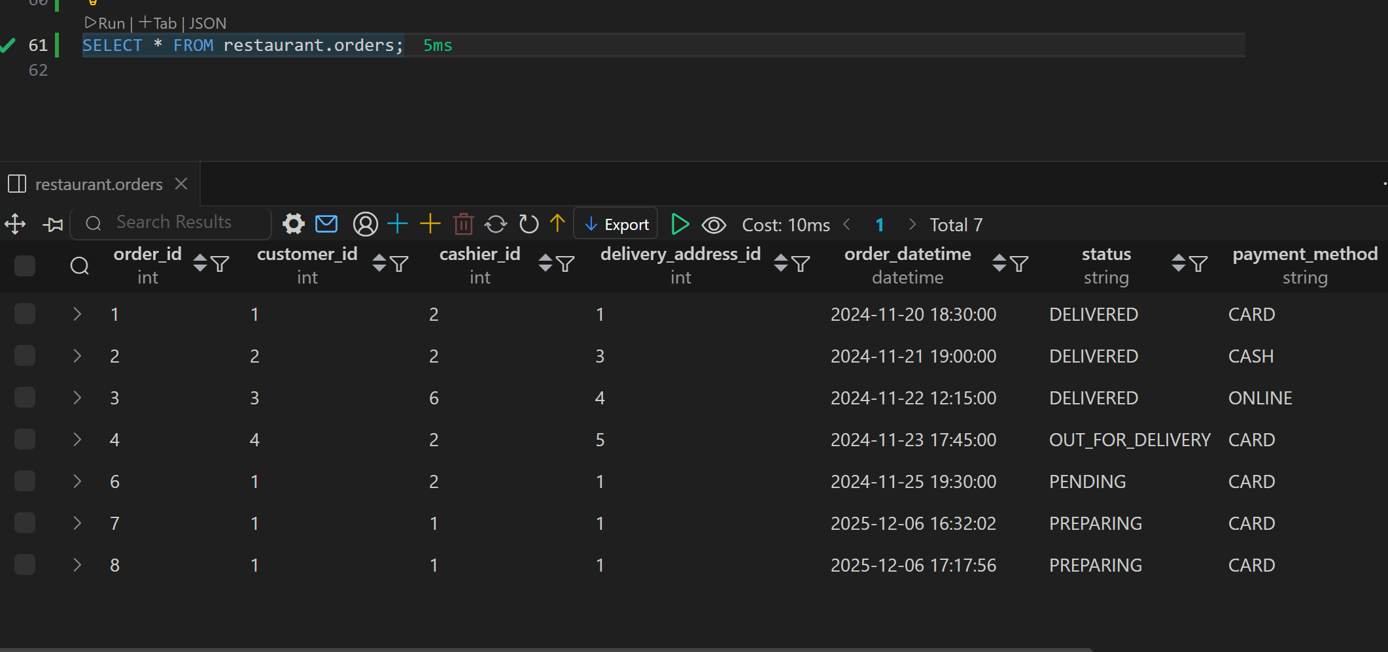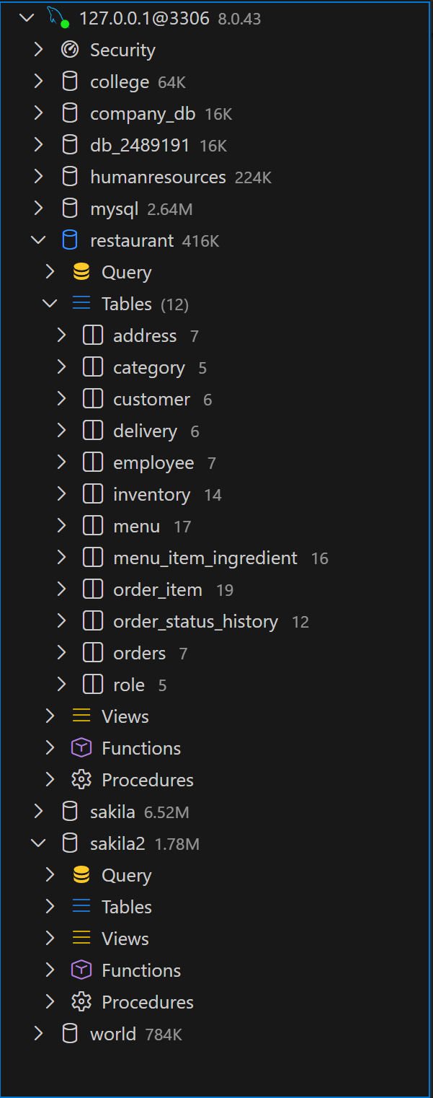
Before restore:
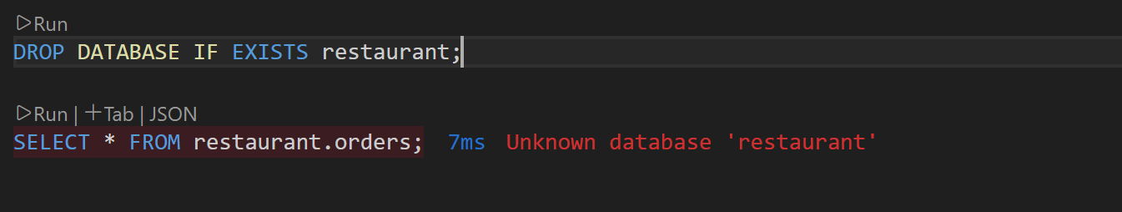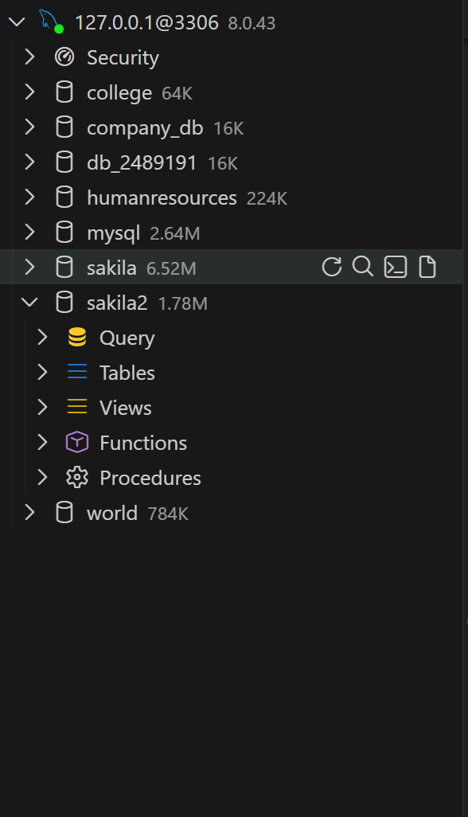
After restore:
