Sexual selection improves population fitness: a systematic review and meta-analysis

Response to Decision Letter

Dear Dr. Jones and colleagues,

Many thanks for your time, and for the very helpful comments on our manuscript. We have made many changes in light of the three reviewers’ detailed feedback, and we feel that the manuscript has been greatly improved. Please see the letter below for our detailed responses to each of the reviewers’ points. In addition to the revised manuscript and revised supplementary material, we attach a copy of the revised manuscript in which the significant changes and additions have been highlighted.

Yours Sincerely,

Justin Cally and co-authors

## Comments from Reviewer 1 (Prof. Jacek Radwan)

*The manuscript presents results of a meta-analysis assessing the effect of sexual selection on population fitness. This topic has been increasingly studied over the past decade or so, and the time seems ripe for a synthesis. The authors have done good job searching the literature – it includes all relevant papers I could remember, and the results should be of interest to a broad range of evolutionary biologists. I cannot expertly judge on state-of-the-art methodology, but I do have several general concerns about how the analyses were performed.*

Many thanks for your time and for you very helpful feedback.

*Firstly, it seems that several male traits like to be under sexual selection, but not related to population fitness were included. I don’t think this is correct given the question being asked (i.e. whether sexual selection increases population fitness). I think traits which are directly under sexual selection (eg. attractiveness, reproductive success) should not be pooled with traits which may respond to manipulation of sexual selection indirectly (eg. male development time, survival) and can affect population fitness. Distinguishing between both types of trait could actually be revealing – e.g. could expose trade-offs between sexually selected traits and fitness components unrelated to reproductive competition (see eg. Radwan et al. 2015 Evol Biol), a thus potentially explain lower effect of sexual selection on (pooled) male traits than on female traits.*

We completely agree that male attractiveness does not affect population fitness directly, and it is important to separate this trait from the “true” measures of population fitness in the meta-analysis. We do this more carefully in the revised meta-analysis. Specifically, in the original study, we classified male attractiveness as having an “indirect” relationship with population fitness (this is also how we classified traits such as body condition and life span; see Table S1 for a full breakdown). However on reflection, we think that attractiveness is only tenuously linked to population fitness, and so we have re-classified its relationship with population fitness as “ambiguous”, along with traits like “Immunity” and “Development rate”. Our main analysis excludes all of the ambiguous traits, and so our main results are now not derived from any effect sizes relating to male attractiveness. The exclusion of the n = 6 attractiveness effect sizes did not qualitatively change the results.

Additionally, we have split the trait “Reproductive success” into “Female Reproductive Success”, “Male Reproductive Success” and “Both Reproductive Success”, the latter from studies where offspring number was measured from a given male-female pair interaction. We have made this reclassification in recognition of the facts that these two fitness components are maximised very differently, and are likely to have differentially related to population fitness. Specifically, we maintain “Female Reproductive Success” and “Both Reproductive Success” as direct measures of fitness but class “Male Reproductive Success” as an ambiguous measure of fitness.

As one can see, this reclassification had minimal impact on the main findings of the study. And the results that the predicted effect size for female reproductive success is significantly positive, while non-significantly positive also align with our main findings that sexual selection on males leads to incrtease in female fitness components.

*Secondly, looking at Figure 1, one notices apparent anomalies, for example significantly positive slope for male attractiveness, based on studies with average effect size close to zero. I think this (and few others) surprising estimates may result from fitting random terms across all trait types (fitted as a fixed factor, second model); I guess fitting interaction (random slopes) would not be feasible for some categories including few data points, but some of them could easily be pooled in wider categories.*

For reference, we here present the result for male attractiveness that the reviewer mentioned. The table shows the estimate from the meta-analysis, and the figure shows the n = 6 effect sizes that underlie it, with the mean effect size plotted as vertical lines.

Model predictions for Male Attractiveness

|  |  |  |  |  |  |  |  |  |  |  |
| --- | --- | --- | --- | --- | --- | --- | --- | --- | --- | --- |
| Fitness Component | Bayes Prediction | Bayes SE | Bayes LCI | Bayes UCI | n | BF | REML Prediction | REML SE | REML LCI | REML UCI |
| Male Attractiveness | 0.302 | 0.14 | 0.031 | 0.59 | 6 | 5.8e+01 | 0.298 | 0.111 | 0.081 | 0.515 |

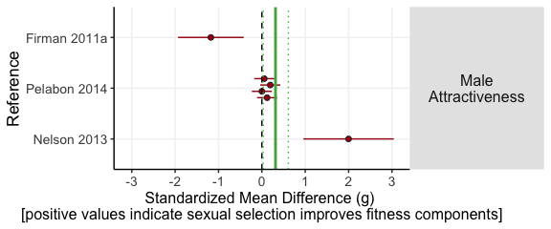

We agree that alone, these 6 studies do not provide strong evidence the mean is positive, although we note that some of the precisely measured effect sizes, and one of the imprecise ones, are positive, so this borderline significant result is not too anomalous.

Secondly, the effect size predictions were made using a single model that incorporated hundreds of other effect sizes, which allows the model is allowed to ‘share information’ between the different fitness measures. For example, if the overall mean effect size is positive, then smaller subsets of the dataset (like the attractiveness subset, with n = 6 studies) will tend to be made slightly more positive. That is, in the absence of precise information about the true average effect size for studies of attractiveness, the model uses some information provided by the global average.

To clarify the effects of sexual selection on ambiguous, indirect and direct fitness-related traits we have changed Figure 1 to a simpler style forest plot, with the forest plot now only found within the Supplementary Material (Fig. S1).

*Thirdly, type of trait measured explained 35% variance, but the authors do not explore this any further. However, examination of Fig. 1 suggest that some indirect/ambiguous fitness measures account for much of this heterogeneity and they generally have higher average effect sizes that direct measures (except for immunity). I’d like to see if the authors recover their main result if they only direct measures.*

In the manuscript, we culled the dataset to only include the “direct” and “indirect” measures of popualtion fitness (this decision was taken to maximise the use of the data). If we were to eliminate indirect measures, it would leave us with approximately half the number of “direct” effect sizes in our main analysis (n = 159 vs n = 289). To facilitate easy comparison, we present the new and old results below: one can see that two things have changed (in terms of statistical significance). Firstly, for the “direct only” model the predicted effect size for males in stressful environments is now significantly negative (*Hedges’ g* = -0.45; 95 % CIs = -0.70 to -0.19). However, because in the revised dataset we have reclassified male reproductive success as an ambiguous measure of fitness, there are only two effect sizes for males in stressful environments; making any conclusions drawn from this finding problematic. Secondly, the predicted effect size for females in benign environments in the “direct only model” are non-significantly positive, unlike the “direct and indirect” model, however, in both cases the positive effect of sexual selection on fitness is magnified for females in stressful environments. To avoid reader fatigue and low-powered predictions in our manuscript (we already chop and change the dataset in many different ways), we have retained the analysis to include both the “indirect and direct” measures. The graph on the right, and the table below show the main results recovered from only “direct” measurements for reference.

**Luke: Might need to argue use of both indirect and direct more.**

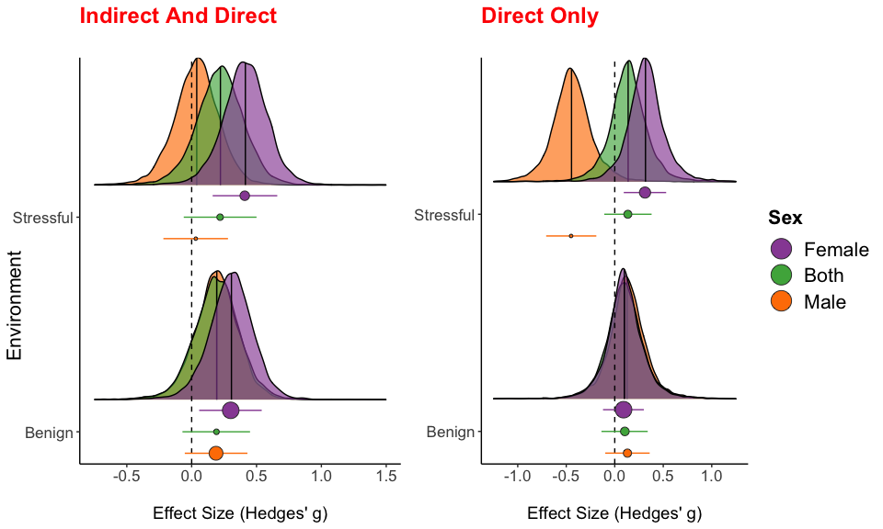

Model predictions using only direct measures of fitness

|  |  |  |  |  |  |  |
| --- | --- | --- | --- | --- | --- | --- |
| Sex | Environment | Prediction | SE | CI.lb | CI.ub | n |
| Male | Benign | 0.131 | 0.12 | -0.098 | 0.36 | 13 |
| Both | Benign | 0.104 | 0.12 | -0.137 | 0.34 | 15 |
| Female | Benign | 0.091 | 0.11 | -0.121 | 0.3 | 86 |
| Male | Stressful | -0.45 | 0.13 | -0.707 | -0.19 | 2 |
| Both | Stressful | 0.135 | 0.12 | -0.108 | 0.38 | 12 |
| Female | Stressful | 0.312 | 0.11 | 0.093 | 0.53 | 31 |

*Another major problem I have with the manuscript concerns interpretation of the very intriguing finding that the response to manipulation of sexual selection was stronger for female traits compared to male traits. I’m confused by the authors’ explanation: do they assume sexual selection acted directly on females, and not only indirectly, via males? Only then things like mother to daughter heritability, or hard selection on females, should matter.*

**Luke: Need to highlight in discussion where we put this in**

We agree that this section could have been much clearer, **and have made some changes in light of this comment to clarify what we meant**. We believe that experiments that manipuate sexual selection on males will alter female fitness traits, even in species where females experience no sexual selection, because of mechanisms such as intra- and inter-locus sexual conflict. That is, evolution in males will almost always have pleiotropic consequences for females, or change how males males affect females (i.e. sexual selection on males causes of evolution of males’ indirect genetic effects on females).

Consider for example the classic Holland and Rice-style experiment, where one removes sexual selection by enforcing random monogamy in a species with ‘traditional sex roles’, such as *Drosophila*. Males are predicted to evolve to be less harmful to females in these experiments, and they are also predicted to evolve a more female-like overall phenotype, due to the removal of selection on male-specific functions involved in sexual selection. Both of these male adaptations are expected to cause a genetically-based change in female traits: the former as a result of inter-locus coevolution (e.g. female resistance should evolve in response to the reduction in male-induced harm), and the latter as a result of pleiotropy between the sexes. We thus might predict that females would adapt even more than males if female traits have more genetic variation, or if selection is ‘harder’ on females than males. These explanations are speculative and *post hoc*, and so in the revision we are careful to identify them as such. Our result is arguably opposite to what one would predict, because naively one would expect sexual selection to have greater effects on the phenotype of males, and we now spell this out as well.

*Perhaps the effect on females is indeed direct, and results from stress imposed by polygamous treatment, which magnifies direct, hard selection on females? This would be an important finding, and perhaps the authors could test it with their dataset by contrasting middle-class-neighborhood-like studies from those which allowed for female evolution. But if correct, this explanation is not exactly the effect of sexual selection, but rather enhanced selection of females due to enhanced (male induced) stress, so the interpretation of results should change.*

Unfortunately, too few studies have manipulated sexual selection (independently of *all* selection) using the middle class neighborhood design for a reliable test. However we did collect data on how sexual selection was manipulated: many studies imposed random monogamy, but other studies instead manipulated the adult sex ratio (e.g. 3 males 1 female, 2 of each, or 3 females 1 male). In the revised manuscript we now included “manipulation type” as a two-level moderator. We find no effect of manipulation type on effect size, suggestion that both ways of removing sexual selection had a similar effect on population fitness traits. See the revised Table S10.

**Other comments:**

*l. 30 – reviews on sexual conflict are OK to cite here, but there are empirical papers actually demonstrating correlation between male sexual selected traits (Harano et al. 2011; Plesnar et al. 2014) which should also be cited.*

Thank you, we have added citations of those papers as suggested.

*l. 151 – the authors discuss beneficial effects of sexual selection on direct fitness measures such as reproductive success or offspring viability, but estimates for both of these measures actually overlapped zero! Perhaps joint analysis of direct fitness measures, as I suggested above, could support this conclusion, but currently this is an overstatement.*

Thank you for catching this – we have tempered our conclusions in the relevant section of the Discussion, since the results provide only moderate evidence for a positive effect.

*In the discussion the authors say they included the number of experimental evolution generations, but I could not find this information in methods.*

For relevant results, please see the section of the results that reads “Other moderator variables that we examined had minimal impacts on effect size (Figure S2, Table S10). Specifically, effect size did not depend on whether or not the study was conducted blind (Figure S6), nor on the number of generations for which the experimental evolution study was run (Figure S7, S8).” In the methods, we wrote “Additionally, we collected details for each effect size on: sex (male, female or a mixed sample of both), taxon (flies, beetles, mice, nematodes, mites, crickets and guppies), blinding of researchers to treatments and number of generations a treatment group underwent experimentally evolution.”

*Fig. S1 is not referred to in the main texts, is it different from Fig. 2, except that the latter contains predicted average values for fitness components?*

Our supplementary material does indeed contain all of our main figures, in order to show the data and code used to generate them. We have changed the numbering of the supplementary figures, so that e.g. Figure 1 in the HTML supplement is correctly labelled as Figure 1 and not as Fig. S1, to make it clear that it is the same figure.

## Comments from Reviewer 2

*This meta-analysis investigated the consequences of sexual selection experiments on trait mean and variance (comparing sexually selected groups vs control groups). Overall, the authors observe sexual selection usually increase mean and reduce variance (especially in females). The authors conclude sexual selection’s benefits outweigh its detrimental effects. This meta-analysis is extremely well conducted (the use of both likelihood-based and Bayesian models for robustness), and although I am not an expert on this topic, I really enjoyed reading it, and it was very clear. Especially, I am impressed with the detailed supplement which showed the code and analysis. However, I have several comments regarding their analysis, which will increase the robustness of results and thus conclusions.*

Many thanks for your time and attention, and for the valuable feedback.

*1 — The use of Hedges’ . I understand that Hedges’ was probably used because it can take interval measurements as well as ratio measurements (lnCVR can only take ratio measurements). However, cannot really deal well with heterogeneity between two groups (i.e. experimental and control groups having different variances). This is why Hedges’ (Cohen’s ) was criticized earlier.*

Osenberg, C. W., O. Sarnelle, and S. D. Cooper. 1997. Effect size in ecological experiments: the application of biological models in meta-analysis. 150:798-812.

*As a response, they come up with log response ratio (lnRR) - see*

Hedges, L. V., J. Gurevitch, and P. S. Curtis. 1999. The meta-analysis of response ratios in experimental ecology. 80:1150-1156.

*I recommend that the authors use lnRR for their effect size for mean comparison as well as Hedge’s to see the robustness of their conclusions for the mean.*

After reading those references, we agree that Hedges’ *g* is imperfect, and so we checked the robustness of our meta-analysis using two alternative measures of effect size. Firstly, we present the log response ratio (*lnRR*) as suggested by this reviewer. Secondly, we present a modified version of Hedges’ *g* that attempts to account for this heterogeneity issue (Bonett 2009), named SMDH (standardized mean difference with heteroscedastic population variances in the two groups). There are several key findings from our new analyses using lnRR and SMDH:

*Firstly*, we found that Hedges’ *g* and SMDH are highly correlated (in means and variance). This suggests that unequal variance between the treatment and control groups (heteroscedasticity) in the primary studies we examined is probably too small to greatly influence Hedges’ *g*, which is interesting for the interpretation of earlier meta-analyses using Hedges’ *g*.

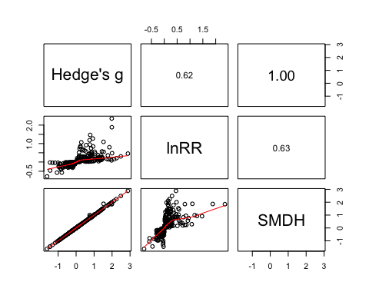

*Secondly*, we note that lnRR and SMDH can only be calculated in cases where the primary study reported means, standard deviations and sample sizes (352 out of 459 primary effect sizes). This is a limitation of lnRR and SMDH, as we must discard roughly 25% of the data in order to use them instead of Hedges’ *g*. We therefore think it is best to focus primarily on Hedges’ *g* despite its minor limitations, and to use lnRR and SMDH for sensitivity analysis in the online supplementary material.

|  |  |  |  |
| --- | --- | --- | --- |
| Sex | Environment | Hedge’s g sample size | lnRR sample size |
| Male | Benign | 83 | 73 |
| Both | Benign | 15 | 12 |
| Female | Benign | 125 | 110 |
| Male | Stressful | 12 | 8 |
| Both | Stressful | 18 | 6 |
| Female | Stressful | 36 | 27 |
| Total | - | 289 | 236 |

*Thirdly*, if we conduct a meta-analysis using lnRR as the effect size we obtain very similar results with all our main conclusions unchanged, keeping in mind that lnRR and Hedge’s are on different scales (see the revised Supplementary Material). Specifically, + The effect of sexual selection on population fitness is generally positive. + This effect is magnified for females in stressful environments with a significantly positive interaction term (stress*females).

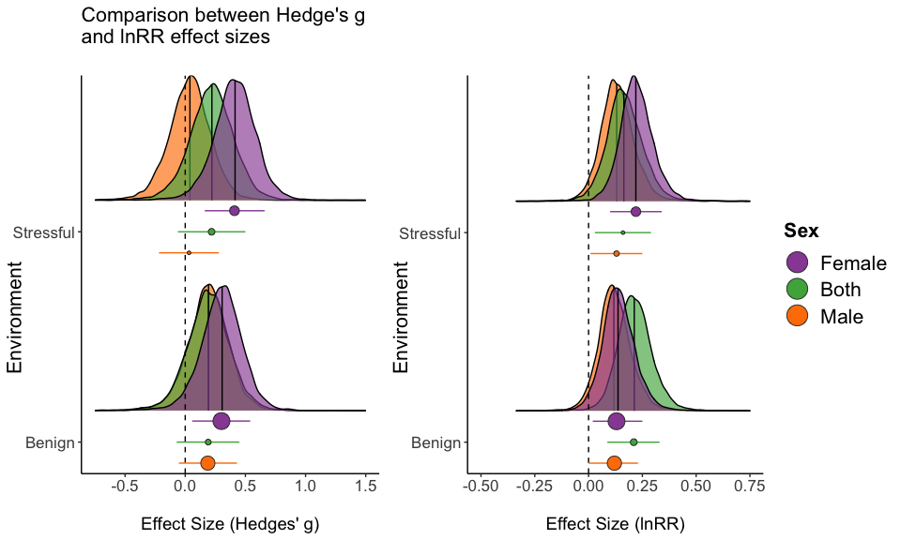

*Fourthly*, the distribution of the lnRR effect sizes is non-normal (notably moreso than the distribution of Hedges’ *g*), perhaps because one can get extreme values when taking a ratio (e.g. if the denominator is close to zero). Accordingly, Lajeunesse (2015) showed that *lnRR* is problematic when quantifying the outcome of primary studies with small sample sizes, and can yield unsuitable variance estimates when the parameter scale of the study are close to zero. So, Hedges’ *g* has the possible practical advantage of increasing model fit in our meta-analysis.

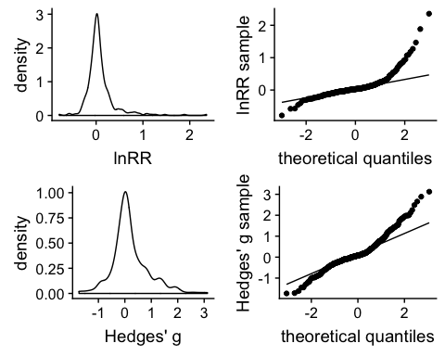

*2 — The authors may consider also doing another set of meta-analyses using lnVR (log variability ratio - proposed in Nakagawa et al. 2015).*

Nakagawa, S., R. Poulin, K. Mengersen, K. Reinhold, L. Engqvist, M. Lagisz, and A. M. Senior. 2015. Meta-analysis of variation: ecological and evolutionary applications and beyond. 6:143-152.

*As one can see in Figure 2, the mean results (Hedges’ ) are a mirror image of the variance results (this makes sense CV controls for means). I would like to see what the absolute change in variances. Probably the authors can put the analysis using lnVR in the supplement. The results of this analysis can be discussed. Also, the mean-variance relationship between mean and variance (sd) should be verified (e.g. plot log mean and log sd or log variance).*

Many thanks – we have now also present a meta-analysis of variation using lnVR in addition to one using lnCVR. We have the following comments on this new analysis:

*Firstly*, as the reviewer suggested, we now justify our use of lnCVR as opposed to lnVR, by assessing the mean-variance relationship in our data. The major limitation of lnVR is that it does not account for the mean-variance relationship; indeed this is why lnCVR has been recommended over lnVR (Nakagawa et al. 2015). We indeed found a strong positive correlation between mean and variance, suggesting that we should indeed lnCVR and not lnVR.

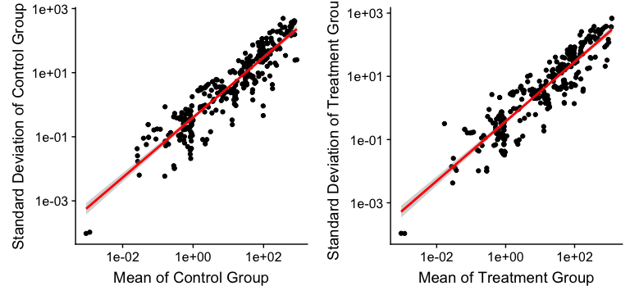

Although we think that *lnVR* is not preferable due to this positive relationship, we ran our meta-analyses using *lnVR* in the interests of completeness. We present this new result in the supplementary material and briefly discuss it in the manuscript. To summarise, we found very similar patterns, although the statistical significance some of the results have changed; see the following figure:

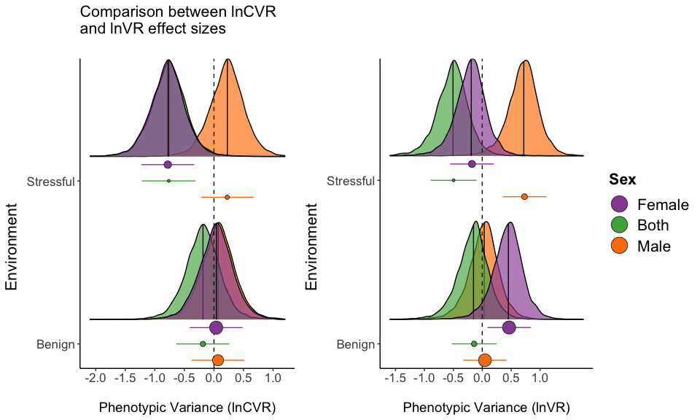

*3 — needs to be explained. is proposed originally here:*

Higgins, J., and S. Thompson. 2002. Quantifying heterogeneity in a meta-analysis. 21:1539 - 1558.

*But later expanded in here for mixed models (hierarchical models)*

Nakagawa, S., and E. S. A. Santos. 2012. Methodological issues and advances in biological meta-analysis. 26:1253-1274.

*This is what the authors use. Also, it will be good to put the degree in I^2 in the context. To do this see this paper:*

Senior, A. M., C. E. Grueber, T. Kamiya, M. Lagisz, K. O’Dwyer, E. S. A. Santos, and S. Nakagawa. 2016. Heterogeneity in ecological and evolutionary meta-analyses: its magnitude and implications. 97:3293-3299.

Many thanks for this feedback – we have incorporated all these suggestions in the Methods section.

*4 — Publication tests have been conducted on, I think, “meta-analytic” residuals results as suggested in Nakagawa and Santos 2012. One could use such residuals to conduct the trim and fill method and see how much the mean could move (see Nakagawa and Santos 2012). One should remember the funnel asymmetry could be caused by the presece of heterogeniety. See:*

Egger, M., G. Smith, M. Schneider, and C. Minder. 1997. Bias in metaanalysis detected by a simple, graphical test. 315:629 - 634.

Thanks – we now remind the reader that funnel plot asymmetry is not decisive evidence for publication bias, because it can also result from unexplained heterogeneity in the original effect sizes. We have elected not to implement trim-and-fill since the method seems to have fallen into disfavour among many readers, and because we are unsure how to correctly implement it using the REML- and Bayesian methods we used. NB that there is no method for trim-and-fill in mixed meta-analysis in the popular R package metafor (which we used), suggesting the method is not simple to implement.

*5 — Figure 3 - are these grey envelopes 95% CI?*

Yes, and we have now included this information in the figure caption. Thank you for highlighting this.

*6 — the title - do the authors include “a systematic review” - so “a systematic reveiw and meta-analysis” - these two things are diferent - see:*

Nakagawa, S., and R. Poulin. 2012. Meta-analytic insights into evolutionary ecology: an introduction and synthesis. 26:1085-1099.

We agree, and we have changed the title to “Sexual selection improves population fitness: a systematic review and meta-analysis”.

*Hope my comments are useful.*

Very useful, thank you!

## Comments from Reviewer 3

*This manuscript addresses the question of whether, on average, sexual selection has a net beneficial or detrimental effect on population fitness, using a meta-analysis of experimental evolution studies comparing the fitness of populations under different intensities of sexual selection. The analyses consider the effects of sexual selection on both the mean and variance of population fitness, and test whether these effects differ for stressful vs. benign environments, or depend on the measure of population fitness.*

*These are issues of longstanding interest, and as there is now quite a wealth of experimental evolution studies addressing these questions a meta-analysis synthesising their findings is timely.*

Many thanks for your time and attention, and for the valuable feedback.

*The results of this meta-analysis broadly concur with current theoretical predictions, and are likely to interest a wide readership. Across all studies, environment types and fitness measures there was a small positive effect of sexual selection on mean population fitness, although effect sizes varied with the fitness measure used. The positive effect of sexual selection on fitness was strongest for females in stressful environments, who also showed reduced variance in fitness under sexual selection.*

*The authors discuss these findings thoughtfully, although they focus more on the (weaker) effects found for ‘direct’ measures of fitness while somewhat neglecting the effects seen for ‘indirect’ fitness measures (e.g. of attractiveness, mating latency, lifespan, ejaculate traits). These potentially deserve more consideration, especially as many appear to be male-limited traits or measured mainly in males, that would appear to have a direct bearing on male mating success (if an indirect link to overall fitness), yet despite this the overall effect of sexual selection on male fitness is not significant.*

Please see our earlier response to Prof. Radwan: we do not consider male mating success (and related traits) to be correlates of population fitness, which is why the results differ between our strict analysis and the one that includes all the traits. Additionally, we chose to spend more time writing about the “direct” effects because our main focus is on population fitness. We agree that our secondary results are interesting as well, but we wanted to keep the manuscript focused and concise. Also, there is no theoretical controversy over how sexual selection should affect traits like male mating success; by contrast, the relationship between sexual selection and population fitness is contentious.

*I have only a few more specific comments:*

*Does your approach consider variation in the intensity of sexual selection exclusively on males? This is worth noting (e.g. statements such as that on line 98-99 might be amended to “Sexual selection on males significantly improved female fitness.”)*

Yes, we now also stress that we consider sexual selection on males, as suggested (changes are made throughout the manuscript).

*Experiments manipulating the sex ratio to alter sexual selection might simultaneously decrease sexual selection on males while increasing sexual selection on females. Would this be classified as reduced sexual selection in your analyses? I don’t think you included this aspect of study design as a moderator variable in any of your analyses – given that close to half of the effects you include come from “alternative manipulations” (line 70) perhaps you could test whether this affects effect size?*

Some of the studies used the enforced monogamy design (as in Holland and Rice 2002), where one compares monogamous family groups with polyandrous ones (i.e. multiple males and one female), and so these manipulate sexual selection on males only, and eliminate sexual selection on females. Others instead manipulated the adult sex ratio (e.g. 3 males 1 female, 2 of each, or 3 females 1 male); these studies manipulate sexual selection on both sexes simultaneously. For the latter type, we considered the strength of sexual selection on males to be variable of interest, though it is confounded with the strength of sexual seleciton on females. To test if there was any difference in the effect sizes induced by these two types of manipulation, we now include ‘manipulation type’ (named “Enforced.Monogamy” in the Supplementary Material and R code) as a moderator variable: there was no effect in our preliminary model (**see above comment to Reviewer 1 and the revised Table S10**).

*It seems possible that sexual selection on females, and not only on males, could affect population fitness – potentially even more directly than sexual selection on males. And might differing extents of sexual selection in each sex interact with the differences you saw in fitness measured in males vs. females?*

It is possible that sexual selection on females on affects population fitness, although to our knowledge no-one has considered or modelled this before. Also, we are not a aware of any experiments that have manipulated the opportunity for sexual selection on females independently of any other factors (e.g. sexual selection on males; see above comment). So, we have opted not to discuss or analyse this further, as we think the data do not yet allow for a robust test.

*L111-118 It seems a little odd that there is no residual heterogeneity in your estimates. From the supplemental information it is not entirely clear to me how you have adapted the function that is under development in “metaAidR”, but can you double check that you have appropriately incorporated the residual variance into these estimates?*

The results are odd, however to the best of our knowledge they are accurate. The REML model estimates the variance component () of the “taxon” random effect as very low (3.38e-09), compared to the other random effects (“Study ID”" = 1.93e-01 and “fitness component” = 1.28e-01). A low value for is the reason is estimated as zero. A potential reason for low heterogeneity is that there are only six taxon levels (campared to 53 studies and 13 fitness components).

**Check this please Justin - I could not see what you changed in the R script** **Luke: I think the function was still in dev when i forked it and there was a bug that stopped in allowing me to get I2 for all three random effects (only last two), I changed the code so it recognised all three random effects. Not sure if the answer I provided makes sense**

*L307-311 Please clarify here that lnCVR was calculated as the ratio*

We now clarify this as suggested.

*Fig. 3 Please explain the dashed red and black lines in the figure caption.*

We now clarify the confidence intervals on the funnel plot as suggested.

*Tables 1, 2 Please check – the parameter estimates for ‘Female sex’ and test for ‘Female > Male’ are bolded inconsistently between the REML and Bayesian models where these estimates are identical.*

The revised manuscript no longer has this disparity between REML and Bayesian estimates. However we noticed that Bayesian estimates had slightly wider confidence intervals than REML models leading to differences in statistical significance (e.g. Table S6).

# References

Bonett, Douglas G. 2009. “Meta-Analytic Interval Estimation for Standardized and Unstandardized Mean Differences.” *Psychological Methods* 14 (3). American Psychological Association: 225.

Lajeunesse, Marc J. 2015. “Bias and Correction for the Log Response Ratio in Ecological Meta-Analysis.” *Ecology* 96 (8). Wiley Online Library: 2056–63.

Nakagawa, Shinichi, Robert Poulin, Kerrie Mengersen, Klaus Reinhold, Leif Engqvist, Malgorzata Lagisz, and Alistair M Senior. 2015. “Meta-Analysis of Variation: Ecological and Evolutionary Applications and Beyond.” *Methods in Ecology and Evolution* 6 (2). Wiley Online Library: 143–52.