10/20/2018

Road Traveler app PRD

Justin Cheng, Peter Cheng

# Vision

For our current customers that are regularly planning road trips within the United States, they need an application that can help them to find interesting locations by category based on their choices. Our product is a new trip planner that provides a detailed search by category while the trip is ongoing. Unlike Google and TripAdvisor, we are a combination of those two.

# Motivation

## Unmet Needs

I believe some families or people find out its time-consuming and difficult when planning a complete road trip with the sites that they can drive through to their destination without diverge their main route and interested in.

## Customer Segmentation（Persona）

### Possible Users:

Possible Users are usually going on road trip once or twice a year, they are either travelling with few friends or with their family. Most of our possible users indicated that they need to run Google maps to search for the route then use either TripAdvisor or its equivalence to find interesting locations for them.

### Possible attractions

Attraction hotel or other paid facilities need to attract new customers, usually restaurants and accommodations. Currently we don’t have any actual hotel or facility owner to discuss with this issue however I believe they are willing to pay for small ads like this to promote themselves.

### Existing Solutions

The most common existing solution for the people that plan to have a road trip is whether search on the google map personally or ask friends about the places they’re interested in and see if that’s on their road trip route. If yes, they’ll put them on the map and plan the route that passing through all these places. And when they’re on their way and want to see if there are some nearby places they want to visit, they’ll simply use google map to guide them there.

# Use Cases

Persona

### Family Man Eric

#### Eric has a happy family with two kids. Between their mortgage, car payments and saving for their children’s education, Eric schedules at least one annual road trip with the family. He is willing to pay a small fee for a better planner rather than go through the trouble with Google Maps and TripAdvisor and dealing with multiple files of interesting location’s information. He also needs an easier way to find kids-friendly locations.

### College Student Sam

### Sam is a college student that enjoys going on road trips, at least once a month. He uses TripAdvisor or Mafengwo (an equivalence of TripAdvisor) for getting reviews on hotels and resorts and Google maps for Navigation and planning his route. Sam enjoys going to beautiful lakes, ocean and waterfall view because it attracts him the most.

Eric wants to plan a long weekend with his family and kids, and this year they wanted to go back up to Door county from Milwaukee again for a family trip. Instead of doing through research and print the itinerary out, Eric just takes out his phone, searched the best route between Milwaukee to Door county with three categories within his mind, Children’s attractions, Points of interests and Outdoor activities. Eric clicked and unselected those spots they’ve been before, then he saves the trip into his profile.

## 

Sam loves to go hiking with his friends. They find hiking spots with beautiful ocean and lake view or waterfalls all the time. They are planning their next hiking trip to Rainier National Park, but they want to find some spots that requires some outdoor hiking to get to the photo opportunity while getting some actions since they are all hiking enthusiasts.

## 

# Detailed design & Features Description

## Design Principles

## Features/Information Architecture

## MVP

# User Walkthroughts: Visual Use Case Walkthroughs with comments

# roadmap/timing

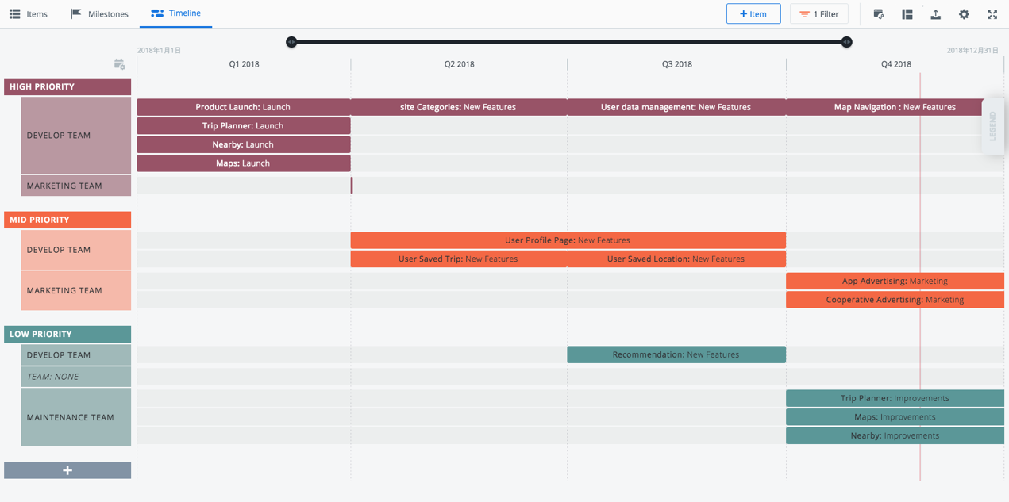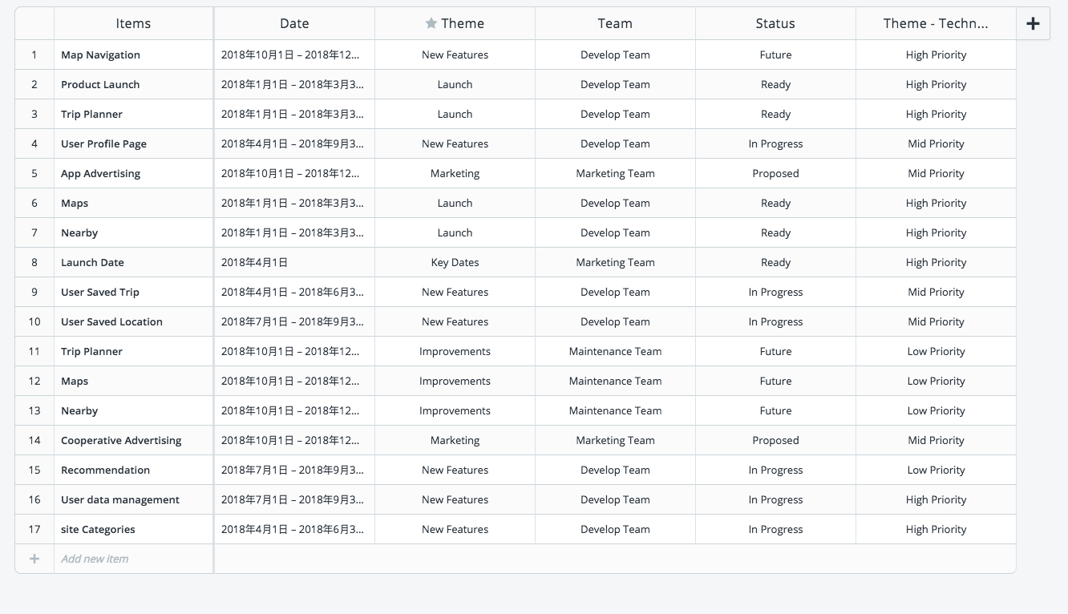

# Metrics

# International

# Projected Costs

# Operational needs

# Caveats/Risks

## Interdependencies with key internal systems: The key internal system heavily relies on the availability of Google Maps

## Availability of required 3rd-party complements: right now, Google is providing Google maps API with a reasonable price. However, the pricing is based on volume.

## Competitors: As of right now the current market relies on Ads, it might be beaten by a well-funded competitor.