**POPSPACE TECHNOLOGIES PRIVATE LIMITED**

**Registered office**: G-2, 1st Floor, Eden Crest, 460, Krishna Temple Road Indiranagar 1st Stage, Bengaluru-560038 Karnataka India

**CIN**: U72900KA2021PTC149415, **E-Mail ID**: support@litestore.in,

**Phone No**.: +91 7760046696, **Website**: litestore.in

**NOTICE**

To,

The Members,

Shorter notice is hereby given that the Second Annual General Meeting of the members of **Popspace Technologies Private Limited** will be held on Wednesday 27th Day of September, 2023 at 11:00 A.M. at the registered office of the company situated at G-2, 1st Floor, Eden Crest, 460, Krishna Temple Road Indiranagar 1st Stage, Bengaluru-560038 Karnataka India, to transact the following business:

**ORDINARY BUSINESS:**

**ITEM NO 1: Adoption of Financial Statements:**

To receive, consider and adopt Financial Statements, reports of the Board of Directors and Auditors

“**RESOLVED THAT** the financial statements of the Company for the year ended March 31st, 2023 including the audited Balance Sheet as on March 31st, 2023 the Statement of Profit and Loss for the year ended on that date and the reports of the Board of Directors (the Board) and Auditors thereon be adopted.”

**ITEM NO 2. Appointment of Statutory Auditors of the Company:**

To consider and, if thought fit, to pass with or without modification(s), the following resolution as an Ordinary Resolution: -

“**RESOLVED THAT**, pursuant to Section 139 (1) and other applicable provisions, if any, of the Companies Act, 2013 read with Companies (Audit and Auditors) Rules 2014, as amended from time to time, Guru Jana & Associates Chartered Accountants, (Firm registration Number: 025194S) are hereby being presented to be re-appointed as statutory auditors from ensuing annual general meeting (“AGM”) to be held in the year, 2023 and shall continue to hold position till the conclusion of AGM to be held in the year 2028 at a remuneration mutually agreed upon by the Directors and the Auditors of the Company.”

By Order of the Board

**For POPSPACE TECHNOLOGIES PRIVATE LIMITED**

**TARUN SUNDARAM**

(Director**, DIN:** 09005359)

**Date:** 26.09.2023

**Place:** Bengaluru

**NOTES**

1. A member entitled to attend and vote at the meeting is entitled to appoint a proxy to attend and to vote instead of himself and the proxy need not be a member of the company.

2. Proxies, in order to be effective, must be received in the enclosed Proxy Form at the Registered Office of the Company not less than forty-eight hours before the time fixed for the Meeting.

3. A person can act as a proxy on behalf of Members not exceeding 50 and holding in the aggregate not more than ten percent of the total share capital of the Company carrying voting rights. A Member holding more than ten percent of total share capital of the Company carrying voting rights may appoint a single person as proxy and such person shall not act as a proxy for any other person or shareholder.

4. During the period beginning 24 hours before the time fixed for the commencement of Meeting and ending with the conclusion of the Meeting, a Member would be entitled to inspect the proxies lodged at any time during the business hours of the Company.

5. A Corporate Member intending to send its authorized representatives to attend the Meeting in terms of Section 113 of the Companies Act, 2013 is requested to send to the Company a certified copy of the Board Resolution authorizing such a representative to attend and vote on its behalf at the Meeting.

6. Members/proxies should fill the Attendance Slip for attending the meeting and bring their Attendance Slip along with their copy of the annual report to the meeting.

7. All documents referred to in the Notice are open for inspection at the Registered Office of the Company on all working days of the Company prior to the date of the meeting and will also be available at the meeting venue on the date of the meeting.

8. The Register of Contracts or Arrangements in which Directors are interested maintained under Section 189 of the Companies Act, 2013 and the Register of Director and Key Managerial Personnel and their shareholding maintained under Section 170 of the Companies Act, 2013, will be available for inspection by the members at the Annual General Meeting (AGM).

9. Any query relating to financial statements must be sent to the Company‘s Registered Office at least seven days before the date of the Meeting.

10. With a view to serving the Members better and for administrative convenience, an attempt would be made to consolidate multiple folios. Members who hold shares in identical names and in the same order of names in more than one folio are requested to write to the Company to consolidate their holdings in one folio.

11. The route-map to the venue for the Annual General Meeting (AGM) is attached herewith.

**ROUTE MAP TO THE VENUE OF AGM FROM SWAMI VIVEKANANDA METRO STATION:**

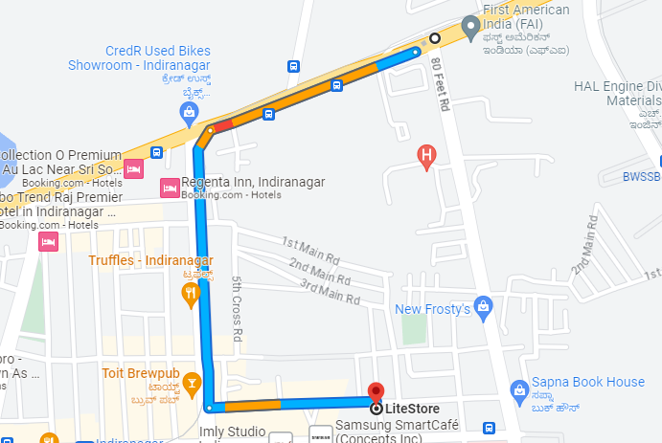

**Annexure A**

**Form No. MGT-11**

**PROXY FORM**

**[Pursuant to section 105(6) of the Companies Act, 2013 and rule 19(3) of the Companies (Management and Administration) Rules, 2014]**

**Corporate Identification Number (CIN):** U72900KA2021PTC149415

**Name of the Company:** POPSPACE TECHNOLOGIES PRIVATE LIMITED**.**

**Registered office :** G-2, 1st Floor, Eden Crest, 460, Krishna Temple Road, Indiranagar 1st Stage, Bengaluru-560038 Karnataka

|  |  |  |
| --- | --- | --- |
| Name of the member (s) | : |  |
| Registered address | : |  |
| E-mail Id | : |  |
| Folio No/ Client ID | : |  |
| DP ID | : |  |

I/We, being the member (s) of …………. shares of the above named company, hereby appoint

|  |  |  |  |
| --- | --- | --- | --- |
| 1. | Name | : |  |
|  | Address | : |  |
|  | E-mail ID | : |  |
|  | Signature | : | , or failing him |

|  |  |  |  |
| --- | --- | --- | --- |
| 2. | Name | : |  |
|  | Address | : |  |
|  | E-mail ID | : |  |
|  | Signature | : | , or failing him |

|  |  |  |  |
| --- | --- | --- | --- |
| 3. | Name | : |  |
|  | Address | : |  |
|  | E-mail ID | : |  |
|  | Signature | : |  |

as my/our proxy to attend and vote (on a poll) for me/us and on my/our behalf at the Annual General Meeting of the company, to be held on Wednesday 27th Day of September, 2023 at 11:00 AM at the registered office of the Company situated at G-2, 1st Floor, Eden Crest, 460, Krishna Temple Road Indiranagar 1st Stage, Bengaluru-560038 Karnataka India at any adjournment thereof in respect of such resolutions as are indicated below:

|  |  |  |
| --- | --- | --- |
| **Resolution No** | **Particulars** | **Favor / against** |
| 1 | To receive, consider and adopt the Audited Financial Statements of the Company for the period ended 31st March 2023 together with the Report of the Board of Directors and of the Auditors thereon. |  |
| 2 | Appointment of Statutory Auditors of the Company |  |

Signed this ­­­­­­­­­­­­_______ day of September, 2023

Affix Revenue Stamp

Signature of shareholder

Signature of Proxy holder(s)

***Note:***

The requirements of Lodging the proxy form not less than **48 hours** before the time fixed for commencement of the meeting as per the articles need not be complied with, as the notice for the meeting to be held in less than 48 hours

**ATTENDENCE SLIP**

Members or their proxies are requested to present this form for admission, duly signed in accordance with their specimen signatures registered with the Company.

|  |  |
| --- | --- |
| Regd. Folio. No/DP.Id/ Client id |  |
| Name of shareholder: |  |
| Address of shareholder: |  |
| Proxy Name: |  |
| Address of proxy: |  |

I/We hereby record my/our presence at the Annual General Meeting of the Company being held on the 27th day of September, 2023, at the registered office of the Company situated at G-2, 1st Floor, Eden Crest, 460, Krishna Temple Road Indiranagar 1st Stage, Bengaluru-560038 Karnataka India

Please (✓) in the box

1. Member

2. Proxy

Signature of member/Proxy