NIT3112 Lab Assessment 1
  - QuTech subscription onboarding
Application report and administrator user manual
Justin Lee
Student ID S8115784
Victoria University
19 October 2026

Purpose
This report explains the QuTech C# console application, the classes and calculation rules used to create client subscriptions, and the observed results of execution tests. The application lists four plans, accepts multiple valid subscriptions, applies a 15% student discount and displays a session summary.
The solution is named JustinLee-QuTech. The administrator is Justin Lee and the discount code is JUST. The application passed all 12 recorded black-box cases; the five-entry scenario confirms the example prices and all required summary fields.

Reading guide
Section | Contents
1 | Scope and operation
2 | Classes and calculation design
3 | Input validation and control flow
4 | Illustrated administrator manual
5 | Test design and observed results
6 | Assessment mapping and limitations

The evidence uses fictional demonstration entries. Subscriptions are retained in memory for the current process only.

1 Scope and operation
QuTech administrators onboard a business by selecting a plan, entering the number of users and choosing whether to apply the student discount. A successful entry immediately shows its monthly price and is available in the summary until the program exits.

Run the submitted application
1. Install the .NET 10 SDK. Verification used SDK 10.0.401 on macOS.
2. Extract JustinLee-Lab1.zip and open the JustinLee-QuTech folder.
3. Run the following command in that folder, or open JustinLee-QuTech.sln in a compatible Visual Studio installation.
dotnet run --project JustinLee-QuTech/JustinLee-QuTech.csproj
4. Choose A to list plans, B to create a subscription, C to view all subscriptions, or D to quit.
5. Enter JUST for the 15% discount or No to continue without it. Menu letters and discount responses are case-insensitive.

Plan catalogue
ID | Plan | Monthly price per user
0 | Startup | $10.00
1 | Standard | $20.00
2 | Premium | $30.00
3 | Enterprise | $40.00

Scope boundaries
The identity banner is hard-coded as permitted by the brief; no credential prompt is required. No database, web server or third-party NuGet packages are used. The supplied scenario mentions optional modules, but provides no module prices or selection specification; this application implements the detailed plan and user workflow.
The project excludes generated bin and obj directories. A compatible SDK rebuilds these files. Subscriptions intentionally do not survive exit, matching the session-based console workflow.

2 Classes and calculation design

Responsibilities and constructors
Program.Main constructs AdminPortal and calls Run. AdminPortal owns the plan array and List<Subscription>, reads inputs, repeats the menu and displays results. Separate ShowPlans, CreateSubscription, ShowSubscriptions, Read and ReadInteger methods keep each operation focused.
Plan stores immutable Id, Name and MonthlyPrice properties. Its constructor creates the four catalogue objects. Subscription stores BusinessName, Plan, Users and HasDiscount. Its constructor validates the business name and user count, then fixes the values for the saved entry. Each successful B operation creates a new object and adds it to the list.

Variables and types
Integer values represent IDs and user counts; string values hold names and menu responses; bool values track the active loop and discount state. Decimal prices and the 0.15m constant preserve exact base-10 arithmetic. Arrays hold the fixed catalogue and a generic list holds the growing subscription collection.

Monthly calculation
Subtotal = monthly plan price × users. DiscountAmount = Subtotal × 0.15 when JUST is supplied, otherwise zero. TotalPrice = Subtotal − DiscountAmount. PricePerUser applies the same percentage to the plan unit price. Monetary output uses invariant two-decimal formatting with a dollar sign.
Example | Subtotal | Discount | Total
Standard × 20, No | $400.00 | $0.00 | $400.00
Premium × 25, JUST | $750.00 | $112.50 | $637.50
Enterprise × 100, JUST | $4000.00 | $600.00 | $3400.00

The supplied example of Standard with 20 users totals $400.00; this establishes that the listed plan amount is multiplied by the user count. All four catalogue prices and the fixed discount produce exact cents, so no additional rounding rule is needed for these inputs.

Project structure
JustinLee-QuTech.sln contains the console project. Program.cs contains the entry point, Plan, Subscription and AdminPortal in the JustinLee_QuTech namespace. tests/run_tests.py builds and executes the program; results.json retains the input sequences, expected output and observed stdout. evidence contains the test output captures.

3 Input validation and control flow
Run uses a while loop and switch to handle A, B, C and D. Invalid options report the available choices and return to the menu. ShowPlans and ShowSubscriptions use foreach loops to display the relevant objects. ReadInteger loops until int.TryParse succeeds and the value lies within its inclusive limits.
Input | Accepted values | Failure behaviour
Menu | A, B, C, D | Explain choices and repeat
Business name | 1–60 printable characters after trimming | Repeat name prompt
Plan ID | Whole number 0–3 | Repeat plan prompt
Users | Whole number 1–100 | Repeat user prompt
Discount | JUST or No, any letter case | Repeat discount prompt
End of input | EOF at any prompt | Exit cleanly; omit unfinished entry

Blank names, control characters, out-of-range values, decimals, text and integer overflow cannot become saved entries. Read trims surrounding whitespace. A mistaken discount is rejected explicitly so that the administrator can correct it before saving.
CreateSubscription adds a record only after every field is valid. The Subscription constructor independently enforces the business name and user count rules. If input ends midway, the exception is handled by Run and the unfinished entry is not added.

Summary behaviour
Option C displays Business name, Plan, Users, Total Price and Discount Y or N for every saved subscription. The business-name column expands to the longest stored name. The summary also shows a record count and combined monthly total. An empty list displays guidance to create a subscription.

Program readability
PascalCase names identify types, methods and properties; camelCase identifies local variables and private fields. Comments explain money types, EOF handling and the save boundary. The source uses consistent indentation and separates input, calculation and output responsibilities through methods and classes.

4 Administrator manual
The following screenshots show a local execution log viewer displaying unchanged stdout from the test runner. They are captures of recorded console output, rather than native Terminal windows. The five subscription captures and the summary originate from one program process. Full inputs and outputs are included in tests/results.json.
Start the program and choose A. Confirm the identity banner and the four plan IDs and prices before creating a subscription.
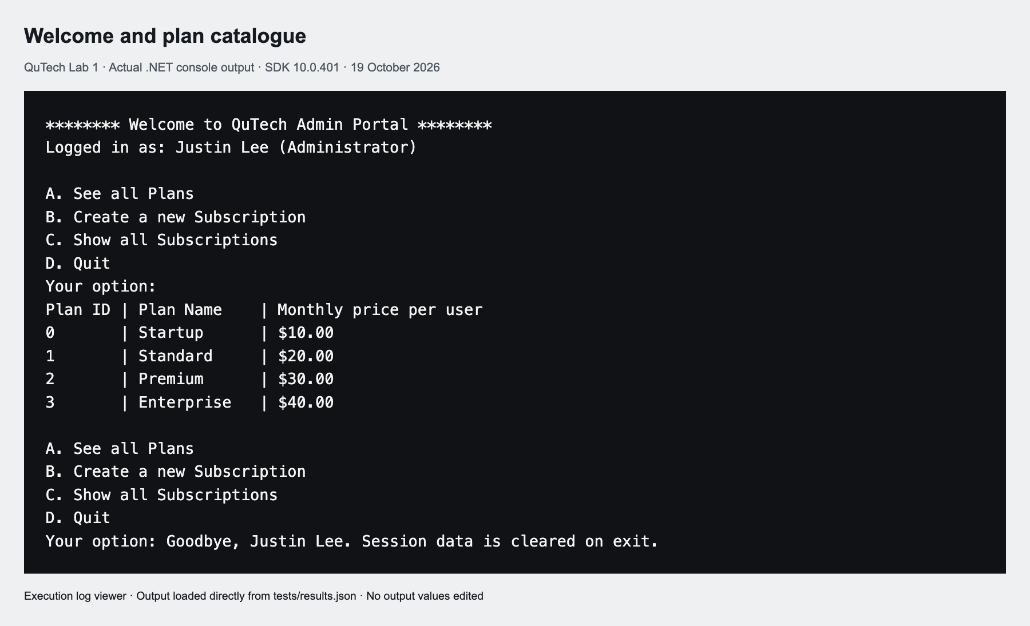
Figure 1. Welcome banner and plan catalogue from an actual execution.
Choose B. Enter Woolies, plan 1, 20 users and No. Confirm a monthly total of $400.00 and no discount.
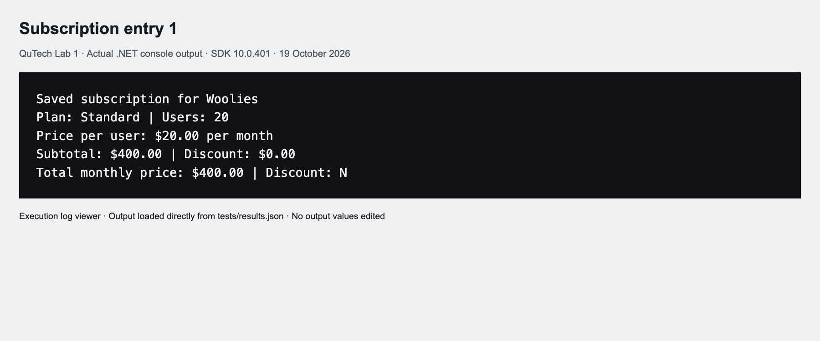
Figure 2. Entry 1 confirms Standard at $20.00 per user for 20 users.

4 Create and confirm subscriptions
For entry 2, choose B and enter Coles, plan 2, 25 users and JUST. The discount reduces $750.00 by $112.50 to $637.50.
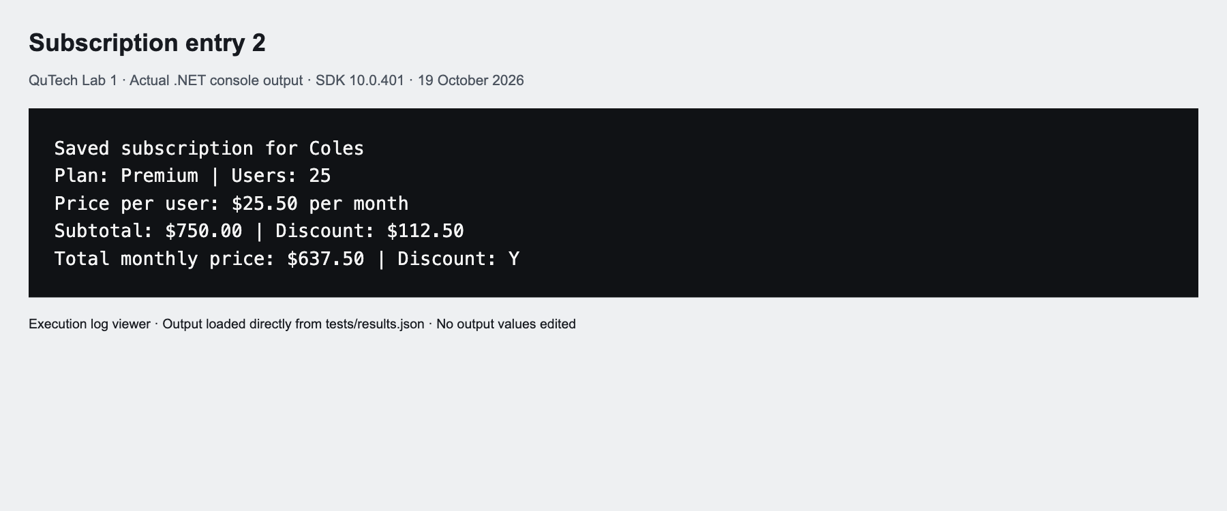
Figure 3. Entry 2 confirms the 15% student discount.
For entry 3, enter Harbour Studio, plan 0, 1 user and No. The minimum accepted user count produces $10.00.
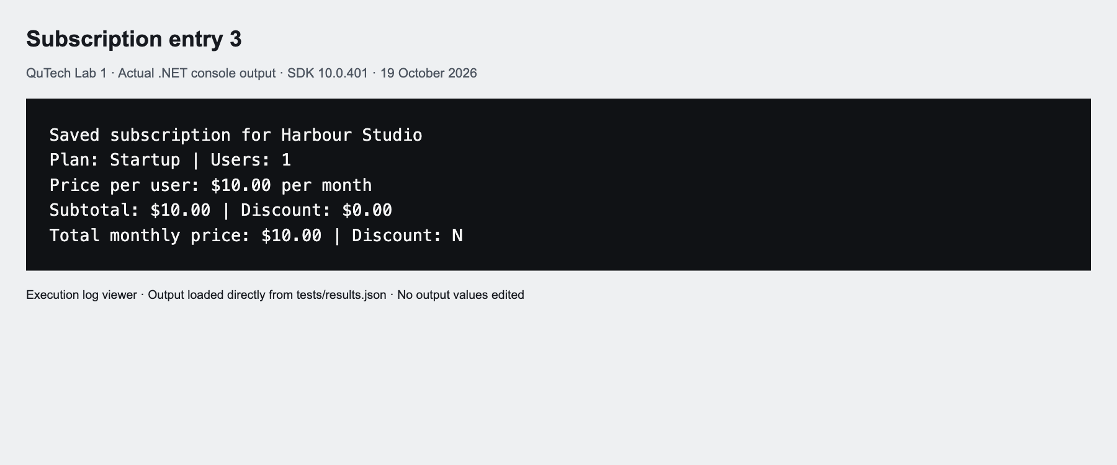
Figure 4. Entry 3 confirms Startup at the lower user boundary.

4 Complete five entries
For entry 4, enter Summit Logistics, plan 3, 100 users and JUST. The upper user boundary is accepted and the total is $3400.00.
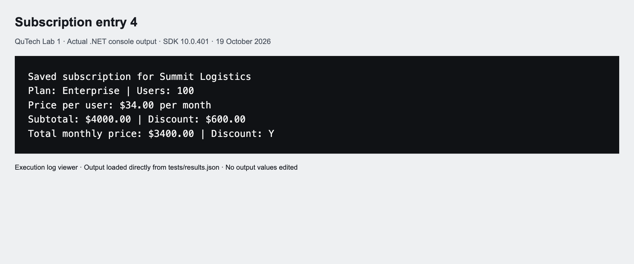
Figure 5. Entry 4 confirms Enterprise at the upper user boundary.
For entry 5, enter Greenfield Dental, plan 1, 10 users and lowercase just. The code is accepted and the total is $170.00.
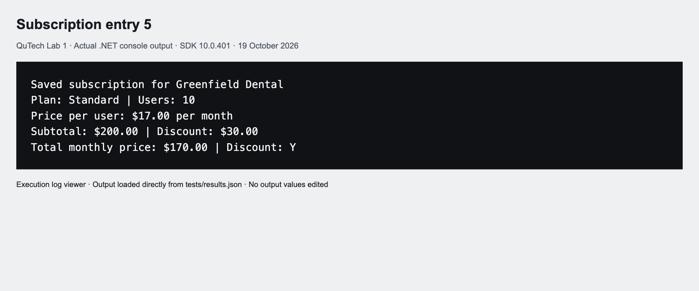
Figure 6. Entry 5 confirms case-insensitive discount input.

4 Review the summary
Choose C after the five entries. Read each business, plan, user count, monthly total and discount indicator. The list contains five records with a combined monthly total of $4617.50. Choose D to exit when finished.
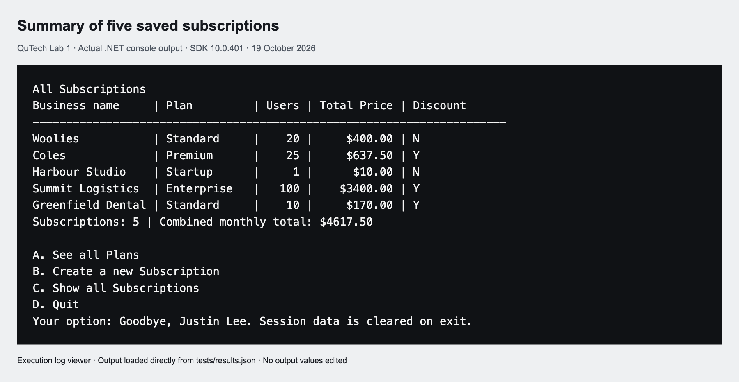
Figure 7. The same process lists all five saved subscriptions with the mandatory fields.

Correct invalid inputs
Use a whole plan ID from 0 to 3 and a whole user count from 1 to 100. An invalid value keeps the current prompt active. A blank business name or unsupported discount code also requires correction. The program does not silently replace invalid values.
The validation test supplies an invalid menu, blank name, invalid plan IDs, text, user values 0 and 101, a decimal, integer overflow and BAD as a discount. It then corrects the entry to Standard, 20 users and No. The recorded outcome is exactly one saved subscription at $400.00. The full validation screenshot is included as evidence/capture-8.png in the source archive.

5 Test design and observed results
The black-box runner builds the project and launches a fresh .NET process for each test. It submits known input lines, checks expected output fragments and process success, and writes the actual stdout into JSON. The five-entry scenario additionally checks each summary row for the business name, total and discount flag. All 12 cases passed. Build verification reported zero warnings and zero errors.
ID | Procedure and expected outcome | Observed
01 | A then D: banner and four priced plans | PASS
02 | C on fresh start: empty-list guidance | PASS
03 | Create five entries then C: five rows, $4617.50 combined | PASS
04 | Invalid menu, name, plan, users and code; recover to one $400 record | PASS
05 | Startup, 100 users, No: $1000.00 | PASS
06 | Standard, 100 users, No: $2000.00 | PASS
07 | Premium, 100 users, No: $3000.00 | PASS
08 | Enterprise, 100 users, No: $4000.00 | PASS
09 | Trimmed lowercase b and just, one Startup user: $8.50 | PASS
10 | 61-character name rejected; corrected name saved | PASS
11 | EOF during an entry: clean exit, no saved entry | PASS
12 | Fresh process: previous session data absent | PASS

Reproduce the results
From the extracted solution directory, run python3 tests/run_tests.py. Python is optional test tooling; the application itself requires only the .NET SDK. The test runner uses subprocess input so stdout does not echo the typed values. Each test record therefore includes its input separately from the captured output.
The checks establish the observed console behaviour on .NET SDK 10.0.401. They do not claim interactive screen-reader, cross-platform terminal or Visual Studio UI testing. Five distinct entries cover all plans, both discount states and both user-count boundaries.

6 Assessment mapping and limitations
Criterion | Marks | Evidence
Variables | 5 | Section 2 and typed source properties
Constructors objects and classes | 10 | Plan, Subscription and AdminPortal
Loops and conditions | 5 | Section 3; while, switch and foreach
Structure and naming | 10 | Named solution, namespace and focused methods
Methods | 5 | Run, input readers, create and display methods
Input and output | 5 | Section 4 and execution evidence
Input validation | 10 | Section 3; test cases 04 and 09–11
Price calculation | 5 | Section 2; cases 03 and 05–09
Summary table | 15 | Figure 7 and five-row assertions
Logic and justification | 10 | Calculation rationale and session workflow
Spacing and indentation | 5 | Consistently formatted C# source
Code comments | 5 | Money, EOF and save-boundary comments
Report and test cases | 10 | Five entry captures and 12 recorded cases

Limitations and references
Records exist only in memory. The console identity banner is not authentication. The application does not calculate tax, annual billing or external payments. The business-name length limit is an implementation usability choice; duplicate business names remain allowed as separate subscriptions.
Teaching source: NIT3112 Advanced Web Application Development, Lab Assessment 1, supplied five-page brief. Pages 1–4 specify the workflow, plan prices, 15% discount, five-entry evidence and Word report plus source ZIP. Page 5 supplies the 100-mark rubric. Report layout follows the previous Justin Lee Lab Assessment 3 report; Lab 1 source and results were produced independently for this submission.
Student: Justin Lee, S8115784. Verification date: 19 October 2026.

