Sample - Sample Correlations From Raw Data

Robert M Flight

There is an Executive Summary at the end of this report.

## Purpose

To evaluate the correlation between various samples.

## Data

**Near Raw Data** provided by Justin. This data includes the intensity values for each peptide in each sample.

library(tidygraph)

##   
## Attaching package: 'tidygraph'

## The following object is masked from 'package:stats':  
##   
## filter

library(dplyr)

##   
## Attaching package: 'dplyr'

## The following objects are masked from 'package:stats':  
##   
## filter, lag

## The following objects are masked from 'package:base':  
##   
## intersect, setdiff, setequal, union

library(ggraph)

## Loading required package: ggplot2

library(visualizationQualityControl)  
library(ComplexHeatmap)

## Loading required package: grid

## ========================================  
## ComplexHeatmap version 2.8.0  
## Bioconductor page: http://bioconductor.org/packages/ComplexHeatmap/  
## Github page: https://github.com/jokergoo/ComplexHeatmap  
## Documentation: http://jokergoo.github.io/ComplexHeatmap-reference  
##   
## If you use it in published research, please cite:  
## Gu, Z. Complex heatmaps reveal patterns and correlations in multidimensional   
## genomic data. Bioinformatics 2016.  
##   
## The new InteractiveComplexHeatmap package can directly export static   
## complex heatmaps into an interactive Shiny app with zero effort. Have a try!  
##   
## This message can be suppressed by:  
## suppressPackageStartupMessages(library(ComplexHeatmap))  
## ========================================

library(ggraph)  
theme_set(cowplot::theme_cowplot())  
knitr::opts_chunk$set(fig.width = 8, fig.height = 8)  
source(here::here("kea3_functions.R"))  
save_loc = here::here("kea3_enrichment_2021-09-29")

raw_data = read_raw_files()

## New names:  
## * `#REF` -> `#REF...7`  
## * `#REF` -> `#REF...8`  
## * `#REF` -> `#REF...9`  
## * `#REF` -> `#REF...10`  
## * `#REF` -> `#REF...11`  
## * ...  
## New names:  
## * `#REF` -> `#REF...7`  
## * `#REF` -> `#REF...8`  
## * `#REF` -> `#REF...9`  
## * `#REF` -> `#REF...10`  
## * `#REF` -> `#REF...11`  
## * ...  
## New names:  
## * `#REF` -> `#REF...7`  
## * `#REF` -> `#REF...8`  
## * `#REF` -> `#REF...9`  
## * `#REF` -> `#REF...10`  
## * `#REF` -> `#REF...11`  
## * ...  
## New names:  
## * `#REF` -> `#REF...7`  
## * `#REF` -> `#REF...8`  
## * `#REF` -> `#REF...9`  
## * `#REF` -> `#REF...10`  
## * `#REF` -> `#REF...11`  
## * ...

names(raw_data) = c("PTK_median", "PTK_saturation", "STK_median", "STK_saturation")

### Transform for Correlation

We will start working with the median values and see what happens.

ptk_data = transform_raw_data(raw_data$PTK_median)  
ptk_info = ptk_data$sample_info  
ptk_info = ptk_info %>%  
 dplyr::mutate(sample_id = paste0(comment, "_", replicate))  
ptk_raw = ptk_data$data %>%  
 mutate(kinases = "ptk")  
  
stk_data = transform_raw_data(raw_data$STK_median)  
stk_info = stk_data$sample_info  
stk_raw = stk_data$data %>%  
 mutate(kinases = "stk")  
  
all_raw = rbind(ptk_raw, stk_raw)

First, we need to check what the distribution of intensity values looks like.

ggplot(all_raw, aes(x = value)) +  
 geom_histogram(bins = 100) +  
 facet_wrap(~ kinases, ncol = 1, scales = "free_y") +  
 labs(subtitle = "Histogram of all intensity values.")

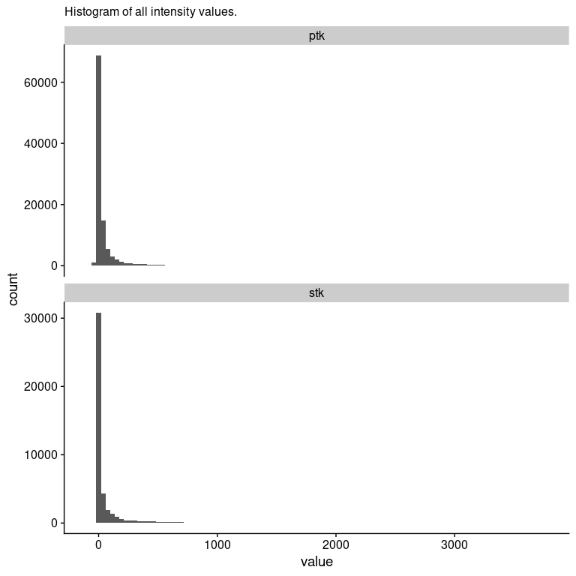

This definitely looks log-normal, so we will transform, and use log10 so we can easily tell where to apply any kind of cutoff.

ggplot(all_raw, aes(x = log10(value))) +  
 geom_histogram(bins = 100) +  
 geom_vline(xintercept = log10(30), color = "red") +  
 facet_wrap(~ kinases, ncol = 1, scales = "free_y") +  
 labs(subtitle = "Histogram of Log10(intensity) values.",  
 caption = "I think ~ 30 is where things actually become useful here, as shown by the red line.")

## Warning in FUN(X[[i]], ...): NaNs produced  
  
## Warning in FUN(X[[i]], ...): NaNs produced

## Warning: Removed 38742 rows containing non-finite values (stat_bin).

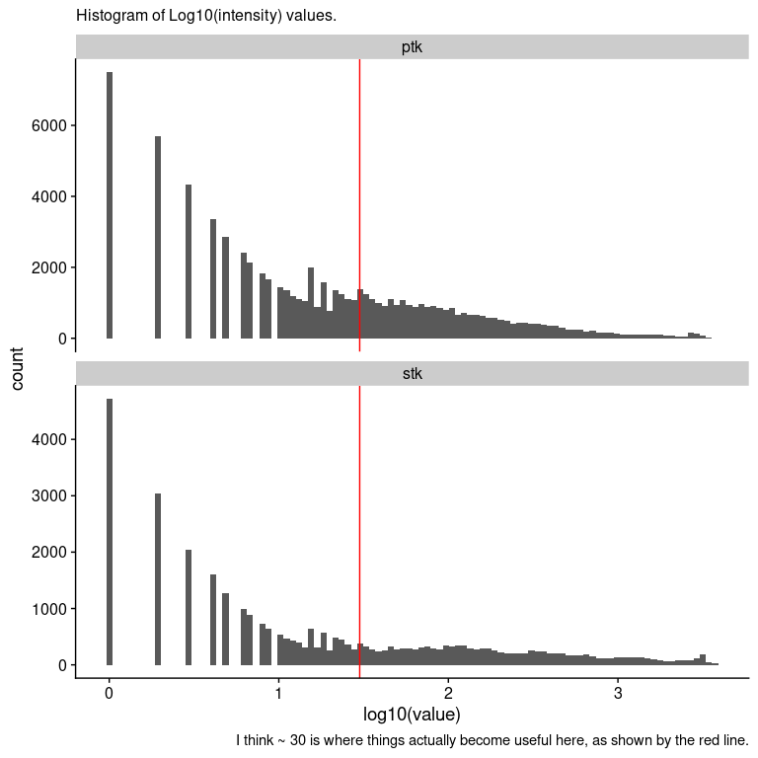

Based on this, I actually wouldn’t trust any intensity values < 30 (1.5) in the data for correlation. Given that, we will take all the intensity values < 30 and set them to 0, and treat them as missing for the ICI-Kendall-tau correlation calculation.

all_raw = all_raw %>%  
 dplyr::mutate(measure_id2 = case_when(  
 kinases %in% "ptk" ~ paste0("p.", measure_id),  
 kinases %in% "stk" ~ paste0("s.", measure_id)  
 ))  
sample_wise = all_raw %>%  
 dplyr::select(sample_name2, value, measure_id2) %>%  
 tidyr::pivot_wider(id_cols = measure_id2,  
 names_from = sample_name2,  
 values_from = value)  
  
sample_matrix = sample_wise %>%  
 dplyr::select(-measure_id2) %>%  
 as.matrix()  
sample_matrix[sample_matrix < 30] = 0  
sample_cor = ICIKendallTau::ici_kendalltau(t(sample_matrix), global_na = c(NA, 0), perspective = "global")$cor

## Warning: UNRELIABLE VALUE: Future ('<none>') unexpectedly generated random  
## numbers without specifying argument 'seed'. There is a risk that those random  
## numbers are not statistically sound and the overall results might be invalid.  
## To fix this, specify 'seed=TRUE'. This ensures that proper, parallel-safe random  
## numbers are produced via the L'Ecuyer-CMRG method. To disable this check, use  
## 'seed=NULL', or set option 'future.rng.onMisuse' to "ignore".

sample_order = similarity_reorder(sample_cor, transform = "sub_1")  
sample_dendrogram = tidygraph::as_tbl_graph(sample_order$dendrogram)  
ggraph(sample_dendrogram, 'dendrogram', height = height) +  
 geom_edge_elbow() +  
 geom_node_text(aes(label = label, filter = leaf), angle = 90,  
 nudge_y = -0.02) +  
 scale_y_continuous(expand = expansion(mult = 0.1, 0))

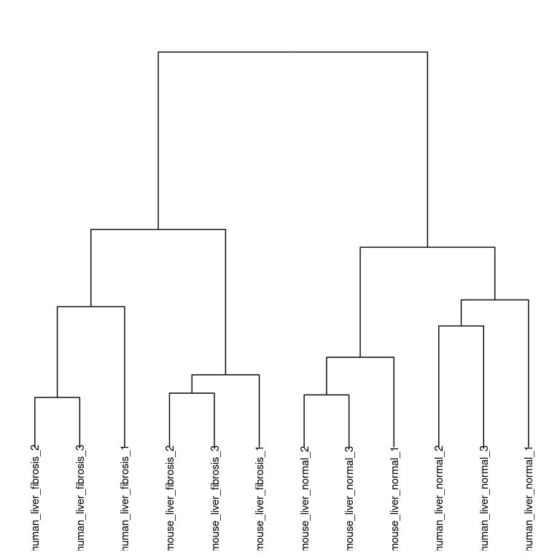

Cool! Everything seems to cluster together by liver status. Note that this only happens after combining both the **PTK** and **STK** data together, and replacing values < 30

Let’s look at the full correlation matrix and verify that this clustering is correct.

ptk_info = dplyr::left_join(data.frame(sample_id = colnames(sample_cor)), ptk_info, by = "sample_id")  
ptk_info = ptk_info %>%  
 dplyr::mutate(organism = case_when(  
 grepl("mouse", comment) ~ "mouse",  
 grepl("human", comment) ~ "human"  
 ),  
 condition = case_when(  
 grepl("normal", comment) ~ "normal",  
 grepl("fibrosis", comment) ~ "fibrosis"  
 ),  
 type = paste0(organism, "_", condition))  
  
col_map = circlize::colorRamp2(seq(0.7, 1, length.out = 20), viridis::viridis(20))  
col_annotation = HeatmapAnnotation(df = ptk_info[, "type", drop = FALSE], which = "column")  
  
  
Heatmap(sample_cor, col = col_map, "ICI-Kt", cluster_rows = sample_order$dendrogram,  
 cluster_columns = sample_order$dendrogram, top_annotation = col_annotation)

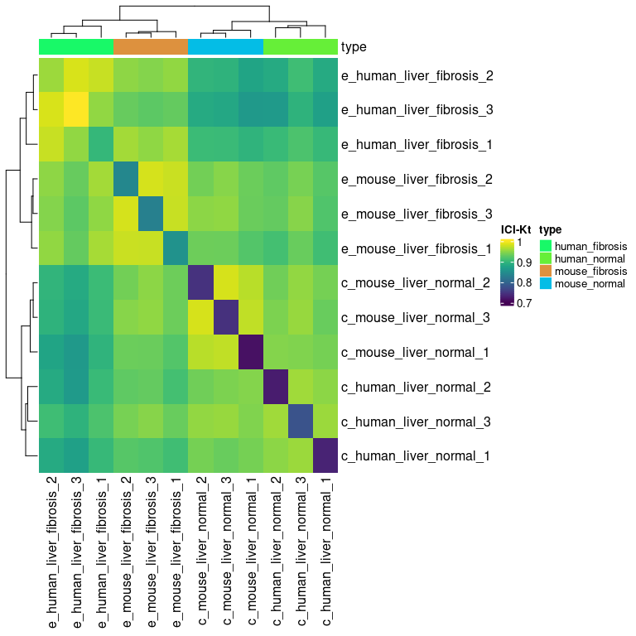

### Variance Measures

variance_measures = all_raw %>%  
 dplyr::select(comment, measure_id2, value) %>%  
 dplyr::group_by(comment, measure_id2) %>%  
 dplyr::summarise(Mean = mean(value),  
 AbsDiff = abs(max(value) - min(value)),  
 SD = sd(value),  
 RSD = abs(SD / Mean),  
 n = n())

## `summarise()` has grouped output by 'comment'. You can override using the `.groups` argument.

variance_long = variance_measures %>%  
 tidyr::pivot_longer(cols = c(-comment, -measure_id2, -Mean, -n),   
 names_to = "summary",  
 values_to = "value")  
variance_long$summary = factor(variance_long$summary, levels = c("AbsDiff", "SD", "RSD"))  
  
ggplot(variance_long, aes(x = Mean, y = value)) +  
 geom_point() +  
 facet_wrap(vars(summary), scales = "free_y") +  
 labs(subtitle = "Absolute difference, relative standard deviation and standard\ndeviation as a function of mean across replicate samples for each peptide.",   
 caption = "Absolute variances (AbsDiff and SD) increase as the mean increases, while RSD is relatively constant\nover a certain value. This is typical of intensity measurements, where the variance increases with\nmean intensity, but over a certain intensity, the relative standard deviation is stable around\na particular value.")

## Warning: Removed 398 rows containing missing values (geom_point).

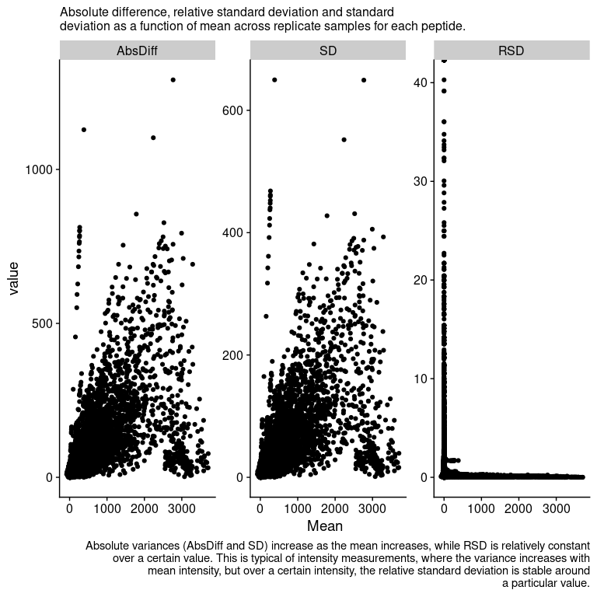

p_rsd = variance_measures %>%  
 dplyr::filter(Mean >= 30) %>%  
 ggplot(aes(x = RSD)) +   
 geom_histogram(bins = 100)  
  
rsd_density = variance_measures %>%  
 dplyr::filter(Mean > 2) %>%  
 dplyr::pull(RSD) %>%  
 density()  
rsd_mode = rsd_density$x[which.max(rsd_density$y)]  
  
p_rsd +   
 geom_vline(xintercept = rsd_mode, color = "red") +  
 coord_cartesian(expand = FALSE) +  
 geom_text(label = paste0("Mode: ", format(rsd_mode, digits = 2)), x = 4, y = 3000) +  
 labs(subtitle = "Histogram of RSD for peptide spots with an mean signal >= 30.")

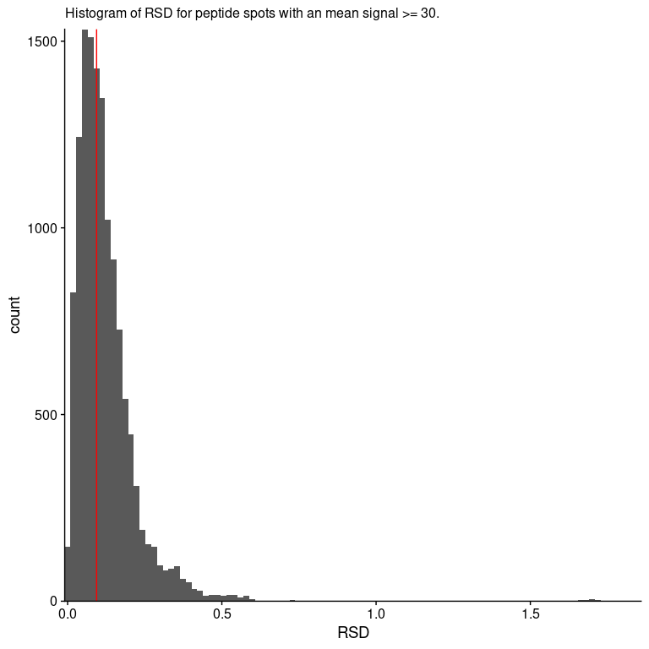

So this is nice, the **relative standard deviation** is fairly small, only 0.094.

### Translation to Log-Fold-Changes

Can we translate these to fold-changes?

log_raw = all_raw %>%  
 mutate(hi_value = case_when(  
 value < 30 ~ 0,  
 TRUE ~ value  
 )) %>%  
 mutate(log_value = log(hi_value + 1))  
  
avg_raw = log_raw %>%  
 dplyr::select(comment, measure_id2, log_value) %>%  
 dplyr::group_by(comment, measure_id2) %>%  
 dplyr::summarise(mean = mean(log_value)) %>%  
 tidyr::pivot_wider(names_from = comment, values_from = mean)

## `summarise()` has grouped output by 'comment'. You can override using the `.groups` argument.

human_diff = avg_raw %>%  
 mutate(log_diff = e_human_liver_fibrosis - c_human_liver_normal, organism = "human")  
mouse_diff = avg_raw %>%  
 mutate(log_diff = e_mouse_liver_fibrosis - c_mouse_liver_normal,  
 organism = "mouse")  
all_diff = rbind(human_diff, mouse_diff)  
  
ggplot(all_diff, aes(x = log_diff)) +   
 geom_histogram(bins = 100) +  
 facet_wrap(~ organism, ncol = 1) +  
 scale_y_continuous(limits = c(0, 500))

## Warning: Removed 4 rows containing missing values (geom_bar).

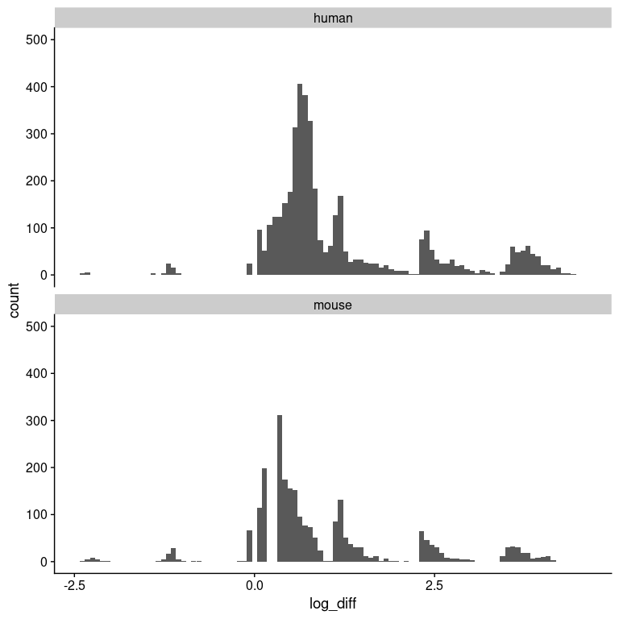

Remember, these are not from the values spit out by PamGene, but based on the background-corrected, median values for each cycle and exposure, and then values < 30 imputed to zero and log-transformed. We average the values across the replicates, and then take the fibrotic - normal.