KEA3 Enrichment for Hinds Kinome Manuscript

Robert M Flight

There is an Executive Summary at the end of this report.

## Purpose

To summarize the enrichment results from KEA3 on input lists of kinase targets via network view.

## Background on KEA3

KEA3 ([web](https://maayanlab.cloud/kea3/), [publication](https://academic.oup.com/nar/article/49/W1/W304/6279841), [my hypothes.is annotations](https://hyp.is/go?url=https%3A%2F%2Facademic.oup.com%2Fnar%2Farticle%2F49%2FW1%2FW304%2F6279841&group=__world__)) curated a list of kinase - substrate interactions from multiple sources. Each of these sources generates a set of kinase - substrate annotations or gene-lists. The idea is that from your experiment, you upload a list of genes that *might* interact with the kinases in KEA3, then for each source: * input list of genes is tested for over-representation in each list of kinase - substrate annotations (hypergeometric test or Fishers test) * this test generates a p-value * all p-values **ranked** for that source

An overall ranking **across** annotation sources is generated by taking the **average** rank (MeanRank), or reporting the **top rank** across the sources (TopRank).

When reporting results from the web application programming interface (API), we get the *MeanRank* for each kinase, as well as which genes in the input list **overlapped** with the annotated list in KEA3. In addition, they make the kinase - substrate gene-list annotations available as gene sets. Finally, for each annotation source, they do have the underlying raw p-values and false-discovery corrected p-values and ranks available.

## Data

library(tidygraph)

##   
## Attaching package: 'tidygraph'

## The following object is masked from 'package:stats':  
##   
## filter

library(dplyr)

##   
## Attaching package: 'dplyr'

## The following objects are masked from 'package:stats':  
##   
## filter, lag

## The following objects are masked from 'package:base':  
##   
## intersect, setdiff, setequal, union

library(ggraph)

## Loading required package: ggplot2

theme_set(cowplot::theme_cowplot())  
knitr::opts_chunk$set(fig.width = 8, fig.height = 8)  
source(here::here("kea3_functions.R"))  
save_loc = here::here("kea3_enrichment_2021-09-29")  
  
set_colors = scale_color_discrete()$palette(3)

### KEA3 Enriched Results

Four lists of input genes were passed to KEA3.

* PTK Human Fib vs Ctrl
* PTK Mouse Fib vs Ctrl
* STK Human Fib vs Ctrl
* STK Mouse Fib vs Ctrl

For each list of genes, they were queried on KEA3 using the [web API](https://maayanlab.cloud/kea3/templates/api.jsp), and results transformed from JSON to a list. The code for the API queries is in “kea3_runs.R” and should be run separately from generating this document.

### Definitions

* **Enriched**: this kinase was in the **top 10** of MeanRank’ed enrichment results from KEA3 (see background on KEA3 above).
* **Overlapped**: this kinase / gene was in the input list of genes and the genes annotated to that kinase in KEA3.

### Human Protein Atlas Data

The consensus expression data from Human Protein Atlas was downloaded. This data will be used to limit results to genes that are known to be expressed in Liver.

## Methods

### Enrichment

For each gene list, we queried KEA3 using the publicly accessible API and stored results as simple lists in R. **Enriched** kinases are those in the **top 10** kinases by MeanRank score. For each of the enriched kinases, we also extracted the genes from the input list that overlap with the kinase annotation.

### Network Generation

From the KEA3 downloads page, various GMT files were downloaded. Using the downloaded datasets, we created weighted networks of kinase-substrate pairs and protein-protein interactions. The weight of the edge in the network between any two genes represents how many datasets that edge was observed in. Therefore, multiple sources of evidence for the pair of proteins to be interacting adds to the weight of the network edge.

### Tissue Expression

Tissue specific gene / protein expression was defined from the Human Protein Atlas (HPA) mRNA expression consensus data, which is defined as maximum observed expression in that tissue for HPA, GTEx, Fantom5. Expression values are first transformed using $log(expression+1)$. The mode for all log(expression) > 1 across all tissues was determined, and a standard deviation (SD) from values greater than the mode calculated, using the mode as the mean for the SD calculation. A lower limit cutoff was calculated as:

$$cutoff=mode−2*sd$$

All genes with a log(expression) > than $cutoff$ in the tissue of interest are said to be expression in the tissue.

## Results

kea3_results = readRDS(here::here("kea3_enrichment_2021-09-29", "kea3_results.rds"))  
hpa_consensus = read.table(here::here("hpa_data", "rna_consensus_2021-09-27.tsv"), header = TRUE, sep = "\t") %>%  
 dplyr::mutate(logX = log1p(NX))  
kea3_network = readRDS(here::here("kea3_datasets", "kea3_networks_2021-09-30.rds"))

First, we need to figure out what is expressed in the liver. We previously examined how to do this in another report. Initially, we will use what is expressed in liver, not necessarily what is “specific” to liver.

mode_sd_all = hpa_consensus %>%  
 dplyr::filter(logX > 1) %>%  
 dplyr::pull(logX) %>%  
 calculate_mode_sd()  
  
min_val = mode_sd_all["mode"] - 2 * mode_sd_all["sd"]  
liver_expressed = hpa_consensus %>%  
 dplyr::filter(Tissue %in% "liver", logX >= min_val) %>%  
 dplyr::pull(Gene.name)  
min_val

## mode   
## 1.157528

Using this cutoff, we have 12238 genes with robust expression in the liver. This number may be too large, and we may need to filter to what is *specific* to liver instead.

Second, lets look at the KEA3 results and the networks, filtered by what is expressed in liver. In this one, we will use the **top ten** enriched kinases (see definitions above) using *MeanRank*, as well as their overlapping genes.

# changing names to make them easier to filter to.  
names(kea3_results) = c("PTK_Human", "PTK_Mouse", "STK_Human", "STK_Mouse")  
  
human_results = create_enriched_network(kea3_results[c("PTK_Human", "STK_Human")], n_gene = 10, kea3_network, liver_expressed)

mouse_results = create_enriched_network(kea3_results[c("PTK_Mouse", "STK_Mouse")], n_gene = 10, kea3_network, liver_expressed)

all_results = create_enriched_network(kea3_results, n_gene = 10, kea3_network, liver_expressed)  
  
all_results_source = annotate_full_network(all_results$network, human_results$network, mouse_results$network, "human", "mouse")

What we’ve done is pull the genes from all the enrichment results, and create a single network from all of those, and then we can lay out the comparison networks based on that, with the edges and nodes that are in the specific networks grayed out or see through. Hopefully.

Here is the full network with all results from both organisms.

set.seed(123)  
ggraph(all_results_source, layout = "graphopt") +  
 geom_edge_link(arrow = arrow(length = unit(4, 'mm')),  
 end_cap = circle(3, 'mm'),  
 alpha = 0.5) +  
 geom_node_label(aes(label = name)) +  
 labs(subtitle = "KEA3 Results, Kinase-Targets")

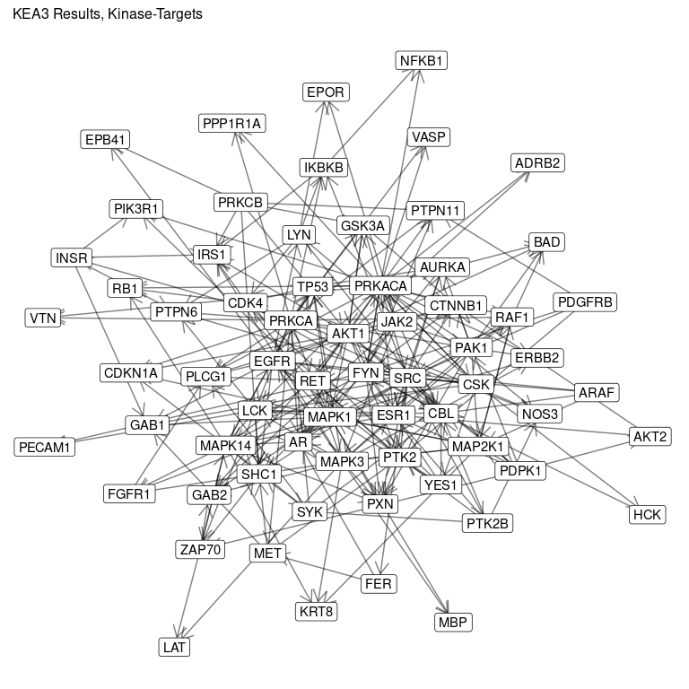

### Add LFC

all_lfc = get_kinase_lfc()  
  
# min_mouse = 0.97  
# min_human = 0.57  
#   
# all_nodes = all_results_source %>%  
# activate(nodes) %>%  
# data.frame() %>%  
# select(name)  
# all_lfc = left_join(all_nodes, all_lfc, by = "name")  
# na_mouse = is.na(all_lfc$LFC.Mouse)  
# all_lfc[na_mouse, "LFC.Mouse"] = min_mouse  
# na_human = is.na(all_lfc$LFC.Human)  
# all_lfc[na_human, "LFC.Human"] = min_human  
  
all_results_source = left_join(all_results_source, all_lfc, by = "name")

Now we want to subset to emphasize the human, with the type of node indicated as well.

human_subset = subset_network_alpha(all_results_source, human_results, c("both", "human"))  
  
set.seed(123)  
human_network = ggraph(human_subset, layout = "graphopt") +  
 geom_edge_link(arrow = arrow(length = unit(4, 'mm')),  
 end_cap = circle(3, 'mm'),  
 aes(alpha = alpha),  
 show.legend = FALSE) +  
 geom_node_label(aes(label = name, alpha = alpha,  
 fill = TypeSource,  
 size = LFC.Human),  
 label.size = NA) +  
 labs(subtitle = "Human KEA3 Network") +  
 guides(alpha = "none", size = "none") +   
 scale_fill_manual(values = set_colors, limits = c("kinase.E", "kinase.O", "other")) +  
 theme(legend.position = c(0.02, 0.92))  
human_network

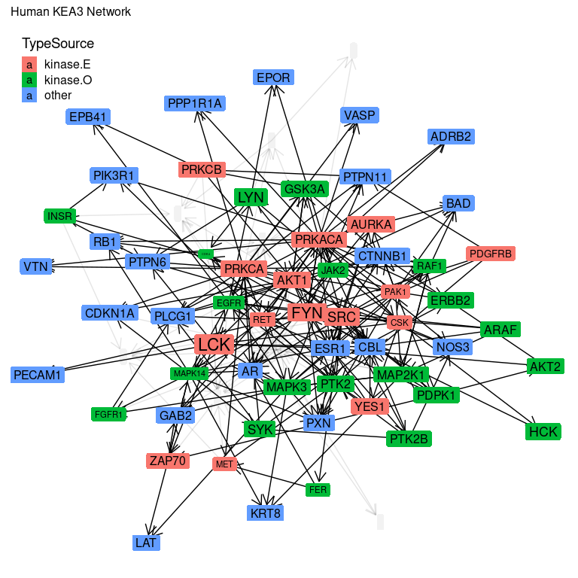

common_subset = subset_network_alpha(all_results_source, human_results, c("both"))  
  
set.seed(123)  
common_network = ggraph(common_subset, layout = "graphopt") +  
 geom_edge_link(arrow = arrow(length = unit(4, 'mm')),  
 end_cap = circle(3, 'mm'),  
 aes(alpha = alpha),  
 show.legend = FALSE) +  
 geom_node_label(aes(label = name, alpha = alpha,  
 fill = TypeSource),  
 label.size = NA) +  
 labs(subtitle = "Common KEA3 Network") +  
 guides(alpha = "none") +   
 scale_fill_manual(values = set_colors, limits = c("kinase.E", "kinase.O", "other")) +  
 theme(legend.position = c(0.02, 0.92))  
common_network

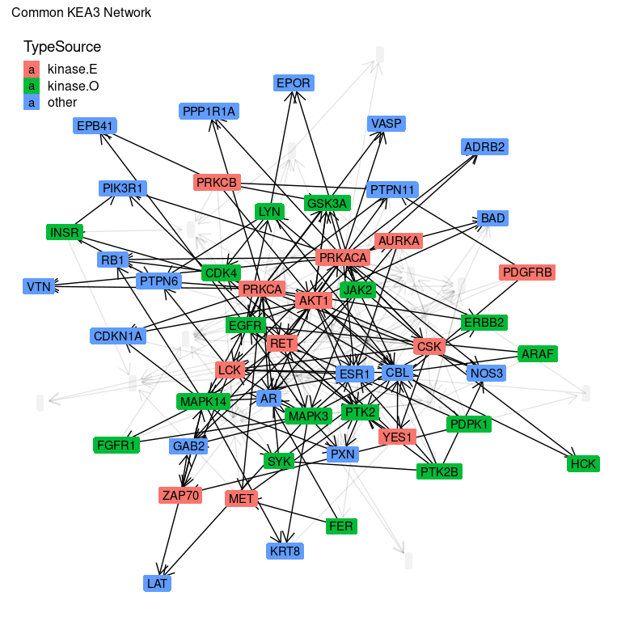

mouse_subset = subset_network_alpha(all_results_source, mouse_results,  
 c("both", "mouse"))  
set.seed(123)  
mouse_network = ggraph(mouse_subset, layout = "graphopt") +  
 geom_edge_link(arrow = arrow(length = unit(4, 'mm')),  
 end_cap = circle(3, 'mm'),  
 aes(alpha = alpha),  
 show.legend = FALSE) +  
 geom_node_label(aes(label = name, alpha = alpha,  
 fill = TypeSource,  
 size = LFC.Mouse),  
 label.size = NA) +  
 labs(subtitle = "Mouse KEA3 Network") +  
 guides(alpha = "none", size = "none") +   
 scale_fill_manual(values = set_colors, limits = c("kinase.E", "kinase.O", "other")) +  
 theme(legend.position = c(0.02, 0.92))  
mouse_network

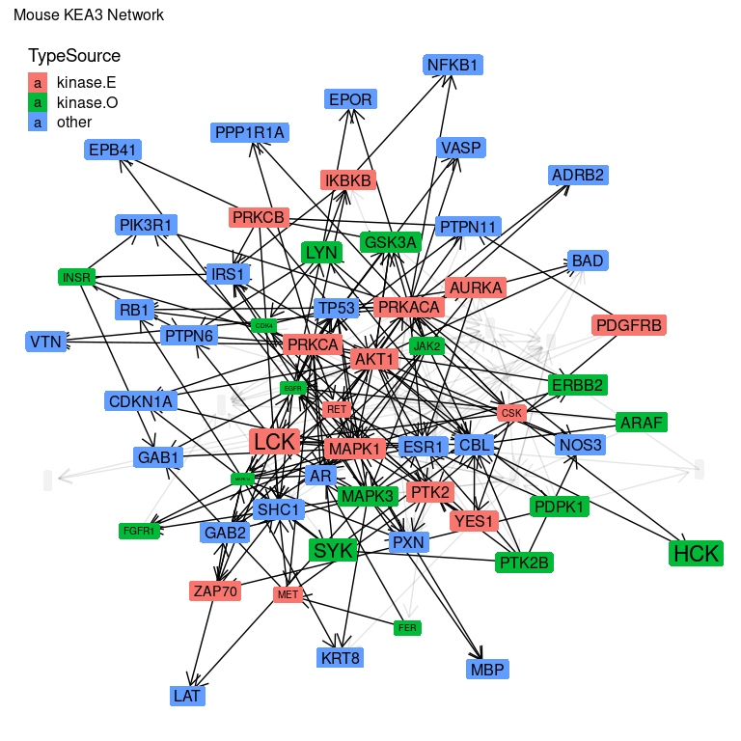

* kinase.E: A kinase gene, and enriched from KEA3
* kinase.O: A kinase gene, and overlapping in the input gene list
* other: A gene that was in the input list, and was a *target* of the kinase in the KEA3 data.

These networks are based on the KEA3 enrichment results, and the differential results.

This is **starting** to look interpretable, I think. We can see the enriched kinases, any overlapping kinases that come up from the enrichment overlapping genes, and then the overlapping genes. I’m not sure what else should be here, so I’m going to stop.

### Export Plots

plot_list = list(human = human_network,  
 common = common_network,  
 mouse = mouse_network)  
export_plots(plot_list, "network_plots.pptx")

## Executive Summary

* Used the differential **human** peptide lists as input to KEA3 enrichment.
* Used the KEA3 kinase-substrate lists to build a gene network.
* Used the HPA consensus data to limit things to what is expressed in Liver.
* Visualized the kinase-substrate network based on the enriched kinases and the differential genes / substrates (see above), with the log-fold-changes applied.

Finally, after reading the KEA3 manuscript, we are not sure about whether the method they use for combining across datasets is appropriate, and their emphasis on selecting only the **top XXX** results.