NIT3004 — IT Capstone Project 2
Technical Implementation Document
Smart Air and Noise Quality
Monitoring System
A serverless smart-city platform for Braybrook, Melbourne
Student: Justin Dang (s8149950)
Unit: NIT3004 IT Capstone Project 2 — Victoria University
Supervisor: Dr Gongqi (Joseph) Lin
Mode: Solo project (sole contributor)
Date: 11 June 2026
Live system
justindang69.github.io/Smart-City-Monitor
github.com/JustinDang69/Smart-City-Monitor

Table of Contents
Right-click the field below and choose “Update Field → Update entire table” to populate page numbers.

1. Introduction and System Overview
The Smart Air and Noise Quality Monitoring System is a smart-city web platform built for the Braybrook region of Melbourne. It ingests four streams of environmental telemetry — air quality, noise, weather and traffic — cleans and stores that data on Amazon Web Services, and presents it to council officers and the public through an interactive dashboard with client-side forecasting, AI-driven cause analysis, and downloadable reports. The entire system was designed, built, deployed and documented by the sole author across NIT3004.
This document is a technical implementation reference. For each of the system's main functions it explains three things in turn: the logic (what the function does and the algorithm behind it), the implementation (the concrete steps and key code), and the justification (why that approach was chosen over the alternatives). The emphasis throughout is on the reasoning behind design decisions, because those decisions — not the line count — are what make the system correct, secure and maintainable.

1.1 What the system does
- Ingests raw council IoT sensor exports (CSV) through an authenticated admin upload page.
- Cleans each upload automatically into a canonical schema using a serverless event-driven pipeline.
- Serves the cleaned data globally through a CloudFront CDN to a static dashboard.
- Analyses the data on the client (forecasting, aggregation) and on the server (Pearson correlation plus a large-language-model explanation).
- Reports findings as on-screen panels and as a downloadable, Excel-ready CSV.

1.2 Technology stack
The frontend is a five-page static site (Home, Dashboard, Reports, Admin Upload, About) written in HTML5, CSS3 and vanilla JavaScript, with Chart.js for visualisation, hosted free on GitHub Pages with automatic deployment on every push to main. The backend is entirely serverless on AWS (region us-east-1): four purpose-built Lambda functions, an S3 bucket, a CloudFront distribution and an HTTP API Gateway. The AI explanation is produced by NVIDIA NIM serving the meta/llama-3.3-70b-instruct model through an OpenAI-compatible endpoint. Admin authentication uses AWS Cognito via the lightweight amazon-cognito-identity-js client. Under typical capstone usage the whole stack costs effectively nothing per month.

2. System Architecture
The system is organised into three cooperating layers: a static frontend served from GitHub Pages, a serverless AWS backend, and the external NVIDIA NIM language-model endpoint. The layers communicate only through HTTPS — there is no always-on server and no virtual machine to maintain. Figure 1 shows the end-to-end data flow.
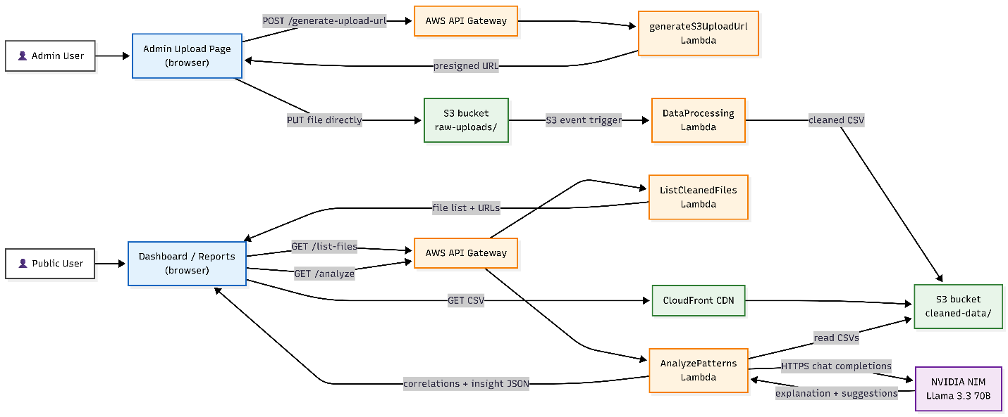
Figure 1. End-to-end architecture and data flow. Admin uploads travel through a presigned S3 PUT; an S3 event triggers the DataProcessing Lambda, which writes cleaned data that CloudFront serves to the dashboard. The dashboard separately calls the AnalyzePatterns Lambda, which reads cleaned CSVs and asks NVIDIA NIM for an explanation.
Two independent paths run through this diagram. The write path (top) is how data enters the system: the admin page requests a presigned URL, uploads a file straight to S3, and an S3 event trigger fires the cleaning Lambda. The read path (bottom) is how the public consumes data: the dashboard lists and downloads cleaned CSVs through CloudFront, and separately requests AI cause analysis. Keeping these paths separate means a slow analysis request can never block the dashboard from rendering, and a malformed upload can never corrupt what the public sees, because cleaning sits between them.

2.1 Why this architecture
Serverless over a managed server. A capstone has no operations team and no budget for an always-on instance. AWS Lambda scales to zero when idle, bills only per request, and removes patching, capacity planning and uptime monitoring entirely. The trade-off — cold-start latency — is irrelevant for an admin tool and is hidden behind a loading state on the dashboard.
Static frontend on a CDN. Hosting the UI as static files on GitHub Pages eliminates an entire class of server-side vulnerabilities and deployment steps. Because the cleaned data is also static (CSV behind CloudFront), the read path is just file delivery — cacheable, fast and globally distributed.
Event-driven cleaning. Triggering DataProcessing from an S3 event (rather than the upload Lambda calling it) decouples upload from processing. The upload returns instantly; cleaning happens asynchronously; and if cleaning logic changes, no other component needs to know.

3. Data Pipeline: the DataProcessing Lambda
Raw council telemetry is not analysis-ready. The IoT platform exports each sensor as a wide CSV with one timestamp triplet per metric, scientific-notation-mangled epoch values, timezone-suffixed dates, and empty JSON context columns. The DataProcessing Lambda is the extract-transform-load (ETL) stage that converts this into a clean, canonical, deduplicated CSV. It is written in Node.js and runs automatically whenever a file lands under the raw-uploads/ prefix.
Figure 2. A sample raw air-quality export opened in Excel: created_at_* / context_* / <metric> column triplets, scientific-notation timestamps, and +11:00 timezone-suffixed dates — none of it directly usable.

3.1 Logic: the cleaning stages
The Lambda processes a file through a fixed sequence of stages, each of which addresses one defect in the raw data:
- Parse. A hand-written CSV parser reads the file, correctly handling quoted fields, escaped quotes inside fields, and CRLF line endings — cases that a naive split(",") would corrupt.
- Normalise column names. Headers are lower-cased and mapped through a canonical alias table so that every downstream consumer sees one stable schema.
- Coerce and bound-check values. Each value is parsed to a number and validated against a physically plausible range for its metric; impossible readings are dropped rather than trusted.
- Drop dead columns. Per-metric created_at_* timestamps (duplicates of the row timestamp to within seconds) and always-empty context_* JSON columns are removed.
- Deduplicate. Rows sharing a (datetime, site) key are collapsed using a Set, so a re-uploaded overlapping file cannot double-count.
- Emit. A cleaned CSV is written to cleaned-data/, plus a JSON cleaning report recording row counts in and out, columns dropped and values rejected — an audit trail of exactly what the pipeline did.

3.2 Implementation
Column normalisation is table-driven so that adding a new source alias is a one-line change rather than a code edit. The canonical map collapses the IoT platform's verbose names onto short, stable identifiers:
const RENAME = {
date_australia_sydney: "datetime",
pm2_5: "pm25",
sound: "noise",
};
const canonical = h => RENAME[h.trim().toLowerCase()] || h;
Canonical column renaming — one alias table drives the whole normalisation stage.
Validation encodes the real operating range of each sensor. Anything outside the range, or any negative reading (a common sign of a sensor fault or a parsing slip), is discarded. Encoding domain knowledge here means the dashboard never has to defend against a humidity of 250 % or a negative decibel level:
const BOUNDS = {
humidity: [0, 100], noise: [0, 150],
temperature: [-20, 60], pm25: [0, 1000],
};
function accept(col, v) {
if (Number.isNaN(v) || v < 0) return false; // fault / parse slip
const b = BOUNDS[col];
return !b || (v >= b[0] && v <= b[1]);
}
Domain-bounded validation: physically impossible values are rejected at the source.
Deduplication uses a Set keyed on the identifying pair, which gives O(1) membership tests and keeps the whole operation linear in the number of rows:
const seen = new Set();
const out = [];
for (const row of rows) {
const key = row.datetime + "|" + row.site;
if (seen.has(key)) continue;
seen.add(key);
out.push(row);
}
Linear-time deduplication keyed on (datetime, site).
The cleaned filename embeds the measurement date range it covers (for example cleaned-data/air-quality/north/2025-05-28_2026-01-04.csv). This single decision is what later lets the file-discovery Lambda decide whether a file is relevant without opening it — the date range is readable straight from the key.
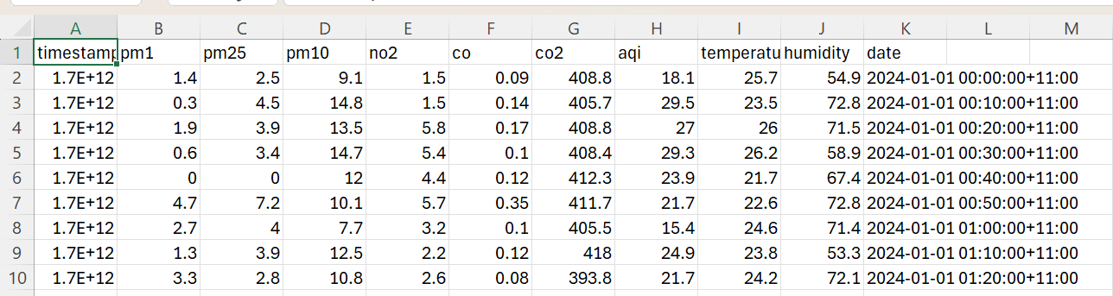
Figure 3. A sample of the raw data the pipeline must repair: the timestamp column is mangled into scientific notation (1.7E+12) and every date carries a +11:00 timezone suffix.

3.3 The S3 event trigger
The Lambda is not called by any other code. It is wired to an S3 “Object Created” event scoped to the raw-uploads/ prefix with a .csv suffix filter, so it runs exactly once per uploaded file and never on its own cleaned output. This is the mechanism that makes the pipeline self-driving.
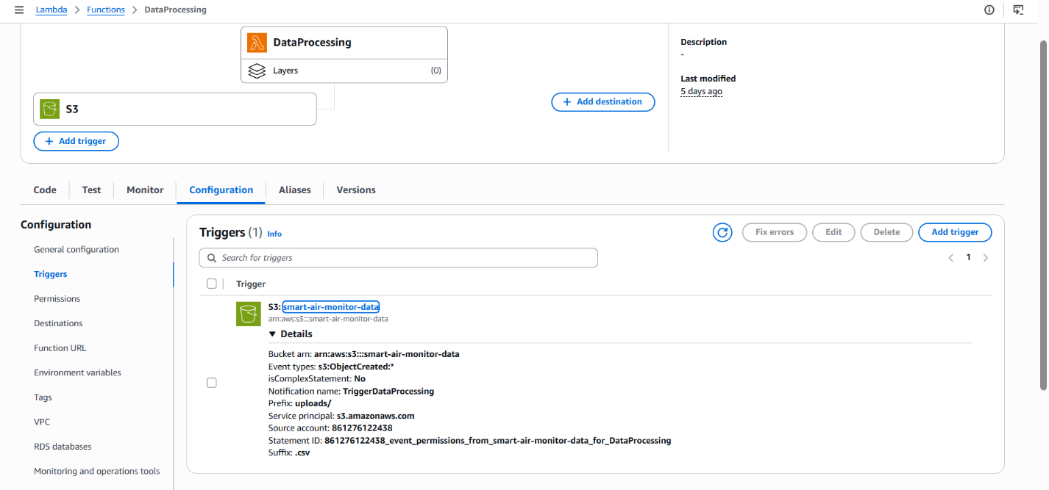
Figure 4. S3 event-trigger configuration on the DataProcessing Lambda — Object Created, scoped to the raw-uploads/ prefix with a .csv suffix filter.

3.4 Storage schema
The bucket uses a parallel prefix tree: raw-uploads/<type>/<site>/ for incoming files and cleaned-data/<type>/<site>/ for processed output, each branching into the four dataset types and five sites. This mirrored layout means the cleaning stage maps an input key to an output key by string substitution alone, and CloudFront can be pointed at the cleaned-data/ subtree only.
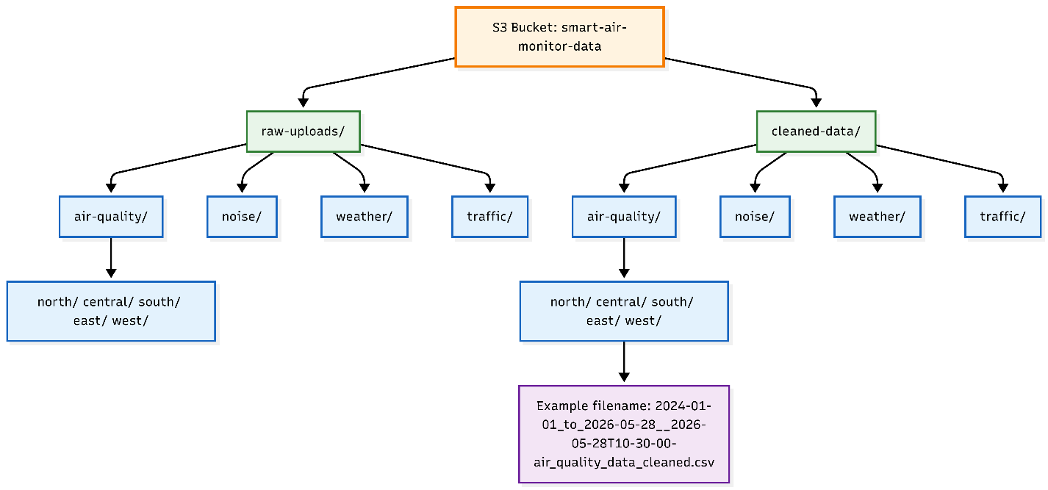
Figure 5. Storage schema: parallel raw-uploads/ and cleaned-data/ trees, each branching into the four dataset types and five monitoring sites.
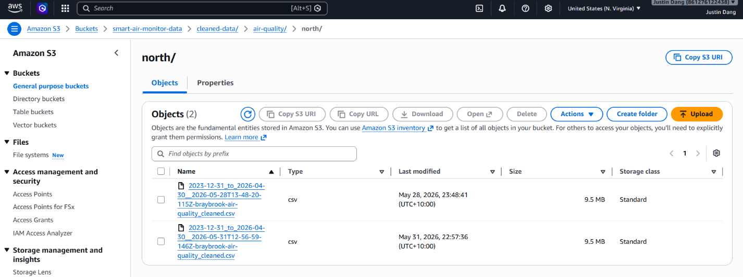
Figure 6. The same layout in the S3 console, showing a cleaned-output filename that encodes the start and end date of the data it contains.

4. File Discovery: the ListCleanedFiles Lambda
Because each cleaned file covers a date range encoded in its name, answering “which files cover the period the user asked for?” must not require downloading any of them. The ListCleanedFiles Lambda (Node.js, fronting GET /list-files) takes a dataset type, site and date range and returns the CloudFront URLs of exactly the files whose coverage overlaps the request.

4.1 Logic: interval overlap
The core is a classic interval-overlap test. A file with coverage [fileStart, fileEnd] is relevant to a request for [userStart, userEnd] if and only if it begins no later than the request ends and finishes no earlier than the request begins. The two parsed dates come straight from the filename:
// keep a file iff its coverage overlaps the requested window
const overlaps = (fileStart, fileEnd, userStart, userEnd) =>
fileStart <= userEnd && fileEnd >= userStart;
The interval-overlap predicate — the whole relevance decision in one line.
Choosing the both-sided overlap test (rather than the easier “file starts within the window” check) is what makes a single long file that spans the entire requested range still match. The cheaper test would silently miss it.

4.2 Implementation: paginated listing
S3 returns at most 1,000 keys per call, so the Lambda must follow continuation tokens to list a prefix fully. It accumulates keys across pages, then filters them through the overlap predicate and rewrites each surviving key as a CloudFront URL:
let token, keys = [];
do {
const page = await s3.send(new ListObjectsV2Command({
Bucket, Prefix, ContinuationToken: token,
}));
keys.push(...(page.Contents || []).map(o => o.Key));
token = page.IsTruncated ? page.NextContinuationToken : null;
} while (token);
Continuation-token pagination — without this loop, listings silently truncate at 1,000 objects.
Returning CloudFront URLs rather than S3 URLs is deliberate: the browser then fetches cached, low-latency files from the CDN edge, and the S3 bucket itself never needs to be publicly reachable.

5. Upload Mechanism: the generateS3UploadUrl Lambda
Uploads never pass through a server. The generateS3UploadUrl Lambda (Node.js, fronting POST /generate-upload-url) issues a short-lived presigned S3 URL, and the browser then PUTs the file straight to S3. This removes the need for any file-handling server and keeps large uploads off the Lambda entirely.

5.1 Logic and implementation
The Lambda validates the request against fixed allowlists of dataset types and sites — never trusting client input to form an S3 key — then constructs a key inside the correct prefix and signs a PUT request with a five-minute expiry:
const TYPES = new Set(["air-quality","noise","weather","traffic"]);
const SITES = new Set(["north","central","south","east","west"]);
if (!TYPES.has(datasetType) || !SITES.has(site))
return resp(400, "invalid dataset type or site");

const key = `raw-uploads/${datasetType}/${site}/${Date.now()}_${fileName}`;
const url = await getSignedUrl(
s3, new PutObjectCommand({ Bucket, Key: key, ContentType: fileType }),
{ expiresIn: 300 } // 5-minute window
);
Allowlist validation and presigned-URL construction; the bucket name comes from an environment variable, never the client.
Three choices here are security decisions. The allowlist guarantees a caller cannot write outside the expected prefixes. The five-minute expiry means a leaked URL is useless almost immediately. And the bucket name lives in a Lambda environment variable, so it is never exposed in client code. CORS on the bucket is locked to the GitHub Pages origin so that only the real site can complete the PUT (Figure 8).
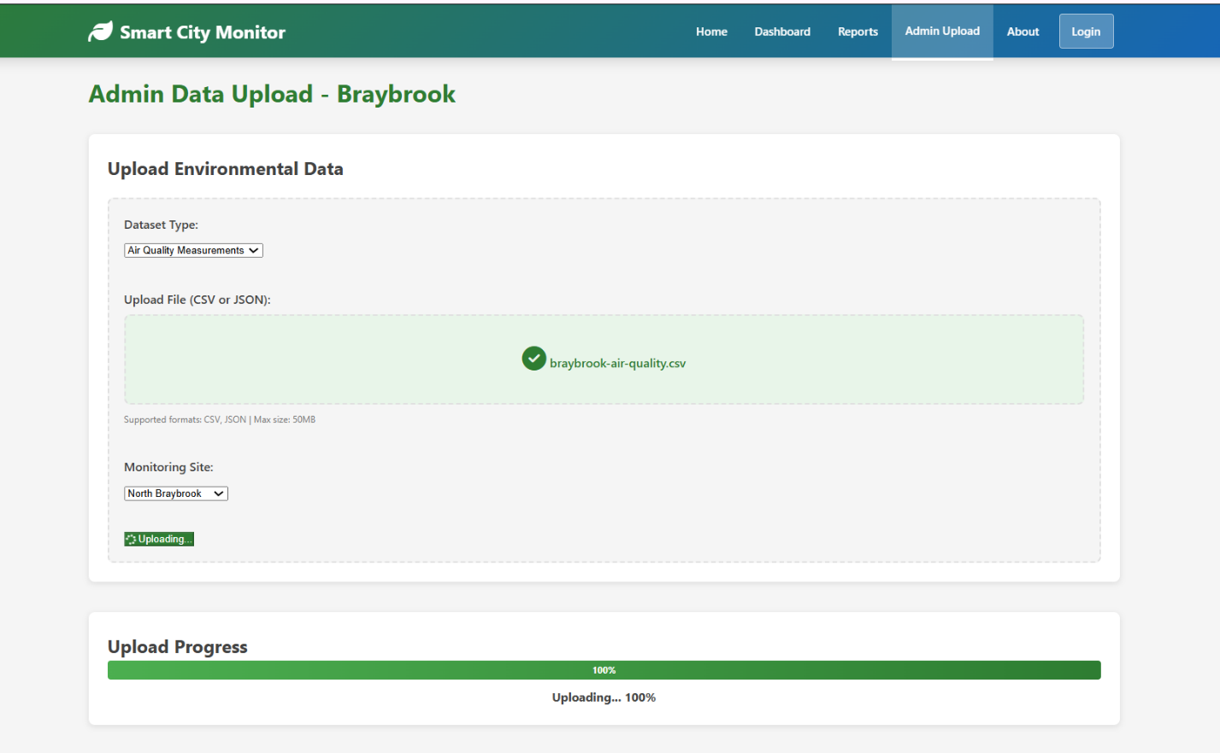
(a) Drag-and-drop dropzone with a file selected and the upload progressing
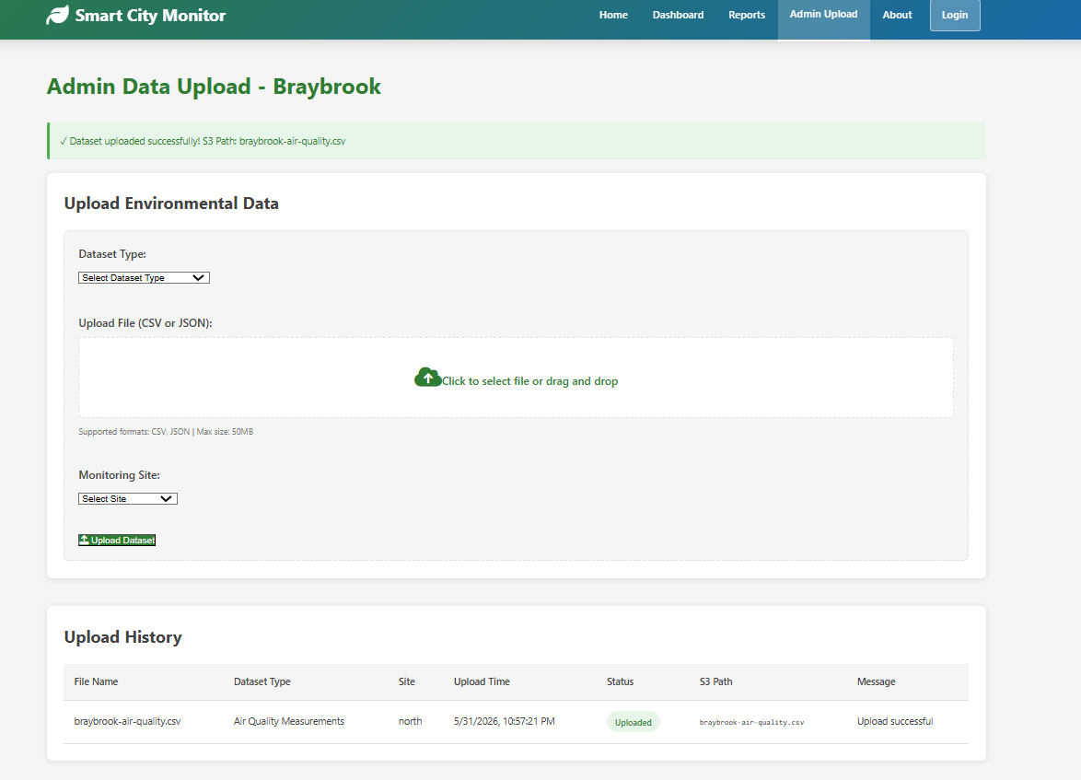
(b) Upload history showing the resulting S3 path
Figure 7. The Admin Upload page driving the presigned-URL flow end to end.
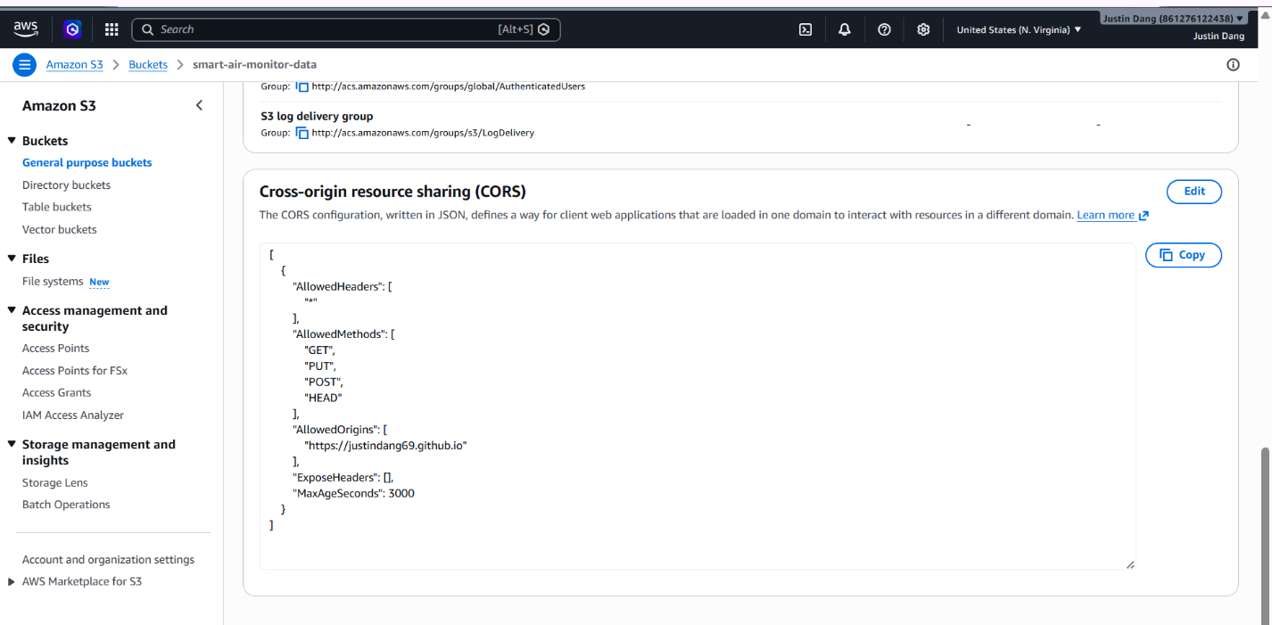
Figure 8. S3 bucket CORS configuration allowing PUT / GET / HEAD only from the GitHub Pages origin.

6. AI Cause Analysis: the AnalyzePatterns Lambda
AnalyzePatterns is the centrepiece of the system and the most statistically careful component. Written in pure-standard-library Python (no pandas, no NumPy — so it deploys with no Lambda layer), it answers a single question for an outcome dataset at a chosen site (or averaged across all sites): what is driving the observed pollution, and what should the council do about it? It does this by computing Pearson correlations between pollution outcomes and traffic/weather drivers, then asking a language model to explain those specific numbers in plain English and propose actions.
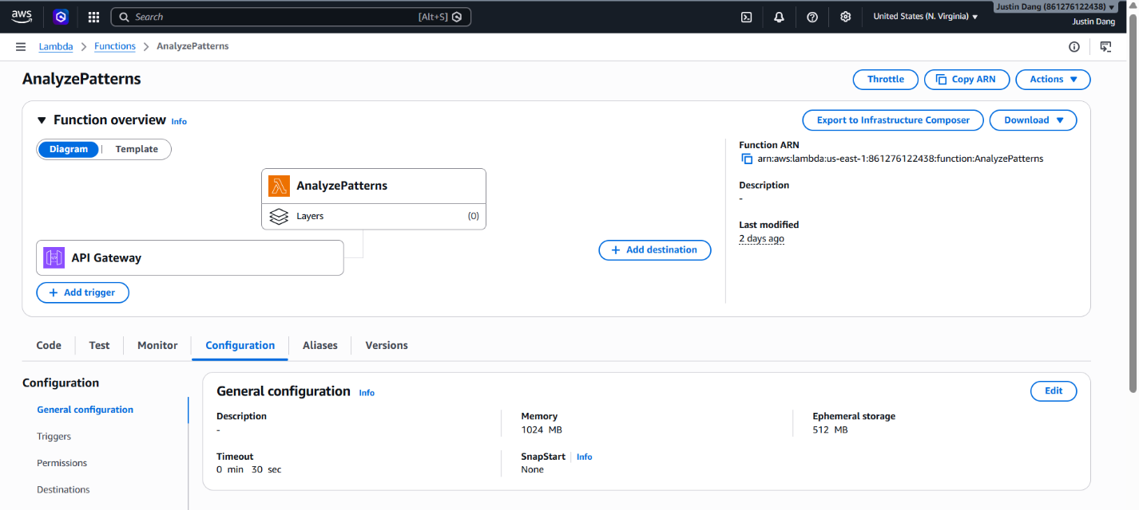
Figure 9. AnalyzePatterns in the Lambda console — Python 3.13 runtime, 1024 MB memory, 30 s timeout, with model and tuning parameters supplied as environment variables.

6.1 Aligning the feeds: the 10-minute bucket key
Air quality, traffic and weather are three separate CSVs whose timestamps drift by a few seconds. To correlate them they must first be joined onto a common time index. The _bucket_key function floors any timestamp to its 10-minute slot, so sub-second drift can never prevent a join:
def _bucket_key(ts):
# floor a timestamp to its 10-minute slot, e.g.
# 2026-01-04 08:17:53 -> "2026-01-04 08:10"
date, hh, mm = ts[:10], ts[11:13], ts[14:16]
minute = (int(mm) // 10) * 10
return f"{date} {hh}:{minute:02d}"
Quantising timestamps to a shared 10-minute grid so independent feeds join cleanly.

6.2 The correlation: Pearson r in pure Python
With the feeds aligned, the Lambda computes the Pearson correlation coefficient for each driver–outcome pair using the closed-form formula, implemented directly so the function carries no third-party dependency:
def pearson(xs, ys):
n = len(xs)
if n < 2: return None
sx, sy = sum(xs), sum(ys)
sxx = sum(x*x for x in xs)
syy = sum(y*y for y in ys)
sxy = sum(x*y for x, y in zip(xs, ys))
num = n*sxy - sx*sy
den = ((n*sxx - sx*sx) * (n*syy - sy*sy)) ** 0.5
return num / den if den else None
Closed-form Pearson r — no NumPy, so the function deploys with zero layers.

6.3 Statistical correctness: excluding a confounder
A naive correlation engine would report that average vehicle speed is strongly (negatively) correlated with air pollutants and present speed as a cause. That is a statistical trap. Speed and pollutant concentration are both consequences of traffic volume; they are not causally linked to each other. Including speed as a “driver” of air pollution would let the LLM suggest a meaningless intervention (“make cars go faster”). The Lambda therefore excludes average_speed as a driver for air pollutants, while keeping it for noise — where engine and tyre noise genuinely does rise with speed:
DRIVERS = ["vehicle_count", "average_speed",
"temperature", "humidity", "wind_speed"]

def drivers_for(outcome):
d = list(DRIVERS)
if outcome in ("pm25", "no2", "co2"):
d.remove("average_speed") # confounded with volume
return d # kept for noise (real cause)
Confounding-variable control — the difference between a correct and a misleading analysis.
This single exclusion is the clearest example in the project of encoding domain understanding into code, and it is what keeps the AI's suggestions defensible.

6.4 Robust spatial and temporal handling
For an “all sites” request the Lambda averages each metric across sites at each time bucket, but it skips missing channels so that one dead sensor reporting nothing does not drag the mean toward zero. It also intersects the available date ranges across the three feeds and returns a helpful, specific error if they do not overlap, rather than a bare failure:
def spatial_mean(readings): # one metric, several sites
present = [v for v in readings if v is not None]
return sum(present) / len(present) if present else None
Spatial averaging that ignores absent channels instead of treating them as zero.
Finally, to stay inside API Gateway's 30-second ceiling, the joined series is downsampled to a maximum of roughly 3,000 rows before correlation and before the scatter sample is built. This keeps even an all-time request responsive.

6.5 The language model: grounded, not free-styling
The plain-English explanation comes from NVIDIA NIM serving meta/llama-3.3-70b-instruct. The model is chosen for a practical reason: it offers production-grade inference on a free tier with no credit card, through an OpenAI-compatible API. The prompt is deliberately constraining. The model is fed every correlation as a number — both r and r-squared (the percentage of variance explained) — and is instructed to quote those exact values and invent nothing:
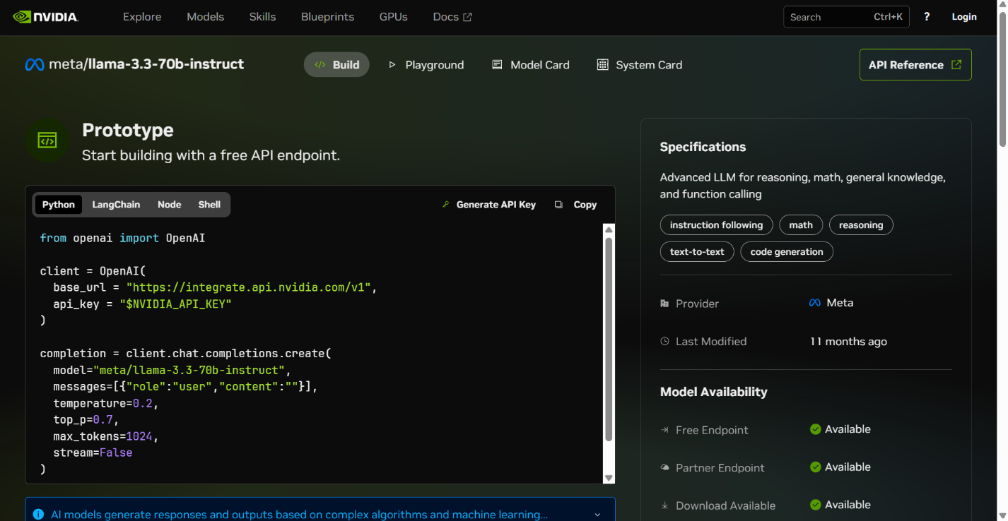
Figure 10. The build.nvidia.com model page for meta/llama-3.3-70b-instruct, the model used for cause-analysis explanations.
prompt = (
"You are an environmental analyst. Using ONLY the "
"correlations below, explain the likely cause in plain "
"English for a council officer.\n"
f"{corr_lines}\n"
"Quote the exact r and r-squared values you are given. "
"Do NOT invent numbers, and do NOT cite sources."
)
The LLM is told to explain the supplied numbers and explicitly forbidden from inventing data or citations.

6.6 Anti-hallucination: references are matched, not generated
The most important trustworthiness decision is that the model never produces the citations. Language models fabricate plausible-looking references, which would be unacceptable in material a council might act on. Instead the system keyword-matches the explanation against a fixed list of real, published sources (WHO, IEA, NEPM, NSW DPE) and attaches those separately. The references the user sees are therefore guaranteed to be real:
REFERENCES = {
"traffic": "WHO (2021) Global Air Quality Guidelines",
"vehicle": "WHO (2021) Global Air Quality Guidelines",
"wind": "NSW DPE Air Quality Categories",
"co2": "IEA (2023) CO2 Emissions in 2022",
}
def refs_for(text):
t = text.lower()
return list({src for kw, src in REFERENCES.items() if kw in t})
References are matched from a curated list — the model cannot fabricate a citation.
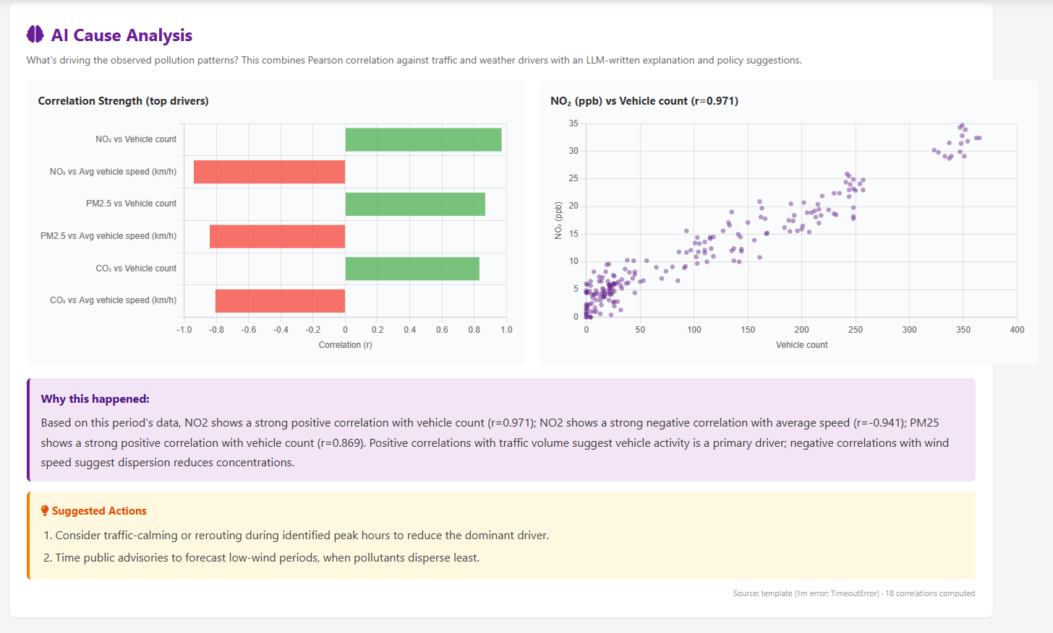
Figure 11. The assembled AI Cause Analysis panel: a signed correlation bar chart (green positive, red negative), a scatter of the strongest driver–outcome pair, the LLM explanation, and council-level suggested actions.
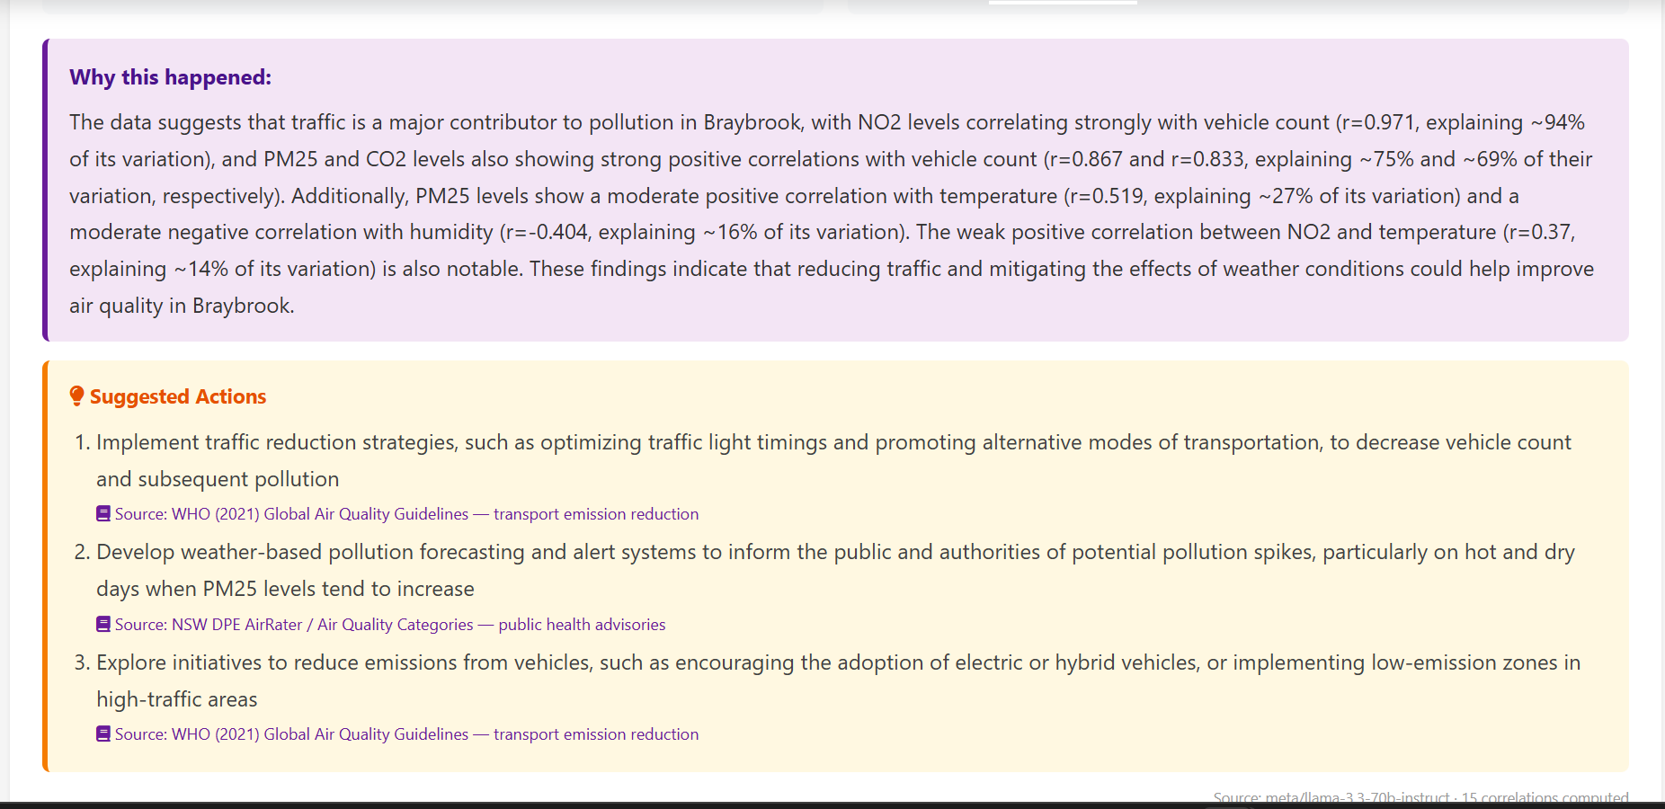
Figure 12. Close-up of the “Why this happened” explanation and the “Suggested Actions” panel, each action tagged with a real, keyword-matched source reference.

6.7 Resilience: the circuit breaker and template fallback
The LLM is an external dependency and may be slow, rate-limited or unavailable. A per-instance circuit breaker tracks recent call timestamps in a rolling 60-second window and trips if too many calls occur, protecting both the free-tier quota and the request latency. When the breaker is open — or the LLM errors or times out — a deterministic template generates the explanation from the same correlation numbers, so the feature degrades gracefully instead of failing:
_CALLS = [] # survives warm invocations
def _breaker_allows(now, limit=8, window=60):
cutoff = now - window
while _CALLS and _CALLS[0] < cutoff:
_CALLS.pop(0)
if len(_CALLS) >= limit:
return False # trip -> template fallback
_CALLS.append(now)
return True
Token-bucket circuit breaker; on a trip the response is built from a template instead.
Every response records a source field stating which path produced it (the model name, or template), so the dashboard can show the user exactly which writer generated the prose — full transparency about provenance.

6.8 Diagnostic-driven debugging
An early version returned zero correlations. CloudWatch diagnostic prints revealed the cause immediately: the joined outcome rows had a None datetime because the column had not yet been renamed to the canonical name at the point of the join. The fix was to align the bucket-key extraction with the canonical schema. The logs below are the evidence that pinpointed it.
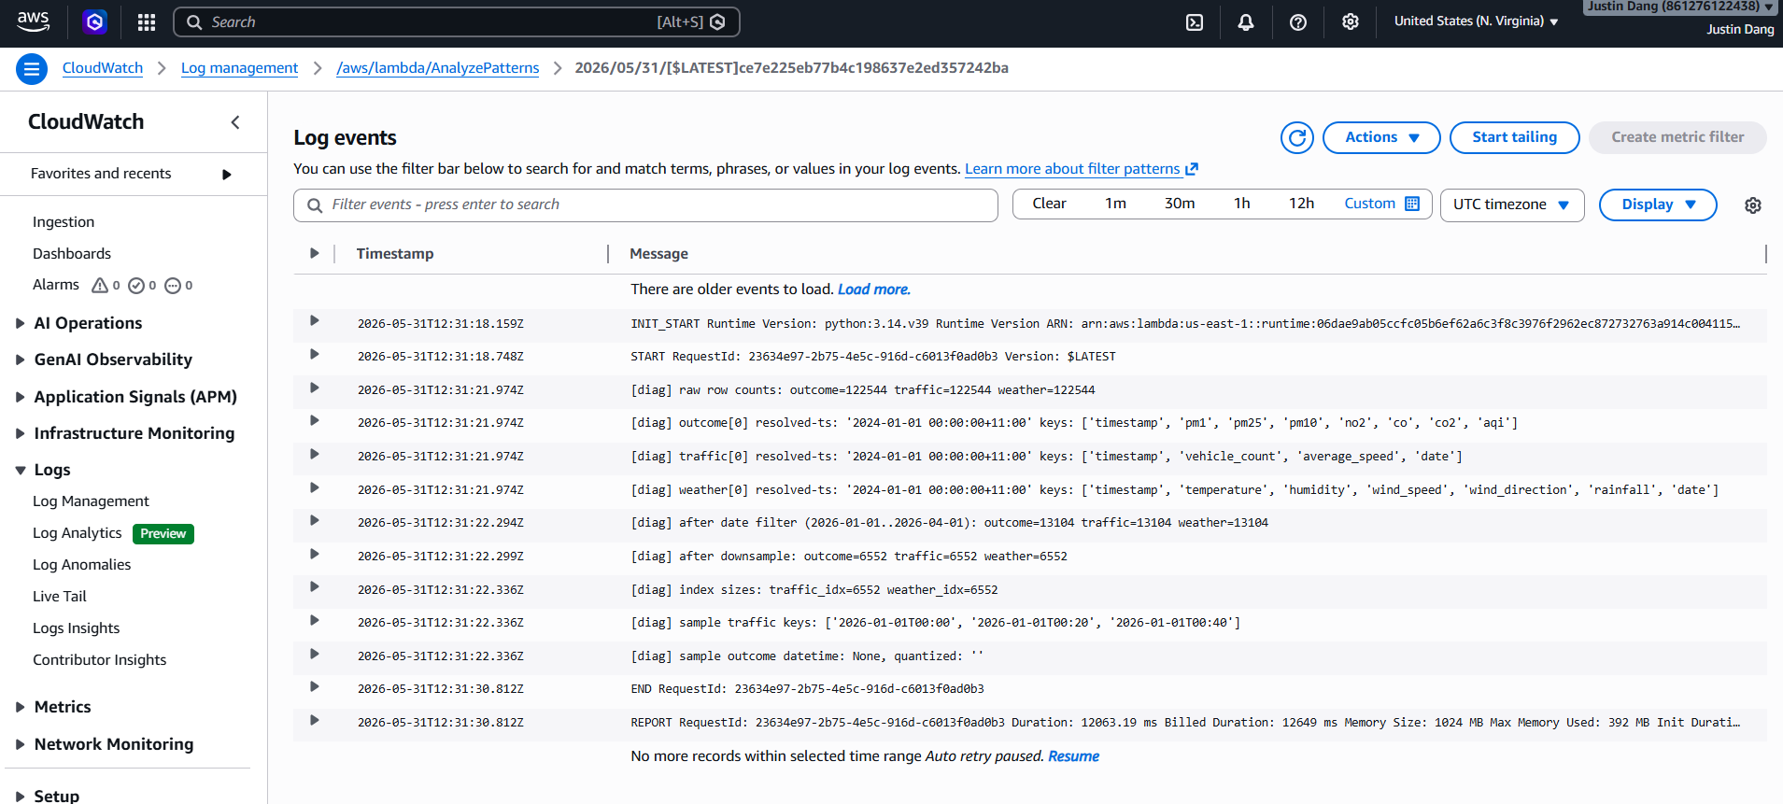
Figure 13. CloudWatch logs showing the diagnostic prints that exposed a column-name mismatch (datetime: None) — the trail that drove the fix.

6.9 Guard rails in the UI
A UI guard keeps the analysis meaningful: cause analysis is offered only for outcome datasets (air quality, noise). For driver datasets (traffic, weather) the section is hidden entirely, because a driver is an input to pollution, not something the analysis should try to explain.
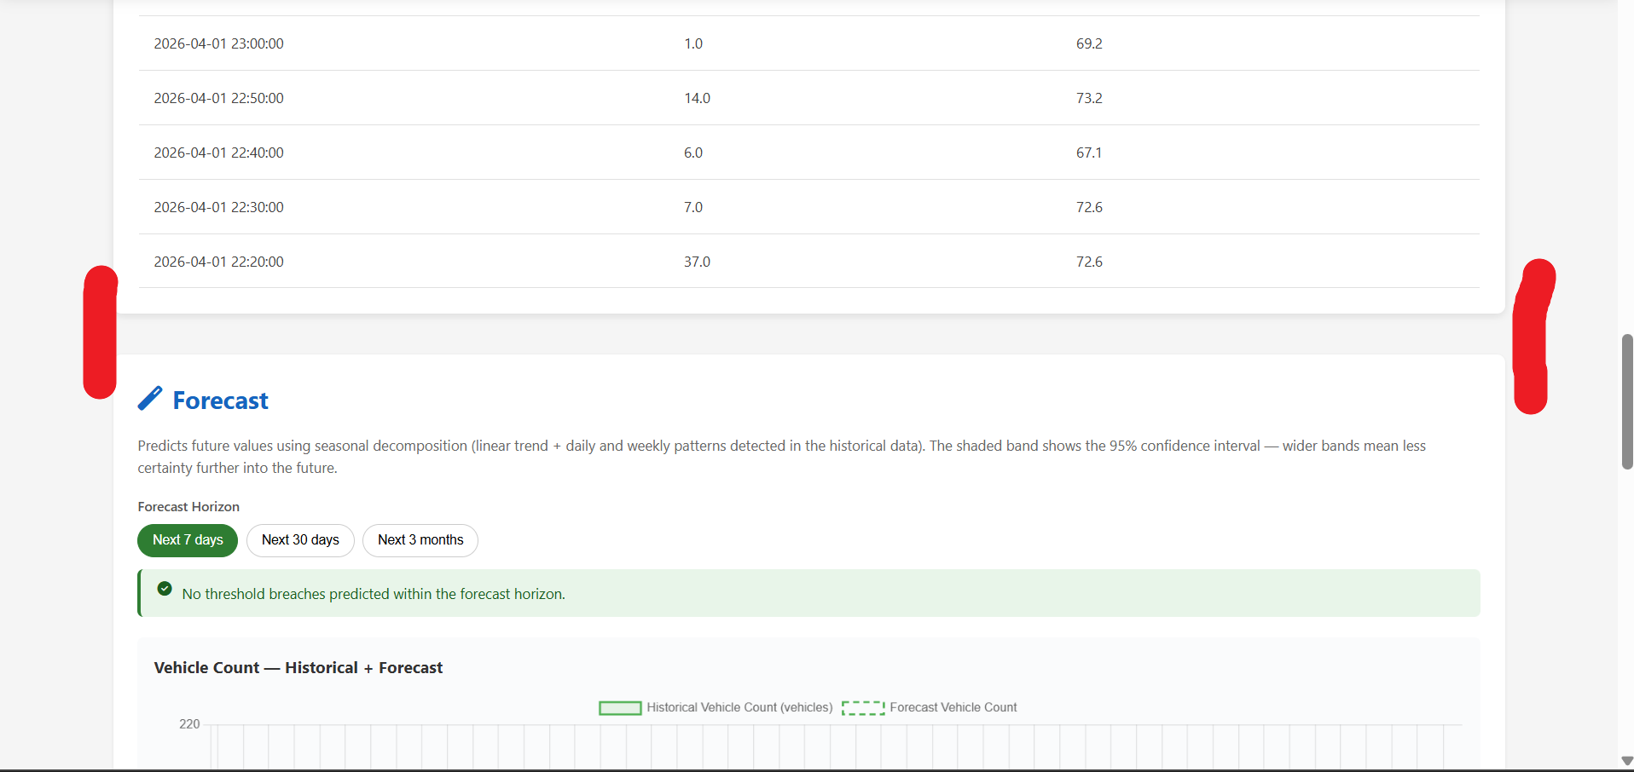
Figure 14. With the Traffic dataset selected the cause-analysis section is correctly absent — traffic is a driver, not an outcome.

7. Frontend Logic
The browser is responsible for everything that is light, stateless and latency-sensitive: assembling data, aggregating it, drawing charts, and forecasting. Heavy or secret work stays on the server. This section covers the frontend's main functions and the design decisions behind them.

7.1 The two-step fetch
Loading the dashboard is a two-step operation. First the dashboard calls /list-files to discover which cleaned CSVs cover the requested window; then it downloads them in parallel with Promise.all, combines them, filters to the exact range, and sorts by time. Parallel download means total latency is set by the slowest single file, not the sum of all of them:
const { files } = await fetch(`${API}/list-files?${qs}`).then(r => r.json());
const texts = await Promise.all(files.map(f => fetch(f.url).then(r => r.text())));
const rows = texts.flatMap(parseCSV);
rows.sort((a, b) => a.datetime - b.datetime);
Discover, then download in parallel, combine, and sort — the dashboard's load path.

7.2 Client-side aggregation
Raw data is 10-minute cadence, which is far too dense to plot over a year. The frontend buckets rows into hour, day, week or month groups and averages each bucket, and it auto-selects a sensible default bucket for the chosen range (a 7-day view defaults to hourly, an all-time view to monthly). Doing this in the browser keeps the interaction instant — changing the aggregation never makes a network call.

7.3 The dual-axis gases chart
NO₂ is measured in parts per billion (typically ~11) and CO₂ in parts per million (typically ~425). Plotted on one shared axis, NO₂ is crushed into a flat line at the bottom (Figure 16a). The fix is a dual-axis chart: NO₂ on a left axis that begins at zero, CO₂ on a right axis with beginAtZero:false so its ~400 ppm floor does not flatten the scale. Both series then read clearly (Figure 16b).
scales: {
yNO2: { position: "left", beginAtZero: true }, // ppb
yCO2: { position: "right", beginAtZero: false, // ppm
grid: { drawOnChartArea: false } },
}
Independent left/right axes so two incompatible scales coexist on one chart.
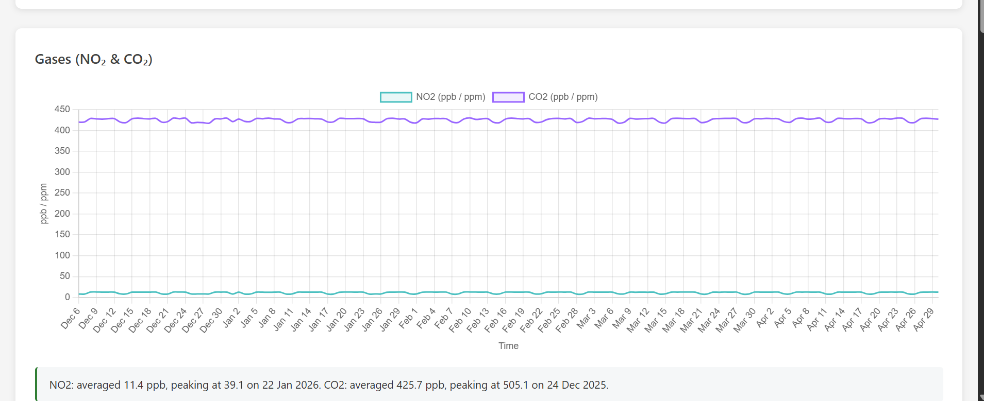
(a) Before — one shared axis crushes NO₂ to a flat line
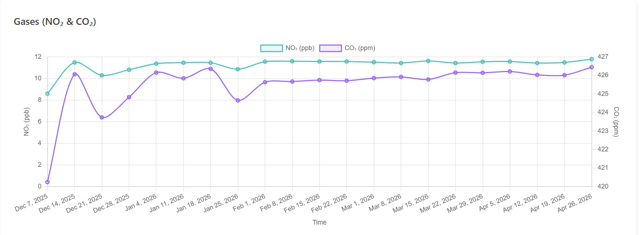
(b) After — NO₂ on the left axis, CO₂ on the right, both legible
Figure 15. The dual-axis fix for the gases chart.

7.4 The forecasting engine
The dashboard forecasts each metric with a seasonal-decomposition model: a linear trend plus a weekly seasonal component. Two corrections were essential. First, the trend is damped (Holt's method with φ = 0.9) so that long-horizon forecasts plateau rather than drifting linearly out of the plausible range. Second, an erroneous diurnal term that biased every daily forecast point upward was removed. The before/after is stark: the original forecast spiked toward 13 µg/m³, while the corrected one plateaus realistically near the recent level of ~9 (Figure 17).
// damped trend: phi<1 makes the horizon plateau
let out = [];
for (let h = 1; h <= horizon; h++) {
const damp = (1 - Math.pow(phi, h)) / (1 - phi); // geometric sum
out.push(level + damp * trend + weekly[h % 7]);
}
Damped-trend extrapolation — the geometric damping factor bounds long-range forecasts.
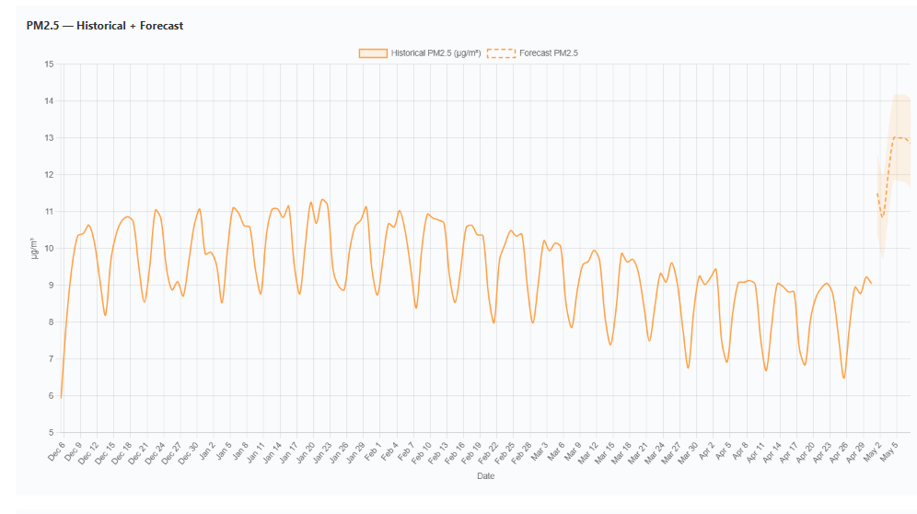
(a) Before — undamped trend plus a diurnal bias spikes the forecast upward
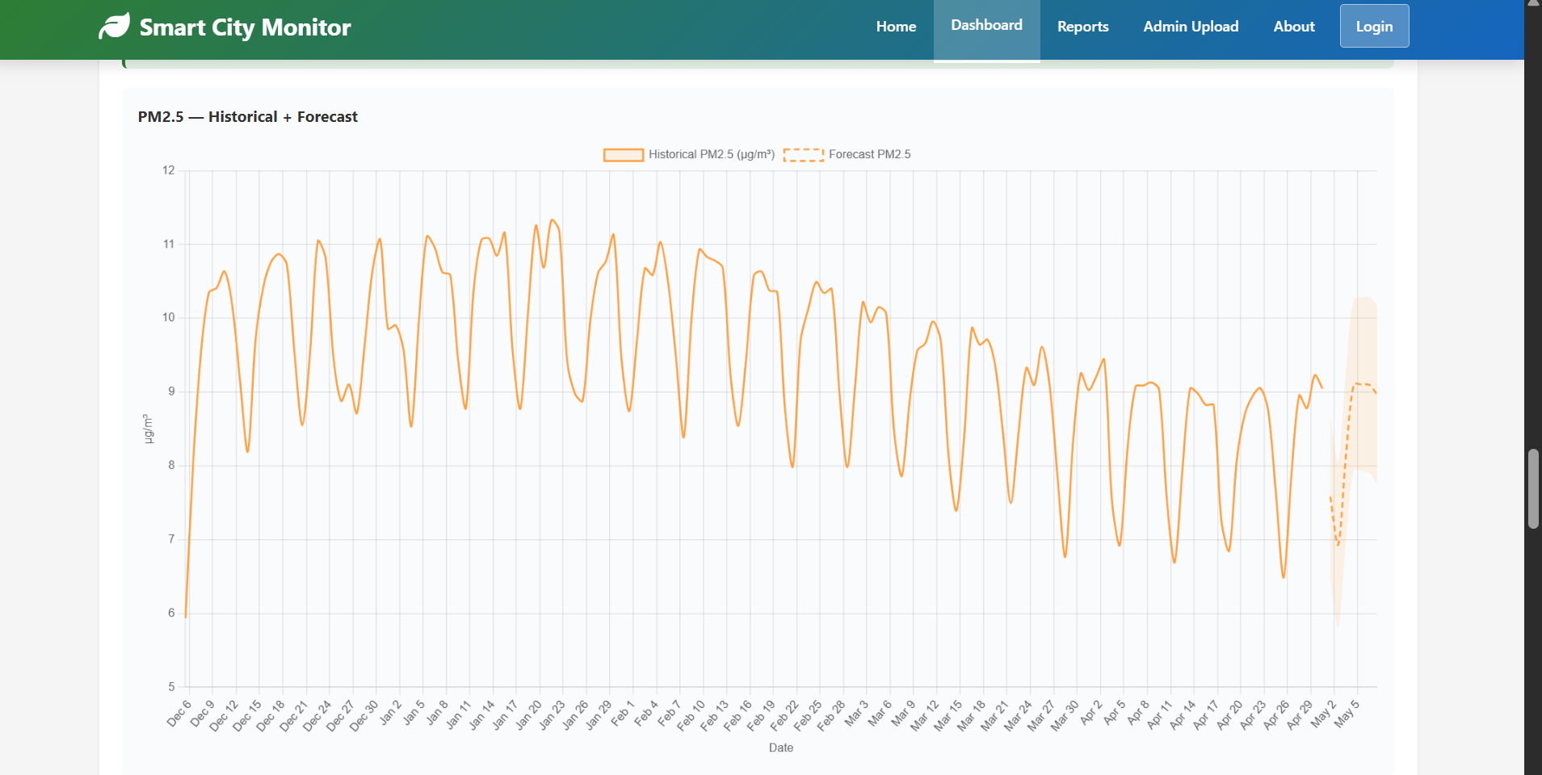
(b) After — damped trend plateaus near the recent level with a 95 % band
Figure 16. The forecasting-method correction.

7.5 The benchmark-line toggle
Users can overlay WHO / Australian standard lines on the charts. The toggle is off by default so the axis auto-fits the data; turning it on caps the axis at the larger of the data maximum and the benchmark, plus 5 % headroom, so the threshold line is always visible. CO₂ is deliberately excluded because there is no outdoor CO₂ standard to draw.
if (showBenchmarks) {
scale.max = Math.max(dataMax, benchmark) * 1.05; // keep line visible
} else {
delete scale.max; // auto-fit to data
}
Axis capping so an overlaid threshold line is never clipped off the top of the chart.
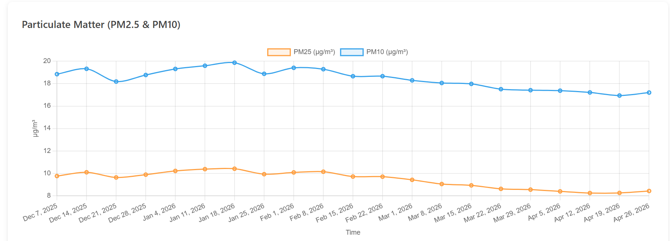
(a) Toggle off — axis auto-fits the data
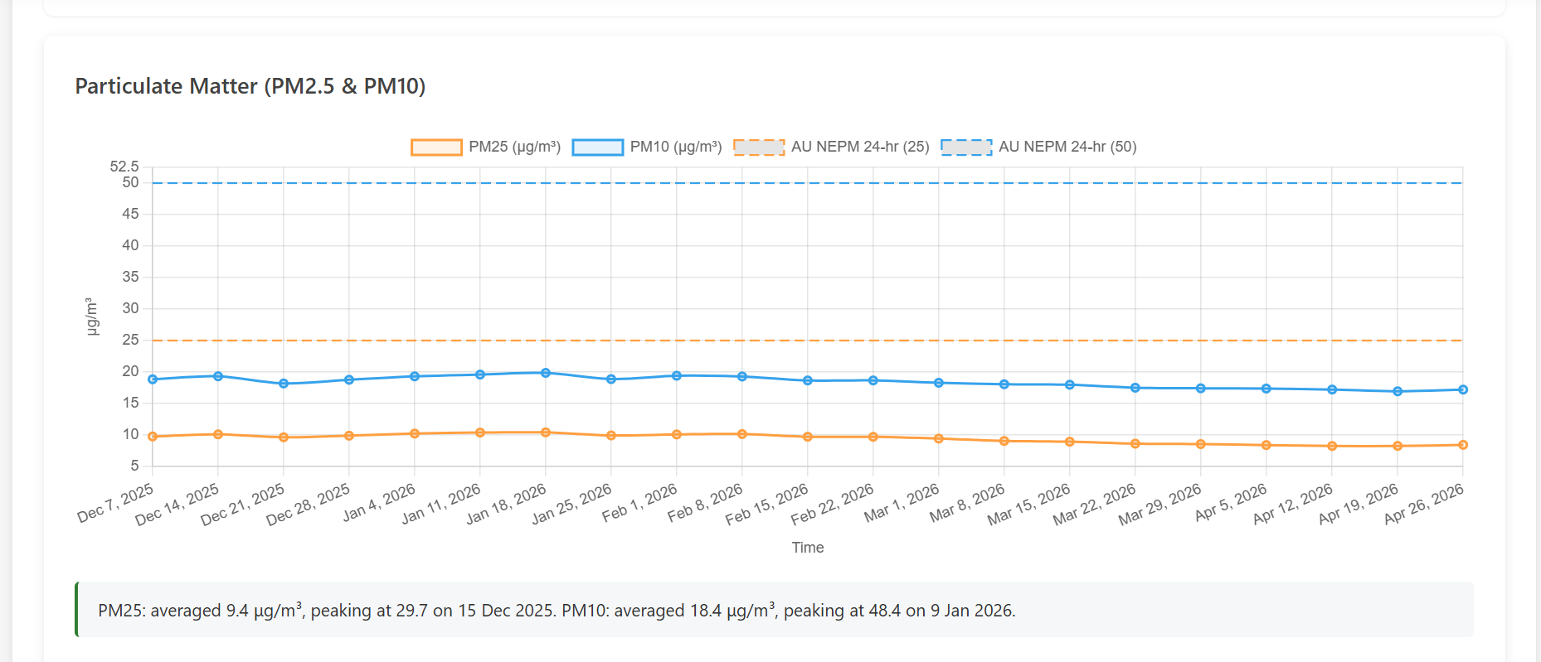
(b) Toggle on — AU NEPM threshold lines shown with headroom
Figure 17. The benchmark-line toggle, off and on.

7.6 CSV export with a UTF-8 byte-order mark
The Reports page exports a multi-section CSV entirely in the browser. Excel, however, assumes a legacy encoding unless told otherwise, so units such as µg/m³ and symbols such as NO₂ rendered as mojibake. Prepending a UTF-8 byte-order mark (BOM) tells Excel the file is UTF-8 and the headers render correctly (Figure 19):
const BOM = "\uFEFF"; // signals UTF-8 to Excel
const blob = new Blob([BOM + csv], { type: "text/csv;charset=utf-8" });
A two-character prefix that fixes Excel's encoding guess.
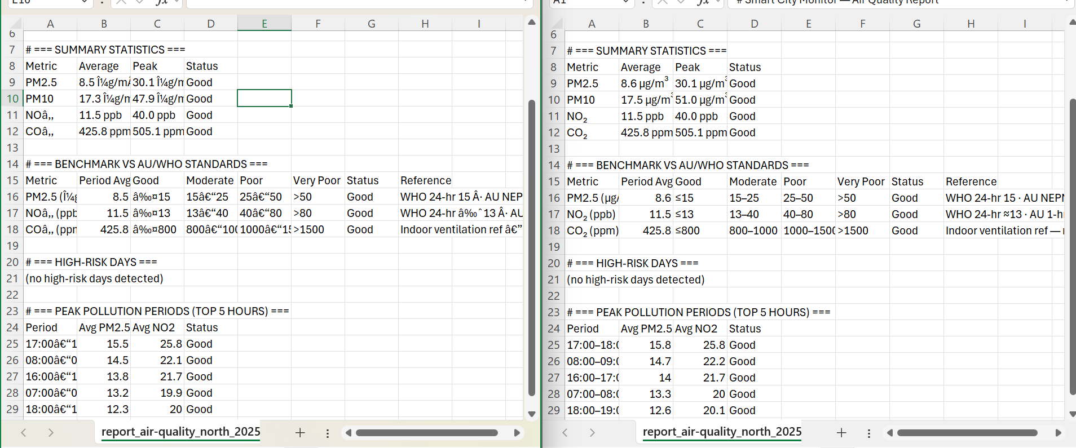
Figure 18. CSV export opened in Excel: before the BOM (left) the special characters are mangled; after (right) µg/m³ and NO₂ render correctly.

7.7 The mobile crash fix
On mobile browsers the dashboard crashed with “Maximum call stack size exceeded” when combining the parallel CSV downloads. The cause was using the spread operator to push a ~130,000-row array into the accumulator: spread passes every element as a separate function argument, and mobile JavaScript engines enforce a much lower argument-count limit than desktop. Replacing the spread with a row-by-row loop removed the limit entirely (Figure 20):
// BEFORE: every row becomes a function argument -> stack overflow
allRows.push(...rows);

// AFTER: append each row; no argument-count limit
for (const r of rows) allRows.push(r);
Replacing a spread with a loop to avoid the engine's argument-count limit on large arrays.
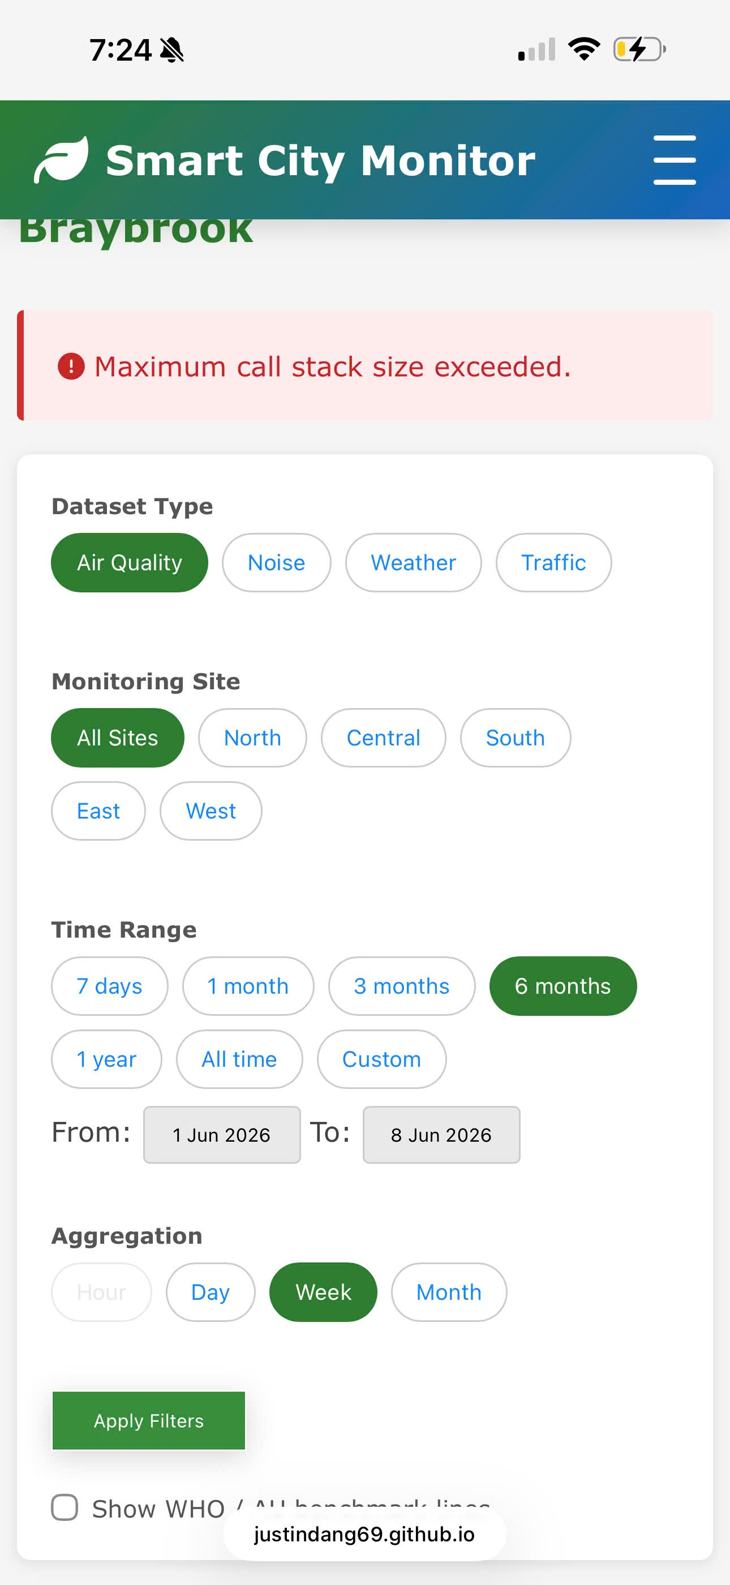  (a) Before — “Maximum call stack size exceeded” on mobile | 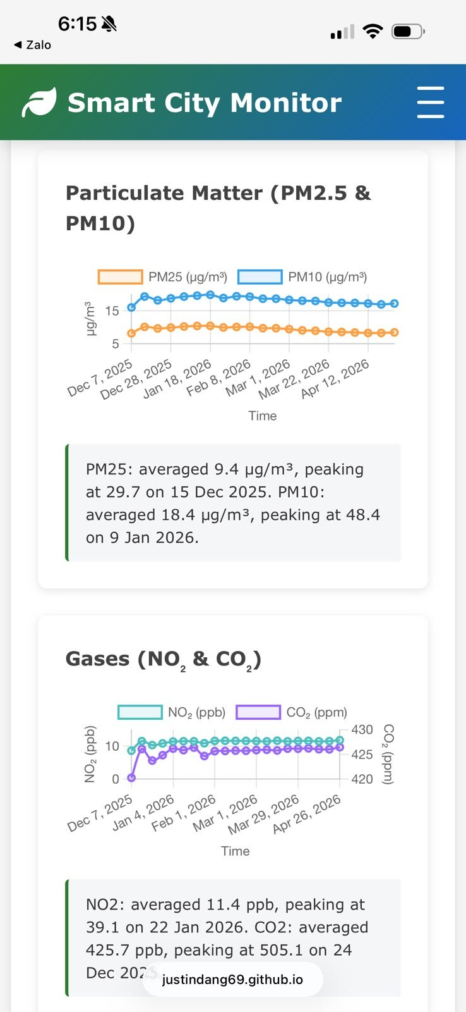  (b) After — the dashboard renders correctly on mobile

Figure 19. The mobile crash, before and after replacing the spread operator with a loop.

8. Security and Design Justifications
Security in this system is about hardening the endpoints, not hiding the source. The frontend is static and fully visible in the browser, so the security boundary is drawn at the server: every secret-bearing or trust-sensitive operation happens inside a Lambda.

8.1 The frontend / backend split
The dividing principle is “compute where appropriate”. The browser does UI, aggregation and forecasting — stateless work that benefits from being instant and that exposes nothing sensitive. The Lambdas do S3 access, correlation, LLM calls and all secret handling — work that must be trusted and is compute-heavy. The NVIDIA API key and the bucket name live only in Lambda environment variables and never reach the client.

8.2 Least-privilege IAM
Each Lambda runs under a role granting only the permissions it needs. The AnalyzePatterns role, for instance, separates s3:GetObject (scoped with a /* resource so it can read objects) from s3:ListBucket (scoped to the bucket itself, without /*), because those two actions take different resource forms. Granting the minimum keeps a compromised function from doing more than its job.
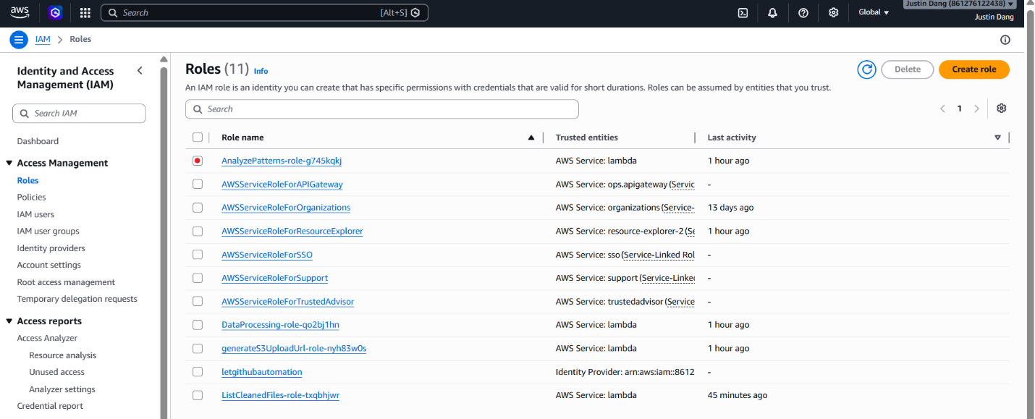
Figure 20. The IAM policy for the AnalyzePatterns role — separate statements for object reads (/*) and bucket listing (no /*).

8.3 A single, minimal API surface
All client–server traffic goes through three API Gateway routes — POST /generate-upload-url, GET /list-files and GET /analyze — each wired to exactly one Lambda. A small, explicit surface is easy to reason about, easy to lock down with CORS, and leaves no incidental endpoints exposed.
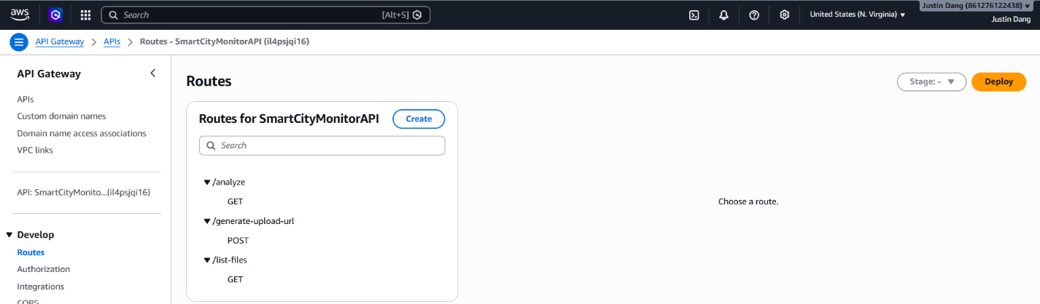
Figure 21. The three API Gateway routes, each wired to its own Lambda integration on the prod stage.

8.4 Summary of key decisions
The table below collects the decisions that most shape the system and the reasoning behind each.
Decision | Reason
Serverless Lambda over a server | Scales to zero, no maintenance, fits a student budget.
Pure-stdlib Python (no pandas layer) | Drop-in deploy with no layer to build or version.
Event-driven cleaning via S3 trigger | Decouples upload from processing; upload returns instantly.
Exclude average_speed for air pollutants | It is a confounder, not a cause — keeps analysis correct.
References matched, not LLM-generated | Guarantees citations are real; prevents hallucination.
Circuit breaker + template fallback | Feature degrades gracefully when the LLM is unavailable.
Domain-bounded validation | Rejects physically impossible sensor readings at the source.
Presigned URLs with 5-min expiry | No upload server; a leaked URL expires almost immediately.

9. Key Environmental Findings
Beyond demonstrating that the platform works, the deployed system was used to analyse roughly five months of Braybrook data (December 2025 to April 2026). Because the AnalyzePatterns Lambda reports every relationship as a Pearson coefficient and an r-squared value, the findings below are read directly from the system's own output rather than asserted. All figures come from a live run over the air-quality dataset joined with the traffic and weather feeds across the monitored sites.

9.1 Traffic is the dominant driver of air pollution
Across every air pollutant, vehicle count is by far the strongest predictor. Nitrogen dioxide tracks traffic almost perfectly (r = 0.971), meaning roughly 94% of its variation is explained by traffic volume alone. Fine particulates and carbon dioxide follow the same pattern (PM2.5 r = 0.865, about 75%; CO₂ r = 0.832, about 69%). Figure 22 shows all three as strong positive bars. This is the single clearest result in the dataset: in Braybrook, road traffic — not industry or weather — is the primary lever on air quality.
Note on causality. Average vehicle speed also correlates strongly with the pollutants, but negatively. As Section 6.3 explains, speed is treated as a confounder (both speed and concentration are consequences of traffic volume, not of each other) and is excluded as a causal driver, so it does not appear among the drivers above. This is what keeps the finding — and any policy built on it — statistically defensible.
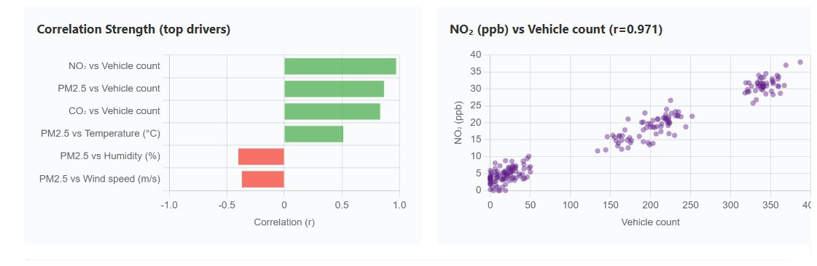
Figure 22. Correlation strength of each driver against the pollution outcomes, shown with the NO₂-versus-vehicle-count relationship (r = 0.971). Green bars are positive correlations, red are negative.

9.2 Weather modulates pollution, but does not dominate
Weather has a secondary, moderating influence. Warmer temperatures are associated with higher PM2.5 (r = 0.512, about 26% of variance), while higher humidity and higher wind speed are associated with lower PM2.5 (r = −0.40 and r = −0.369). The negative wind-speed relationship is the expected dispersion effect — wind clears accumulated particulates. The practical reading is that weather shapes how severe a pollution episode becomes, but traffic determines whether one occurs at all.

9.3 Pollution and noise follow daily activity cycles
Because the pollutants share a single traffic driver, they rise and fall together on a daily cycle that peaks during the morning and evening commutes. Noise follows the same rhythm — and it is the one outcome for which average vehicle speed is kept as a legitimate driver, since engine and tyre noise genuinely increase with speed. Over the monitored period noise averaged about 50.7 dB(A) with short peaks to about 84.5 dB(A), a profile consistent with traffic-driven exposure rather than constant industrial noise.

9.4 Overall levels sit within health benchmarks for the period
Encouragingly, average concentrations over the period sit within WHO and Australian (NEPM) guidelines: NO₂ averaged about 11.5 ppb, PM2.5 about 8.5 µg/m³, PM10 about 17.3 µg/m³ and CO₂ about 426 ppm, and the system flagged no high-risk days. The value of the analysis is therefore preventive: it identifies traffic as the dominant lever while levels are still healthy, so the council can act before urban growth pushes concentrations toward the thresholds. The correlations are summarised below.
Relationship | r | Variance explained | Reading
NO₂ vs vehicle count | 0.971 | ~94% | Traffic is the dominant driver
PM2.5 vs vehicle count | 0.865 | ~75% | Strong traffic driver
CO₂ vs vehicle count | 0.832 | ~69% | Strong traffic driver
PM2.5 vs temperature | 0.512 | ~26% | Warmer air, higher particulates
PM2.5 vs humidity | −0.40 | ~16% | Humidity suppresses particulates
PM2.5 vs wind speed | −0.369 | ~14% | Wind disperses particulates

10. System Evaluation
The system was evaluated against five practical criteria: dashboard load performance, AI analysis response time, server-side compute cost, cross-device compatibility, and the accuracy and usefulness of the generated insights. All measurements were taken on the live, deployed system using Chrome DevTools and AWS CloudWatch.

10.1 Performance
Loading the dashboard for a site is a two-step operation: a file-discovery call (the ListCleanedFiles Lambda, about 2.9–3.6 s) followed by the parallel download of the cleaned CSVs. Because each cleaned file covers the full measurement range (about 10 MB) and the files are fetched together with Promise.all, a full all-sites load completed in roughly 13–14 seconds end to end. Critically, once the data is loaded every subsequent interaction — changing the date range or the aggregation — is instant, because filtering happens client-side with no further network calls. The initial transfer is the cost of doing all later analysis offline in the browser.
The AI cause-analysis call is the heaviest single request. End to end it took 12.1 s for an all-sites analysis and 21.2 s for a single site, both comfortably inside API Gateway's 30 s ceiling. The server-side CloudWatch report (Figure 23) shows the AnalyzePatterns Lambda itself ran in 12.06 s using only 392 MB of its 1024 MB allocation, with a cold-start initialisation of just 0.59 s — confirming that the downsampling strategy and memory sizing keep the function well within budget even on a large request.
Metric | Measured | Source
Dashboard load — all sites, full dataset | ~13–14 s | DevTools Network
File-discovery call (ListCleanedFiles) | ~2.9–3.6 s | DevTools Network
AI analysis — end to end (all sites) | 12.1 s | DevTools Network
AI analysis — end to end (single site) | 21.2 s | DevTools Network
AI analysis — Lambda compute time | 12.06 s | CloudWatch REPORT
AI Lambda memory used | 392 / 1024 MB | CloudWatch REPORT
AI Lambda cold-start (init) | 0.59 s | CloudWatch REPORT
Rows combined per AI run (then downsampled) | 245,088 | Browser console

Figure 23. CloudWatch REPORT line for the AnalyzePatterns Lambda: 12.06 s duration, 392 MB of 1024 MB used, and a 0.59 s cold start — well inside the 30 s API Gateway limit.

10.2 Cross-device compatibility
The responsive layout was tested across five device classes — two physical phones and three emulated form factors — covering small phones, a large tablet, a smart display and a foldable. The dashboard, charts and AI Cause Analysis panel rendered correctly on all five: the navigation collapses to a hamburger menu and the charts reflow to a single column on narrow screens (Figure 24). The mobile crash described in Section 7.7 no longer reproduces on any device tested.
Device | Form factor | Result
iPhone 14 Pro Max | Phone (physical) | Pass
Samsung Galaxy S20 Ultra | Phone (physical) | Pass
iPad Pro | Tablet | Pass
Google Nest Hub | Smart display | Pass
Asus Zenbook Fold | Foldable | Pass

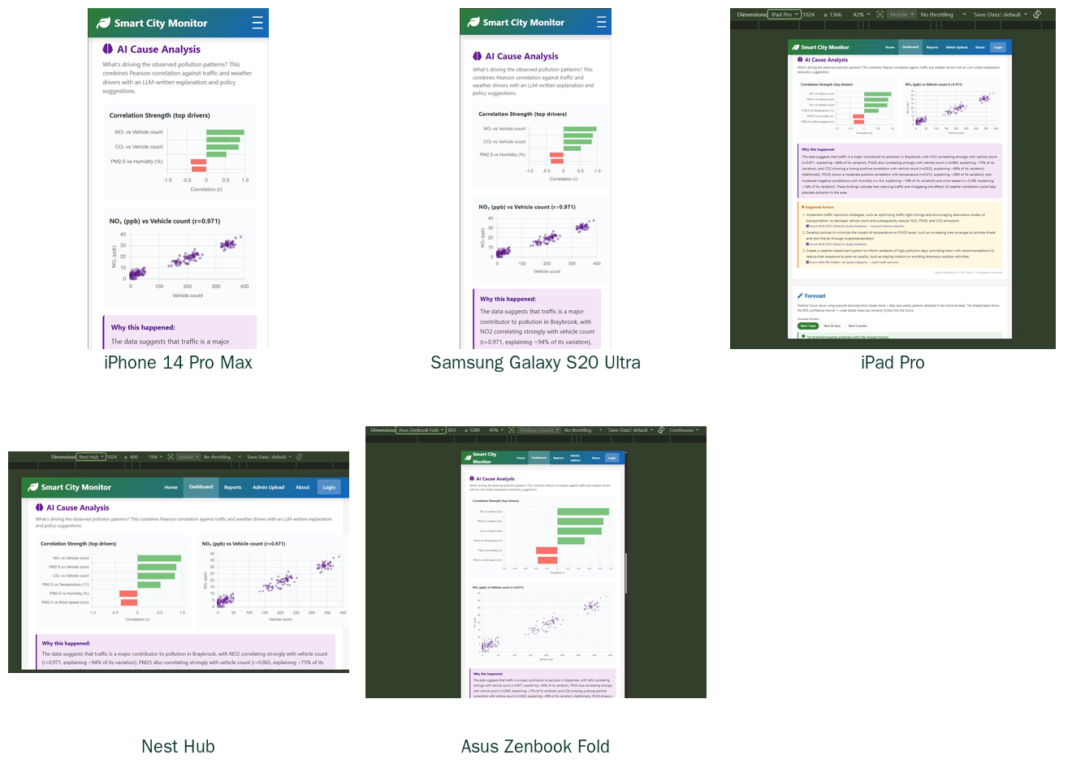
Figure 24. The AI Cause Analysis view rendering correctly across five device classes, from a 391-px phone to a foldable and a smart display.

10.3 Insight accuracy and usefulness
Two checks support the quality of the generated insights. First, accuracy of attribution: because the explanation is assembled from coefficients computed in Python and the model is explicitly forbidden to invent numbers, the headline claim — that traffic explains about 94% of NO₂ variance — is a direct, reproducible statistic, not a model guess. Second, provenance: the browser console confirms the insight was produced by the live model (insightSource: meta/llama-3.3-70b-instruct) over 245,088 combined rows, not by the template fallback (Figure 25). The usefulness of the output is evidenced by the suggested actions, each of which targets the strongest measured driver — traffic — and carries a real WHO or NEPM source, so a council officer receives not just a number but a defensible, actionable recommendation.
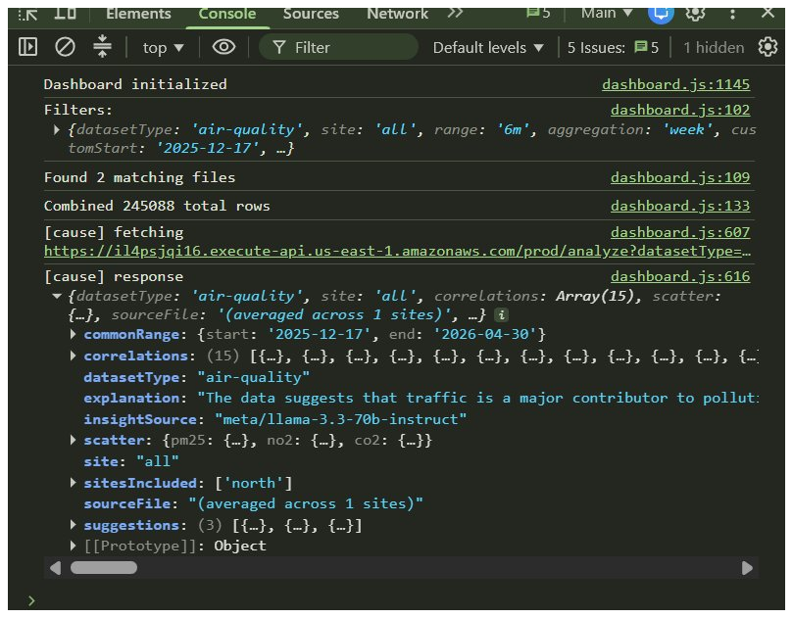
Figure 25. Browser console confirming the insight was generated by the live LLM (insightSource: meta/llama-3.3-70b-instruct) over 245,088 combined rows — evidence that the genuine analysis path, not the template fallback, produced the result.

11. Limitations and Future Work
- Demonstration authentication. Admin sign-in uses Cognito scoped to the admin page; a production deployment would extend role-based authorisation across the API and add per-request signing.
- Forecast model scope. The seasonal-decomposition forecaster captures trend and weekly seasonality well; richer models (for example incorporating weather as an exogenous regressor) would improve multi-day accuracy and could be evaluated offline in a notebook.
- Synthetic data coverage. Real council telemetry is complemented by a causal synthetic dataset to give full date-range coverage; as more real sensor data becomes available the synthetic component can be retired.
- LLM latency. A cause-analysis call takes 5–15 seconds because it reads three CSVs and calls the model; caching recent analyses per (site, range) would make repeat views instant.
- Single region. All backend resources are in us-east-1; a latency-sensitive production system would front the API with a multi-region or edge deployment.

12. Conclusion
The Smart Air and Noise Quality Monitoring System is a complete, deployed, end-to-end platform that takes raw council sensor exports and turns them into clean data, interactive visualisation, forecasting and trustworthy AI-driven analysis — on an architecture that costs almost nothing to run. Its defining qualities are in the reasoning: an event-driven serverless pipeline chosen for maintainability and cost; a correlation engine that controls for a confounding variable to stay statistically honest; an LLM integration that is grounded in real numbers, cannot fabricate citations, and fails gracefully; and a frontend/backend split that keeps secrets server-side while keeping the interface instant. Each main function has been presented here with its logic, its implementation and — most importantly — the justification for why it was built that way.

