VICTORIA UNIVERSITY

MINI ASSIGNMENT
  - Malicious Website Classification
NIT3202 Statistics and Data Mining

Student | Justin Dang
Student ID | s8149950
Submission date | 13 September 2026
Complete reproducible R code is submitted separately.

Executive Summary
This report develops and evaluates three supervised classifiers—logistic regression, a radial support vector machine (SVM), and random forest—for detecting malicious websites. The original dataset contains 1,781 websites and is substantially imbalanced: 216 observations (12.13%) are malicious and 1,565 (87.87%) are benign. Because overall accuracy can obscure performance on the minority class, model selection emphasises malicious-class recall, precision, F1-score, balanced accuracy and ROC AUC.
A critical audit identified that the URL identifier prefix perfectly encoded the target label. The raw URL field was therefore removed before modelling to prevent target leakage. Date fields and disguised missing values were handled explicitly, and a training-only preprocessing recipe performed median imputation, rare-level pooling, dummy encoding, zero-variance removal and numeric normalisation. A stratified 70:30 split preserved the class distribution. All models were tuned using the same repeated five-fold cross-validation folds (three repeats) and the same security-focused custom summary function.
Random forest produced the strongest held-out performance: F1 = 0.8288, balanced accuracy = 0.8583 and ROC AUC = 0.9842. It correctly detected 46 of 64 malicious websites while producing only one false alarm. Logistic regression achieved the same recall but generated ten false positives; the SVM reduced false positives to four but missed three additional malicious websites. Random forest is therefore recommended for this dataset, subject to threshold calibration and validation on newer, independently collected websites before operational deployment.
Table 1. Headline held-out result
Recommended model | F1 | Recall | Precision | Balanced accuracy | ROC AUC
Random Forest | 0.8288 | 0.7188 | 0.9787 | 0.8583 | 0.9842

1. Introduction and Objectives
Malicious website detection is an asymmetric classification problem: failing to identify a malicious website can expose users and systems to harm, while falsely blocking a benign website also carries an operational cost. The purpose of this analysis is therefore not simply to maximise accuracy, but to compare classifiers using measures that describe minority-class detection and false-alarm behaviour.
The analysis addresses three objectives:
- prepare a modelling dataset without target leakage and with reproducible handling of missing and categorical values;
- compare logistic regression, radial SVM and random forest under an identical resampling design; and
- select a model using held-out security-relevant performance and interpret the strongest predictive features.

2. Data Understanding
Table 2. Dataset overview
Item | Value
Original observations | 1,781 websites
Original variables | 21 variables, including the target
Target | Type (benign or malicious)
Positive class | malicious
Predictors after feature engineering | 22 predictors before dummy encoding
Encoded modelling columns | 58 predictor columns plus the outcome

The target distribution is strongly skewed toward benign websites (Figure 1). A naive classifier that always predicts benign would achieve approximately 87.9% accuracy while detecting no malicious websites. This establishes why accuracy is reported but not treated as the primary selection criterion.
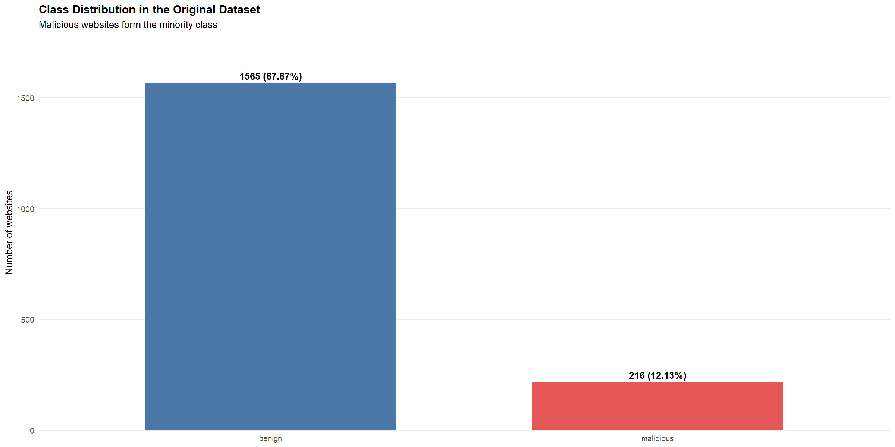
Figure 1. Class distribution in the original dataset.

3. Data Quality and Preparation
Table 3. Key data-quality risks and treatments
Issue | Risk | Treatment
URL identifier prefix | Perfectly revealed the target label | Removed before modelling to prevent leakage
Disguised missing values | Text placeholders could be learned as real categories | Standardised to explicit missing values or indicators
WHOIS date fields | Raw strings are not directly model-ready | Parsed into year-based features with missingness indicators
Rare/unseen categories | Can cause unstable dummy columns at prediction time | Pooled rare levels and added a novel-level rule
Different numeric scales | Especially relevant to distance-based SVM fitting | Median-imputed and normalised using training estimates only
Class imbalance | Accuracy can favour the majority class | Used stratification and security-focused metrics

The most important quality-control decision was removing the URL field after confirming that its identifier prefix mapped perfectly to the class label. Retaining it would have produced misleadingly high validation and test scores rather than a generalisable detector. The preprocessing recipe was estimated on the training set and then applied unchanged to the test set, avoiding information leakage from the held-out data.

3.1 Train–test split
Table 4. Stratified 70:30 data split
Partition | Total | Benign | Malicious | Malicious share
Training | 1,248 | 1,096 | 152 | 12.18%
Testing | 533 | 469 | 64 | 12.01%

The seed was set to 8,149,950 and stratification preserved the original minority-class prevalence in both partitions. The testing set remained untouched during model tuning.

3.2 Leakage-safe preprocessing
The training recipe applied novel-level handling, rare-level pooling at a 1% threshold, median imputation for numeric variables, dummy encoding, zero-variance removal and numeric normalisation. The resulting training and testing matrices contained 59 columns including the outcome, with no remaining missing values. Applying the fitted recipe to the test set ensures that every transformation reflects only training information.

4. Modelling and Validation Strategy
Table 5. Classifiers and tuning configuration
Model | Role | Tuning / configuration
Logistic Regression | Interpretable linear probability baseline | Binomial GLM; no tuning grid
Radial SVM | Non-linear maximum-margin classifier | Best: sigma = 0.0145, C = 4
Random Forest | Non-linear tree ensemble robust to interactions | 500 trees; best: mtry = 20, Gini split, minimum node size = 5

All models used the same repeated five-fold cross-validation folds with three repeats. Reusing identical folds makes the comparison fair because performance differences are not confounded by different resamples. The custom summary function explicitly defined malicious as the positive class and returned F1, recall, precision, specificity, balanced accuracy and ROC AUC. This extends the standard caret workflow (Kuhn, 2008) with metrics aligned to the security context.

Table 6. Why the principal evaluation metrics matter
Metric | What it measures | Security interpretation
Recall | TP / (TP + FN) | Share of malicious websites detected
Precision | TP / (TP + FP) | Reliability of a malicious prediction
F1-score | Harmonic mean of recall and precision | Balances missed threats and false alarms
Specificity | TN / (TN + FP) | Share of benign websites correctly allowed
Balanced accuracy | Mean of recall and specificity | Less distorted by class imbalance
ROC AUC | Ranking performance across thresholds | Threshold-independent discrimination

4.1 Cross-validation results
Table 7. Repeated cross-validation performance
Model | F1 | Recall | Precision | Specificity | Bal. acc. | ROC AUC
Logistic Regression | 0.7805 | 0.7637 | 0.8041 | 0.9738 | 0.8687 | 0.9505
Support Vector Machine | 0.8083 | 0.7305 | 0.9112 | 0.9900 | 0.8602 | 0.9582
Random Forest | 0.8305 | 0.7372 | 0.9604 | 0.9954 | 0.8663 | 0.9864

Random forest achieved the strongest cross-validated F1-score, precision, specificity and ROC AUC. Logistic regression produced the highest recall and a slightly higher balanced accuracy than random forest, illustrating the central trade-off: the ensemble was more conservative and accurate when flagging a website as malicious, whereas logistic regression detected a somewhat larger share of threats during resampling.

5. Held-out Test Results
Table 8. Performance on the held-out testing set
Model | Accuracy | F1 | Recall | Precision | Specificity | Bal. acc. | ROC AUC
Logistic Regression | 0.9475 | 0.7667 | 0.7188 | 0.8214 | 0.9787 | 0.8487 | 0.9355
Support Vector Machine | 0.9531 | 0.7748 | 0.6719 | 0.9149 | 0.9915 | 0.8317 | 0.9239
Random Forest | 0.9644 | 0.8288 | 0.7188 | 0.9787 | 0.9979 | 0.8583 | 0.9842

The held-out results confirm random forest as the best overall model. It matched logistic regression's recall (0.7188) while substantially improving precision (0.9787 versus 0.8214), F1-score and specificity. The SVM generated few false positives but had the lowest recall, missing 21 of the 64 malicious websites. Figure 2 makes the metric trade-offs visible, while Figure 3 shows that random forest provides the strongest ranking performance across decision thresholds.
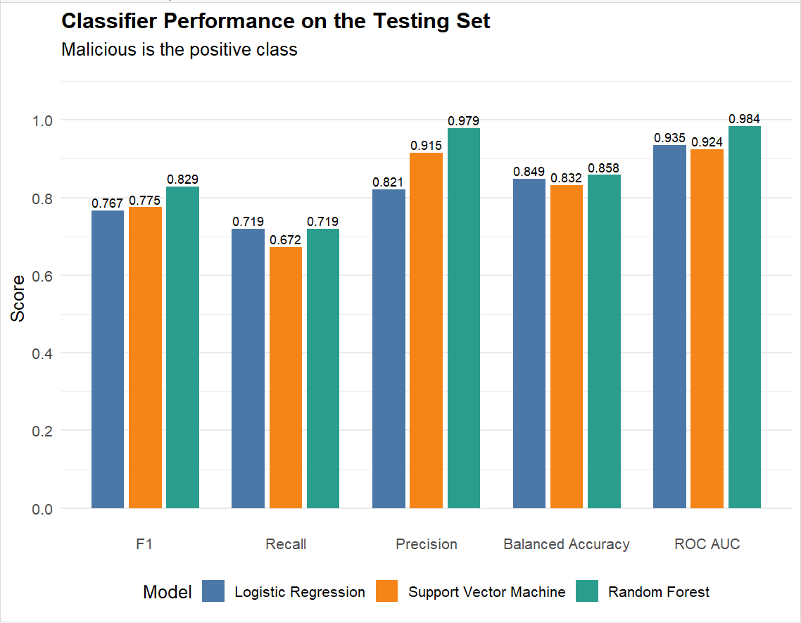
Figure 2. Security-relevant classifier performance on the held-out testing set.

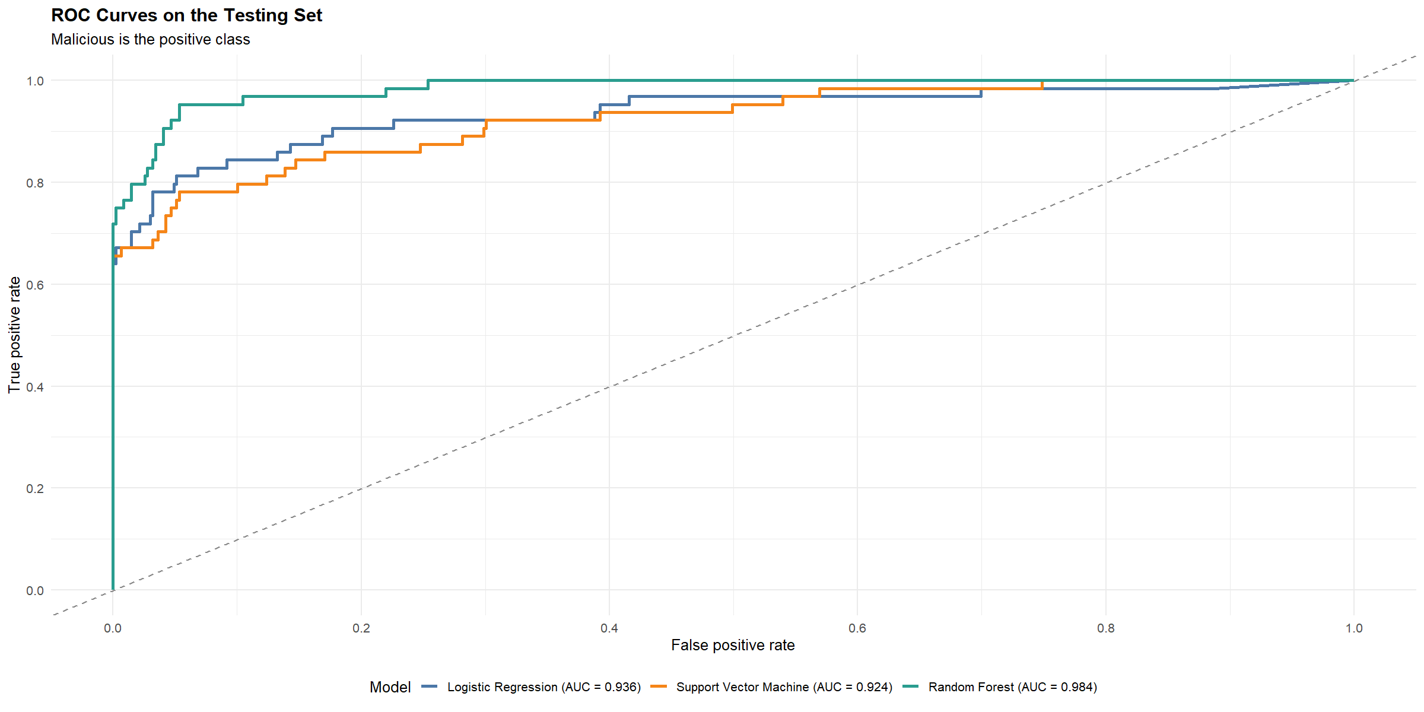
Figure 3. ROC curves for the three classifiers on the held-out testing set.
The random forest ROC curve dominates most of the plotted range and has an AUC of 0.984, compared with 0.936 for logistic regression and 0.924 for the SVM. ROC AUC is useful for assessing discrimination, but the operating threshold should ultimately be chosen using the relative costs of false negatives and false positives rather than AUC alone (Robin et al., 2011).

6. Error Analysis
Table 9. Confusion-matrix counts on the testing set
Model | True positive | False negative | False positive | True negative
Logistic Regression | 46 | 18 | 10 | 459
Support Vector Machine | 43 | 21 | 4 | 465
Random Forest | 46 | 18 | 1 | 468

Random forest offers the strongest error profile at the default decision rule: it detects the same 46 malicious websites as logistic regression but reduces false positives from 10 to 1. The SVM also limits false alarms, but this comes at the cost of three additional missed malicious websites. In a high-risk deployment, the random forest probability threshold could be lowered to increase recall; that change should be selected using a documented cost function and re-evaluated on validation data.
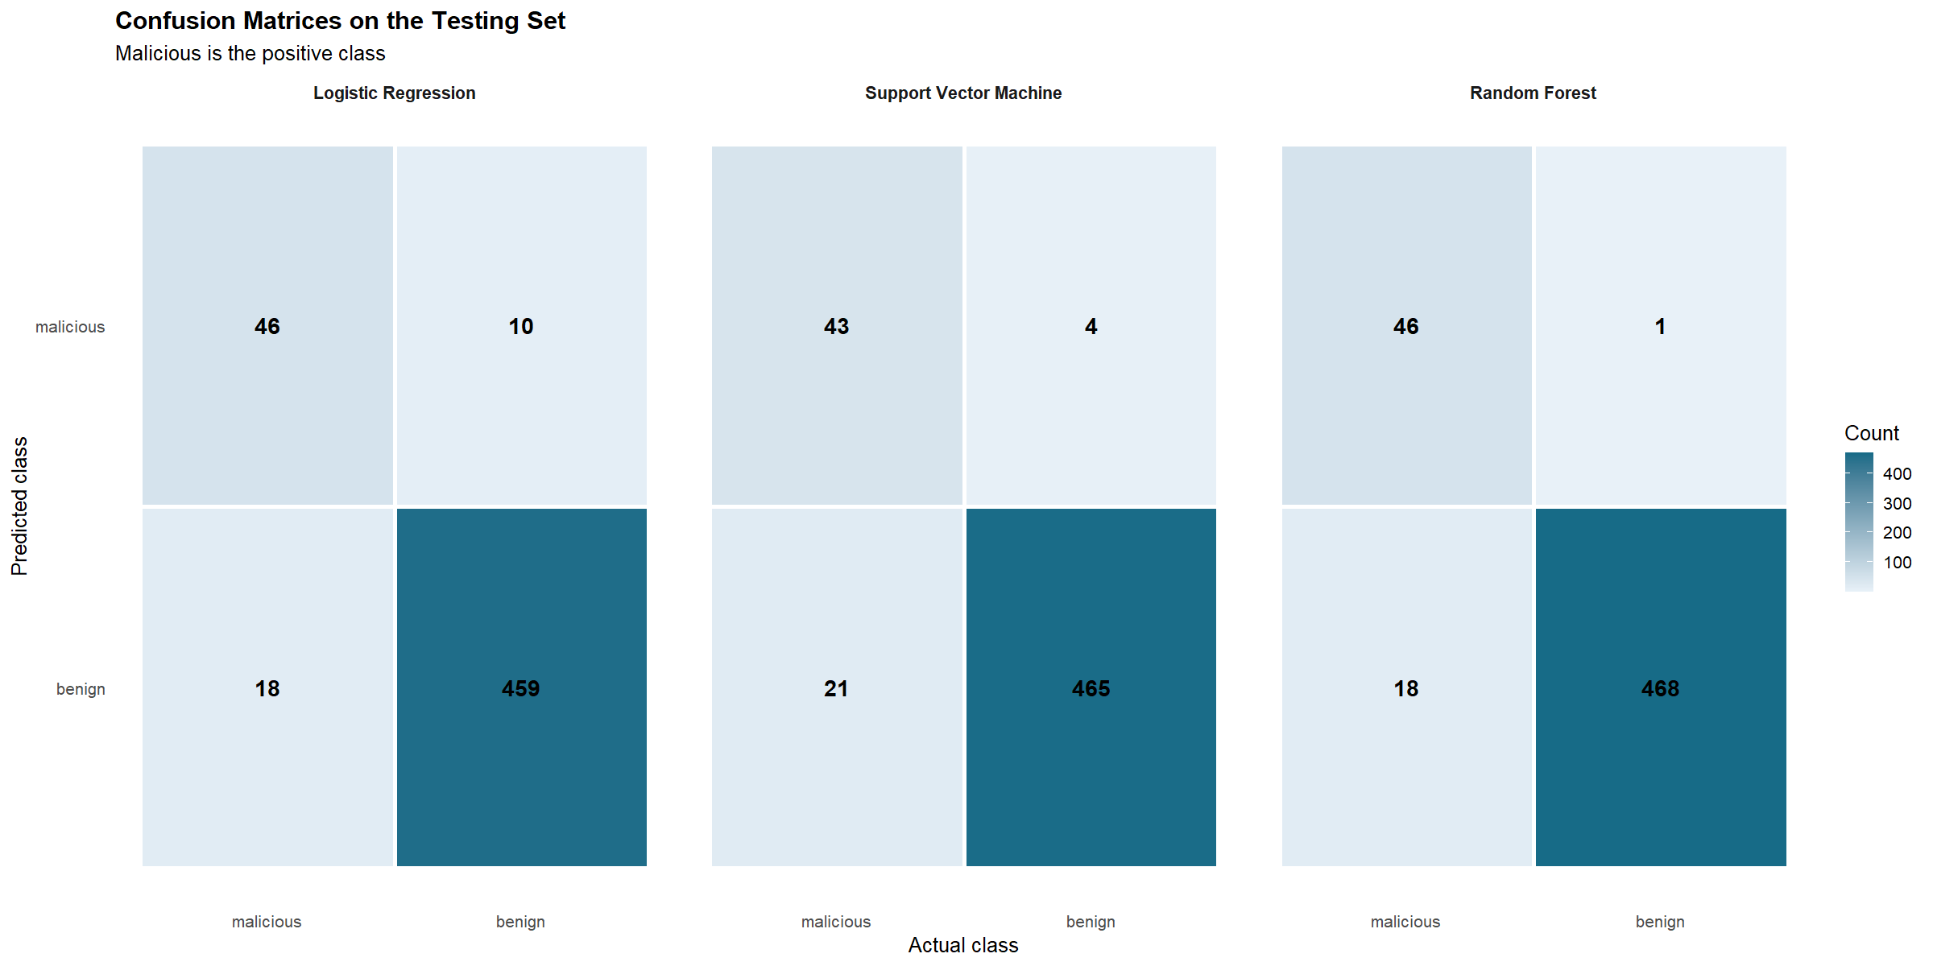
Figure 4. Confusion matrices for the three classifiers on the held-out testing set; malicious is the positive class.

7. Random Forest Feature Importance
Permutation importance from the selected random forest was scaled relative to the most important feature (Figure 5). Network-traffic measures dominate the ranking: source application bytes, remote application packets and destination remote TCP port are the three strongest contributors. WHOIS status, DNS activity and URL length also appear in the top ten, indicating that the ensemble combines evidence across traffic, registration and URL-related feature groups.
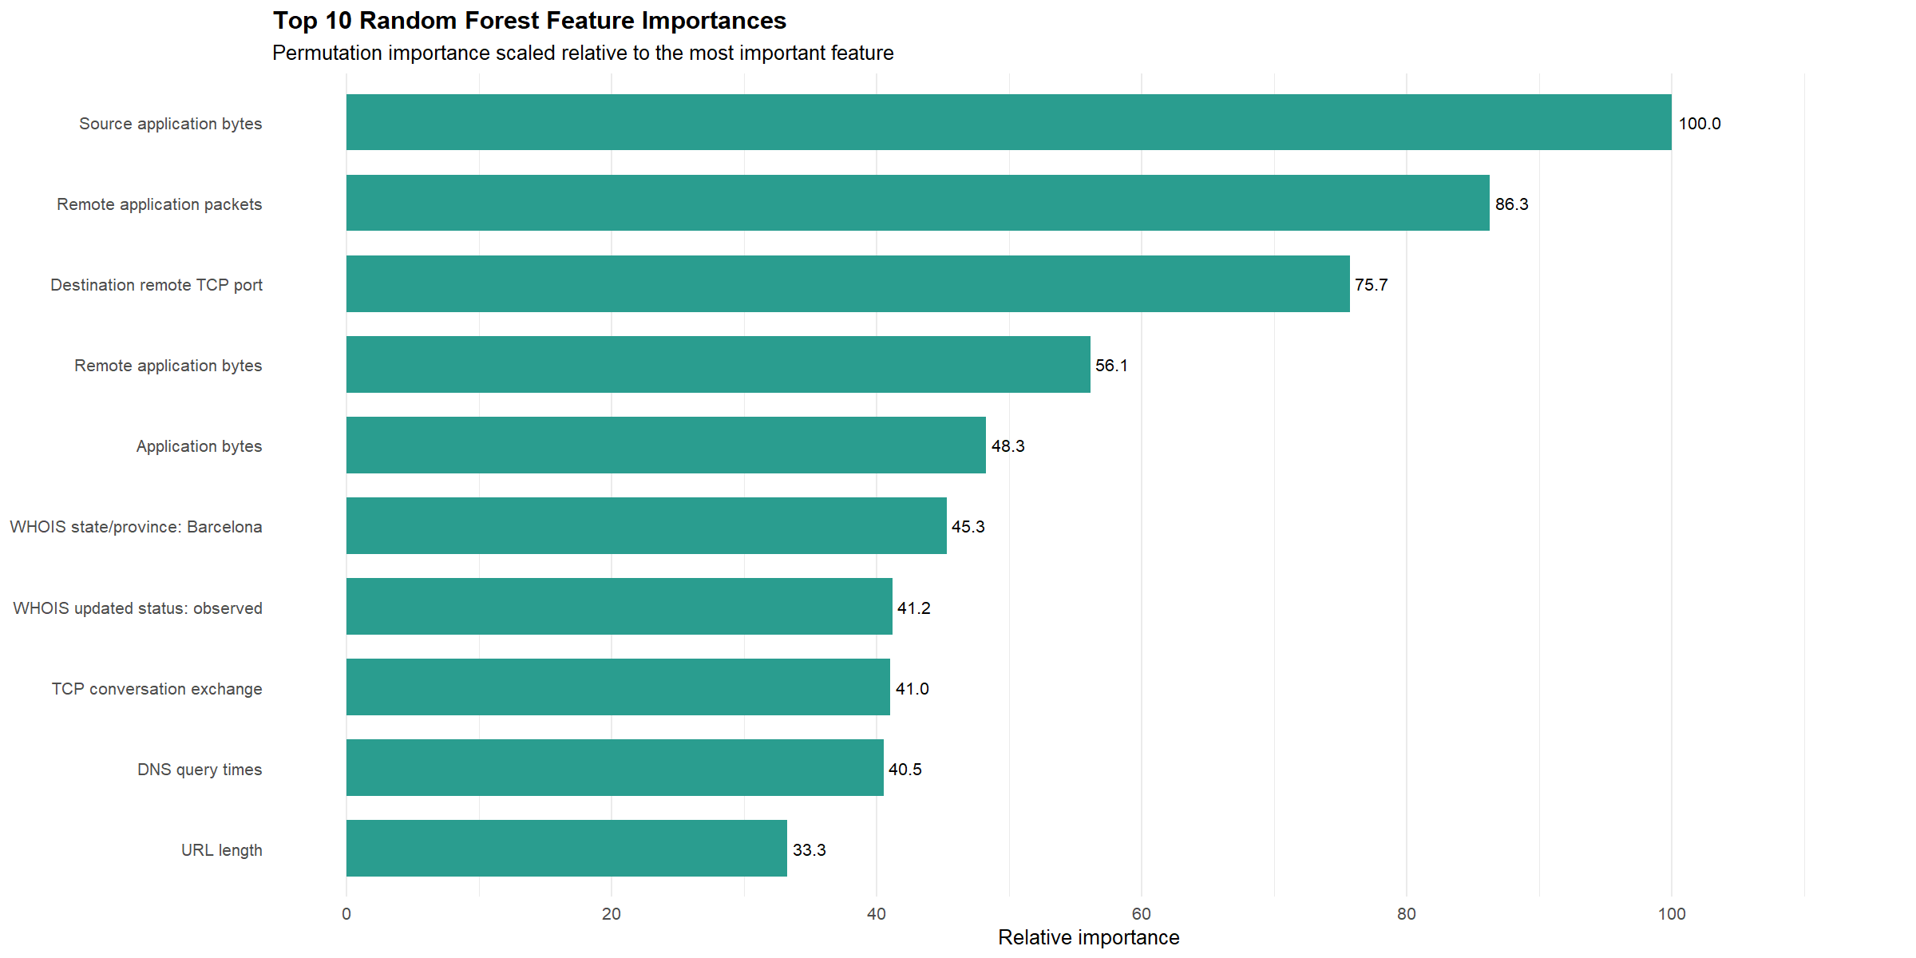
Figure 5. Top 10 random forest permutation importances, scaled relative to the most important feature.
These values describe predictive contribution within this fitted model; they do not establish causality. Importance can also be distributed among correlated variables. In particular, the Barcelona WHOIS dummy should not be interpreted as evidence that location causes maliciousness. The ranger implementation provides an efficient random-forest framework for high-dimensional data, but interpretation remains model- and sample-dependent (Wright and Ziegler, 2017).

8. Discussion
Table 10. Random forest performance stability from resampling to test data
Metric | Repeated CV | Held-out test | Difference (test − CV)
F1 | 0.8305 | 0.8288 | −0.0017
Recall | 0.7372 | 0.7188 | −0.0184
Precision | 0.9604 | 0.9787 | +0.0183
Balanced accuracy | 0.8663 | 0.8583 | −0.0080
ROC AUC | 0.9864 | 0.9842 | −0.0022

Random forest performance is highly consistent between repeated cross-validation and the held-out test set. The F1 and ROC AUC changes are both below 0.003, while the 0.018 decrease in recall is offset by a similar increase in precision. This consistency supports the conclusion that the model's superiority is not an artefact of one validation split, although the small number of malicious test cases means uncertainty remains.

8.1 Strengths
- A leakage audit identified and removed a target-revealing URL identifier before fitting models.
- All preprocessing steps were estimated from training data and applied consistently to held-out data.
- The three models used identical repeated cross-validation folds and a common custom metric function.
- Evaluation combines threshold-dependent metrics, confusion counts and threshold-independent ROC AUC.

8.2 Limitations and next steps
- Only 64 malicious websites appear in the testing set; confidence intervals or bootstrap uncertainty should be reported in a larger study.
- The data source and collection period may not represent future attacks, so temporal or external validation is required before deployment.
- The default classification threshold was compared. A cost-sensitive threshold should be selected using explicit organisational costs for missed threats and false alarms.
- Feature importance is global and non-causal. Partial-dependence or SHAP-style analyses could investigate direction and local behaviour.
- Future work should evaluate probability calibration, class-weighted training and drift monitoring as attacker behaviour changes.

9. Conclusion
This study compared logistic regression, radial SVM and random forest for an imbalanced malicious-website classification task. After removing a target-leaking URL identifier and applying training-only preprocessing, all models were evaluated with identical repeated cross-validation and a held-out test set. Random forest delivered the best overall test performance, with F1 = 0.8288, balanced accuracy = 0.8583, ROC AUC = 0.9842, 46 true positives and only one false positive. It is therefore the preferred model for this dataset. Nevertheless, 18 malicious websites remained undetected, so operational use should prioritise threshold calibration, external validation and ongoing monitoring rather than treating the current model as deployment-ready.

10. Reproducibility Statement
The complete reproducible analysis is submitted separately as S8149950_Mini Assignment.R. Selected implementation evidence is retained in Appendix A to connect the report's claims to the executed R workflow without overwhelming the main analysis with full-length code. The environment record is included in Appendix Figure A12.

References
Kuhn, M. (2008) ‘Building predictive models in R using the caret package’, Journal of Statistical Software, 28(5), pp. 1–26. https://doi.org/10.18637/jss.v028.i05
R Core Team (2026) R: A language and environment for statistical computing. Vienna: R Foundation for Statistical Computing.
Robin, X., Turck, N., Hainard, A., Tiberti, N., Lisacek, F., Sanchez, J.-C. and Müller, M. (2011) ‘pROC: an open-source package for R and S+ to analyze and compare ROC curves’, BMC Bioinformatics, 12, 77. https://doi.org/10.1186/1471-2105-12-77
Wright, M.N. and Ziegler, A. (2017) ‘ranger: A fast implementation of random forests for high dimensional data in C++ and R’, Journal of Statistical Software, 77(1), pp. 1–17. https://doi.org/10.18637/jss.v077.i01

Appendix A. Selected Implementation Evidence
The appendix records the principal implementation decisions and outputs used to support the analysis. Full code is supplied in the separate R script; screenshots are retained here only where they provide concise evidence of data auditing, leakage control, preprocessing, validation, tuning and final evaluation.

A1. Initial audit and leakage detection
This audit establishes the class imbalance, identifies disguised missing values and demonstrates that the URL prefix perfectly encoded the target.
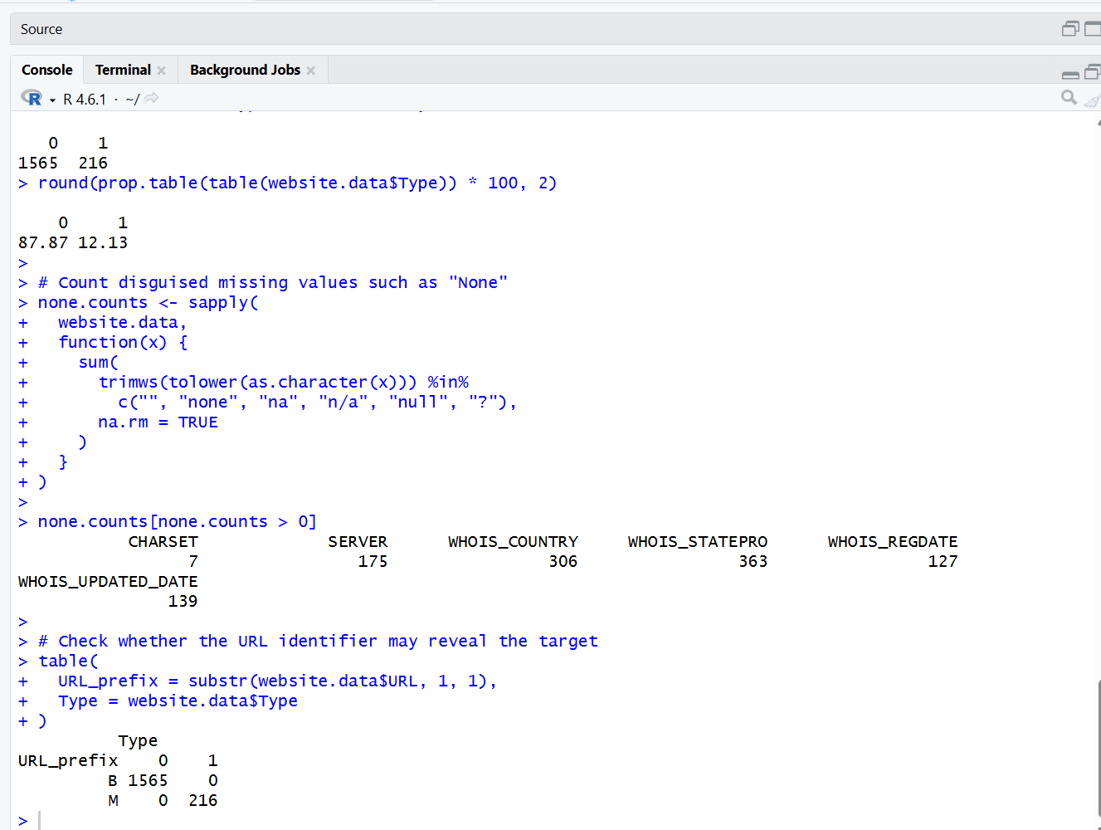
Appendix Figure A1. Initial class, missing-value and URL-prefix audit.

A2. Target preparation and leakage removal
The target is explicitly ordered with malicious as the positive class, and the raw URL identifier is removed before modelling.
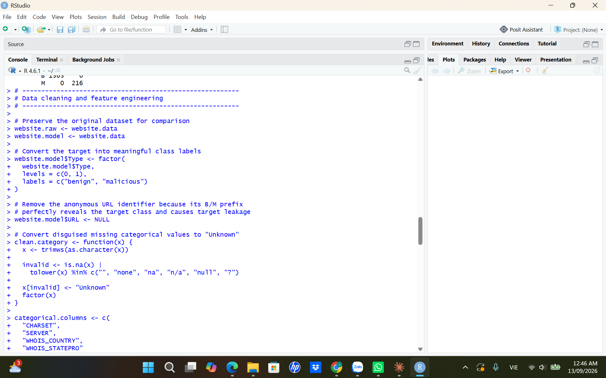
Appendix Figure A2. Target recoding, URL removal and initial feature preparation.

A3. Stratified partition verification
The console output confirms the 70:30 split and near-identical malicious-class prevalence across partitions.
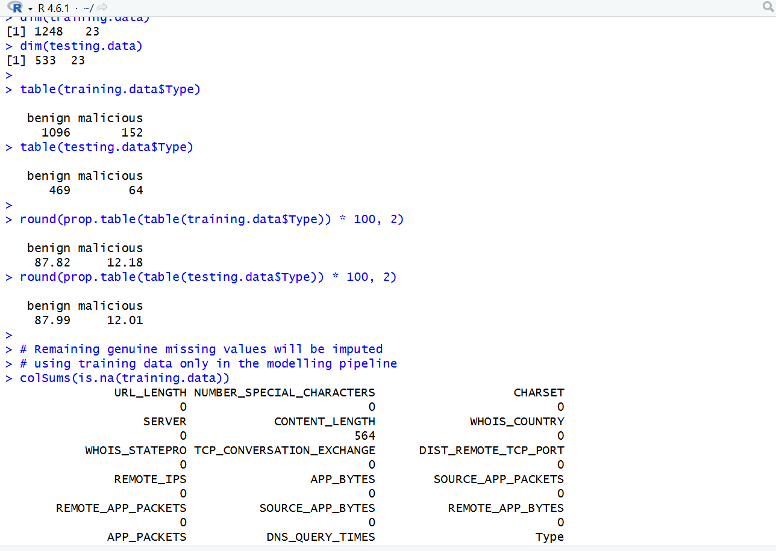
Appendix Figure A3. Training/testing dimensions, class counts and class proportions.

A4. Training-only preprocessing recipe
The recipe handles novel and rare categories, numeric missing values, dummy encoding, zero-variance predictors and scaling.
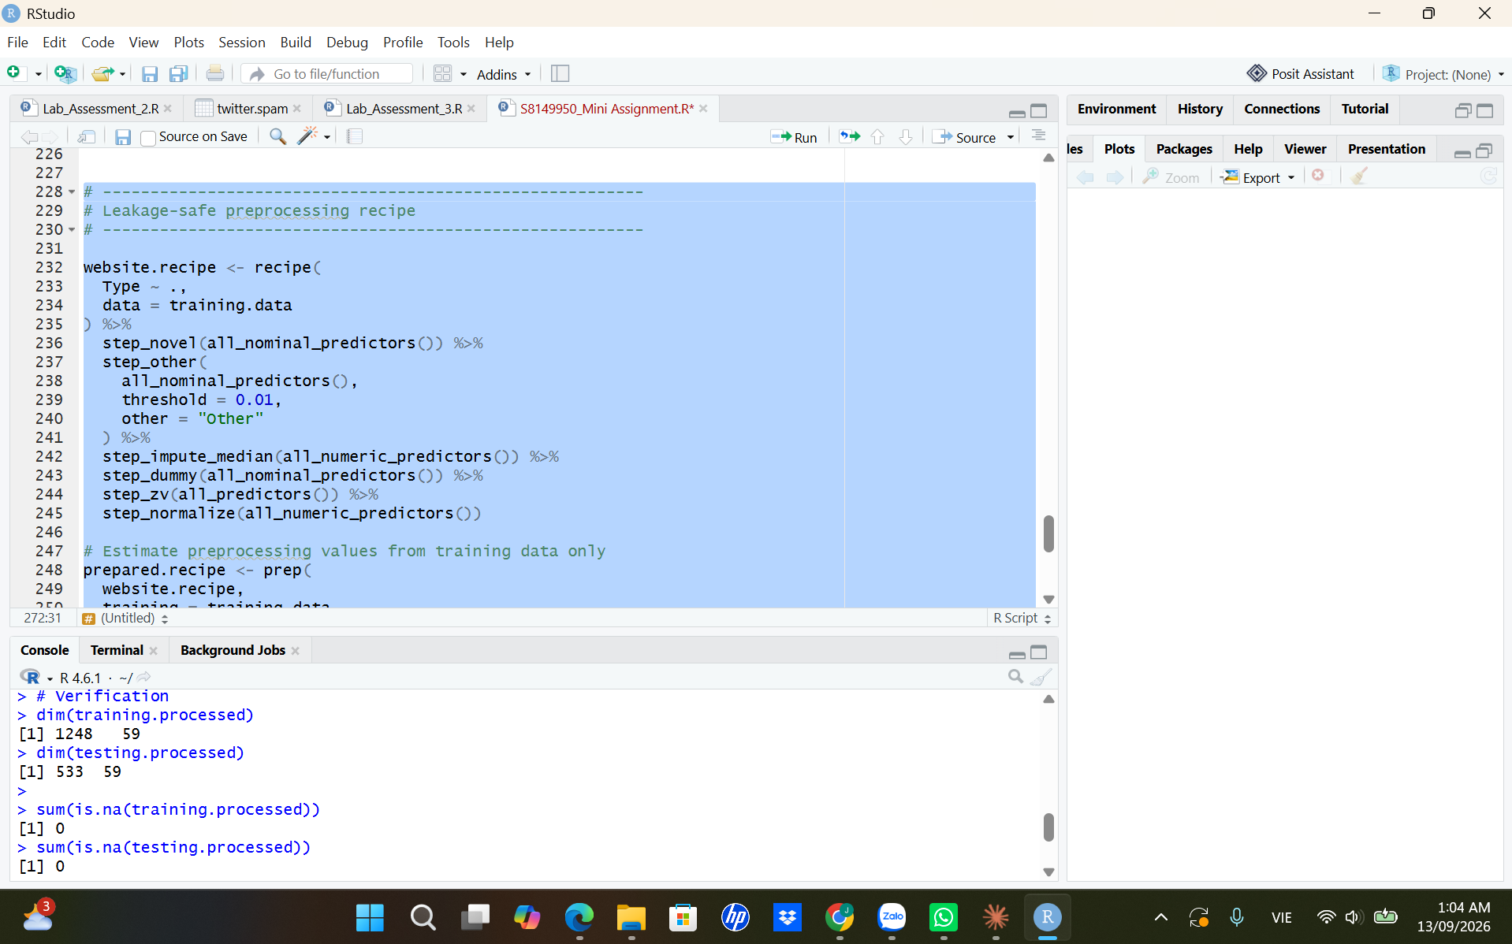
Appendix Figure A4a. Preprocessing recipe specification.

A4. Preprocessing verification
The baked training and testing datasets contain a consistent encoded feature space and no remaining missing values.
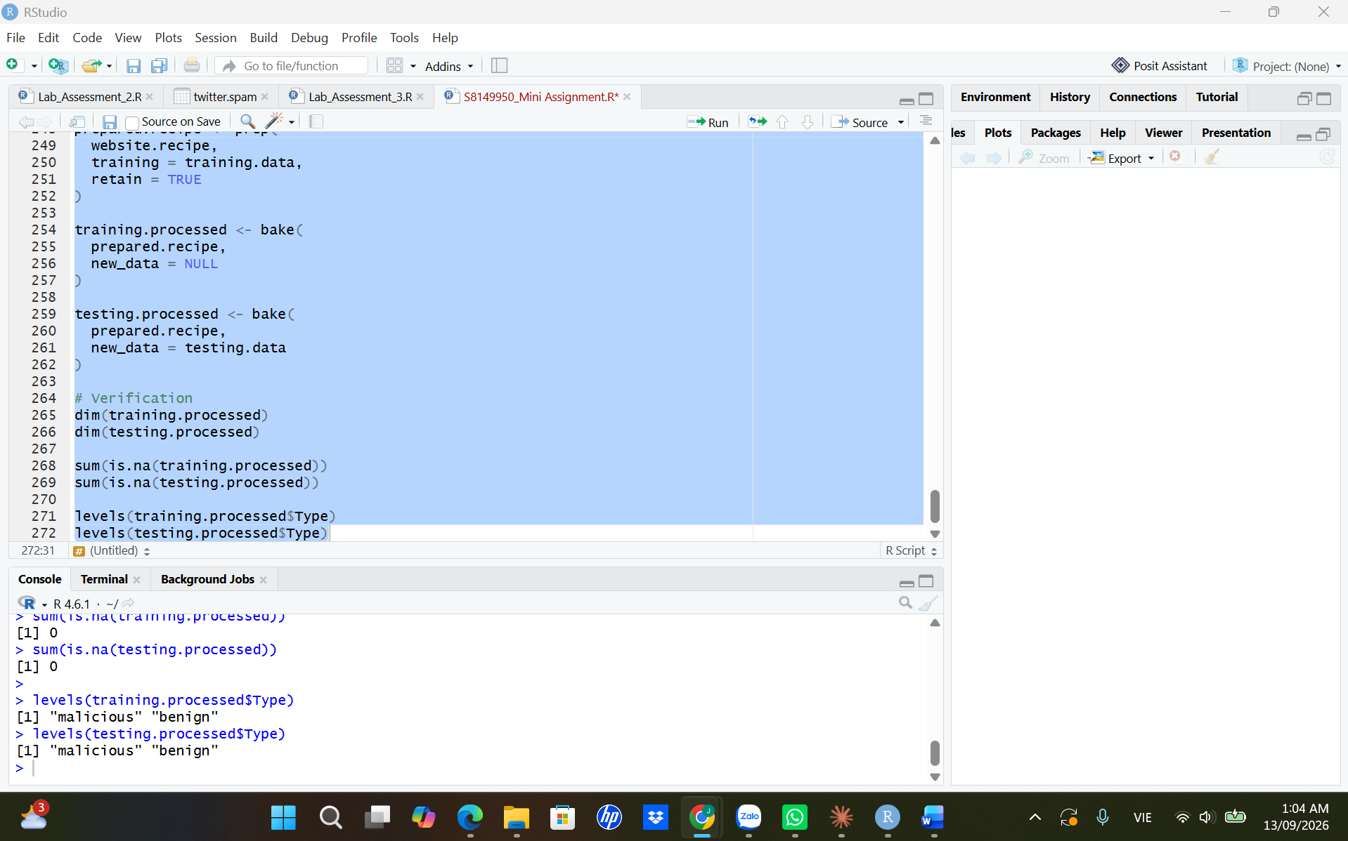
Appendix Figure A4b. Prepared-data dimensions and missing-value verification.

A5. Security-focused metric function (part 1)
The custom summary function extracts minority-class precision, recall, specificity and balanced accuracy.
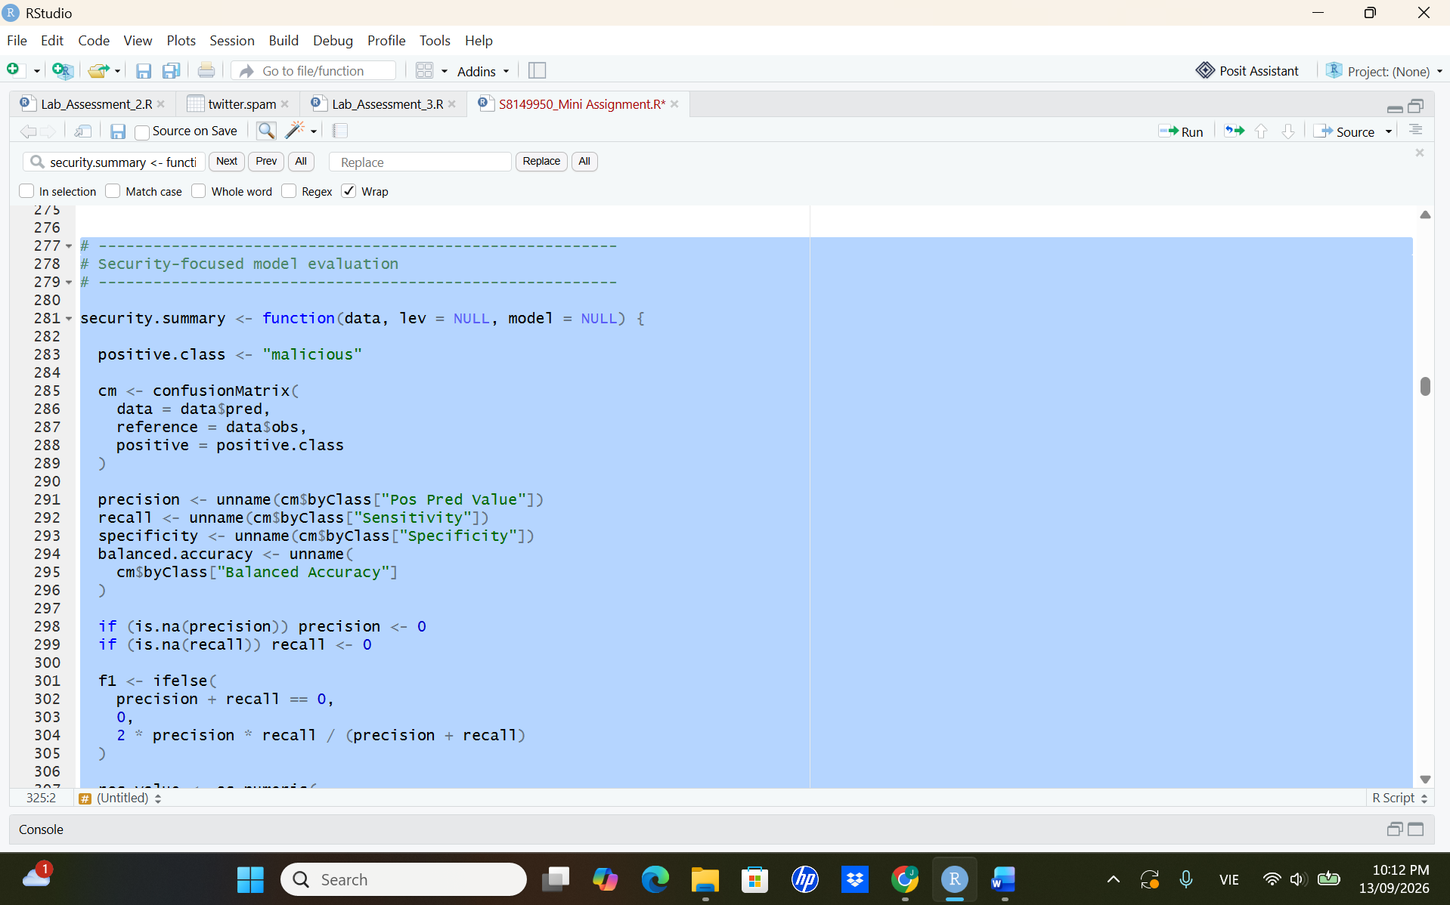
Appendix Figure A5a. Confusion-matrix metric extraction with malicious as the positive class.

A5. Security-focused metric function (part 2)
The function completes F1 and ROC AUC calculation and returns the full security-focused metric vector.
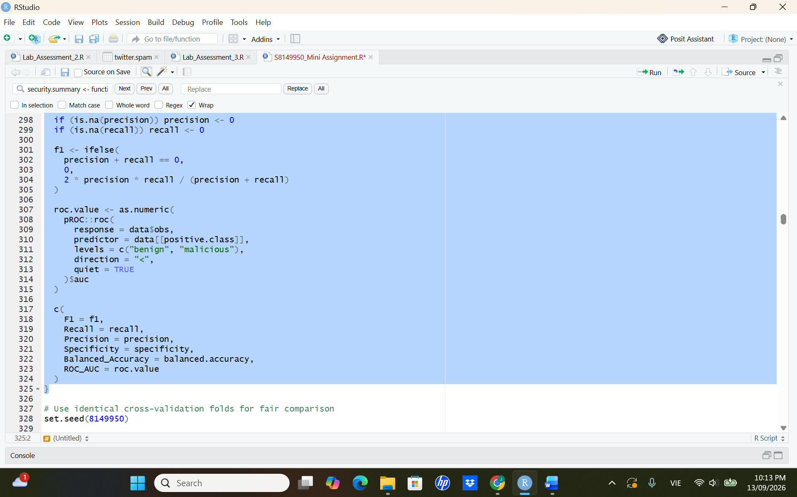
Appendix Figure A5b. F1 and ROC AUC calculation returned to caret.

A6. Common cross-validation control
The same repeated-CV folds, class probabilities, saved predictions and custom metric function are used for all classifiers.
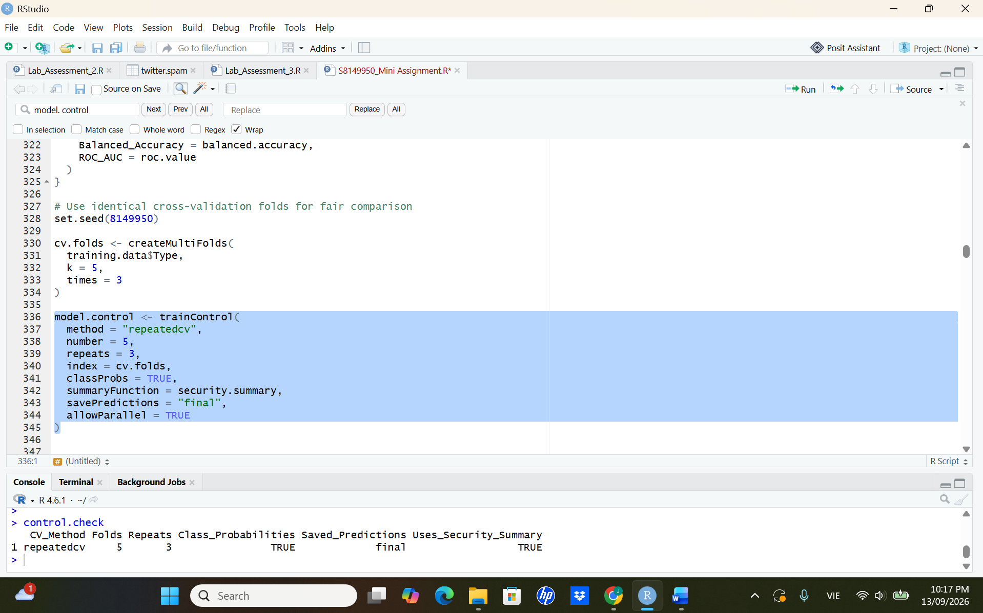
Appendix Figure A6. Repeated five-fold cross-validation configuration and console check.

A7. Logistic regression validation
This output records the resampled performance of the linear baseline.
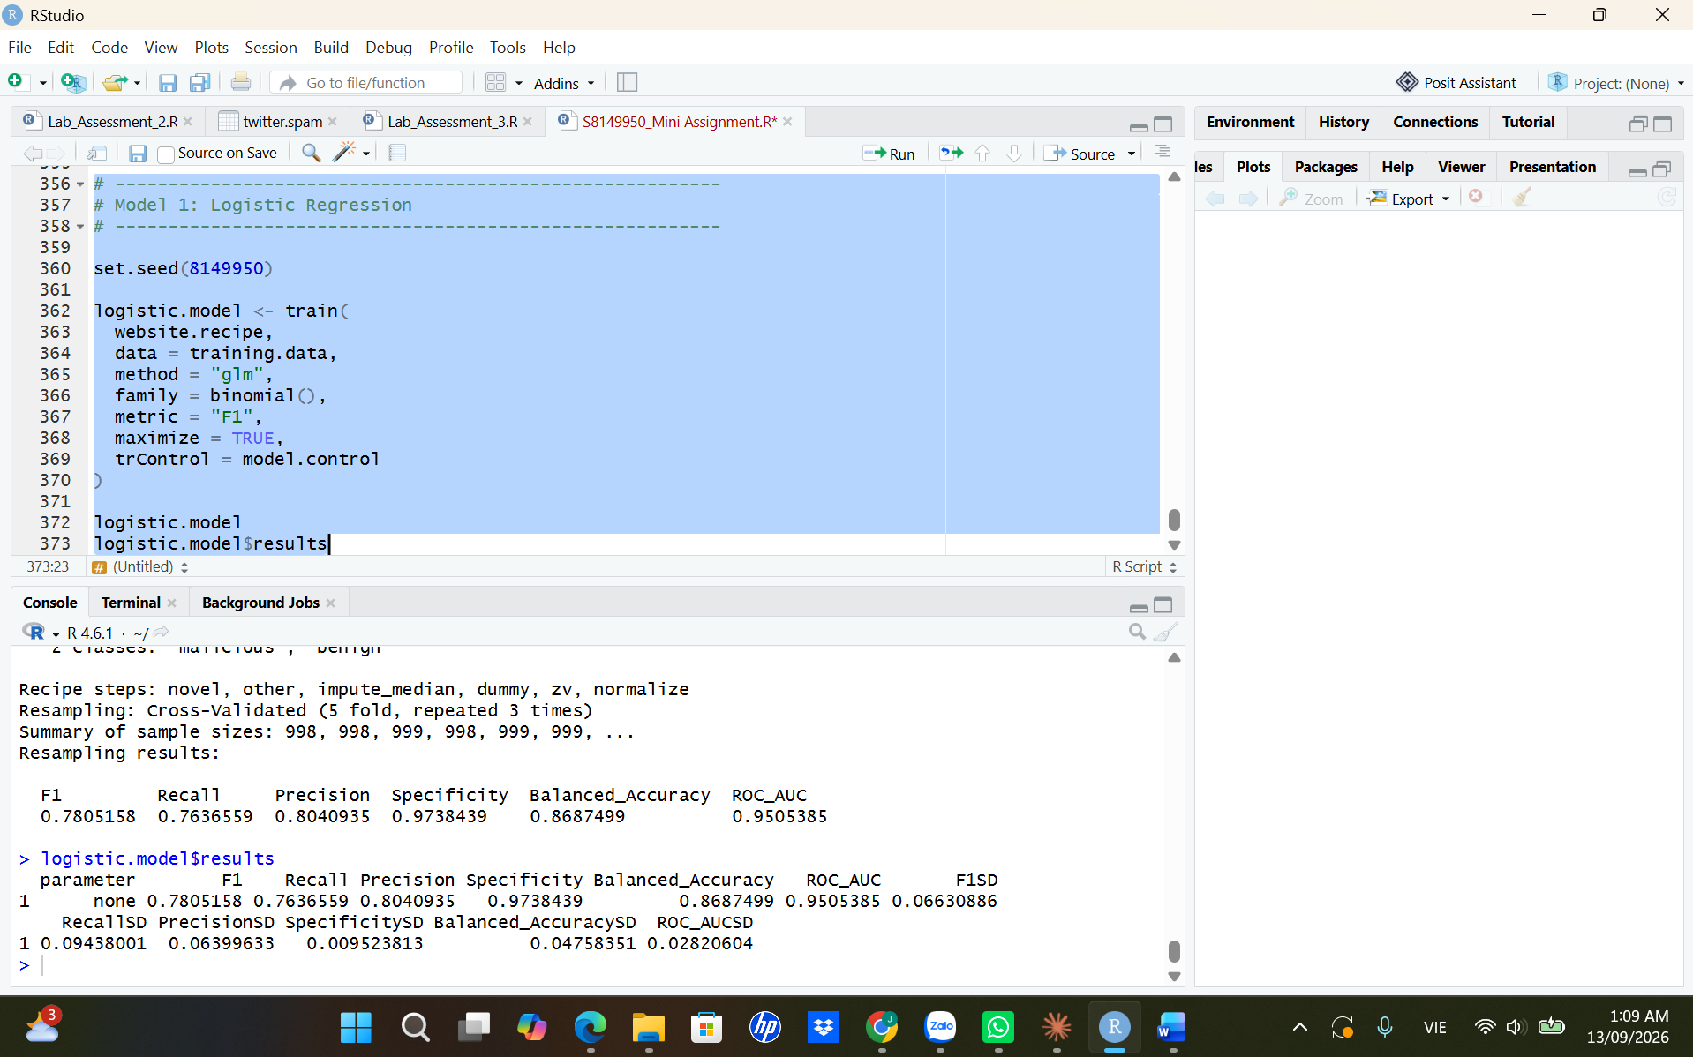
Appendix Figure A7. Logistic regression repeated-CV performance.

A8. Support vector machine tuning
The output documents the search across sigma and cost values and the selected SVM configuration.
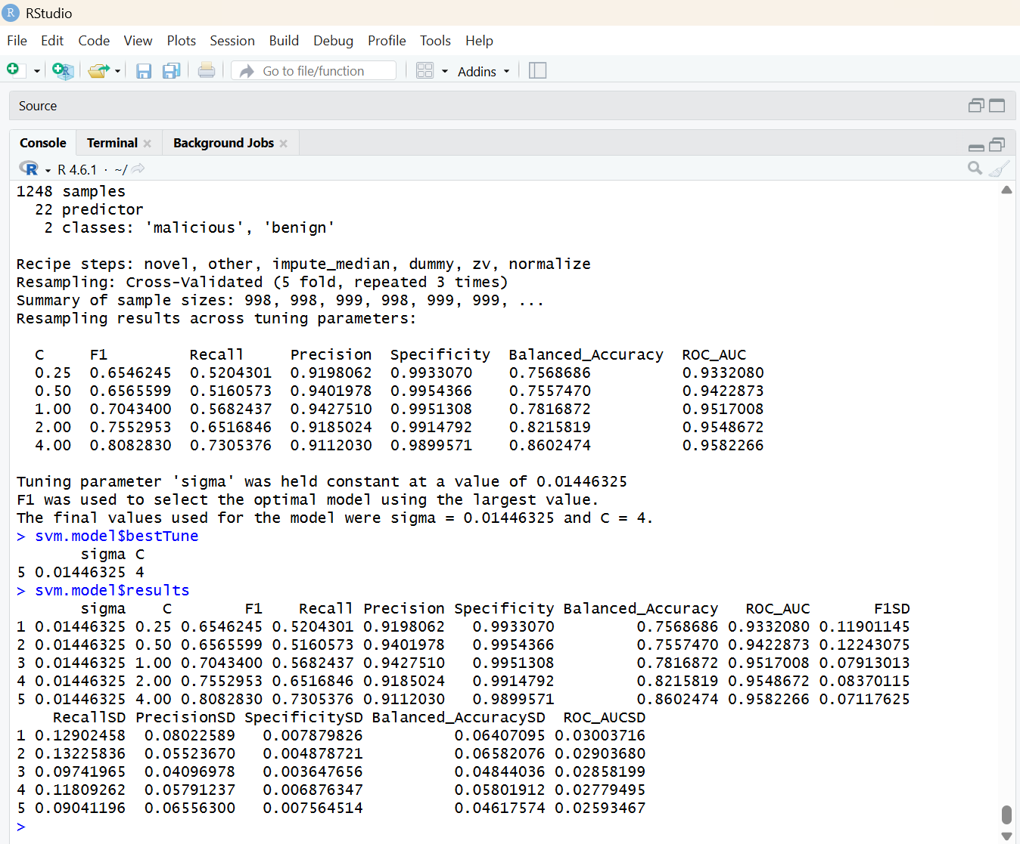
Appendix Figure A8. Radial SVM tuning grid and selected hyperparameters.

A9. Random forest tuning
The output supports selection of mtry = 20, Gini splitting and a minimum node size of 5.
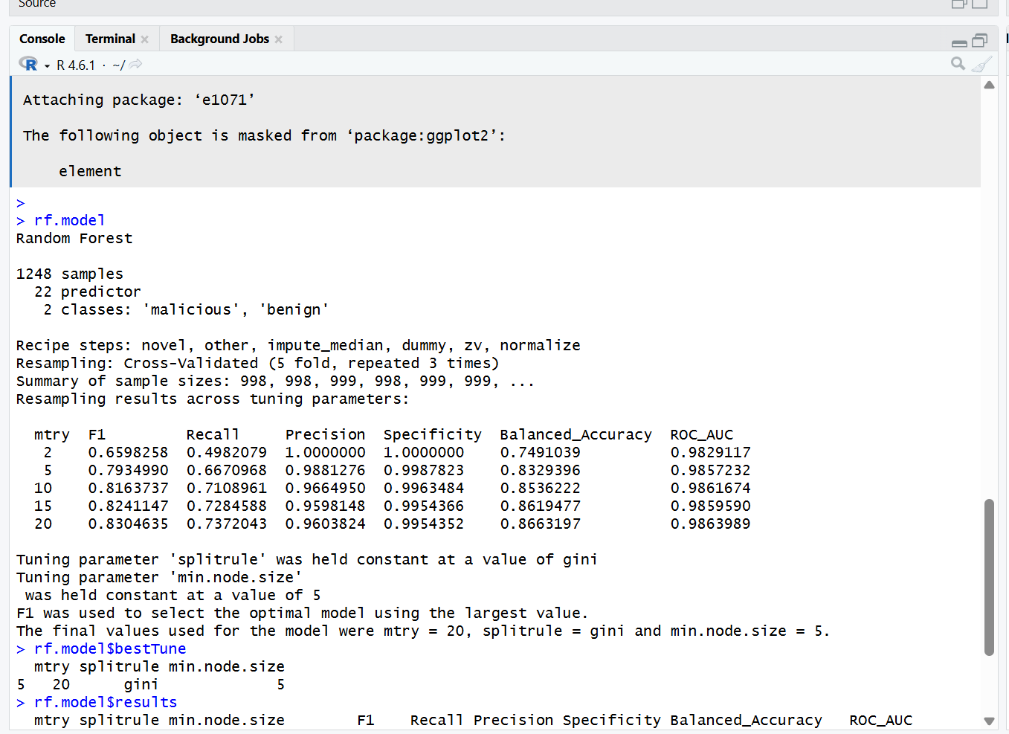
Appendix Figure A9. Random forest tuning results and selected hyperparameters.

A10. Held-out metric calculation
The displayed table is the numerical source for the main test-performance comparison.
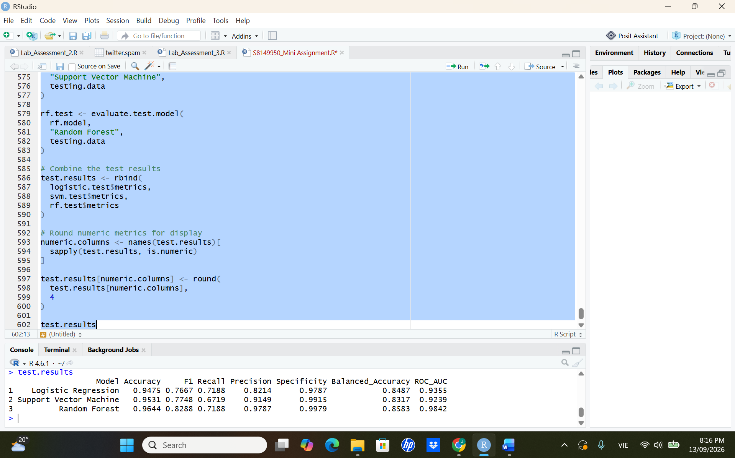
Appendix Figure A10. Held-out test metrics for all three classifiers.

A11. Confusion-matrix counts
The counts make the security trade-off between missed threats and false alarms transparent.
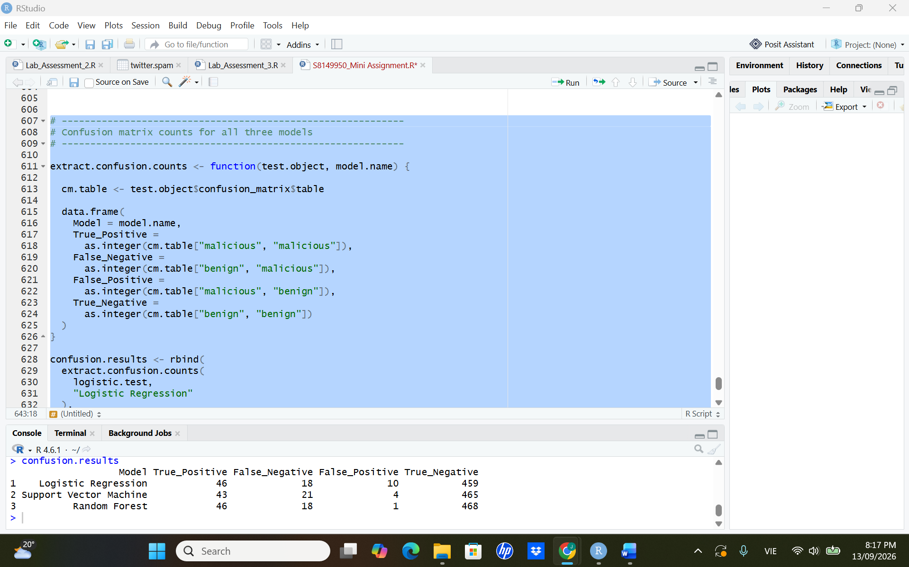
Appendix Figure A11. True-positive, false-negative, false-positive and true-negative counts.

A12. Software environment
The environment record supports computational reproducibility of the submitted R script.
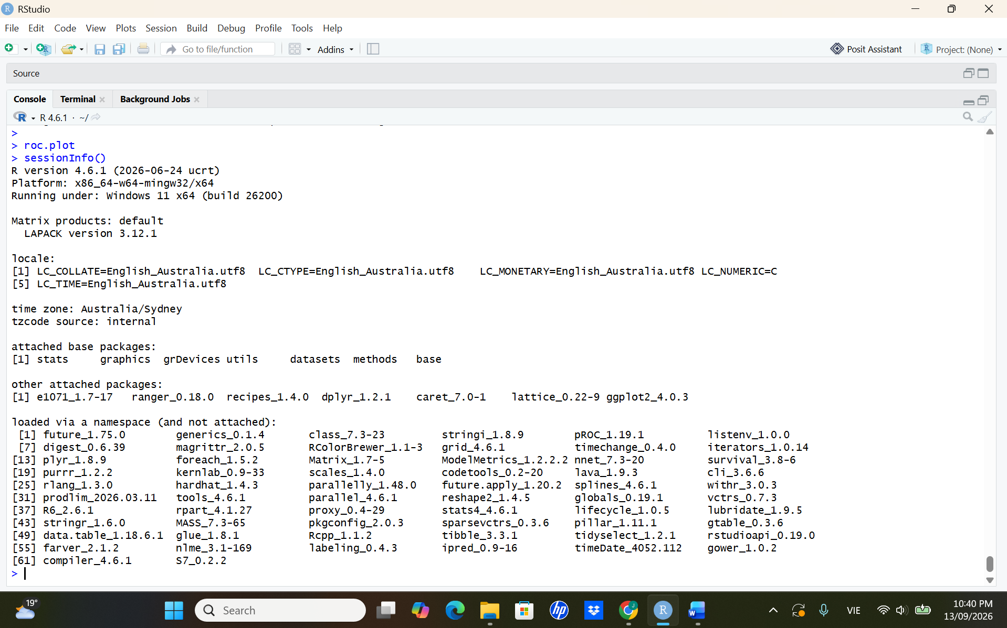
Appendix Figure A12. R session information and package environment.

