Compiler Final Project

# 文法規則 :

1. <Program> ::= “int” “main” ‘(’ ‘)’ <CompoundStatement>

2. <CompoundStatement> ::= ‘{’ {<IntDeclaration> ‘;’} {<StringDeclaration> ‘;’} {<Statement>} ‘}’

如果我在中間才宣告???(暫改好)

3. <IntDeclaration> ::= “int” <IdentifierList>

4. <StringDeclaration> ::= “char” <Identifier> ‘[’ ‘]’ ‘=’ <String> {‘,’ <Identifier> ‘[’ ‘]’ ‘=’ <String>}

5. <Statement> ::= [<CompoundStatement> | <AssignmentStatement> ‘;’ | <IfStatement>

| <WhileStatement> | <ReadStatement> ‘;’ | <WriteStatement> ‘;’]

6. <AssignmentStatement> ::= <Identifier> ‘=’ <Expression>

7. <IfStatement> ::= “if” ‘(’ <Condition> ‘)’ <Statement> [“else” <Statement>]

如果缺少{，但有右大括號?

8. <WhileStatement> ::= “while” ‘(’ <Condition> ‘)’ <Statement>

9. <ReadStatement> ::= “scanf” ‘(‘ ‘“’ ‘%’ ‘d’ {‘%’ ‘d’} ‘”’ ‘,’ ‘&’ <Identifier> {‘,’ ‘&’ <Identifier>} ‘)’

10. <WriteStatement> ::= “printf” ‘(‘ ‘“’ ‘%’ \‘d’ | ‘s’\ {‘%’ \‘d’ | ‘s’\} ‘”’ ‘,’ <Identifier> {‘,’ <Identifier>} ‘)’

11. <Condition> ::= <Expression> \<|<=|==|!=|>|>=\ <Expression>

12. <Expression> ::= [+|-] <Term> {\+|-\ <Term>}

13. <Term> :: = <Factor> {\*|/|%\ <Factor>}

14. <Factor> ::= <Identifier> | <Number> | ‘(’ <Expression> ‘)’

15. <IdentifierList> ::= <Identifier> {‘,’ <Identifier>}

16. <Identifier> ::= <Alpha> {<Alpha> | <Digit>}

17. <Number> ::= <Digit> {<Digit>}

18. <Alpha> ::= A|B|C|D|E|F|G|H|I|J|K|L|M|N|O|P|Q|R|S|T|U|V|W|X|Y|Z|

a|b|c|d|e|f|g|h|i|j|k|l|m|n|o|p|q|r|s|t|u|v|w|x|y|z

19. <Digit> ::= 0|1|2|3|4|5|6|7|8|9

20. <String> ::= “任何非雙引號的字元集合”

# 正確程式 : correct_program.txt

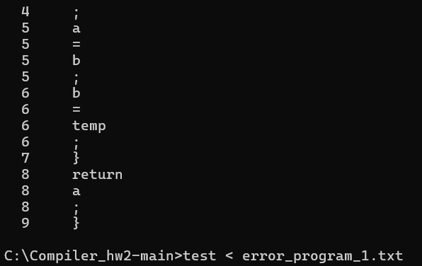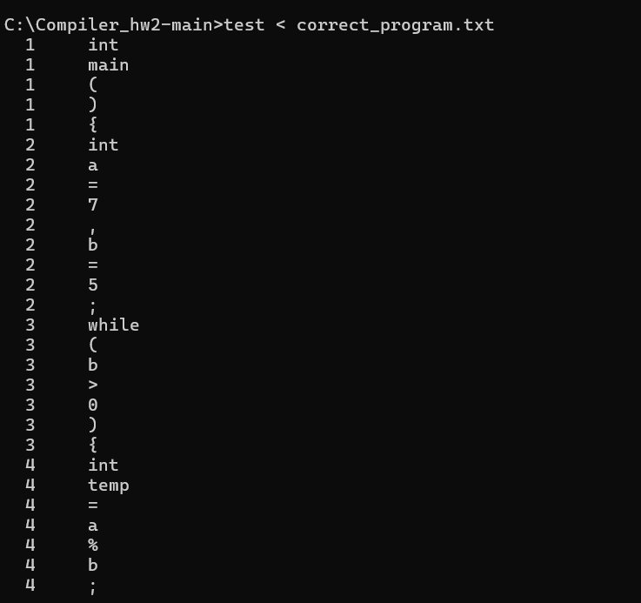Parsing結果 :

# 錯誤程式1: error_program_1.txt(僅一錯)

錯誤地方 : assignment少分號

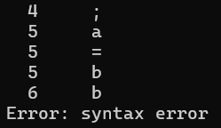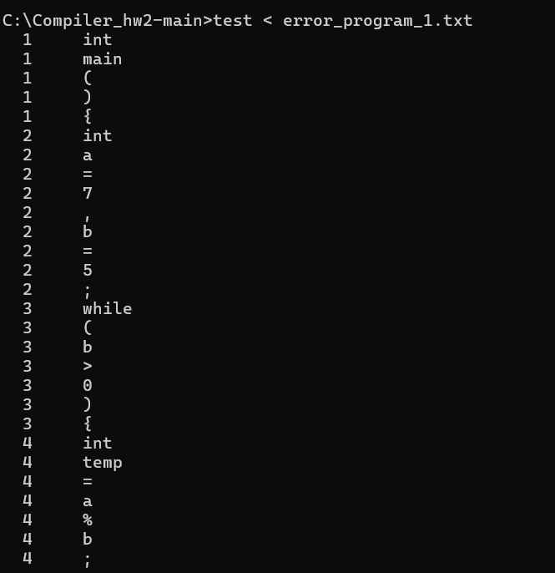Parsing結果 :

# 錯誤程式2 : error_program_2.txt(有兩錯)

錯誤地方 :

1. while條件缺少右小括號
2. assignment少分號

Parsing結果 : 僅顯示第一個錯誤就跳出程式

