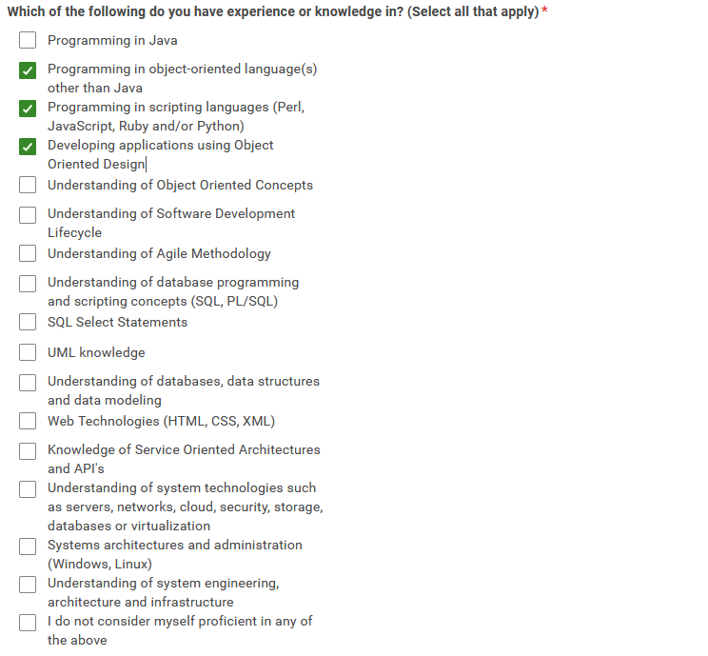

What am I unsure / not too familiar about that I’ve check

* Understanding Object Oriented Concepts
  + 4 Pillars → Abstraction, Inheritance, Encapsulation, Polymorphism
  + Abstraction
    - Simplifying complex things by modeling classes on a more general level. Its often similar to a blueprint only showing the necessary parts
  + Inheritance
    - Allows a child classes to have properties of it’s parent classes like methods or attributes creating this parent-child relationship
  + Encapsulation
    - Is about hiding and restricting certain components like variables and methods. In python _ for variables and __ for methods
  + Polymorphism
    - Focuses more on Diversity & reusability as child classes can override methods of its superclass/parent class
* SDLC (Software Development Life Cycle)
  + Phases/Stages of Software Development → Planning, Designing, Development, Testing, Deployment, Maintenance
* Agile Methodology
  + Built off of SDLC; The agile methodology includes several teams working on a specific stage of the life cycle often having several tasks during a code sprint. The general idea is that each team is responsible for a certain stage.
    - Includes Standups Meetings, Sprint planning and Review
    - User stories → Building based off the users perspective
* Data Modeling

Cert leap pro look prof

Email Prep

* Hey Ms. Negron!
* My name is Justin Do, your interviewee for 2023 Summer Internship Program at Fidelity Investments. Unfortunately I was not able to take part of the program during the summer; however, I am writing this email to inform you that I have submitted an application for the 2023 - 2024 Undergraduates - Leap: Full Stack Engineer and I was wondering if you could take a look at my profile and received my application.
* Thank you in advance and enjoy the rest of your day!