Functions Analysis:
F1:
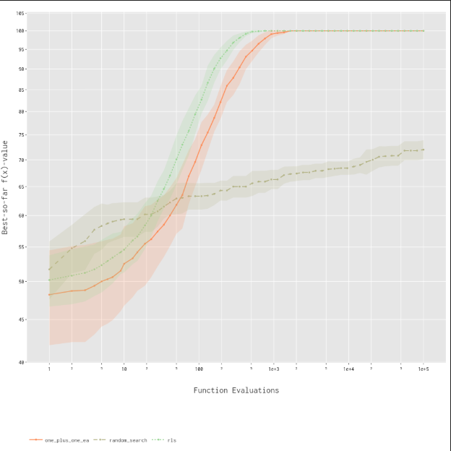
For Function 1, both RLS and the (1+1) EA reaches the optimum consistently, with RLS showing faster early progress. In comparison, random Search performs much worse, never reaching optimum. Variance is low for RLS and (1+1) EA across different runs, but random search is higher. It highlights the effectiveness of guided search over random sampling.

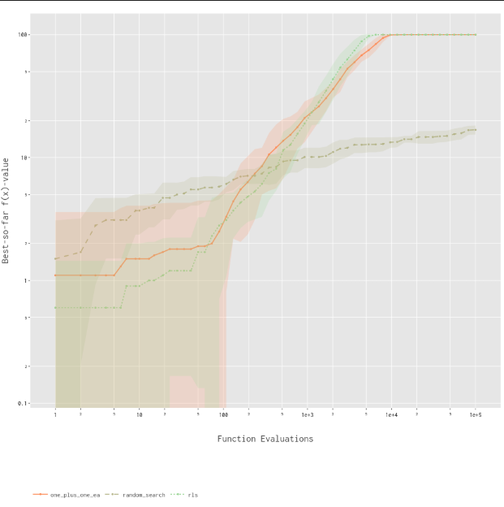
F2:
For function 2, both algorithms, RLS and the (1+1) EA, slowly improves and reaches optimum, with (1+1) EA showing steadier progress. Random Search lags significantly, plateauing below optimum. Variance is higher early on for all methods but starts to narrow as RLS and (1+1) EA begin converging. Once again, random sampling is at a disadvantage.

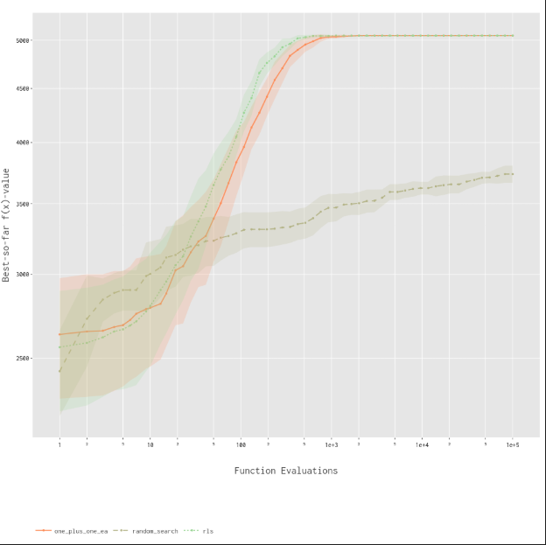
F3:
For function 3, both RLS and the (1+1) EA reaches optimum quickly once again, with RLS having best performance. Random Search, once again, levels below optimum, and increases much more slowly. Standard deviation for random search remains pretty much similar for the entire budget.

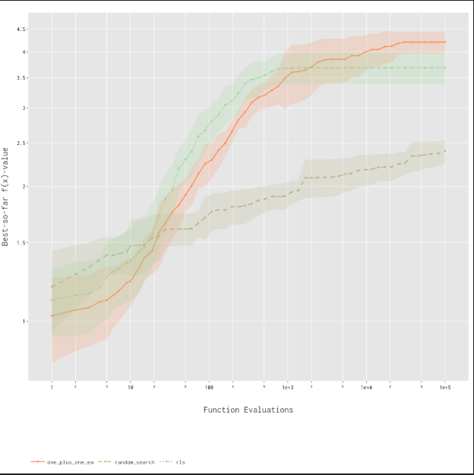
F18:
For function 18, algorithms RLS and (1+1) EA illustrates improves smoothly and outperforms Random Search. It is noticed that convergence for function 18 is much slower compared to previous, more simpler functions.

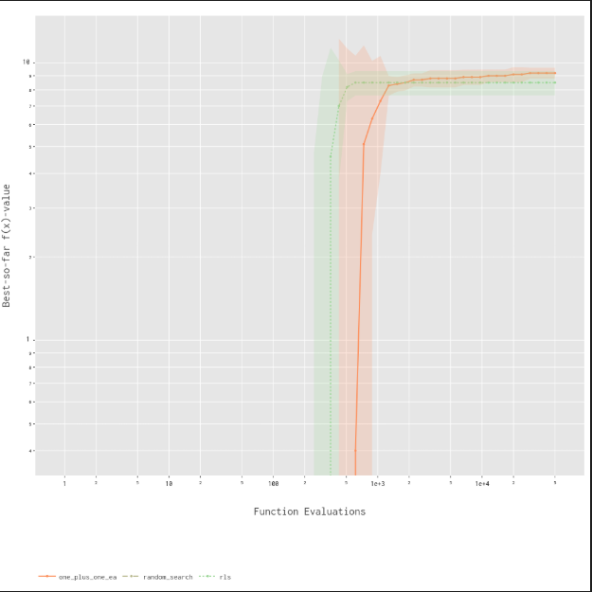
F23:
For function 23, all three algorithms quickly converges, nearly reaching optimum within the range of only a few thousand evaluations. Consistent with previous functions, both RLS and the (1+1) EA outperforms Random Search. The small shaded areas demonstrates stability for all three algorithms.
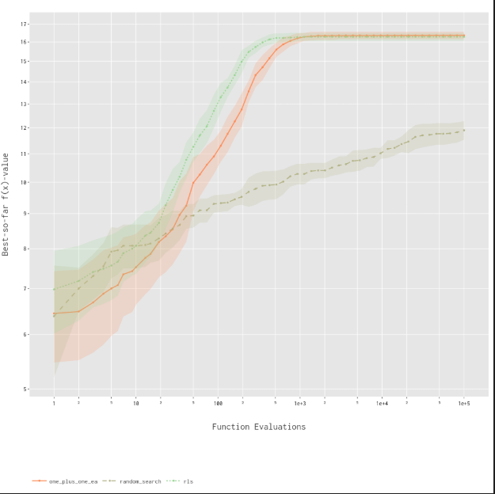
F24:
For function 24, Random Search once again plateaus far below the optimum. Instead, both RLS and the (1+1) EA converges to the maximum, with RLS having slightly better performance. The shaded areas shows standard deviation that is of moderate level, but overall, random sampling remains on bottom.

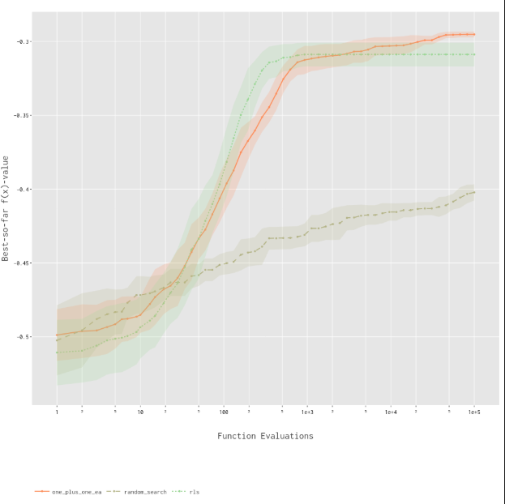
F25:
For function 25, random Search again falls far behind, though improving slowly. RLS and the (1+1) EA improves quickly at first, but rls plateau earlier, while the (1+1) EA continues to progress, and exceeds RLS' max score. Overall, (1+1) EA came out on top with best top score.

Summary:
Across all functions, RLS and (1+1)EA consistently outperforms random search which would plateau below the optimum and demonstrate higher variance across different runs. On the other hand, RLS was much faster in gaining early progress and reliably reaches the optimum with lower variance, often emerging as the strongest performing out of the three on simpler functions. The (1+1) EA also reaches the optimum consistently, and in some cases surpasses RLS for harder functions. In general, guided methods such as RLS and (1+1)EA proved much better than random search.

