Justin Friends

LabOne

Task: Java screenshot



Task: JAVA_HOME variable



Task: JAVAFX variable



Task: HelloFX commands and application



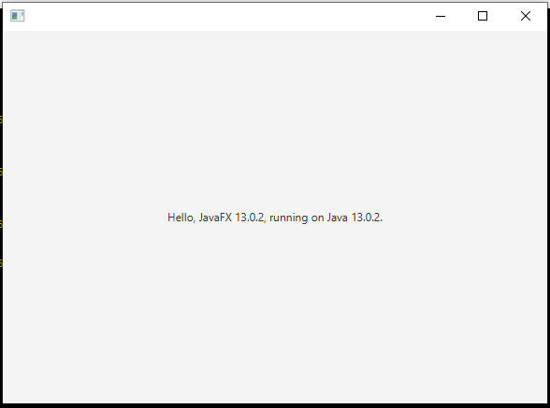

Task: Program being compiled and executed from terminal

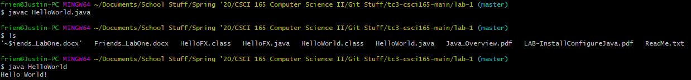

Task: HelloWorld2



Additional Problems:

1. She should take score1, add score2 to it, add score3 to that total, add score4 to that total, add score5 to that total, add score6 to that total, add score7 to that total, add score8 to that total, add score9 to that total, add score10 to that total, and then finally divide the total by 10 for the homework grade average.

2. An algorithm for a Caesar cipher shift might consist of just using simple math on the letter in a program, while making two if statements (one for upper case, and one for lower case). If it’s upper case, and the starting value is equal to or greater 65, and less than or equal to 90, if the value plus the shift is greater than 90, roll over to 65 and add the remainder (the total – 90 ) to 65. Likewise, one for 97 to 122, and then if the value plus the shift is greater than 122, roll over to 97 and add the remainder to 97.

3. “puzzles are fun”. I’m not sure it would 100% always find it, but if you set up a list of dictionary words (perhaps more common ones), and then checked each word against it until all the words were equal to a list word, that should get you the correct answer most of the time (assuming they’re not just putting in junk words that mean nothing to throw you off, etc.).

4. There’s a few things you could do, one of which is to divide the four digits into one digit and three digits, the one being a counter for how many scores have been counted, and the three being a running total for the homework assignments. This isn’t perfect, as you could only store up to 9 assignments and up to 999 points for the assignments total. You could also do the same thing, but with a different numbering system, like hexadecimal. This would allow up to 15 scores recorded and up to 4095 points for the assignments total.

5.

0 => Print N. N = 15

1 => If N equals 1, stop. N does not equal 1

2 => If N is even, divide it by 2. N is not even

3 => If N is odd , triple it and add 1. N is odd, 15 x 3 + 1 = 46

4 => Go to step 0.

0 => Print N. Back to step 0, N = 46

1 => If N equals 1, stop. N is not equal to 1

2 => If N is even, divide it by 2. N is even, 46 / 2 = 23

3 => If N is odd , triple it and add 1. N is odd, 23 x 3 + 1 = 70

4 => Go to step 0.

0 => Print N. N = 70

1 => If N equals 1, stop. N is not equal to 1

2 => If N is even, divide it by 2. N is even, 70 / 2 = 35

3 => If N is odd , triple it and add 1. N is odd, 35 x 3 + 1 = 106

4 => Go to step 0.

0 => Print N. N = 106

1 => If N equals 1, stop. Not equal to 1

2 => If N is even, divide it by 2. Even, 106 / 2 = 53

3 => If N is odd , triple it and add 1. Odd, 53 x 3 + 1 = 170

4 => Go to step 0.

0 => Print N. N = 170

1 => If N equals 1, stop. Not equal to 1

2 => If N is even, divide it by 2. Even, 170 / 2 = 85

3 => If N is odd , triple it and add 1. Odd, 85 x 3 + 1 = 256

4 => Go to step 0.

0 => Print N. N = 256

1 => If N equals 1, stop. Not equal to 1

2 => If N is even, divide it by 2. Even, 256 / 2 = 128

3 => If N is odd , triple it and add 1. Not odd

4 => Go to step 0.

0 => Print N. N = 128

1 => If N equals 1, stop. Not equal to 1

2 => If N is even, divide it by 2. Even, 128 / 2 = 64

3 => If N is odd , triple it and add 1. Not odd

4 => Go to step 0.

0 => Print N. N = 64

1 => If N equals 1, stop. Not equal to 1

2 => If N is even, divide it by 2. Even, 64 / 2 = 32

3 => If N is odd , triple it and add 1. Not odd

4 => Go to step 0.

0 => Print N. N = 32

1 => If N equals 1, stop. Not equal to 1

2 => If N is even, divide it by 2. Even, 32 / 2 = 16

3 => If N is odd , triple it and add 1. Not odd

4 => Go to step 0.

0 => Print N. N = 16

1 => If N equals 1, stop. Not equal to 1

2 => If N is even, divide it by 2. Even, 16 / 2 = 8

3 => If N is odd , triple it and add 1. Not odd

4 => Go to step 0.

0 => Print N. N = 8

1 => If N equals 1, stop. Not equal to 1

2 => If N is even, divide it by 2. Even, 8 / 2 = 4

3 => If N is odd , triple it and add 1. Not odd

4 => Go to step 0.

0 => Print N. N = 4

1 => If N equals 1, stop. Not equal to 1

2 => If N is even, divide it by 2. Even, 4 / 2 = 2

3 => If N is odd , triple it and add 1. Not odd

4 => Go to step 0.

0 => Print N. N = 2

1 => If N equals 1, stop. Not equal to 1

2 => If N is even, divide it by 2. Even, 2 / 2 = 1

3 => If N is odd , triple it and add 1.

4 => Go to step 0.

0 => Print N. N = 1

1 => If N equals 1, stop. N is 1, stop

6.

0 => Print N. N = 6

1 => If N equals 1, stop. Not equal to 1

2 => If N is even, divide it by 2. Even, 6 / 2 = 3

3 => If N is odd , triple it and add 1. Odd, 3 x 3 + 1 = 10

4 => Go to step 0.

0 => Print N. N = 10

1 => If N equals 1, stop. Not equal to 1

2 => If N is even, divide it by 2. Even, 10 / 2 = 5

3 => If N is odd , triple it and add 1. Odd, 5 x 3 + 1 = 16

4 => Go to step 0.

0 => Print N. N = 16

1 => If N equals 1, stop. Not equal to 1

2 => If N is even, divide it by 2. Even, 16 / 2 = 8

3 => If N is odd , triple it and add 1. Not odd

4 => Go to step 0.

0 => Print N. N = 8

1 => If N equals 1, stop. Not equal to 1

2 => If N is even, divide it by 2. Even, 8 / 2 = 4

3 => If N is odd , triple it and add 1. Not odd

4 => Go to step 0.

0 => Print N. N = 4

1 => If N equals 1, stop. Not equal to 1

2 => If N is even, divide it by 2. Even, 4 / 2 = 2

3 => If N is odd , triple it and add 1. Not odd

4 => Go to step 0.

0 => Print N. N = 2

1 => If N equals 1, stop. Not equal to 1

2 => If N is even, divide it by 2. Even, 2 / 2 = 1

3 => If N is odd , triple it and add 1.

4 = 0 => Print N. N = 1

1 => If N equals 1, stop. N is 1

8.

9.

10. // file name must match the public class identifier

public class FOX{

    //main method is the starting point of any Java app

    public static void main(String[] args){

    //for(int x = 6; x < 0; x = x - 1){

    System.out.println("*****");

    System.out.println("****");

    System.out.println("***");

    System.out.println("**");

    System.out.println("*");

    System.out.println();

    System.out.println("*****");

    System.out.println("*   *");

    System.out.println("*   *");

    System.out.println("*   *");

    System.out.println("*****");

    System.out.println();

    System.out.println("*****");

    System.out.println(" *** ");

    System.out.println(" **  ");

    System.out.println(" *** ");

    System.out.println("*****");

    //}

    } //end of main

} //end of class