# Entry: 01/07/2021

# Outline

## Goal: To keep a hinged panel vertical (perpendicular to the ground).

The initial conditions will be:

1. start from a vertical position, and remain vertical upon impulse disturbance
2. start from a small angle, and return to a vertical position

## Component of the System:

Motor: it will be used to produce a torque to counter any disturbance on the hinged panel, and return the panel to a equilibrium position. A fly wheel might be used to ensure the motor can provide larger torque for a longer priod of time.

Accelerometer: it will be use to measure the angle of the hinged panel relative to the ground

PID controller: it will be used to determine the terminal voltage of the motor/set the amount of torque on the motor.

Plant: a hinged panel fix to a surface.

## To-Do list

A Simulink simulation would be carried out to test the various gain for the PID controller before parts arrive for the simulation

Analytical analysis would be carried out to deter the PID gains and the stability of the system

Build the device

# Modelling

## Plant

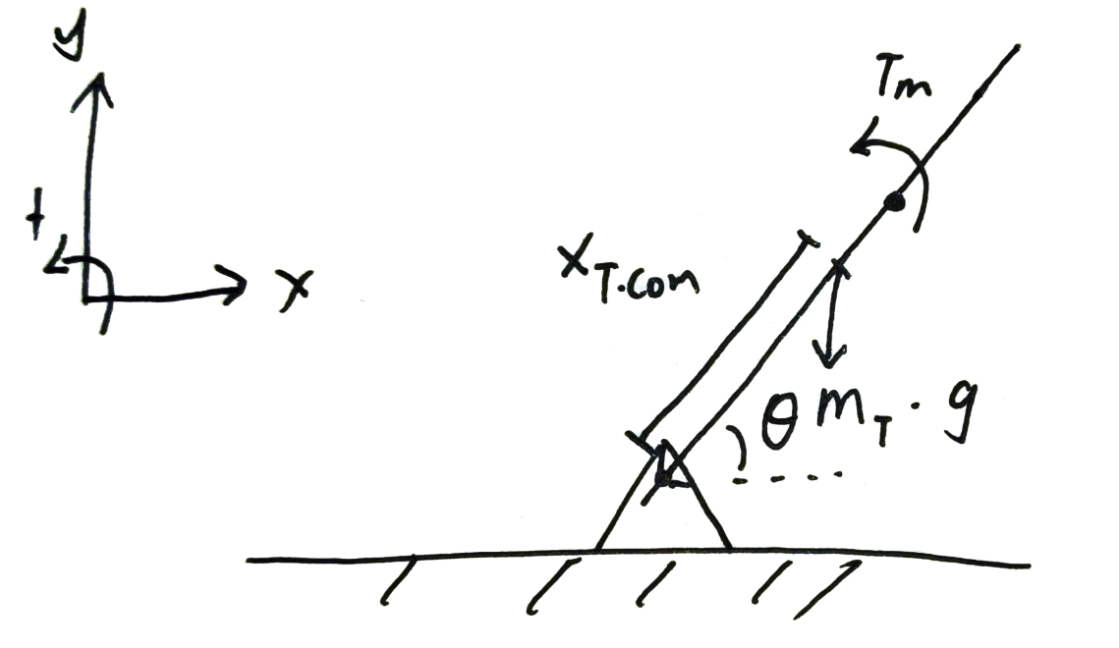

Calcualte the torque on the system around the hinged point

Where:

T­plant : the total troque applied to the plant around the hinge dpoint

mplant: is the total mass of the plant

Xplant.COM: is the distance from the hinged point to he CoM of the whole plant

T­m: is the torque applied by the motor onto the system

Iplant: is the angular inertia of the plant

αplant: is the angular acceleration of the plant

Mass and CoM location can be further break down:

Where:

mplant: mass of the entire plant

mpanel: mass of the panel

mmotor: mass of the motor

mflywheel: mass of the flywheel

The CoM of the system can be calculated by the equation below:

Where:

Xplant.CoM: the CoM of the plant form the hinged point

Xmotor.CoM: the CoM of the motor form the hinged point

The CoM of the plant form the hinged point can be calculated by:

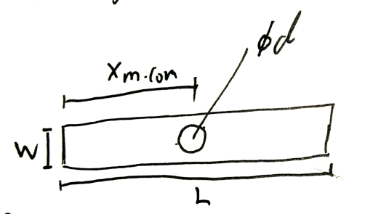

The hinged panel can be model as a rectangle with a circle in the middle, with a density of ρ (mass per. unit area).

Where:

ρpanel: mass per unit area will be used, kg/m^2

d: the diameter of the motor

L: the length of the panel

W: the width of the panel

Therefore, the equation for the CoM of the plant is:

## Motor

The fundamental motor dynamic equations are:

Where:

Te: Torque produce by the motor

Jeq: The rotational inertia as seen by the motor

αmotor: angular acceleration of the motor

Beq: motor damping coeffient

ωmotor: angular velocity of the motor

TL: Torque loss sue to external factors

Vt: terminal voltage supply to the motor

Ea: armature voltage induces by the motor

Ia: armature current

Ra: armature resistance

KE: EMF constant

KT: Torque constant

Jeq in this case is the rotational inertia of the motor core plus the fly wheel, this mean Tmotor is equals to Jeq * αmotor for a direct drive fly wheel.

The motor dynamic equation would be:

# Entry 02/07/2021

# Choosing motor:

The budget of this project is limited, so a hobby motor would be used to keep the cost down. By browsing Jaycar’s webpage, the cheapest motor that can deliver a reasonable amount of torque is YM2707 which delivery 0.01Nm of stall torque.

Not a lot but, after some prelimary calculation, it would be able to handle about 70g of mass with Xplant.CoM of 0.08m at ±10 degrees from vertical position.

# Calculate motor parametrs:

The following constant are need for Simulink simulation: KE, KT, Ra, Jeq, Beq.

### From the data sheet of YM2707:

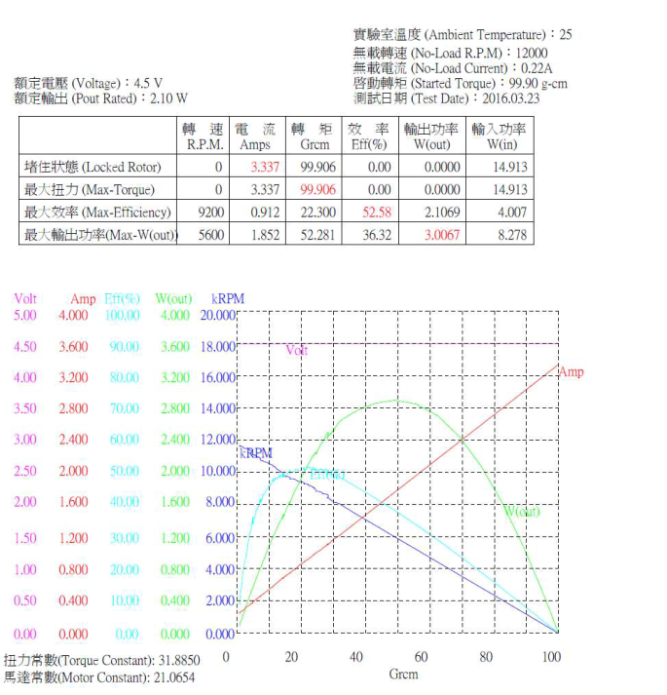

KT: 31.885 Grcm/A = 0.0031885 Nm/A

Max torque: 99.906Grcm = 0.01Nm

Max RPM: 12000rpm = 1257 rad/s

By measuring the armature resistance on the motor: 1.4 ohms

### Calculate KE, Beq

Based on the no load parameter of the data sheet, no load ω is 1257 rad/s, with current of 0.22A @ 4.5V

by comparing coefficient

Calculate KE

### Summary

KE: 0.003179 V s/rad

KT: 0.0031885 Nm/A

Ra: 1.4 ohms

Beq: 558.05 e-9 Nm s/rad

# Entry 03/07/2021

# Design the system

Goal update:

The whole system would be about 70g = 0.007kg (panel + motor + flywheel). Where the motor is about 30g, panel about 20g, and the flywheel about 20g

The system would be able to recover from ±10 degrees from vertical position

Calculate Xplant.COM and Xmotor.COM of the system

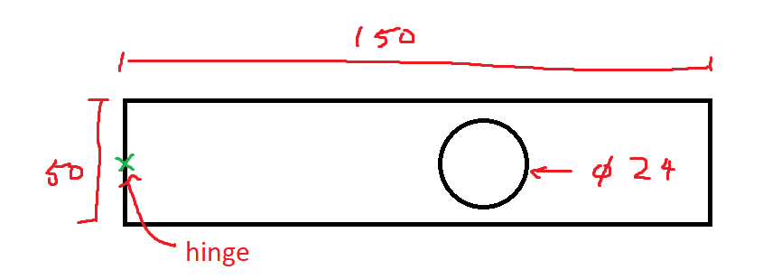

Equilibrium position at 80 deg from horizontal, and estimate the location of CoM of the system

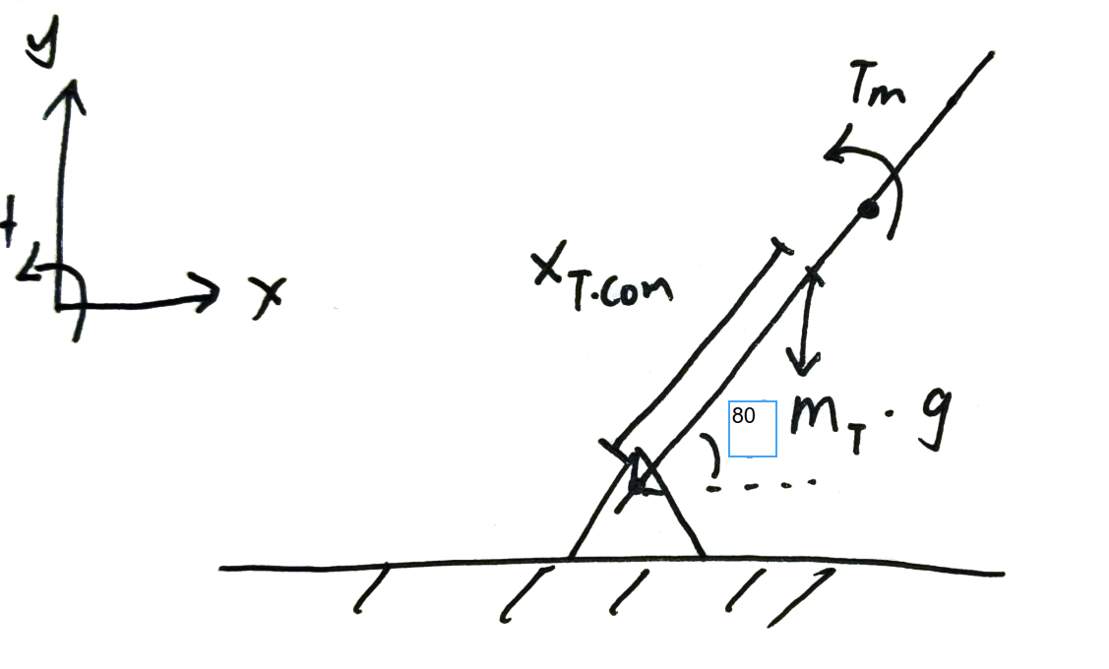

Base on the location of CoM of the system, calculate the required location of Xmotor.CoM

Calculate ρpanel

Solve for the equation for Xmotor.CoM

# Fusion 360 modelling

After a few iterations, this is the final design with approx. physical properties

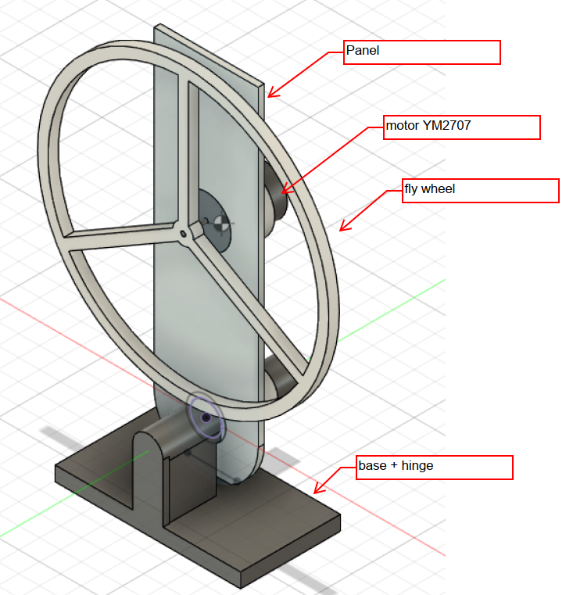

General

Part Number Panel

Physical

Mass 18.283 g

Volume 24088.075 mm^3

Density 0.001 g / mm^3

Area 17570.531 mm^2

World X,Y,Z 0.00 mm, 0.00 mm, 0.00 mm

Center of Mass 0.00 mm, 1.50 mm, 64.138 mm

Moment of Inertia at Center of Mass (g mm^2)

Iyy 50127.173

Moment of Inertia at Origin (g mm^2)

Iyy 1.253E+05

General

Part Number Motor

Physical

Mass 48.996 g

Volume 12249.07 mm^3

Density 0.004 g / mm^3

Area 3009.646 mm^2

World X,Y,Z 0.00 mm, 0.00 mm, 0.00 mm

Center of Mass 1.252E-09 mm, 13.446 mm, 82.00 mm

Moment of Inertia at Center of Mass (g mm^2)

Iyy 3517.848

Moment of Inertia at Origin (g mm^2)

Iyy 3.330E+05

Physical

Mass 11.755 g

Volume 15488.023 mm^3

Density 0.001 g / mm^3

Area 12296.233 mm^2

World X,Y,Z 0.00 mm, 0.00 mm, 0.00 mm

Center of Mass 3.638E-08 mm, -8.50 mm, 82.00 mm

Moment of Inertia at Center of Mass (g mm^2)

Iyy 41933.026

Moment of Inertia at Origin (g mm^2)

Iyy 1.210E+05

### Summary:

|  |  |  |
| --- | --- | --- |
| m_panel | 18.2 | g |
| m_motor | 49 | g |
| m_flywheel | 11.8 | g |
| m_plant | 0.08 | kg |
| I_panel.hinge | 1.25E+05 | g mm2 |
| I_motor.hinge | 3.33E+05 | g mm2 |
| I_flywheel.hinge | 1.21E+05 | g mm2 |
| I_plant.hinge | 5.79E-04 | kg mm2 |
| I_motor.CoM | 3517.848 | g mm2 |
| I_flywheel.CoM | 41933.026 | g mm2 |
| I_motor.CoM+ I_flywheel.CoM | 4.54509E-05 | kg m2 |
| X_plant.CoM | ≈0.08 | m |

# Entry 05/07/2021

# Simulink modelling

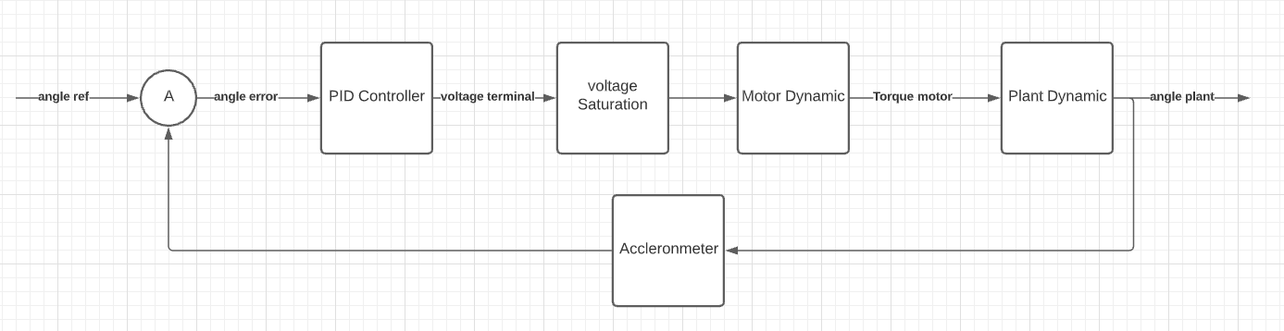

The control lop above will be the basis used for the Simulink simulation.

The dynamic each section is based on the equation derive from earlier

## PID controller

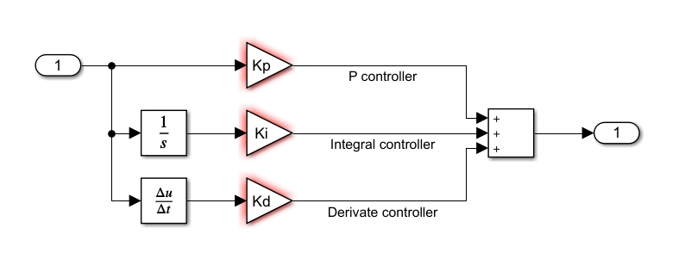

## Voltage Saturation

The voltage supply to the motor is limited to 4.5v as it’s the rate voltage for the motor

## Motor Dynamic

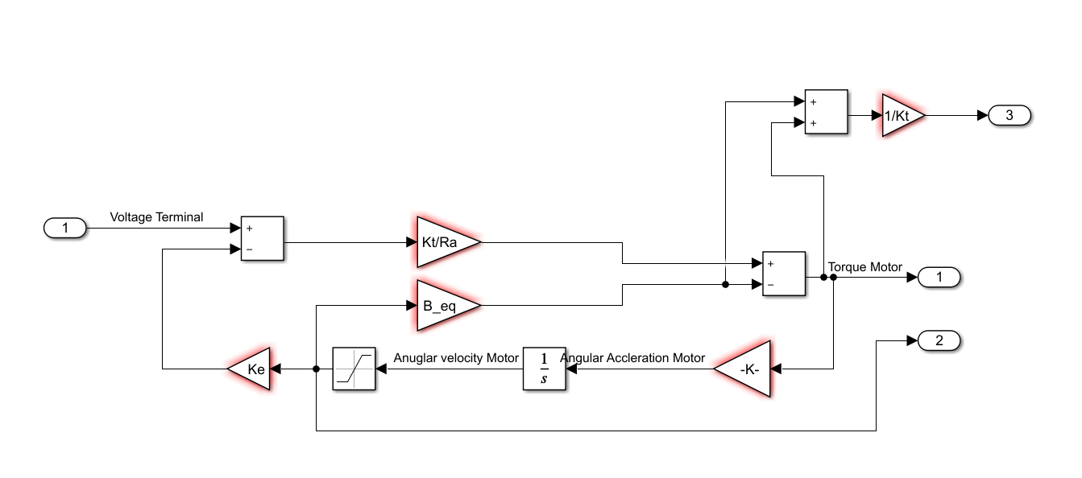

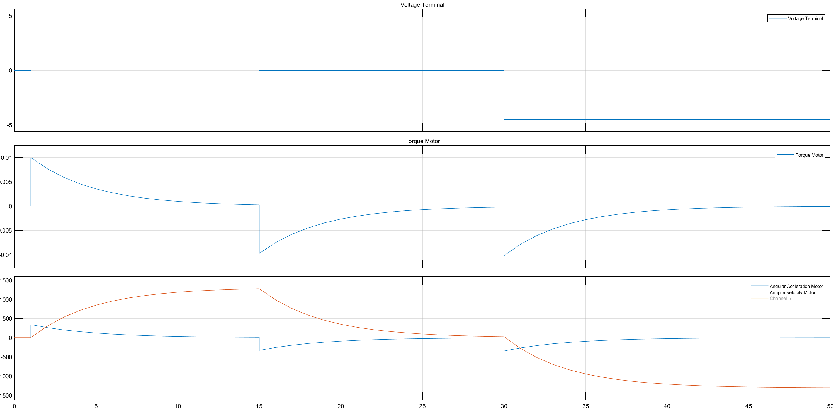

The figure above shows the characteristics of the motor dynamic when applied a step input

Note: this is when there is a flywheel attached to the motor directly, so the angular acceleration curve is different without the flywheel



The angular velocity – torque characteristic curve roughly matched the spec sheet. It would be interesting to compare this to the actual graph

## Plant Dynamic

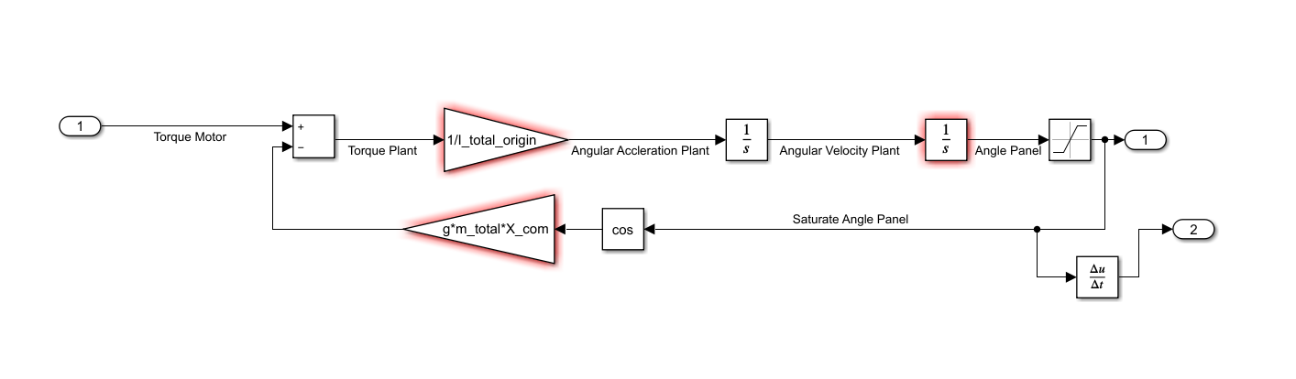

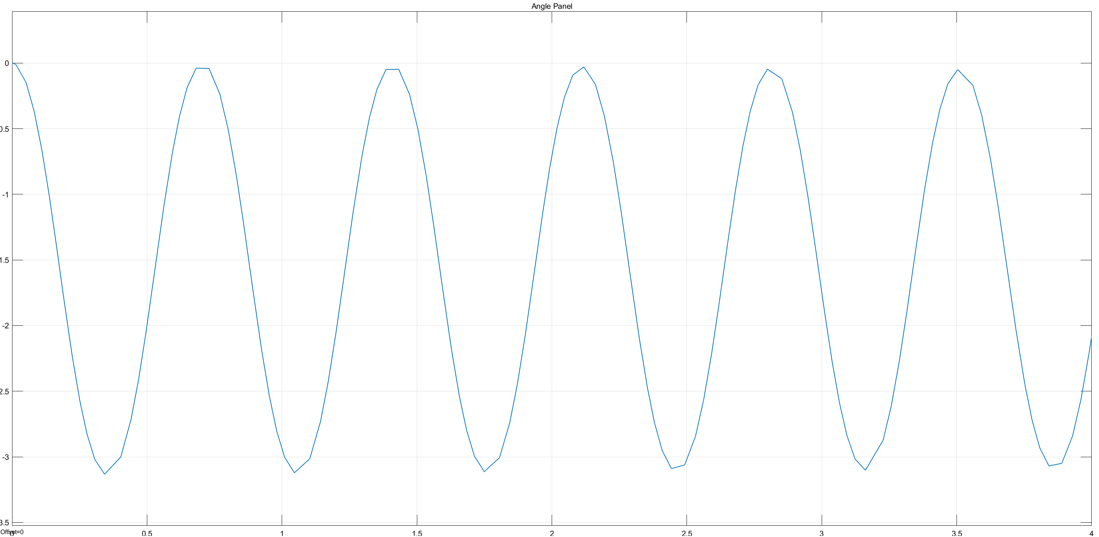

Angles are in radians, the output graph matches the behaviour of the real system a part from non-stop oscillation.

## Update: 11/07/2021

Could include a damping term to ensure the oscillation would end at some point

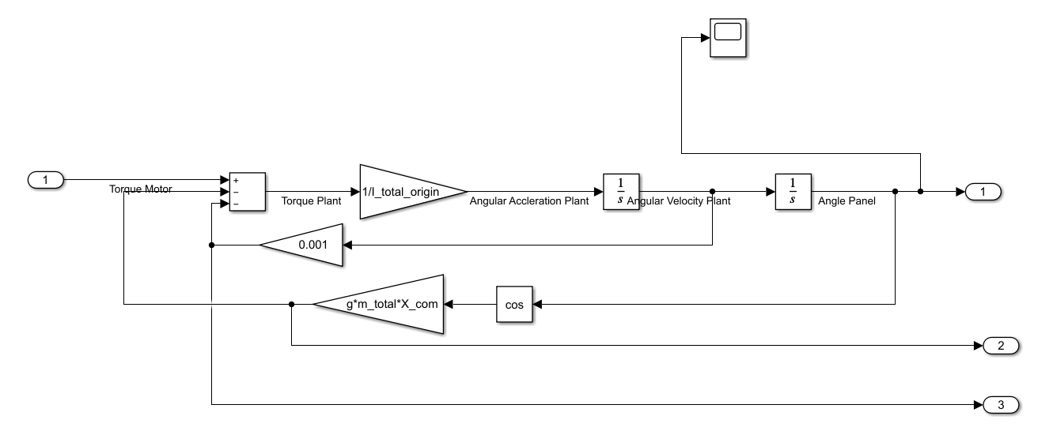

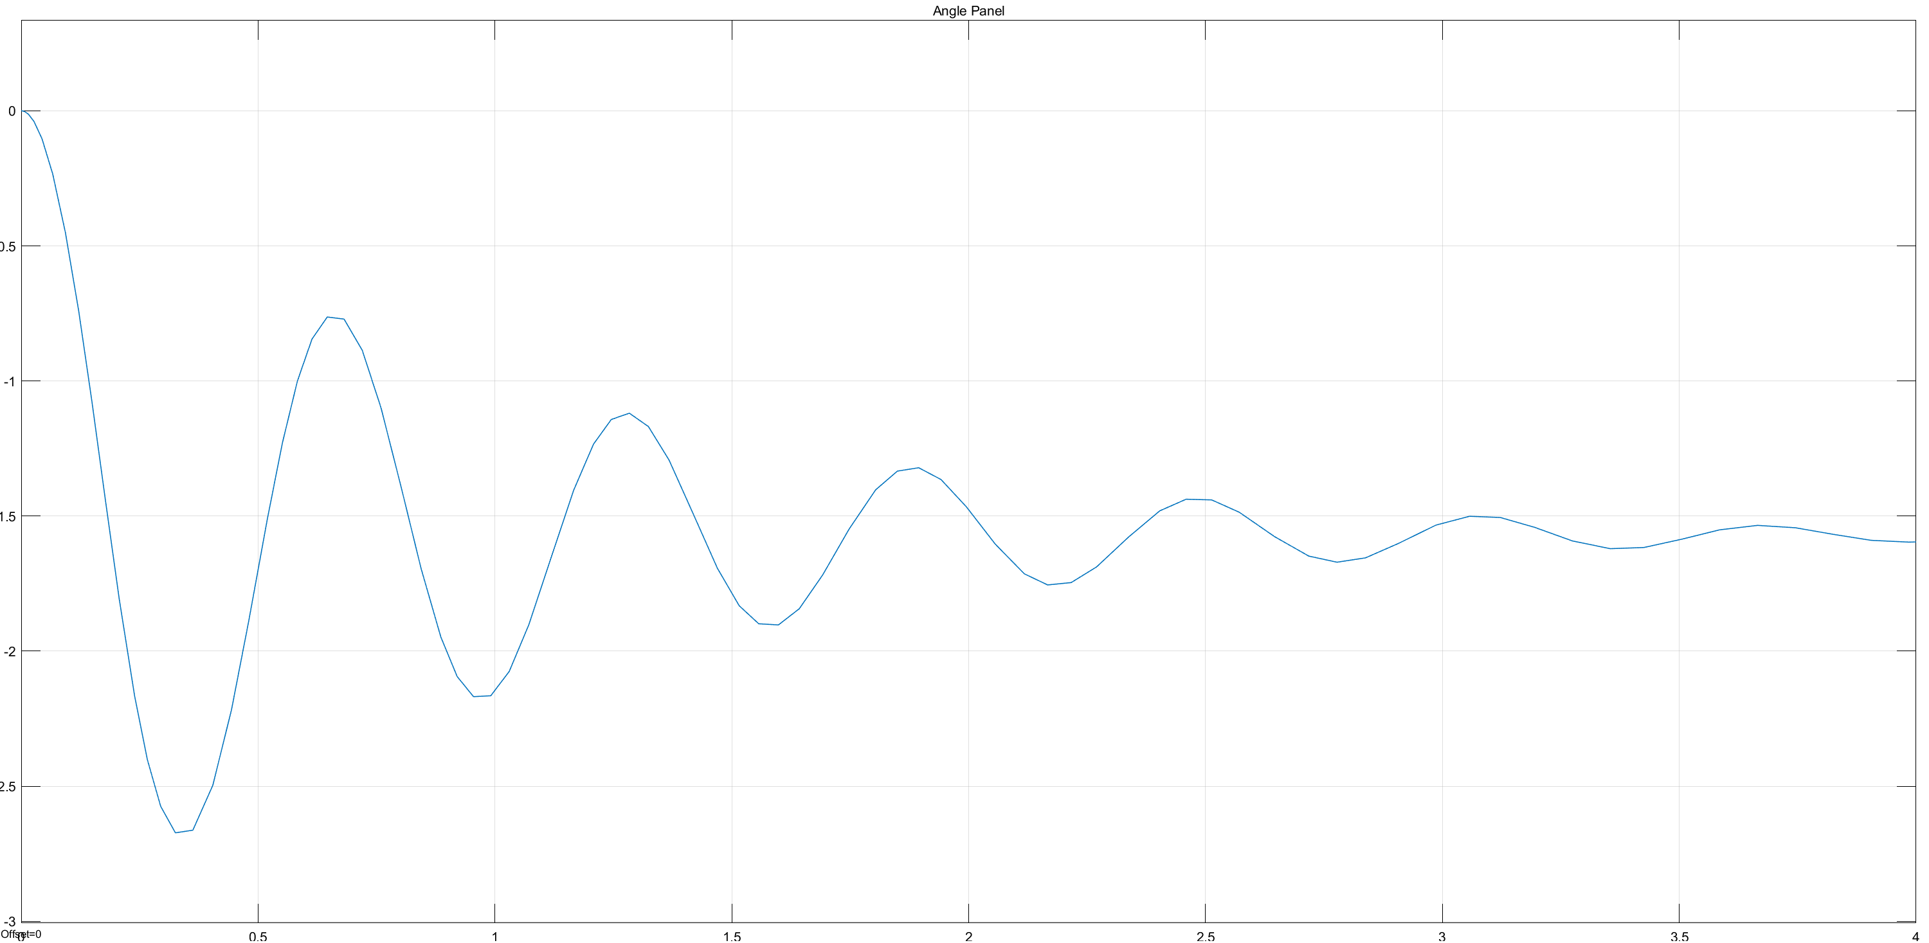

The oscillation eventually die out around -pi/2 which is -90degree (eg. lowest point) this match the real plant.

# Entry 07/07/2021

# Choosing parts:

## Motor driver

A full H bridge will be used to control the motor to allow forward and reverse direction od the motor. The component must be rated for 4.5V at up to 3A to ensure it can delivery the maximum current drawn by the motor.

A variant of cheap IC L298 will be used to drive the motor, more specifically https://www.aliexpress.com/item/1005001621936295.html?

It should be fine, if not we can supply 3V to the motor to ensure the IC wouldn’t be fried.

## Accelerometer

An Arduino mega will be used to control the motor driver, so a compatible Accelerometer will be used.

ADXL3xx accelerometer will be used, specifically: [ADXL345](https://www.aliexpress.com/item/1pcs-GY-291-ADXL345-3-Axis-Digital-Gravity-Sensor-Acceleration-Module-IIC-SPI-transmission/32452794842.html?spm=a2g0s.9042311.0.0.27864c4d4rFhfv)

<https://www.aliexpress.com/item/32452794842.html>

which is a 3 axis accelerometer that utilise i2c or spi transmission protocol. This should enable the panel to measure the angle of the panel relative to the horizontal panel.

# Entry 08/07/2021

## Analytical analysis

Analysis the stability of the system, and how it reacts to various input/disturbance

## Plant

From earlier, the equation describe dynamic of the panel movement is:

Given all initial conditions are 0 except angel of the plant is a value of 90 deg

Linearise cos(θ) to mθ+c around θ = 90deg = 1.57rad

linear rise around θ = 1.57rad

This make the equation impossible to transform to the term ϴplant(s)/τm(s).

### Redefine reference point for θplant

Require redefining the point of reference such that 0 rad is at vertical position.

Now all initial condition will be 0

Linearise sin(θ) around θ=0deg

linearise around θ = 0deg

## Motor

From earlier, the equation for the dynamic of motor is:

Since the flywheel will be directly driven by the motor, TL term can be omitted

Where:

Therefore:

## Control loop

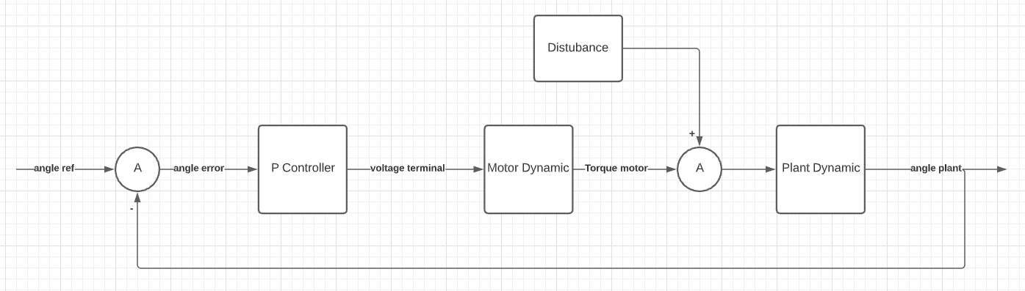

Since the reference angle will be 0, I would be interested in the repose of the system to different disturbance. (test for ability to recover)

# Entry 11/07/2021

## Transfer function

### The input is the disturbance

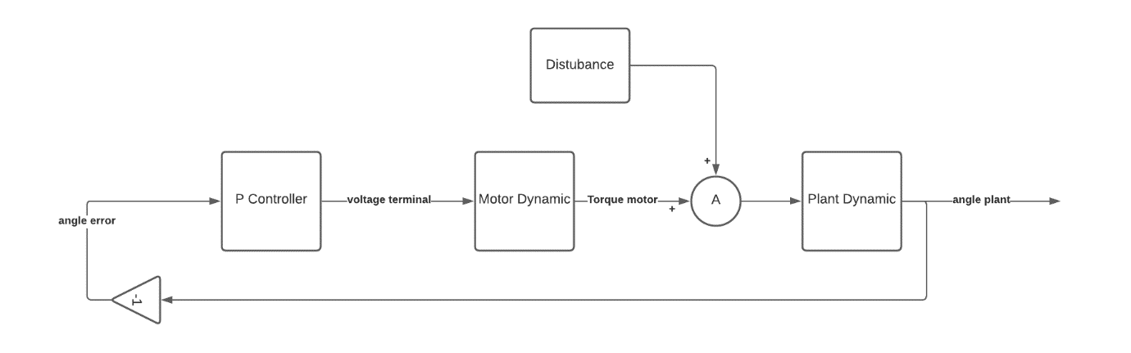

All location of the close loop poles are expected to the on the left hand side of the imaginary axis, this mean the system will be stable.

# Entry 13/07/2021

## Root Locus of the system

From earlier, the value of the variables are:

|  |  |  |
| --- | --- | --- |
| I_plant.hinge | 5.79E-04 | kg mm2 |
| M_plant | 0.08 | kg |
| x_plant.com | 0.08 | m |
| I_motor.CoM+ I_flywheel.CoM | 4.54509E-05 | kg m2 |
| K_T | 0.0031885 | Nm/A |
| K_E | 0.003179 | V s/rad |
| B_eq | 558.05 e-9 | Nm s/rad |
| R_a | 1.4 | ohms |

### OLTF

### Root locus plot

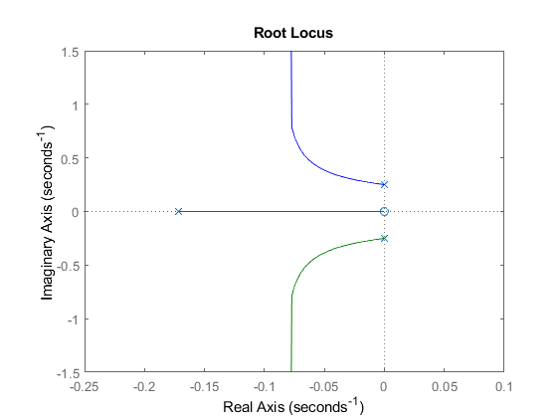

The system would therefore be stable for all values of K, this is a good reflection of the real system.