DBD281 Project 1

Dean Kruger 577867

Ferdinando Storm Speranza 577252

Stephanus Albertus Buys 577519

Justin Gibbon 577407

Contents

Introduction 2

Entity Relationship Diagram 2

Normalization Process 2

Identifying and explaining entities 4

Customers 4

Discounts 4

Employees 4

Orders 5

Product 5

Suppliers 5

List of queries and Views 6

Stored Procedures 6

Triggers and logins 6

# Introduction

We have been tasked to find a business with finding a small to medium size business and help design or improve their existing database.

Fatimas is a convenience store at the corner of veronica road and 6th road. Recently this stored has gained popularity as it started doing deliveries, and is currently struggling to keep up with the increase in demand. We have offered to create a new database to suit their needs. This database will track the orders that they need to deliver, their current stock, the employee details will also be on the system as well as that of customers. There will also be discount codes that can be applied for certain customers like pensioners or students.

# Entity Relationship Diagram

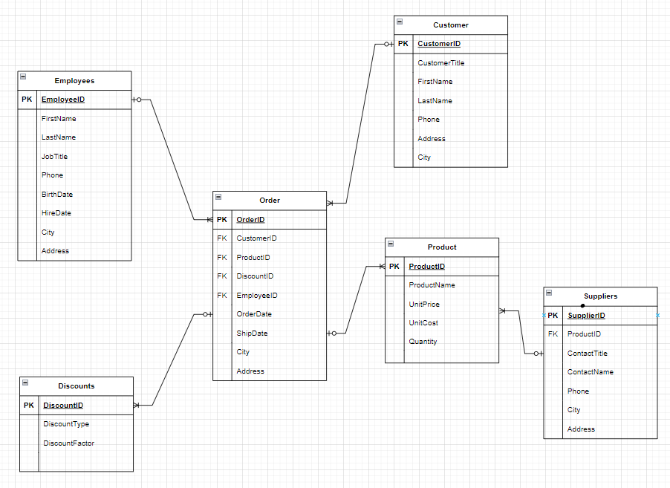

# Normalization Process

To eliminate data redundancy and guarantee data consistency, normalizing a database entail dividing the data into smaller, more manageable tables. Third Normal Form (3NF), Second Normal Form (2NF), and First Normal Form (1NF) are the three normal forms that this process often takes (3NF). The process for normalizing an ERD diagram to 1NF, 2NF, and 3NF is as follows: 1NF, or First Normal Form Verify that a primary key exists in each table. Make sure that atomic values are present in each column (i.e., each cell should only contain one piece of information). 2NF, or Second Normal Form

Check to see if the table is in 1NF.

Eliminate any incomplete dependencies. When a non-key attribute relies solely on a portion of a composite main key, there is a partial reliance. Create new tables with a unique primary key for each non-key attribute to eliminate partial dependencies.

3NF, or third normal form

Check to see if the table is in 2NF.

Any transitive dependencies should be removed. When one non-key attribute depends on another non-key attribute, there is a transitive dependency. Create new tables with a unique primary key for each non-key attribute that depends on another non-key attribute to eliminate transitive dependencies.

# Identifying and explaining entities

## Customers

This table is used to store and document the customers of Fatimas. The customers table will consist of the following seven tables:

* CustomerId

This will be the primary key of the customer table

* CustomerTitle

This will be the preferred title of the customer and will be used to address the customer.

* FirstName
* LastName
* Phone

The Phone number used to contact the customer.

* Address

Address of the customer

* City

The city in which the customer is located in.

## Discounts

Fatimas provides discounts to certain customers such as the elderly or students. This table will record the different type of discounts. This table will consist of the following three columns:

* DiscountID

The primary key of the discount table.

* DiscountType

Fatimas provides a student discount as well as a pensioners discount.

* DiscountFactor

The discount factor will be used to calculate how much of a discount the client will receive.

## Employees

This table will be used to document and record all the employees under the employ of Fatimas. This table will consist of the following seven columns:

* EmployeeID

The primary key of the employees table

* FistName

Employees first name

* LastName

The last name of the employee

* JobTitle

The title of the employee

* BirthDate

The birth date of the employee

* City

The city of where the employee is born

* Address

## Orders

The orders table is used to document the orders that need to be completed by Fatimas. This will be largest table consisting of the following ten columns:

* OrderID

The primary key of the orders table.

* OrderDate

The date when the order was placed.

* ShipDate

The date of when the order is shipped.

* City

The city to which the order needs to be sent.

* Address

This will be the address to which the order will be delivered.

* Phone

This will be used to store the contact number of the person who placed the order.

* ProductID

This will act as a foreign key linking the product table to the orders table.This will enable us to see what products each orders consist of.

* EmployeeID

This column is a foreign key that creates a relationship between the employee and order table. In this manner we can see what employee took each order.

* DiscountID

This foreign key will link enable us to see what discounts are linked to which orders.

* CustomerID

This will be a foreign that links the customer table and will enable us to see which customer placed the order.

## Product

The product table will be used to record what products are in stock. The product table consists of the following five columns:

* ProductID

The productid will serve as the primary key of the products table.

* ProductName

The name of each product will be provided in this column.

* UnitCost

This column will give the total cost of acquiring each product.

* UnitPrice

This column will be used to store the price the product is sold at.

* Quantity

This will be used to store the amount of each product in stock.

## Suppliers

This table will be used to document what supplier supply what product. This table will consist of the following seven columns:

* SupplierID

This will be the Primary key of the Suppliers table and will be used to uniquely identify each supplier.

* ProductID

This is foreign key of the table and will link each product to a supplier.

* ContactTitle

This table provides the title of the contact person at the supplier.

* ContactName

This is the name of the contact person at the supplier.

* Phone

This field will be used to supply the contact number of the contact person at the supplier.

* City

This is the city where the supplier is located at

* Address

This is where the supplier is located at.

# List of queries and Views

* Percentage_Profit

We calculated this query to be able to see how much profit we make for every product we sell.

* View_082

We created this view to find all the numbers that start with 082.

* View_ADD_Stock

We created this view to show us when any of the stock drops below 20 units. Which will allow us to refill our stock.

* View_Pensioner

We calculated this view to be display when a customer is eligible for a pensioner's discount.

* Years_Worked

We calculated this query to determine how long each employee has been working at Fatimas

# Stored Procedures

* SpOrders,SpCustomers,SpEmployees,SpSuppliers,SpProducts:

Our database was populated by making use of 5 different stored procedures. These stored procedures are named after their corresponding tables for example SpCustomers was used to populate the Customers Table.

* SpOrdersDate :

This stored procedure is used to display orders that are placed or shipped between two certain dates.

* sp_PriceLessThan

This stored procedure is used to display any product with a price less than whatever is used as the @Maxprice variable.

# Triggers and logins

* SQL_Login

This is a login created for the owner to access the database.

* Restricted_Login

This restricted login was created to be used by Daniel Deng to access the database while not being allowed to see sensitive information.

* Test_Login_Trigger

This test login trigger test if the login trying to be used exists.

* Trigger_Ref_Integrity

This Referential integrity trigger is used to ensure the referential integrity between the tables.