## Environment Instruction

IDE:

IntelliJ IDEA

Environment:

jdk1.8.0_202

jre1.8.0_202

Open the project in an IDE. Build and run the project with “main.java” in Genealogy\src\scene

## Use Instruction

##### login

Admin user account:

admin

123456

Common user account:

j

111111

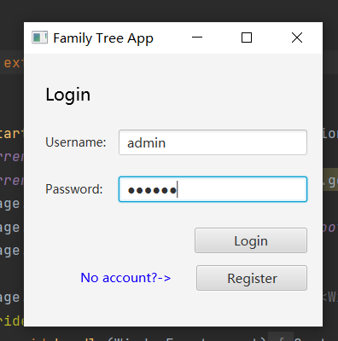

##### Register

Type in username and password to create a normal account.

##### Display tree

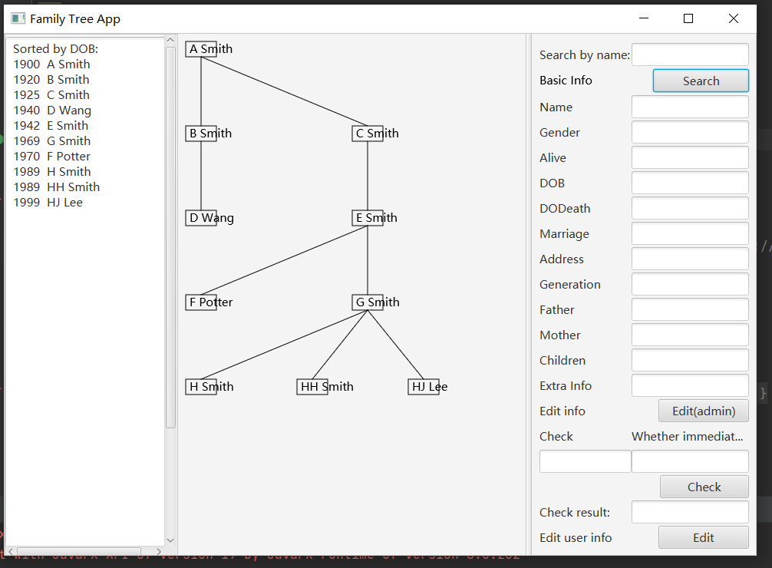

Click “search” when “search by name” field is empty to load / refresh the tree graph.

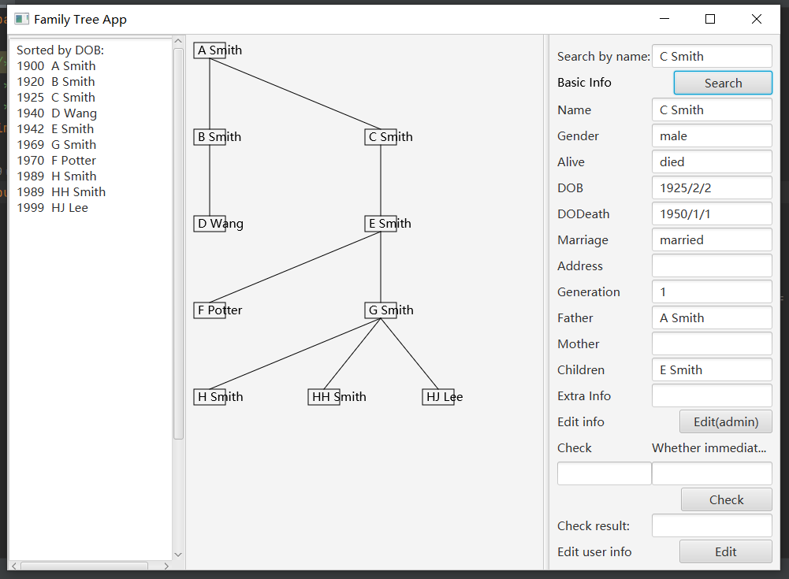

Enter a name in “search by name” field to load information

##### Immediate family check

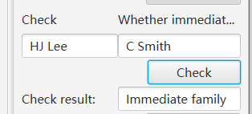

Enter 2 names to check whether they are immediate family members.

##### Edit Member Information



Click the button.

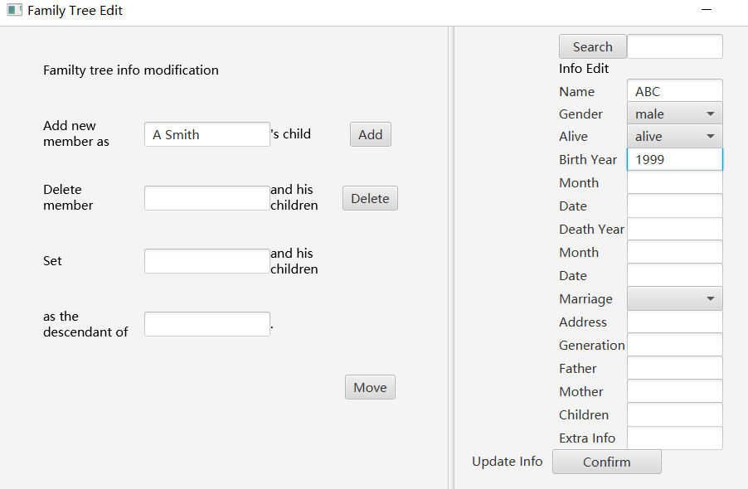

To add a new member:

Enter info on the right hand fields

Add the father/mother’s name on the left hand field

Then click button “add”

To delete:

Enter name and then press delete

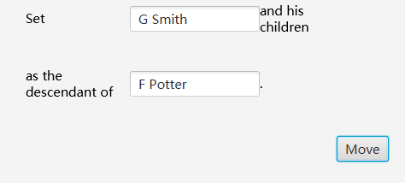

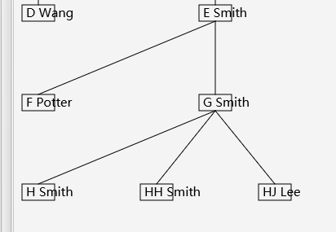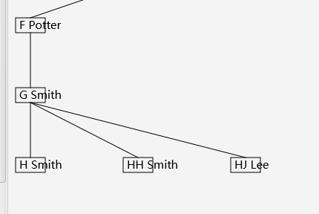

To move a member and his/her descendant under another member:

Fill 2 fields on the left hand side

Click Move button

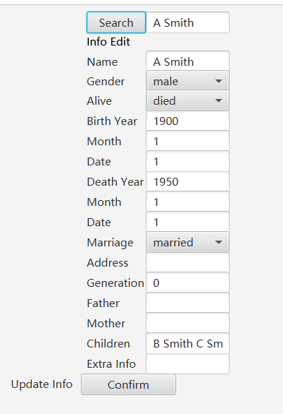

To edit an existing member:

Enter name in the search field

Click search button

Modify information

Click confirm button

User account management

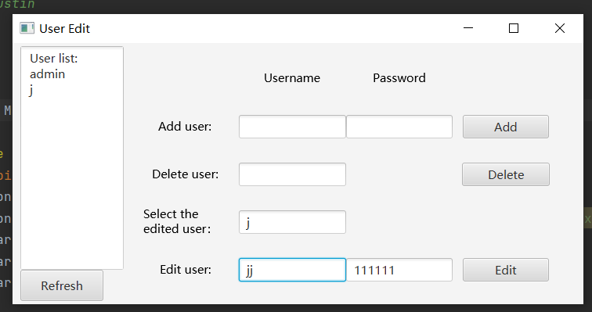

Click refresh to load all users’ accounts

To edit an existing user:

Enter current username in “select the edited user” field

Enter new username and pwd below

Click edit button