A).

I analyzed the part sales data for the four different departments and went into depth with what sales and profit are in one region. To start off, the first sheet I created was to narrow the data down to a way I could make it meaningful to study. I put the “Year(Sales)” in the column category to only look at the years 2017-2018, then placed the “Department” category in the columns section to study each Department product individually. For the rows section, I placed “Sum(Sales)” and “Sum(Profit)” to compare profit and sales for 2017-2018. I added a color mark to show lower profit in light orange and higher scores in darker orange. In my second sheet I created I further narrowed the data by only looking at the eastern region through a filter. Then by moving “State” into the rows category, I selected to only look at the top 10 states for sales that also had to coincide with the eastern region. This ended up only being three states, which were New York, Ohio, and Pennsylvania. This helped to compare 2017-2018 sales and profit data for each of these three states. In my third sheet, I focused on the sales and profit for the “Misc Supplies” department and compared the data for the 3 states. Lastly, I made a geographical map to show the sales and profit data for misc supplies, as well as adding in the profit ratio for each state. From the data visualization I set up, I learned that top eastern states profit and profit ratio for misc supplies is in the negative for Ohio and Pennsylvania. I knew that the best visualization to simply compare two things would be bar graphs so I went with those. It was challenging to get started because I didn’t know how to analyze the data in a meaningful way so figuring out which step to take was hard.

B).

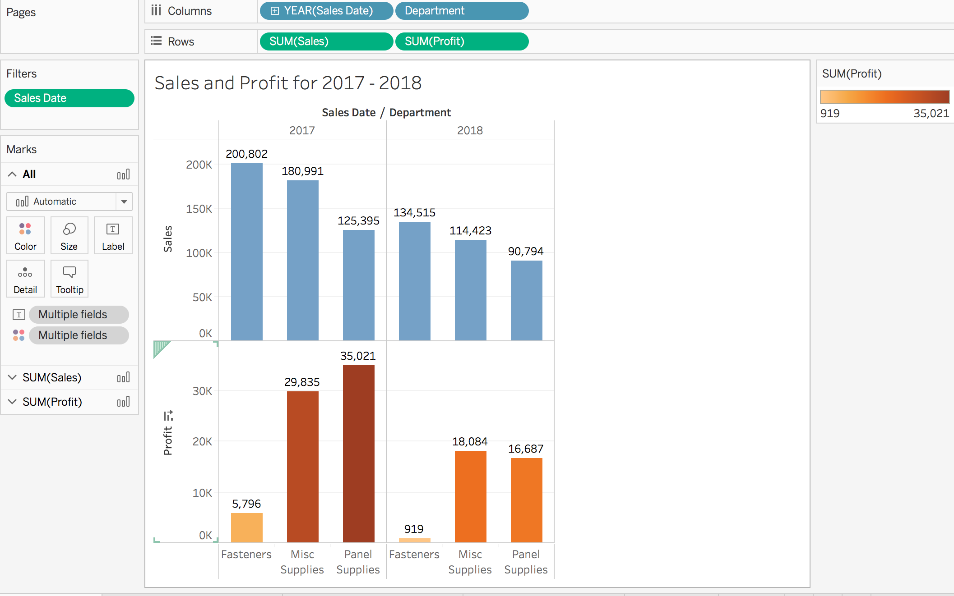

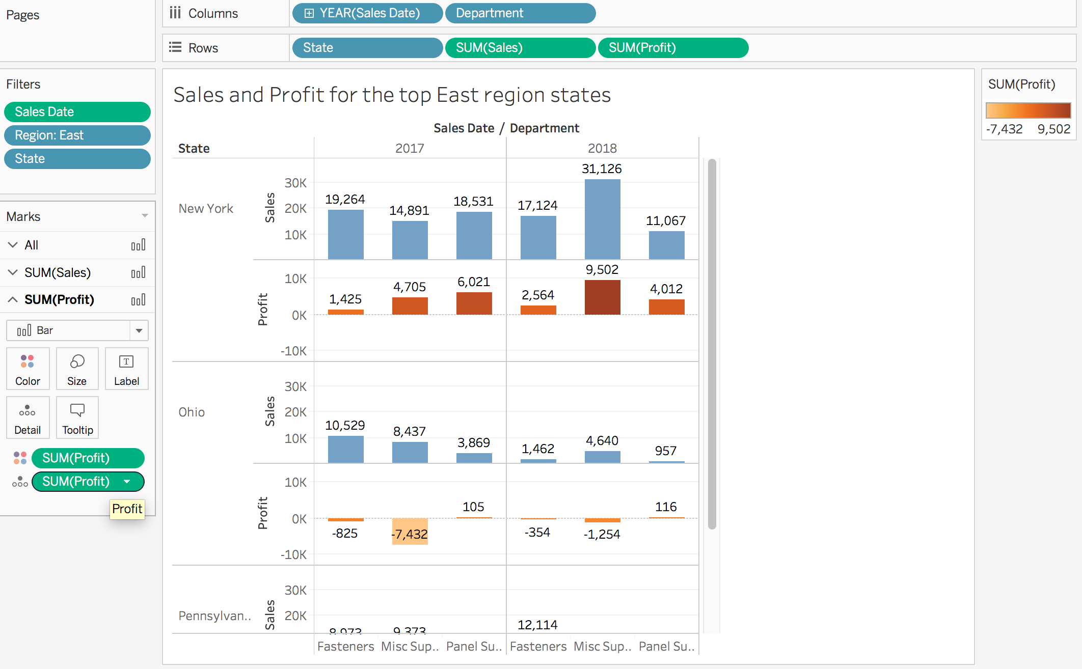This data is the Sales and Profit numbers for 2017-2018 using all departments. This is the base grouping of statistics for my project. I chose a bar graph format because it is easy to compare the profit and the sales, so you are able to tell the gains from each department. This is meaningful because it helps lay the ground work for what’s to come and show relationship between profit and sales.

This next worksheet is where I start to narrow down the data to only eastern region states in the top 10 for all regions. Only three states in the East were in the top ten, that was New York, Pennsylvania, and Ohio. Only using these three states, I compared sales and profit data. This data is meaningful because closing the scope of the amount of data I was given is crucial. Having a more precise region to look at helps identify problems for individual states, allowing for a chance to attempt to find a solution.

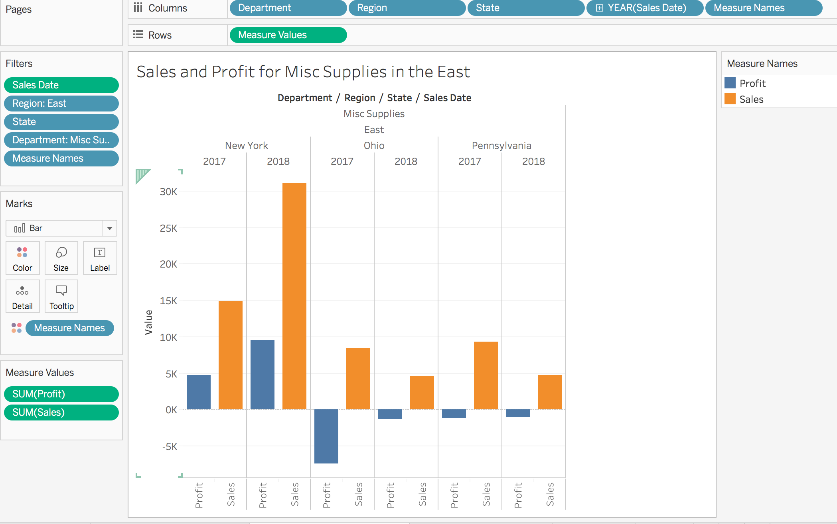

I once again narrowed the data down to only looking at one of the four departments, and which I chose the “Misc Supplies”. Now I have a bar graph to show the sales and profits for the three states but only in one category. This information can be relevant because now it is a lot easier to identify which states are not doing as well in profit. As you can see Ohio and Pennsylvania are making negative profit across the board, and New York is doubling its profit in a year.

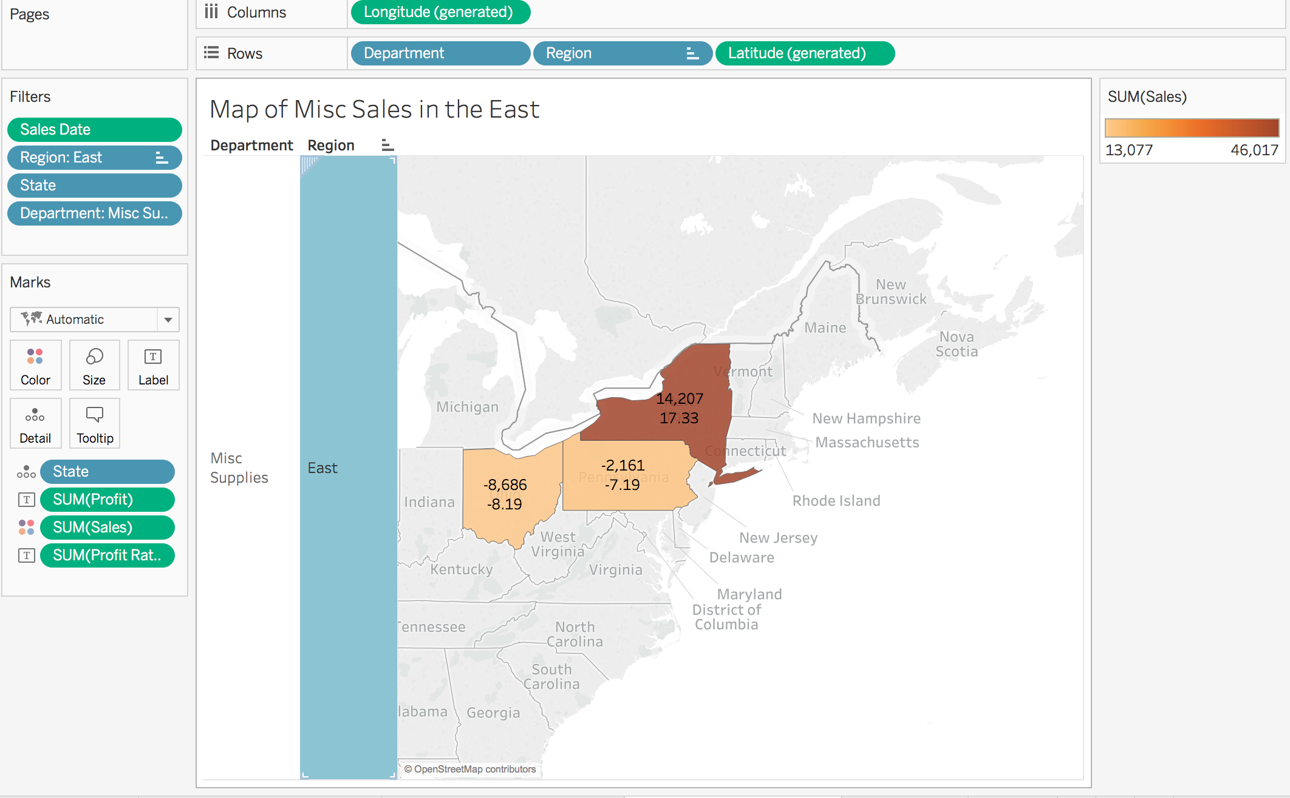

This worksheets purpose is to make the data into a map visual for the audience, allowing them to visualize on the map the amount of profit is being made. I also added profit ration underneath the first profit number to help get a better feel for the numbers and how the businesses are doing in misc supplies sales. I believe this data is relevant because now the business can view this data and decide to start working harder in those states that profit is low in.

C).

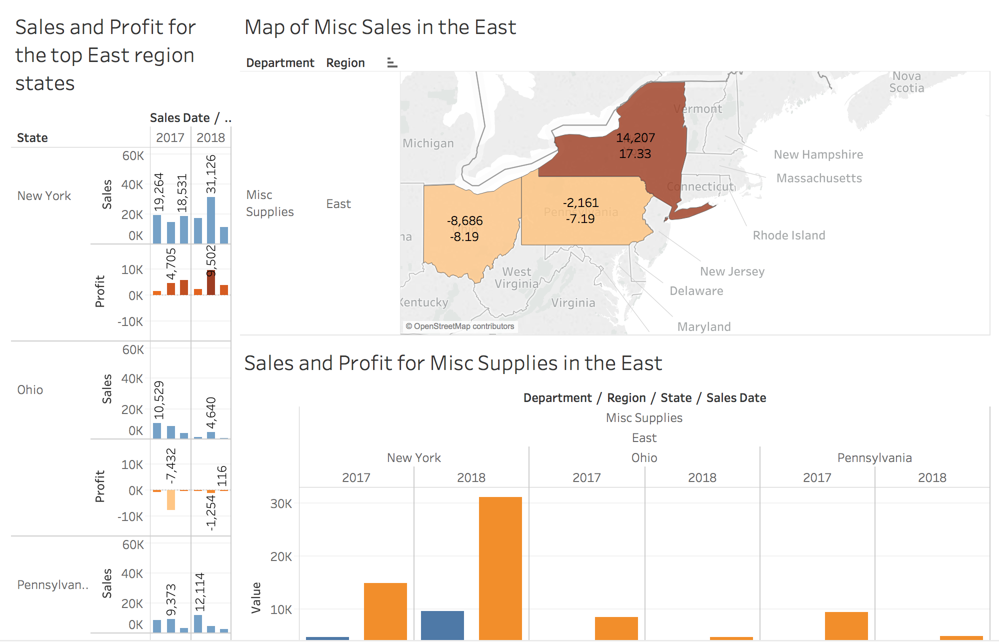

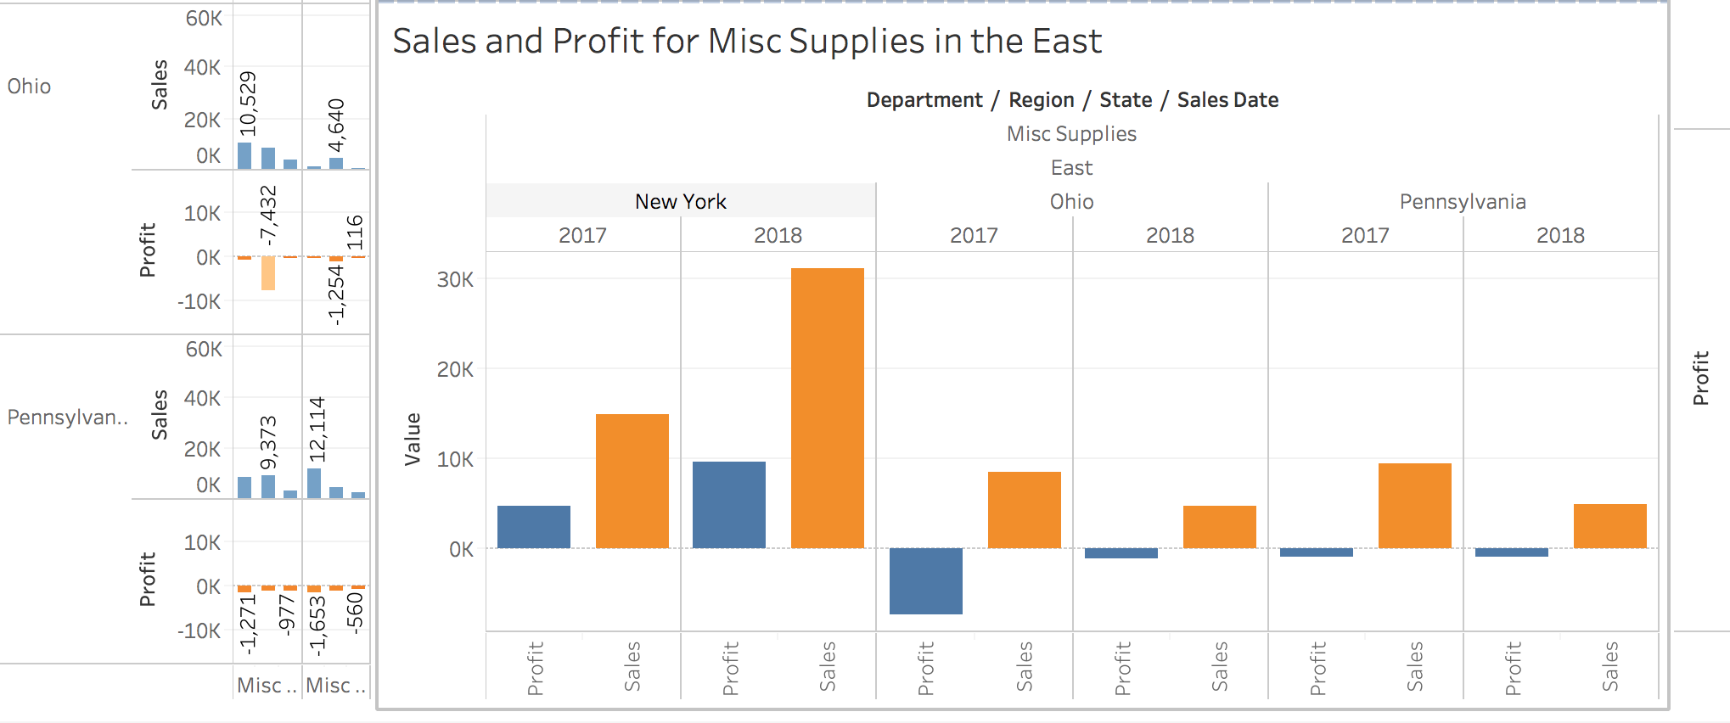

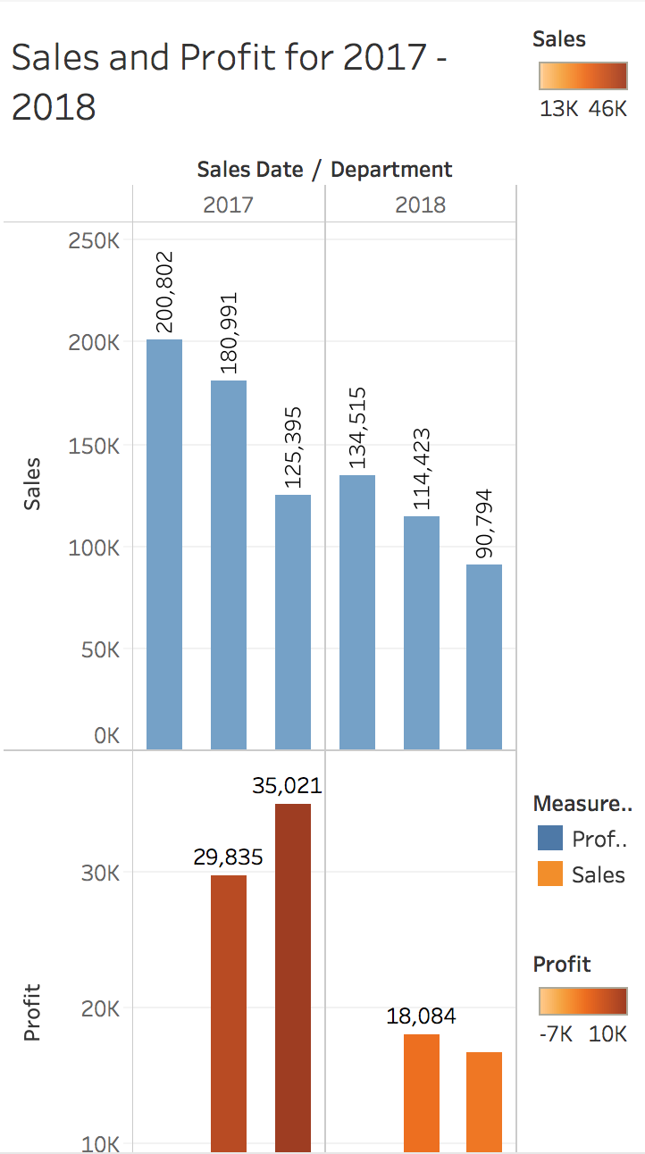

The above page is my dashboard I created for my data visualizations. I Included everything that I included because everything has to build on each other in order to be understood. Having the sales and profit data for 2017-2018 helps to show the wide scale of the business as a whole. Then moving on to show the Easter region Misc supplies earnings helps to let the business know that they are struggling in Ohio and Pennsylvania. Including the map helps to visualize where this struggle is occurring and also has the profit ratio attached to it. The point is to show that there is a negative profit being made because sales are down this year.

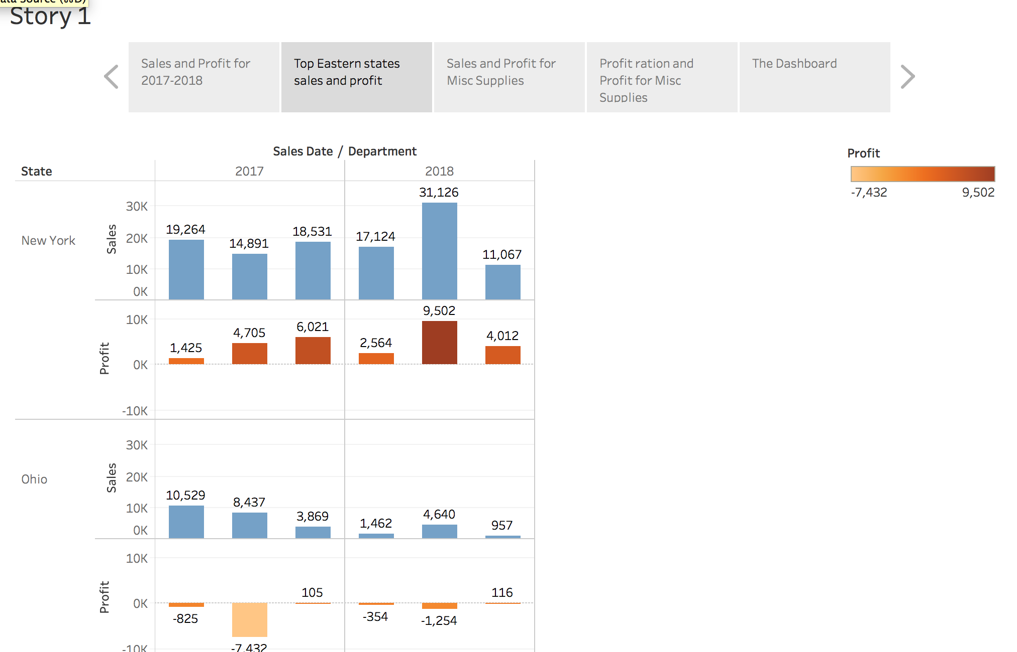

D).

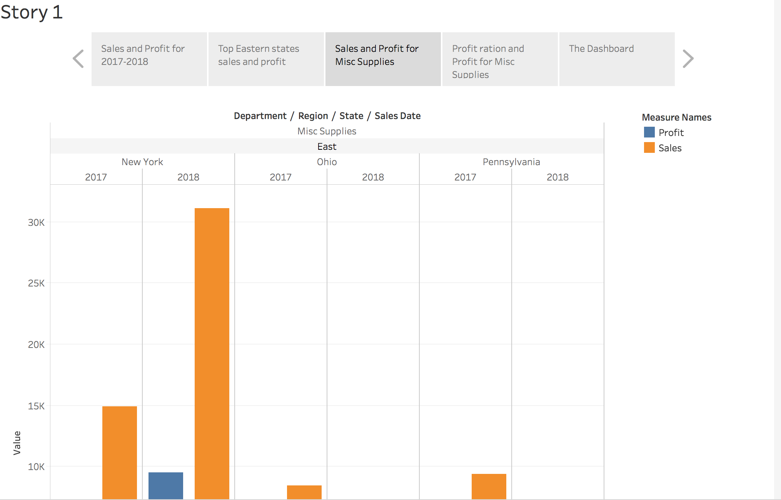

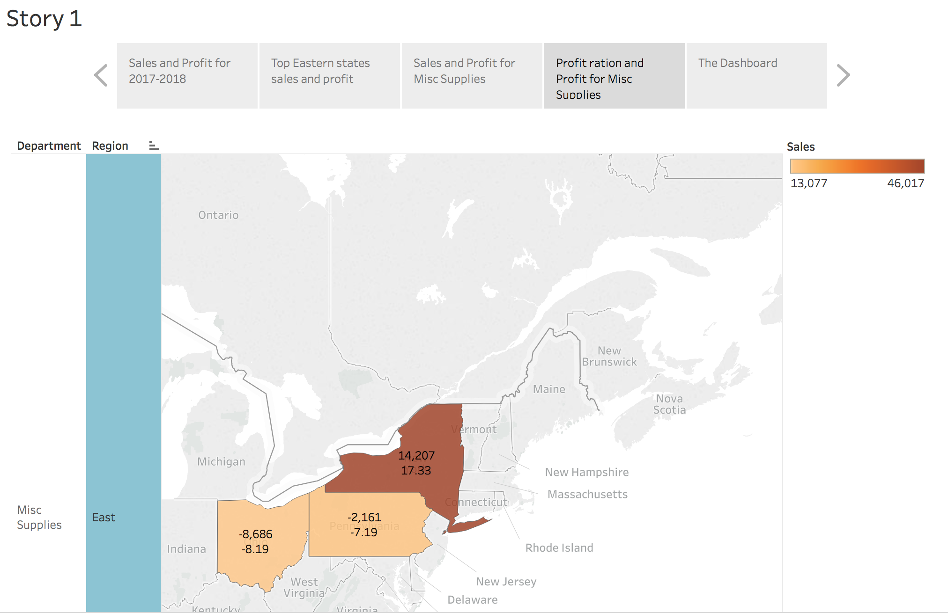

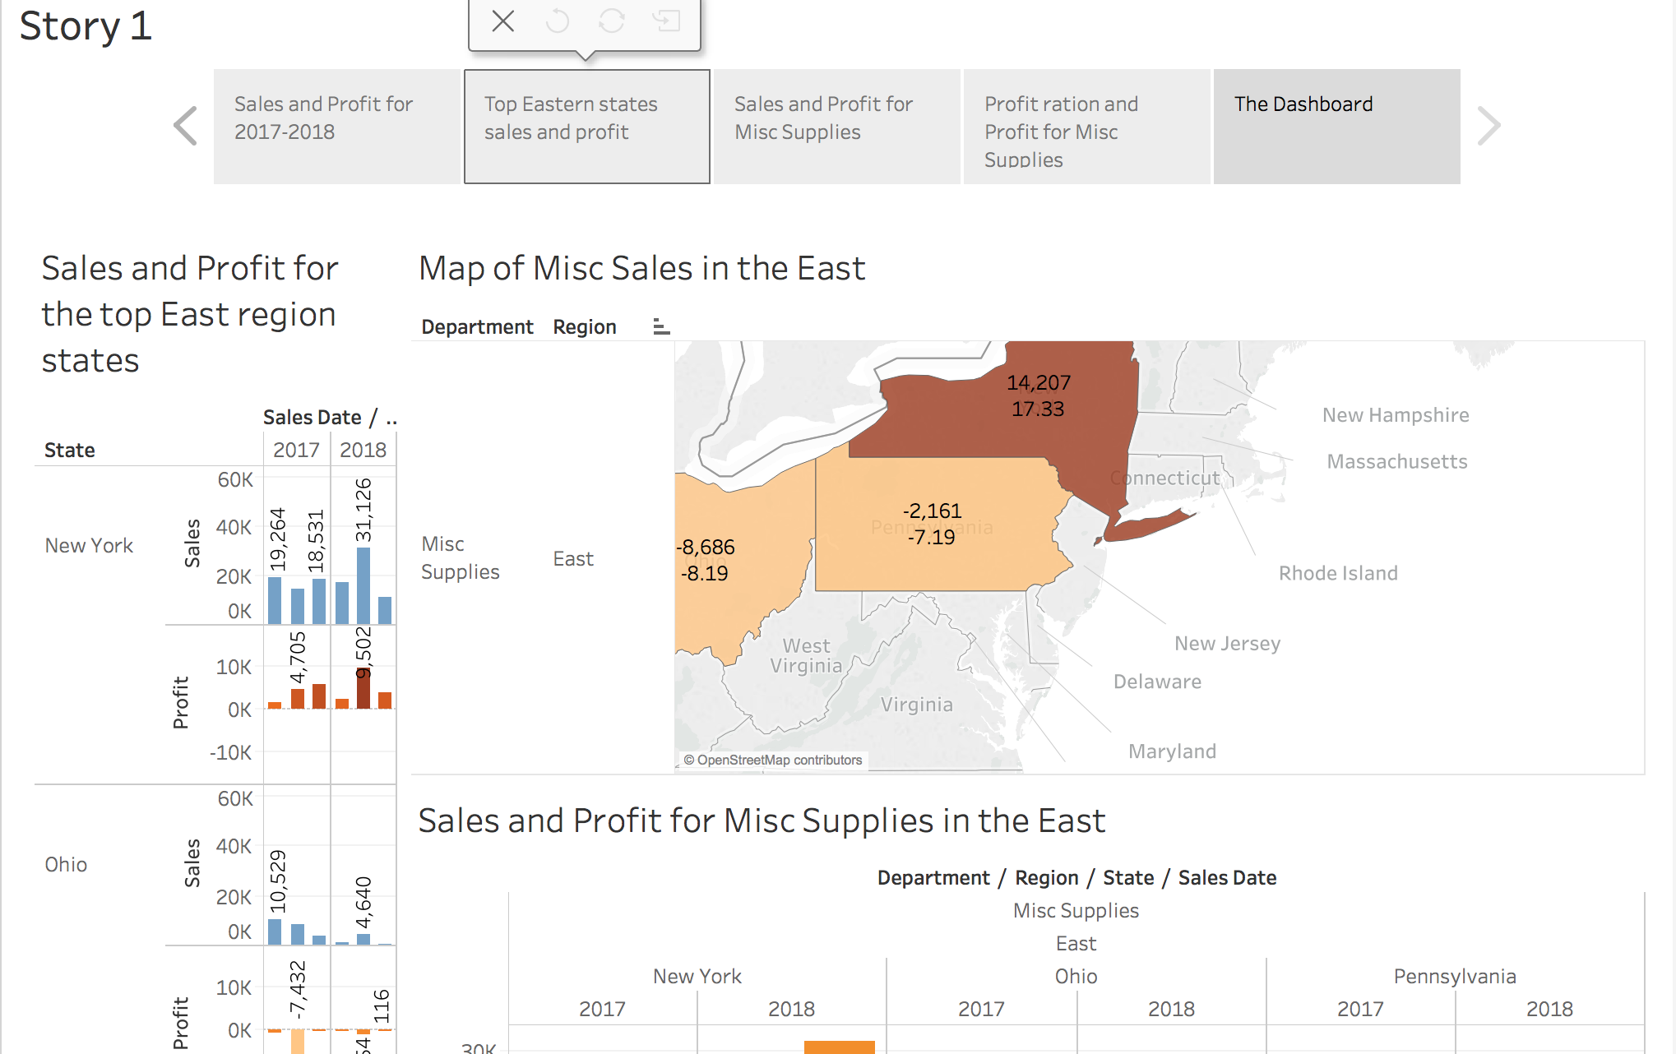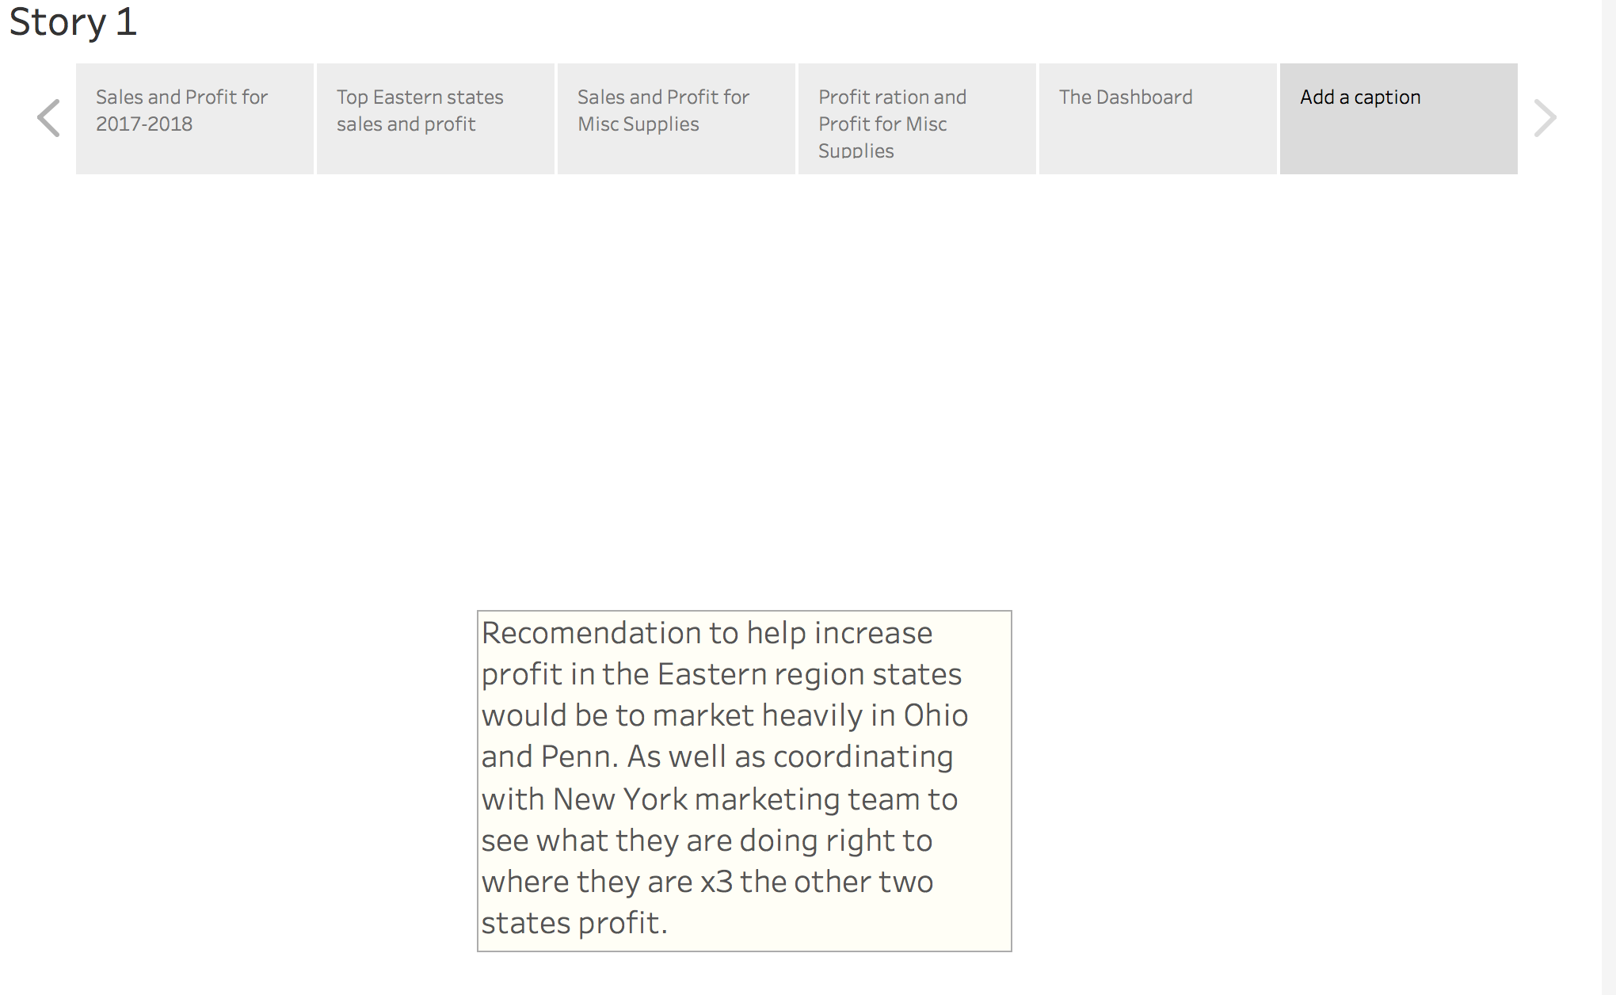

The story version of my Tableau project helps walk through the audience to see the in depth problems with eastern region. Starting off with the sales/profit for 2018, you can see the change in the past year for sales and how to better predict how much will be sold next year. Then the story takes you into a closer look into the three of the eastern region states that have the most sales. Story page three is about Misc supplies which is one of the four departments, and the sales/profit data it has gathered over the past few years in the Eastern Region. Lastly the map helps to show that profit is down this year in misc supplies, and that the profit ratio is lower in two out of three states. The recommendation is to coordinate with the marketing team in New York to see what they are doing well in so Ohio and Penn. can replicate success.

I learned that my data interpretation is very interesting to into because you can where the business is faulting in east, as well as compare large scale data such as sales and profit for the current and past years. Tableau is very interesting program to use and has been my favorite project in a class in a while. Having the ability to take a part large amounts of data and finding ways to make sense of the data is a very interesting and rewarding experience. The interface for Tableau is a great piece of work that is some what easy to use with help and beneficial for the user or reader. I am glad I had the ability to use Tableau and I hope to use it in the future.