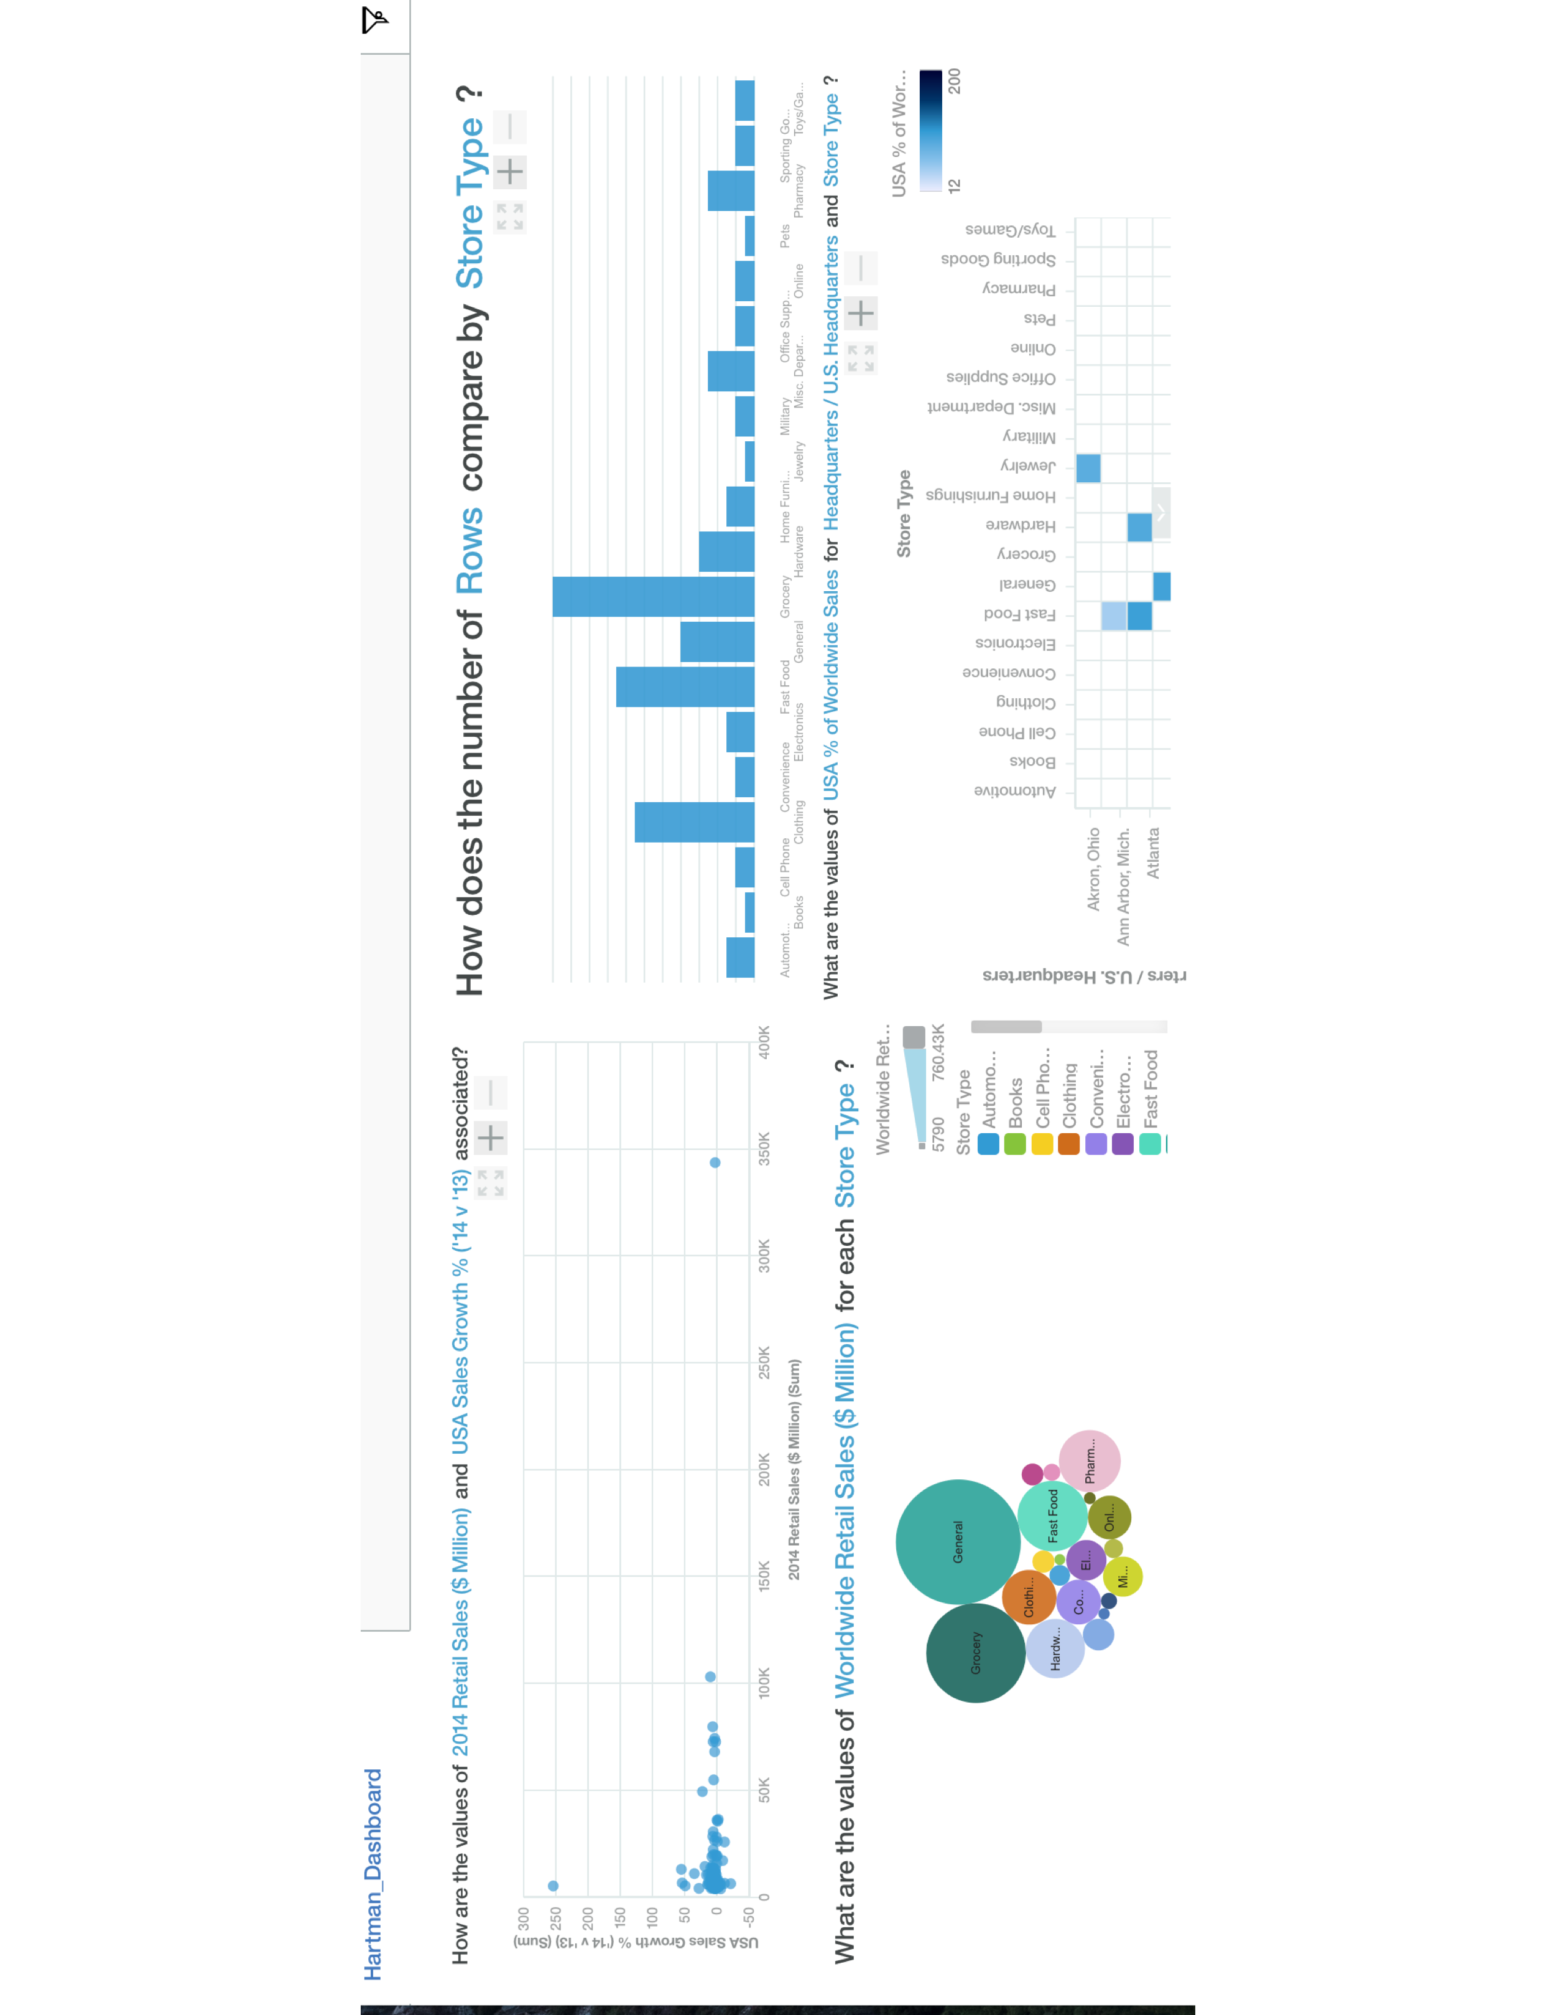

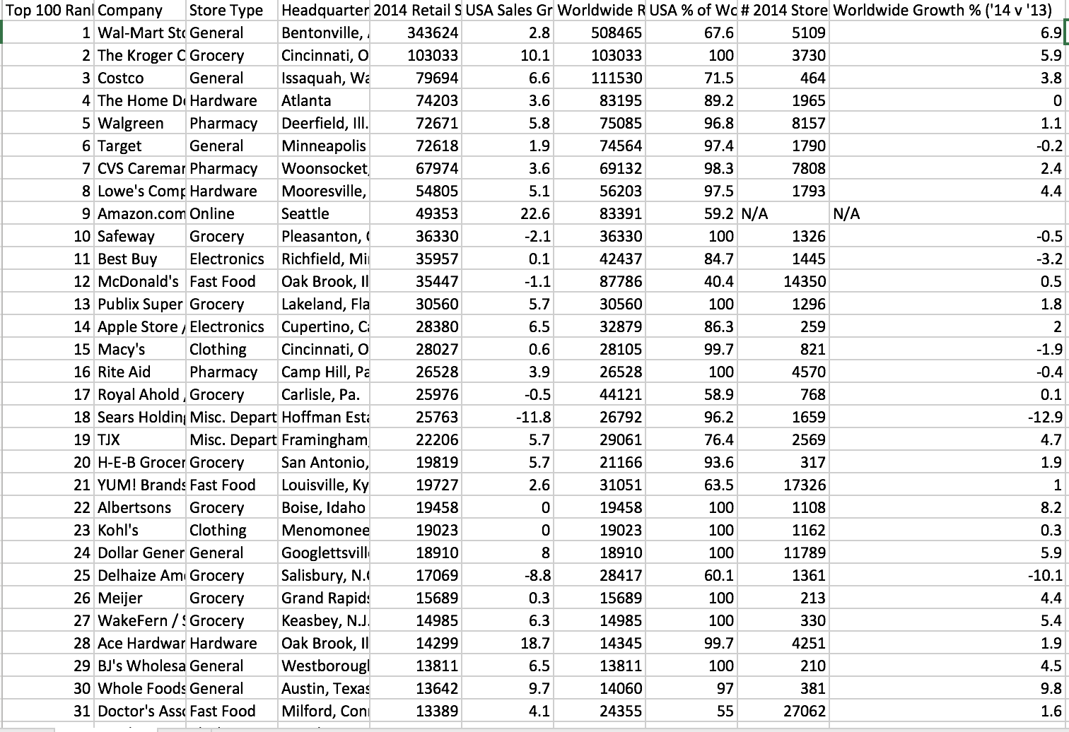

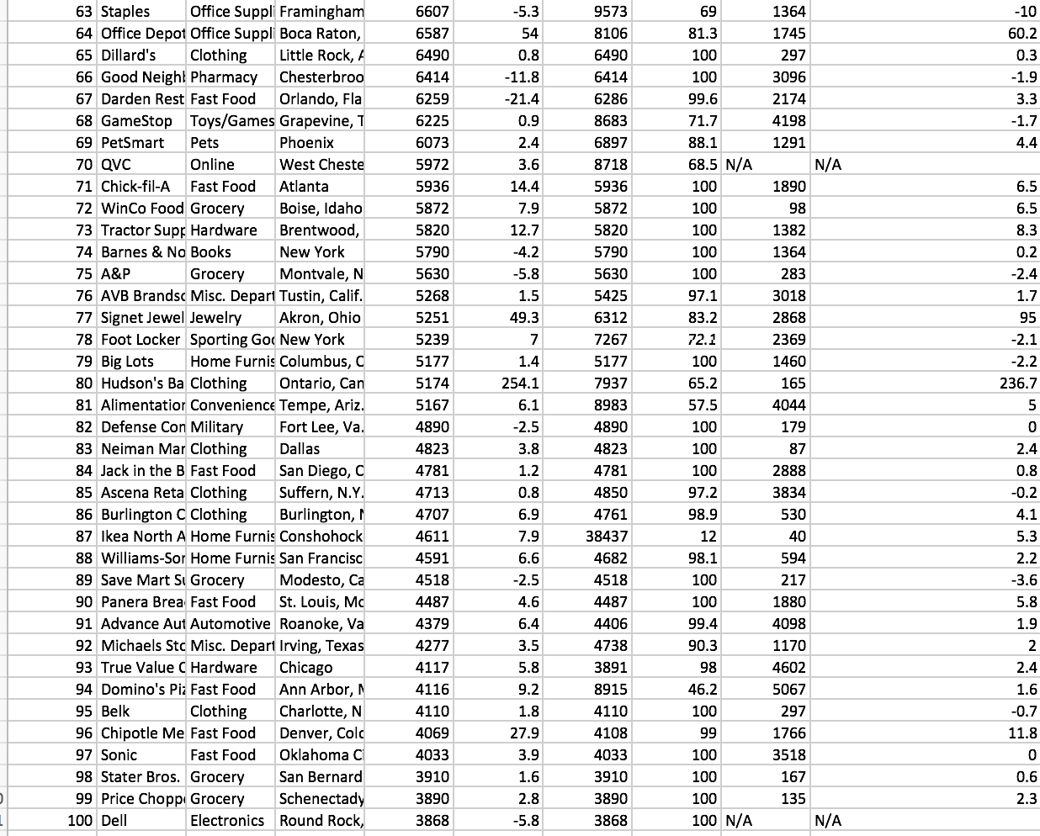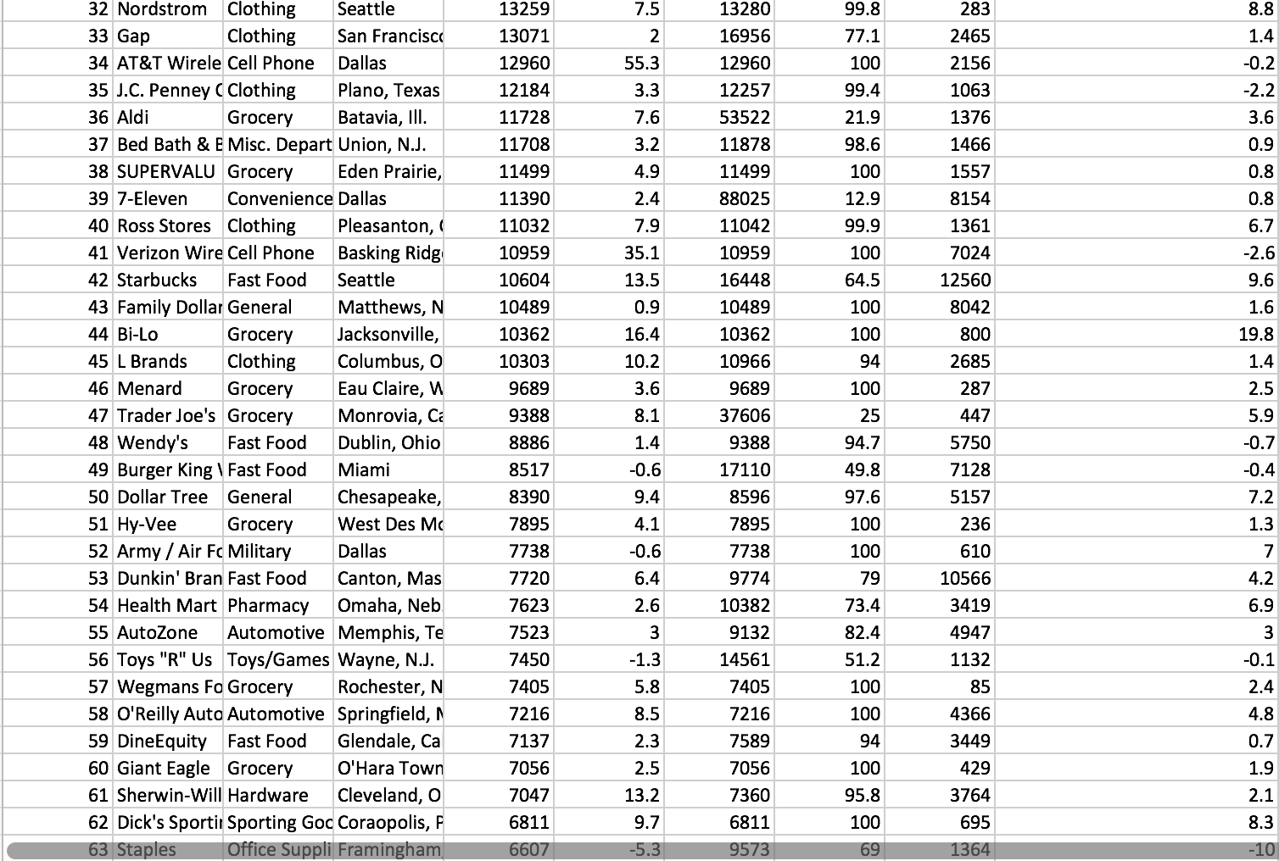

This data I am presenting is the top 100 ranked retail stores by sales and can be organized to show store type, headquarters, sales growth, and percentage of U.S. sales. I found this data at <https://www.statcrunch.com/app/index.php?dataid=2433113> , which is a reliable site to find data to analyze. The list is organized by worldwide sales in millions with Walmart topping off the list. This data is very interesting to look over because you can see how shopping trends were in 2015 and which companies are making the money.

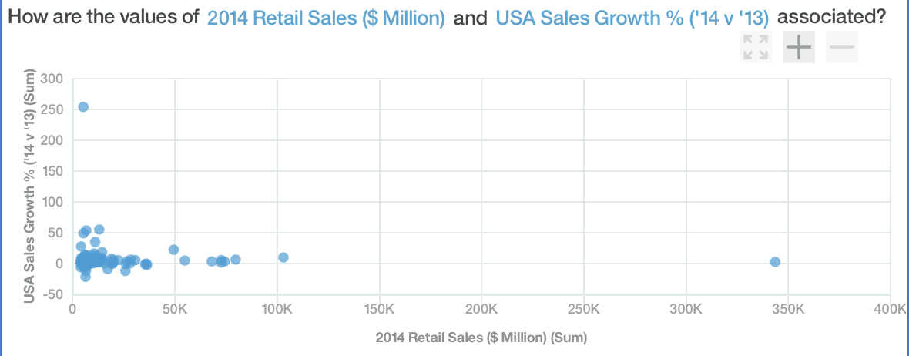

The data visualization above is showing the sales growth from 2013 to 2014 and their 2014 sales value. As you can see most companies did not grow or grew very little between the year, and only a few outliers can be spotted. Most companies are in the same area so if your company is further right you are making more money and if it is further above other then you are growing faster in that year.

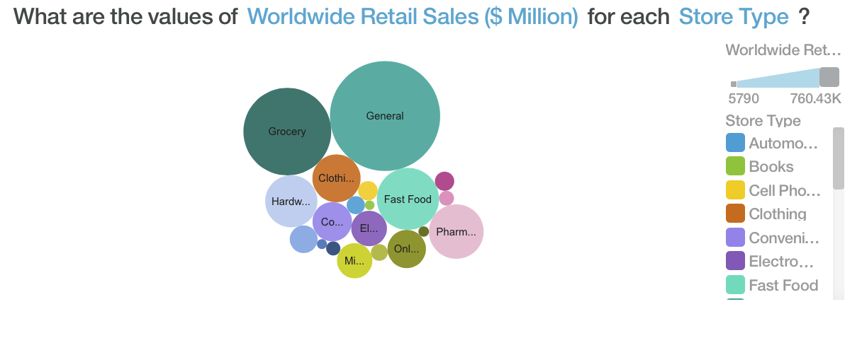

In the visualization I am presenting the sales in millions by each store type. This data is important because it helps put into perspective which store type is most profitable worldwide. It’s also fairly easy to read because the size of the circle corresponds to how much of a percentage the store type is to worldwide sales. This information can be useful to those wishing to see what type of products they should sell in their stores and which business to enter.

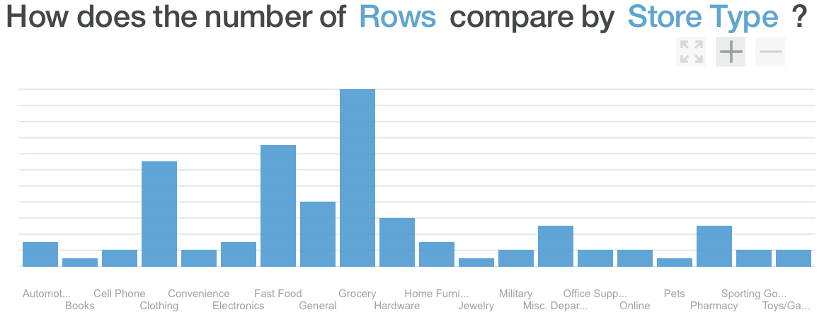

In the visualization, I am displaying how many of each store type there are in the top 100 ranked retail stores. These are very interesting stats because you can see which store type is popular with the people. If you were to combine this data with the sales of each company you can see how many of the same type of retail store place in the top 10, such as Walmart and Costco.

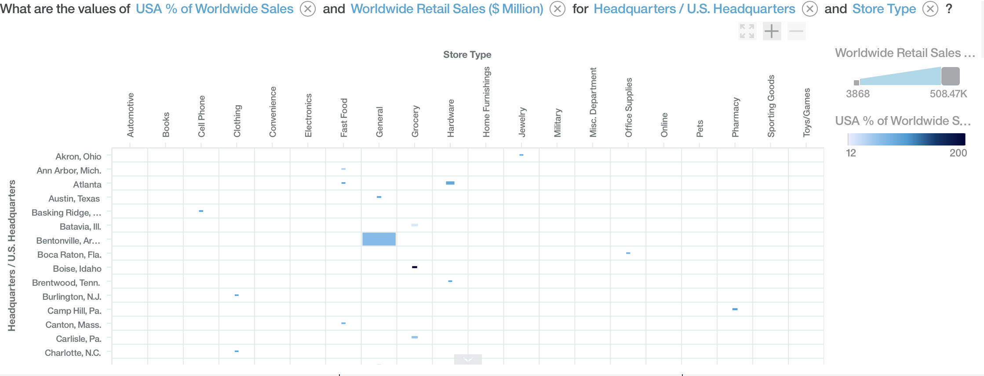

The data above illustrates a multitude of factors in one visualization. Starting with store type on the X-axis and U.S. Headquarters on the Y-axis. However, in each box the mark that is placed varies on the percentage of U.S. sales or Worldwide sales. For example, if you are looking at Bentonville, Arkansas the entire box is lit up blue compared to others, and that is because that is Walmart’s headquarters and they are leading worldwide retail store. This data can be beneficial to look at because it has three separate features to expand your knowledge on.

In summary, I learned that retail store data is complicated and can be evaluated in many ways. I thought there were plenty of interesting facts about the data that I would have not thought to be true such as, Clothing and Hardware retail stores to be a larger percentage of sales than electronics and online stores. I also learned that business data analysts have their work cut out for them ,trying to decipher data to help better the retail store. However, I believe when used correctly IBM’s Watson analytics is a great tool for looking at data in a different but better way. This was my first time using the program and I am glad I got to get some hands-on experience using the product even if at times it was very hard to comprehend how to use it. I think in the years to come IBM will upgrade Watson analytics making it more user friendly and boosting the features that can be accessed. Overall it was very interesting to work with a data analytics tool like this, especially since I was used to excel being the only tool I have use to look at data like this.