|  |
| --- |
| RespMAT |
| Software user’s guide |
| A Matlab deployed component for automated processing of invasive respiratory signals and work of breathing estimation. |

|  |
| --- |
| Louis MAYAUD  1/27/2012 |

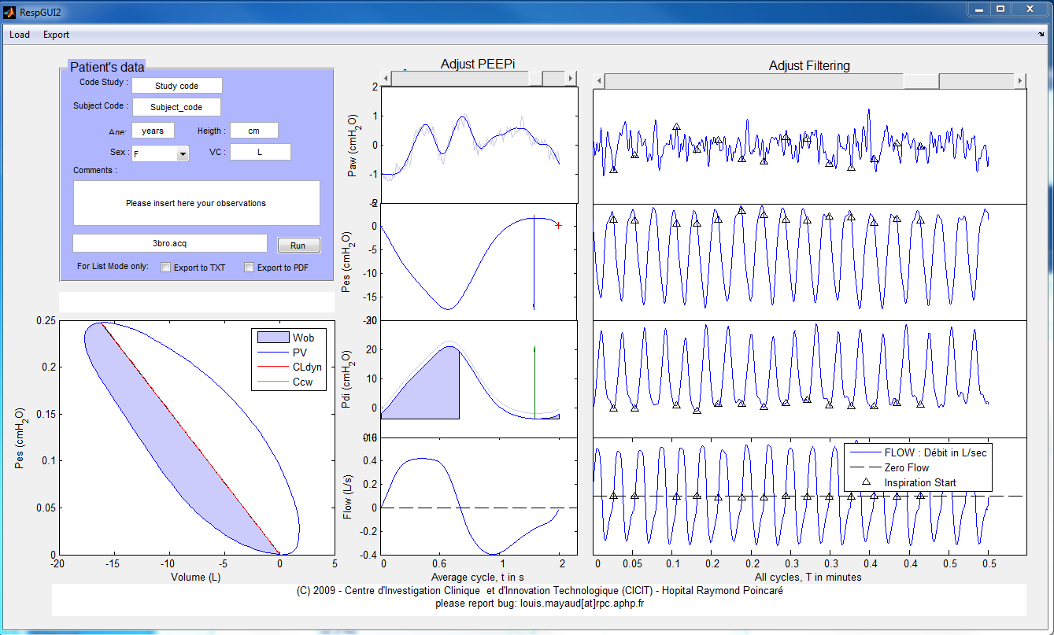

## Introduction

This document is a user guide that will help you to download, install and use the RespMAT software. RespMAT is a Matlab generated application that is deployed as a standalone application. It processes files with invasive respiratory signals (oesophageal and gastric) in order to provide several parameters related to lung function (works of breathing, resistance …).

We stress the fact that this application **must not be used for clinical purposes.** It has been developed by and for researchers. It can only be used by expert lung specialists. In no circumstance the results provided by the application should be used for diagnosis.

## Descriptions of the package

The RespMAT_package contains the following files:

* RespMAT.exe: the application (**only click on this file at the end**, MCR must be installed first)
* MCRInstaller.exe: the installer for the Matlab component
* Helpme.pdf: this document
* RespMat.pdf: a document that describes the signal processing steps
* Readme: a simple readme file generated by Matlab that explains the MCR component
* Test_listing.lst: a file used to illustrate the listing function detailed below
* TEST1.acq a sample ACQ file to try your application

## Install

### Download the software

Currently, the software is available at the following address:

<http://code.google.com/p/respmat>

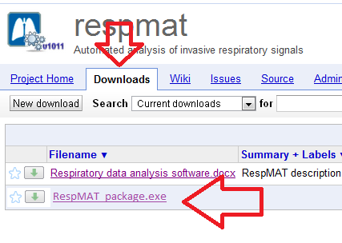

Select the Downloads tab and click on RespMAT_package.exe   
Save the file to your home directory.

The file contains the Matlab Runtime Componant (MRC) and should take up to 30min to download if your connection is weak. Double-click on the package named *RespMAT*_pkg.exe. This extracts the MCR Installer from the archive, along with all the files that make up the MCR. Once all the files have been extracted, the MCR Installer starts automatically.

If you missed or cancelled this step, you can always go back to your home directory and double click on “MCRInstaller.exe”

### Install the Matlab MRC

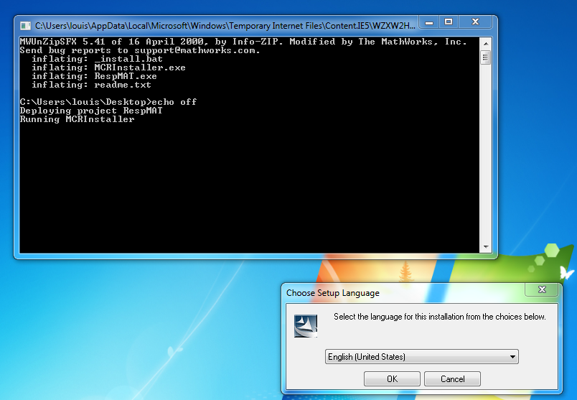

1. Open the file you downloaded
2. A command window will automatically open (black window on the left)
3. A second window “Choose Setup Language” automatically open
4. Select language and press OK
5. Perhaps your system is going to complain about missing components as illustrated below:  
   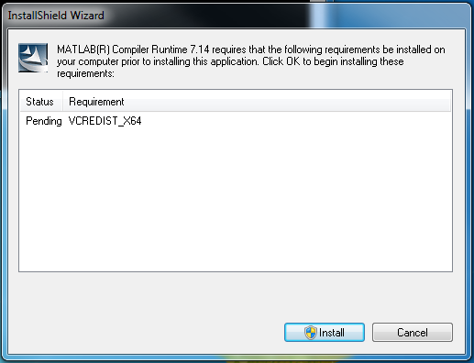
6. Press “Install”

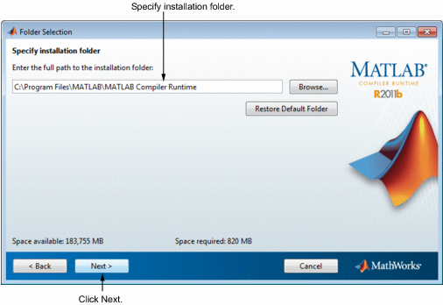

1. Confirm your choices and click **Next**. The MCR Installer starts copying files into the installation folder.

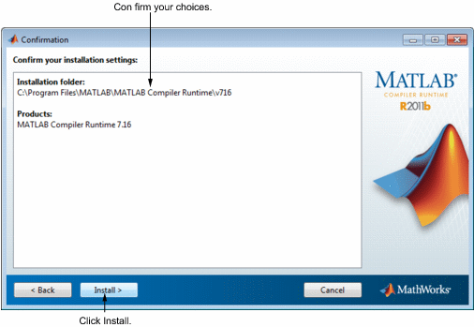

1. On Linux and Macintosh systems, after copying files to your disk, the MCR Installer displays the Product Configuration Notes dialog box. This dialog box contains information necessary for setting your path environment variables. Copy the path information from this dialog box and then click **Next**.

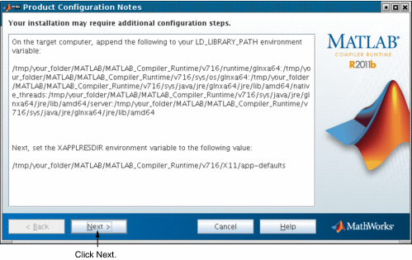

1. Click **Finish** to exit the MCR Installer.

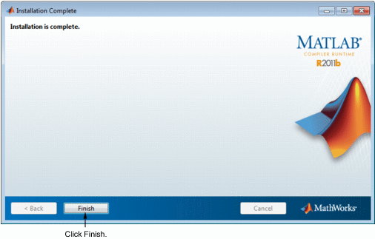

**MCR Installer Readme File.**A readme.txt file is included with the MCR Installer. This file, visible when the MCR Installer is expanded, provides more detailed information about the installer and the switches that can be used with it.

Now you should be able to double-click and start RespMAT.exe (the loading time can be as long as minutes if your computer is old) and should run in about 20s on new machines.

You will find at the root of the working directory (where you should have found this document) two files:

* An ACQ sample file to be used as a test
* A LST file to illustrate the data format detailed further down in this document

## Using RespMAT

### Importing data

It can use four input file format: *acq*, xls, *csv* and *list*. The first two are for single file mode while the latter allows automated processing of a set of exams.

##### ACQ files

This file format comes from Acqknowledge™ recordings. The use of this type of file is kind of straight forward. It does not require any pre-processing (filtering, smoothing), you just have to make sure that your file contains enough data samples and to sort signals in the following order: Peso, Pga, Flow and Paw.

##### CSV files

If you have any other type of acquisition system, you might be able to export data as ASCII format. It is thus possible to import CSV files into the software where data separated by a semi-column character ‘;’. Columns should be sorted as follow: Flow, Peso, Paw and Pga.

Since there is no header in the CSV file, you will need to specify the sampling frequency of the record when prompted.

##### XLS files

It is also possible to import XLS files into the software. Make sure that the columns ar sorted from left to right as follow: Peso, Pga, Flow, Paw.

Since there is no header in the XLS file, you will need to specify the sampling frequency of the record when prompted.

##### LST file

If you wish to automatically process a set of files, you will have to write a LST file. The format of the LST file should be: one line per exam with the following data separated by a blank space:

* File type (acq/csv so far)
* Name_field1
* Name_field2
* Age
* Size
* Sex
* Comments (within double quotes)

### Loading your data

Once you have your data ready, open the RespMAT. In the upper left hand side corner of the application you will have to:

1. Fill your entire patient’s information in the blue frame: study_name, Subject_code, age, height and sex. The VCI field will update automatically unless you have the value from a previous exam. If you have any observations about the patient fill the appropriate box.
2. Select a file by clicking on load (or pressing Ctrl+O)  
   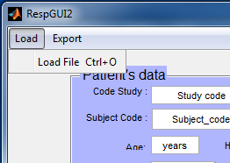  
   Before you click on “Load File”, if you’re willing to run a LST file you should tick the following boxes if you’re willing to export your results:  
   
3. A prompt window will ask you to select the file. To select the file type, click on the drop down menu  
   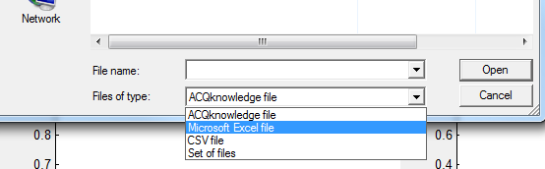
4. At this stage you should see the plotting areas populated with your data as seen on the front page of this document. **Check that each signal form corresponds to the label in the left of the plot.**

### Analyse your data

##### Tune AutoPEEP if necessary

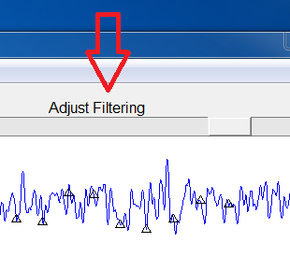You can tune the iPEEP point by moving the cursor the red arrow. If you slide the cursor on the right, you will move the AutoPEEP point on the right as indicated by oranges arrows.

##### Change the filtering parameters

Similarly, the Filtering sliding command will allow you to tune the amount of filtering. If you slide it to the left you will see black triangles (indicating the beginning of the inspiratory effort) disappearing. It indicates a stronger filter being applied on the data. On the contrary, if you slide the filter to the right, you will see new cycle being included in the analysis.

### Export your results

Finally, once you are happy with you parameters, you can select the “export” menu in the top-left hand side of the application. It will prompt you for a file to export the results to.

You will have the choice between the following options:

* PDF to save a screen shot of the current exam
* XLS to export the numerical results in an XLS sheet