Lab 4 - Design
Ensure you rename this document to your student number before uploading to git.

Task 1 - Other Products in your market

Soundcloud
https://soundcloud.com/
Soundcloud is the world’s largest audio streaming site founded in 2007. On the site, anybody can listen or upload songs along with being able to curate songs for others to browse e.g. Making playlists.

Task 2 - Potential customer (what do they want, make them as real as possible)

Creators. Almost all video media these days contains some form of music. Creators of this content may not want to spend as much time looking for music as editing. Creating a product that allows sorting of music by feel will help them to find the perfect music in a pinch.

Instrument manufacturers e.g. Gibson will want to advertise to their target markets. Therefore by linking advertisements to different genres of music would be a good selling point. Targeted advertising could include marketing guitars and accessories to big rock/ pop punk fans or if somebody only listens to Romanian folk music, show them some accordions. Moreover lesser known streetwear brands would like to advertise on new age rap music as these are most likely their end customers.

Task 3 - Potential end-user (fictional biography, highlight why they would care about your product)

Skyler Brockson is a white suburban 14 year old boy who thinks he’s different and knows much more than his parents because they just don’t understand. He writes on social media about his struggles and creates edgy fan edits of the Simpsons for his Instagram meme page. His large following on this Instagram page has him feeling pressured to pump out content in order to remain relevant.

Because of this, Skyler wants to have an easy and quick way to find music which suits each fan edit. He likes the way our website sorts music into different emotions as he can up his edit quality by linking each one to a feeling.

Task 4 - What will attract end users (reference existing products)

A clean and intuitive user interface: Soundcloud has a uniform colour scheme which matches their orange logo. It is mostly white/ grey with orange accents which are non-overpowering.

The ability to find large amounts of music to suit their mood at a glance. Soundcloud has the largest collection of music however it is mostly sorted into genres which can vary in terms of emotion. E.g. Sad/happy pop music will both come under pop.

Task 5 - Suggest essential & nice-to-have features (make them emotional not technical)

Intuitive searching methods
Brief but insight full information
A clear and deliberate colour scheme
Social media links
Relevant advertisements
Login and account system

Task 6 - Use case (A story of one of your end users first experience and feelings interacting with your website)

Skyler comes home from a draining day of high school. He’s annoyed by how they don’t allow him to express his creativity by making him wear a uniform; so looks forward to changing into regular clothes and going onto the internet.

He boots up his MacBook and loads Instagram to check the meme page he runs. He realizes that his followers are dropping as he hasn’t posted any original content in a while. This panics him and so he gets to work on a new sad Simpsons fan edit. Once he has completed the visuals, he wants to find fitting music for it.

For this, he goes to our music site as he has heard about how quickly he can find the correct music. When the home page loads he goes to the intuitive search features in order to sort the large selection of music into moods. From there he browses to sad music and further into trap music as that has been a key theme of his Instagram page. He sees many songs listed and enjoys how clearly they are presented. After this he follows links to find the songs on Spotify where he can easily listen to them.

Due to how quickly he has found the correct song he decides he wants to procrastinate finishing his edit and explore the sire further. He goes to the store page and finds how cleanly the products are presented along with the familiar PayPal widgets so decides to add some of the merchandise to his cart and buy it. He wants to give the site a shout out on his Instagram page and so browses to the about us section – allowing him to get in contact with any of the team along with browsing their social media.

Task 7 - Minimal list of pages necessary for your team to deliver your usecases

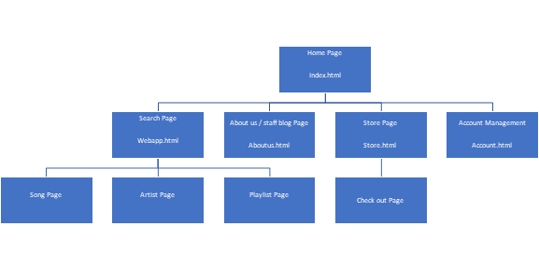

Upload your basic HTML page exploring your use case (see use case example document for help).

Also upload this document to you project folder (same folder containing src & httpdocs) ensuring you have renamed to your student number.

Screenshot this in your github repository and submit this to QOL by Monday.

