Lab 4 - Design
Ensure you rename this document to your student number before uploading to git.

Task 1 - Other Products in your market

http://freemusicarchive.org/

The Free Music Archive –
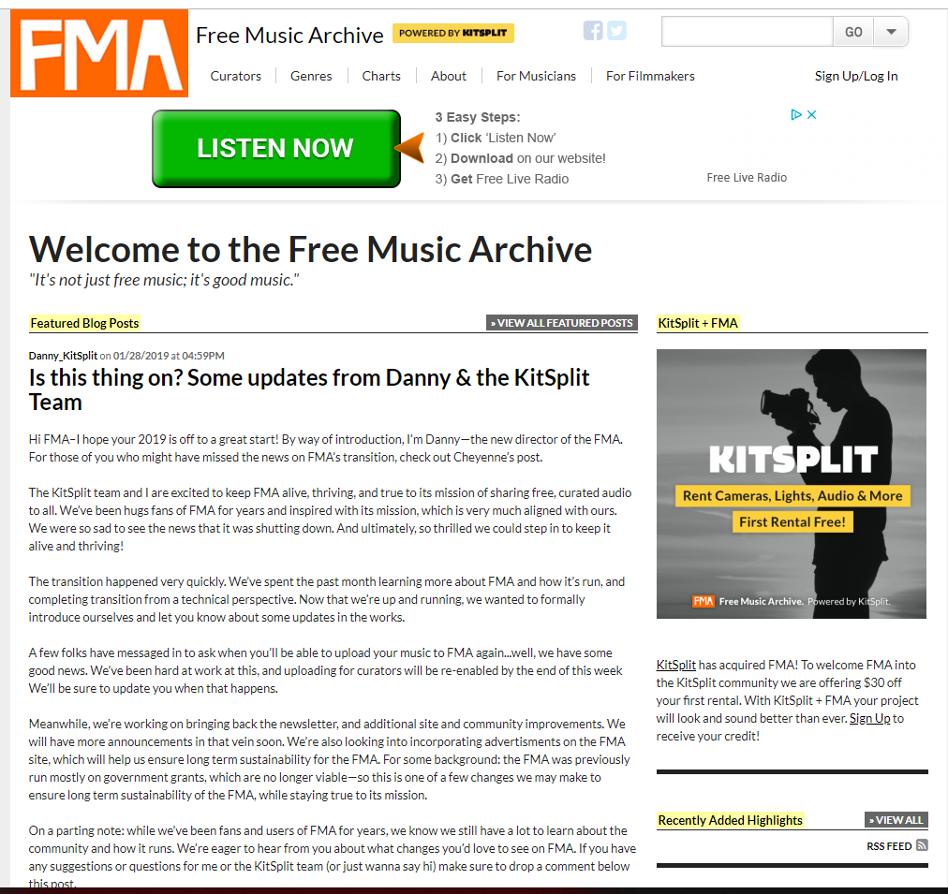

The Free Music Archive (FMA) is an interactive library of high-quality audio files available for download. FMA is directed by WFMU, the longest-running, listener-supported, independent community radio station in the United States.

Their Customer –
Initial funding for the Free Music Archive came from the New York State Music Fund, which exists as a program of Rockefeller Philanthropy Advisors. The Rockefeller Philanthropy Advisors is a nonprofit organisation. Additional funding has also been provided by numerous other nonprofits, and from the project’s users.
The main customers for The Free Music Archive are advertisers. Ads for products and services relevant to the content of the site itself are displayed throughout most pages of the platform. An example as shown below is an advertisement for a music streaming website:
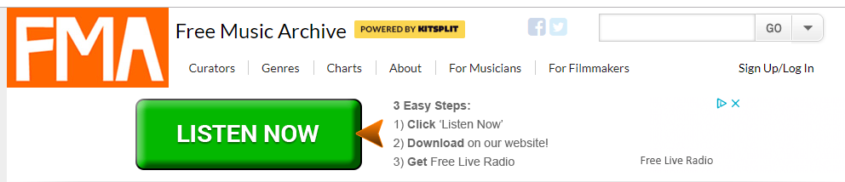

Task 2 - Potential customer (what do they want, make them as real as possible)

Potential customers for our music database would include advertisers. Existing companies selling a product or service and seeking further outreach and exposure to the relevant audience would give our organisation money in return for an advertisement of their design upon our website. The scale of payment from these companies to our own could be one determined by how long the advertisement is to be displayed on our website, how often the page containing the advertisement has been viewed, or how much traffic the advert brings from our website to their service.
A real life example – ReaSound

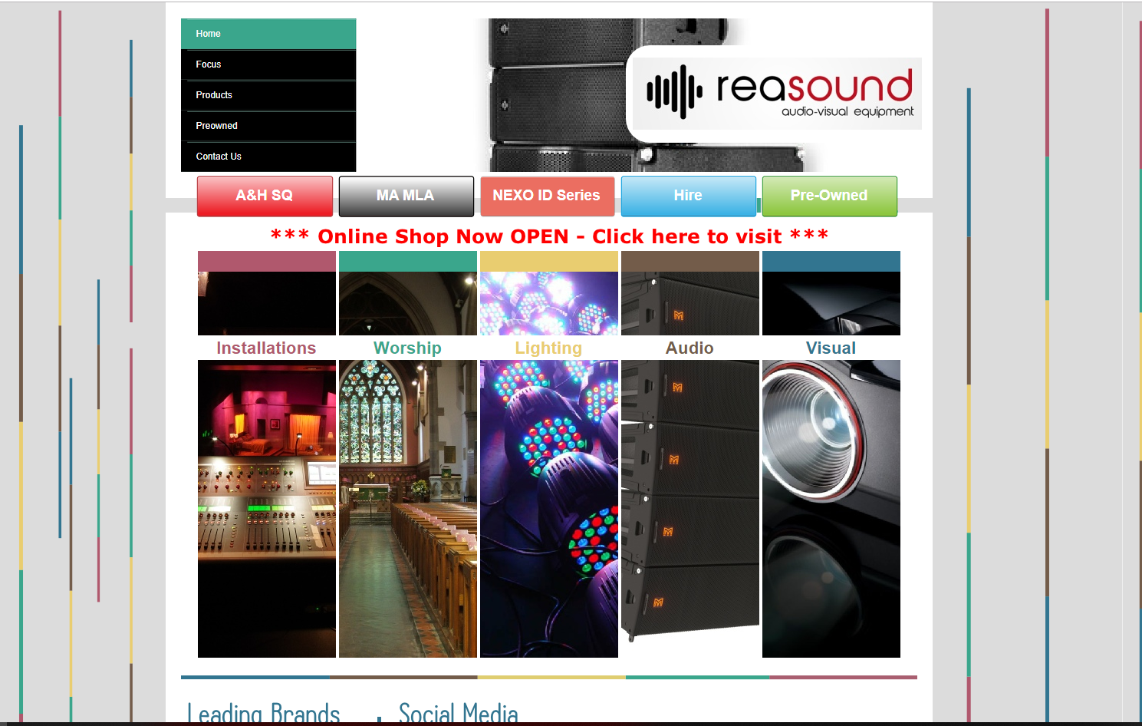

ReaSound audio-visual equipment offers customers the hire or purchase of audio recording and visual recording devices for a competitive rate. This company may seek to place an advertisement on our website, which could draw traffic to their own, therefore increasing their sales and rate of rentals.
Because the people that visit our site have an interest in music/audio files and their download, it is likely that many of these people may also require tools to record their own audio. This is the service ReaSound provides, meaning there is a large overlap in our customers and theirs. By directing traffic from our website to ReaSound’s website, we are ultimately helping this organization become more successful, making the placement of ads on our platform a worthwhile endeavor for them.

Task 3 - Potential end-user (fictional biography, highlight why they would care about your product)

Megan is a 21 year old film studies student at Queens University Belfast



As part of her degree, she has been given an assignment which involves creating a short film. Her short film is a horror. She requires a soundtrack to give her short film depth and to help set the mood for certain scenes. Our website offers Megan categorized sound files which she can use to enrich her project. She can search for soundtracks which will match particular scenes (e.g. a chase scene).

Task 4 - What will attract end users (reference existing products)

What draws in users such as the example above, is that our website is easy to navigate, allows the user to search for the specific ‘mood’ of sound file they require, and allows them to play a sample of it with ease. It is the ease of use and availability of product that attracts the end users and keeps them returning to the site.

An existing product offering a similar service to our own is Spotify, a music and podcast streaming platform. Users can use Spotify as a guest for free, however they will be limited to only a number of ‘skips’ when scrolling through songs and also be forced to listen to audio advertisements between songs. They can also make a subscription to a monthly payment plan which removes the ads and allows them to navigate through songs however they please, with unlimited ‘skips’.

Spotify appeals to the largest demographic that makes up its users, students, by offering a lower monthly payment to those who can prove student status. This is perhaps a strategy our website could also adopt in some form.

Task 5 - Suggest essential & nice-to-have features (make them emotional not technical)

Essential
- Categories for different emotion that songs could come under
- Minimum number of sound files under each category e.g. 5
- The ability to search for a sound file by entering a key word referenced with it e.g. ‘sad’
- About us page – a profile of the website creator and a message about our goal with the company
- Welcome page with login system that can allow the users to make an account and login each time they visit the site
- The website must be easy to navigate
- Advertisements submitted by our customers

Nice-to-have
- Ability to rate the songs
- A comments section for every song
- On the homepage, have a table where people can click on different tabs of emotion categories and witness the top 10 song rankings for the songs of that specific emotion
- Recommendations to users as they log in based on songs they have previously listened to or rated highly

Task 6 - Use case (A story of one of your end users first experience and feelings interacting with your website)

For this use case we will be using Megan, the 21 year old film studies student

Why she would find the website useful
Megan has undertaken a project as part of her degree, which involves making a short film. She must produce a soundtrack for her film with music that matches the ‘mood’ of each scene perfectly. Simply browsing for these songs can be a laborious task. With the help of our website, Megan will be able to quickly find what she is looking for by searching the database for the appropriate songs.

How she might encounter it
When discussing the project and its upcoming deadlines with a friend from her course over lunch, Megan was informed that there existed an excellent tool for students to meet their every musical need – our website – where her friend managed not only to discover every song for their project soundtrack but also where they noticed a convenient advertisement for the hiring of camera equipment by a local company, which helped them further in production.

First page
Upon opening our website, Megan is greeted with a friendly welcome page and is encouraged to either make an account with our company or to browse the site as a guest. She also has the options from here to open the ‘about us page’; which has information on the founders of the company and links to their social meda, or to browse s
the ‘store page’.

Task 7 - Minimal list of pages necessary for your team to deliver your usecases

