**Address, City, State, Zip Code**

# beds, # baths, garage?, ## sqft, year built xxxx. Closing date: xx/xx/xxxx

**Zillow Link Here**

**Trulia Link Here**

**Pictures Link Here**

**Scope of Work Link Here**

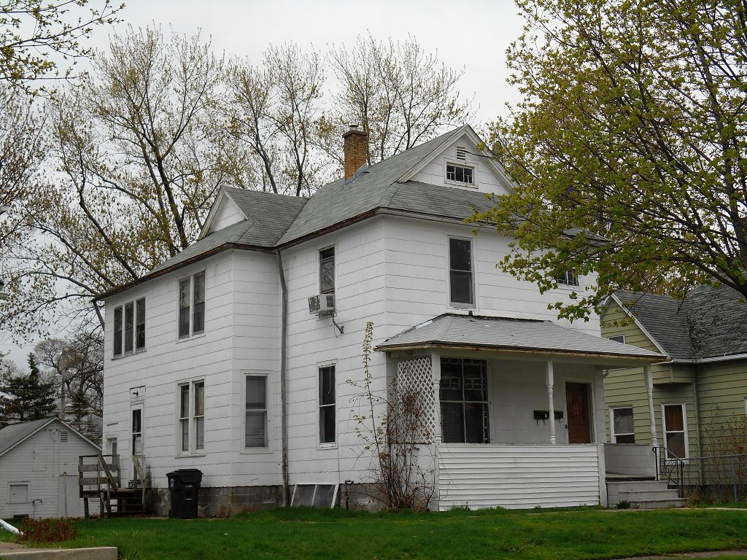**<---- Update Exterior Front Picture here**

**Price**: $xx,xxx

Rehab: $xx,xxx

Carrying Costs: $x,xxx

Closing Costs: $x,xxx

**Total Turnkey Price**: $xx,xxx

ARV: $xx,xxx

Rental Projections

**Monthly Rent**: $

Taxes: $

Management: $

Vacancy Reserve: $

Insurance: $

Maintenance Reserve: $

Net: $

Monthly x 12: $

**Strictly Cash on Cash ROI**:

Financed/Refinanced 75%

**Down Payment** : $

Mortgage Interest Rate:

Mortgage Amortization:

Mortgage Monthly Payment: $

Net Cash Flow Less Mortgage: $

Net Net x 12: $

**Financed Cash on Cash ROI**: %

**Comps-- Update Comps here with front exterior picture below from google.com/maps street view**

804 w 14th st Sold $80K 4/15 (45.82)

4 bed/ 1 bath 1746 sqft

2 story frame built 1910

No garage/ full basement

.4 miles away

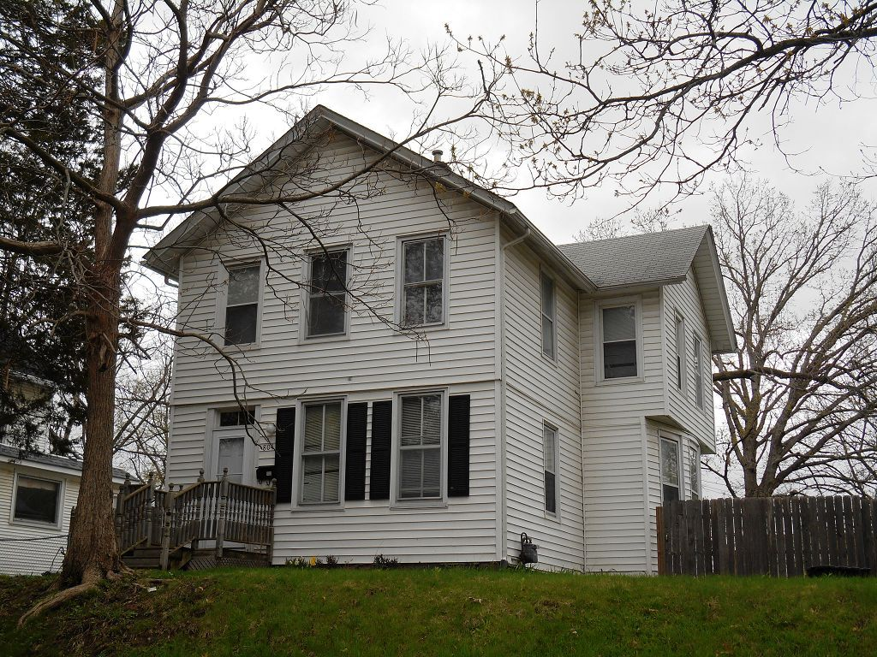

2309 Scott st Sold $90K 5/15 (56.25)

3 bed/ 2.5 bath 1600sqft

2 story frame built 1925

2 car garage/ full basement

.85 miles away

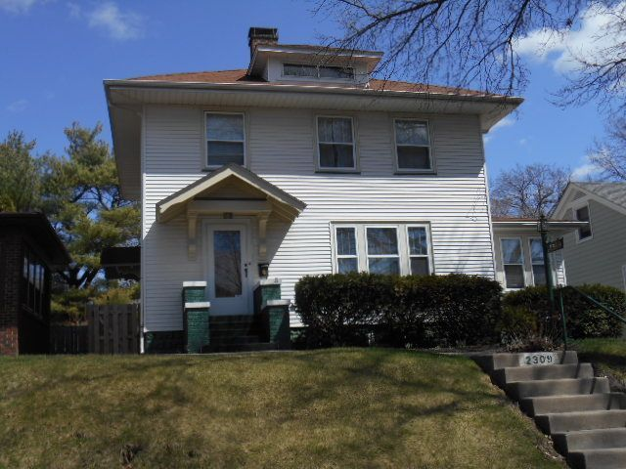

2031 N Harrison St Sold $80,500 4/15 (63.78)

3 bed/ 1.5 bath 1262 sqft

1.5 story frame built 1910

1 car garage/ partial basement

.9 miles away

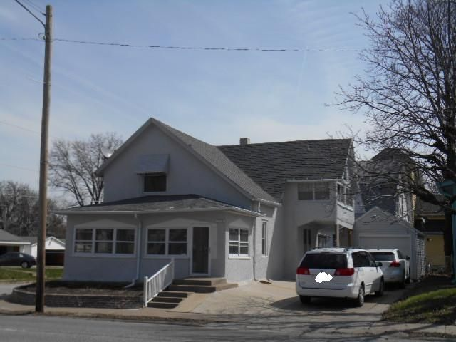

**Comps on a Map:**

**You can use** [**https://www.google.com/maps/d/**](https://www.google.com/maps/d/) **or zeemaps.com to create points on a map.**

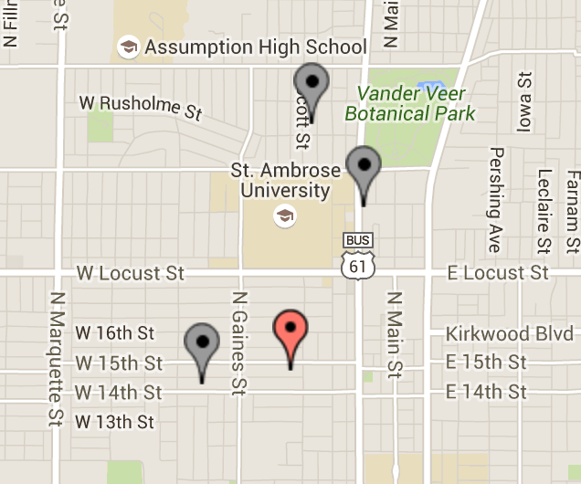

**Use your scope of work template to create a scope of work for your house.**

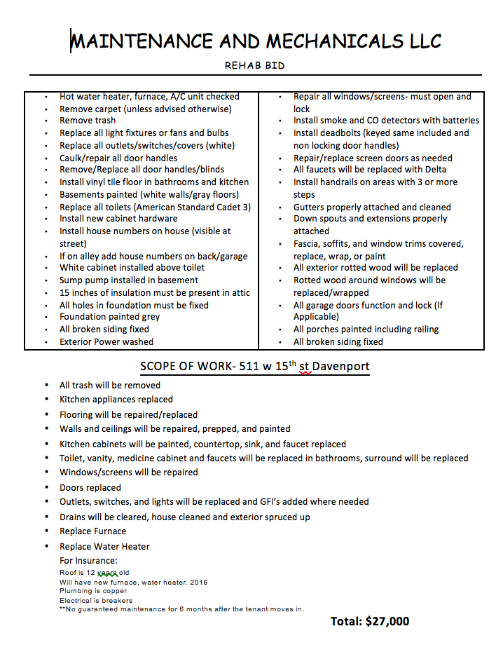

**Notes and Disclosures: The ARV (After Repair Value) is based on a broker’s and/or Realtor’s price opinion. The broker and/or Realtor is not an appraiser, and does not claim to be an appraiser. We are real estate investment service entities. We have provided the information within this brochure for the benefit of investors. Investors are encouraged to verify all estimations independently. We assume no liability, expressed or implied, for the accuracy of our estimations. We do not give authority, expressed or implied, to the recipient of this information to enter onto this property.**