The Economics of Transformative AI
Part 1 — AI-lab revenue research, and Part 2 — a reproducible model of the compute & revenue calculations
Prepared for Justin, Arcadia Impact | 14 June 2026

This document accompanies the working draft of your two-page brief and the live workbook AI_revenue_model.xlsx. Part 1 is a one-page research synthesis on AI-lab revenue with appendices. Part 2 summarises the reproduction of your “Back-of-napkin” calculations and the Monte-Carlo stress tests. A separate audit report (Part 3) red-teams everything. All figures are sourced with live links.
Bottom line: Your arithmetic is sound — every headline figure reproduces within rounding. The inputs are defensible and, where they differ from the latest sources, your numbers tend to be conservative. The $2T-by-2031 revenue figure sits near the 25th percentile of a probabilistic re-estimate (median ≈$6.5T). The weak points are not the headline numbers but three internal price/per-copy inconsistencies and a few scenario claims — all detailed below and in the audit.

Contents

Part 1 — AI-lab revenue: research synthesis

1.1 One-page summary
Revenue is real, large, and growing fast. Frontier-lab serving revenue went from roughly nothing in 2023 to an industry run-rate on the order of $70–100B by mid-2026. Anthropic alone reports a run-rate of about $44–47B (May 2026), having roughly doubled every ~6 weeks through the year; OpenAI is around $25B. Adding Google, Microsoft, Meta, xAI and the cloud resellers, your rounded $100B industry figure is reasonable — though note OpenAI+Anthropic alone is closer to $70B than the $80B stated in the doc.
The compute base checks out too. Epoch AI estimates the world had about 16.5M H100-equivalents at end-2025, growing ~3.3×/year (a ~7-month doubling). Your “at least 20M” for mid-2026 is therefore plausible and, if anything, mildly conservative. Your 3×/year growth assumption matches both Epoch (3.3×) and Dario Amodei’s own “~3× a year” on the Dwarkesh podcast.
Where the estimate is fragile is the revenue-per-unit-of-compute link. Three independent anchors give very different numbers: the macro average ($100B ÷ 20M ≈ $5k/chip), Anthropic’s empirical figure (~$45k per inference chip), and your bottom-up DeepSeek figure (~$90k/GPU/yr). The DeepSeek figure is the least reliable: it uses a token price ($3.5/M) that is actually DeepSeek V4’s pre-discount, output-only price — the current blended price is ~$2.17/M and output-only ~$0.87/M — and a 40% utilisation that exceeds Epoch’s 5–30% range. Treat $45k (empirical) as the better 2026 anchor; $90k overstates by roughly 2×.
Verdict: the revenue thesis is well-supported and the inputs are sound. The headline trajectory ($100B → $2T by 2031) is conservative relative to frontier-lab guidance — Amodei expects “multiple trillions per year by 2028–2029.” Your work’s real exposure is in the per-token / per-copy economics, not the direction or scale.

1.2 Your numbers vs. current sources
Input | Doc value | Researched | Comment / source
Anthropic ARR | $45B | $44–47B | Matches. Willison
OpenAI ARR | (implied ~$35B) | ~$25B | Combined ≈$70B, not $80B. Sacra
Industry LLM revenue | $100B | $70–100B | Reasonable once Google/MSFT/xAI etc. included.
Global compute stock | 20M H100e | 16.5M (end-25) | 20M for mid-26 is fine. Epoch
Compute growth | 3×/yr | 3.3×/yr | Matches Epoch & Amodei. Epoch
Anthropic fleet | 1M (inference) | ~2M total | 1.3M Trn2 + 1M TPUv7 + ~220k GPU. Epoch
DeepSeek price | $3.5/M blended | $0.87 out / $2.17 blend | $3.5 = pre-discount output price. Morph
Inference utilisation | 40% | 5–30% | 40% optimistic. Epoch
Green = your figure stands. Red = revise or re-label (full detail in the audit).

1.3 Sources you should consider (with links)
Beyond the five papers already in your draft, these are the most directly relevant primary sources for the revenue/compute argument. Most are free.

Epoch AI (the single best data source for this brief)
- “How many digital workers could OpenAI deploy?” — the closest published analogue to your token-vs-human calculation (median 7M digital workers; method you should mirror). — https://epoch.ai/gradient-updates/how-many-digital-workers-could-openai-deploy
- “Is a compute crunch coming?” — global inference capacity ~0.5–20B tokens/sec (Q4-2025), tripling each year; the basis for your 2031 token figure. — https://epoch.ai/gradient-updates/is-a-compute-crunch-coming
- “Inference economics of language models” — peer-level treatment of tokens/sec, utilisation and $/token. — https://epoch.ai/blog/inference-economics-of-language-models
- “Can AI companies become profitable?” and “Company spending breakdown” — revenue, margins and the training/inference split. — https://epoch.ai/gradient-updates/can-ai-companies-become-profitable
- AI Chip Sales / Chip Owners / Companies data explorers — primary compute-stock and per-company figures. — https://epoch.ai/data/ai-chip-owners
- GATE — Epoch’s formal model of the AI-and-automation trajectory (a rigorous alternative to back-of-napkin). — https://epoch.ai/publications/announcing-gate

Industry / market
- SemiAnalysis — “Tokenomics” model, “AI Cloud TCO” model, and “InferenceMAX” benchmarks: the deepest cost-per-token and revenue-per-MW modelling available. — https://semianalysis.com/tokenomics-model/
- Sacra — independent revenue/valuation tracking for OpenAI, Anthropic and peers. — https://sacra.com/c/anthropic/
- Dwarkesh Patel × Dario Amodei (2026) — Amodei’s own numbers: ~3×/yr compute, 10–15GW built in 2026, “multiple trillions/yr by 2028–29”, $50T human wages, 10–20%/yr GDP-growth ceiling. — https://www.dwarkesh.com/p/dario-amodei-2

Academic / framing (complements your five papers)
- Korinek & McKelvey, “Measuring the AI Economy” (PIIE, 2026) — already in your draft; the natural home for the tax-base argument. — https://www.piie.com/
- AI-2027 compute forecast — a detailed inference/compute build-out model. — https://ai-2027.com/research/compute-forecast
- Forethought — software-intelligence-explosion modelling (upside scenarios for digital workers). — https://www.forethought.org/research/will-ai-r-and-d-automation-cause-a-software-intelligence-explosion

1.4 Similar modelling already out there
Epoch’s “digital workers” piece is the model to know. It does almost exactly your token-vs-human comparison, but more carefully: it converts a lab’s inference compute (OpenAI ~1.1M H100e total, ~44% to inference) into ~19 trillion tokens/day, divides by a human “effective token” rate (380 words/min thinking ≈ 240k tokens/day), and gets a median of ~7M “digital workers” (90% CI 0.4M–300M). Crucially, Epoch warns this is not the same as replacing 7M jobs, because token-parity ≠ capability-parity. That caveat is the single most important import for your brief.
On the revenue side, Amodei’s framing on Dwarkesh is the best sanity check: industry compute builds ~10–15GW in 2026 growing ~3×/yr (≈30–40GW in 2027, ~100GW in 2028, ~300GW in 2029) at ~$10–15B/GW, implying “multiple trillions per year by 2028–2029.” His caveat — that revenue could lag capability by 1–5 years, and might even “bend” below 10× growth this year — is the main downside risk to your trajectory. SemiAnalysis’s Tokenomics/TCO models and Epoch’s compute-crunch piece give you the supply side. Taken together, these put your $2T-by-2031 squarely inside (toward the conservative end of) the consensus envelope.

Part 2 — Reproduction & simulation

2.1 What the workbook does
The companion file AI_revenue_model.xlsx rebuilds every calculation from the “Back-of-napkin” section using live formulas (not hard-coded results), with a single sourced Inputs & Sources sheet driving everything. Sheets cover the 2026 baseline, the 2031 projection (all three methods), the scale/human comparisons, a live 2,000-trial Monte Carlo, and a deterministic scenario/tornado. Inputs are colour-coded (blue = change me) and every hardcode carries a source link and a confidence flag. Each calculation shows your original figure beside the recomputed one.
Reproduction result: every figure reproduces within rounding. Independently re-deriving the same calculations in Python (the script reproduce.py, also in your folder) gives identical results, confirming there are no hidden spreadsheet errors.
Figure | Doc | Recomputed | Note
Concurrent copies, 2026 | 830,000 | 833,333 | 20M ÷ 24.
Revenue / H100e (macro) | $5,000 | $5,000 | $100B ÷ 20M.
Anthropic rev / chip | $45,000 | $45,000 | Label as per-inference-chip (fleet ≈2M).
Anthropic rev / model | $1.07M | $1.08M | $45B ÷ 41,667.
DeepSeek rev / GPU @40% | $90k | $92.7k | Arithmetic OK; inputs questionable (see audit).
Compute stock 2031 | 4.8B | 4.86B | 20M × 3^5.
Copies 2031 | 24.3M | 24.3M | 4.86B ÷ 200 (29× 2026).
Model-based revenue | $2T | $2.00T | 10M × $200k — but see inconsistency 2.7.
Token-based revenue | $2.6T | $2.63T | $5M/min annualised.
LLM : human tokens | 4× | 4.0× | Sensitive to cognition basis (→24× on Epoch's).

2.2 Monte-Carlo re-estimate of 2031 revenue
Rather than three single-point estimates, the workbook (and a 900k-draw Python run) puts probability distributions on the tenuous inputs — compute growth, starting stock, revenue-per-chip and its decay, copies served, revenue-per-copy, token capacity, utilisation and price — and runs all three methods, then pools them. The result reframes the $2T headline.
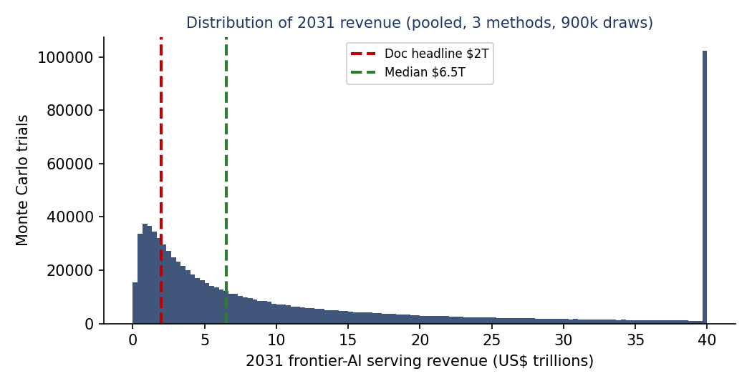
Figure 1. Pooled distribution of 2031 frontier-AI serving revenue (three methods). Doc headline $2T (red) vs. simulated median ~$6.5T (green).
Reading: pooled median ≈ $6.5T; 90% interval roughly $0.6T–$72T. Probability the figure exceeds your $2T is ~79%; exceeds $1T, ~91%; exceeds $10T, ~38%. In other words your $2T is near the 25th percentile — a deliberately cautious headline, which is the right posture for a government brief.
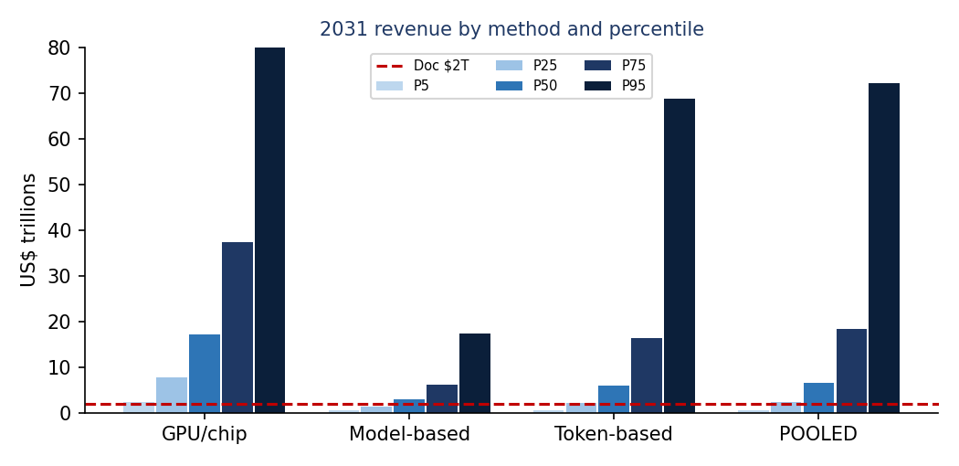
Figure 2. 2031 revenue by method and percentile. The GPU/per-chip method runs hot (it inherits the inflated $90k/chip); the model- and token-based methods are better behaved and bracket the doc figure.

2.3 What actually drives the answer
Sensitivity analysis (Spearman rank correlation on the token method, and the spreadsheet’s tornado) is unambiguous: token-capacity dominates (ρ≈0.83), then price per token (ρ≈0.42), then utilisation (ρ≈0.31). Practically, the brief’s revenue claim stands or falls on how much inference capacity exists in 2031 and what a token sells for — not on the utilisation assumption people instinctively argue about. This is useful: the two dominant inputs are exactly the ones with the best external data (Epoch capacity, public API prices).

2.4 Human-parity of cognitive output
Your claim that 2031 token volumes rival human cognitive labour is robust in direction but soft in magnitude. Simulated LLM-to-human token ratio has a median of ~10× with a 95% chance of exceeding parity. The specific “4×” depends on assuming humans process 1,000 tokens/min; on Epoch’s basis (240k tokens/day) the ratio is ~24×. Either way the qualitative point holds — but state it as “on the order of, or exceeding, total white-collar cognitive throughput,” not a precise multiple. And carry Epoch’s caveat: raw token parity is an upper bound on economic substitution, not a measure of it.

2.5 Trajectory cross-check
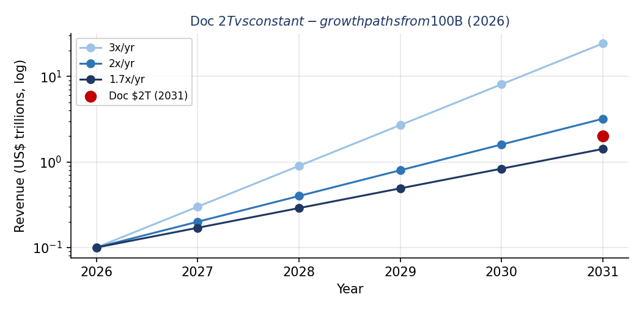
Figure 3. The doc's $2T-by-2031 against constant-growth paths from $100B (2026). $2T implies ~82%/yr — well below a compute-linked 3×/yr path (~$24T) and below Amodei's 'multiple trillions by 2028–29.'
$100B → $2T over five years is an ~82%/year CAGR. Because compute grows ~243× over the same window while revenue grows only ~20×, the projection implicitly assumes revenue-per-unit-of-compute falls ~12× — i.e. a steep, Korinek-style price deflation. That is a coherent and even likely story, but it is currently unstated; making it explicit both strengthens the argument and pre-empts the obvious “why so low vs. compute?” challenge.

2.6 Reconciliation issues found (summary)
The arithmetic is clean, but three internal inconsistencies and a sourcing gap should be fixed before the figures travel into a brief. These are fully tested in the Part 3 audit; in brief:
- “$200k per copy, same as today.” Your 2026 case studies gave $1.07M and $2.16M per model, not $200k. The $2T headline depends on the lower figure; at $1.07M it would be ~$10.8T. Re-label or re-derive.
- Three different token prices. The DeepSeek calc uses $3.5/M; the token method’s “$5M/min” implies $0.83/M; current DeepSeek output is $0.87/M. Pick one defensible blended price and apply it consistently.
- $90k/chip held flat to 2031. This makes the GPU method give $180T — about 1.6× world GDP — which is why it should be dropped or floored. It also contradicts the price-deflation implied by your own trajectory.
- “Epoch predicts ~1 trillion tokens/sec in 2031.” I could not find that as a direct Epoch statement. It is consistent with Epoch’s “triple each year” from the 0.5–20B tokens/sec of late-2025, so soften the attribution to “consistent with Epoch’s trend” rather than “Epoch predicts.”

Appendix A — Data & sources
Datum | Value used | Source
Anthropic ARR (2026) | $45B | Willison / SemiAnalysis
OpenAI ARR (2026) | ~$25B | Sacra
Global compute stock | 16.5M H100e (end-25) | Epoch / The Decoder
Compute growth | 3.3×/yr | Epoch chip production
Anthropic compute | 1.3M Trn2 +1M TPUv7 | Anthropic / Epoch
DeepSeek V4 pricing | $0.87 out / $2.17 blend | Morph / CloudZero
OpenAI digital workers | ~7M (0.4–300M) | Epoch
Inference capacity 2025 | 0.5–20B tok/sec | Epoch compute crunch
Token demand 2030 | 1.27T per 10s | Qualcomm / CryptoBriefing
Internet size | ~500T tokens | Educating Silicon
White-collar workers | ~1.25B (2018) | Forrester
Global wages / GDP ceiling | $50T / 10–20% | Amodei (Dwarkesh)

Appendix B — Comparable models, one line each
- Epoch, Digital workers: tokens÷human-token-rate → ~7M digital workers; warns token-parity ≠ job replacement.
- Epoch, Compute crunch: inference capacity 0.5–20B tok/s (2025), tripling yearly; demand outrunning supply.
- Epoch, GATE: formal general-equilibrium model of compute-driven automation and growth.
- SemiAnalysis, Tokenomics/TCO: bottom-up $/token and revenue-per-MW; the rigorous version of your DeepSeek calc.
- Amodei (Dwarkesh): 3×/yr compute, $10–15B/GW, multiple-trillions revenue by 2028–29, diffusion lag 1–5 yrs.
- AI-2027 compute forecast & Forethought: detailed build-out and software-intelligence-explosion upside cases.

Appendix C — Workbook guide
Open AI_revenue_model.xlsx. Start at the Cover sheet for the colour legend. Change any blue cell on Inputs & Sources and every downstream figure (including the Monte Carlo summary) updates. Press F9 / reopen to redraw the 2,000-trial simulation. The Python script reproduce.py runs the authoritative 300k-trial version and prints a side-by-side of doc vs. recomputed values.

