**Supplemental Materials**

**Fahlbusch and Harrington 2019**

Tapered Wings Logger (TWLogger) Build Instructions & Circuitry Diagram

**Equipment**

Soldering iron

Nonconductive table clamps (or prefabricated soldering clamp stand)

Lead-free solder

26-gauge solid core wire

Wire strippers

Electrical tape

Foam paper (e.g., craft supply store)

Glue (e.g., clear liquid super glue)

Fig. A1: Sample solder station and equipment. Note the blue rubber dish is the nonconductive safety pad upon which all soldering takes place.

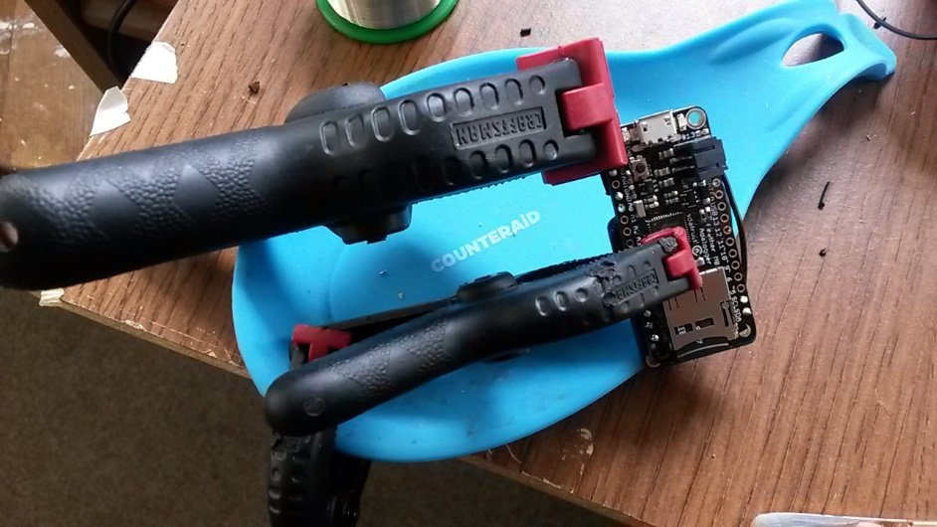

Fig. A2: Example for how to configure clamps to hold circuit boards while soldering.

**Components List**

Purchased from [www.adafruit.com](http://www.adafruit.com) (part #)

1. Feather M0 Adalogger (#2796)
2. Flora LSM303 (#1247)
3. Ultimate GPS Breakout (#746)
4. Lithium - 3.7v 500mAh (#1578)

**Build Instructions**:

This is a 4-part process. Prepare each circuit board separately prior to combining. Wire lengths are given with the corresponding pin name to which they need to be soldered.

1. Accelerometer: Flora LSM303- v1.0
   1. Solder wires to Flora (i.e., pin name: required wire length) (Fig. A3A)
      1. GRD: 3.5cm
      2. SCL: 6cm
      3. SDA: 6cm
      4. 3V: 3cm, 6cm
   2. Cut chafe guard from foam sheet and glue to back of Flora (Fig. A3B)

B

A

Fig. A3. Accelerometer top (A) with wires coming up through pins and soldered from topside of board; and underside of accelerometer showing chafe padding (B) (Photo credit: P. Forman).

1. GPS: Ultimate GPS Breakout – 66Channel
   1. Solder wires to GPS (i.e., pin name: required wire length)
      1. TX: 3.5cm
      2. RX: 4.0cm
      3. GRD: 4.5cm
      4. EN: 4.5cm
      5. ******VIN: 2.5cm

Fig. A4. Underside of GPS circuit board with wires going through pins to other side where they are soldered (Photo credit: P. Forman).

Fig. A5. Adding chafe pad to underside of GPS board (Photo credit: P. Forman).

1. Connect GPS to Feather board (M0)
   1. Line up TX, GRD, GRD on the GPS to MO and solder.
   2. Add small chafe guard to battery area.
2. Glue Accelerometer to the Feather MO
   1. Locate the sensor orientation icon on the ACC board and confirm it is in line with the text on the Feather M0 (e.g. the “USB” text is a good indicator).
   2. Glue in place.

**APPENDIX B**

Tapered Wings Logger (TWLogger) Software and User Interface

**Downloads**

1. SD Formatter

<https://www.sdcard.org/downloads/formatter_4/>

1. Arduino

<https://www.arduino.cc/en/main/software>

1. R Studio

<https://www.rstudio.com/products/rstudio/download/>

**SD Formatter**

1. Name and format SD card prior to using with TWLogger

**Arduino**

1. Install Arduino software
   1. Follow setup instructions on Adafruit website: <https://learn.adafruit.com/adafruit-feather-m0-adalogger/using-with-arduino-ide>
2. Plug TWLogger into computer
   1. **Confirm battery is plugged into TWLogger and confirm SD card is inserted**
3. Open TWLogger Arduino software found here:

<https://github.com/harrington-et-al/TWLogger>

* 1. As of 24 June 2019, version to use is SensorLoggerV3.2.1_GPS_LSM303

1. Confirm computer recognizes and can communicate with TWLogger
   1. 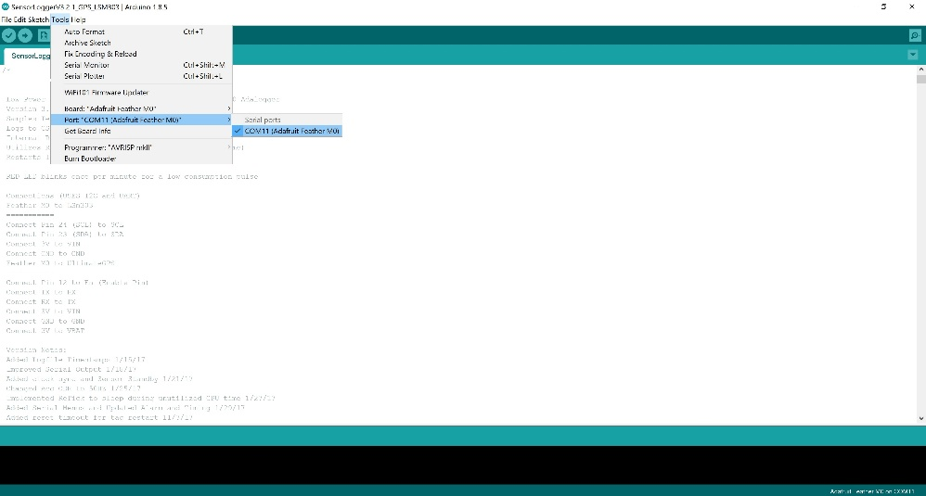Tools → Port → [select COM port that lists Feather M0 as connected] (Fig. B1)

Fig. B1. Confirm COM port.

* 1. If Feather M0 isn’t listed, try two options:
     1. Confirm you properly followed Adafruit setup instructions (step 1 above)
     2. 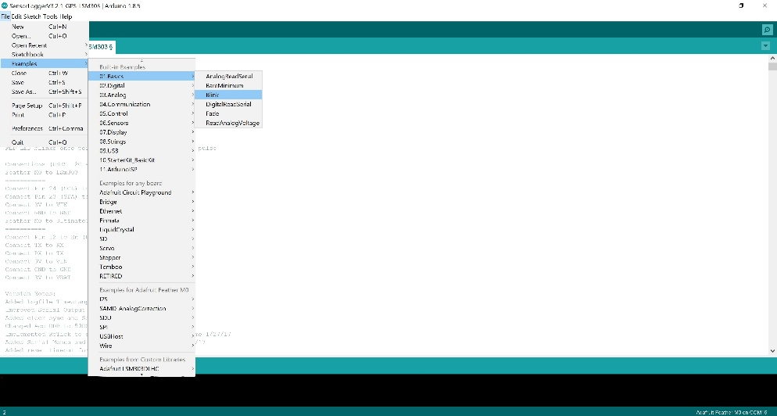After confirming proper setup, go to File → Examples → Basics → Blink (Fig. B2)

Fig. B2. Open Blink.

* + 1. 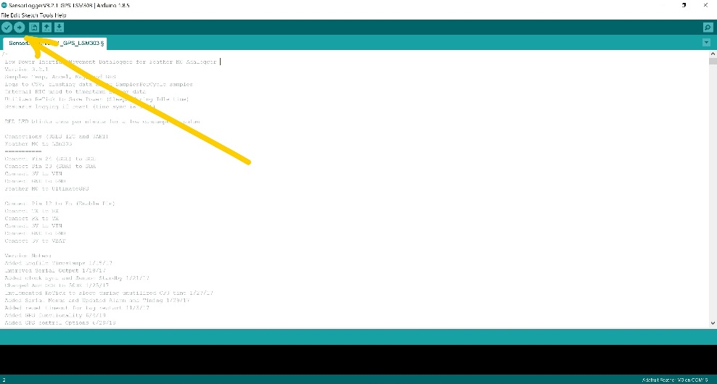Open Blink and click upload (on the toolbar below menu options, click the right-hand arrow that is 2nd icon from left) (Fig. B3)

Fig. B3 Upload Blink.

* + 1. Note: Timing is important in this step. Watch progress report (bottom left, orange writing on black area of program screen). After it switches from “Compiling Sketch” to “Uploading” quickly double click reset button on TWLogger.
    2. Now check if Feather M0 is listed as available on a COM port

1. After correct COM port is selected, press upload (on the toolbar below menu options, click the right-hand arrow that is 2nd icon from left) to upload TWLogger software.
2. 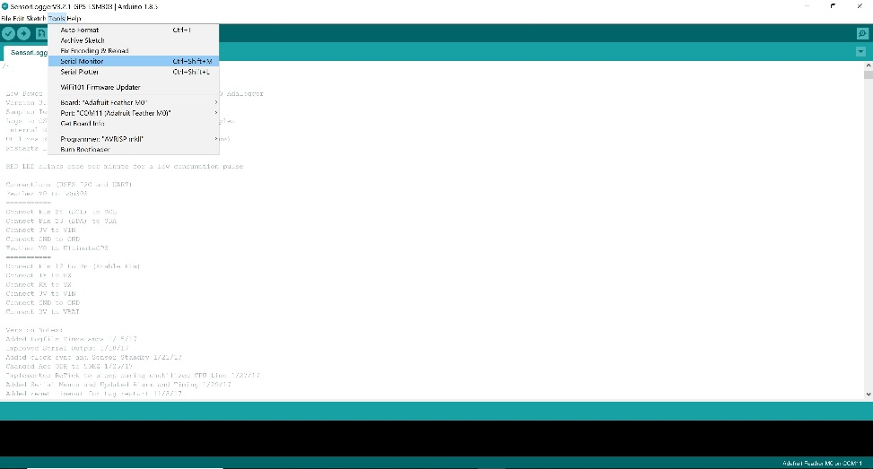Immediately after progress bar says “Done Uploading” (bottom left, orange writing on black area of program screen), go to Tools → Serial Monitor (Fig. B4)

Fig. B4. Open serial monitor programming menu.

* 1. Complete programming prompts by entering the number into the text bar
  2. for the parameter you would like to define, then press enter. When prompted, enter preferred settings (Table B1; Fig. B5).

|  |  |  |
| --- | --- | --- |
| Settings Prompt | Parameter Options | Description |
| Enter Tag Number | 1-99 | User enters tag number which sets initialization file name |
| Set Date and Time (GMT) | YYYY-m-d H:M:S | User syncs the date and time to a GPS |
| Display Time | - | Displays the clock to confirm sync with external source |
| Set Sampling Rate | 5 Hz, 10 Hz, 25 Hz, 40 Hz, 50 Hz | User sets the sampling rate |
| Set Local Time Zone Offset | +/- GMT, hour 0-12 | User defines local offset from GMT |
| Check GPS Fix | - | Displays scrolling status of GPS fix |
| Set GPS Parameters | Sampling Rate (s) - default is 120 (1-600)  Timeout (s) - default is 60 (20-90)  Read Delay (s) - default is 8 (1-30)  Samples per interval - default is 1 (1-30)  Smart Delay (ms) - default is 10 (1-20) | User selects interval between GPS data acquisition  User selects interval to wait for a fix before sleeping  User selects interval to wait before trying to log (allows for a fix)  Interval to spend encoding GPS data between other instructions |
| Start Logging | - | User selects start logging to initialize the tag |

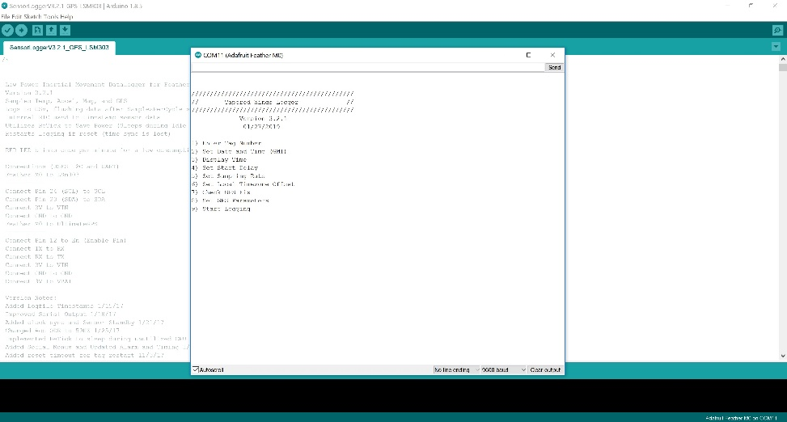Table B1. User-defined parameters available in the TWLogger setup state.

Fig. B5. Serial monitor parameter options.

* + 1. Troubleshooting: If Serial Monitor screen is blank, press spacebar and then press enter. The prompts should appear.
    2. Date: This will default to the date the software was uploaded.
    3. Time: Always program in UTC.
    4. GPS: To check GPS is able to properly establish satellite connections,
  1. To begin logging, enter parameter number 9 in the serial monitor text bar and press enter. Logger will begin logging.

1. Unplug TWLogger --- TWLogger is logging!
   1. A red LED pulse will confirm the device is logging properly. The microprocessor will blink at top of each minute and the GPS will blink at 1-Hz while it is attempting a fix.
   2. If the microprocessor LED is flashing rapidly, it means there is an error. The most likely cause the inability to read or write to the SD card.

**R Studio**

1. tagtools packages

http://www.animaltags.org/doku.php?id=tagwiki:info:people

1. See [http://github.com/Harrington-et-al/TWLogger](http://github.com/Harrington-et-al/TWLoggerS) for documented analysis toolkit.