# Genetic Analysis of Model Organisms: Exam #1 (2015)

**PLEASE WRITE YOUR NAME ON EVERY PAGE OF THE EXAM**

# The exam is worth 250 points. There are 6 questions

Please read the exam first to budget your time.

You may use a calculator, however, **NO MOBILE PHONES ALLOWED**

# You have 3 hours to complete the exam. Please show your calculations.

Corrected Map Distance: [(1/2T + 3NPD)/total] X 100

**PLEASE WRITE YOUR NAME ON EVERY PAGE OF THE EXAM**

**NO MOBILE PHONES ALLOWED**

**PLEASE WRITE YOUR NAME ON EVERY PAGE OF THE EXAM**

**NO MOBILE PHONES ALLOWED**

# (40 points) Starting with a diploid (2N) yeast strain that can grow in the absence of the amino acid arginine (Arg+), you isolate 5 independent mutants that fail to grow in the absence of arginine (Arg-). You sporulate your mutant strains to obtain tetrads of haploid ascospores. You allow the ascospores to germinate and test the phenotype of the ascosporal colonies. You find that all 5 segregate 2Arg+ to 2Arg-.

* 1. (20 points) What two important properties of these mutations have you determined from this analysis?
  2. (10 points) How would you use the 5 mutants to determine the number of complementation groups?
  3. (10 points) You decide to map your Arg- mutants relative to the *LEU2* gene. To examine this, you cross a *leu2* haploid to each of your Arg- haploids and sporulate the resulting diploid. After tetrad dissection, growth of ascosporal colonies and replica plating to appropriate media you obtain the following data. For 4 of the 5 mutants you conclude that the mutation responsible for the Arg- phenotype is not linked to the *LEU2* gene (data not shown). For the remaining mutant (call it *arg20*) you obtain the following data.

|  |  |  |
| --- | --- | --- |
| **895** | **100** | **5** |
| Leu- Arg+ | Leu- Arg+ | Leu- Arg- |
| Leu- Arg+ | Leu- Arg- | Leu- Arg- |
| Leu+ Arg- | Leu+ Arg+ | Leu+ Arg+ |
| Leu+ Arg- | Leu+ Arg- | Leu+ Arg+ |

What is the corrected map distance between the *LEU2* locus and *ARG20* locus? [Corrected Map Distance: [(1/2T + 3NPD)/total] X 100]

1. (40 points) U. of C. Prof. Emeritus Shelly Esposito was responsible for isolation of “*spo*” mutants including *spo11*, *spo12*, and *spo13* among many other things. In 1981, Esposito published a landmark paper that involved a *spo13/spo13 rad50/rad50* double mutant diploid strain.

*RAD50* is required for initiation of meiotic recombination. In a *rad50/rad50* mutant, recombination does not initiate, i.e. DNA double strand breaks do not occur. A *rad50/rad50* mutant produces some tetrads, but the spores in those tetrads are usually dead (<1% spore viability).

*SPO13* is required for modification of kinetochores for the first round of meiotic chromosome segregation (MI) and for protection of centromeric cohesion at MI. Furthermore, the s*po13* mutant packages spores after executing only one round of chromosome segregation (like the *spo12/spo12* mutants we learned about in discussion section). Esposito and Malone did not know these mechanistic details at the time, but they knew that the *spo13/spo13* mutant produced dyads that had undergone a single equasional division (i.e. a division like a mitotic division). The dyad spores produced by *spo13/spo13* diploids produced were mostly viable.

When they made a *spo13/spo13 rad50/rad50* double mutant they found that it produced dyads and that the spores in the dyads were viable, i.e. the *spo13* mutation rescued the spore inviability caused by the *rad50* mutation.

1. (10 points) Why do *rad50* mutations cause low spore viability? Explain specifically how the relevant biological process works normally, what goes wrong in the mutant, and how that defect causes production of dead spores.
2. (15 points) Why does a *spo13* mutation rescue the low spore viability caused by

*rad50* mutations?

1. (10 points) Some meiotic recombination mutants block the recombination process after DNA double strand breaks form, but before those breaks are healed to form

recombination products. Broken chromosomes accumulate. Would you expect the spore inviability phenotype conferred by this type of mutant to be rescued by a *spo13* mutation? Why?

1. (5 points) Design a genetic test to determine whether a newly-identified meiotic Rec- mutant blocks the recombination pathway before vs. after the formation of meiotic DNA double strand breaks.
2. (45 points) A former lab member carried out a forward genetic screen in a haploid strain. He identified a mutant that was temperature sensitive (ts), i.e. unable to grow at all 33o. The same mutant also showed slow growth (sg) at 23oC. You decide to further characterize this mutant strain. You cross the mutant haploid to a wild type strain of the opposite mating type (i.e. a strain that grows normally at both temps), dissect tetrads, and allow the spores to germinate and form colonies. You then use replica plating onto rich medium to make two identical replicas and you incubate one of the plates at 33oC and one at 23oC and obtain the following results:

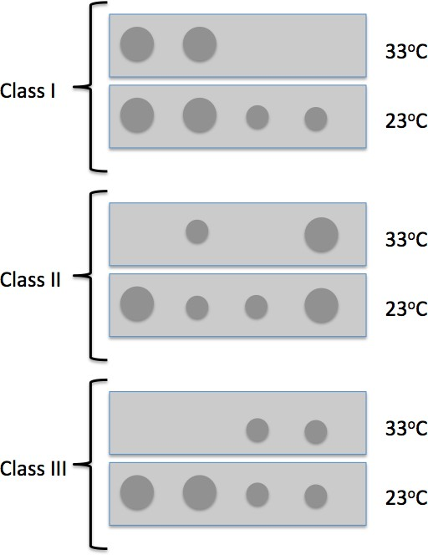Class I: 15 tetrads gave 2 spores that were both ts (no growth at 33oC) and sg at 23oC, and two that grew normally at both 23oC and 33oC.

Class II: 68 tetrads gave a spore that was ts, but grew normally at 23oC, a spore that grew slowly at both temps, a spore that was ts and grew slowly at 23oC, and a spore that grew normally at both temps.

Class III: 17 tetrads with two spores that were ts, but grew normally at 23oC, and two spores that grew slowly at both temperatures.

1. (10 points) What hypothesis would you draw from these results?
2. (10 points) What two crosses would you do to test the hypothesis?
3. (10 points) What results does your hypothesis predict for each cross at 23oC and at 33oC?
4. (15 points) Assume that when original ts sg mutant haploid strain was crossed to the wild type haploid strain, the resulting diploid showed normal growth at both 23oC and 33oC. How would you use a genomic centromere plasmid library to isolate relevant plasmids?
5. (40 points) The phenotypic sex of *Drosophila* is determined by its genotype: XX flies are female and XY flies are male. In flies, phenotypic sex is determined by the X to autosome (X:A) ratio. Thus, for proper sex determination, the fly must have a way of both specifying the X:A ratio and interpreting the X:A ratio. This information then instructs the downstream program of sexual differentiation.

As part of the program of sexual differentiation, a second process, dosage compensation, ensures that X chromosome gene expression is equivalent between XX and XY animals. In flies, the expression of the single X chromosomes in the male is elevated so that it equals the expression of the two X chromosomes in the female. XY flies without dosage compensation die as embryos, as do XX flies in which the male program of dosage compensation has been activated.

1. (15 points) You seek to identify genes necessary for proper sex determination and/or dosage compensation. In the course of your analysis, you isolate and map an X-linked mutation, *M-let*, which is dominant and causes XY lethality, but has no effect as a heterozygote in XX flies. (Homozygous *M-let* females cannot be obtained because of the dominant male lethal phenotype).

You then isolate a second mutation, *f-let*, which is recessive and causes XX lethality, but has no effect on XY flies. You map this mutation and discover that it maps to the same location on the X chromosome as does the *M-let* mutation. You do additional genetic tests (not complementation tests!!) to show that the two mutations affect the same gene, which you call *Sex lethal* (*Sxl*), and you rename the alleles *SxlM* and *Sxlf*. From these data, infer the state of *Sxl* gene activity in XX and XY flies, and how the mutations you isolated affect the activity state of the gene in each sex.

1. (25 points) Meanwhile, another graduate student in the lab uncovers mutations in two additional genes, *daughterless* (*da*) and *maleless* (*mle*), involved in sex determination and/or dosage compensation. Both genes map to the autosomes.

Mutations in the *daughterless* (*da*) gene have a recessive, maternal effect. If a female is homozygous for the *da* mutation, all her XX progeny die, while all her XY progeny are normal.

Mutations in the *maleless* (*mle*) gene have a recessive, zygotic effect. All XY embryos homozygous for *mle* die; all XX *mle* progeny are normal. In other words:

|  |  |  |  |
| --- | --- | --- | --- |
| Maternal  genotype | Zygotic  genotype | XX viability | XY viability |
|  | (XX) *SxlM*/+  (XY) *SxlM*/Y | viable  ---- | -----  dead |
|  | (XX) *Sxlf*/*Sxlf*  (XY) *Sxlf*/*Y* | dead  ---- | ------  viable |
| *da*/*da* |  | dead | viable |
|  | *mle*/*mle* | viable | dead |

To order the action of the *da*, *Sxl*, and *mle* genes, you make double mutant strains. These strains have the following phenotypes:

|  |  |  |  |
| --- | --- | --- | --- |
| Maternal  genotype | Zygotic  genotype | XX viability | XY viability |
| *da*/*da* | (XX) *SxlM*/+ | viable | ----- |
| *da*/*da* | (XY) *SxlM*/Y | ---- | dead |
|  | (XX) *mle*/*mle*; *Sxlf*/*Sxlf*  (XY) *mle*/*mle*; *Sxlf*/*Y* | viable  ---- | -----  dead |
| *da*/*da* | *mle*/*mle* | viable | dead |

Focusing only whether XX and XY flies survive in the various double mutants, propose an order of gene action for *da*, *Sxl*, and *mle*. State the reasoning behind your answer. Based on the order of gene action, in which pathway (i.e., sex determination or dosage compensation) does each gene likely act?

1. (40 points) Adult stem cells maintain homeostasis of individual tissues through the life of an organism. The Drosophila gut contains stem cells, called intestinal stem cells (ISCs) that divide asymmetrically to produce one ISC and one epithelial cell (an EC) that differentiates and does not divide further.

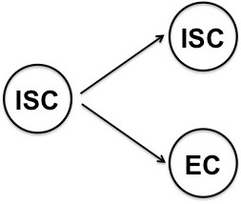Normally, the half-life of an EC cell is about four days (there is a 50% chance that a given EC cell will be lost in a period of four days), while an ISC will continue to divide approximately every fourth day over the 4-week lifetime of the fly. However, pathogen infection can cause massive damage to the gut epithelium, necessitating an increased rate of ISC division to maintain tissue homeostasis and prevent organismal lethality.

Investigators wished to document the increase in the rate of ISC division after pathogen infection. They constructed larvae containing **all** of the following P element transgenes:

Esg::Gal4 (an ISC-specific promoter, Esg, driving Gal4)

Tub::Gal80ts (a ubiquitous promoter, Tubulin[Tub], driving a ts form of Gal80, which is active at 18o, but inactive at 29o)

UAS::Flp (A UAS construct driving the FLP recombinase)

Tub::>RFP stop>Gal4 (the Tub promoter in front of a construct that encodes a membrane localized RFP [Red Fluorescent Protein] and a transcriptional stop flanked by FRT sites [>] and followed by Gal4)

UAS::GFP (A UAS construct driving a membrane localized GFP [Green Fluorescent Protein]).

They grew the larvae at 18o. At day 0, some larvae were infected with pathogens, others were kept as a control. All larvae were immediately shifted to 29o and the expression of RFP and GFP in intestinal cells was assayed at various time points afterwards.

For each of the following questions, please give your answer **AND** state the reasoning underlying your answer. To reiterate, full credit will only be given for the proper answer and the correct reasoning. Assume that the Gal80ts and FLP work with 100% efficiency, i.e., they always do what they are supposed to do.

* 1. (10 points) In the control larvae, what color(s) were present in each type of gut cell at day 0 prior to the temperature shift?
  2. (10 points) In the control larvae, what gut cell types were labeled with what colors at day 1 after the temperature shift? (Note: not all cells of a given type need be labeled with the same color.)
  3. (10 points) What would be the difference (if any) in the expression pattern of RFP and GFP between control larvae at day 1 and day 4?
  4. (10 points) How can you use these constructs to infer that the ISCs in the pathogen- infected larvae divide more quickly than the ISCs in the control larvae?

1. (45 points) The CRISPR – Cas9 system gives an investigator the capability to induce double strand breaks (DSBs) at a multitude of specific sites within the genome, thereby gaining the ability to make precise targeted changes to individual genes.

Recently, a paper was published that used a plasmid (see below) to construct what the authors called “a mutagenic chain reaction” in *Drosophila* that can result in the non- Mendelian inheritance of a given mutant phenotype.

As a proof of principle, the authors used this system to mutate the *yellow* gene, which encodes a protein necessary for the normal body color of the *Drosophila* adult. Null mutations in *yellow* are recessive and result in a yellow body color, as opposed to the normal brownish body color.

Note: The yellow gene is located on the X chromosome.

The authors first injected the plasmid diagrammed below, called the MCR plasmid, into the posterior of pre-blastoderm embryos.

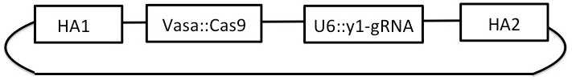

*HA1* and *HA2* are homology arms (HA) that are identical in sequence to parts of the main exon in the *yellow* gene, which is diagrammed in the figure below.

*Vasa-Cas9* is a construct in which the Cas-9 protein is expressed under the *vasa* promoter. In practice, this results in *cas-9* being expressed in both the germline and soma of the early embryo.

*U6:3-y1-gRNA* causes uniform expression of a guide RNA that is homologous to a sequence in the *yellow* gene (the triangle in the figure below) between the genomic sequences identical to the homology arms.

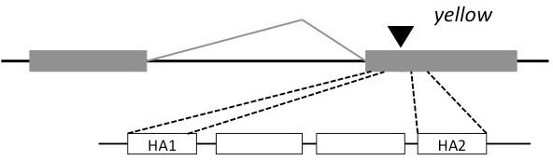

MCR plasmid

* 1. (10 points) The authors allowed the injected embryos to develop into phenotypically wild-type adults. The females from this pool of injected embryos were then mated with wild-type males. Among the F1 progeny, the authors recovered some phenotypically yellow males. Describe (or diagram) the two most common types of mutations in *yellow* that could have arisen after Cas9 expression from the MCR plasmid and state how each class of mutation would have been generated.
  2. (5 points) If investigators had injected a Vasa::Cas-9 plasmid without the homology arms, they would not have expected to observe any *yellow* mutant females in the F1 of the injected embryos. What is the reasoning behind this statement? (Assume a normal pattern of chromosome segregation during meiosis.)
  3. (10 points) However, using the MCR plasmid, the investigators recovered a small number of *yellow* mutant females among the F1 progeny of the injected females. Assuming a normal pattern of chromosome segregation during meiosis, how could *yellow* mutant females have been generated among the F1 progeny? What is the likely structure of the *yellow* gene in these flies?
  4. (10 points) When they mated an F1 yellow female with genotypic wild-type males, they saw the following classes of F2 progeny.

|  |  |  |  |
| --- | --- | --- | --- |
| WT males | Yellow males | WT females | Yellow females |
| 2 | 107 | 3 | 102 |

Given the likely genotype of the yellow female, provide an explanation for the observed ratio of phenotypic classes. Make sure you present a reason for the observance of each phenotypic class.

* 1. (10 points) During their investigations, the scientists took extreme care both to isolate these *Drosophila* cultures from other stocks in the lab, and to prevent any flies from escaping from the laboratory. Why was it necessary to do so, and what are the more general implications of this technology?