Justin Rigby

Compositional change of the phyllosphere due to secondary metabolite production

The plant rhizosphere is the culmination of all bacteria, and phages, that are present in the below ground tissues of plants starting at the base of the above ground plant material – the crown. These communities are comprised of harmful bacterial (such as pathogenic bacteria like *Agrobacterium tumefaciens*), neutral bacteria, and beneficial bacteria like Rhyzobia which are a symbiont for plants that form root nodules where they fix nitrogen and transfer it to the host plant in exchange for nutrients from the plant (1). While the root microbiome has an extensive list of research focused on the interactions within the rhizosphere, there is not much research looking at the interaction between the phyllosphere (the microbial community within the above ground plant material) and the rhizosphere even though there is evidence of interaction between both the rhizosphere and phyllosphere.

While the beneficial and harmful bacteria are easy to catalogue via phenotyping the plant, the influence of the neutral bacterium can also have an affect on the host plants ability to resist pathogens due to an induced systematic resistance (ISR) caused by the presence of said bacterium. One of the prime examples is the effect that *Pseudomonas fluorescens* has on the phyllosphere when it is present in the rhizopshere of the host plant. The mere presences of *Pseudomonas fluorescens* within the rhizosphere reduces the ability of *Pseudomonas syringae* to infect the leaves of the plant due to the induced defence response caused by the presence of the chemical diacetylphloroglucinol (DAPG) which is released by *P. fluoresces* in the rhizosphere (2)*.* The inclusion of this chemical has been found to have significant effects on the growth, and resistance to pathogenic bacteria such as *Pseudomonas syringae* and fungal infections.This interaction between *P. fluoresces* and its host plant are not the only instance of rhizosphere bacteria and the host plant interacting together, and there is converse example where a bacterium utilizes the chemical galactinol which is released by the host plant as a nutrient.

Previous studies looking at the interactions between the host-plant and the root microbiota have given way to complex interactions where the host-plant (*Arabidopsis thailiana*) releases a defence compound called galactinol which is in-turn is utilized as a nutrient by the bacterial pathogen *Agrobacterium fabrum.* Because of its ability to utilize galactinol as a source of sugar,thereforenegating its anti-microbial effects, that allows it to resist the host plant defence response and instead exploits the defence response for its own gain (3). With this in mind, the next question to be asked is if this interaction has any induced systematic resistance and if there are any down stream effects associated with the presence of *Agrobacterium fabrum* in the rhizosphere.

Specific Aim 1

The first aim of this project will be investigate if plants that are exposed to *Agrobacterium fabrum* show signs of ISR due to the interactions between the rhizosphere and phyllosphere. It is predicated that the presences of *A. fabrum* in the rhizosphere will have an effect on the phyllosphere due to the induced galactinol response and the ability for *A. fabrum* to utilize the chemical as a nutrient instead of being negatively effected by the chemical. I expect to see a reduction in the infection rate of *Pseudomonas syringae* due to the increase in galactinol due to *A. fabrum* presence.

References

1. Lindow, Steven E., and Maria T. Brandl. "Microbiology of the phyllosphere." *Applied and environmental microbiology*69, no. 4 (2003): 1875-1883.

2. Bakker, Peter AHM, Corné MJ Pieterse, and L. C. Van Loon. "Induced systemic resistance by fluorescent Pseudomonas spp." Phytopathology 97, no. 2 (2007): 239-243.

3. *The plant defence signal galactinol is specifically used as a nutrient by the bacterial pathogen Agrobacterium fabrum.* Meyer et al. 2018

4.Morella, Norma M., Annika L. Gomez, Grant Wang, Michelle S. Leung, and Britt Koskella. "The impact of bacteriophages on phyllosphere bacterial abundance and composition." *Molecular ecology* (2018).

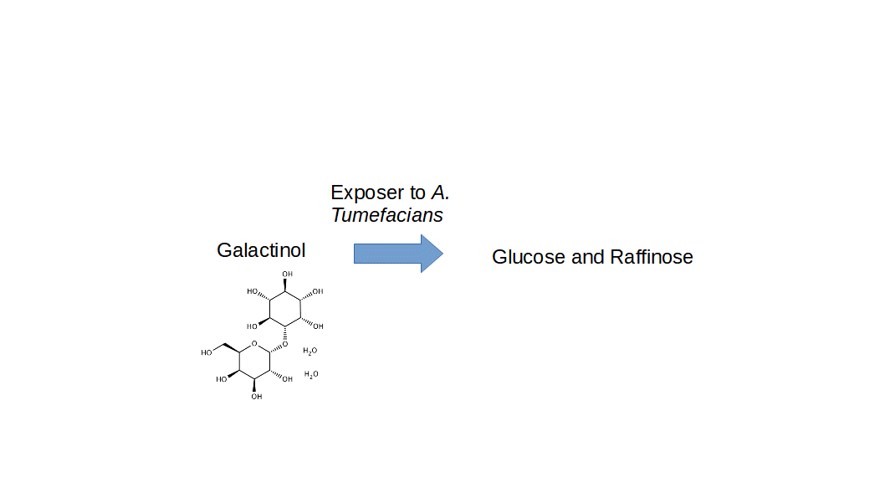

Figure