**Title**

Selective constraints on oligomerization domains of viral cell death regulators.

**Abstract**

Two paralogs in the human genome govern opposite outcomes during a cell death program; caspase 8 executes the cell by protease activity and cellular FLIP (cFLIP) prevents caspase activation by binding caspase 8. Association of these two proteins occurs by interaction between ancestrally-related death effector domains (DEDs) present in both sequences [1]. Activation of caspase 8 from pro-caspase 8 is dependent on DED-driven self-assembly following an upstream signal; cFLIP competitively oligomerizes with available DED sites and thus prevents pro-caspase activation [2].

Two DNA viruses have incorporated FLIP into their genomes and experimentally demonstrate increased infected cell survival even in the presence of pro-apoptotic signals. Kaposi’s sarcoma herpes virus (KSHV) protein K13 and molluscum contagiosum poxvirus (MCV) MC159 are viral FLIPs (vFLIPs) that have anti-apoptotic activity similar to cFLIP [3,4].

MCV encodes a second vFLIP, MC160, which does not retard cell death, making its economy in a viral genome less evident. Two possibilities include failure of MC160 DEDs to oligomerize as favorably as other FLIPs, or that the C terminal sequence prevents caspase suppression following oligomerization. Differential evolutionary constraints of either DEDs or C terminal domains provide a diagnostic of the structural source of MC160’s divergent indifference to death. Regulation and misregulation of this pathway of cell death impacts considerations of both acute infectious disease and long term oncogenesis or autoinflammation [5].

**Hypothesis**

cFLIP suppression of caspase occurs by competitive occupation of DED association sites on the caspase. When activated, cFLIP prevents self-association of the caspase and subsequent cleavage/release from the death-inducing signaling complex.

1. If MCV vFLIP gene MC160 does not suppress caspase due to failure to oligomerize, there may be evidence of lower DED sequence selection of MC160 compared to MC159.
2. Additionally, there may be greater selective constraint on the DEDs than the C terminal domains in MC159, KSHV K13, or human cFLIP.

**Figure One**

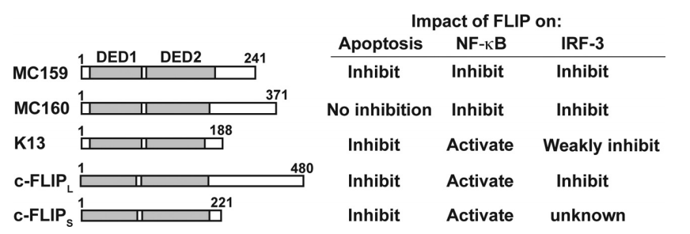

**Figure Two**

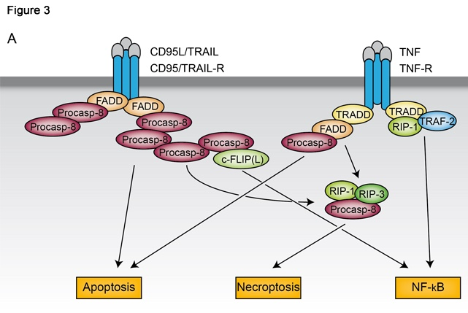

**Pilot Aims**

1. Determine synonymous and non-synonymous substitution rates of multiple aligned sequences using SNAP, comparing DEDs among FLIPs and DED vs C terminal region in MC160 to quantify relative effect of selection on oligomerization of ‘non-functional’ vFLIP.
2. Compare sequence alignment findings to a crystal structure of MC159 [6] in PyMol to assess structural and substitutional trends to cell fate outcomes.

**Project Aims**

1. Propose mutagenesis, deletion and substitution-based cloning strategies and test efficacy of cell death activation or suppression given alternate sequence composition in cell culture and in mouse models of multiple sclerosis [5].
2. Propose directed evolution experiment of vFLIPs to optimize cell death suppression and observe effect on oncogenesis in a mouse model of KSHV [7].

**References**

[1] Ozturk et al. Atlas of Genetics in Oncolology & Haematology. November 2013. (Figure Two)

[2] Hughes et al. Molecular Cell. March 2016.

[3] Shisler, J. Virology. June 2014. (Figure One)

[4] Thome et al. Nature. April 1997.

[5] Ofengeim et al. Cell. March 2015.

[6] Yang et al. Molecular Cell. December 2005.

[7] Wang et al. PNAS. February 2014.

1) What is the theme of the proposed research? What are the major questions to be addressed?

The theme is to investigate the role of a cell regolatory gene which signals for the apoptosis of a cell. Pathogens ultilize this pathway in order to prevent the cell from destroying itself upon infection – thus securing a foothold into the host.

2) Do the methods and preliminary analyses used integrate concepts that lie at the interface of molecular evolution and biochemistry? Do they address the questions being asked?

Yes they do address the concepts of the course in a proper manner. If more honed and specific hypotheses on the predicted results would be preferable.

3) What major improvements would you suggest?

More refined predictions of the results would help bolster the project and bring it into focus. If the author wished to have a more concretated and rigid analysis there additonal analyses which could be implemented with the proposed data set. However, in order to use these the author would need to state what kind of evoluton/selection they are expecting.

Overall I really like this idea and I am excited to see what the preliminary data shows. I would love to read it once you are done – so send it my way if you feel comfortable with sharing it (JustinRRigby@gmail.com).