Results

References

Tables and Figures

Whole Protein
Kappa | 1.61213
Omega | 0.64688
Table 1. Kappa and Omega (dN/dS) ratios for the entire protein.

Extra Celluar Portion
Kappa | 1.80485
Omega | 1.01620
Table 2. Kappa and Omega (dN/dS) ratios for the extra cellular flagella sensing portion of the protein.

Residues under Postive Selection in the Extracelluar Portion of the Protein
Residue | Pr (w>1) | A. thailiana Amino Acid
5 | 1.000 | L
37 | 1.000 | R
42 | 1.000 | S
43 | 1.000 | A
44 | 1.000 | S
70 | 1.000 | K
98 | 1.000 | I
109 | 1.000 | L
140 | 1.000 | L
153 | 1.000 | G
179 | 1.000 | H
180 | 1.000 | L
184 | 1.000 | P
194 | 1.000 | E
195 | 1.000 | A
200 | 1.000 | S
208 | 1.000 | H
209 | 1.000 | L
215 | 1.000 | S
218 | 1.000 | H
219 | 1.000 | H
222 | 1.000 | P
235 | 1.000 | R
290 | 1.000 | V
297 | 1.000 | S
299 | 1.000 | P
300 | 1.000 | R
Table 3. Residues under positive seleciton in the extracellular portion of the protein. [** P < 0.01, * P< 0.05]
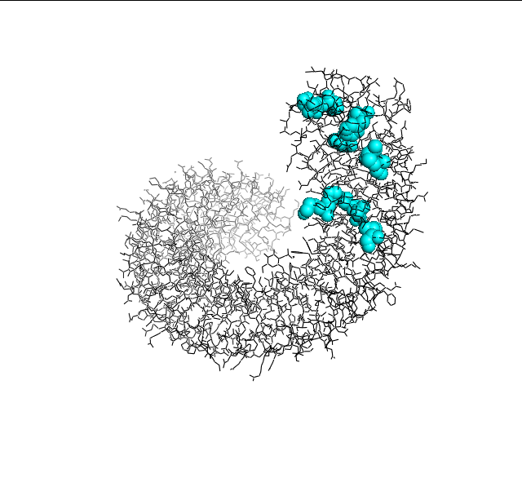
Image 1. Crystal Structure of the FLS2 Protein with Positively Selected Site in Cyan. Orientation 1.
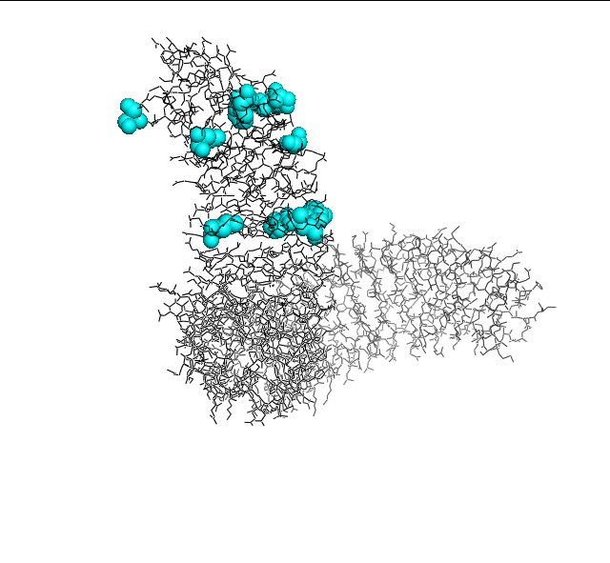
Image 2. Crystal Structure of the FLS2 Protein with Positively Selected Site in Cyan. Orientation 2.

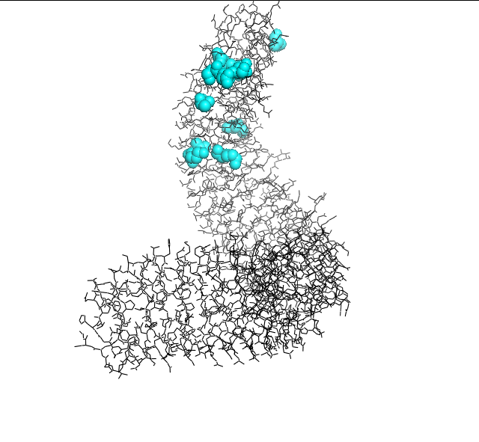
Image 3. Crystal Structure of the FLS2 Protein with Positively Selected Site in Cyan. Orientation 3.

