Justin Ryan Rigby
EBM
7th March 2018
Elucidating the specificity of the flagella sensing FLS2 protein in Arabidopsis thaliana and its homologs.
Summary
The goal of this preliminary analyses and proposed research is to elucidate the effects of the flagella sensing protein FLS2 in Arabidopsis thaliana, and its homologs in other plant species, in order to discover the specificity of the flagella sensing extracellular portion of the protein. The FLS2 protein in A. thaliana is responsible for the innate immune response found in plants and is consider to be a pathogen-associated molecular pattern (PAMPs) identifier (Chinchilla 2006). The flagella sensing portion of the protein is located on the extracellular matrix of plant cells, and is considered to be a leucine rich repeat (LRR) and a receptor like kinase (RLK) due to the signal cascade that occurs when flagella binds to the protein, and is synonymous with other defensive proteins located on the extracellular matrix. Due to it being a LRR and a RLK, when it is activated by a flagella protein coming in contact with the binding domain is begins a phosphorylation signaling cascade similar to a Mitogen-activated protein kinase (MAPK) where it starts a trans-autophosphorylation event in the cytoplasm that eventually leads to the gene WRKY33 activating transcription factors to elucidate a defensive response in the plant (Park et al. 2012). While the signaling pathways after flagella binding to the protein is similar between homologs, the actual specificity of the FLS2 protein differs across species.

The mechanism of flagella binding in A. thailiana is by the FLS2 extracellular domain recognizing a ubiquitous flagella protein (flg22) found in many different pathogens, but in Oryza sp. the protein which the FLS2 homolog identifies is the Ax21 ligand which is excreted by the pathogens (Park et al. 2012). Thus there is a large change specificity for the FLS2 homologs in other species, and it would be interesting to see if mutations in the Oryza sp. Variant similar to those found in Arabidopsis would confer the same level of specificity and pathogen host response. However, the first step to this analysis would be to identify portions of the extracellular protein which are undergoing positive selection in order to determine which residues are being changed between species.

Specific Aim 1
The first step of the preliminary analyses will be to obtain sequences of the FLS2 homolog found in other plant species in order to perform comparative genomics on the sequences. Once the sequences are obtained they will be aligned to the Arabidopsis variant of the gene, and then a phylogenetic tree will be constructed from the genes in order to conduct site tests and whole sequence tests for positive selection in PAML. Initially, the whole sequence will be tested to see if the entire protein is evolving between the species. Afterwhich the extracellular domain used in both flagella and Ax21 sensing will be analyzed looking for positive selection across the entire portion of the protein and at each site.

Once the sites undergoing positive have been identified in the extracellular portion of the gene each residue will be mapped to the crystal structure of the protein in PyMOL to infer if the residues are in a region which would be accessible to the flagella protein and the Ax21 ligand.

Specific Aim 2
To determine if these mutations in the positively selected residues confer an increase in affinity to Arabidopsis specific pathogens such as Pseudomonas syringae and Xanthomonas campestris. This will be done by first extracting the FLS2 gene from an Oryza sp. and to have it placed into a plasmid alongside a high expression promoter. Once the gene has been placed into the plastid it will mutagenized in the positively selected for residues found in the preliminary analyses so that it is similar to the Arabidopsis variant of the gene. Then the flagella of the two Arabidopsis pathogens (Pseudomonas syringae and Xanthomonas campestris) will be isolated and purified using methods previously show to work in Brett et al (2004) in order to properly isolate the flagella. Both the mutagenized FLS2 Oryza sp. protein and the pathogen flagella proteins will be mixed into a single tube and then analyzed to see if there is binding occurring between the two proteins. We hypothesize that the change in positively selected residues of the Oryza sp. to those found in A. thaliana will confer additional specificity to the Arabidopsis pathogens Pseudomonas syringae and Xanthomonas campestris.

Specific Aim 3
The next aim of the project is to perform an in vitro experiment using Oryza sp. FLS2 mutagenized lines which have the same residues in the Arabidopsis thaliana that were found to be positively selected for in the preliminary results. Strains of Oryza sp. will have their FLS2 gene mutated at the positively selected sites found in the preliminary results to mimic those found in the Arabidopsis copy of the gene. They will then been grown in the greenhouse under similar conditions, and will the be exposed to the Arabidopsis pathogens Pseudomonas syringae and Xanthomonas campestris and screened for the severity of infection. The severity of infection will then be compared to the control Oryza sp. which were infected with the same pathogens as the mutagenized line to see if the mutations confer additional resistance to the Arabidopsis pathogens. It is hypothesized this experiment should yield results showing a decrease in the pathogen response of the mutagenized line compared to the control lines indicating that the FLS2 mutation confers additional resistance to Arabidopsis pathogens.

Specific Aim 4
The final specific aim of the experiment will be looking at the converse of what was described in the specific aim 3 where the Arabidopsis lines will be mutagenized at the positively selected sites found in the extracellular domain in the preliminary analyses to match the residues found in Oryza sp. This additional experiment will help tease apart if the changes in the positively selected residues to their species counterpart are sufficient enough to decrease the pathogen response of the plant in vitro. The mutagenized Arabidopsis plants, along with Arabidopsis controls, will be exposed to the rice pathogen strains Xanthomonas oryzae pv. Oryzae and Pseudomonas fuscovaginae and then will be subsequently screened for the host plants response to the pathogens. Similar to the previous hypothesis, we expected to see a decrease in the level of host pathogen response for the mutated lines when compared to the control line due to increased specificity to the pathogen due to the mutations.

Background and Justification
The FLS2 gene in Arabidopsis thaliana is a broad spectrum flagella binding protein which is used in pathogen detection and response, and lies in the plasma membrane of the plant cell (Gómez-Gómez and Boller, 2000). The way it senses pathogen flagella is by the extracellular matrix of the protein being exposed to the outside of the cell where it stays put until it binds to a bacteria flagella (it binds specifically to the flg22 protein in the flagella) which then creates a signal cascade which leads into the cell where multiple round of trans-autophosphorylation occur until it activates WRKY 33 which activates transcription factors responsible a defense response in the plant (Chinchilla et al. 2006). This is the one way FLS2 has evolved to be used in pathogen resistance, but there is also a separate pathway that differs from A. thaliana in Oryza sp.
In the homologous gene found in Oryza sp. it does not bind directly to the flagella of a pathogen, but instead responds to the Ax21 peptide which is excreted by different pathogens (Park et al. 2012). The effector initiating the response may be different in both species, but the actual mechanism of the signal cascade and trans-autophosphorylation are very similar to one another – both initiate the activation of WRKY33 which then initiates various transcription factors associated with the defense response (Park et al. 2012). Seeing as both copies initiate the same pathway it leads us to believe that the the intracellular domain is conserved with respect to the pathway, but that the extracellular portion of the protein is not conserved. From the preliminary results of this paper we can see that there are residues under positive selection in the extracellular domain of the protein that may be conferring the specificity to both the flagella and Ax21 peptide when compared across species.
Previous research into the effects of mutations in the extracellular domain of the protein have been performed (Gómez-Gómez and Boller, 2000), which showed that mutation in the FLS2 extracellular domain will negate specificity, but their results did not show a change in specificity (Gómez-Gómez and Bauer, 2000). However some research has shown that there are specific domains in the FLS2 extracellular portion of the protein which confer specificity for different flagella type in different species (Mueller et al. 2012). Even though that study focused on chimeric proteins there is still evidence from their results that there are specific residues which lead to increased specificity for their respective pathogen. This point leads us to believe that modifying these particular residues will allow different species of pathogens, and different peptides, to bind to FLS2.

Seeing as there is no published literature on mutations in the FLS2 protein conferring a change in specificity in substrate binding we find our project and proposal to be the next big step in understanding both the evolution of defensive proteins. Alongside this, how a few small amino acid changes in the extracellular domain could have a major effect on its ability to sense other peptides like Ax21 through a few amino acid mutations. Continuing this project will allows us to elucidate how plants have evolved to their specific pathogens in an arms-race dynamic.
Results
Specific Aim 1
Gathering sequences and preparation for analysis
All gene copies were obtained online using the Ensembl Plants database to get obtain the FLS2 gene in the reference genome (A. thailiana) along with the homologs found in other plant species (Kersey et al. 2018). The information on the homologs, and types of sequences used, are outlined in table 1 below. Only the protein coding sequence was used due to the genomic size of the gene being variable and inconsistent between homologs, and that the final results of the project were to look at the residues associated with positive selection in the protein crystal structure (see mapping positively selected site to the crystal structure). After the sequences were downloaded and converted to FASTA files they were uploaded into the SeaView program for alignment using the MUSCLE algorithm according to the Arabidopsis thaliana sequence (Gouy et al. 2010). The proteins were successfully aligned to the reference sequence, and were then download as a sequential FASTA file containing all of the species homologs.
After the sequences had been aligned a gene tree was created using PhyML 3.0 software using SPR and aLRT Bayesian methods in order to have a tree for codeml analysis (Guindon et al. 2010). The phylogeny (Image 1) shows that as expected the two Brassica species cluster together on one branch as sister taxa and that they also have a most recent common ancestor (MRC) with Arabidopsis which is logical because all three of them are mustards. All of the rice species are also clustered together in the phylogeny as expected also, so the accuracy of the phylogeny created reflects that of known phylogenies and would be applicable to use in the analysis.

Whole protein analysis of FLS2
The FLS2 protein is made up of three domains; the extracellular domain, membranous domain, and the intracellular domain. The extracellular domain is responsible for the flagella sensing portion of the protein while the intracellular portion of the protein is responsible for initiating the signal cascade to initiate the signal cascade which elucidates the defensive response in the plant. The membranous domain is responsible for anchoring the protein into the membrane to keep the flagella sensing domain exposed to the outside of the cell.
The first analysis performed was to look at the transversion ratio (Ts/Tv) and omega ratio (dN/dS) in order to determine, on a naive level, what the general evolutionary trend is for the entire protein using the codeml package in PAML using the aligned sequences and the tree built from PAML (Yang 2007). The initial results have show that transversion ratio is biased towards transversions instead of transitions due to the value being lower than the 1.8 expected to found generally between sequences but not much can be inferred from these results. The omega value was found to be much less than one which indicates that there is evidence of negative/purifying selection occurring in the protein as whole which is logical because the intracellular domains and the membrane domain of the protein are expected to be highly conserved due to the pathway itself being found in other species besides Arabidopsis. No analysis was performed on the intracellular and intermembrane portion of the protein due to this result because with such a low omega compared to the omega found in the extracellular domain (Table 3).
One interesting caveat of the alignment results is that the FLS2 protein found in Arabidopsis is longer than all other copies of the homolog by ~300bp or so with no real explanation as to why. It is something that will be investigated further in the next part of the project in order to determine the reason to why this is, and if it has any bearing on the signaling pathway.

Extracellular domain analysis of FLS2

The extracellular domain was inferred from from the crystal structure created by Sun et al (2013) where they both published the crystal structure and annotated the domains. This domain is measured to be 806 amino acids long, and is made up of both structure motifs and regions specializing in the binding of flagella in order to initiate the signal cascade for the defensive pathogen response. The majority of the flagella binding portion is located in the first 300 amino acids of the extracellular domain. This portion of the protein has major regions where the protein is capable of binding to flagella of pathogens in order to sense when the plant is infected with some sort of pathogen.
The data was analyzed in codeml again to calculate the level of positive and neutral selection present in the extracellular domain of the protein. It was found to have a kappa of 1.80485 which is more in line with what was expected in a general plant gene, but the omega was found to be 1.01620 which is much higher than what was found when the entire protein was analyzed (Table 3). This value of omega is not indicating that there is positive selection occurring across the whole protein, but is informing us that taken as a whole this portion of the protein is undergoing neutral evolution. This does not mean that there are not portion of the gene which are not under selection, but instead tells us that the entirety of the protein is not undergo positive selection which is logical because we would not expect the entire portion of the extracellular domain to be under any positive selection. However, we would expect for there to be evidence of positive selection occuring in specific portion of the flagella binding domain region.
Each amino acid of the extracellular domain sequence was then analyzed in order to see if there is evidence of positive selection occuring at specific amino acids in the hopes of finding amino acids under positive selection. A total of 27 amino acids were found to be under positive selection in the flagella binding portion of the extracellular domain (Table 4). The substitutions caused a shift to a different amino acid in the domain, and there was no pattern on which amino acid replaced the original Arabidopsis amino acid. Each amino acid substitution was also found to be very significant (P < 0.01) in these regions.

Mapping positively selected site to the crystal structure

After the sites under positive selection were identified they were then input into the PyMOL software package alongside the crystal structure file for FLS2 (The PyMOL Molecular Graphics System). Each of the 27 amino acids residues were then selected and transformed into spheres for easier viewing. What can be seen in the images from PyMOL is that the majority of the positively selected residues are on the outside of the protein near the flagella response region (Image 2). These residues span the majority of the outside of the protein and may indicate a positive selection for specific binding residues (Image 3, Image 4). These different residues may also confer a different specificity for particular pathogens which plague the different species. However, this cannot be confirmed unless there is additional work done to test the specificity of these mutations with various pathogens specific to these species.

Proposed Future Research

The preliminary analysis has shown that there are sites located within the extracellular domain of the protein which are under positive selection, but the next part of the project is to investigate what these different residues infer for the specificity of the flagella sensing portion of the protein. One way to go about this problem is to mutate the specific residues found in the preliminary analysis to a different codon and check the response the plant has to specific pathogens. This is plausible by introducing point mutations into these protein using CRISPR-Cas9 systems, specifically those outline in Slaymaker et al 2016 to induce specific amino acid changes, into Arabidopsis and exposing them to pathogens specific to the other plant species to see if it infers additional resistance to these pathogens.

Specific Aim 2
The first portion of the additional experiments will be to induce amino acid changes in Oryza sp. homologs similar to those found in Arabidopsis thaliana in order for it to mimic the flagella sensing portion of the mustard proteins. This will not be an in vivo experiment, but will instead be done using plasmids containing the gene and an over expressor (Cauliflower Mosaic Virus 35S promoter) in order to insure constant transcription of the protein in the plasmids. The specific amino acid mutations will then be induced using the CRISPR-Cas9 system in order to mimic the different positively selected residues found in A. thailana in the preliminary analysis above and will be confirmed using RT-PCR and Sanger Sequencing. This should create proteins that have specificity for the pathogens which affect mustard species, and not those which affect rice species. After the transformation of the host proteins, the flagella proteins of the mustard pathogens Pseudomonas syringae and Xanthomonas campestris will be isolated and purified according to a similar protocol by Brett et al (2004) in order to conduct the additional analysis. The flagella proteins will then be introduced into the plasmids alongside the modified FLS2 protein mutagenized earlier. They will be left for a few hours, and will then have the proteins purified using a protocol by Rigaut et al (1999) in order to get a vial containing the assumed fused FLS2 and flagella proteins. In order to reduce convolution and unexpected binding of mustard pathogens to Oryza sp. FLS2 we will also be using an unmodified FLS2 Oryza sp. in order to determine if there is inherent binding of mustard pathogen flagella to the rice FLS2 homolog. A western blot and ELISA blot will then be performed to check for shorter bands indicating that there is a fusion of the flagella and the FLS2 proteins (Neal 1981). The ELISA blot portion of the experiment will be to quantify the level of specificity that rice pathogens have to both the Oryza sp. control variant of FLS2 and the mutagenized FLS2 protein. We expect to see the fusion of the proteins in vitro due to the changes in residues conferring additional specificity for these pathogenic flagella, and if there is binding of the pathogen flagella to the control variant, we would expect to see a lower level of binding in the ELISA blot. The ELISA blot will be used to quantify the level of bound proteins using the R statistical program, or an excel spreadsheet, in order to conduct the analysis (R Core Team, 2017). This experiment will primarily give us confirmation of the residues found in the preliminary analysis conferring additional specificity to mustard pathogens, but it will not infer that these residues also confer a higher level of resistance to the pathogens themselves so additional experiment must be performed.

Specific aim 3
In the second portion of the experiment in vivo assays will be done using transformed lines of Oryza sp. matching the residues found in Arabidopsis thaliana. The transformed line of Oryza sp. will be created using the CRISPR-Cas9 system mentioned previously, and the mutations will be confirmed using RT-PCR and Sanger Sequencing methods using primers associated with the FLS2 homolog found in rice. Due to the nature of CRISPR-Cas9 systems having imperfect levels of mutation, each mutation will be confirmed using the RT-PCR methods mentioned above in order to confirm that each sequential mutation is accurate. Once the lines are created they will be grown in a greenhouse in order to create homozygous lines of the mutation and reduce the chance of heterozygosity having an impact on the results. From the homozygous lines, 10 replicates (2 wild type controls) of 50 plants will be grown for forty days in order to have them in their adult stage, but not yet in their reproductive phase of their life cycle. Once they have aged to the correct time, they will be sprayed with both Pseudomonas syringae and Xanthomonas campestris at high multiplicity of infection (M.O.I) in order to guarantee that they are infected to a degree. After which they will be assayed every 4 hours for signs of infection which include; discoloration of leaf lamina and midrib, chlorosis, and wilting. After a period of 72 hours they will have photographs taken of them in order to quantify the leaf area using Fiji software to determine if the infection had any affect on the leaf area and growth of the plant (Schindelin et al 2012). Alongside leaf area data, phenology will also be recorded for every plant to determine if the infection had an effect on flowering time and if there was a delay in the life cycle shift to its reproductive stage. The data will then be compiled and put into an AIC (Akaike information criterion) analysis to determine if infection by the pathogen has any effects on the covariates measured during the 72 hour screening process. From the type of analyses performed I would expect the results to show that when the plants are infected with the rice pathogens that there is a reduction in the pathogen host response of the mutagenized Arabidopsis while the control Arabidopsis show a worse response when exposed to pathogens. The AIC model is appropriate due to the number of covariates recorded and would control for each parameter added to the model in a proper manner. The results expected are to see a decrease in the host pathogen response due to the inclusion of these specific mutation introduced into Oryza sp. and that it confers higher levels of resistance to pathogens.

Specific aim 4
The final aim of the project is to perform an experiment converse to the one where an Arabidopsis thaliana line is mutated in order to mimic the residues found in Oryza sp. The same mutagenizing methodology will return as before, but the way that they plants are grown and screened differs. They will be selfed like the Oryza sp. before in order to create homozygous lines and to negate any heterozygous effect. Then 10 replicates (2 wild type controls) of 50 plants will be grown in the greenhouse for 20 days according to the standard protocol. The change to 20 days reflects the smaller life cycle of Arabidopsis and is used in order to keep both species at more or less the same life cycle phase. Once they are 20 days old they will be exposed to the Oryza sp. pathogens Xanthomonas oryzae pv. Oryzae and Pseudomonas fuscovaginae. After being infected they will be screened and scored every four hours for; discoloration of leaf lamina and midrib, chlorosis, and wilting. After the period of 72 hours they will have photographs taken of them in order to quantify the leaf area using Fiji software to determine if the infection had any affect on the leaf area and growth of the plant (Schindelin et al 2012). Samples of the leaves of each mutagenized and control Arabidopsis thaliana will have three leaves cut from each plant and they will be placed into a vial which will be dunked in liquid nitrogen to flash freeze the plant material. The plant material will then be transferred to a -80 C freezer, and then have their metabolites extracted using phenethyl and will be analyzed on the HPLC-QTOF in order to quantify the levels of salicylic acid present in the plant tissue. All of the data will then be organized into a single data set where it will be analyzed using the AIC model to measure the effect of all of the covariates on infected and non-infected plants. The results expected are to see a decrease in the host pathogen response due to the inclusion of these specific mutation introduced into Arabidopsis thaliana and that it confers higher levels of resistance to pathogens, and we will expect to see an increased level of salicylic acid in the mutagenized plants due to their better response to the pathogen.

References
P.J. Kersey, J.E. Allen, A. Allot, M. Barba, S. Boddu, B.J. Bolt, D. Carvalho-Silva, M. Christensen, P. Davis, C. Grabmueller, N. Kumar, Z. Liu, T. Maurel, B. Moore, M. D. McDowall, U. Maheswari, G. Naamati, V. Newman, C.K. Ong, D.M. Bolser., N. De Silva, K.L. Howe, N. Langridge, G. Maslen, D.M. Staines, A. Yates.
Ensembl Genomes 2018: an integrated omics infrastructure for non-vertebrate species
Nucleic Acids Research 2018 46(D1) D802–D808
Gouy M., Guindon S. & Gascuel O. (2010) SeaView version 4 : a multiplatform graphical user interface for sequence alignment and phylogenetic tree building. Molecular Biology and Evolution 27(2):221-224.
Guindon S., Dufayard J.F., Lefort V., Anisimova M., Hordijk W., Gascuel O., "New Algorithms and Methods to Estimate Maximum-Likelihood Phylogenies: Assessing the Performance of PhyML 3.0." Systematic Biology, 59(3):307-21, 2010.
Yang, Z. 2007. PAML 4: a program package for phylogenetic analysis by maximum likelihood.
Molecular Biology and Evolution 24: 1586-1591
Sun, Yadong, Lei Li, Alberto P. Macho, Zhifu Han, Zehan Hu, Cyril Zipfel, Jian-Min Zhou, and Jijie Chai. "Structural basis for flg22-induced activation of the Arabidopsis FLS2-BAK1 immune complex." Science 342, no. 6158 (2013): 624-628.
The PyMOL Molecular Graphics System, Version 2.0 Schrödinger, LLC.
Salzberg, Steven L., Daniel D. Sommer, Michael C. Schatz, Adam M. Phillippy, Pablo D. Rabinowicz, Seiji Tsuge, Ayako Furutani et al. "Genome sequence and rapid evolution of the rice pathogen Xanthomonas oryzae pv. oryzae PXO99 A." BMC genomics 9, no. 1 (2008): 204.
Slaymaker, Ian M., Linyi Gao, Bernd Zetsche, David A. Scott, Winston X. Yan, and Feng Zhang. "Rationally engineered Cas9 nucleases with improved specificity." Science 351, no. 6268 (2016): 84-88.
Rigaut, Guillaume, Anna Shevchenko, Berthold Rutz, Matthias Wilm, Matthias Mann, and Bertrand Séraphin. "A generic protein purification method for protein complex characterization and proteome exploration." Nature biotechnology 17, no. 10 (1999): 1030.
Burnette, W. Neal. "“Western blotting”: electrophoretic transfer of proteins from sodium dodecyl sulfate-polyacrylamide gels to unmodified nitrocellulose and radiographic detection with antibody and radioiodinated protein A." Analytical biochemistry 112, no. 2 (1981): 195-203.
Salzberg, Steven L., Daniel D. Sommer, Michael C. Schatz, Adam M. Phillippy, Pablo D. Rabinowicz, Seiji Tsuge, Ayako Furutani et al. "Genome sequence and rapid evolution of the rice pathogen Xanthomonas oryzae pv. oryzae PXO99 A." BMC genomics 9, no. 1 (2008): 204.
Brett, Paul J., D. C. Mah, and Donald E. Woods. "Isolation and characterization of Pseudomonas pseudomallei flagellin proteins." Infection and immunity 62, no. 5 (1994): 1914-1919.
R Core Team (2017). R: A language and environment for statistical computing. R Foundation for Statistical Computing, Vienna, Austria. URL https://www.R-project.org/.
Schindelin, J.; Arganda-Carreras, I. & Frise, E. et al. (2012), "Fiji: an open-source platform for biological-image analysis", Nature methods 9(7): 676-682, PMID 22743772, doi:10.1038/nmeth.2019
Chinchilla, Delphine, Zsuzsa Bauer, Martin Regenass, Thomas Boller, and Georg Felix. "The Arabidopsis receptor kinase FLS2 binds flg22 and determines the specificity of flagellin perception." The Plant Cell 18, no. 2 (2006): 465-476.
Park, Chang-Jin, Daniel F. Caddell, and Pamela C. Ronald. "Protein phosphorylation in plant immunity: insights into the regulation of pattern recognition receptor-mediated signaling." Frontiers in plant science 3 (2012): 177.

Gómez-Gómez, Lourdes, and Thomas Boller. "FLS2: an LRR receptor–like kinase involved in the perception of the bacterial elicitor flagellin in Arabidopsis." Molecular cell 5, no. 6 (2000): 1003-1011.
Gómez-Gómez, Lourdes, Zsuzsa Bauer, and Thomas Boller. "Both the extracellular leucine-rich repeat domain and the kinase activity of FLS2 are required for flagellin binding and signaling in Arabidopsis." The Plant Cell 13, no. 5 (2001): 1155-1163.
Mueller, Katharina, Pascal Bittel, Delphine Chinchilla, Anna K. Jehle, Markus Albert, Thomas Boller, and Georg Felix. "Chimeric FLS2 receptors reveal the basis for differential flagellin perception in Arabidopsis and tomato." The plant cell 24, no. 5 (2012): 2213-2224.

Tables and Figures

Species | Gene Reference | Type off Sequence Obtained
Arabidopsis Thailiana [Reference Gene] | AT5G46330 | Protein Coding Sequences
Brassica rapa [Homolog 1] | Bra017563 | Protein Coding Sequences
Brassica rapa [Homolog 2] | Bra022032 | Protein Coding Sequences
Oryza barthii | OBART04G25930 | Protein Coding Sequences
Oryza glaberrima | ORGLA04G0225900 | Protein Coding Sequences
Oryza nivara | ONIVA04G24540 | Protein Coding Sequences
Oryza brachyantha | OB04G32410 | Protein Coding Sequences
Oryza glumaepatula | OGLUM04G25430 | Protein Coding Sequences
Oryza longistaminata | KN540018.1_FG005 | Protein Coding Sequences
Amborella trichopoda | AMTR_s00092p00147780 | Protein Coding Sequences
Triticum aestivum | TRIAE_CS42_7BL_TGACv1_577914_AA1886020 | Protein Coding Sequences
Brachypodium distachyon | BRADI5G21960 | Protein Coding Sequences
Populus trichocarpa | POPTR_0004s06420 | Protein Coding Sequences
Table 1. Information on the sequences used for the anaylsis.

Whole Protein
Kappa | 1.61213
Omega | 0.64688
Table 2. Kappa and Omega (dN/dS) ratios for the entire protein.

Extra Celluar Portion
Kappa | 1.80485
Omega | 1.01620
Table 3. Kappa and Omega (dN/dS) ratios for the extra cellular flagella sensing portion of the protein.

Residues under Postive Selection in the Extracelluar Portion of the Protein
Residue | Pr (w>1) | A. thailiana Amino Acid
5 | 1.000** | L
37 | 1.000** | R
42 | 1.000** | S
43 | 1.000** | A
44 | 1.000** | S
70 | 1.000** | K
98 | 1.000** | I
109 | 1.000** | L
140 | 1.000** | L
153 | 1.000** | G
179 | 1.000** | H
180 | 1.000** | L
184 | 1.000** | P
194 | 1.000** | E
195 | 1.000** | A
200 | 1.000** | S
208 | 1.000** | H
209 | 1.000** | L
215 | 1.000** | S
218 | 1.000** | H
219 | 1.000** | H
222 | 1.000** | P
235 | 1.000** | R
290 | 1.000** | V
297 | 1.000** | S
299 | 1.000** | P
300 | 1.000** | R
Table 4. Residues under positive seleciton in the extracellular portion of the protein. [** P < 0.01, * P< 0.05]

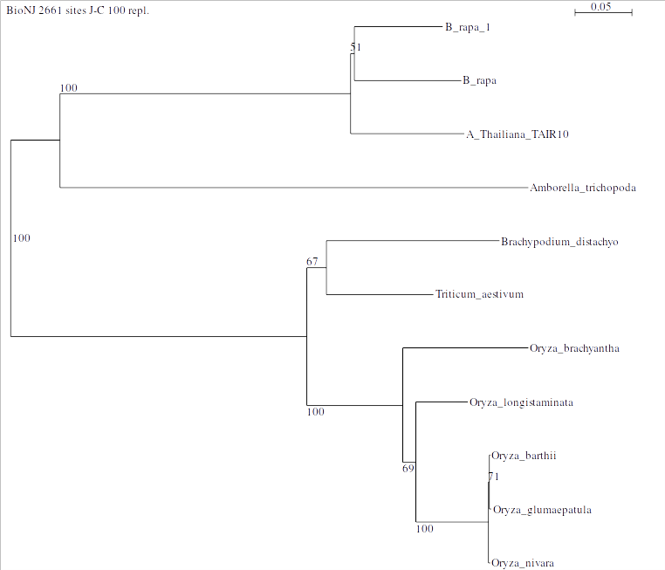
Image 1. Phylogeny of the gene FLS2 and its homologs.
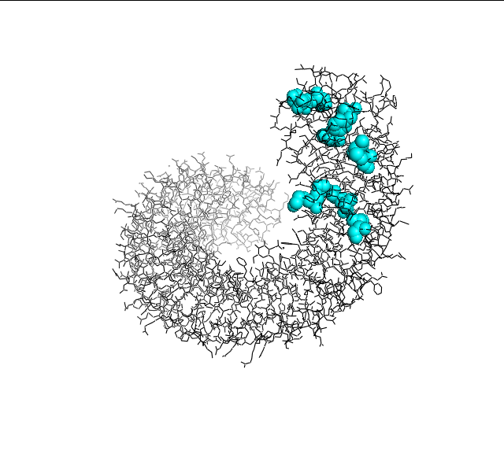
Image 2. Crystal Structure of the FLS2 Protein with Positively Selected Site in Cyan. Orientation 1.
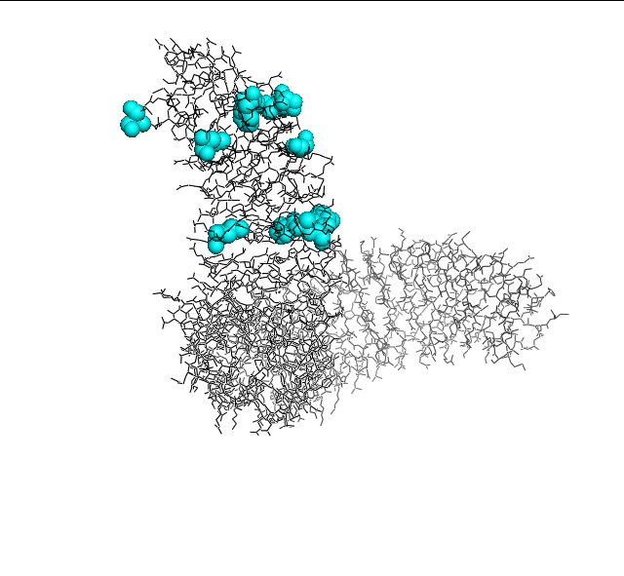
Image 3. Crystal Structure of the FLS2 Protein with Positively Selected Site in Cyan. Orientation 2.

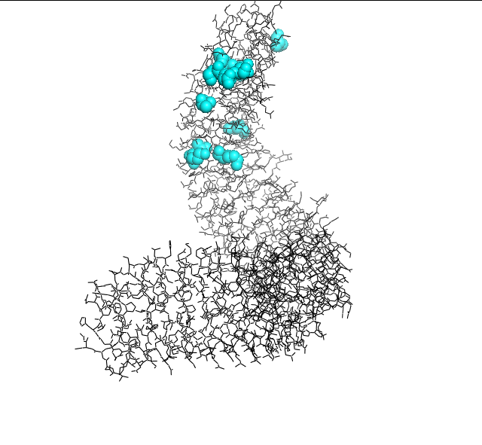
Image 4. Crystal Structure of the FLS2 Protein with Positively Selected Site in Cyan. Orientation 3.

