Justin Rigby
06/09/18
Elucidating the phylogenetic relationship of basal gymnosperms
Specific Aims
Specific Aim 1
To perform an multigene analysis of extant gymnosperm species in order to compare it to the most likely tree found by only using the highly conserved Leafy and Needly gene. The difference in my analysis will be inclusion of 18s sequences, which were initially used in a previous study using 18s rDNA sequences, where it found that it places Gnetum and Ginkgo within the same clade with a low bootstrap value (Chaw et al. 1995). I expected that these results will resolve the positions of Gnetum and Ginkgo within a newly constructed tree using a more appropriate model.
- Retrieve Leafy, Needly, and 18s rDNA sequences from the two previous papers (Lu et al. 2014 and Chaw et al. 1995) from their respective location on the GenBank Nucleotide Archive (cite).
- Perform a Maximum Likelihood GTR + Gamma Distributed analysis with 150 bootstrap replicates with the initial ML tree created by using NJ/BioNJ. Both alignment and construction will be done in the Mega Software Package (cite).
- Compare the resulting to phylogeny to each paper to determine if there is a change in the position of the Gnetum and Ginkgo branches, and also compare the rest of the phylogeny to see if any other branches differ from both paper’s conclusion.

Specific Aim 2
After the multigene tree is constructed (using Needly, Leafy, and 18s rDNA genes) the resulting tree will be compared to those found in both Lu et al. (2014) and Chaw et al. (1995) using the Shimodaira-Hasegawa test (Shimodaira and Hasegawa 1999). It is expected to see a difference in the tree constructed versus those found in the previous papers due to the inclusion of three single copy genes which will allow for a more robustly built tree, and the exclusion of the out groups which may confound the results instead opting to root the tree on the Cycad branch due to known data showing it is the most basal branch on the tree.
- Trees from previous studies will be acquired by downloading them from TreeBase (cite) or reconstructed using the data and parameters laid out in their article in order to have an accurate representation of their results for further analysis.
- Once all trees are acquired they will be analyzed using R Statistical Software (R Core Team 2018) using the Shimodaira-Hasegawa (1999) test in order to determine if there is a significant difference between the new constructed tree, and the previous ones, in order to confirm the differences seen between the trees.

Specific Aim 3
The final aim of the project is to obtain samples of each species analyzed in tree built from the three genes (Leafy, Needly, and 18s rDNA) in order to obtain more single copy genes to be used in the analysis of the new tree to be built. After the extraction, a final tree will be constructed in order to see if these additional genes allow for a more resolute tree to be built from the data. It is expected that this methodology will lead to a more refined tree with higher bootstrap values and new clades being present in the tree.

- Once extracted, the DNA will be multiplexed on a Illumina HiSeq 4000 with individual barcodes on three lanes. After which, they will be reconstructed and ran through the Mega Software Package (Tamura et al. 2007).
- After sequencing, potential single gene copies will be found using the COSII method (Wu et al. 2006) of analysis to confirm, and the sequences of these genes will be used in the construction of the tree.
- The tree will use the GTR + Gamma Distribution model with 150 bootstrap replicates with the initial ML tree created by using NJ/BioNJ. Both alignment and construction will be done in the Mega Software Package (Tamura et al. 2007).
- The tree will then be rooted again to the Cycads, and will be compared to the previous trees using the Shimodaira-Hasegawa test (1999) in order to determine if there is a significant difference between the new constructed tree and the previously constructed trees in order to confirm if this tree is in fact different from the previously constructed trees.

Background and Justification
The basal branches of the gymnosperm phylogeny on the tree of life have been of great interest to researcher over the last few centuries due to gymnosperms being considered to be the sister to all angiosperms which have dominated the earth since the early Cretaceous period. This is primarily due to both angiosperms and gymnosperms being spermatophytes, or more collegially known as seed plants, which are the dominant terrestrial plants on the planet (Pryer et al. 2004). Being the dominant flora of the planet, the evolutionary history of their emergence is of importance if we wish to understand the evolution of angiosperms and gymnosperms.

Gymnosperms are one of the dominant land plants, spread across all continents and ecosystems, but the actual evolution of them is hard to pinpoint. Gymnosperms are an interesting clade of plants since a majority of their evolution has involve multiple polyploidy events (Khoshoo 1959) which make it difficult to do whole genome phylogenetics in the age of cheap sequencing and advanced supercomputer which we can carry in our backpack. Previously, many researchers have resorted to morphological traits studies (Flory 1936. Coulter 1910, and Beck 1962) in order to get around this problem, but recently with the increase in advanced software and DNA extraction and sequencing it has given way to more research in elucidating the basal branches of the gymnosperm lineage, but this is not an easy problem.

With gymnosperms being sister to all angiosperms, they are a prime target for phylogenetics due to the abundance of extant species, but therein lies the problem with constructing the phylogeny. While angiosperms have a variety of clades and families to choose from gymnosperms are limited in their choices. It has been known for decades that the extant gymnosperm species, through morphological inference and confirmation for early genetic studies (Bremer 1985), that there are a few extant monophyletic gymnosperms. These gymnosperms are: Welwitschia mirabilis, Ginkgo biloba, and Sciadopitys verticillata which are spread throughout the world. These species are critical for the elucidation of the basal tree of the gymnosperm lineage. While previous genetic studies have both confirmed and reworked the gymnosperm phylogeny (Lu et al. 2014, Wang and Ran 2104, and Chaw et al. 1995) there is still much more to be done in terms of phylogenetics.

While earlier studies have confirmed and added to the gymnosperm lineage, the actual genetic analysis implemented is lacking and requires analysis with more genes. In a study by Lu et al. (2014) they used two single copy genes in gymnosperms, LEAFY and NEEDLY, in order to construct a gymnosperm phylogeny -- including all monphyletic species. This study was able to construct a more relevant phylogeny, given the genetic data, but two genes is not enough to construct a rigorous phylogeny. Moving forward, it is going to be imperative to use more than two genes in the construction of the gymnosperm phylogeny if we wish to understand the evolution of extant land plants. Using a recently implemented methodology in plants, the COSII method (Wu et al. 2006), it would be possible to scan the genomes of extant gymnosperms in order to identify possible single copy genes that could be used in phylogenetic analysis. Through the use of COSII it would be possible to identify potential genes for phylogenetic analysis which could be used to construct a phylogeny which would show the relationship between the basal branches of the gymnosperm lineage.
Preliminary Data/Analysis
Data Acquisition
Nucleotide data for the LEAFY and NEEDLY genes were obtained from GeneBank (Sayers 2012) from the accession numbers given by Lu et al. 2014, and the 18s rDNA sequences were also obtained from GeneBank from Chaw et al 1995. The original tree data for LEAFY and NEEDLY was obtained from TreeBASE (Vos et al. 2012) via accession numbers supplied (Lu et al. 2014), and the original tree for the 18s rDNA sequences (Chaw et al. 1995) was obtained also from TreeBASE. All nucleotide data was downloaded in the FASTA format while the tree data was given in the NEXUS format – no conversion of the data was applied.

Alignment of Sequences
All sequence alignment was done in the MEGA software package (v. 7.0.26) using the MUSCLE alignment algorithm (Edgar 2004). All three gene sequences were concatenated and clustered using MUSCLE with the UPGMA method for the first 2 iterations and then UPGMB for the next 12 iterations for a total of 14 iterations and a gap penalty of -400 (Edgar 2004). Once aligned, they were manually inspected for accuracy and were exported as a FASTA file.

Building of Phylogenetic Tree
The aligned sequences were then analysed in MEGA software (Edgar 2004) using maximum likelihood with a generalized time reversible gamma distributed model (Waddell et al. 1997) using 4 discrete categories and the tree search was done using an SPR method. The starting tree was constructed using a NJ/BioNJ with no swap filter. The entire process was run on an Intel i7-7700HG using seven threads for a period of 7 hours.

Shimodaira-Hasegawa Test
The R statistical software package (R Core Team 2018) was used in order to conduct the Shimodaira-Hasegawa test for selecting the most appropriate tree given the data. First the aligned sequences in FASTA format were converted into a PhyDat object using the Phytools package (Revell 2012) for pre-processing. The trees from this study, and the Lu et al. 2014 study, were input into R using the Phylobase package (Bolker et al. 2017) in order to have them converted into the appropriate phylo4d object format for analysis. Once the files were in the proper format, the package Phangorn (Schliep et al. 2017) was used in order to conduct the Shimodaira-Hasegawa Test using the “SH.test” function. All code for this process has been provided in the supplemental materials folder provided with the proposal.

Current Progress
As of writing this proposal the tree construction of the three genes was completed (Fig. 1 and Fig. 2). While the tree recovered, when not adjusted for the 70% bootstrap cutoff, is analyzed it returns a tree similar to the one seen in Lu et al. (2014), but with much lower bootstrap values. This may be due to a few things, primarily it could be due to the lack of complete 18s rDNA sequences for some of the species sampled in the analysis. Another issue could be the exclusion of the complete Gnetales family which may help resolve the basal branches which are poorly resolved.
The tree corrected for the 70% bootstrap cutoff is very poorly resolved and barely resolves the basal Gnetales, Ginkgo, and Cycads clades where there are major instances of polytomy to point where even major families are reduced (Fig. 2). This being said, the podocarpacaea and taxaceae family are resolved in the phylogeny, but this may just have been caused by the abundance of those species present in the analysis.
The preliminary data preparation for the Shimodaira-Hasegawa which includes tree reconstruction of Lu et al (2014) data and the data acquired from this project. The anticipated results from this test, with inference of the trees constructed, will be that there is a significant difference between the constructed trees, but that difference is not a useful finding. Since the trees constructed has low resolution, even if there is a significant difference between the trees, it is not helpful because the differences do not indicated a better tree but a worse one. Additional data will be gathered of 18s rDNA sequences from recently published papers, and from the proposed research, in order to mitigate this problem and construct a more viable tree.

Proposed Research
Due to the various genome duplication events that occurred within the gymnosperm lineage there are a plethora of duplicated genes which would not be appropriate for this analysis, thus excises the ability to do whole genome analysis, but there is the COSII genome scanning method which allow one to isolate single copy genes within a genome. Thus this methodology will be used in order to screen for single copy genes within the genomes of extant gymnosperms. All extant gymnosperms with an available genome will be skipped due to time and monetary constraints. All remaining plants will have their DNA extracted using a CTAB protocol, due to the large polysaccharide concentration found in gymnosperm leaves, and DNA will be quantified using a nanodorp. A cut off of 20 mg/uL will be used in order to have a respectable amount of DNA in each sample in order to reduce the dilution factor and increase the resolution of the sequences. After which they will be barcoded and sequenced on an Illumina HiSeq 4000 thousand, genomes will be constructed from the data, and then they will be screened using the COSII method. Once viable single copy genes are identified, they will be used to construct a phylogeny using maximum likelihood and the GTR + Γ substitution model with Cycads as the outgroup. To date, this would be the most robust dataset used to elucidate the gymnosperm lineage and will give us more insight into the basal branches of the evolution of terrestrial vascular land plants

References
Beck, Charles B. "Reconstructions of Archaeopteris, and further consideration of its phylogenetic position." American Journal of Botany (1962): 373-382.
Ben Bolker, Marguerite Butler, Peter Cowan, Damien de Vienne, Dirk Eddelbuettel, Mark Holder, Thibaut Jombart, Steve Kembel, Francois Michonneau, David Orme, Brian O'Meara, Emmanuel Paradis, Jim Regetz, and Derrick Zwickl. 2017. https://cran.r-project.org/package=phylobase
Benson, Dennis A., Mark Cavanaugh, Karen Clark, Ilene Karsch-Mizrachi, David J. Lipman, James Ostell, and Eric W. Sayers. "GenBank." Nucleic acids research 41, no. D1 (2012): D36-D42.
Bremer, KÅRE. "Summary of green plant phylogeny and classification." Cladistics 1, no. 4 (1985): 369-385.
Chaw, Shu-Miaw, Huang-Mo Sung, Huei Long, Andrey Zharkikh, and Wen-Hsiung Lie. "The phylogenetic positions of the conifer genera Amentotaxus, Phyllocladus, and Nageia inferred from 18S rDNA sequences." Journal of molecular evolution 41, no. 2 (1995): 224-230.
Coulter, John Merle, and Charles Joseph Chamberlain. Morphology of gymnosperms. University of Chicago Press, 1910.
Edgar, Robert C. (2004), MUSCLE: multiple sequence alignment with high accuracy and high throughput, Nucleic Acids Research 32(5), 1792-97
Flory, Walter S. "Chromosome numbers and phylogeny in the gymnosperms." Journal of the Arnold Arboretum 17, no. 2 (1936): 83-89.
Khoshoo, T. N. "Polyploidy in gymnosperms." Evolution 13, no. 1 (1959): 24-39.
Lu, Ying, Jin-Hua Ran, Dong-Mei Guo, Zu-Yu Yang, and Xiao-Quan Wang. "Phylogeny and divergence times of gymnosperms inferred from single-copy nuclear genes." PloS one 9, no. 9 (2014): e107679.
Pryer, Kathleen M., Harald Schneider, and Susana Magallón. "The radiation of vascular plants." Cracraft and Donoghue(2004): 138-153.
R Core Team (2018). R: A language and environment for statistical computing. R Foundation for Statistical Computing, Vienna, Austria. URL https://www.R-project.org/.
Revell, L. J. (2012) phytools: An R package for phylogenetic comparative biology (and other things). Methods Ecol. Evol. 3 217-223. doi:10.1111/j.2041-210X.2011.00169.x
Schliep, K., Potts, A. J., Morrison, D. A., Grimm, G. W. (2017), Intertwining phylogenetic trees and networks. Methods in Ecology and Evolution, 8: 1212--1220. doi:10.1111/2041-210X.12760
Shimodaira, Hidetoshi, and Masami Hasegawa. "CONSEL: for assessing the confidence of phylogenetic tree selection." Bioinformatics 17, no. 12 (2001): 1246-1247.
Tamura K, Dudley J, Nei M & Kumar S (2007) MEGA4: Molecular Evolutionary Genetics Analysis (MEGA) software version 4.0. Molecular Biology and Evolution 24:1596-1599. (Publication PDF at http://www.kumarlab.net/publications)
Waddell, Peter J., and M. A. Steel. "General time-reversible distances with unequal rates across sites: mixing Γ and inverse Gaussian distributions with invariant sites." Molecular phylogenetics and evolution 8, no. 3 (1997): 398-414.
Wang, Xiao-Quan, and Jin-Hua Ran. "Evolution and biogeography of gymnosperms." Molecular phylogenetics and evolution 75 (2014): 24-40.
Wu, Feinan, Lukas A. Mueller, Dominique Crouzillat, Vincent Pétiard, and Steven D. Tanksley. "Combining bioinformatics and phylogenetics to identify large sets of single-copy orthologous genes (COSII) for comparative, evolutionary and systematic studies: a test case in the euasterid plant clade." Genetics 174, no. 3 (2006): 1407-1420.
Vos, R. A., Balhoff, J. P., Caravas, J. A., Holder, M. T., Lapp, H. Maddison, W. P., Midford, P. E., Priyam, A., Sukumaran, J., Xia, X. and A. Stoltzfus 2012. NeXML: rich, extensible, and verifiable representation of comparative data and metadata. Systematic Biology 61(4): 675-689.

Figures and Tables
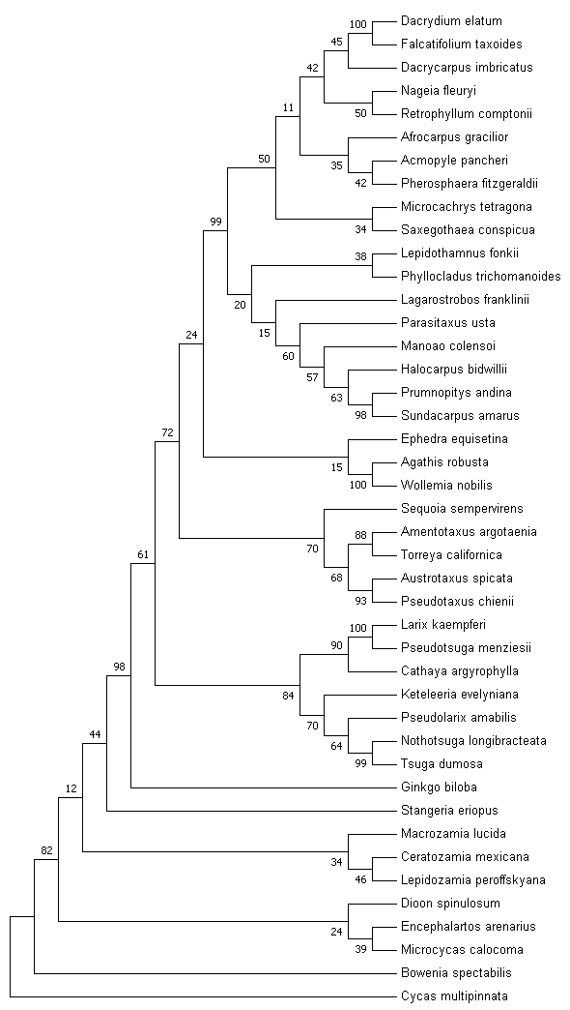
Figure 1. Tree constructed from three genes of the gymnosperm clade (LEAFY, NEEDLY, and 18s rDNA) using maximum likelihood and GTR + Γ model with a bootstrap consensus. This tree does not show the condensed format with a cut off bootstrap value of 70%.
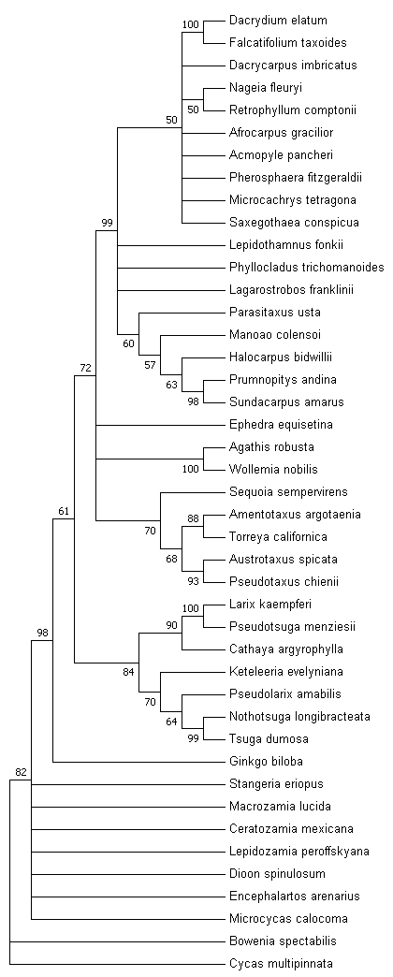

Figure 2. Condensed tree constructed from three genes of the gymnosperm clade (LEAFY, NEEDLY, and 18s rDNA) using maximum likelihood and GTR + Γ model with a bootstrap consensus. A bootstrap cutoff of 70% was applied to the tree in order to determine which clades have the least support.

