Salvatores CakePHP project and database

STEP 1 – import the database … attached to moodle as a .sql file and as a mysqlworkbench file

1. Download the **salvatoresdb.sql** file to your computer
2. Start XAMPP – start apache and mysql
3. Navigate in your web browser to <http://localhost/phpmyadmin>
4. Login as the root user
5. Add a user called **salvatoresdb** and select the option to create a database for the user (see screenshot below) -  
   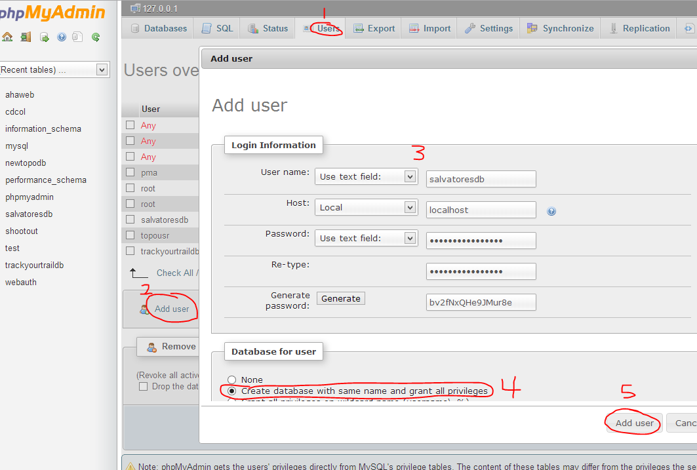
6. 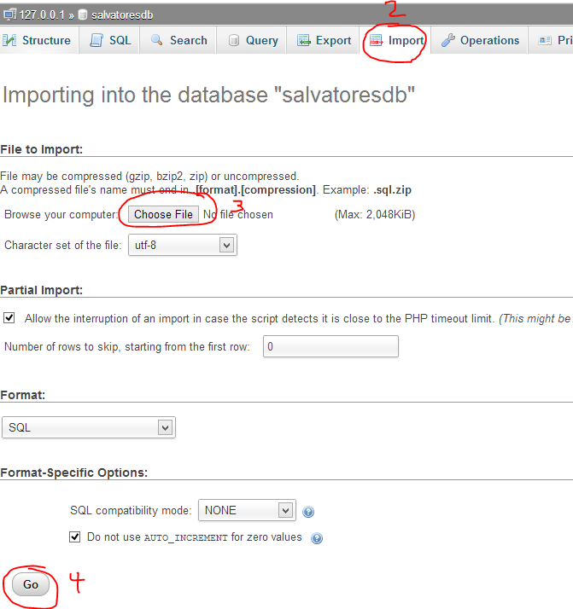Import the **salvatoresdb.sql** file you downloaded in step a (see screenshot below) -  
   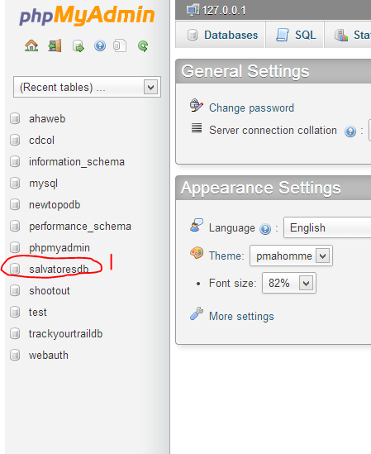

Step 2 – Unzip the CakePHP archive

1. Download the Salvatores.zip file to your computer
2. Unzip (extract) the archive into your htdocs folder
3. Step b should create a subfolder called **Salvatores** inside your htdocs folder
4. Open netbeans and select File🡪 New Project 🡪 PHP 🡪 PHP Application with Existing Sources
5. Browse to the Salvatores folder inside htdocs per the screenshot below and select open -  
   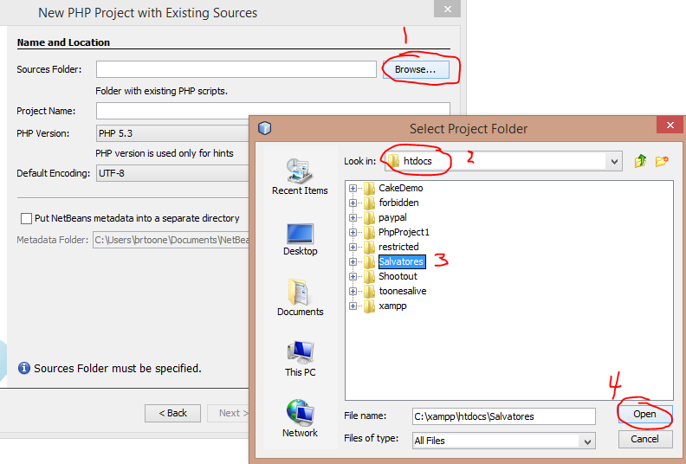
6. Update the config 🡪 database.php file with the password generated by phpmyadmin when you added the **salvatoresdb** user to phpmyadmin. See screenshot below -  
   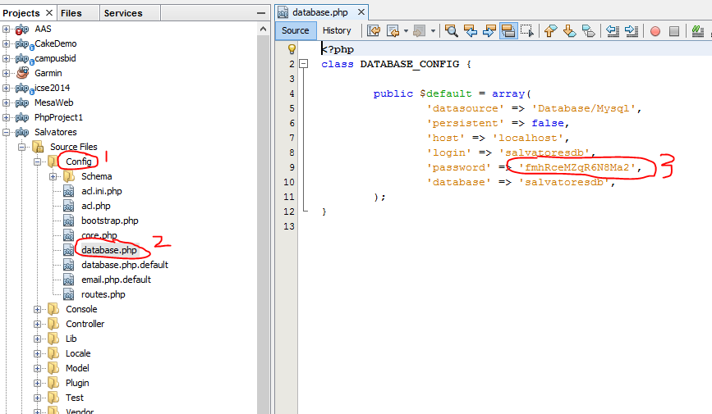
7. Done! At this point your system should be working. Navigate to the following URL to verify that you can see the existing menu categories that I have already added: <http://localhost/Salvatores/menu_categories>
8. You can also download the **salvatoresdb.mwb** mysql workbench file in case you want to make changes to the schema of the database and synchronize with the phpmyadmin database.