**Additional Changes for Cashier:**  
1. Add Action Button here to delete item.   
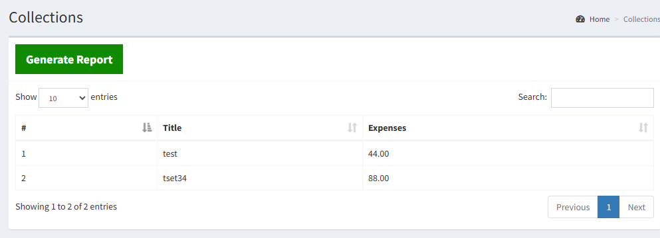

2. Dashboard for Cashier is missing.

3. Office Expenses should be included.

**Additional Changes for Admin**:  
1. All the system’s functionalities should be included for the admin

**Additional Changes for General Manager:**

1. Delete button should be included here:

1. In generating of report, Filter for Start Month-End Month should be included here.  
   A screenshot of a computer

   Description automatically generated
2. Drivers listed here can’t be deleted.

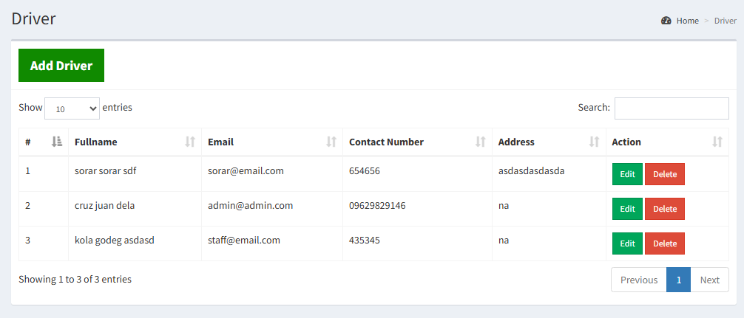

1. Action column such as edit and delete should be included on Expenses.

