**Wireframe of Basic Manobo Expressions Dictionary**

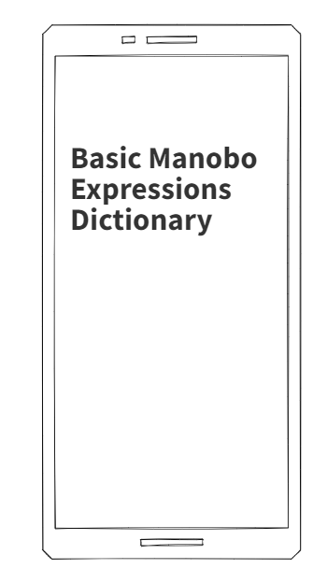

***Figure 8.0*** *Home Page for Basic Manobo Expressions Dictionary*

The Basic Manobo Expressions Dictionary's homepage has a straightforward, goal-oriented design. The application's name, which is shown prominently to greet users and create a distinct brand for the app, is the main component.

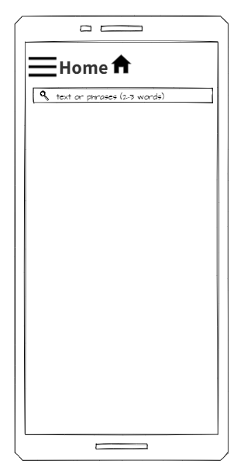

***Figure 8.1*** *Search for text and phrase for Basic Manobo Expressions Dictionary*

This feature of the Basic Manobo Expressions Dictionary will assist users in finding, quickly, translations of certain words or phrases. There is also a well-placed search bar, thus easily accessible and intuitive to use. Input one word or a short phrase, and it will bring back either in Manobo or English. The design is lean, making quick and efficient searches possible to get the desired information.

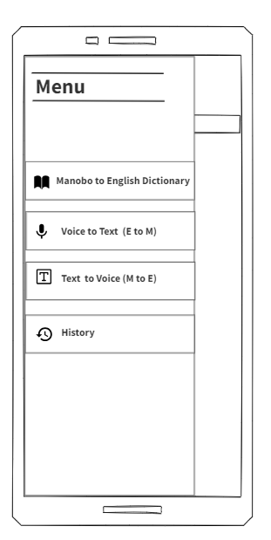

***Figure 8.2*** *Menu for Basic Manobo Expressions Dictionary*

Through Menu, the user can easily access the main functions of the Basic Manobo Expressions Dictionary. It then has the following options:

**Manobo to English Dictionary:** This is a search function for users to look up words in Manobo and their corresponding equivalents in the English language, thus serving as quick reference for language learners and speakers.

**Voice to Text (English to Manobo):** This feature allows the user to input English sentences through voice and see its equivalent Manobo text. It shall be available and very easy to use.

**Text to Voice (Manobo to English):** Manobo words can be typed into this and the user will hear it spoken in English. This will enhance pronunciation and listening comprehension.

**History:** This is a log of all your recent translations, both text and voice. This enables users to scroll back through and repeat previous searches or translations, therefore making the application more user-friendly and streamlined in its operations.

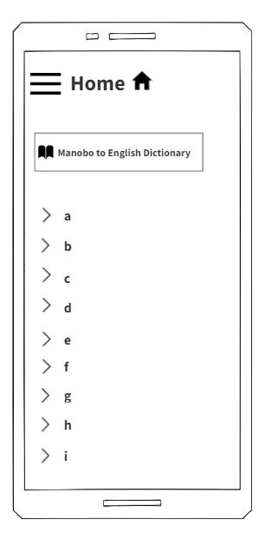

***Figure 8.3*** *Dictionary Page for Basic Manobo Expressions Dictionary*

The Dictionary Page of the Basic Manobo Expressions Dictionary is dedicated to the translation of Manobo words into English. An A-Z index and alphabetical arrangement assist the reader in quickly scanning the vocabulary listed on this page. By selecting a letter, a user can go directly to the page with words starting with the chosen letter.

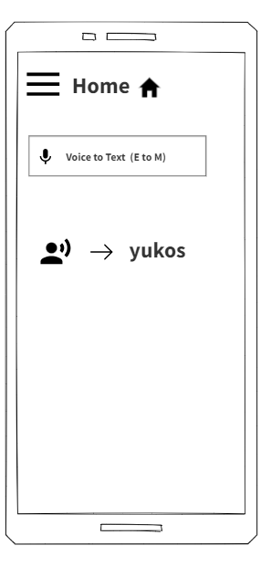

***Figure 8.4*** *Voice to Text Search for Basic Manobo Expressions Dictionary*

The Voice-to-Text Search feature of the Basic Manobo Expressions Dictionary involves speaking an English word or phrase and it will be transcribed into written Manobo text. This page enables the user to record his voice input by pressing a microphone icon, part of its simple interface design. The software captures the input and analyzes the audio data to show on the screen the text equivalent of the Manobo translation.

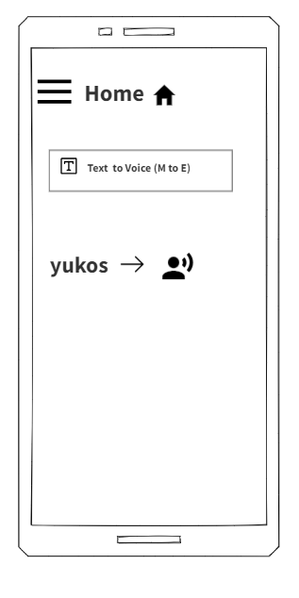

***Figure 8.5*** *Text to Voice Search for Basic Manobo Expressions Dictionary*

**Text-to-Voice Search (M-E):** a feature of the Basic Manobo Expressions Dictionary through which users are able to input Manobo text and then have the English translation read. This feature on the website provides visitors with the option to type a single word or a phrase in Manobo into a given text box and then press the "Play" button to hear it in English