**Name: Justin Senia**

**EID: E00851822**

**Date: 11/2/2017**

**Class: COSC 471 T 10:00am-11:50am**

**Assignment: Homework_3**

**Chapter 7**

**7.0 (10 pts.) – This question is not included in the textbook.**

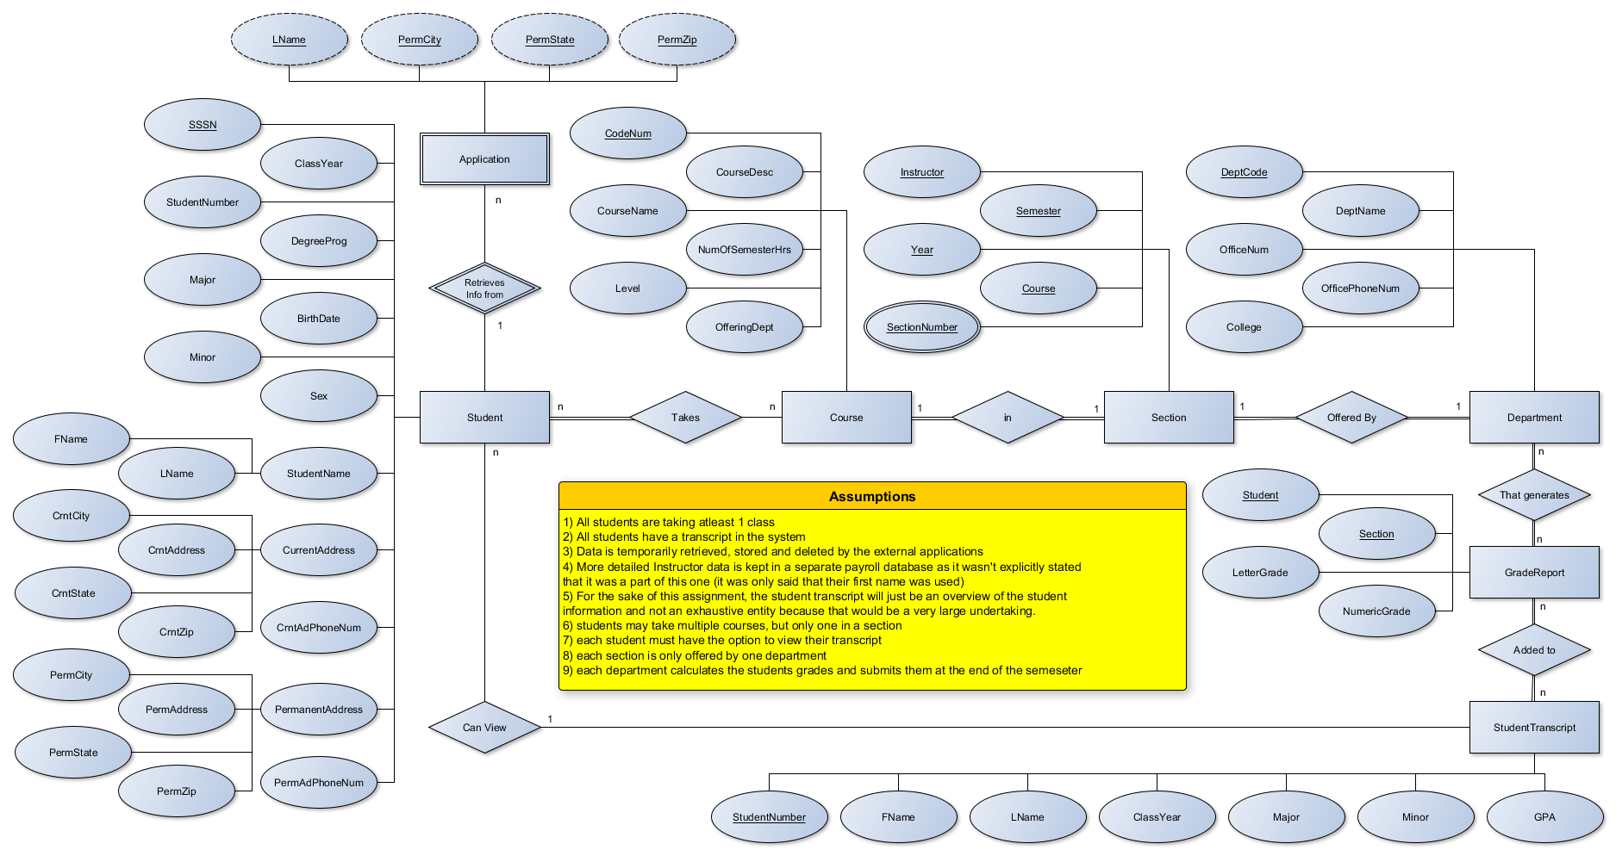

**Draw an ER diagram for this database. Specify key attributes of each entity type and structural constraints on each relationship type. Note any unspecified requirements, and make appropriate assumptions to make the specification complete.**

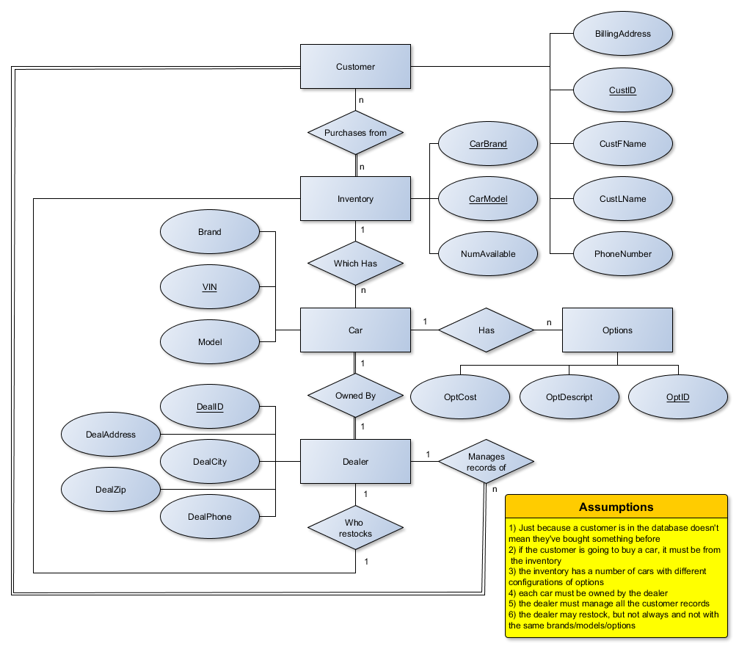

**7.26 (5 pts.) – Draw the EER diagram and explain. Include at least one attribute with each entity.**

Design a generalization–specialization hierarchy for a motor vehicle sales

company. The company sells motorcycles, passenger cars, vans, and buses.

Justify your placement of attributes at each level of the hierarchy. Explain

why they should not be placed at a higher or lower level.

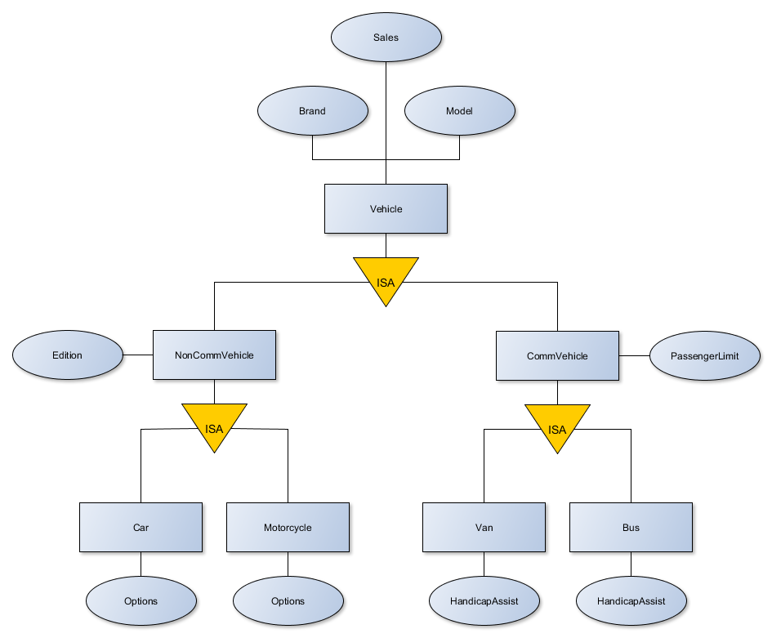

Every vehicle produced would share the attributes of a brand and model as well as sales related information so that all classes below it could inherit those information headings. Then breaking it up into both noncommercial and commercial below that seemed like a good idea because the actual types of vehicles could each be categorized under both of those headings which would allow for more adaptability, and would better describe whats needs to be described.

**7.30 (10 pts.) – This question is not included in the textbook.**

* **Forward engineer the EER diagram located at this site, to a relational schema:**

[**http://www.texample.net/media/tikz/examples/PDF/entity-relationship-diagram.pdf (Links to an external site.)Links to an external site.**](http://www.texample.net/media/tikz/examples/PDF/entity-relationship-diagram.pdf)

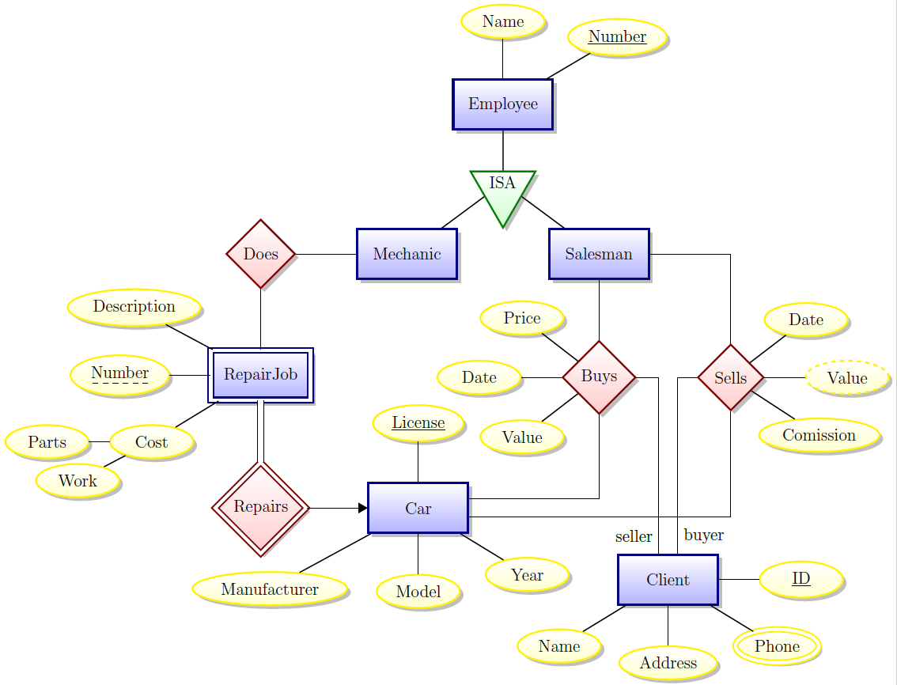

Car(ClientID, License, Manufacturer, Model, Year)

Client(ClID, CLName, ClPhone, ClAddress)

RepairJob(MechanicName, *CarLicense*, Description, Number, PartsCost, LaborCost)

Mechanic(MechNumber, Name)

Buys(SalesmanName, *carLicense*, BuyPrice, BuyDate, BuyValue)

Sells(SalesmanName, *carLicense*, SellValue, SellComission, SellDate)

Salesman(SalesNumber, Name)

**7.31 (5 pts.) – This question is not included in the textbook.**

* **Reverse engineer the relational database schema in figure 5.25 on page 212 in the textbook to an ER diagram. This is the Banking database. Make sure you document any assumptions.**

